**CSI Assignment 2 Report**

**Miner ID: nshar082 Nischal Sharma Student ID: 300023475**

Class Transaction:

Class Block:

Class BlockChain:

Proof of Work Algorithm:

Table:

|  |  |
| --- | --- |
| Trial Index | Number of Trials |
| 1 | **661667** |
| 2 | **206616** |
| 3 | **22785** |
| 4 | **1133604** |
| 5 | **13769** |
| 6 | **233937** |
| 7 | **1843957** |
| 8 | **890430** |
| 9 | **1182939** |
| 10 | **91563** |
| Median | **447802** |
| Average (Mean) | **628126.7** |

Number of Trials per index:

661667

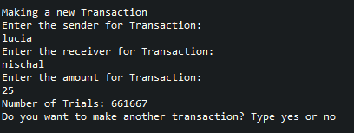

206616

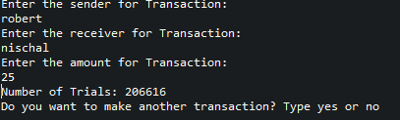

22785

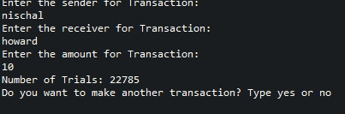

1133604

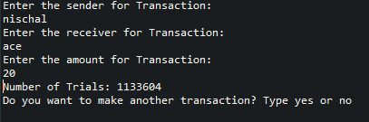

13769

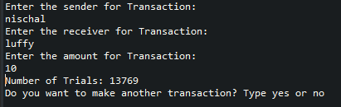

233937

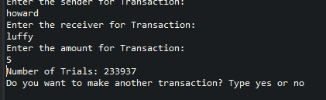

1843957

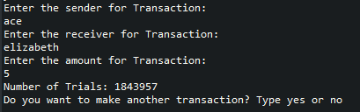

890430

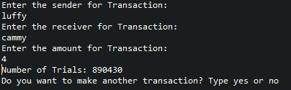

1182939

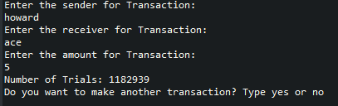

91563

