By: Nischal Sharma: 300023475

By: Nishchal Nepal: 300018661

**JPS**

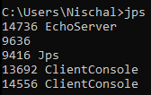

**JConsole**

**E**choServer

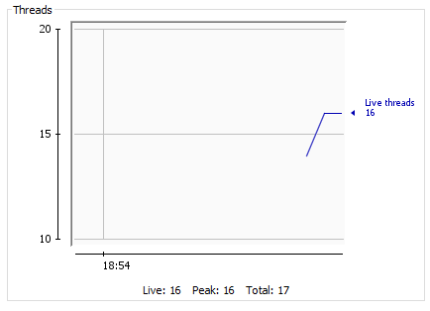

ClientConsole - 1

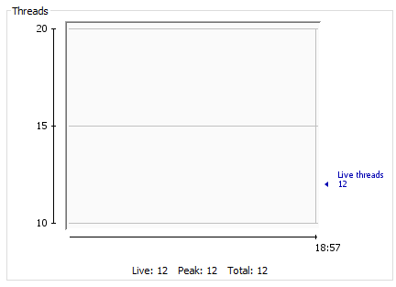

ClientConsole – 2

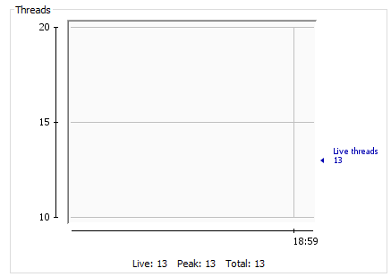

Followed by JStack in the next page.

**Jstack**

JStack for EchoServer

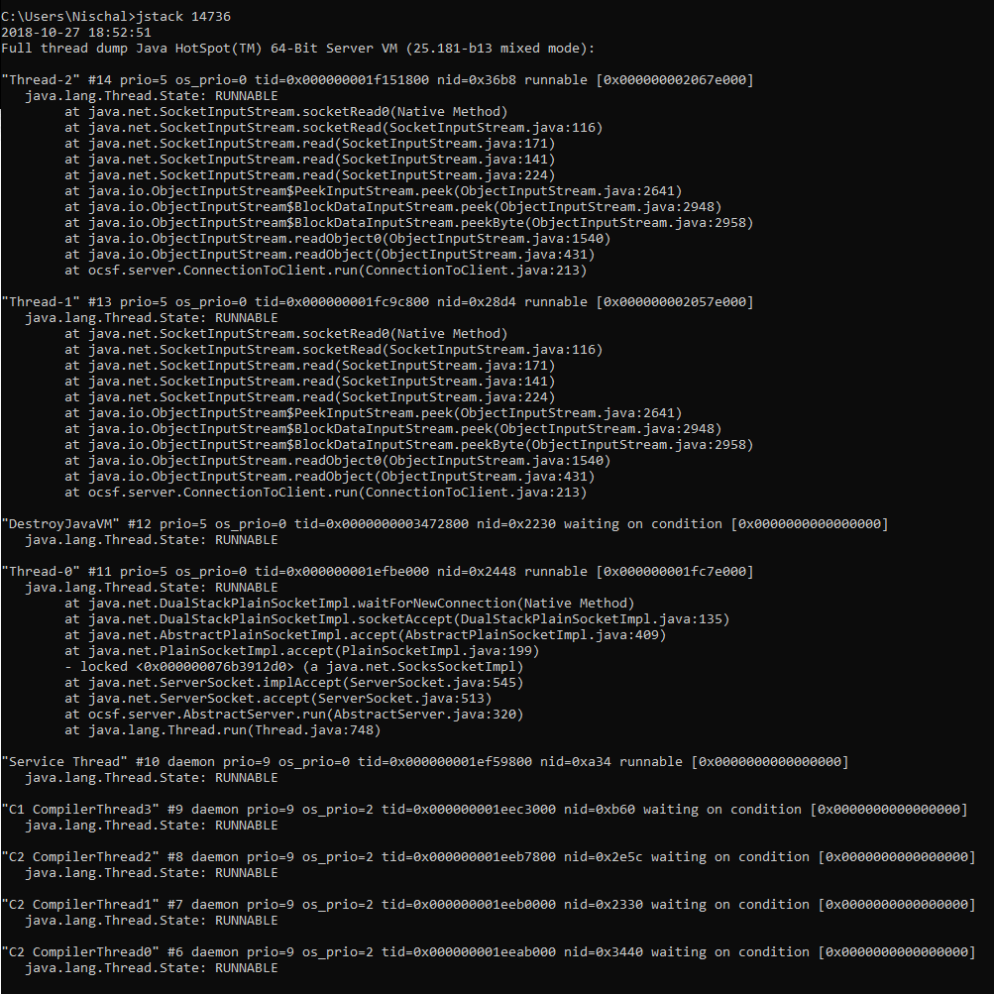

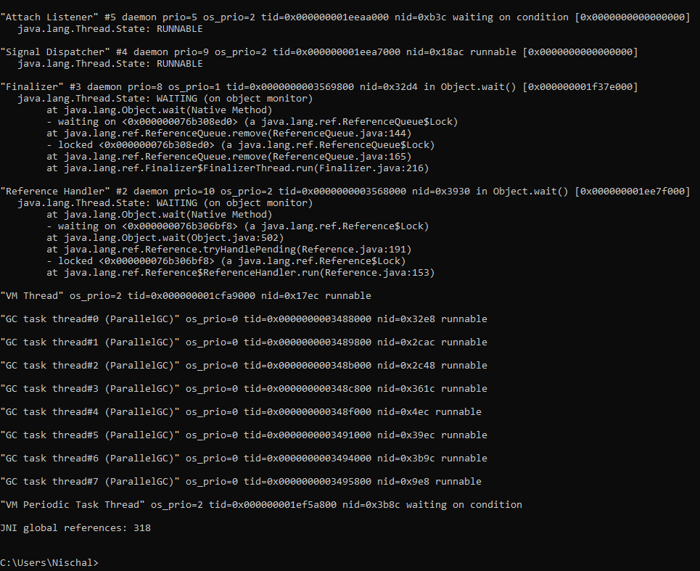

Total Running Threads = 16 Threads running and the rest are runnable

JStack for ClientConsole – 1

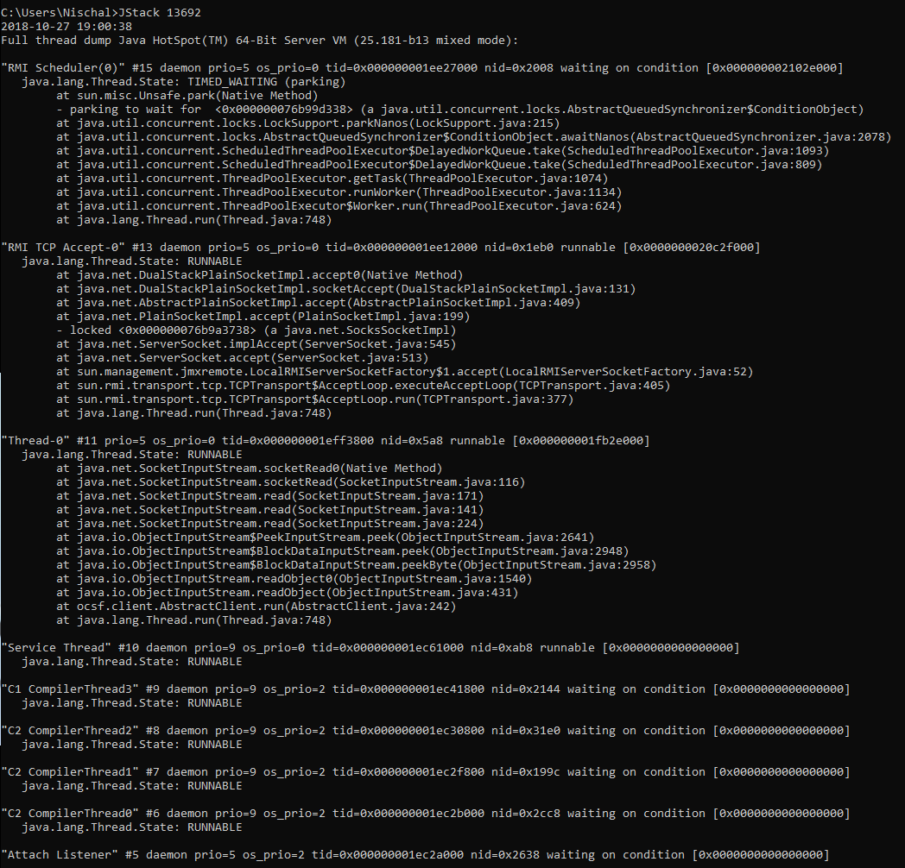

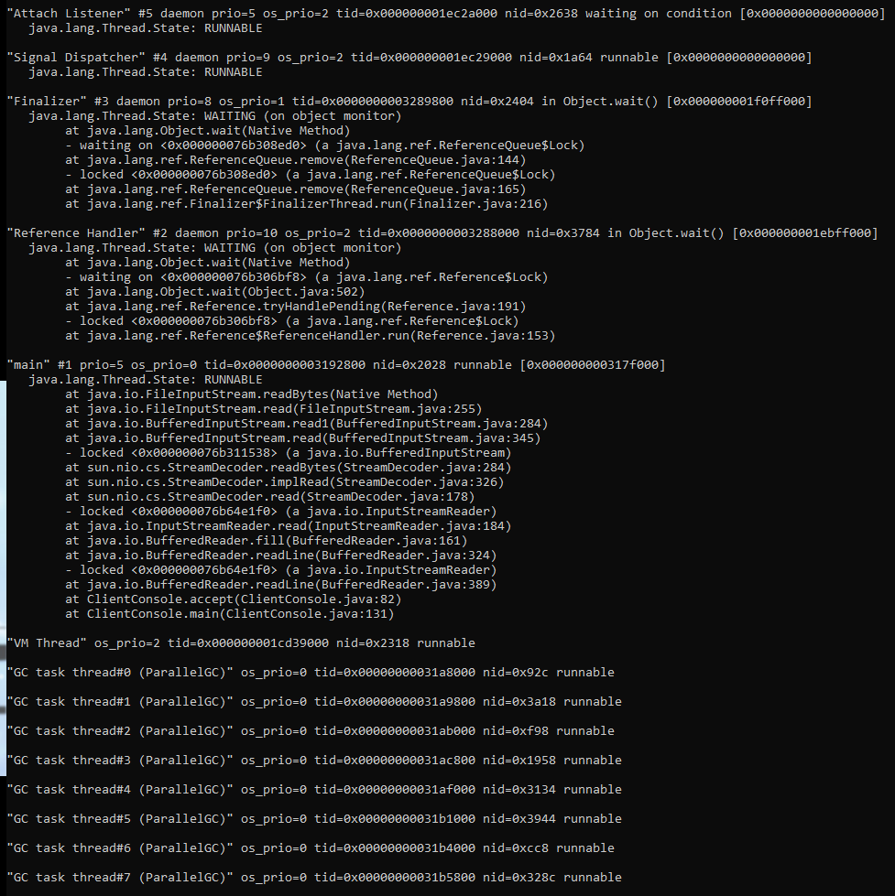

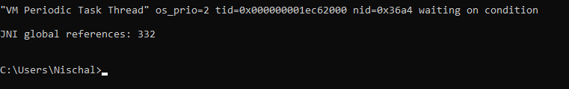

Total running threads = 12 and the rest are runnable

Jstack for ClientConsole – 2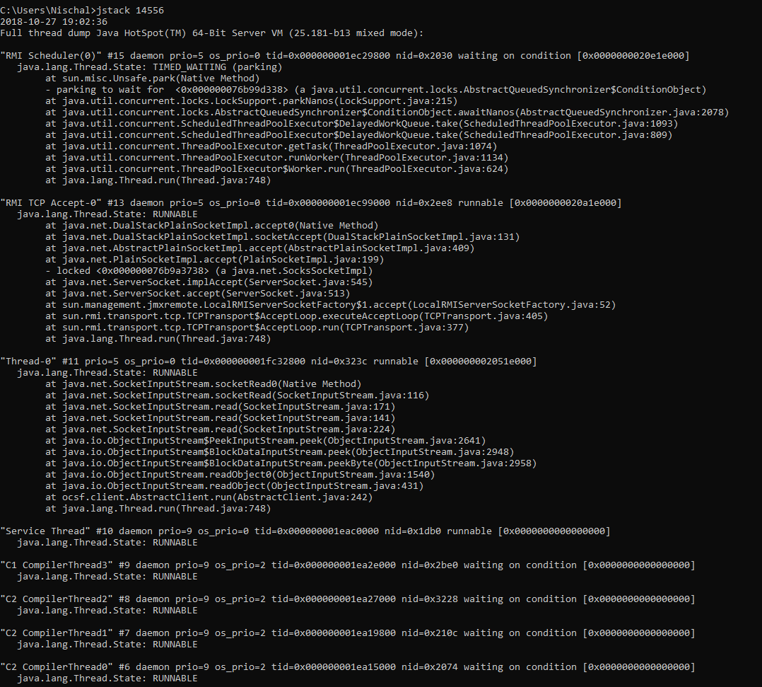 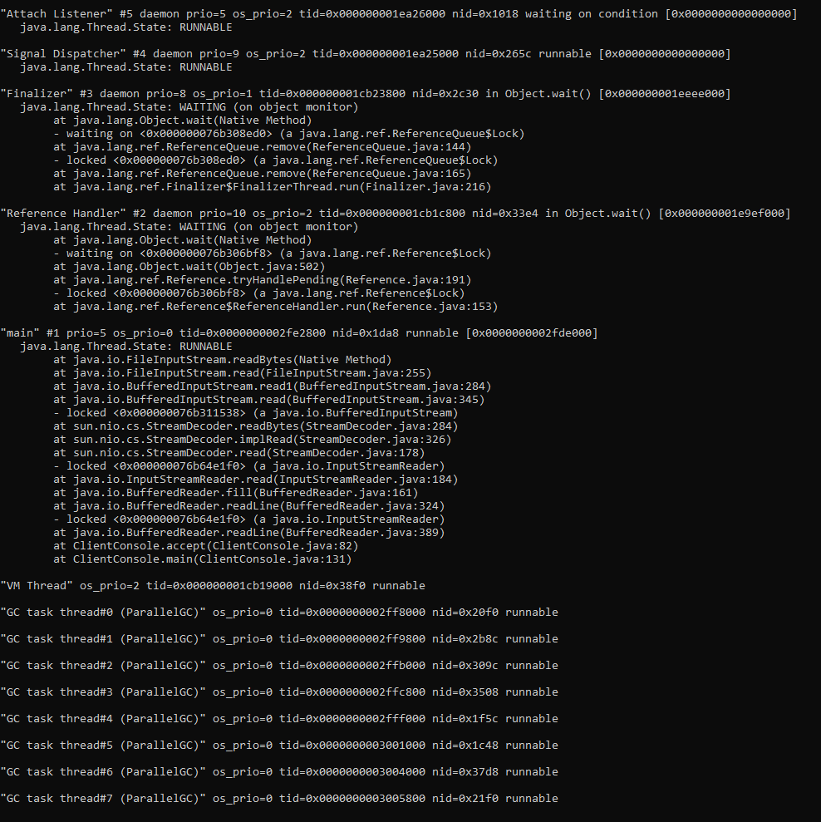 

Total Running Threads = 13 and the rest are runnable but not used

**Netstat -aon**

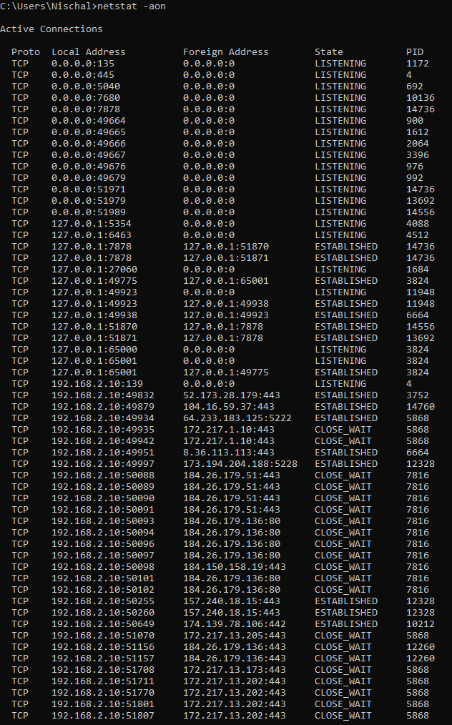

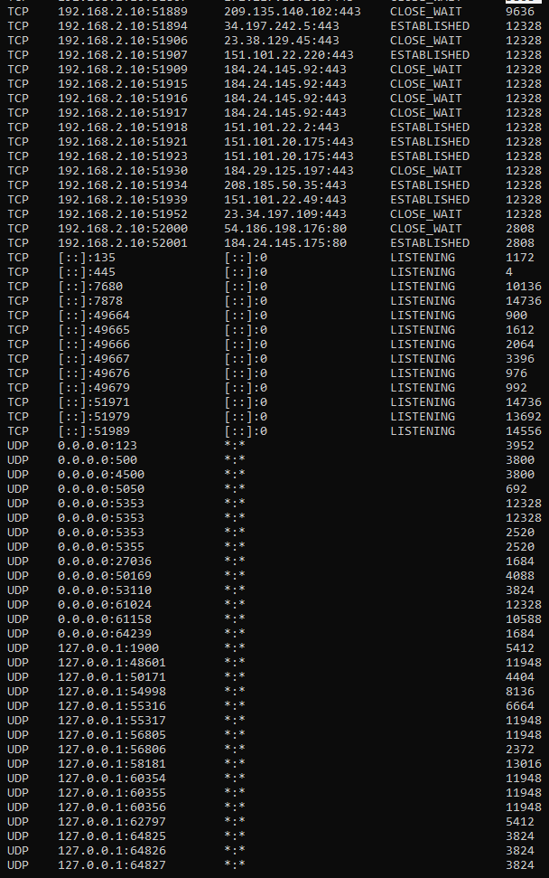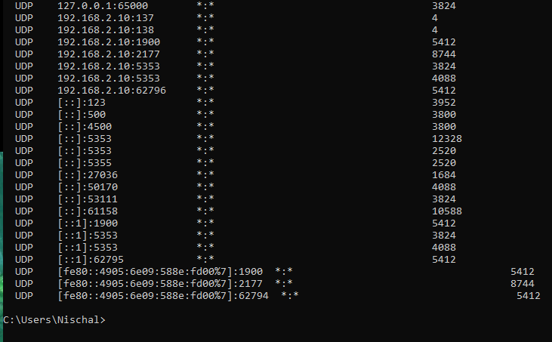

The ones used by the server are <PID>

14736 Server

13692 ClientConsole -1

14556 ClinetConsole -2

Finding the neccesary <PID> above:











  

