# Design

Design is the process after analysis and also it is also known as logical and physical plan of the project. Also, Design also reduces the future risk factors in the system. It also make the system development process smooth. Design also helps in developing the structural and logical functionalities of the system.

# 3.1 Structural Modelling

#### 3.1.1 Final Class diagram

Class diagram is the static design which reflects the structure of the classes by showing the system’s classes, attributes, methods as well as relation among object. It is helpful to model the system for business analyst.

* Justification

I have used the class diagram for the project I have used object oriented and in object oriented there may occur class and object so the best diagram would be class diagram. It shows us the how system’s classes interacts with one another. It helps in modelling the system.

#### Optional

Flow chart is a diagram which represents the process of the system. It is also known as step by step process of doing a task. Flow chart also represent the many boxes of many kinds and their work flow by connecting them by the arrows. Flow chart also plays an important role in displaying the properties of the system.

* Justification

I have used the flow chart diagram as my optional diagram because flow chart diagram helps the system to be prevented by future risk. It is also known as one the most powerful tool used in every sector for development. It has also helped me to communicate with process in a more easy way.

* Notation

|  |  |  |
| --- | --- | --- |
| Notation | Name | Explanation |
|  | Flow line | A line is a connector that shows relationship between the shapes. |
|  | Terminator | An oval represents a start or end point. |
|  | Process | A rectangle shape represents as a process. |
|  | Decision | A diamond shape indicates as a decision. |
|  | Input/output | A parallelogram represents input or output of data, as in entering data or displaying result. |
|  | On-page connector | It helps to remove or replace long or confusing lines on flowchart. |

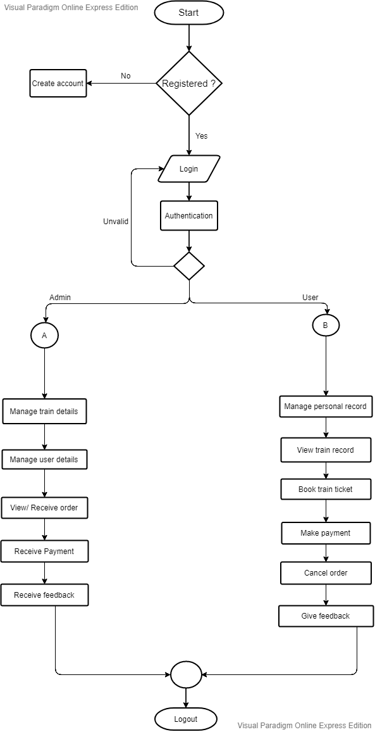

Figure 1: Flow chart

This figure represents the flow of the system. It shows us all the process of registration, login. In addition, this figure shows us what are the works of an admin in the system and what are the features which the users are getting in the system. In the simple term, this figure is showing the functionality and using methodology of the system.

# 3.2 Behaviour modelling

#### 3.2.1 Activity Diagram

Activity diagram is a behaviour figure which shows the flow of activities through the system. It can also be used to show the flow of events in business process. They also been used in business to see the flow of process.

* Justification

In this project I have decided to make activity diagram because it describes the sequences from one activity to other. It also describes the parallel flows of the system and gives out the flow of activates between data’s. It is also a step by step process.

* Notation

|  |  |  |
| --- | --- | --- |
| Notation | Name | Explanation |
|  | Start | Show the first phase of the workflow. |
|  | Decision | It is diamond shaped which represent a decision with different paths. |
|  | Action | It is a task to be performed. It is also represented by rectangle with round circle on sides. |
|  | Control Flow | It shows the sequences of the execution. |
|  | Activity Final Node | It is a final phase. |
|  | Sent signal | It show that the signal is being sent. |
|  | Receive signal | It shows the signal is being received. |
|  | Time event | This represents to an event that stop the flow of a time. |
|  | Note | It is used to show additional information. |
|  | Fork node | Splits the behaviour into a set of parallel or concurrent flows of activities. |
|  | Join node | Bring back together a set of a parallel or concurrent flows of activities. |

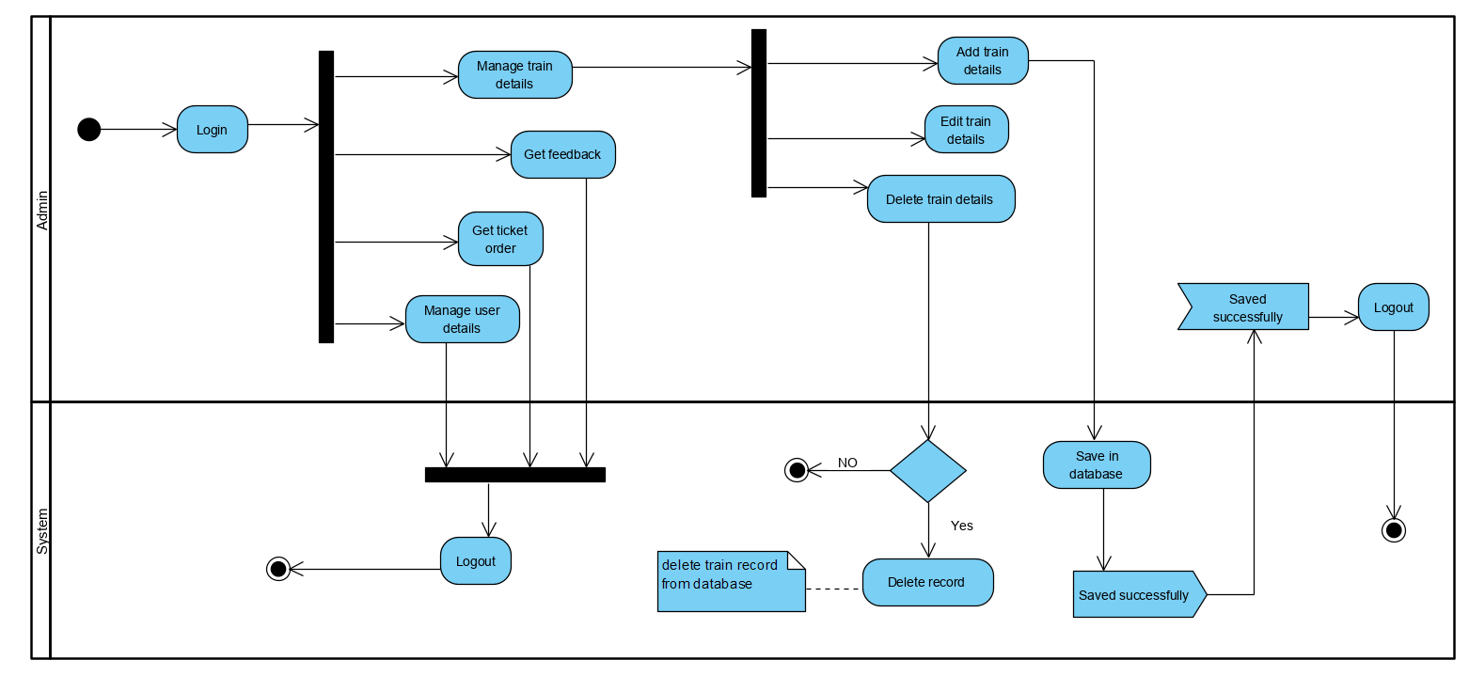

Figure 2: System admin activity

This figure shows the login method and the process of using the system by admin. So, to make some change in the system admin should be logged in to the system and afterwards they can manage bookings, manage user details, and delete the records. Admin is also able to receive the orders and see the feedbacks of the customers.

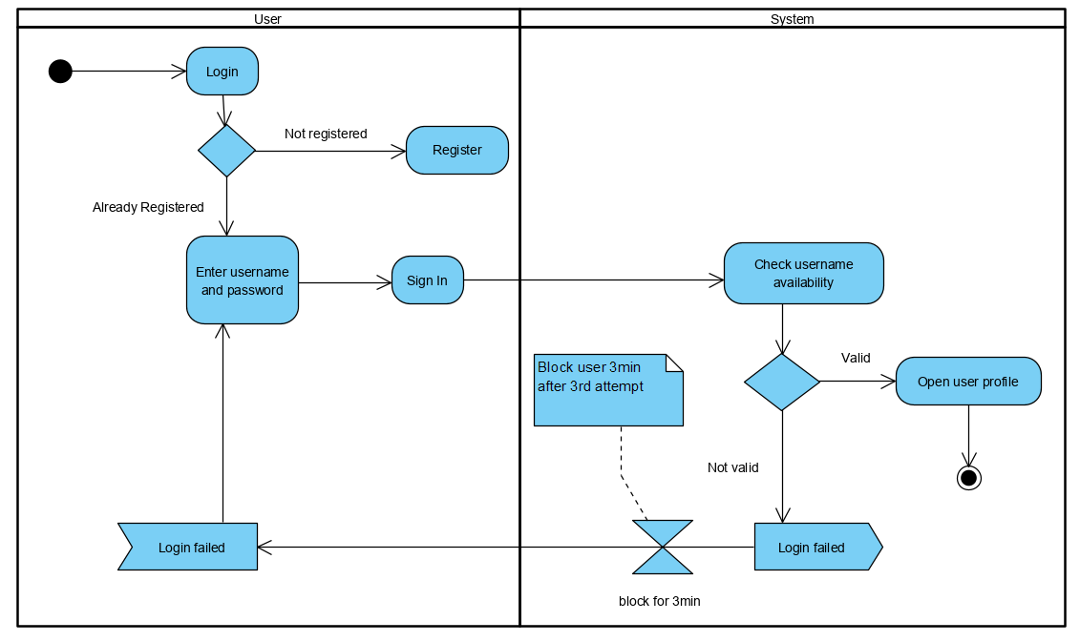

Figure 3: System user login activity

This figure shows the login activity of the user. At first phase the user is require to register themselves so that they can login to the system. While getting login if the user fail to use the right username and password until the 3rd attempt they would be block for 3 minutes.

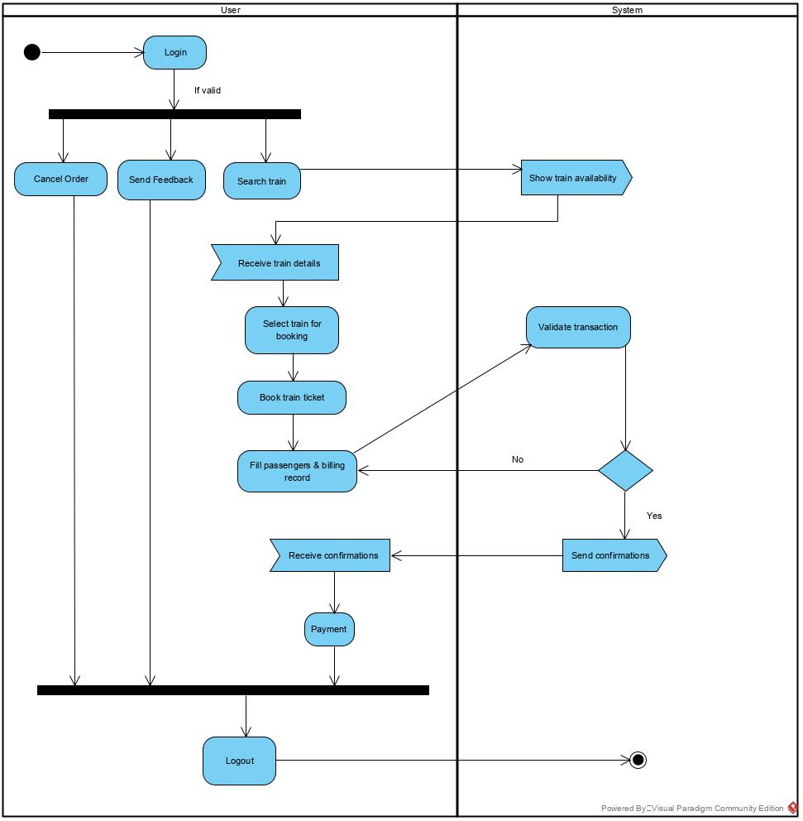

Figure 4: system user activity

This figure shows the process of using the system by the user. While users can search the train and can see their schedules also they can cancel the bookings, make payment for the tickets through the system.

#### 3.2.2 Sequence Diagram

Sequence diagram is one of the UML diagram which falls under behaviour diagram. It shows how the system is worked and also is a good way to validate the runtime scenario.

* Justification

I have made sequence diagram because it shows the active objects in a system. It will also help us to change the behaviour of the system in the future use. It models the system accordingly the various scenario.

* Notation

|  |  |  |
| --- | --- | --- |
| Notation | Name | Explanation |
|  | Actor | Actor are the role played by the users which interact with the system. |
|  | Activation box | Activate is used to denote participation activation. |
|  | Object | They are model elements which represents the instance of the class. |
|  | Life line | It represents each instance in an interaction. |
|  | Loop symbol | It is used when the scenario occurs only under certain conditions. |
|  | Alternative symbol | It is used to represent alternatives. It is a rectangular box which consist dash line inside. |
|  | Synchronous message | It is used when sender must wait for the response to the message. |
|  | Reply message | They are the dash line with arrowhead which replies to calls. |
|  | Self-message | Self-message is a kind of message that represents the invocation of message of the same lifetime. |
|  | Note | Used to attach various remarks to elements. |

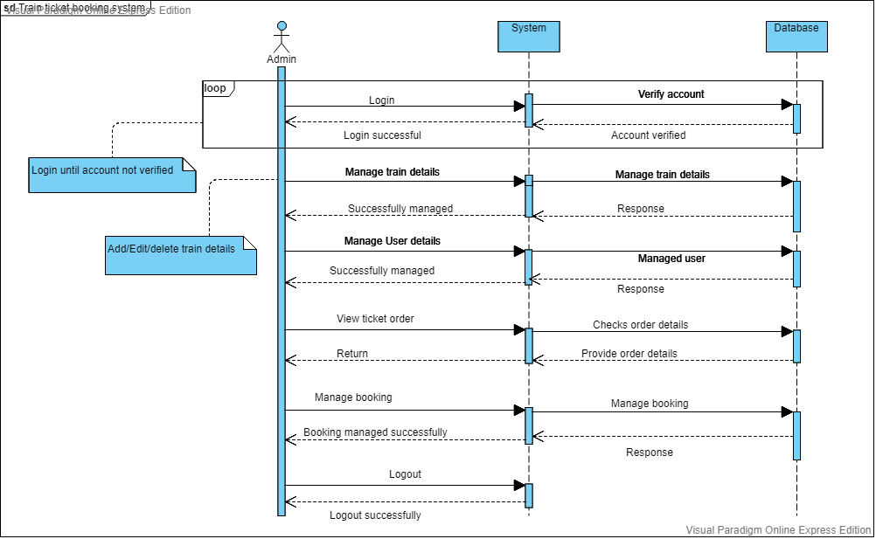

Figure 5: Sequence diagram of system admin

The given figure is the sequence diagram of system admin in which admin should be logged in to get access of all the features of the admin panel. In admin panel they can manage train details, manage user details manage bookings, response to the feedbacks and also receives the payment done by the user.

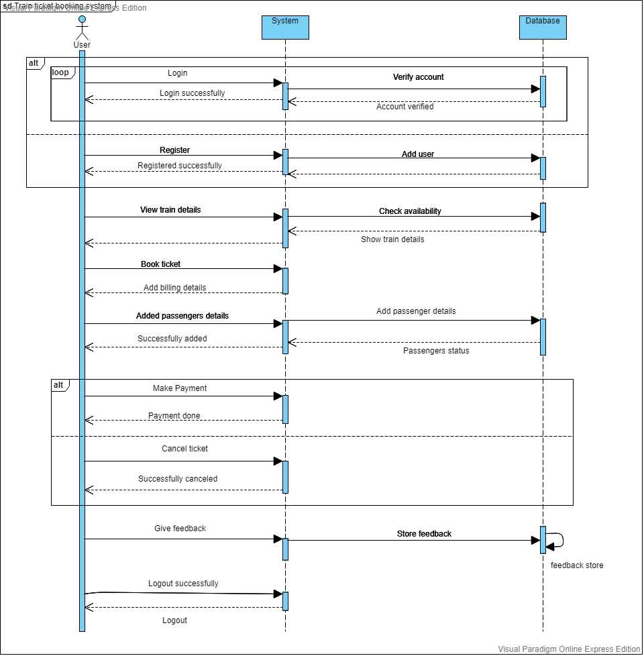

Figure 6: Sequence of system user

In the above figure of system user. The user of the system must require to get register to get access in the system and after getting access in the system they can view he train details, check the availability of the train make payment for their tickets and send the feedback to the system regarding their experiences.

# 3.3 Data Modelling

### 3.3.1 Data Dictionary

* User registration

|  |  |  |  |  |  |
| --- | --- | --- | --- | --- | --- |
| **No.** | **Attribute** | **Data Type** | **Length** | **Constraint** | **Description** |
| 1 | Reg_id | Integer | 255 | Primary key | It store registration id. |
| 2 | Username | varchar | 30 | Not Null | It store username of user. |
| 3 | Email | varchar | 50 | Not Null | It store email of user. |
| 4 | Password | varchar | 20 | Not Null | It store user password. |
| 5 | Confirm password | varchar | 20 | Not Null | It store and confirms user password. |
| 6 | Phone number | varchar | 30 | Not Null | It store user phone number. |

* User login

|  |  |  |  |  |  |
| --- | --- | --- | --- | --- | --- |
| **No.** | **Attribute** | **Data Type** | **Length** | **Constraint** | **Description** |
| 1 | Userid | Integer | 255 | Primary key | It store User id. |
| 2 | Username | varchar | 30 | Not Null | It store username of user. |
| 4 | Password | varchar | 20 | Not Null | It store user password. |

* Admin Login

|  |  |  |  |  |  |
| --- | --- | --- | --- | --- | --- |
| **No.** | **Attribute** | **Data Type** | **Length** | **Constraint** | **Description** |
| 1 | Adminid | Integer | 255 | Primary key | It store Admin id. |
| 2 | Username | varchar | 30 | Not Null | It store username of admin. |
| 3 | Password | varchar | 20 | Not Null | It store admin password. |

* Train details

|  |  |  |  |  |  |
| --- | --- | --- | --- | --- | --- |
| **No.** | **Attribute** | **Data Type** | **Length** | **Constraint** | **Description** |
| 1 | Trainid | Integer | 255 | Primary key | It store Train id. |
| 2 | Adminid | Integer | 255 | Foreign key | It comes from admin table. |
| 3 | Train_no | varchar | 30 | Not Null | It store the train number. |
| 4 | From | varchar | 30 | Not Null | It store passenger on boarding place. |
| 5 | To | varchar | 30 | Not Null | It store passenger arrival place. |
| 6 | Cost | varchar | 50 | Not Null | It stores Train ticket price. |
| 7 | Departure_time | varchar | 255 | Not Null | It store train departure time. |
| 8 | Arrival time | varchar | 255 | Not Null | It stores arrival time of train. |
| 9 | Duration | varchar | 50 | Not Null | It stores time taken to reach destination place. |
| 10 | Date | date |  | Not Null | It stores traveling date. |

* Passenger details

|  |  |  |  |  |  |
| --- | --- | --- | --- | --- | --- |
| **No.** | **Attribute** | **Data Type** | **Length** | **Constraint** | **Description** |
| 1 | Passenger_id | Integer | 255 | Primary key | It store Passengers id. |
| 2 | Trainid | Integer | 255 | Foreign key | It comes from train details. |
| 3 | Name | varchar | 50 | Not Null | It store passengers' name. |
| 4 | Address | varchar | 50 | Not Null | It store passengers address. |
| 5 | Contact No. | varchar | 30 | Not Null | It stores passengers contact number. |
| 6 | No_of_passenger | Integer | 30 | Not Null | It stores number of passenger. |
| 7 | No_of_ticket | Integer | 30 | Not Null | It store number of ticket. |

* Payment

|  |  |  |  |  |  |
| --- | --- | --- | --- | --- | --- |
| **No.** | **Attribute** | **Data Type** | **Length** | **Constraint** | **Description** |
| 1 | Payment_id | Integer |  | Primary key | It store Payment id. |
| 2 | Passenger_id | Integer |  | Foreign key | It comes from passenger table. |
| 3 | Fname | varchar | 30 | Not Null | It store card holder’s first name. |
|  | Lname | varchar | 30 | Not Null | It store card holder’s last name. |
| 4 | Postal_code | varchar | 20 | Not Null | It store postal code |
| 5 | Card_type | Varchar | 30 | Not Null | It stores card type. |
| 6 | Card_no | varchar | 100 | Not Null | It stores card number. |
| 7 | Expiry_date | date |  | Not Null | It stores expiry date of card |

* Feedback

|  |  |  |  |  |  |
| --- | --- | --- | --- | --- | --- |
| **No.** | **Attribute** | **Data Type** | **Length** | **Constraint** | **Description** |
| 1 | F_id | Integer |  | Primary key | It store User id. |
| 2 | Userid | Integer |  | Foreign key | It comes from user table. |
| 3 | Name | varchar | 20 | Not Null | It store username. |
| 4 | Date | date |  | Not Null | It stores date of given feedback. |
| 5 | Comment | varchar | 500 | Not Null | It store feedback. |

### 3.3.2 ER Diagram

It is a graphical representation of entities and their relationship to each other. It is mostly used in computing in regards to the organization of data within the databases.

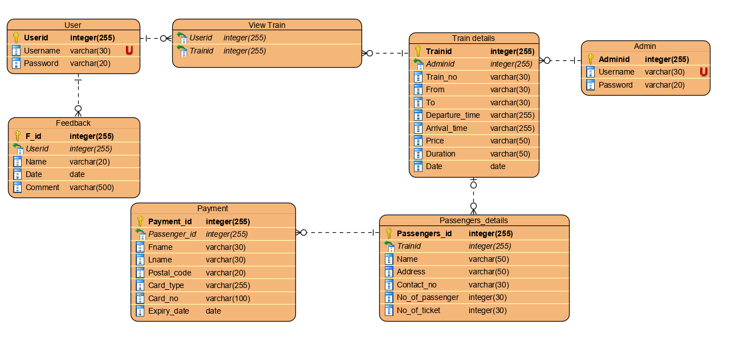

Figure : ER diagram

# 3.4 UI Modelling

* Home page

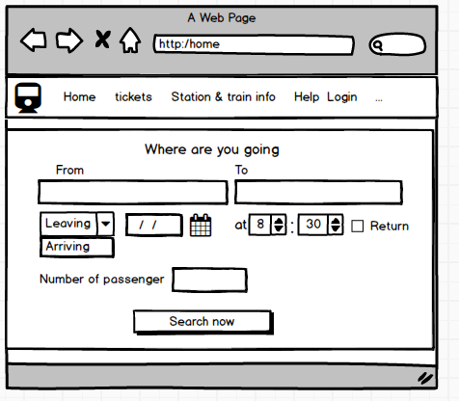

Figure : Home page

* 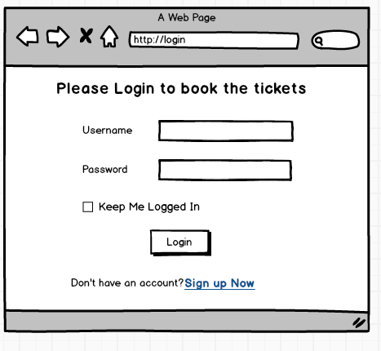Login page for user

Figure : User login

* Registration for user

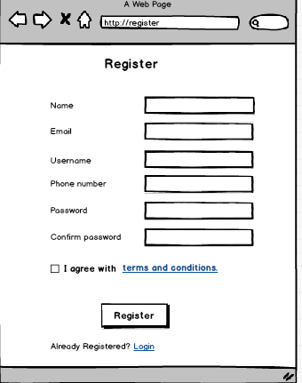

Figure : Registration

* Train Schedule

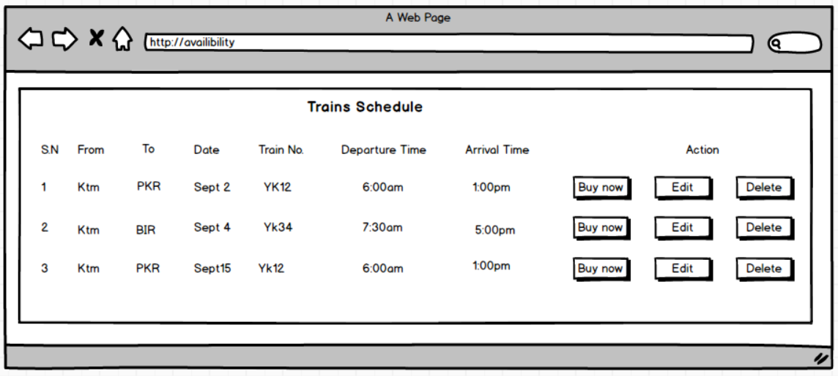

* Passengers information

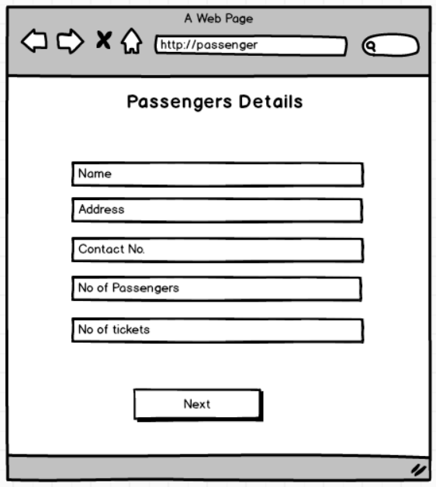

* Train details

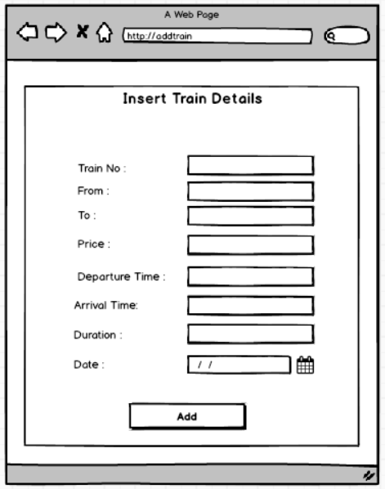

* Payment

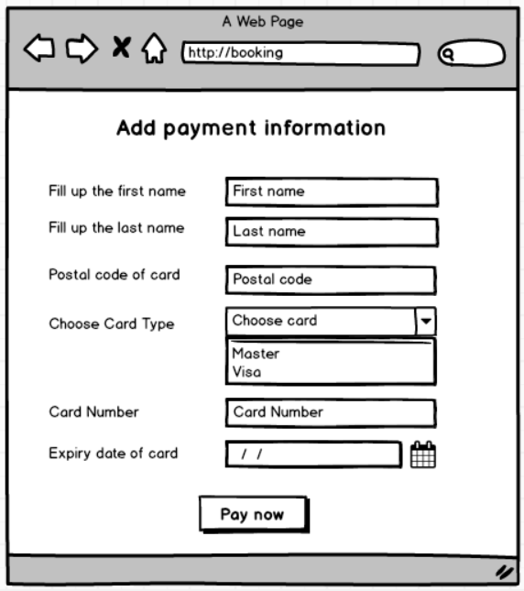

* Invoice

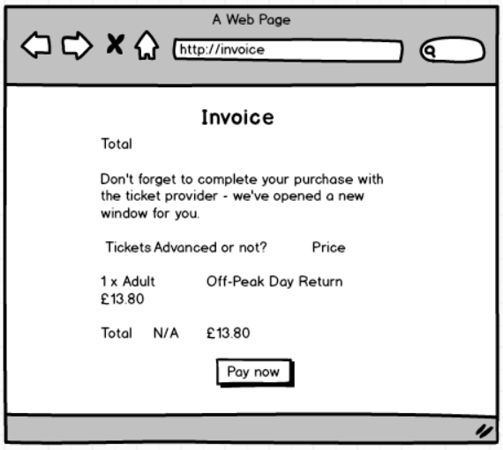

* Admin login page

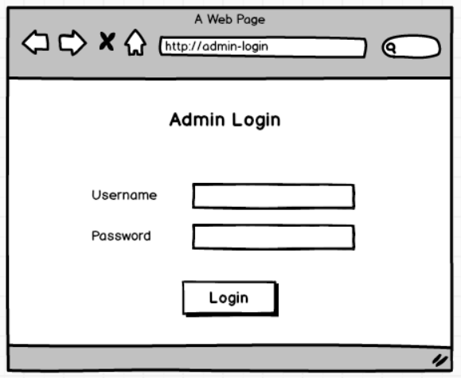

* Admin dashboard

