# A1 Overview

## 1.1 Introduction

This world is also known as the world of technologies. In this era or technologies we can do anything from the internet. Similarly, people face many difficulties while travelling for ticket booking process because they have to stand in line and while they get their turn in the reception the ticket might get sold out so I decided to create a train ticket booking system for the easiness of the customer.

Train Ticket Booking System is an online service which will help the customer to have a great ticket booking experience for train and also they can register themselves to book, change or delete there ticket bookings also they can pay the ticket fare through their payment card and can get their booking receipt too. Similarly in the staff side they will also get great experience in editing rescheduling and confirming the bookings from the online system itself.

## 1.2 Background of the system

This system is mostly used to make the users life easier and it does it so by helping the peoples to book the online ticket whenever they like and also allows the users to edit, delete or reschedule their ticket booking. While in the past this system was not online it was only computer based system but I have decided to create it online by using php so that everyone can book their own ticket from anywhere.

### 1.2.1 Problem statement

While every system has its own problems so does train management system and the problem was unmanaged booking system, data delicacy so I decided to create the system which prevents from these problems and helps on easy usability.

## 1.3 Justification of proposed system

Thus this is the technical era and everyone has their own gadgets which supports internet like smart phones, tablet, laptop etc. in which the users can run this project from. Likewise this project is made using PHP. I will make the ticket booking experience more unique and will also help in business growth.

## 1.4 Overview of the proposed system

# 2 Scope

## 2.1 Aims

Our aims in developing the system is to make the work pressure less of the employees and admins by making the reservations and ticket system computerized. User experience in using the system will be improved through online railway booking system. It will also help the staff to keep the data’s of the customer for security and future marketing reasons.

## 2.2 Objectives

* Customer can check the train details and its availability.
* Customer can register / login to the system.
* Customer can make changes to their bookings.
* Customer can book tickets along with their travel class.
* Customer can cancel the bookings.
* Customer can give ratings as well as their feedbacks regarding the service.
* Customer can pay online through their card.
* Admin can reschedule the time of the train.
* Admin can edit, Delete the user’s records.

## 2.3 Features

* Customer:
* Registration and login
* Edit, delete or book the ticket
* Online payment
* Update their profile information
* View the train information
* Admin
* Login panel
* Edit/delete records of customer as well as train
* View users information
* Confirmation of booking

## 2.4 Overview of scope

The system which I am creating is fully web based made from core php. This system can be used from anywhere at any time if they are connected to the internet. Also, to make in online at the internet we have to use some webhosting sites and host the system.

# 3 Development methodology

## 3.1 Methodologies to be used

Software Development methodology is a framework that is used for structural, plan and control the process of developing an information system. For this project I have used Waterfall model. Water fall model is a traditional system development life cycle (SDLC) his method involves a complete set of steps that a team follows. The fundamental idea is to divide the development process into a series of the phases or stages, each of which finished before next one starts.

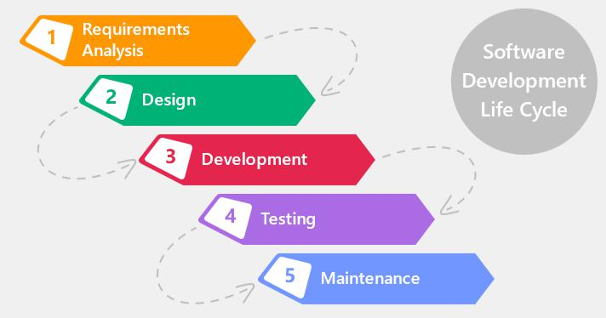

Figure : Waterfall Approach

Advantages of waterfall model:

* It’s simple and very easy to understand.
* It is easy to manage.
* It works well for smaller projects too because due to the requirements are easier to understand.
* In this approach phrases are processed and completed at a time.

Disadvantages of waterfall model:

* High amount of risk with uncertainty.
* Poor model for long project.
* Not suitable for complex Object oriented projects.
* Going back from ongoing phrase for some changes will be very difficult.

## 3.2 Design pattern

Design pattern is a repeatable solution to commonly occurring problem in software development. Similarly, there are many design pattern but for this project I have used Model View Controller (MVC) pattern. MVC design pattern specifies that an application consist of a data model, presentation information, and control information. MVC pattern is for architect patter not for complete application. This is really effective and efficient design pattern due to this I will be using it for my system.

## C:\Users\Hactivist\Desktop\model-view-controller-light-blue.png

Figure : MVC pattern

## 3.3 System Architecture

System architecture that I will use in this system will be 3-tier because the user don’t have to use the database so we are using this method. 3-tier architecture also improves the horizontal stability, performance and availability. Below down are the three tiers,

1) Presentation tier: It is a tier which is built with HTML, CSS and JavaScript and is deployed to the computer by web browsers.

2) Application tier: Application tier also known as logic tier is written in java which contains the business logic which supports the application core functionalities.

3) Data tier: It consist of database and programs for managing read and write access to a database. The database system for managing read/write access are MYSQL, Microsoft SQL Server and MangoDB.

# 4 Scheduling

## 4.1 Work breakdown structural

It is a method of getting complex, multi-step projects done. I t is a process of dividing the large projects to complete the project in fast way. While projects are divided in small chunks it will help to know the information in more depth. Dividing the projects will help in proper planning.

# 4.2 Milestone

|  |  |  |
| --- | --- | --- |
| **Task number** | **Task Description** | **Deadline** |
| **1.** | **Proposal** | **1st July** |
|  |  |  |
| **2.** | **Analysis** | **29th July** |
| i. | Planning | 3rd July |
| ii. | Requirement gathering | 8th July |
| iii. | Feasibility study | 12th July |
| iv. | Analysis method | 18th July |
| v. | System Requirement Specification (SRS) | 23rd July |
| vi. | Use case diagram | 29th July |
|  |  |  |
| **3.** | **Design** | **29th Aug** |
| i. | Structural model | 7thth Aug |
| ii. | Behavioural model | 12th Aug |
| iii. | UI design | 23rd Aug |
| iv. | Database design | 29th Aug |
|  |  |  |
| **4.** | **Coding** | **20th Sept** |
| i. | Frontend | 11th Sept |
| ii. | Backend | 20th Sept |
|  |  |  |
| **5.** | **Testing** | **30th Sept** |
| i. | Unit testing | 25th Sept |
| ii. | Blackbox testing | 30th Sept |
|  |  |  |
| **6.** | **Documentation** | **12th Oct** |
| i. | User manual | 7th Oct |
| ii. | Final documentation | 12th Oct |
|  |  |  |
|  | **Final deadline** | **12th Oct, 2019** |

Scheduling

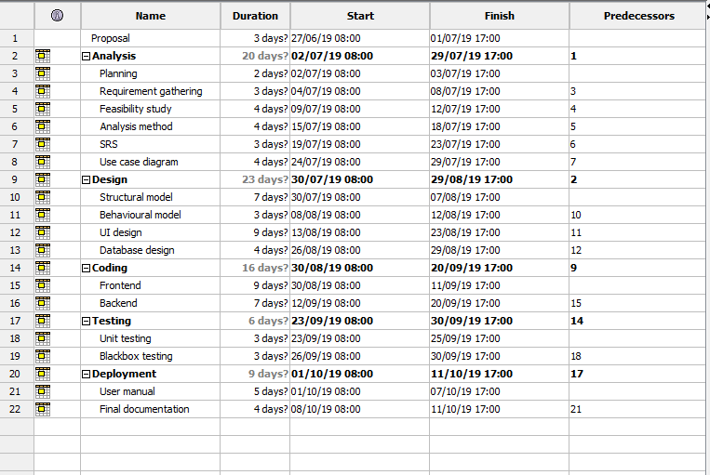

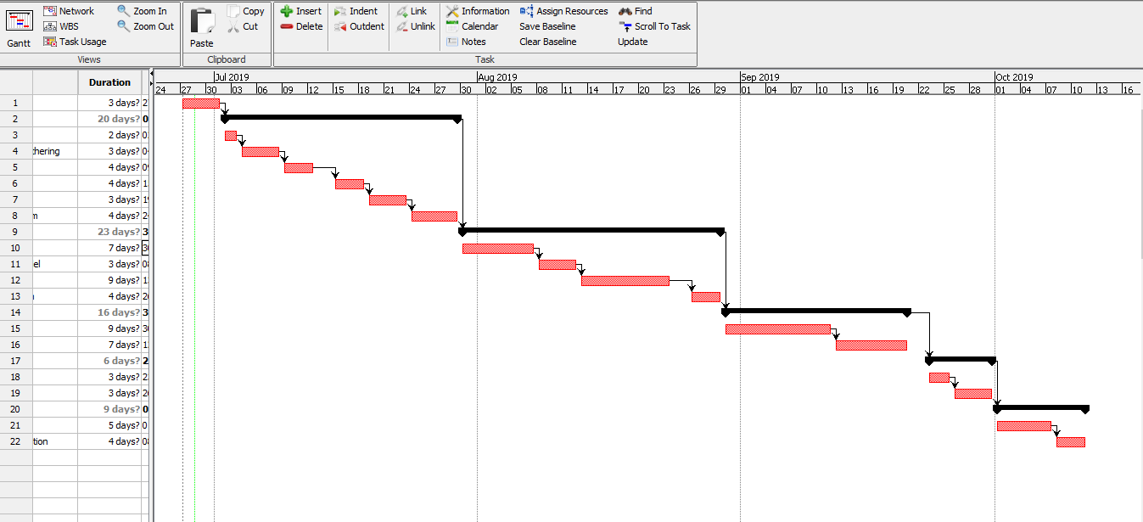

# Other Project Activities:

## 5.1 Risk Management

Developing system is one of the most difficult part of information technology and as everything developing a system also has its own risks. So, risk management is an approach of identifying risk, assessing risk as well as taking step to reduce risks to an acceptable level. The risk management approaches requires certain tools, team. The risk management plan also describes how the risk management will be structuralized and will be performed on the project.

For calculating process we will use two tables,

1. Likelihood table

|  |  |
| --- | --- |
| **Likelihood** | **Value** |
| Low | 1 |
| Medium | 2 |
| High | 3 |

1. Consequences table

|  |  |
| --- | --- |
| **Consequences** | **Value** |
| Very Low | 1 |
| Low | 2 |
| Medium | 3 |
| High | 4 |
| Very High | 5 |

Now for the calculation process we calculate the impacts of risks by multiplying likelihood to consequences.

|  |  |  |  |  |  |
| --- | --- | --- | --- | --- | --- |
| SN | Risks | Likelihood | Consequences | Impact | Actions |
|  | Requirements changes | 1 | 5 | 5 | Should discuss about the requirements with clients as well aa with team before developing |
|  | Malwares | 2 | 5 | 10 | Should use antivirus software and prevent downloading from unknown sites. |
|  | Hard disk crash | 1 | 5 | 5 | Should keep backups. |
|  | Hard UI | 2 | 3 | 6 | Should include instructions and as well as give training regarding the system. |
|  | Less functionality | 1 | 4 | 4 | Should follow the requirements. |
|  | More time taken than estimation | 2 | 5 | 10 | Should make schedules for tasks and follow the schedule. |

Here are the impacts which has score more than 6 and their precautions,

1. Malware: Malware also known as virus are the common issues which every system or software faces. It affects the system by corrupting the files and its databases. Some of the preventive measures are as follows,
2. Installing antivirus software’s.
3. Downloading from genuine sites.
4. Backup files.
5. Preventing opening unusual links.
6. More time taken than estimation: This is a really serious issues in system development because if it occurs both client and the developer will lose money as well as time. So some of the preventive measures are as follows,
7. Conducting meeting regarding the time and the project.
8. Following the time protocols.

## 5.2 Configuration management

Configuration management is the task of tracking the changes in a system. Configuration management also helps companies to manage, organize and control the changes in the codes, files or other documents during SDLC.

Therefore, for this project also I have created various files which will be the backup files which would be updated in every 2 to 3 days before the submission and it is uploaded in GitHub. We keep the backup to ensure that if our system gets corrupted we can re-use the system from the backup.

