Data Analytics Internship

SEMENSTER INTERNSHIP REPORT

*A report submitted in partial fulfillment of the requirements for the Award of Degree*

*of*

### BACHELOR OF TECHNOLOGY

**In**

**COMPUTER SCIENCE AND ENGINEERING**

**By**

**NISCHAL KATARA**

**Reg. No. 21BCE10575**

**Under Supervision of**

**Dr. Vishal Singh Bhati**

**Internship Studio,**

**Maharashtra, IN.**

**(Duration: 1st June, 2024 to 5th August, 2024)**



**School of Computing Science and Engineering (SCOPE)**

**VIT BHOPAL UNIVERSITY**

**2021 – 2025**

**School of Computing Science and Engineering (SCOPE)**

**VIT BHOPAL UNIVERSITY**



***CERTIFICATE***

This is to certify that the “**Internship report”** submitted by **Nischal Katara (Reg. No.: 21BCE10575)** is work done by him and submitted during 2024 – 2025 academic year, in partial fulfillment of the requirements for the award of the degree of **BACHELOR OF TECHNOLOGY in COMPUTER SCIENCE AND ENGINEERING**, at **INTERNSHIP STUDIO, MAHARASHTRA .**

|  |  |  |
| --- | --- | --- |
| **College Internship Guide**  Dr. G. Ganeshan  Assistant Professor |  | **Dean**  Dr. S. Poonkuntran  Dean & Senior Associate Professor  School of Computing Science and Engineering (SCOPE) |

**CERTIFICATION**



# ACKNOWLEDGEMENT

I would like to express my sincere gratitude to the **Director of Internship Studio, Maharashtra** for providing me with the invaluable opportunity to intern within the organization.

I am also deeply thankful to all my colleagues at **Internship Studio, Maharashtra (Remote),** as well as the instructors and staff, for their unwavering support, patience, and openness. Their guidance created an enjoyable and knowledge-rich working environment.

I am highly indebted to **Dr. S. Poonkuntran, Dean**, for providing the necessary facilities and support to accomplish this internship.

I extend my heartfelt thanks to **Dr. Dheresh Soni, Program Chair**, for his constructive feedback and encouragement throughout my internship.

I am also grateful to **Dr. G. Ganeshan** for his valuable guidance, support, and advice during my tenure at the organization.

Furthermore, I sincerely appreciate the support of my institution, particularly my department staff members and friends, whose assistance played a crucial role in the successful completion of this internship.

### Nischal Katara

### (21BCE10575)

**ABSTRACT**

The Data Analytics Internship at Internship Studio is an awesome chance for anyone looking to dive into the data world and gain practical skills. This program is perfect for those interested in uncovering trends in data and turning numbers into useful insights. With a strong emphasis on SQL, Python, Excel, and data visualization, the internship prepares participants to face today’s data challenges head-on.

A major focus of the program is getting comfortable with SQL, the key language for working with databases. Interns will learn how to write effective queries to pull and organize data, clean datasets, and enhance database performance. Mastering SQL is crucial in data analytics, and by the end of the internship, participants will be confident in navigating and understanding complex data landscapes.

The internship also highlights Python, a flexible programming language that’s a staple in the analytics industry. Interns will use libraries like Pandas and NumPy for data manipulation and employ Matplotlib and Seaborn for creating visualizations. Python’s capability to handle everything from basic data cleaning to more complex analyses makes it an essential tool for any future data analyst. This hands-on experience will help interns build the technical skills necessary for real-world projects.

Additionally, Excel is a vital component of the program. Participants will become skilled in advanced functions such as VLOOKUP, pivot tables, and macros, which will help them clean and organize data effectively. Excel’s user-friendly nature and versatility make it an essential tool for quick and efficient data analysis.

One of the standout features of the internship is data visualization. Interns will get hands-on experience with tools like Tableau and Power BI, along with Python libraries, to create dashboards and visual reports. These resources help present trends, patterns, and insights in a clear and engaging way, making it easier to share data-driven conclusions with stakeholders.

By the end of the internship, participants will have a solid skill set in data analysis. They'll know how to query databases, analyze data, and produce impactful visualizations, all while gaining a better grasp of how data shapes decision-making in the real world. Plus, they'll have the advantage of building a strong project portfolio, making the Data Analysis Internship at Internship Studio a perfect launchpad for anyone eager to start a career in data analytics.

# Methodology:

The Data Analytics Internship at Internship Studio aims to equip participants with vital technical and analytical skills necessary for effective data handling. By combining theoretical insights with practical experience, the program prepares interns to work with real-world datasets and make informed, data-driven decisions confidently.

Interns will develop proficiency in data management by learning to use tools like SQL, Python, and Excel for tasks such as querying, cleaning, and manipulating data. They will enhance their analytical skills to derive valuable insights from raw datasets through statistical and computational methods. The program also emphasizes data visualization, allowing interns to produce high-quality visual representations using Power BI, Tableau, and Python libraries, which are essential for effective storytelling and decision-making.

In addition to technical expertise, the internship promotes critical thinking and problem-solving skills, enabling interns to address business challenges through a data-centric lens. By the conclusion of the program, participants will be well-equipped for careers in data analytics, possessing the knowledge, experience, and confidence necessary to thrive in this evolving field.

# Programs and Opportunities:

The ‘**Internship Program**’ offers a comprehensive learning experience through structured training and hands-on practice. Interns will develop expertise in essential data analytics tools and techniques, covering SQL for database management, Python for data manipulation and visualization using Pandas, NumPy, Matplotlib, and Seaborn, and advanced Excel functions like pivot tables and macros. Additionally, they will enhance data visualization skills using Tableau, Power BI, and Python, enabling them to create insightful dashboards and communicate findings effectively.

Interns will gain real-world experience by working on practical business problems with actual datasets, strengthening their problem-solving abilities. The program includes mentorship from industry professionals, ensuring a supportive learning environment for skill enhancement. Interns will build a strong portfolio, showcasing their projects, dashboards, and analytics work, which boosts their career prospects. Workshops, guest lectures, and networking events further enhance the internship, connecting participants with industry experts and peers. This well-rounded experience prepares interns for successful careers in data analytics by combining technical skills, practical application, and professional development.

# Organization Information:

**Internship Studio** is a career development platform dedicated to empowering students and young professionals with practical skills and industry experience. Recognizing the gap between academic learning and professional demands, the organization provides structured internship programs that blend training, mentorship, and hands-on projects, equipping participants with the skills needed for career success.

Headquartered at MVPM Spark, Lane No 6, Ram Indu Park, near Balewadi High Street, Baner, Pune-411045, Maharashtra, India, Internship Studio collaborates with industry experts and leading organizations in technology, data analysis, management, design, and pharmaceuticals. These partnerships ensure that the internship programs remain industry-relevant and help participants develop in-demand skills.

With a personalized approach to learning, Internship Studio tailors its programs to meet individual needs, focusing on technical mastery, problem-solving, and professional networking. Through a mix of theoretical training, practical application, and mentorship, Internship Studio stands out as a platform dedicated to nurturing talent and fostering career growth.

# Benefits to the company / institution through your report:

The **‘Internship Report’** plays a crucial role in enhancing decision-making at Internship Studio by providing data-driven insights that help identify trends, inefficiencies, and opportunities. These insights support the organization in optimizing operations, refining strategies, and improving productivity.

If the report focuses on customer behaviour or market trends, it offers valuable recommendations for marketing strategies, service improvements, and business growth. Additionally, the report demonstrates the effectiveness of the internship program, reinforcing the organization’s reputation as a talent development hub. Interns bring fresh perspectives and innovative ideas, and their findings contribute to enhancing products, services, and overall business efficiency.

Beyond immediate improvements, the report serves as a knowledge resource for future projects, acting as a benchmark for performance enhancement. A well-structured analytical report strengthens the organization’s industry positioning, showcasing its commitment to innovation and data-driven decision-making. By leveraging intern-driven insights, Internship Studio and its interns mutually benefit, fostering continuous growth and development.

**Learning Objectives/Internship Objectives**

The **Data Analytics Internship** at **Internship Studio** provides a comprehensive understanding of data analysis concepts and practical experience. It equips interns with technical proficiency, problem-solving skills, and business applications in data analytics.

A key objective is to build technical expertise in SQL, Python, and Excel for data extraction, cleaning, transformation, and analysis. Interns will gain hands-on experience in writing SQL queries, manipulating data with Pandas and NumPy, and automating tasks using Python scripts to handle complex datasets.

Data visualization and reporting are crucial for communicating insights effectively. Interns will learn to create interactive dashboards and reports using Power BI, Tableau, and Python libraries like Matplotlib and Seaborn, translating raw data into meaningful insights for stakeholders.

Interns will develop problem-solving skills by analyzing complex datasets, identifying trends and patterns, and deriving actionable insights. Through real-world case studies and business scenarios, they will learn to apply analytics for data-driven decision-making.

Understanding the business context of data analysis ensures that insights align with organizational goals. Interns will explore industry-specific use cases in finance, marketing, healthcare, and e-commerce, gaining exposure to real-world business challenges.

The internship emphasizes hands-on project experience, where interns work on live datasets or simulated projects to apply theoretical knowledge. They will present their findings, methodologies, and insights, improving their communication and storytelling skills.

Collaboration and communication are vital, with interns encouraged to work in teams, engage with mentors, and present structured reports. Feedback will help them refine their data presentation and storytelling techniques, essential for a career in analytics.

The program also focuses on professional development, providing exposure to industry best practices, analytics workflows, and career guidance. Interns will receive support in resume building, interview preparation, and networking opportunities, ensuring a smooth transition into the industry.

# WEEKLY OVERVIEW OF INTERNSHIP ACTIVITIES

|  |  |  |
| --- | --- | --- |
| **WEEK** | **DATES** | **NAME OF THE TOPIC** |
| **1st** | **1/6/24 – 2/6/24** | Team Briefing & Self-Presentation.  Company Introduction & Internship Schedule |
| **2nd** | **3/6/24 – 8/6/24** | Data Analytics Overview  Excel Practical Session |
| **3rd** | **10/6/24 – 15/6/24** | PowerBI Overview & Example Projects |
| **4th** | **17/6/24 – 22/6/24** | SQL Practice Sessions |
| **5th** | **24/6/24 – 29/6/24** | Basic Python Programming (Operations & Control Flow) |

|  |  |  |
| --- | --- | --- |
| **WEEK** | **DATES** | **NAME OF THE TOPIC** |
| **6th** | **1/7/24 – 6/7/24** | Data Handling with NumPy |
| **7th** | **8/7/24 – 13/7/24** | Introduction to Python Data Types  Getting Started with Pandas |
| **8th** | **15/7/24 – 20/7/24** | Data Analysis using Pandas |
| **9th** | **22/7/24 – 27/7/24** | Example Projects & Applications |
| **10th** | **29/7/24 – 3/8/24** | Abstract and Presentation Submission |

**INDEX**

**Chapter No.**

|  |  |  |  |
| --- | --- | --- | --- |
|  |  | **Contents** | **Page No.** |
| 1. |  | Introduction | 1 |
| 2. |  | History | 2 |
| 3. |  | Definition | 3 |
| 4. |  | Architecture | 4 |
| 5. |  | Applications | 5 |
| 6. |  | Skills Acquired | 6 |
|  | 6.1 | SQL (Structured Query Language) | 6 |
|  | 6.2 | Excel | 6 |
|  | 6.3 | |  | | --- | | Power BI | | 6 |
|  | 6.4 | Python | 7 |
|  | 6.5  6.6 | NumPy  Pandas | 7  7 |
| 7. |  | Google Colab | 8 |
|  | 7.1  7.2 | Advantages  Disadvantages | 9  9 |
| 8. | 8.1  8.2 | Project Apparatus  Objective  Skills Used | 10  10  10 |
| 9. |  | Project Implementation | 10 |
| 10. |  | Project Deployment Results | 11 |
| 11. |  | Conclusion | 12 |
| 12. |  | Bibliography | 13 |
| 13. |  | References | 13 |
| 14. |  | Appendix | 14 |

1. **INTRODCTION**

Data analysis is all about systematically looking at, cleaning, transforming, and interpreting data to find valuable insights, patterns, and trends. With data being produced at an incredible pace these days, businesses in various sectors depend on data analysis to make smart choices, boost efficiency, and stay ahead of the competition. Whether it’s in business intelligence, healthcare, finance, marketing, or tech, data analysis is key to streamlining processes and forecasting future trends.

The data analysis journey starts with gathering information from different sources like databases, APIs, surveys, and logs. After collecting the data, it often needs some cleaning and preprocessing to fix inconsistencies, fill in missing values, and correct errors. Once the data is ready, analysts apply exploratory data analysis (EDA) techniques to spot patterns, correlations, and trends within the data. To take it a step further, advanced statistical methods and machine learning algorithms can improve predictions and decision-making.

There are plenty of tools and technologies that make data analysis easier. SQL (Structured Query Language) is crucial for pulling and managing data from databases, while Python, with its libraries like Pandas, NumPy, and Matplotlib, offers robust options for data manipulation and visualization. Microsoft Excel is a popular choice for spreadsheet analysis, featuring pivot tables and built-in functions for quick data handling. Plus, data visualization tools like Power BI and Tableau turn complex datasets into interactive and easy-to-understand visuals.

As big data and artificial intelligence (AI) become more prominent, data analysis is evolving rapidly, incorporating automation and predictive analytics to provide real-time insights. Companies are using data analysis not just to assess their past results but also to make precise predictions and foster innovation. With more businesses and sectors embracing data-driven decision-making, the need for talented data analysts is on the rise, establishing it as one of the most valuable and in-demand career options in the current digital landscape.

# HISTORY

The development of data analysis is closely tied to the evolution of statistics, computing, and the growing need for businesses and governments to make data-driven decisions. Here's a brief history:

**1. Pre-20th Century: Early Data Collection & Analysis**

* **Ancient Civilizations**: The earliest forms of data collection and analysis can be traced back to ancient civilizations. The Egyptians, Greeks, and Romans collected data for purposes like agriculture, taxation, and census-taking.
* **17th-18th Century**: Early statistics emerged during this period, mainly for demographic data and commerce. John Graunt (1662) is often credited with laying the groundwork for modern statistics with his work on London’s population and mortality rates, which was one of the first applications of quantitative data analysis.

**2. 19th Century: Formalization of Statistics**

* **Augustin-Louis Cauchy** and **Karl Pearson**: The 19th century saw the establishment of probability theory and early statistical methods. Cauchy worked on the theory of least squares, and Pearson introduced the correlation coefficient, a fundamental concept in data analysis.
* **Florence Nightingale** (1850s): Known for her work with health statistics, she used data visualization techniques (such as pie charts) to show the impact of sanitation on health, thus influencing public health reforms.

**3. Early 20th Century: The Birth of Modern Statistics**

* **1910s-1930s**: During this period, statistical techniques like regression analysis and hypothesis testing became more standardized.
* **Ronald A. Fisher** (1930s): Fisher is considered one of the founders of modern statistical science. He developed Analysis of Variance (ANOVA) and maximum likelihood estimation, which are still fundamental in data analysis today.
* **1920s-1940s**: Data collection became more systematic with the rise of government censuses and business surveys.

**4. Mid-20th Century: The Rise of Computing**

* **1940s-1950s**: The advent of computers revolutionized data analysis. The first computers, such as the ENIAC (1945), began to handle large amounts of data, allowing for more complex analyses.
* **Early Data Analysis Software**: Pioneering programs such as Fortran (1957) and IBM's SPSS (1968) started being used to run statistical analyses, making data more accessible.

**5. Late 20th Century: The Era of Big Data and Data Science**

* **1980s-1990s**: Data analysis expanded beyond academic and governmental use to industry. The development of relational databases (e.g., Oracle, Microsoft SQL Server) and data warehouses enabled large organizations to store and manage massive amounts of data.
* **Data Mining and Machine Learning**: As computing power grew, so did the sophistication of data analysis techniques. The development of data mining and machine learning algorithms during the 1990s allowed businesses to uncover patterns and insights from vast datasets.

**6. 21st Century: Data Science and Big Data**

* **2000s-Present**: The digital revolution has made data more abundant than ever. With the rise of big data technologies like Hadoop, Spark, and cloud computing, analysts can process vast amounts of unstructured data from social media, sensors, and other sources.
* **Data Visualization**: Tools like Tableau (2003) and Power BI (2014) popularized data visualization, making data insights more accessible and understandable to a broader audience.

# DEFINITION

Data analysis is the process of inspecting, cleaning, transforming, and modeling data to discover useful information, draw conclusions, and support decision-making. It involves various techniques such as statistical analysis, machine learning, data visualization, and predictive modelling to extract meaningful insights from raw data.

**Definitions according to some Famous Personalities:**

1. **John W. Tukey (Mathematician & Statistician)**  
   *"Data analysis is a procedure for analyzing data, techniques for interpreting the results of such procedures, ways of planning the gathering of data to make its analysis easier, more precise, or more accurate, and all the machinery and results of (mathematical) statistics which apply to analyzing data."*
2. **William Edwards Deming (Statistician & Quality Control Expert)**  
   *"In God we trust. All others must bring data."*  
   *(Emphasizing the importance of data-driven decision-making.)*
3. **Clive Humby (Data Scientist, Architect of Tesco’s Loyalty Card System)**  
   *"Data is the new oil. It’s valuable, but if unrefined, it cannot really be used. It has to be changed into gas, plastic, chemicals, etc., to create a valuable entity that drives profitable activity."*
4. **Thomas H. Davenport (Professor & Analytics Expert)**  
   *"Data analysis is the process of using data to derive insights, test hypotheses, and support decision-making, often using computational, statistical, and machine learning techniques."*

In essence, data analysis serves as the backbone of informed decision-making, enabling organizations to optimize performance, predict trends, and uncover valuable insights. By leveraging statistical techniques, machine learning models, and visualization tools, data analysts can transform raw data into meaningful knowledge that drives innovation and progress across various fields.

# ARCHITECTURE

The architecture of data analysis provides a structured framework for collecting, processing, storing, analyzing, and visualizing data. This framework ensures an efficient data flow from raw sources to actionable insights that support informed decision-making. With the increasing volume of data generated across industries, a well-defined architecture helps in managing data effectively and optimizing analytical processes. The entire system is built on multiple layers, each playing a critical role in transforming raw data into meaningful information.

* The first stage, **Data sources**, involves collecting structured data from relational databases like MySQL and PostgreSQL, and unstructured data from emails, social media, and IoT devices. High-quality data collection is crucial, as errors at this stage can lead to inaccurate insights.
* In the **Data Ingestion and Storage** layer, data is organized for future analysis. Relational databases manage structured data, while NoSQL databases like MongoDB handle unstructured information. Data warehouses store structured data for analytics, whereas data lakes like Hadoop allow raw data storage, offering flexibility for diverse analytical needs.
* The **Data Processing and Transformation** stage ensures data cleanliness and consistency. ETL tools like Apache Spark and Talend standardize data by removing inconsistencies and missing values, making it suitable for analysis. Proper preprocessing is essential to prevent misleading insights.
* The **Data Analysis and Processing** layer applies various techniques to extract insights. Descriptive analytics identifies past trends, predictive analytics forecasts future outcomes, and prescriptive analytics recommends actions. Real-time analytics processes live data for instant decision-making in areas like fraud detection and stock trading. Tools such as Python, R, and Power BI facilitate these analyses.
* **Data Visualization and Reporting** translate insights into interactive charts and dashboards using tools like Tableau and Matplotlib. Well-designed visualizations simplify complex data, helping stakeholders understand trends, patterns, and anomalies.
* In the **Decision-making and Action stage**, insights guide business strategies and operational improvements. Companies optimize marketing, enhance customer experiences, and streamline operations based on data-driven recommendations.

# APPLICATIONS

Data analysis has transformed various industries by enabling organizations to extract insights, optimize processes, and make data-driven decisions. From healthcare to business intelligence, its applications span multiple domains, impacting efficiency, accuracy, and innovation.

In the business and finance sector, data analysis plays a crucial role in financial forecasting, risk assessment, fraud detection, and customer insights. Stock market predictions rely on historical data and AI-driven algorithms, while banks assess loan eligibility and credit scoring through risk management techniques. Fraud detection systems analyse transaction patterns to identify anomalies, and companies use customer relationship management (CRM) data to enhance marketing strategies and improve user experience.

The healthcare industry heavily depends on data analysis for diagnosis, treatment optimization, and medical research. Machine learning models predict the likelihood of diseases based on patient history, while AI-powered tools enhance medical image analysis for accurate diagnoses. Drug discovery and clinical trials are expedited using big data analytics, and hospitals optimize resource allocation to improve service quality and reduce patient wait times.

In retail and e-commerce, businesses leverage data analytics to understand customer behaviour and maximize sales. Recommendation systems provide personalized product suggestions, demand forecasting helps prevent stock shortages, and dynamic pricing strategies adjust product prices based on demand and competitor trends. Sentiment analysis of customer reviews and social media feedback also guides product development and marketing strategies.

The manufacturing and supply chain industry benefits from predictive maintenance, where sensors collect data to anticipate machine failures and reduce downtime. Quality control processes are enhanced by identifying defects in production lines using real-time analytics. Logistics optimization ensures efficient route planning and inventory management, reducing costs and improving supply chain efficiency.

Governments and public service sectors use data analysis for policy-making, infrastructure planning, and public welfare programs. In smart cities, analytics optimize traffic management, waste disposal, and energy consumption. Crime prediction models help law enforcement agencies analyse crime patterns, while public health monitoring enables authorities to track disease outbreaks and manage vaccination campaigns effectively.

In education and research, data analysis helps improve learning experiences and academic performance. Institutions analyse student performance to identify learning patterns and provide personalized education. E-learning platforms enhance online learning experiences by offering AI-driven content recommendations, while academic researchers rely on data-driven studies in various fields such as science, economics, and social sciences.

The sports and entertainment industry also benefits from data analysis, as sports teams analyse player performance statistics to develop game strategies. Streaming platforms study viewer preferences to recommend content, and real-time game analytics enhance decision-making in professional sports.

1. **Skills Acquired :**
2. **SQL**

SQL is the standard programming language used to manage and query data stored in relational databases. It allows analysts to perform operations such as retrieving data, filtering, joining tables, and performing calculations on large datasets. SQL is essential for data manipulation and retrieving the information needed for analysis. It's used in environments where large volumes of structured data are stored, such as in corporate databases.

**6.2. Excel**

**Microsoft Excel** is one of the most widely used tools in data analysis, especially for beginners and intermediate users. It allows analysts to organize data in a tabular format and perform basic analysis using formulas, pivot tables, and charts. Excel is particularly useful for smaller datasets and tasks like data cleaning, summarization, and simple visualizations. While it lacks the advanced functionality of some other tools, its familiarity, user-friendliness, and wide accessibility make it an essential tool for many data analysis tasks.

**6.3. Power BI**

**Power BI** is a powerful business analytics tool from Microsoft that helps in data visualization and reporting. It allows users to connect to various data sources (e.g., Excel, SQL databases) and transform raw data into interactive and visually appealing reports and dashboards. Power BI is widely used in organizations for business intelligence (BI), enabling users to make data-driven decisions by providing insights at a glance

**6.4. Python**

**Python** is a versatile and widely used programming language in data analysis and machine learning. It has an extensive ecosystem of libraries and tools that allow data analysts to work with large datasets, perform advanced data analysis, and create visualizations. Python is particularly powerful because of its flexibility, readability, and the number of libraries that support data analysis, such as NumPy, Pandas, and Matplotlib.

**6.5. NumPy**

**NumPy** is a powerful library in Python used for numerical computing. It provides support for large, multi-dimensional arrays and matrices, as well as a collection of mathematical functions to operate on these arrays. NumPy is widely used in data analysis because it offers efficient handling of large datasets, especially numerical data, and performs operations like matrix manipulation and linear algebra quickly and efficiently.

**6.6. Pandas**

**Pandas** is a popular Python library used for data manipulation and analysis, particularly with structured data (e.g., CSV, Excel files, SQL databases). Pandas provides two primary data structures: DataFrame (for 2D data, like tables) and **Series** (for 1D data). It makes data cleaning, transformation, and aggregation simple, and integrates well with other Python libraries like NumPy, Matplotlib, and Scikit-learn. Pandas is widely used for its ability to quickly load, clean, filter, and analyse datasets.

|  |  |  |
| --- | --- | --- |
|  |  |  |
| Reinventing the Python Logo: Interview ... |  |  |

1. **Google Colab**

Google Colaboratory, often referred to as Google Colab, was instrumental in project execution by offering a cloud-based platform for coding, data analysis, and machine learning. As a complimentary service from Google, it enabled users to run Python code effortlessly without requiring local installations or advanced computing capabilities. This feature was especially advantageous for managing large datasets and performing intricate computations, ensuring both efficiency and accessibility throughout the project.

A significant benefit of Google Colab was its cloud-based architecture, which removed the complications associated with manual software installation. Users could access their notebooks from any internet-enabled device, providing the flexibility to work on the project from various locations. Furthermore, its integration with Google Drive facilitated effective file management, simplifying the storage, access, and processing of datasets. Users could easily import large data files directly from Drive or other external sources, streamlining data handling during the project lifecycle.

Google Colab also offered a variety of pre-installed libraries, including NumPy, Pandas, Matplotlib, and TensorFlow, which were crucial for data manipulation, visualization, and model development. This availability saved time and effort, allowing users to concentrate more on analysis and implementation rather than setup. Another significant feature was its real-time collaboration capability, which allowed multiple users to work on the same notebook at the same time. This enhanced teamwork by enabling instant sharing of edits and insights among contributors.

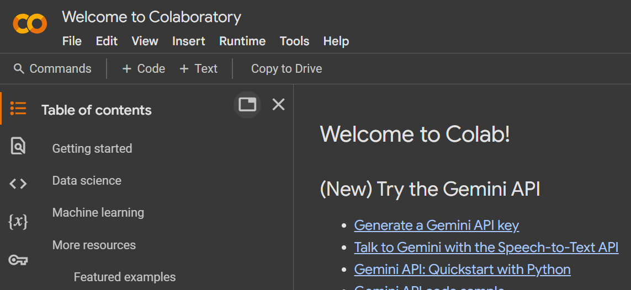For tasks requiring substantial computational power, Google Colab provided free access to GPU (Graphics Processing Unit) and TPU (Tensor Processing Unit) acceleration, greatly improving processing capabilities. This feature was particularly beneficial for deep learning and machine learning projects, as it reduced training times and allowed for the efficient execution of complex models. By eliminating the need for costly hardware, Colab emerged as a budget-friendly solution for data-driven initiatives.

**7.1. Advantages**

Google Colab provides free cloud-based access, eliminating the need for expensive hardware or local installations, making it accessible to a wide range of users. It supports real-time collaboration, allowing multiple users to work on the same notebook simultaneously, making it ideal for teamwork and research projects.

The platform comes with pre-installed libraries such as NumPy, Pandas, Matplotlib, and TensorFlow, reducing the need for manual setup and configuration. It also offers free access to GPUs and TPUs, significantly improving computational efficiency for deep learning and large-scale data processing.

Seamless integration with Google Drive and cloud storage allows users to easily store, access, and share files, improving data management and workflow. Additionally, Google Colab supports external data sources, enabling users to import datasets from Google Drive, GitHub, and other online repositories.

As a cloud-based tool, Colab is device-independent, allowing users to work from any device with an internet connection, removing hardware constraints and providing greater flexibility.

**7.2. Disadvantages**

One of the major drawbacks of Google Colab is its reliance on a stable internet connection, which can be a challenge in areas with limited access. The free-tier version also comes with session timeouts and RAM limitations, which can interrupt long-running computations.

Customization options are limited compared to local development environments like Jupyter Notebook or PyCharm, making it less flexible for advanced configurations. Additionally, file storage is temporary, meaning users must frequently back up their work to Google Drive or download important files to avoid data loss.

Security concerns are another factor to consider, as working with sensitive or confidential data in a cloud-based environment requires extra precautions. Lastly, while Colab is excellent for development, experimentation, and research, it is not well-suited for deploying large-scale applications in production environments.

# Project Apparatus:

**8.1. Objective :**

**The classification goal is to predict the likelihood of a liability customer buying personal loans.**

The bank has a growing customer base. The bank wants to increase borrowers (asset customers) base to bring in more loan business and earn more through the interest on loans. So , the bank wants to convert the liability-based customers to personal loan customers (while retaining them as depositors). The department wants you to build a model that will help them identify the potential customers who have a higher probability of purchasing the loan.

# 8.2. Skills Used :

1. Google Colab
2. Python
3. Python Libraries)
4. Excel

# 9. Project Implementation

1. **Set Up Environment**
   * Install necessary libraries: numpy, pandas, seaborn, matplotlib, scikit-learn.
2. **Import Libraries**
   * Import required libraries for data manipulation, visualization, and machine learning.
3. **Import Dataset**
   * Read the dataset from the Excel file into a DataFrame.
4. **Data Exploration**
   * Check the first few rows, missing values, and basic statistics.
5. **Data Cleaning**
   * Drop irrelevant or highly correlated columns.
   * Handle missing or problematic data (e.g., zero values).
6. **Exploratory Data Analysis (EDA)**
   * Visualize distributions and relationships using plots.
7. **Feature Engineering**
   * Modify or create new features if necessary.
   * Encode categorical variables.
8. **Split Data**
   * Split the data into training and test sets.
9. **Model Building**
   * Choose and train a classification model (e.g., Random Forest, Logistic Regression).
10. **Model Evaluation**

* Evaluate the model using metrics like accuracy, precision, and recall.

1. **Model Tuning**

* Fine-tune the model for better performance.

# Project Deployment Results:

# 

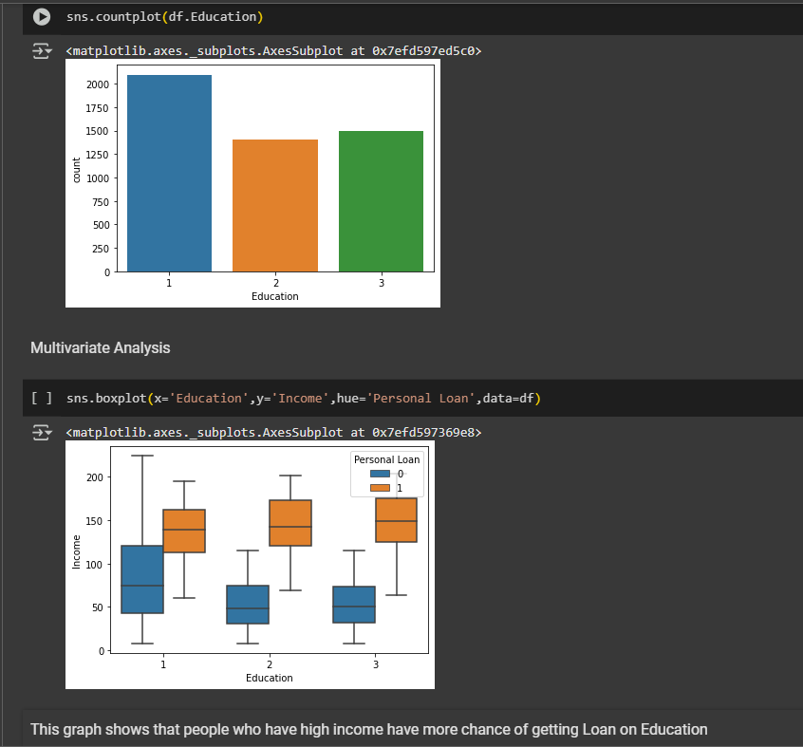

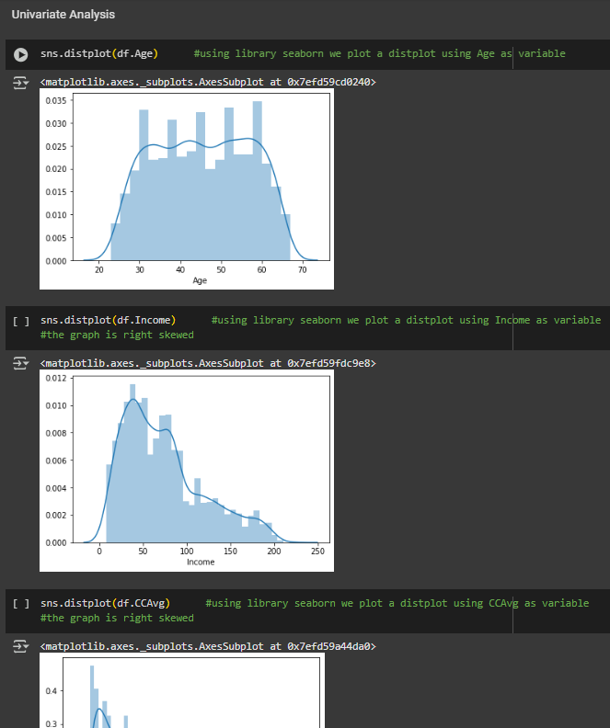

**11. CONCLUSION**

Data-driven marketing strategies are rapidly transforming the banking sector. Previously, customer outreach relied on traditional methods with limited accuracy. The rise of machine learning-based predictive analytics has enhanced targeted marketing, optimizing campaign efforts. The project **“**Marketing Campaign for Banking Products**”** has been successfully implemented using advanced predictive modelling.

Each parameter in the dataset has been carefully analysed, ensuring precise targeting and improved campaign efficiency. By integrating data analytics and machine learning techniques, the system effectively identifies potential customers, making the marketing campaign more efficient and data-driven. This project streamlines the process, reducing manual effort while increasing the accuracy of customer identification.

# BIBLIOGRAPHY

The following books are referred during the analysis and execution phase of the project

* **"**The Elements of Statistical Learning" by Trevor Hastie, Robert Tibshirani, and Jerome Friedman
* "Machine Learning: A Probabilistic Perspective" by Kevin P. Murphy
* "Data Science for Business" by Foster Provost and Tom Fawcett
* "Practical Statistics for Data Scientists" by Peter Bruce and Andrew Bruce

# REFERENCES :

Institutional Course Platform:

* <https://learn.internshipstudio.com/learn>

Project:

* <https://colab.research.google.com/drive/1nZDhPUYGeyF4lR6KeIUH139EKBOwW9Uf?usp=sharing>

Project Referral Sites:

* <https://www.w3schools.com/>
* <https://github.com/>
* <https://www.kaggle.com/>
* <https://www.analyticsvidhya.com/>

**Appendix :**

The project made use of various tools and technologies to achieve its objectives. Python and SQL served as the primary programming languages, while libraries such as Pandas, NumPy, Matplotlib, and Scikit-learn facilitated data processing and analysis. Visualization tools like Microsoft Excel, Google Data Studio, and Seaborn helped in interpreting insights effectively. Google Colab and GitHub were used for collaborative development, while MySQL and PostgreSQL managed database operations.

The data sources for the project included customer demographic information, transaction history, and previous campaign responses. Additional datasets incorporated financial indicators such as interest rates, market trends, and credit risk scores, along with external socioeconomic data to provide a comprehensive analysis. These datasets helped in building a robust predictive system for targeted marketing.

The project aimed to develop a data-driven strategy for banking product marketing by leveraging machine learning techniques to predict customer responsiveness. Statistical analysis and predictive modelling improved targeting efficiency, while automation streamlined campaign evaluation for future marketing efforts. The knowledge and skills acquired during the internship played a significant role in achieving these objectives.

Throughout the internship, several key learnings emerged. SQL was extensively used for database management and data extraction, ensuring efficient handling of large datasets. Data preprocessing techniques such as cleaning and transformation were applied to prepare raw data for analysis. Predictive analytics was implemented using Python, allowing the development of machine learning models to identify potential customers. Creating interactive visualizations improved the interpretation of business insights, while a deeper understanding of data-driven decision-making in the banking and finance sector was gained.

The project encountered challenges, including handling large datasets, addressing missing values, and optimizing machine learning models for higher accuracy. Managing real-time data integration for marketing campaigns also required careful planning. Despite these challenges, the project successfully demonstrated how data analytics can enhance marketing strategies.

In the future, expanding predictive modelling to incorporate real-time customer behaviour analytics can further improve targeting precision. The integration of AI-powered chatbots can provide personalized marketing recommendations, while deep learning techniques may enhance model accuracy. Exploring additional financial products will also help in refining marketing efforts for a broader audience.

This appendix provides a comprehensive summary of the tools, methodologies, challenges, and learnings associated with the project, along with potential future advancements.

**Profile:**



**21BCE10575 - Nischal Katara**

Hey, I’m Nischal Katara, a motivated Computer Science and Engineering student with a strong foundation in front-end development, programming, and data analysis. Currently pursuing my Bachelor of Technology at VIT Bhopal University, my academic journey began at Colonel’s Brightland Public School, where I developed a keen interest in technology and problem-solving**.**

Throughout my journey, I have worked on several impactful projects, including an Amazon Clone, which replicates the UI/UX of the e-commerce giant, and an HR Portal built using Django and Python, designed to streamline employee data management and enhance organizational efficiency. These projects showcase my ability to integrate design principles with back-end functionality, ensuring robust and user-friendly solutions.

I also gained valuable professional experience during an internship in data analysis, where I worked on data exploration, time series analysis, cohort analysis, and developed automated reports using Python and Excel. This experience strengthened my analytical mindset and taught me how to derive meaningful insights from complex datasets.

My technical skill set includes C++, Python, SQL, Django, HTML/CSS, and object-oriented programming, along with a strong understanding of data structures and algorithms, database management, and software development. I have also completed certifications such as Google’s Crash Course on Python and Kaggle’s SQL training, which have further enhanced my programming and data analysis capabilities.

These experiences have instilled in me qualities like discipline, resilience, and strategic thinking, which I apply to both technical problem-solving and teamwork.

I am Fluent in English, I am always eager to explore innovative technological solutions, contribute to meaningful projects, and grow as a professional in the ever-evolving tech industry.