Write a Query for the following outputs:
Tables:
DEPT
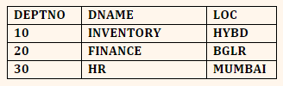
EMP
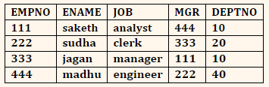

- EQUI JOIN
Select E.Empno,E.Ename,E.Job,D.Dname,D.Loc From Dept D Join Emp E On(D.Deptno=E.Deptno);
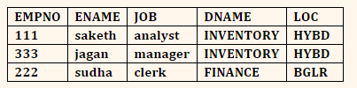

- NON-EQUI JOIN

Select E.Empno,E.Ename,E.Job,D.Dname,D.Loc From Dept D Join Emp E On(D.Deptno<E.Deptno);
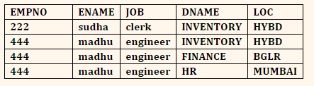

- NATURAL JOIN

Select E.Empno,M.Ename,E.Job,M.Deptno From Emp E Join Emp M On E.Empno=M.Mgr Order
by e.empno;

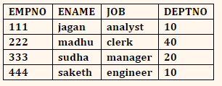

- CROSS JOIN

Select Empno,Ename,Job,D.Dname,D.Loc From Emp cross Join Dept D;
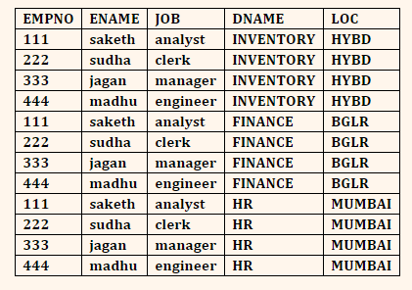

- OUTER JOIN
5. (A) LEFT OUTER JOIN

Select E.Empno,E.Ename,E.Job,D.Dname,D.Loc From Emp E left Join Dept D On(D.Deptno=E.Deptno);
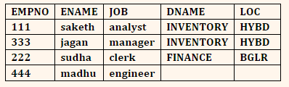

5. (B) RIGHT OUTER JOIN

Select E.Empno,E.Ename,E.Job,D.Dname,D.Loc From Emp E right Join Dept D On(D.Deptno=E.Deptno);
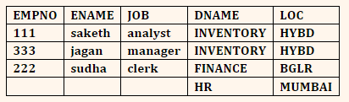

5. (C) FULL OUTER JOIN

Select E.Empno,E.Ename,E.Job,D.Dname,D.Loc From Emp E full Join Dept D On(D.Deptno=E.Deptno);
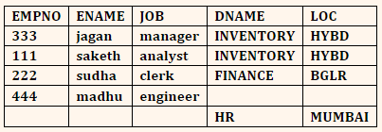

- INNER JOIN

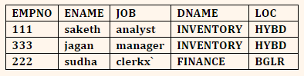
select E.Empno,E.Ename,E.Job,D.Dname,D.Loc From Dept D inner Join Emp E On(D.Deptno=E.Deptno);

