Abstract
HamroByapar is an e-commerce platform that connects sellers, buyers, and the government. The system enables sellers to list their products, buyers to browse and purchase items, and the government to monitor and verify tax compliance efficiently. The system is built using Node.js and Express.js for the backend. The frontend, developed with React.js and styled using Tailwind CSS, ensures a user-friendly and responsive interface. It simplifies tax calculations, ensures secure transactions, and makes the entire process transparent and efficient. HamroByapar aims to create a reliable e-commerce system that supports smooth trade while following tax regulations. Future improvements include adding more features and handling a larger number of users.
Keywords: Ecommerce platform, Node.js, Express.js, React.js, Tailwind CSS, Transparent Transaction, User-friendly interface.
Table of Contents
Abstract I
Chapter 1: Introduction 1
1.1. Background 1
1.2. Problem Statement 1
1.3. Objective 1
1.4. Scope 2
1.4.1. User Scope 2
1.4.2. System Scope 2
1.5. Limitations 2
Chapter 2: Literature Review 3
2.1. Literature Review 3
Chapter 3: Methodology 5
3.1. Development Methodology 5
Iterative Waterfall Model: 5
3.2. Requirement Analysis 6
3.2.1. Functional Requirements: 6
3.2.2. Non-Functional Requirements: 7
3.3. Feasibility Analysis 8
3.3.1. Technical Feasibility 8
3.3.2. Operational Feasibility 8
3.3.3. Economic Feasibility 8
3.3.4. Schedule Feasibility 9
Chapter 4: Expected Outcome 9
Chapter 5: Conclusion 9
References 10

List of Figures
Figure 1: Iterative Waterfall Model 5
Figure 2:Use Case Diagram of HamroByapar 7
Figure 3:Gantt Chart 9

List of Table
Table 1: The Internet Penetration of Nepal [2]. 3

Chapter 1: Introduction

Background
Ecommerce has transformed how people and businesses buy and sell goods. Ecommerce has proved a platform for buyers and sellers to engage in a seamless trade with the comfort of browsing through their devices without having to go physically. However, with the exponential growth of ecommerce new challenges have been introduced. Challenges like tax compliance and transparency. Goverments often struggle to monitor and regulate ecommerce transactions effectively.
In many cases, sellers do not understand tax regulations whereas buyers do not have any idea how taxes are applied to their purchase. HamroByapar aims to address this gap by creating a transparent platform. HamroByapar is an online ecommerce platform that connects buyers, sellers and government in one system. HamroByapar makes buying and selling easier while also keeping track of taxes on the products for the government.

Problem Statement
With the rapid growth of ecommerce platforms, government faces significant challenges in tracking, monitoring and collecting taxes from these digital transactions. Sellers often struggle to navigate tax regulations, leading to errors, inefficiencies or tax evasion. Similarly, buyers lack visibility and transparency into tax components of their purchase which can result in reduced trust in the system. These challenges can cause government loss in revenue from tax, an increase in burden for the sellers and lack of transparency. HamroByapar addresses these issues by providing a transparent platform which calculates the taxes based on the transactions. It provides a government monitoring system that tracks transaction, ensuring effective tax collection.

Objective
The main objective of this project is:
- To provide a platform for sellers to list their products and track sales.
- To provide a user-friendly platform for users to browse products, view tax details and complete purchases.
- To integrate automated tax calculation during transactions.
- To design a government dashboard for monitoring transactions and tax compliance.

Scope

User Scope
- Buyer: Users can register and log in to their account, browse available products, view product details, add items to their cart and complete purchase.
- Seller: Sellers can register, list their products with details. They can manage their product listings and view tax details.
- Government (Administrator): Government authorities can monitor all transactions on the platform and calculate taxes. They can track sales data for individual sellers and ensure the appropriate taxes are being applied.

System Scope
- Product and Inventory Management: The system allows sellers to list and manage products.
- Automated Tax Calculation: The system automatically calculates taxes on each purchase based on predefined rules.
- Transaction Monitoring and Reporting: The system provides the government with access to transactions data. The government can monitor sales and track tax amount collected.

Limitations
- Limited Tax Rules Integration: The system will only use basic tax rules for demonstration purposes.
- Manual Data Input: Sellers will manually enter product details and tax categories, which could lead to inaccuracies if not carefully managed.
- Prototype: This system is only a prototype with limited functionalities like product listing, tax calculation and transaction monitoring.

Chapter 2: Literature Review

2.1. Literature Review
E-commerce in Nepal has been growing rapidly in recent years. With the increase of internet penetration and smartphone usage the e-commerce industry has seen exponential growth. However, with the growth of e-commerce industry challenges like tax compliance and lack of transparency can hinder its growth. HamroByapar aims to address these challenges by integrating sellers, buyers, and government authorities into a single platform. This literature review provides research and practices in the e-commerce of Nepal.
E-commerce in Nepal
E-commerce in Nepal is still quite new and started growing in the late 2000s. At first, progress was slow because people were not familiar with online shopping or digital payments, and businesses were unsure about using it. Over time, with better technology and changing global trends, more people and companies have started to adopt e-commerce, and it is now growing faster [1].
In the early 2000s, very few people in Nepal used the internet. By 2010, only 7.5% were online. Things improved in the mid-2010s when cheaper phones helped more people get connected, and by 2019, 39% of the population was using the internet.
During the COVID-19 pandemic, people started relying more on online platforms, which helped e-commerce grow. By 2022, 45% of Nepalis were online, mostly using mobile phones. This means about 16 million people could use e-commerce, and this number is expected to reach 25 million by 2025 [2]. Here, we can the number of people with access to internet increase every year.
Table 1: The Internet Penetration of Nepal [2].
Year | Number of People in Nepal with Internet Access
2012 | 2.44M
2013 | 3.01M
2014 | 3.58M
2015 | 4.16M
2016 | 4.77M
2017 | 7.11M
2018 | 9.47M
2019 | 9.46M
2020 | 10.1M
2021 | 10.7M
2022 | 11.5M
2023 | 15.85M

E-commerce in Nepal has grown significantly in recent years due to increased internet and smartphone usage. In 2023, 11.2 million online transactions worth 30 billion rupees were recorded, according to Nepal Rastra Bank. Platforms like Daraz, Hamrobazar, and Sastodeal have thrived, allowing vendors to sell directly from their shops and transforming consumer behavior and purchasing preferences. The e-commerce sector has seen notable changes over the past year [3].
Most e-commerce platforms focus solely on connecting buyers and sellers. These platforms do not have government monitoring and tax compliance. While platforms like Daraz are popular, problems like trust issues, delivery delays, and tax evasion still exist [4]. This shows the need for a system that supports transactions and follows government rules. Existing systems do not provide real-time monitoring or automated tax calculation [5]. A platform like HamroByapar, which integrates automated tax calculation and government oversight

Chapter 3: Methodology
For the development of this project, iterative waterfall model is being used. The iterative waterfall model combines the sequential steps of the traditional Waterfall Model with the flexibility of iterative design.

Development Methodology

Iterative Waterfall Model:
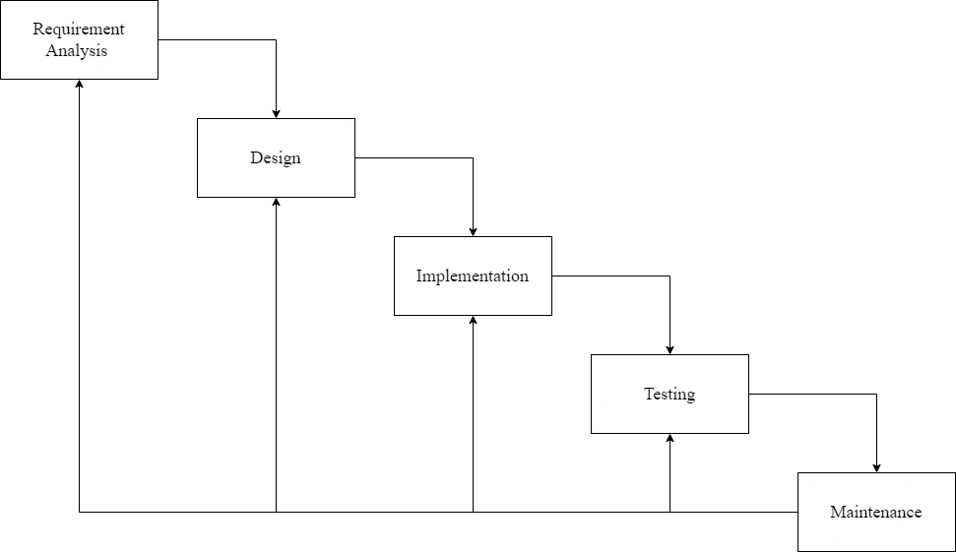
Figure 1: Iterative Waterfall Model

- Requirement Analysis: The first step of the iterative waterfall model is to analyze and define the system’s requirements. For HamroByapar, the key requirement includes seller product listing, buyer purchase, automated tax calculations and government monitoring.
- Design: The design phase focuses on creating the system architecture. In this stage, a design is developed for the platform. The system was divided into distinct modules for sellers, buyers and government.
- Implementation: HamroByapar platform is built using Node.js with Express.js framework for the backend. The front end was designed with React.js for a responsive and user-friendly interface.
- Testing: Testing is carried out after each iteration to ensure that all system components work as intended. Unit testing is carried out on individual components such as tax calculations. System Testing was also conducted to make sure that all the components function correctly.
- Maintenance: Once the system is deployed regular operation and maintenance are carried out. This includes improving the platform based on user feedback and addressing any new needs.

Requirement Analysis

Functional Requirements:
The functional requirements of this project are:
- User Registration and Login: The system should allow users to register and log in securely using unique credentials.
- Product Management: Sellers should be able to add, update, and delete product listings, including details such as name, price and description.
- Product Browsing and Searching: Buyers should be able to browse through listed products and search.
- Shopping Cart: Buyers should be able to add products to their cart, modify quantities, and remove items before proceeding to check out.
- Tax Calculation: The system should be able to automatically calculate applicable taxes during transactions based on government regulations.
- Transaction Monitoring: Admin (Government) should be able to monitor all transactions and ensure compliance and transparency.
- Inventory Management: The system should update product inventory in real time as items are sold or restocked by sellers.

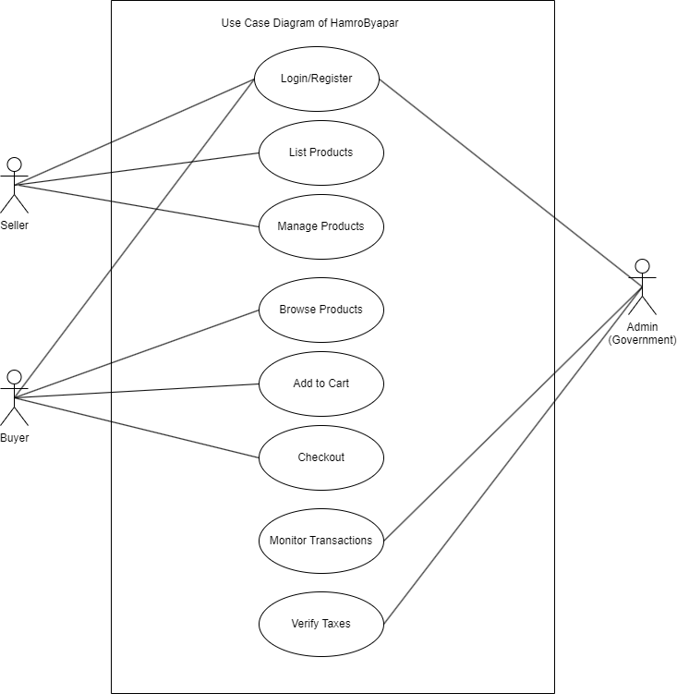
Figure 2:Use Case Diagram of HamroByapar

Non-Functional Requirements:
The non-functional requirements of this project are:
- User friendly Interface: The system should have user friendly interface which is easy to use and navigate.
- Responsive User Interface: The system should be able to adapt to different device sizes.
- Reliability: The system should be reliable with high precision.
- Security: The system should be secure enough. All the user’s data should be securely stored.
- Error Handling: The system should be able to handle errors and display error messages to the user.

Feasibility Analysis

Technical Feasibility
The project is built using Node.js and Express.js for the backend, React.js for the frontend and PostgresSQL for database management. All the technological stacks used are well supported and widely adopted. For development tools, tools like Visual Studio Code, Postman and Git are used.

Operational Feasibility
- The system’s user-friendly user interface makes it easy for sellers, buyers and government to adopt and use.
- The system’s responsiveness will allow users to access it from any devices.
- The system automates many processes like tax calculation, inventory updates, and reporting, reducing manual effort and errors.
- The system will have support and clear instructions to help make it easy for all users to get started.

Economic Feasibility
The platform is cost-effective as it uses open-source technologies like Node.js, Express, React.js, and PostgresSQL. The system is also user-friendly, requiring minimal training. Although there are some costs for hosting, development, and maintenance, these are justified by the system’s potential for future growth. Overall, HamroByapar is economically feasible.

Schedule Feasibility
The schedule for the development of the project is shown below:
Months (In Week) | January |  |  |  | February |  |  |  | March
Tasks | 1 | 2 | 3 | 4 | 1 | 2 | 3 | 4 | 1 | 2 | 3 | 4
Planning
Design
Implementation
Testing
Maintenance
Documentation

Figure 3:Gantt Chart

Chapter 4: Expected Outcome
The goal of HamroByapar is to create an easy and trustworthy online marketplace for sellers, buyers, and the government. Sellers will get more exposure and have a better chance to sell their products, while buyers will find it easier to shop. The government will help make sure that taxes are collected properly, reducing tax evasion and increasing revenue. The platform will be transparent, so both buyers and sellers can see prices, transactions, and taxes clearly, which builds trust.

Chapter 5: Conclusion
HamroByapar is designed to provide a simple and trustworthy platform where sellers can reach more buyers, and buyers can easily make purchases. With the government's role in ensuring proper tax collection, the platform helps reduce tax evasion while contributing to government revenue. By promoting transparency and following legal regulations, it builds trust among users.

References

[1] | The Khatapana Guy, "Khatapana," 19 December 2023. [Online]. Available: https://khatapana.com/blogs/124/understanding-ecommerce-and-growth-of-ecommerce-in. [Accessed 2 Janaury 2025].
[2] | "Makura Creation," [Online]. Available: https://makuracreations.com/emerging-trends-of-ecommerce-in-nepal/. [Accessed 2 Januray 2025].
[3] | "Nepal Can Move," [Online]. Available: https://www.nepalcanmove.com/e-commerce-in-nepal-insights-from-2080/. [Accessed 2 Janaury 2025].
[4] | Ravishu Barnawal, "Linkedin," [Online]. Available: https://www.linkedin.com/pulse/unveiling-challenges-why-local-ecommerce-struggles-nepal-barnawal-x26wc. [Accessed 2 January 2025].
[5] | HIMAL THAPA, "UNDERSTANDING E-COMMERCE AND NAVIGATING CHALLENGES," Global Scientific Journals, vol. 12, no. 7, 2024.

