MUTUAL FUND ANALYTICS AND BUSINESS INTELLIGENCE PLATFORM
Comprehensive Data Engineering, Analytics and Dashboard Development Project Report

Executive Summary
The Indian mutual fund industry has witnessed unprecedented growth in assets under management (AUM), systematic investment plan (SIP) contributions, and investor participation over the last few years. With increasing market participation and the availability of large-scale financial datasets, there is a growing need for analytical platforms that can transform raw financial data into actionable business intelligence.

This project focuses on the development of a comprehensive Mutual Fund Analytics and Business Intelligence Platform capable of processing, analyzing, and visualizing mutual fund industry data. The project integrates data engineering, database management, exploratory data analysis (EDA), performance analytics, risk analytics, investor behavior analysis, and interactive dashboard development.

The workflow begins with data collection from multiple sources containing information related to fund performance, net asset values (NAV), assets under management (AUM), investor transactions, SIP inflows, benchmark indices, portfolio holdings, and sector allocations. The raw datasets undergo extensive preprocessing and validation before being integrated into a centralized SQLite database using a star-schema architecture.

Advanced analytics techniques are subsequently applied to evaluate mutual fund performance using metrics such as CAGR, Sharpe Ratio, Sortino Ratio, Alpha, Beta, and Maximum Drawdown. Investor behavior is analyzed through demographic segmentation, transaction patterns, geographic distribution, SIP continuity assessment, and cohort analysis.

The final stage involves the development of interactive dashboards that enable decision-makers to monitor industry trends, compare fund performance, identify investment opportunities, and assess portfolio risk.
The platform demonstrates how modern analytics can support evidence-based investment decision-making and improve financial transparency.

Introduction

The mutual fund industry plays a critical role in modern financial markets by providing investors with professionally managed investment vehicles. As the industry continues to expand, investors face increasing challenges in selecting suitable funds, evaluating risk-adjusted performance, and understanding market dynamics.

Traditional investment analysis methods often rely on isolated performance indicators and lack a comprehensive view of risk, investor behavior, and market trends. Consequently, there is a need for integrated analytical platforms that combine multiple dimensions of financial analysis into a single decision-support framework.

This project addresses these challenges by developing a complete analytics ecosystem capable of transforming raw mutual fund data into meaningful insights. The platform combines data engineering, statistical analysis, financial performance evaluation, and business intelligence visualization techniques to provide a holistic view of the mutual fund landscape.

Problem Statement
Investors and financial analysts frequently encounter several challenges:

  - Large volumes of fragmented mutual fund data.

  - Difficulty in comparing funds across different categories.

  - Limited visibility into risk-adjusted performance metrics.

  - Inadequate understanding of investor behavior patterns.

  - Lack of integrated dashboards for strategic decision-making.

  - Challenges in identifying top-performing schemes under varying market conditions.

The objective of this project is to develop a unified analytics platform capable of addressing these challenges through automated data processing, advanced analytics, and interactive visualization.

Project Objectives
The primary objectives of the project are:

- Design a scalable mutual fund analytics pipeline.
- Clean and preprocess multiple financial datasets.
- Build a centralized relational database.
- Perform exploratory data analysis.
- Evaluate fund performance using advanced financial metrics.
- Analyze investor demographics and transaction behavior.
- Develop risk analytics models.
- Create interactive business intelligence dashboards.
- Generate actionable investment insights.

Project Architecture

The overall architecture consists of five major layers:

Data Layer
Raw CSV datasets containing:-
    - Fund Master
    - NAV History
    - AUM Data
    - SIP Inflows
    - Benchmark Data
    - Investor Transactions
    - Scheme Performance
    - Portfolio Holdings

Data Engineering Layer
  - Data cleaning
  - Missing value treatment
  - Date standardization
  - Validation checks
  - Duplicate removal

Database Layer
SQLite star-schema database consisting of:-
      - Dimension tables
      - Fact tables
      - Relationship mapping

Analytics Layer
  - Performance Analytics
  - Risk Analytics
  - Investor Analytics
  - Market Trend Analysis

Visualization Layer
  - Tableau Dashboards
  - Power BI Dashboards
  - Executive Reporting

Dataset Description

The project utilizes ten major datasets.

Fund Master
Contains scheme information including AMFI code, fund house, category, plan type, and scheme name.

NAV History
Daily net asset values for all schemes between 2022 and 2026.

AUM Dataset
Assets under management across major fund houses.

SIP Dataset
Monthly SIP contributions and industry inflows.

Benchmark Dataset
Historical Nifty 50 and Nifty 100 index values.

Transactions Dataset
Investor-level transaction records including SIP, redemption, and lump-sum investments.

Portfolio Dataset
Sector allocation and portfolio composition.

8.Performance Dataset
Returns, volatility, Sharpe ratio, expense ratio, and related performance metrics.

Data Cleaning and Preprocessing
- Several preprocessing techniques were implemented.

Missing Value Handling

- Missing NAV values were forward-filled using historical observations.

Date Standardization
- All date fields were converted to datetime format for consistency.

Duplicate Removal
- Duplicate transaction and NAV records were identified and removed.

Validation Checks
- NAV > 0
- Amount > 0
- Valid transaction types
- Consistent AMFI codes

Feature Engineering

Additional variables generated:-
- Daily Returns
- CAGR
- Fund Scores
- Age Groups
- Investor Cohorts
- Monthly Aggregations

Database Design
A star schema was implemented to optimize analytical queries.

Dimension Tables
  - dim_fund
  - dim_date

Fact Tables
  - fact_nav
  - fact_aum
  - fact_transactions
  - fact_performance

Benefits:

  - Faster aggregation
  - Simplified dashboard integration
  - Improved scalability

[INSERT DATABASE SCHEMA SCREENSHOT]
Exploratory Data Analysis
EDA was conducted to understand industry trends and identify patterns.

AUM Growth Analysis

The analysis indicates continuous growth in industry assets between 2022 and 2025.

Key observation:- SBI Mutual Fund emerged as the industry leader with approximately ₹12.5 lakh crore AUM by 2025.

Category Inflows
Liquid funds received the largest inflows across categories, reflecting investor preference for liquidity and stability.

Investor Demographics
The 26–35 age group constituted the largest investor segment, indicating strong participation from young professionals.

Geographic Analysis
Major investment contributions originated from metropolitan and Tier-1 cities.

Performance Analytics
Performance evaluation was conducted using multiple financial indicators.

CAGR Analysis - Three-year CAGR was calculated for all schemes.

Sharpe Ratio - Measures risk-adjusted return.
- Higher values indicate superior performance per unit of risk.

Sortino Ratio - Focuses on downside volatility rather than total volatility.

Alpha and Beta - Evaluates fund performance relative to benchmark indices.

Maximum Drawdown - Measures peak-to-trough decline experienced by investors.

Composite Fund Score
A weighted score was created using:
- CAGR (30%)
- Sharpe Ratio (25%)
- Alpha (20%)
- Expense Ratio (15%)
- Maximum Drawdown 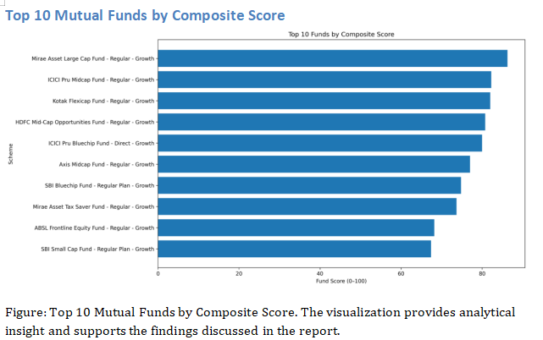

Risk Analytics
Risk assessment was performed at both scheme and portfolio levels.

Correlation Analysis

- Correlation matrices identified diversification opportunities across schemes.

Rolling Sharpe Ratio

- A rolling 90-day Sharpe ratio was used to monitor changing risk-adjusted performance.

Sector Concentration Analysis

- Herfindahl-Hirschman Index (HHI) was used to evaluate portfolio concentration.

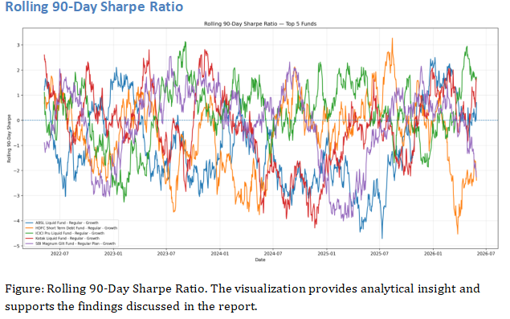

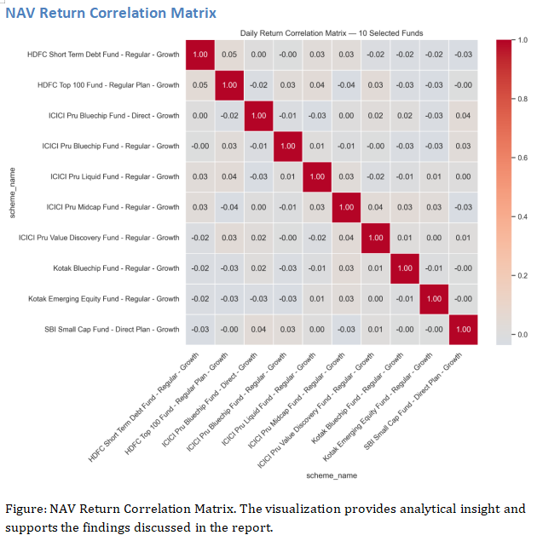

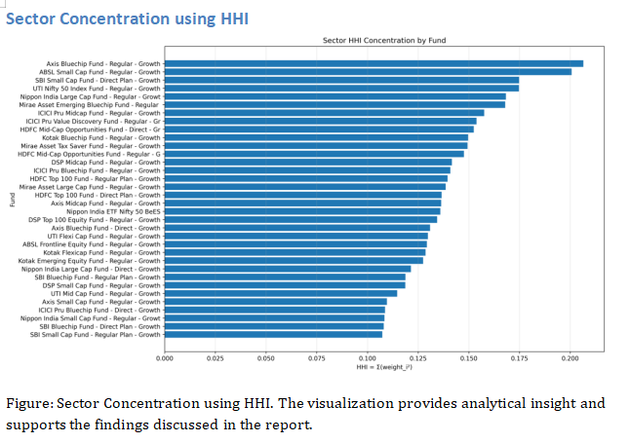

Investor Analytics

Transaction Type Analysis

- Lump-sum investments accounted for the largest share of total transaction volume. [INSERT TRANSACTION PIE CHART]

Gender Analysis

- Male investors represented approximately two-thirds of total investors. [INSERT GENDER CHART]

City Tier Analysis

- T30 cities contributed the majority ofinvestments.

Cohort Analysis

- Investor cohorts were analyzed based on their firstinvestment year.

SIP Continuity Analysis

- Most investors demonstrated strong SIP continuity, indicating long-term investment behavior.

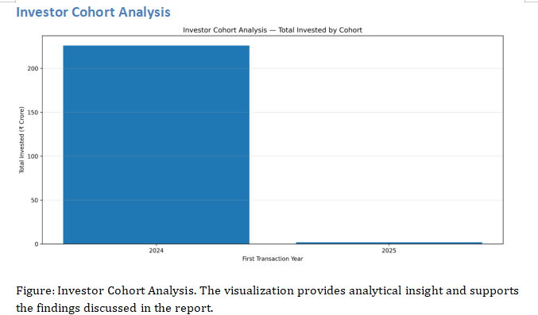
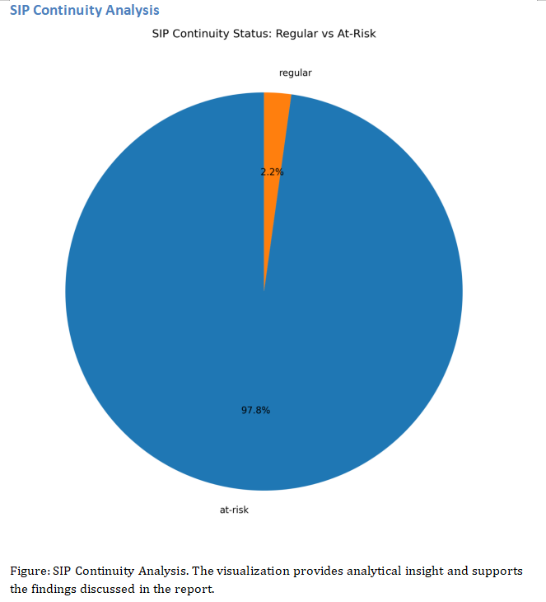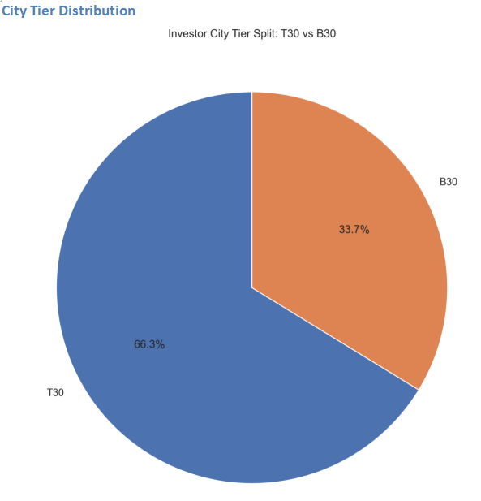

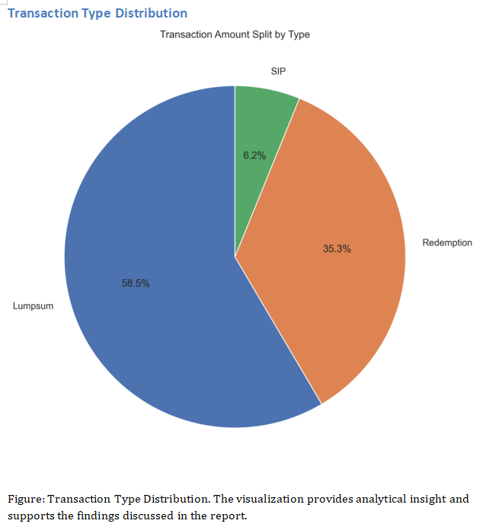
Dashboard Development
Four interactive dashboards were developed.

Dashboard 1: Industry Overview

KPIs:-
  - Total AUM
  - SIP Inflows
  - Folios
  - Schemes

Dashboard 2: Fund Performance

Features:-
  - Risk vs Return Scatter Plot
  - Benchmark Comparison
  - Fund Scorecard

Dashboard 3: Investor Analytics

Features:
  - State Analysis
  - Demographic Insights
  - Transaction Trends

Dashboard 4: SIP and Market Trends

Features:
  - SIP vs Nifty Comparison
  - Category Inflows
  - Market Trend
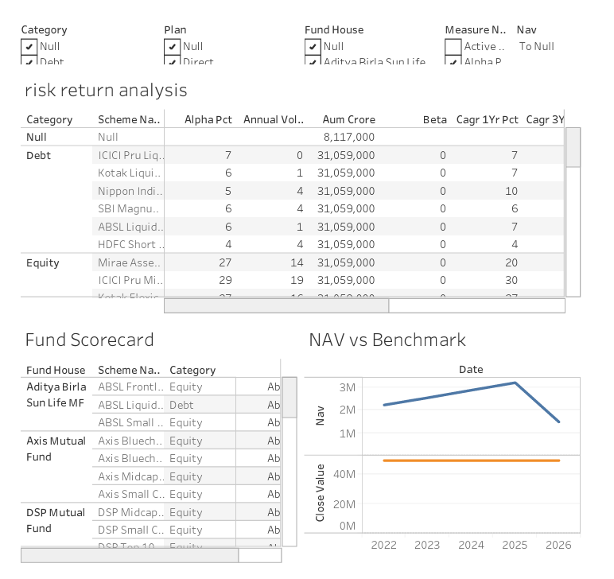
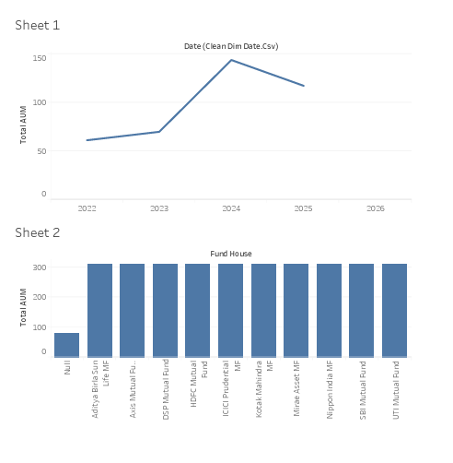

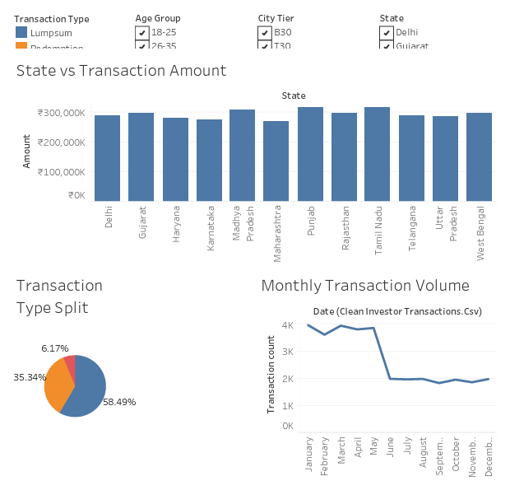
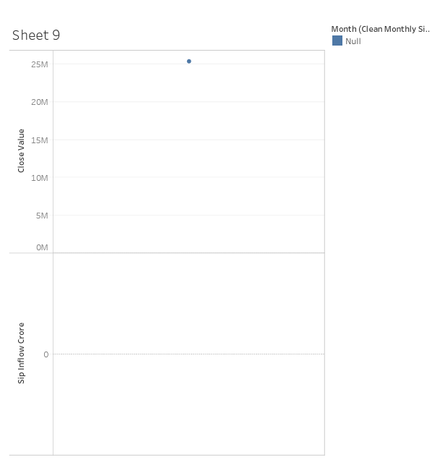

Key Findings

- SBI Mutual Fund leads industry AUM.
- Liquid Funds attract maximum inflows.
- Age group 26–35 dominates investment activity.
- T30 cities contribute the majority of investments.
- Several mid-cap and flexi-cap schemes outperform benchmarks.
- Risk-adjusted performance varies significantly across categories.
- Portfolio diversification remains a critical determinant of risk.

Recommendations

- Increase allocation toward consistently high-scoring schemes.
- Monitor rolling Sharpe ratios for early risk signals.
- Improve diversification using correlation analysis.
- Expand investor awareness in B30 cities.
- Incorporate predictive analytics for future fund performance.

Limitations

- Limited number of schemes.
- Historical analysis may not guarantee future performance.
- Synthetic assumptions used for certain investor demographics.
- Market conditions may influence performance metrics.

Future Scope

Future enhancements may include:

  - Machine Learning Fund Recommendation Engine
  - Portfolio Optimization Models
  - Real-Time Market Integration
  - Sentiment Analysis
  - AI-powered Investment Advisor
  - Predictive Risk Modeling

Conclusion

This project successfully demonstrates the application of data engineering, financial analytics, and business intelligence techniques in developing a comprehensive mutual fund analytics platform. The integration of database design, exploratory data analysis, performance evaluation, risk assessment, and dashboard visualization provides investors and decision-makers with a powerful framework for informed investment decisions.

The developed platform not only improves transparency and accessibility of financial information but also establishes a strong foundation for future AI-driven investment analytics systems.

