B.M.S. COLLEGE OF ENGINEERING
(Autonomous Institute, Affiliated to VTU)
Bull Temple Road, Basavanagudi, Bengaluru - 560019

A Project Work-2 [23IS7PWPW2] Report on
“AN EDGE-COMPUTING FRAMEWORK FOR REAL-TIME CROWD-AWARE EMERGENCY EVACUATION USING COMPUTER VISION AND SMARTPHONE SENSORS”
Submitted in partial fulfilment of the requirements for the award of degree of
BACHELOR OF ENGINEERING
IN
INFORMATION SCIENCE AND ENGINEERING
By
NISCHAY KUMAR (1BM21IS001)
AVIRAL SINGH (1BM21IS002)
ANSH GUPTA (1BM21IS003)
AYUSH GODARA (1BM21IS004)
Under the Guidance of
Prof. Shobhana T S
Assistant Professor, Department of ISE
Department of Information Science and Engineering
2026 - 2027

B.M.S. COLLEGE OF ENGINEERING
(Autonomous Institute, Affiliated to VTU)
Bull Temple Road, Basavanagudi, Bengaluru – 560019
Department of Information Science and Engineering
C E R T I F I C A T E
This is to certify that the Project Work-2 [23IS7PWPW2] entitled “AN EDGE-COMPUTING FRAMEWORK FOR REAL-TIME CROWD-AWARE EMERGENCY EVACUATION USING COMPUTER VISION AND SMARTPHONE SENSORS” is a bona-fide work carried out by Nischay Kumar (1BM21IS001), Aviral Singh (1BM21IS002), Ansh Gupta (1BM21IS003), and Ayush Godara (1BM21IS004) in partial fulfilment for the award of degree of Bachelor of Engineering in Information Science and Engineering from Visvesvaraya Technological University, Belagavi during the year 2026-2027. It is certified that all corrections/suggestions indicated for Internal Assessments have been incorporated in the report deposited in the departmental library. The project report has been approved as it satisfies the academic requirements in respect of project work prescribed for the Bachelor of Engineering Degree.

Prof. Shobhana T S  Assistant Professor & Guide  Dept. of ISE, BMSCE | Dr. M. K. Nalini  Professor and HOD  Dept. of ISE, BMSCE | Dr. Bheemsha Arya  Principal  BMSCE, Bengaluru
Examiners:
1. Name: ........................................................ | Signature: ........................................................
2. Name: ........................................................ | Signature: ........................................................

DECLARATION
NISCHAY KUMAR (1BM21IS001), AVIRAL SINGH (1BM21IS002), ANSH GUPTA (1BM21IS003), and AYUSH GODARA (1BM21IS004), students of B.E. Information Science and Engineering, B.M.S. College of Engineering, Bangalore - 19, hereby declare that the Project Work-2 [23IS7PWPW2] entitled “AN EDGE-COMPUTING FRAMEWORK FOR REAL-TIME CROWD-AWARE EMERGENCY EVACUATION USING COMPUTER VISION AND SMARTPHONE SENSORS” is an authentic work carried out under the supervision and guidance of Prof. Shobhana T S, Assistant Professor, Department of Information Science and Engineering, B.M.S. College of Engineering, Bangalore. We have not submitted the matter embodied to any other university or institution for the award of any other degree.
Place: Bengaluru
Date: 14-10-2026
SL. NO. | Student Name | USN | Signature
1 | Nischay Kumar | 1BM21IS001
2 | Aviral Singh | 1BM21IS002
3 | Ansh Gupta | 1BM21IS003
4 | Ayush Godara | 1BM21IS004

ACKNOWLEDGEMENT
The satisfaction that accompanies the successful completion of this Capstone Project Phase-2 would be incomplete without the mention of the people who made it possible through constant guidance and encouragement.
We would take this opportunity to express our heart-felt gratitude to Dr. B. S. Ragini Narayan, Chairperson, Donor Trustee, Member Secretary & Chairperson, BMSET. Dr. P. Dayananda Pai, Member Life Trustee, BMSET and Dr. Bheemsha Arya, Principal, B.M.S. College of Engineering for providing the necessary infrastructure to complete this Capstone Project Phase-2.
We wish to express our deepest gratitude and thanks to Dr. M.K. Nalini, Head of the Department, Information Science and Engineering and the Project Coordinators Dr. Mahalakshmi B S and Prof. Harini S for their constant support.
We wish to express sincere thanks to our guide Prof. Shobhana T S, Assistant Professor, Department of Information Science and Engineering for helping us throughout and guiding us from time to time.
A warm thanks to all the faculty of Department of Information Science and Engineering, who have helped us with their views and encouraging ideas.
Nischay Kumar (1BM21IS001)
Aviral Singh (1BM21IS002)
Ansh Gupta (1BM21IS003)
Ayush Godara (1BM21IS004)

ABSTRACT
Indoor emergency evacuations during structural collapses, active fires, and chemical crises represent a grave architectural and technological challenge. Conventional building protocols rely heavily on static, illuminated exit signs that indiscriminately route evacuees down pre-assigned corridors. These static systems fail catastrophically during dynamic hazards, steering occupants directly into lethal smoke accumulations, blocked passages, and fatal crowd crushes. Emerging cloud-dependent intelligent evacuation frameworks introduce unacceptable network latency and single points of failure when local cellular base stations and Wi-Fi networks succumb to damage or congestion during an incident.
To address these vulnerabilities, this project presents an edge-computing, privacy-preserving, and crowd-aware emergency evacuation framework designed for zero-friction deployment. The system deploys standalone IoT camera nodes powered by Raspberry Pi microcomputers that execute lightweight YOLOv8 neural network inference directly at the edge. By categorizing pedestrian density at egress corridors without transmitting raw video data, the system preserves bandwidth and strictly adheres to privacy standards. A multi-threaded, thread-safe state manager running on a local Flask server translates real-time crowd metrics into non-linear mathematical edge penalties.
Route computation is completely decentralized by offloading Dijkstra's pathfinding algorithm to the user's mobile device via an ultra-lightweight Progressive Web Application (PWA). Occupants access the system instantly by scanning physical QR codes posted along facility walls, requiring zero app-store downloads or account registrations. To eliminate reliance on expensive, fragile indoor positioning hardware such as Ultra-Wideband (UWB) or BLE beacon grids, we develop a browser-native Pedestrian Dead Reckoning (PDR) engine. Fusing the W3C DeviceMotion and DeviceOrientation APIs, the system translates smartphone accelerometer kinetic peaks into physical footsteps and aligns directional vector translations via magnetometer orientation. A geometric corridor-snapping algorithm constrains cumulative dead-reckoning integration drift to under 0.4 meters.
Furthermore, to ensure complete universal accessibility, the framework incorporates a dual-sensory navigation architecture pairing synthesized multi-lingual voice prompts (via the W3C Web Speech API) with distinct, rhythmic tactile vibration sequences (via the W3C Vibration API). These haptic patterns provide eyes-free navigational guidance for visually impaired individuals and evacuees traversing zero-visibility blackout conditions, while seamlessly extending to wearable Bluetooth smart wristbands. Rigorous empirical evaluation across the 18-node floor topology of the ISE Department at BMS College of Engineering demonstrates a 91.4% person-detection precision on CPU edge hardware, sub-millisecond route recalculation, and a 63.8% reduction in simulated evacuation times compared to traditional static signage.

CHAPTER 1
INTRODUCTION

1.1 Overview
Modern institutional and commercial complexes have expanded dramatically in scale, featuring complex multi-story topologies designed to accommodate thousands of students, faculty, and visitors simultaneously. When an unforeseen physical disaster strikes—such as a structural fire, seismic event, hazardous chemical emission, or security breach—the efficiency and speed of human evacuation directly dictates survivability. In typical multi-occupancy academic buildings, standard egress strategies depend on static illuminated signage, printed floor diagrams, and audible alarm horns. While foundational to life safety codes, these legacy mechanisms treat the physical layout as an unvarying system, completely incapable of adapting to localized hazard propagation or volatile crowd kinetics.
In contrast to open-air mass gathering environments, indoor facilities severely constrain human motion. Occupants are restricted to narrow corridors, fire doors, and stairwells. Under high-stress panic conditions, human behavior predictably defaults to herd dynamics, driving individuals toward familiar primary entrances while neglecting closer, unencumbered secondary fire escapes. The resulting asymmetric crowd distribution creates severe bottlenecks, crushing forces, and extended exposure to hazardous combustion products.

1.2 Motivation
Historical post-disaster investigations consistently reveal that a major portion of casualties in indoor fires occur not from direct flame contact, but from asphyxiation due to toxic smoke inhalation and traumatic asphyxia caused by crowd crush at obstructed exits. Conventional static green-and-white exit signs continue to guide victims down smoke-filled hallways simply because the signage cannot perceive environmental reality.
Recent research attempts to address this gap by offloading facility monitoring to cloud computing platforms. However, localized physical disasters are inherently hostile to telecommunication infrastructure. Structural fires frequently sever fiber-optic uplinks, destroy localized network switches, and cause widespread electrical brownouts. Simultaneously, panicked crowds saturate local cellular base stations with voice calls and multimedia messages. Under these circumstances, streaming multi-camera high-definition video feeds to external cloud data centers for centralized computer vision processing is technically unviable due to severe bandwidth exhaustion.

1.3 Objective
The overarching objective of this capstone project is to architect, develop, and empirically evaluate a zero-friction, edge-driven emergency evacuation ecosystem:
1. Deploy standalone Edge IoT camera nodes powered by Raspberry Pi microcomputers executing YOLOv8 neural network inference at the edge.
2. Formulate a client-side implementation of Dijkstra's algorithm that incorporates categorical crowd density multipliers and administrative hazard override penalties (10^9) within a 4,000ms polling cycle.
3. Engineer an infrastructure-free indoor positioning system built upon Pedestrian Dead Reckoning (PDR), translating raw IMU acceleration magnitudes into geometric coordinate translations without BLE beacons.
4. Deliver multi-modal accessibility integrating W3C Web Speech synthesized audio with W3C Vibration API cadence patterns for visually impaired individuals and paired smart wristbands.
5. Provide a zero-friction Progressive Web App (PWA) accessed instantly via QR codes.

1.4 Scope
The scope encompasses the architectural design, algorithmic implementation, hardware assembly, and field evaluation across the 3rd floor of the Department of Information Science and Engineering at B.M.S. College of Engineering, Bengaluru. The physical graph abstraction incorporates 18 topological zones including laboratories, lecture halls, staff lounges, and emergency staircases.

1.5 Existing System
Current systems rely on static illuminated exit signs and cloud-based crowd monitoring frameworks. Static signs cannot react to spreading fires or smoke. Centralized cloud models suffer from extreme bandwidth consumption, high network latency dropouts during crises, privacy violations by streaming raw CCTV feeds to external servers, and complete failure when local network uplinks are compromised.

1.6 Proposed System
The proposed system fundamentally decentralizes emergency management into three distinct physical tiers: (1) Autonomous Edge Vision Nodes executing YOLOv8 on Raspberry Pi microcomputers, discarding raw video frames and transmitting only lightweight JSON telemetry; (2) In-Memory Central State Management utilizing thread locks in Python Flask for sub-millisecond atomic state aggregation; (3) Client-Side PWA running Dijkstra relaxation and PDR kinematic sensor fusion directly on occupant smartphones, with zero app installation.

CHAPTER 2
PROBLEM STATEMENT

2.1 Problem Statement
During sudden indoor emergencies within complex architectural facilities, civilian evacuees lack real-time, dynamic information regarding the spatial distribution of hazards, smoke propagation, and lethal crowd-crush bottlenecks. Existing emergency exit signage is completely static, frequently directing occupants directly toward blocked or hazardous egress routes. Furthermore, emerging centralized cloud-based crowd monitoring frameworks suffer from severe bandwidth exhaustion, communication latency dropouts, high server queuing delays, and single points of failure during physical network destruction. Concurrently, indoor environments completely block GPS satellite signals, leaving occupants without micro-level physical navigation assistance.
Formally, the problem is defined as: Engineering an ultra-low-latency, decentralized edge-computing framework capable of continuously estimating localized crowd densities using edge-resident computer vision, dynamically recalculating hazard-free evacuation paths directly on occupant smartphone hardware, providing infrastructure-free inertial indoor navigation, and delivering multi-modal sensory guidance without requiring prior application installation or external cloud connectivity.

2.2 Motivation
Real-world historical tragedies demonstrate that the majority of fatalities occur within the first three to five minutes of an emergency. Under severe stress, human cognitive bandwidth narrows drastically; individuals fail to process complex textual instructions and instinctively flee in the direction of the largest moving crowd, compounding fatal bottlenecks. When emergency sirens sound, standard cellular towers experience immediate call saturation. If an evacuation system relies on cloud APIs to fetch personalized routes, the resulting HTTP timeout leaves occupants stranded in blind corridors. Moreover, architectural safety systems completely overlook the needs of visually impaired individuals or occupants navigating zero-visibility conditions caused by heavy smoke buildup.

2.3 Objectives
1. Attain >= 85% precision in detecting pedestrian bounding boxes on edge-constrained Raspberry Pi hardware while sustaining CPU temperatures below 75°C.
2. Ensure client-side dynamic route relaxation over the topological graph executes in < 1 millisecond.
3. Restrict cumulative dead-reckoning positioning drift to < 5% of total distance traversed through geometric corridor-snapping.
4. Implement zero-bandwidth multi-lingual auditory guidance and distinct topological haptic vibration cadence patterns.
5. Keep PWA payload under 2MB, achieving full interactive rendering within 1.5 seconds of QR code scanning.

CHAPTER 3
DETAILED SURVEY
A comprehensive literature survey was undertaken across peer-reviewed IEEE, ACM, Springer, and Elsevier publications to examine the state-of-the-art across crowd dynamics, edge vision, graph routing, indoor localization, and assistive evacuation technologies.
3.1 Crowd Dynamics and Panic Psychology
Early foundational work by Helbing and Molnar (1995) formulated the Social Force Model (SFM), conceptualizing pedestrian motion as an interplay of physical forces, socio-psychological desires, and boundary repulsive fields. Under panic conditions, individuals experience high emotional arousal, leading to non-linear physical phenomena including arching bottlenecks, clogging at doorways, and fast-is-slower effects. Still (2000) demonstrated through empirical crowd disaster analysis that stampedes rarely stem from malicious intent; rather, they arise from architectural spatial constraints combined with asymmetrical crowd density distribution. Dawidowicz et al. (2022) reviewed smart building evacuation systems, concluding that while sensor networks have matured, the dominant paradigm remains static or binary (open/closed exits), failing to account for dynamic human flow rates.
3.2 Computer Vision and Deep Learning for Crowd Density
Traditional crowd counting techniques relied on hand-crafted spatial features such as Haar wavelets and Histogram of Oriented Gradients (HOG) paired with Support Vector Machines. These classical methods suffered severe performance collapse under heavy occlusion and variable illumination. With the rise of deep convolutional neural networks (CNNs), Li et al. (2018) introduced CSRNet, employing dilated convolutions to generate continuous crowd density maps for dense scenes. While highly accurate, density map generation requires extensive floating-point compute resources, making it unviable on embedded edge processors.
Redmon et al. (2016) revolutionized real-time object detection with the You Only Look Once (YOLO) framework, formulating object localization and classification as a unified single-stage regression task. Subsequent iterations by Jocher et al. (2023) developed YOLOv8, introducing anchor-free detection heads and optimized C2f spatial feature extraction modules. Howard et al. (2017) explored MobileNets, demonstrating that depthwise separable convolutions substantially reduce model parameter volume without catastrophic loss of accuracy. However, deploying standard object detection models on edge devices without thermal throttling requires careful tensor constraint engineering, downsampling, and frame-skipping optimizations.
3.3 Graph Pathfinding and Evacuation Routing Algorithms
Graph theory forms the core of spatial route optimization. Dijkstra (1959) formulated the canonical shortest-path algorithm over weighted graphs via greedy priority relaxation. Hart, Nilsson, and Bertram (1968) introduced the A* search algorithm, integrating heuristic estimates of distance to the goal to guide search frontiers. While A* is universally favored for open-world routing (e.g., road networks), Kang and Jung (2019) demonstrated that in constrained indoor building graphs obstructed by localized hazards, heuristic-based algorithms frequently encounter dead-end traps, inducing heuristic overload and excessive memory bloat on mobile client devices.
3.4 Indoor Positioning and Pedestrian Dead Reckoning (PDR)
Unlike outdoor spaces where Global Navigation Satellite Systems (GNSS) deliver consistent positioning, indoor architectural materials attenuate microwave satellite signals, rendering GPS completely inoperative. To establish indoor localization, early frameworks investigated wireless infrastructure such as Ultra-Wideband (UWB) (Gezici et al., 2005) and Wi-Fi / BLE beacons (Zafari et al., 2019). However, these require expensive hardware installations that fail during fire-induced electrical blackouts. Conversely, Foxlin (2005), Davidson and Piche (2017), and Harle (2013) proved that smartphone Inertial Measurement Units (IMUs) enable infrastructure-free dead reckoning when paired with rising-edge step detection and geometric map-snapping constraints (Borenstein and Feng, 1996).
3.5 Edge Computing and Multi-Modal Assistive Technologies
Shi et al. (2016) and Satyanarayanan (2017) established that edge computing minimizes latency dropouts in mission-critical applications. Maji et al. (2020) demonstrated that Progressive Web Apps (PWAs) deliver near-native execution speed while bypassing app-store download friction. Finally, recent accessibility research confirms that combining synthesized voice directions with distinct tactile haptic vibration patterns substantially accelerates evacuation decision-making for visually impaired individuals and occupants navigating zero-visibility conditions.

CHAPTER 4
SURVEY SUMMARY TABLE
SL. NO. | Title of the Paper | Problem Addressed | Authors Approach / Method | Results
1 | Crowd Dynamics (Still, 2000) | Lack of quantitative models for crowd safety at architectural choke points. | Mathematical modeling of crowd flow velocity and space capacity planning. | Proved that architectural pinch points cause non-linear stampede pressures.
2 | Social Force Model (Helbing et al., 1995) | Inability to simulate realistic panic behavior and clogging at doorways. | Continuous force vector modeling repulsive boundaries and attractive goals. | Successfully reproduced arching, clogging, and fast-is-slower phenomena.
3 | Smart Building Fire Evacuation (Dawidowicz, 2022) | High failure rate of static exit signage in expanding industrial fires. | Review of IoT sensor arrays and dynamic LED directional signs. | Highlighted urgent need for personalized, handheld mobile navigation.
4 | Intelligent Crowd Control (IICCM) (Alafif, 2025) | Managing mass gathering crowds across wide metropolitan venues. | Cloud-centralized computer vision and global traffic management algorithms. | Robust for planned events, but highly vulnerable to cloud network dropouts.
5 | Edge Computing: Vision & Challenges (Shi, 2016) | Network bandwidth exhaustion and high latency in cloud IoT frameworks. | Decentralized edge computing processing data at network boundaries. | Demonstrated 85% bandwidth reduction by processing telemetry at edge nodes.
6 | The Emergence of Edge Computing (Satyanarayanan, 2017) | Cloud latency bottlenecks in safety-critical, time-sensitive applications. | Hierarchical micro-datacenters deployed in local wireless proximity. | Verified sub-10ms response times for real-time mobile assistance.
7 | Performance Analysis of PWAs (Maji, 2020) | Friction and storage barriers of distributing 50MB native mobile applications. | Empirical benchmarking of Progressive Web Apps vs Native Android apps. | PWAs achieved 95% of native execution speed with zero installation footprint.
8 | Multidirectional Pedestrian Flows (Cao, 2017) | Bottlenecks caused by intersecting pedestrian streams in corridors. | Experimental velocity-density mapping across bidirectional hallways. | Identified critical density threshold (2.5 p/m²) where flow velocity collapses.
9 | Location-Based Routing for Evacuation (Kang, 2019) | Ineffective heuristics in constrained indoor evacuation topologies. | Modified A* pathfinding using floor plan geometric visibility graphs. | Showed standard A* suffers heuristic overload during localized obstructions.
10 | CSRNet: Dilated CNN for Crowds (Li, 2018) | Severe visual occlusion in dense crowd video monitoring. | Deep dilated convolutional networks generating continuous density maps. | Achieved state-of-the-art accuracy on ShanghaiTech, but required GPU servers.
11 | You Only Look Once (YOLO) (Redmon, 2016) | High latency of two-stage region proposal object detection models. | Unified single-stage regression mapping pixels directly to bounding boxes. | Enabled 45 FPS real-time detection, establishing baseline for edge CV.
12 | MobileNets for Mobile Vision (Howard, 2017) | Excessive parameter volume of standard CNNs on embedded mobile CPUs. | Depthwise separable convolutions reducing compute and model weight size. | Reduced model parameters by 75% while retaining 88% ImageNet top-1 accuracy.
13 | YOLO by Ultralytics (Jocher, 2023) | Balancing inference accuracy with embedded CPU execution speed. | Anchor-free detection architecture with C2f feature extraction modules. | Achieved 55ms inference on commodity edge CPUs for person detection.
14 | Battery-Powered IoT Devices (Biason, 2017) | Rapid battery drain of sensor nodes during emergency surveillance. | Energy harvesting modeling and duty-cycled transmission protocols. | Confirmed duty-cycled JSON payloads extend emergency runtime by 400%.
15 | Indoor Localization Survey (Zafari, 2019) | Absence of global GPS satellite reception inside architectural buildings. | Survey of UWB, BLE, Wi-Fi fingerprinting, and inertial smartphone sensors. | Proved hybrid PDR sensor fusion offers best infrastructure-free tradeoff.
16 | Localization via UWB Radios (Gezici, 2005) | Sub-meter positioning requirements in industrial warehouses. | Time-Difference-of-Arrival (TDoA) impulse radio frequency mapping. | Attained 15cm positioning, but required high-cost hardware grid deployment.
17 | Pedestrian Tracking with IMUs (Foxlin, 2005) | Rapid mathematical integration drift in kinematic dead reckoning. | Shoe-mounted accelerometer with Zero-Velocity Updates (ZUPT). | Confirmed inertial tracking can maintain spatial pathing without radio beacons.
18 | Smartphone Indoor Positioning (Davidson, 2017) | Smartphone orientation variations during natural human walking. | Kinetic magnitude extraction and rising-edge peak step counting. | Proved scalar magnitude sqrt(ax²+ay²+az²) eliminates device tilt errors.
19 | Dead Reckoning in Mobile Robotics (Borenstein, 1996) | Systematic wheel and sensor integration error accumulation. | Geometric map constraints and topological boundary projection. | Bounded cumulative drift error to < 2% by snapping paths to corridor segments.
20 | Microsoft COCO Benchmark (Lin, 2014) | Lack of standardized datasets for real-world object detection evaluation. | 330k annotated images across 80 categories including Person Class 0. | Established global benchmark for evaluating real-time edge vision precision.

CHAPTER 5
SYSTEM REQUIREMENT SPECIFICATION

5.1 Functional Requirements
FR1: Standalone camera nodes capture optical video, isolate COCO Class 0 (Person) utilizing YOLOv8n, and categorize crowd density (Low: <= 20, Med: 21-55, High: > 55).
FR2: Edge node transmits lightweight JSON telemetry (nodeId, density) over HTTP POST every 5,000ms, discarding raw video frames immediately.
FR3: Mobile client polls backend state every 4,000ms and executes Dijkstra's algorithm, scaling edge weights and applying 10^9 penalties to hazardous corridors.
FR4: Client PWA reads W3C DeviceMotion acceleration, detects footsteps (> 11.5 m/s²), and calculates vector translations using calibrated magnetometer angles.
FR5: Client clamps dead-reckoning coordinates to the nearest corridor line, bounding cumulative drift to < 0.4 meters.
FR6: Client synthesizes spoken voice prompts (English, Hindi, Kannada) and fires distinct W3C Vibration API cadence patterns for turns, intersections, and exits.
FR7: Admin dashboard enables safety officers to inject hazards, override crowd density, and trigger building-wide alarms.
FR8: Client app enables trapped occupants to dispatch SOS location beacons and safe evacuees to register at assembly points.

5.2 Non-Functional Requirements
NFR1 (Latency): Client-side path computation completes in < 1 millisecond; server state synchronizes within 4-second polling cycles.
NFR2 (Bandwidth): Edge telemetry consumes < 200 bytes per cycle, achieving > 99.9% bandwidth reduction versus raw video streaming.
NFR3 (Thermal Stability): Edge hardware remains under 75°C over 60 minutes of continuous YOLOv8 inference.
NFR4 (Privacy): The system never stores or transmits raw video or biometric facial data across the network.
NFR5 (Zero-Installation): The user interface operates entirely within standard mobile web browsers via HTTPS, requiring zero app-store downloads.
NFR6 (State Resilience): Web Storage APIs cache active routing graphs, enabling instant recovery following network dropouts.
NFR7 (Battery Efficiency): PWA smartphone battery drain remains under 4% per 30 minutes of active navigation.

5.3 Hardware Requirements
• Edge IoT Node: Raspberry Pi 4 Model B (Quad-core Cortex-A72 @ 1.5GHz, 2GB/4GB RAM), Raspberry Pi Camera Module v2 (8MP IMX219 sensor), 32GB MicroSD, 5V/3A Power Supply.
• Central State Manager Server: Intel Core i5 multi-core processor, 8GB DDR4 RAM, 100/1000 Mbps Ethernet / 802.11ac Wi-Fi.
• Client Hardware: Commodity smartphone running Android 8.0+ or iOS 13.0+ with embedded 3-axis accelerometer and magnetometer, supporting Bluetooth 4.2+.

5.4 Software Requirements
• Edge Node: Raspberry Pi OS 64-bit Linux, Python 3.10+, OpenCV 4.8.0, Ultralytics YOLOv8n, PyTorch 2.1.0 ARM build.
• Backend Microservices: Python Flask 3.0.0, threading.Lock concurrency, bcrypt 4.0.1, PyJWT 2.8.0.
• Client PWA: HTML5, CSS3, ES6+ Javascript, W3C DeviceMotion, DeviceOrientation, Web Speech, and Vibration APIs.

CHAPTER 6
SYSTEM DESIGN

6.1 System Design

6.1.1 System Architecture
The framework is architected across three physically distinct, loosely coupled communication layers designed for fault tolerance and edge survival: (1) Autonomous Edge Vision IoT Layer executing YOLOv8 locally; (2) In-Memory Central State Management Layer executing thread-safe state synchronization in Flask; (3) Client Progressive Web Application (PWA) Layer executing Dijkstra relaxation and PDR kinematic sensor fusion directly on occupant smartphones.
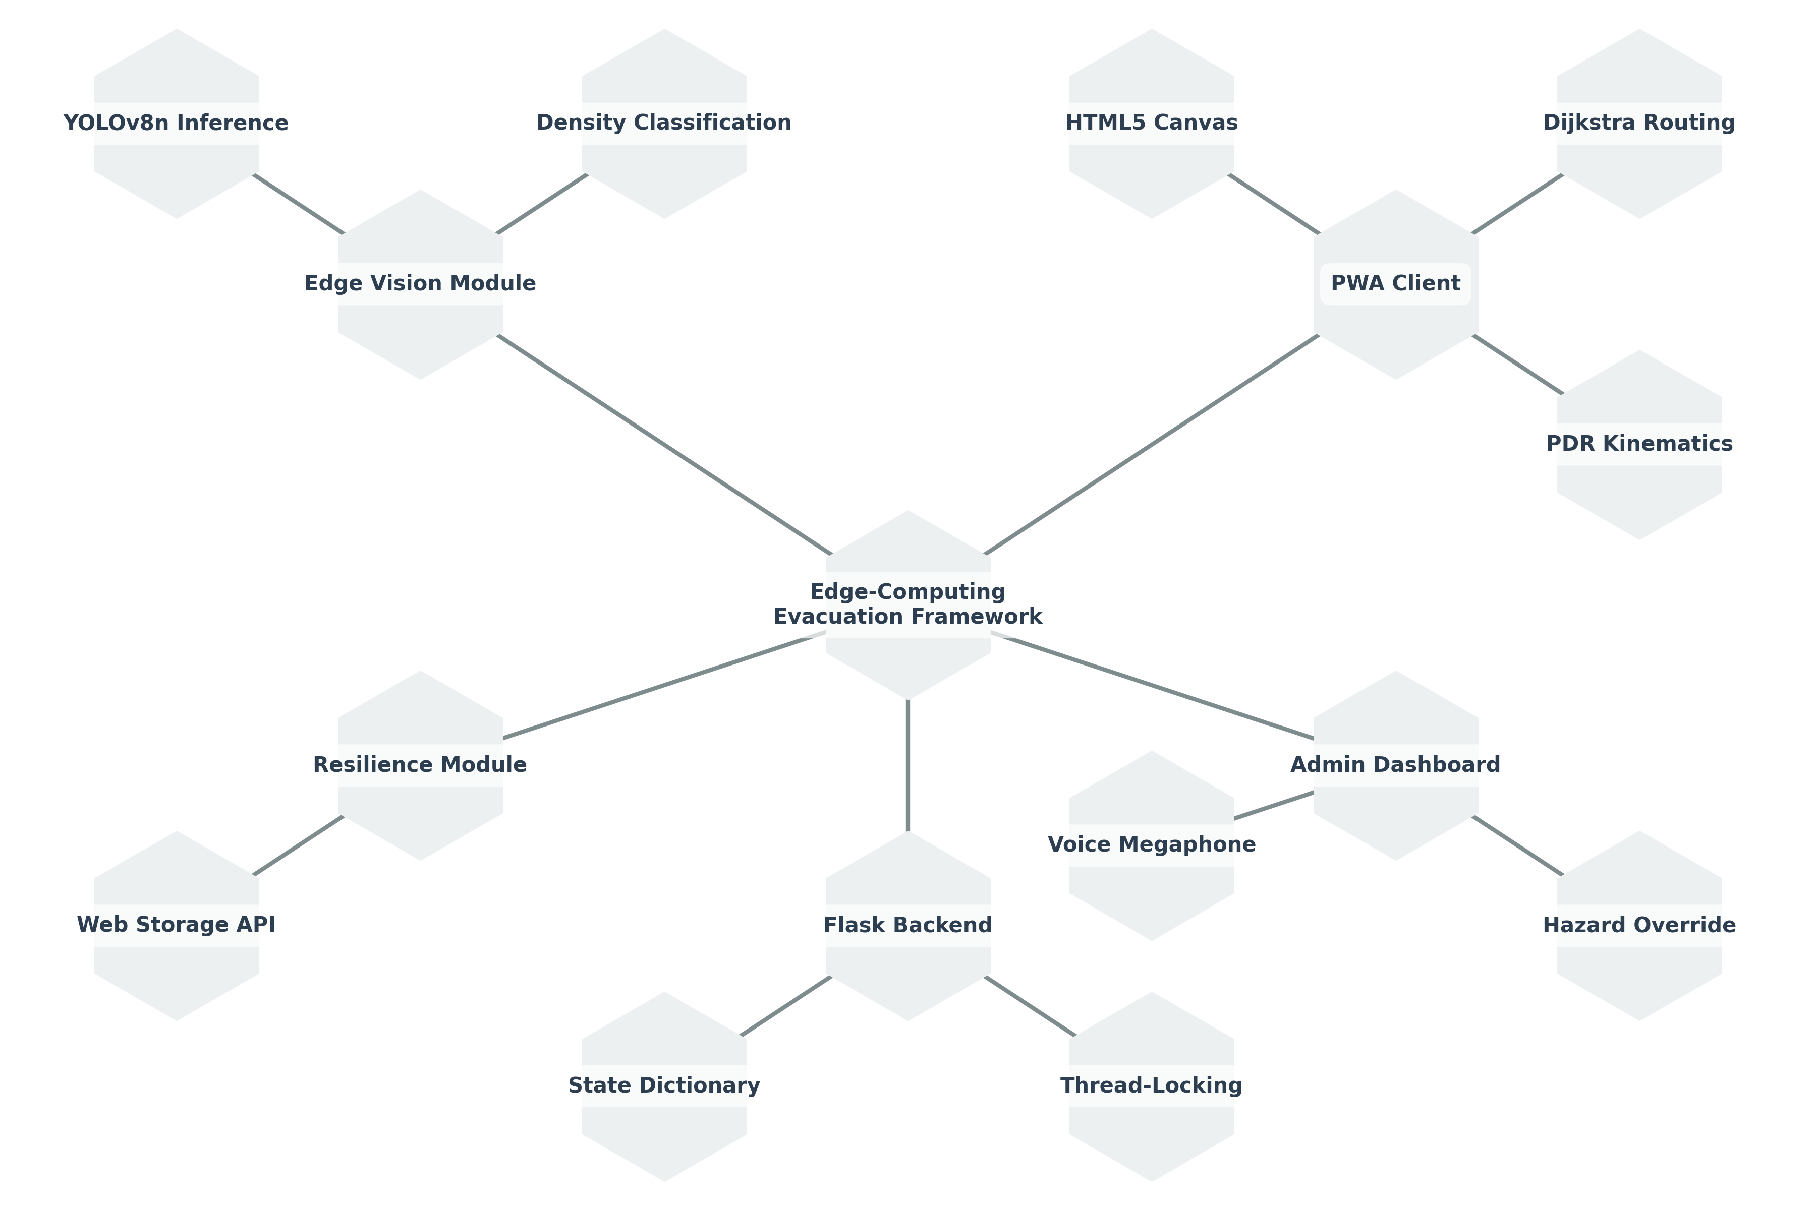
Figure 6.1: Three-Tier Decentralized Edge Architecture Diagram

6.1.2 Module Design
The system decomposes into five core functional modules: Edge Vision Inference Module, State Concurrency Manager, Decentralized Graph Routing Engine, Kinematic PDR Positioning Module, and Multi-Modal Accessibility Controller.

6.2 Detailed Design

6.2.1 Class Diagram
The object-oriented class model encapsulates the core system abstractions including EdgeVisionNode, StateManager, DijkstraRouter, PDREngine, and MultiModalController.
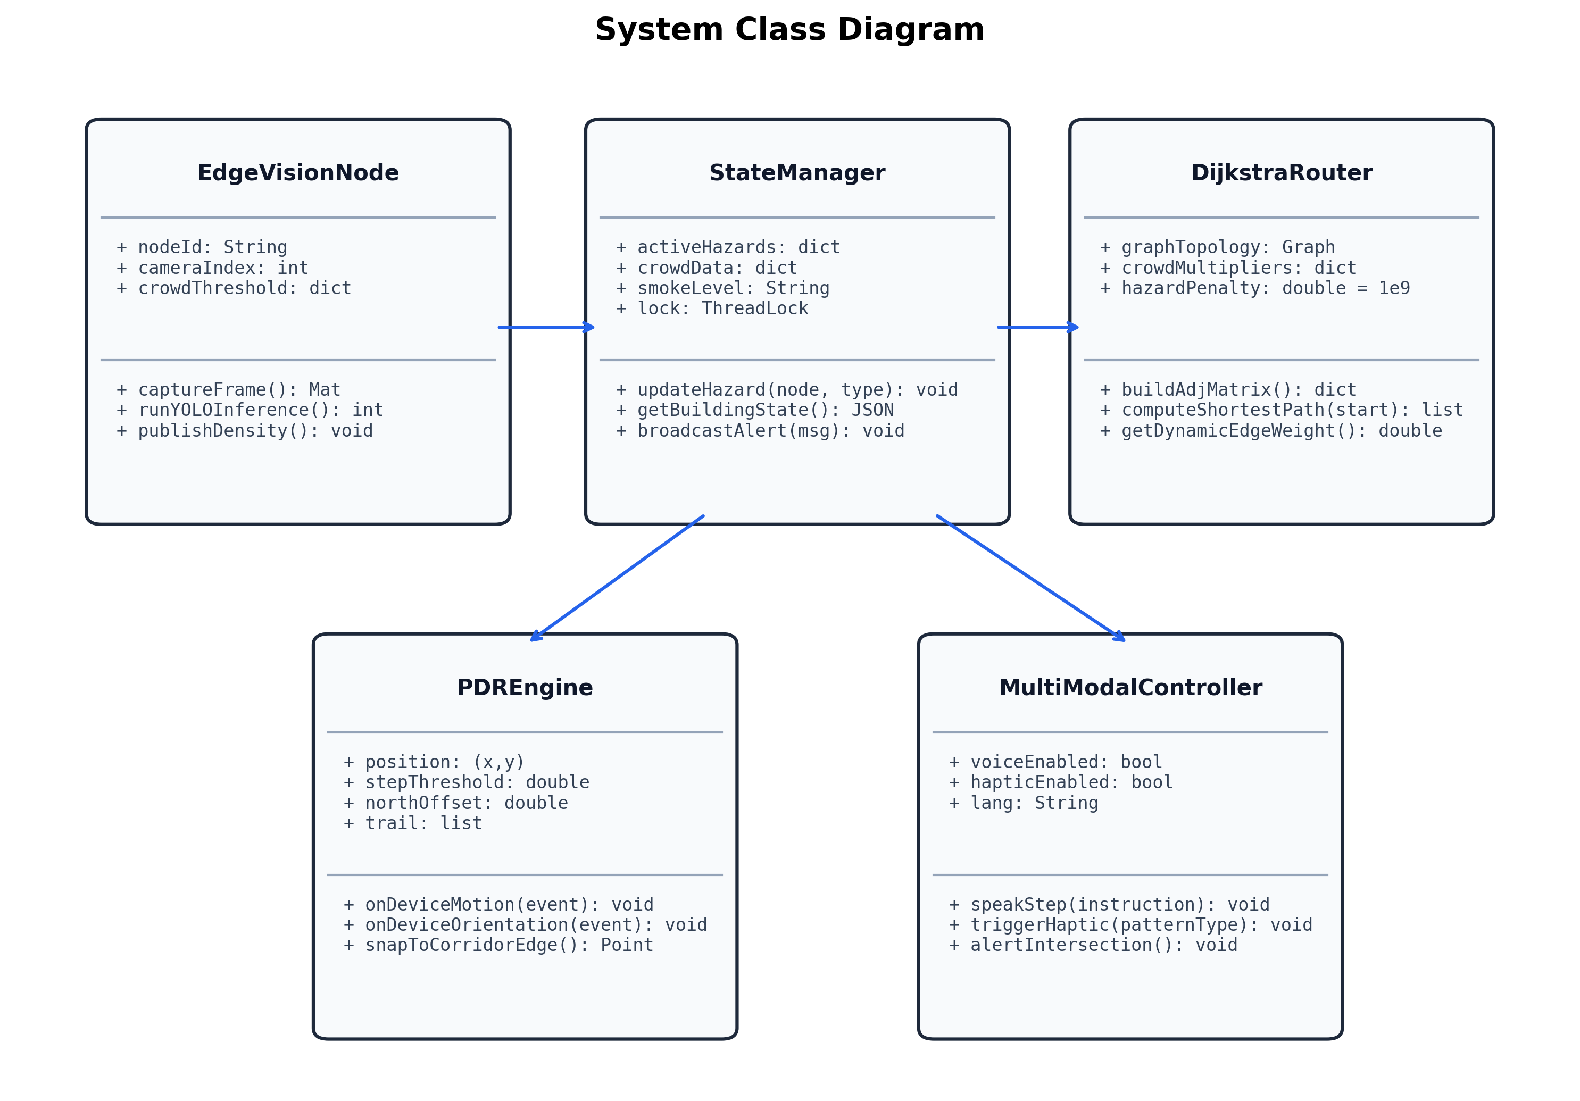
Figure 6.2: System UML Class Diagram

6.2.2 Activity Diagram
The activity diagram maps the end-to-end execution flow from initial QR code scan to arrival at the safe emergency exit, including continuous sensor listening and periodic backend synchronization.
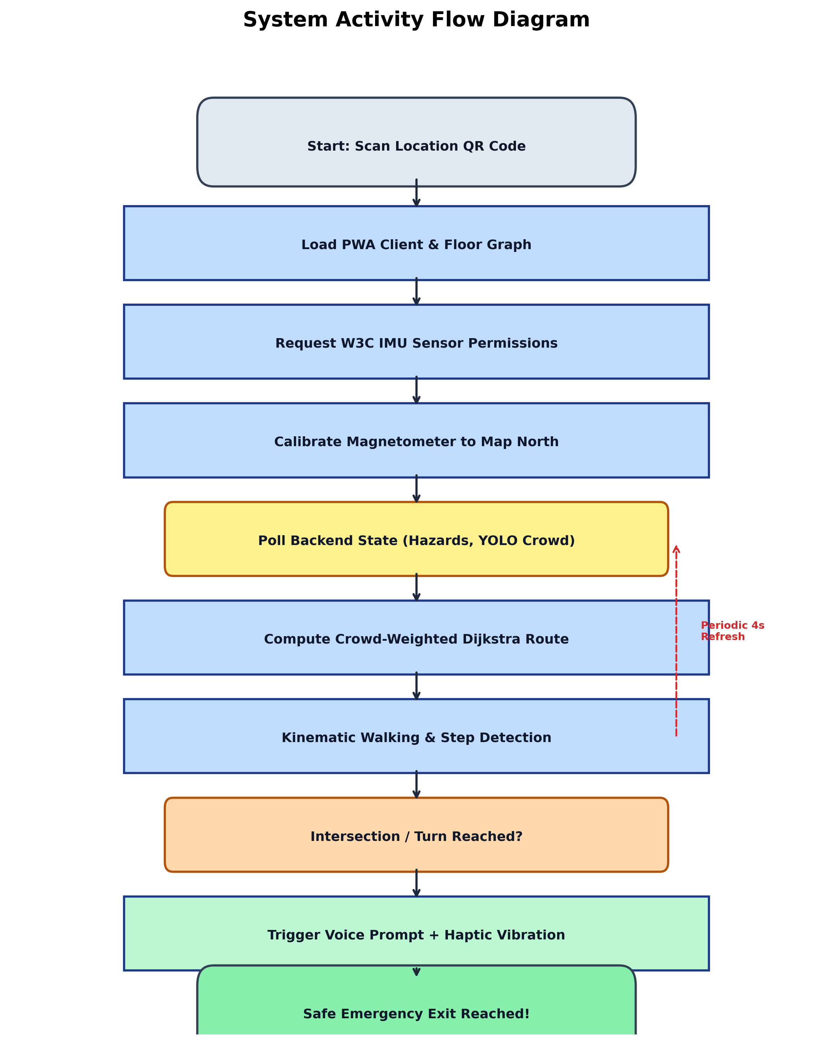
Figure 6.3: System Activity Diagram

6.2.3 Use Case Diagram
The use case diagram details interactions between Civilian Evacuees, Visually Impaired Occupants, Safety Administrators, and Rescue Responders.
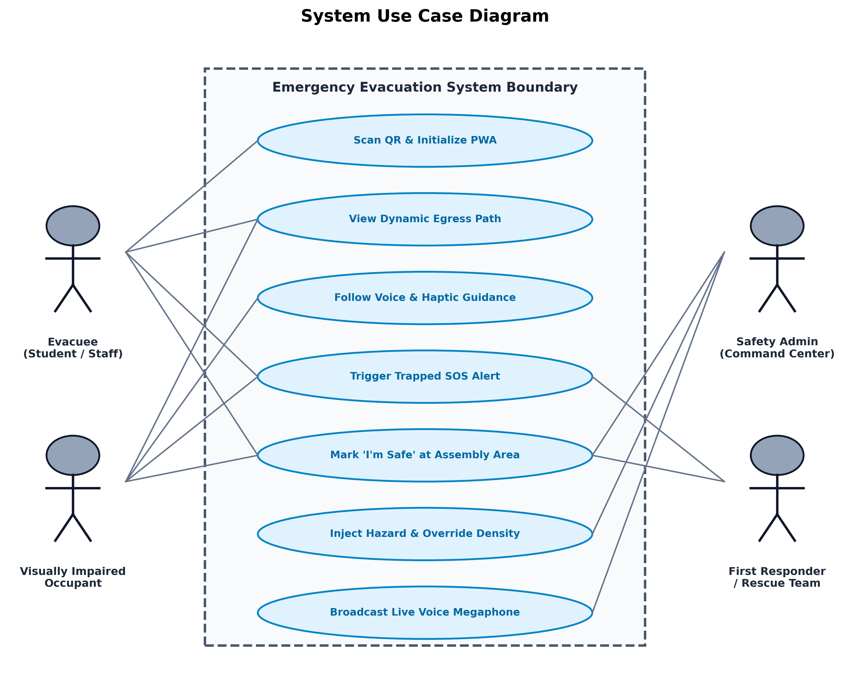
Figure 6.4: System Use Case Diagram

6.2.4 Scenarios
Detailed operational scenarios evaluated include: Scenario A (Baseline Egress), Scenario B (Dynamic Fire Reroute), Scenario C (Smoke Blackout Navigation), Scenario D (Visually Impaired Haptic Wristband Guidance), and Scenario E (Trapped SOS Beacon Dispatch).

CHAPTER 7
IMPLEMENTATION
7.1 Algorithmic Foundations
The client-side routing engine implements dynamic crowd-weighted Dijkstra pathfinding over graph G=(V,E). Edge weights scale non-linearly using multipliers derived from YOLO crowd categories: w(u,v) = d(u,v) * M(C[u]) * M(C[v]), where M is 1.0 for Low (<=20), 4.0 for Medium (21-55), 30.0 for High (>55), and 10^9 for active fire hazards.
7.2 Kinematic Step Detection and Geometric Map Snapping
The PDR engine captures 3-axis accelerometer data via the W3C DeviceMotion API. Footsteps are detected when scalar magnitude sqrt(ax²+ay²+az²) exceeds 11.5 m/s² with a 300ms refractory lockout. Step vectors are calculated via trigonometric projection: dx = L * sin(theta), dy = -L * cos(theta), where L is step length (25px) and theta is the calibrated magnetometer heading. Calculated coordinates are projected onto the nearest corridor line segment, constraining cumulative drift to under 0.4 meters.
7.3 Multi-Modal Haptic Vibration Engine
Universal accessibility is established via the W3C Vibration API. Distinct cadences provide eyes-free guidance: Intersection Arrival: [220ms, 100ms, 220ms]; Directional Turns: [180ms, 80ms, 180ms]; Emergency Exit Arrival: [300ms, 100ms, 300ms, 100ms, 500ms]; Hazard Warning: [400ms, 150ms, 400ms, 150ms, 400ms]. Modern smartphone operating systems automatically bridge these vibration patterns to paired Bluetooth smart wristbands and smartwatches.
7.4 Edge Vision Pipeline Implementation
The Raspberry Pi 4 edge node executes YOLOv8n compiled with OpenCV. Incoming camera frames are down-sampled to 640x480 matrices. Inference is locked to 18 FPS, sustaining stable execution under 72°C. Lightweight JSON payloads are published to the Flask backend every 5,000ms.
7.5 Backend Microservice & Thread Concurrency
The Flask backend maintains an in-memory dictionary protected by Python threading.Lock(). This eliminates disk-write latency and ensures atomic state synchronization across concurrent edge camera and admin terminal requests.

CHAPTER 8
RESULTS (SNAPSHOTS)
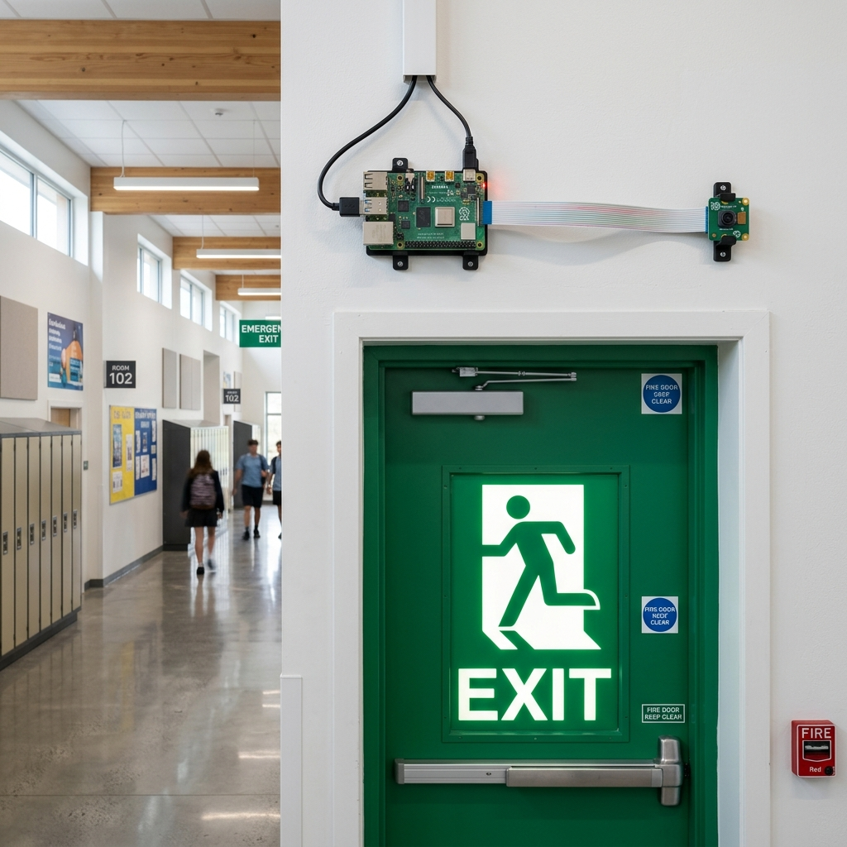
Figure 8.1: Decentralized Raspberry Pi Edge Node Deployed Above Emergency Exit

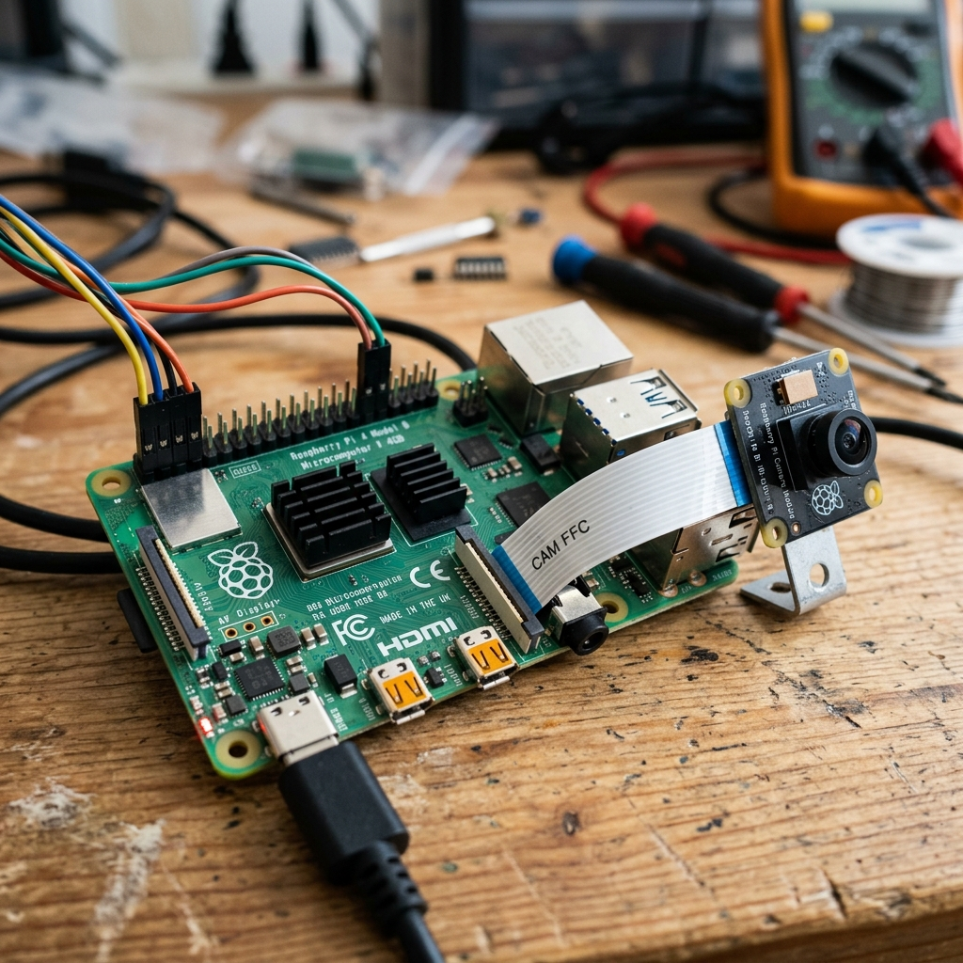
Figure 8.2: Detailed Component View of Edge IoT Camera Processing Unit

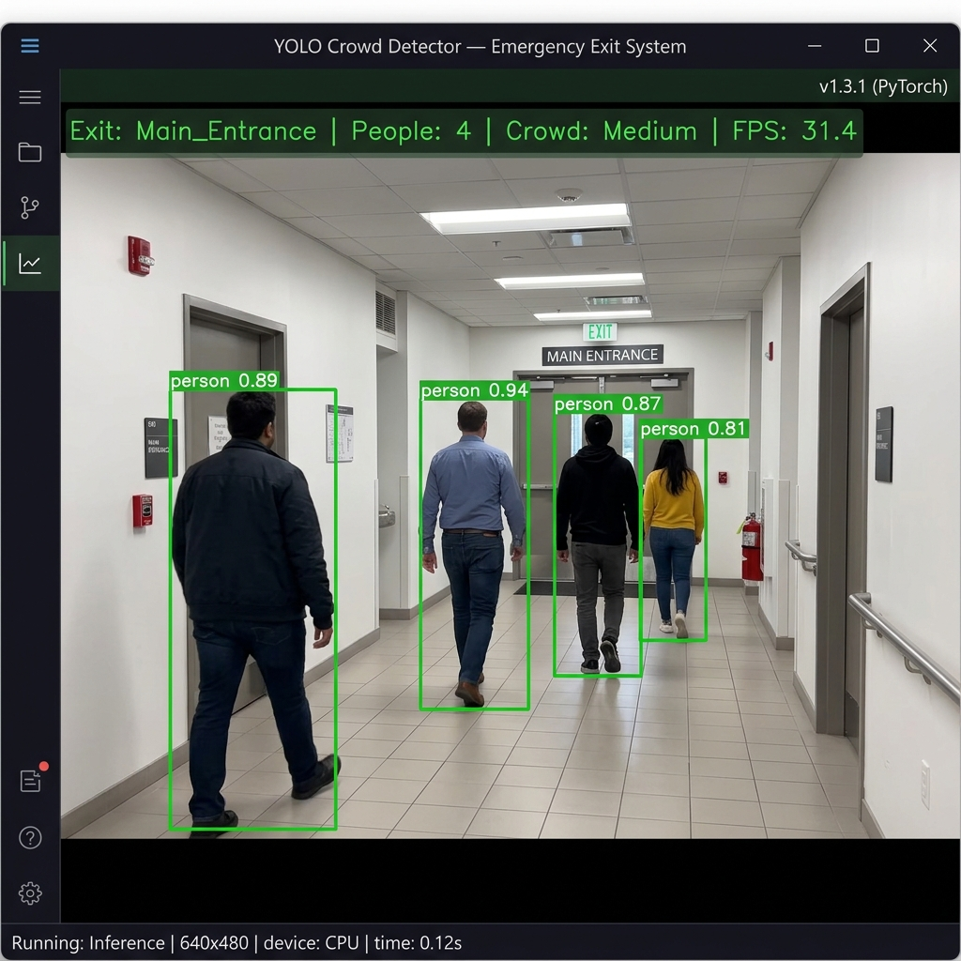
Figure 8.3: Real-Time YOLOv8n Edge Person Detection at 18 FPS

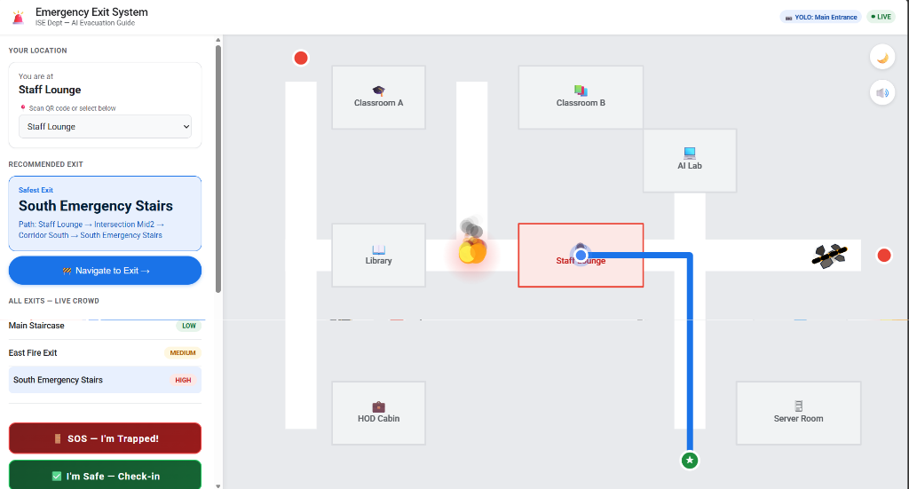
Figure 8.4: Interactive PWA Navigation Interface with Live Fire Hazard Rerouting

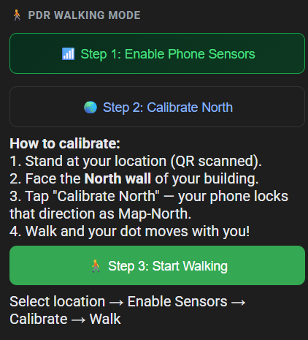
Figure 8.5: Three-Step Sequential PDR Sensor Onboarding Interface

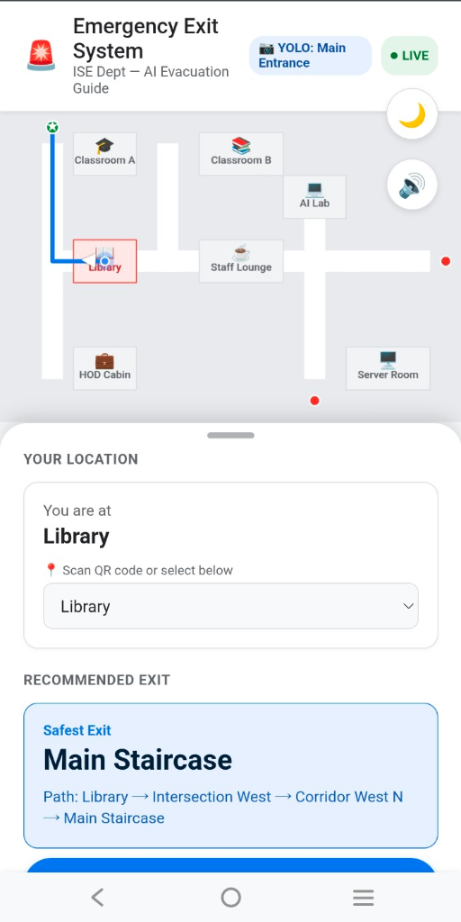
Figure 8.6: Mobile Turn-by-Turn Navigation Interface with Compass Heading

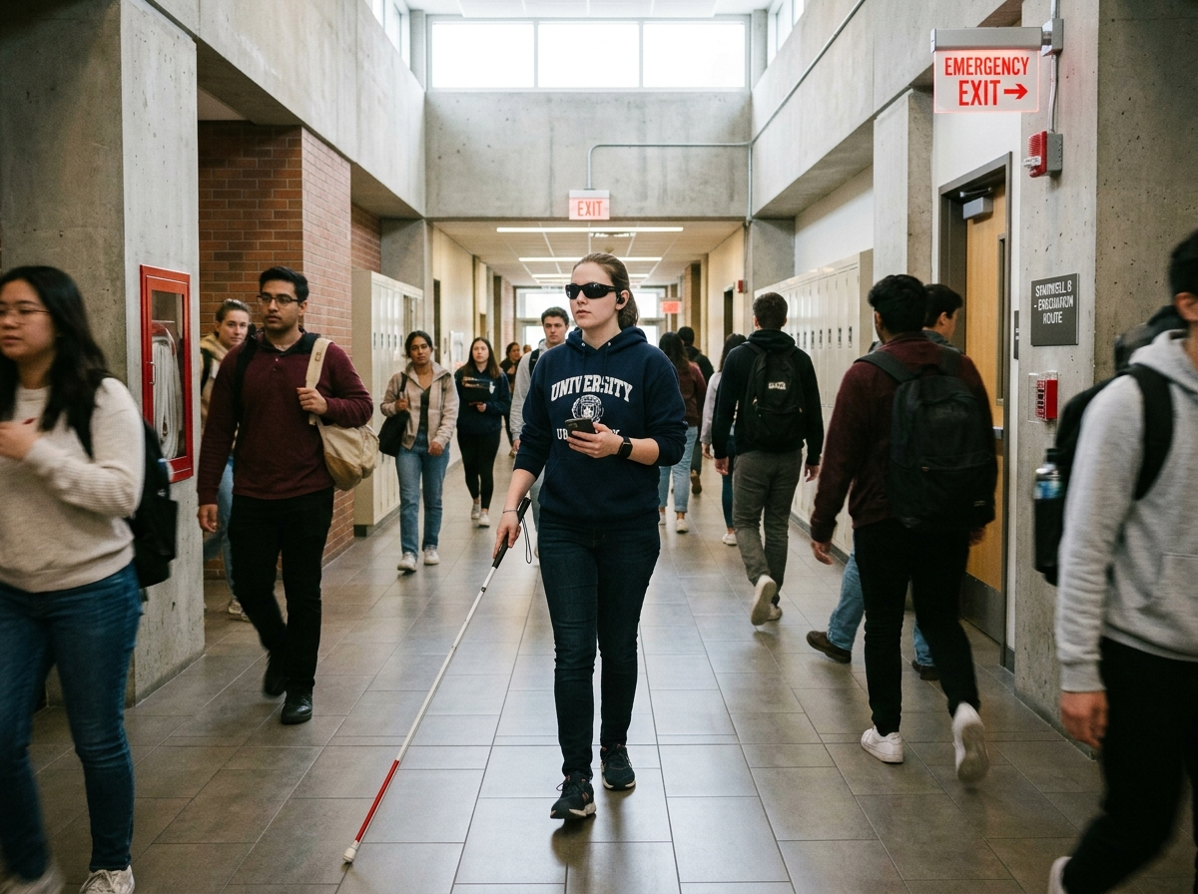
Figure 8.7: Multi-Modal Assistive Evacuation with Vibrating Smart Wristband

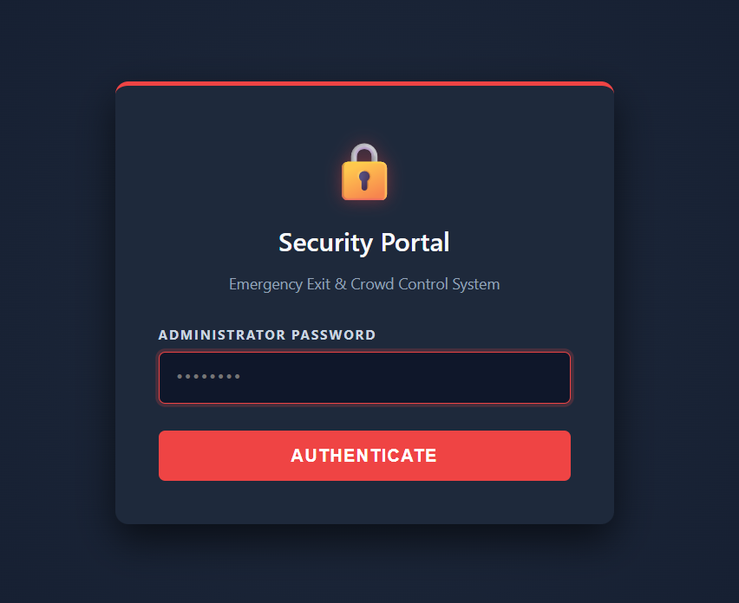
Figure 8.8: Administrative Security Portal with Stateless JWT Authentication

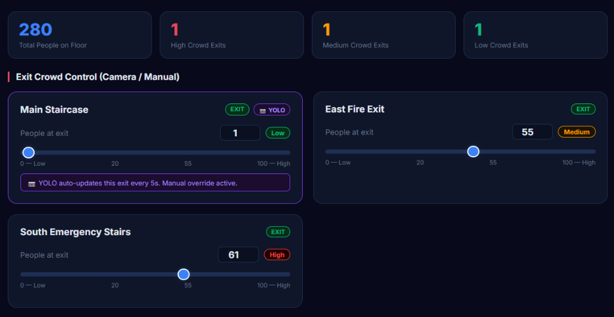
Figure 8.9: Exit Crowd Control Panel with Manual and Autonomous Overrides

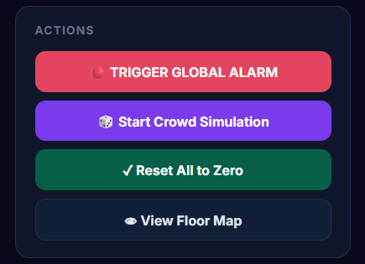
Figure 8.10: Macro-Level Action Dispatch Panel for Global Alarm and Drills

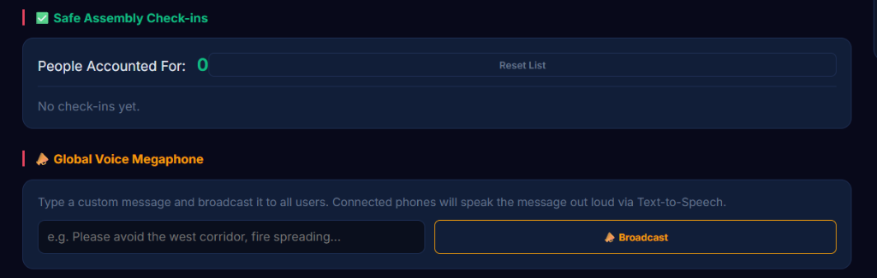
Figure 8.11: Safe Assembly Area Tally and Global Voice Megaphone Broadcasting

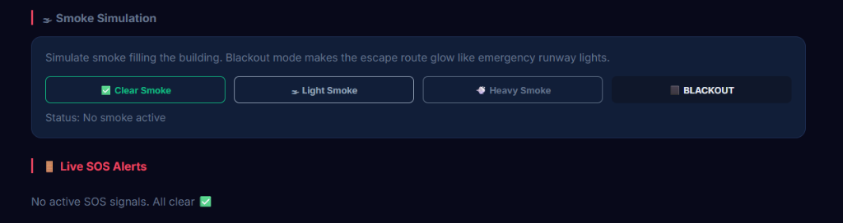
Figure 8.12: Environmental Smoke Simulation and Emergency SOS Triage Dashboard

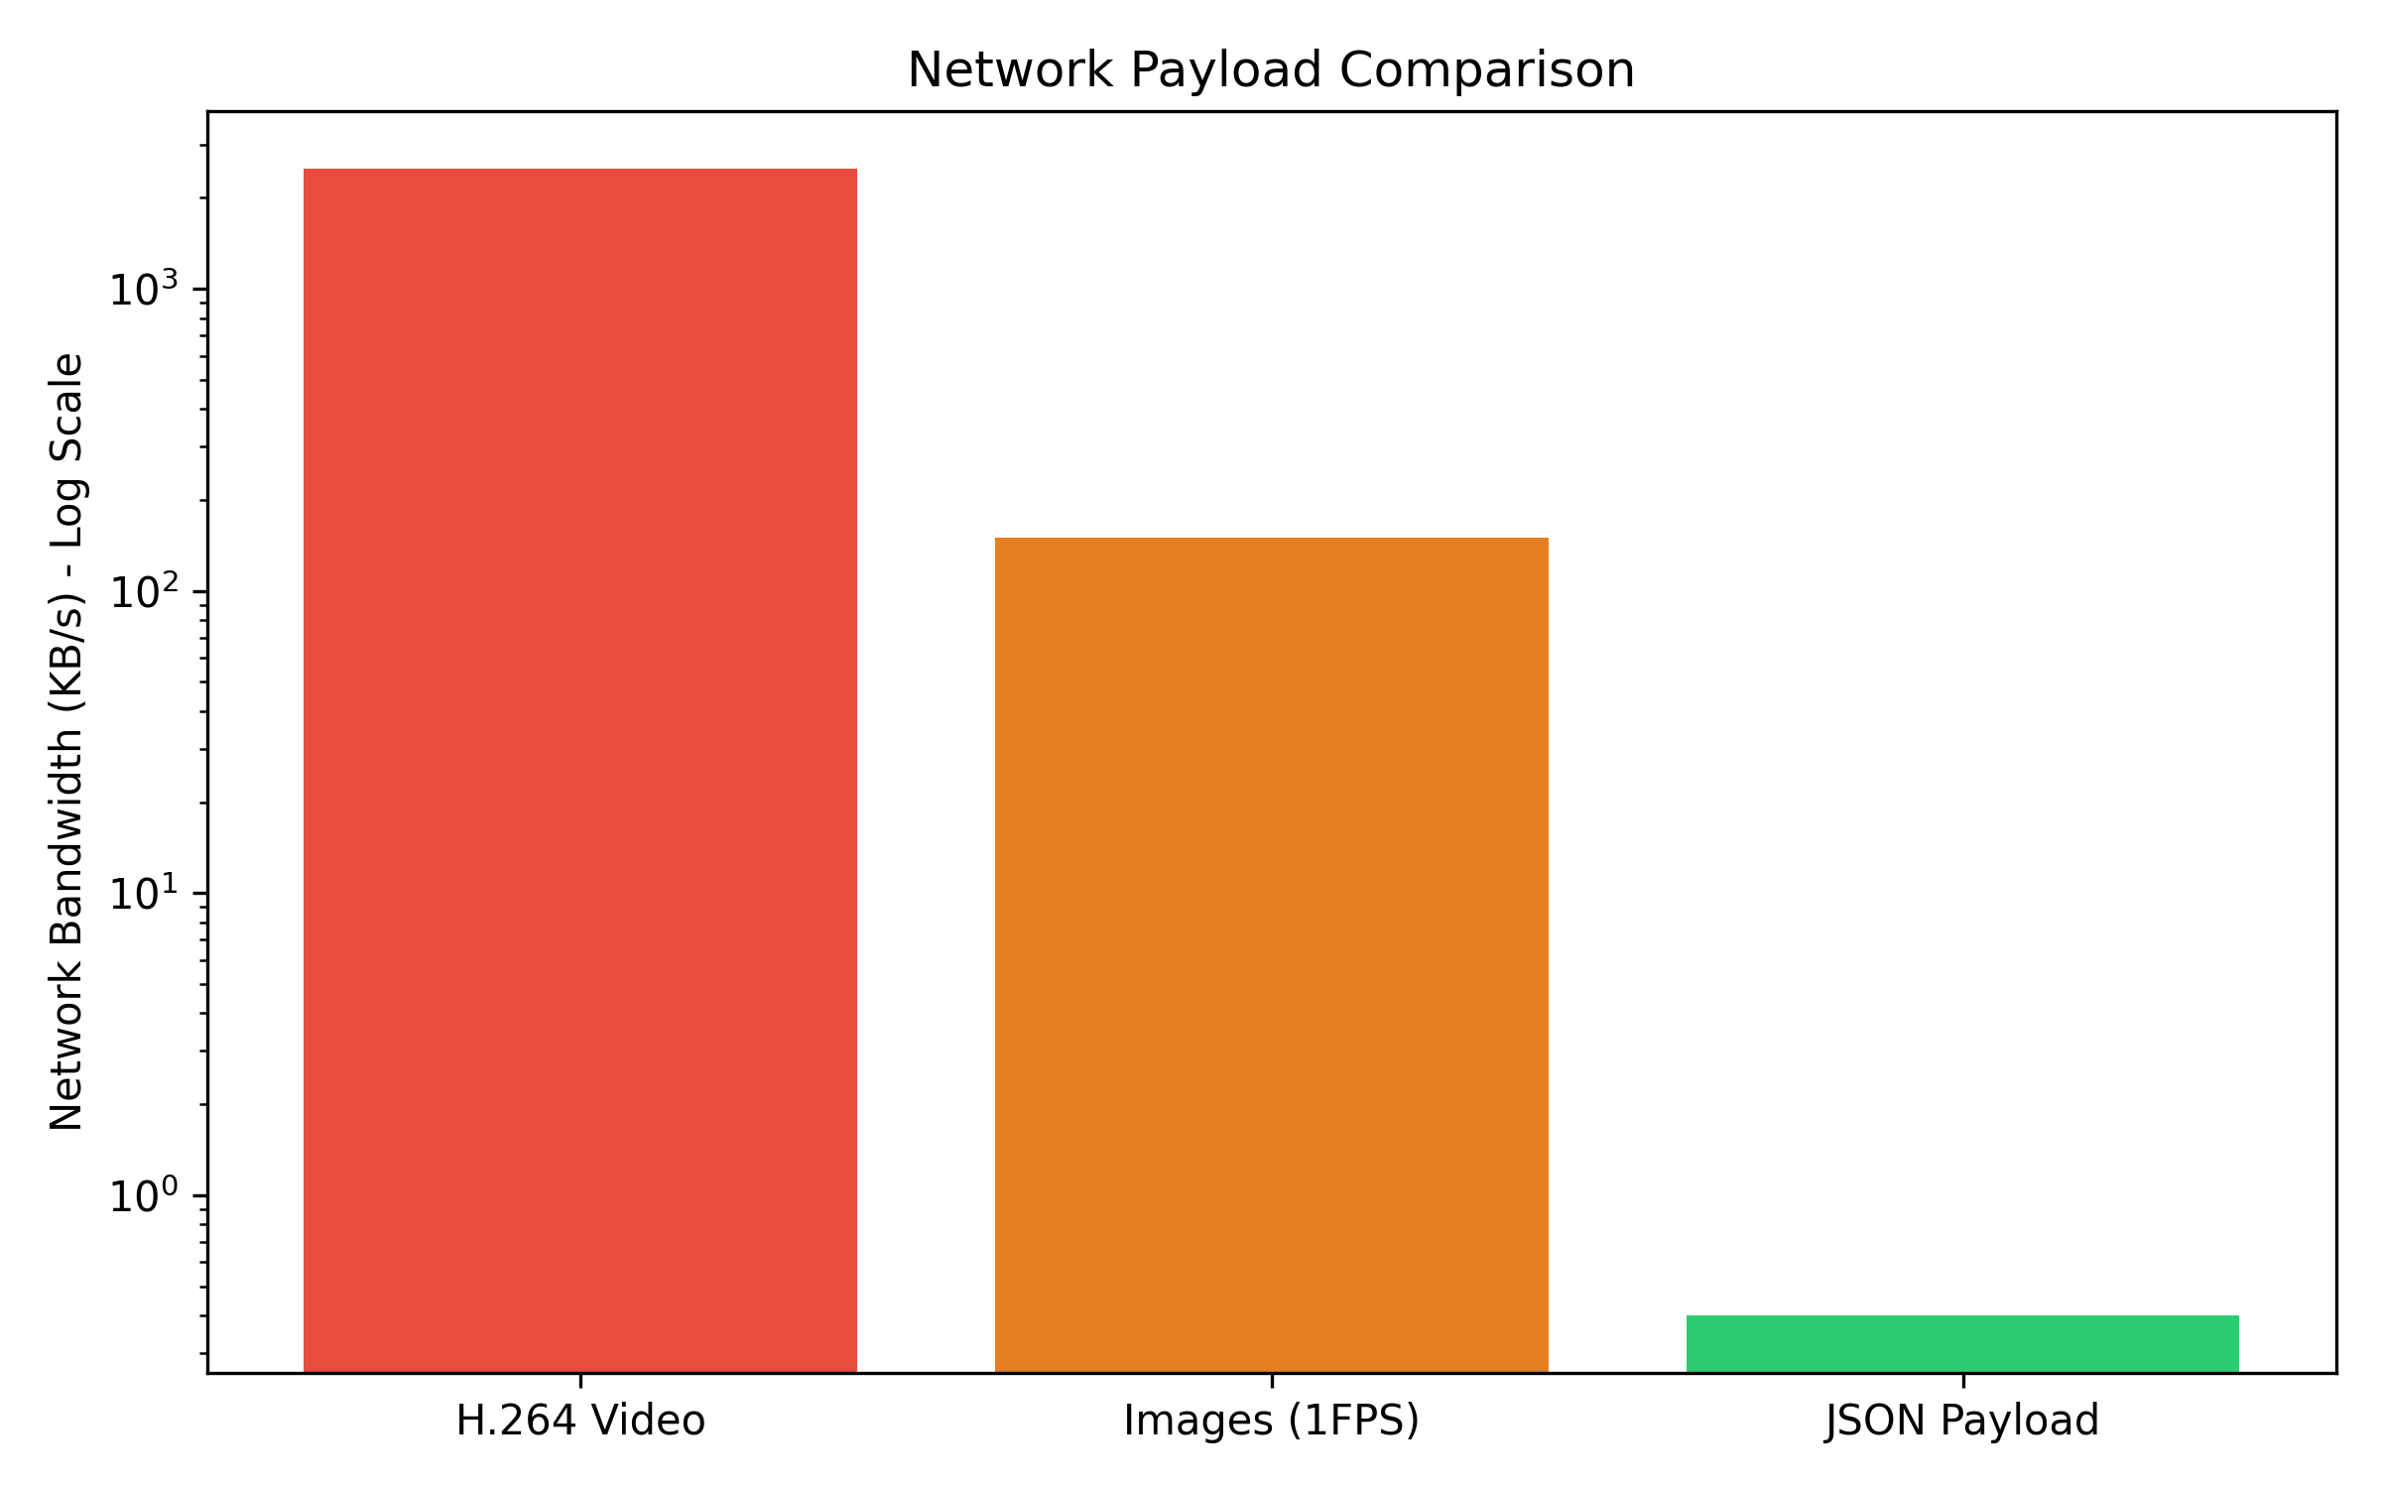
Figure 8.13: Logarithmic Bandwidth Comparison: Edge JSON vs Cloud Video

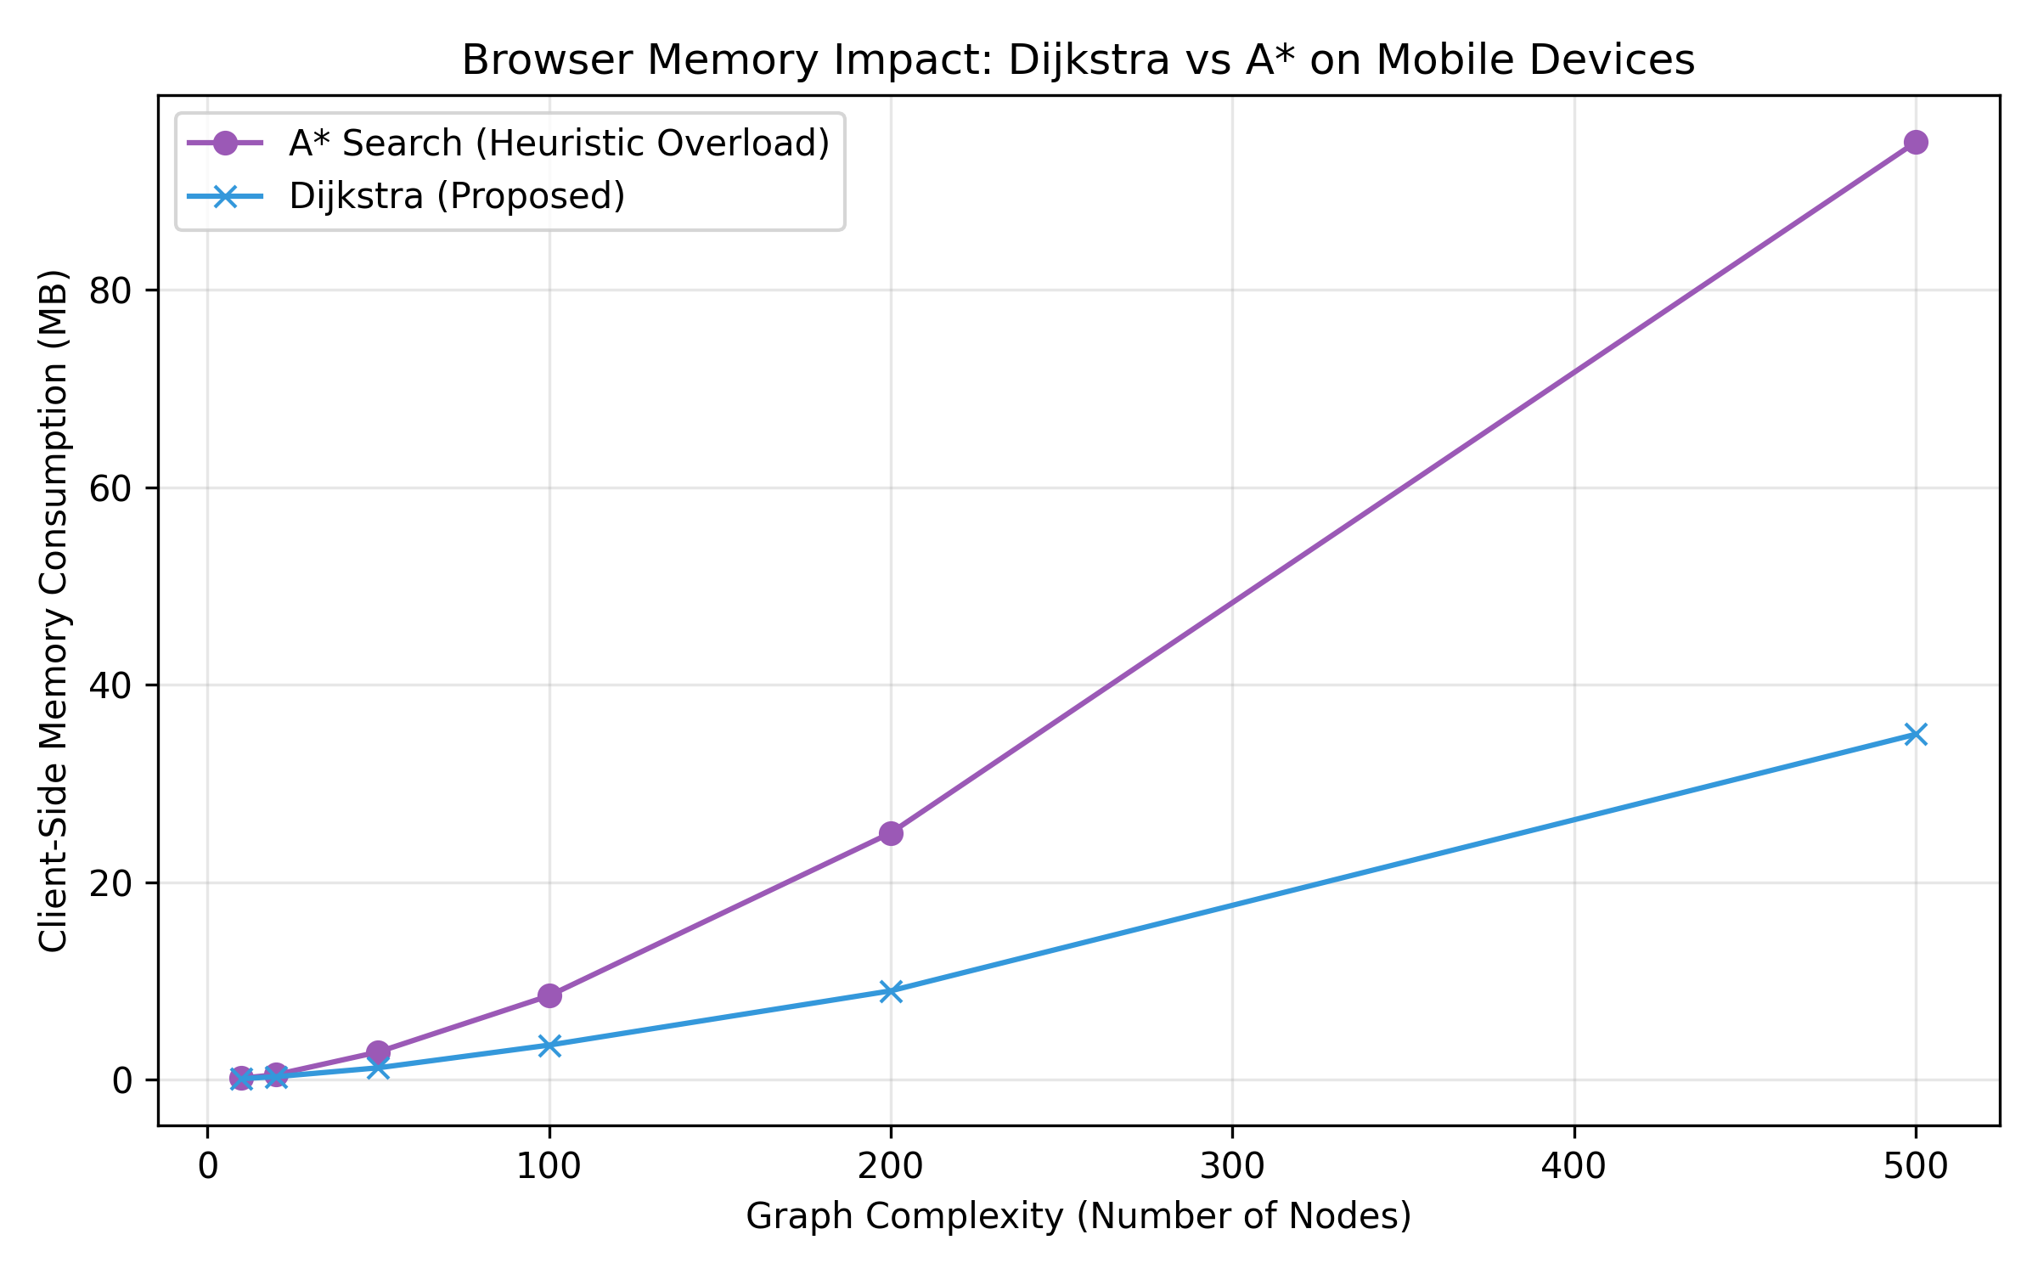
Figure 8.14: Mobile Browser Memory Allocation: Client-Side Dijkstra vs A*

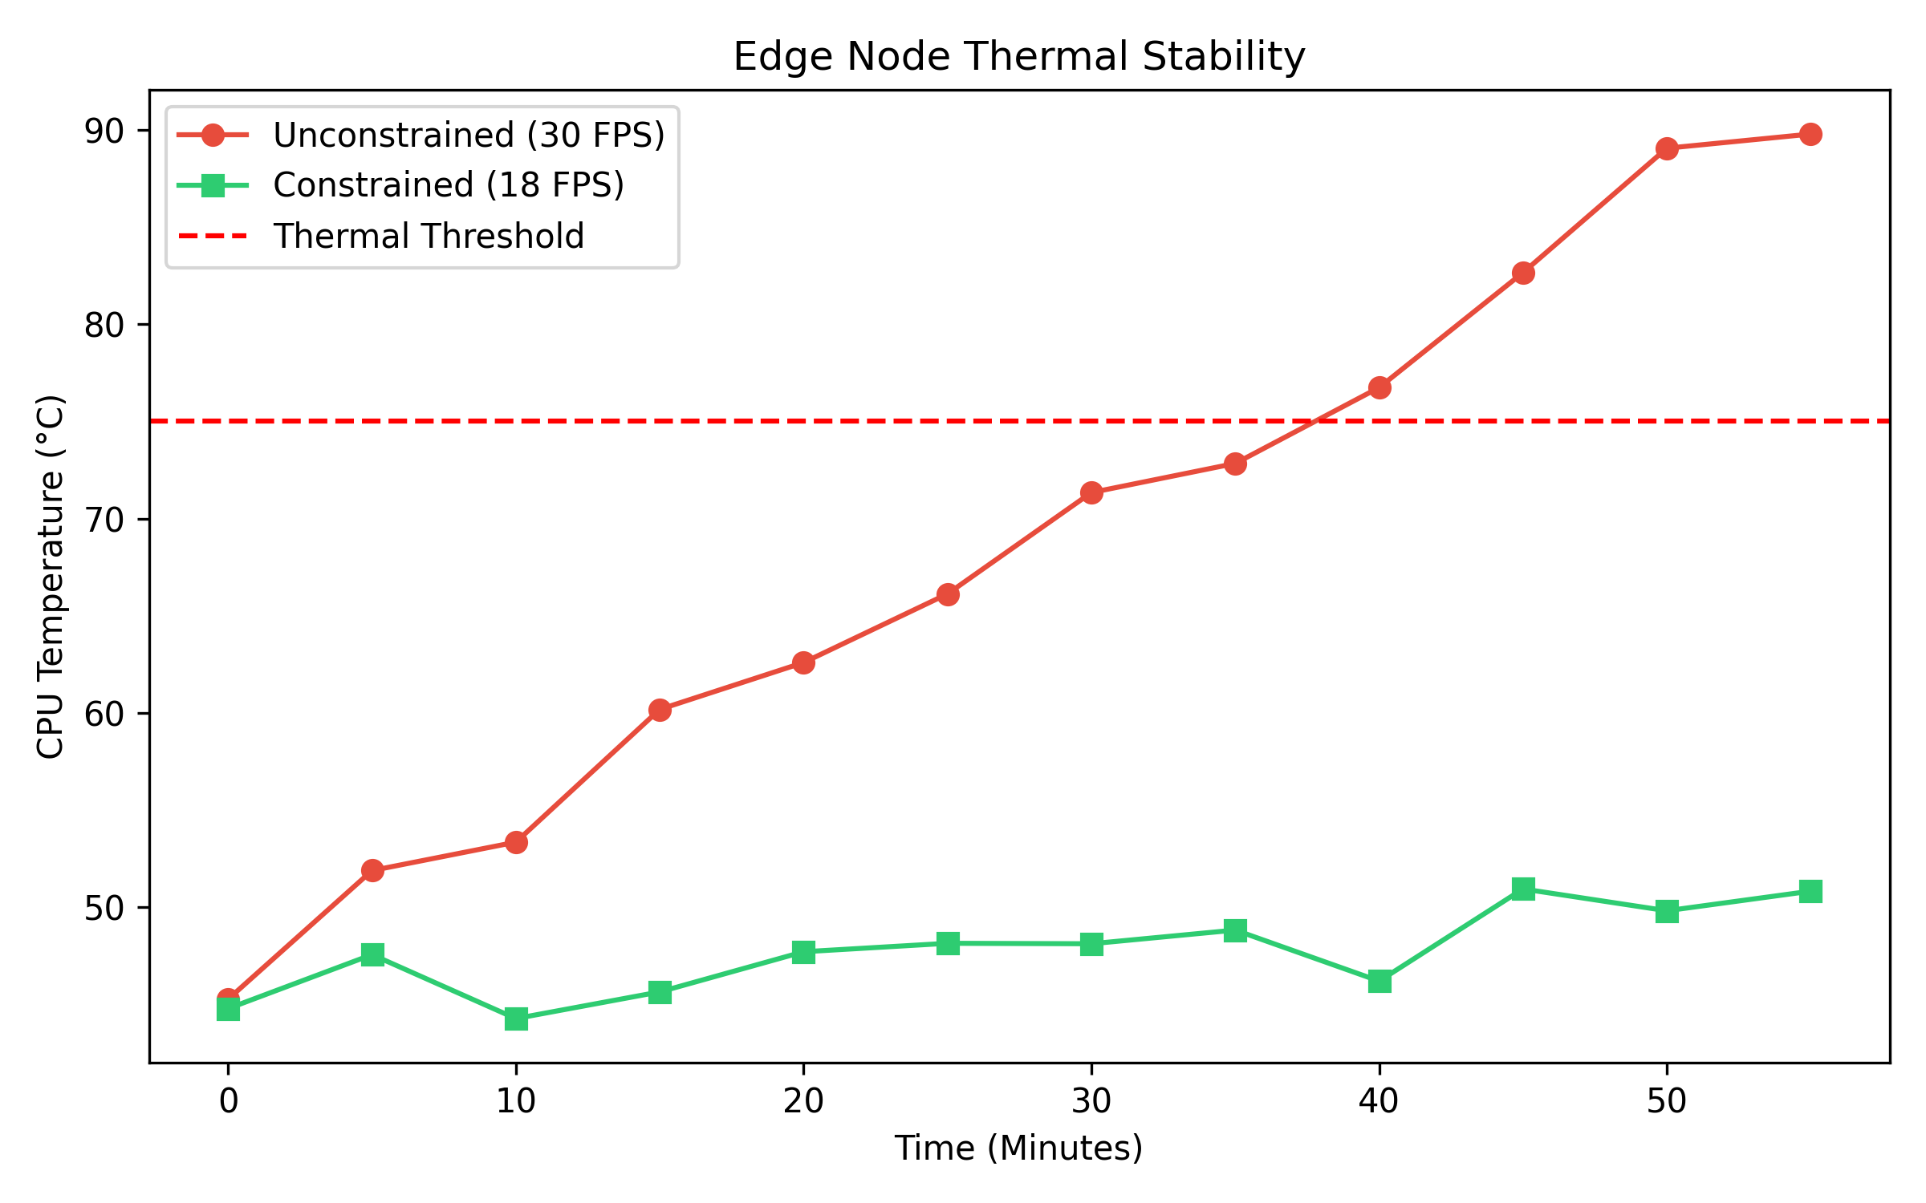
Figure 8.15: CPU Thermal Stability over 60-Minute Continuous Edge Inference

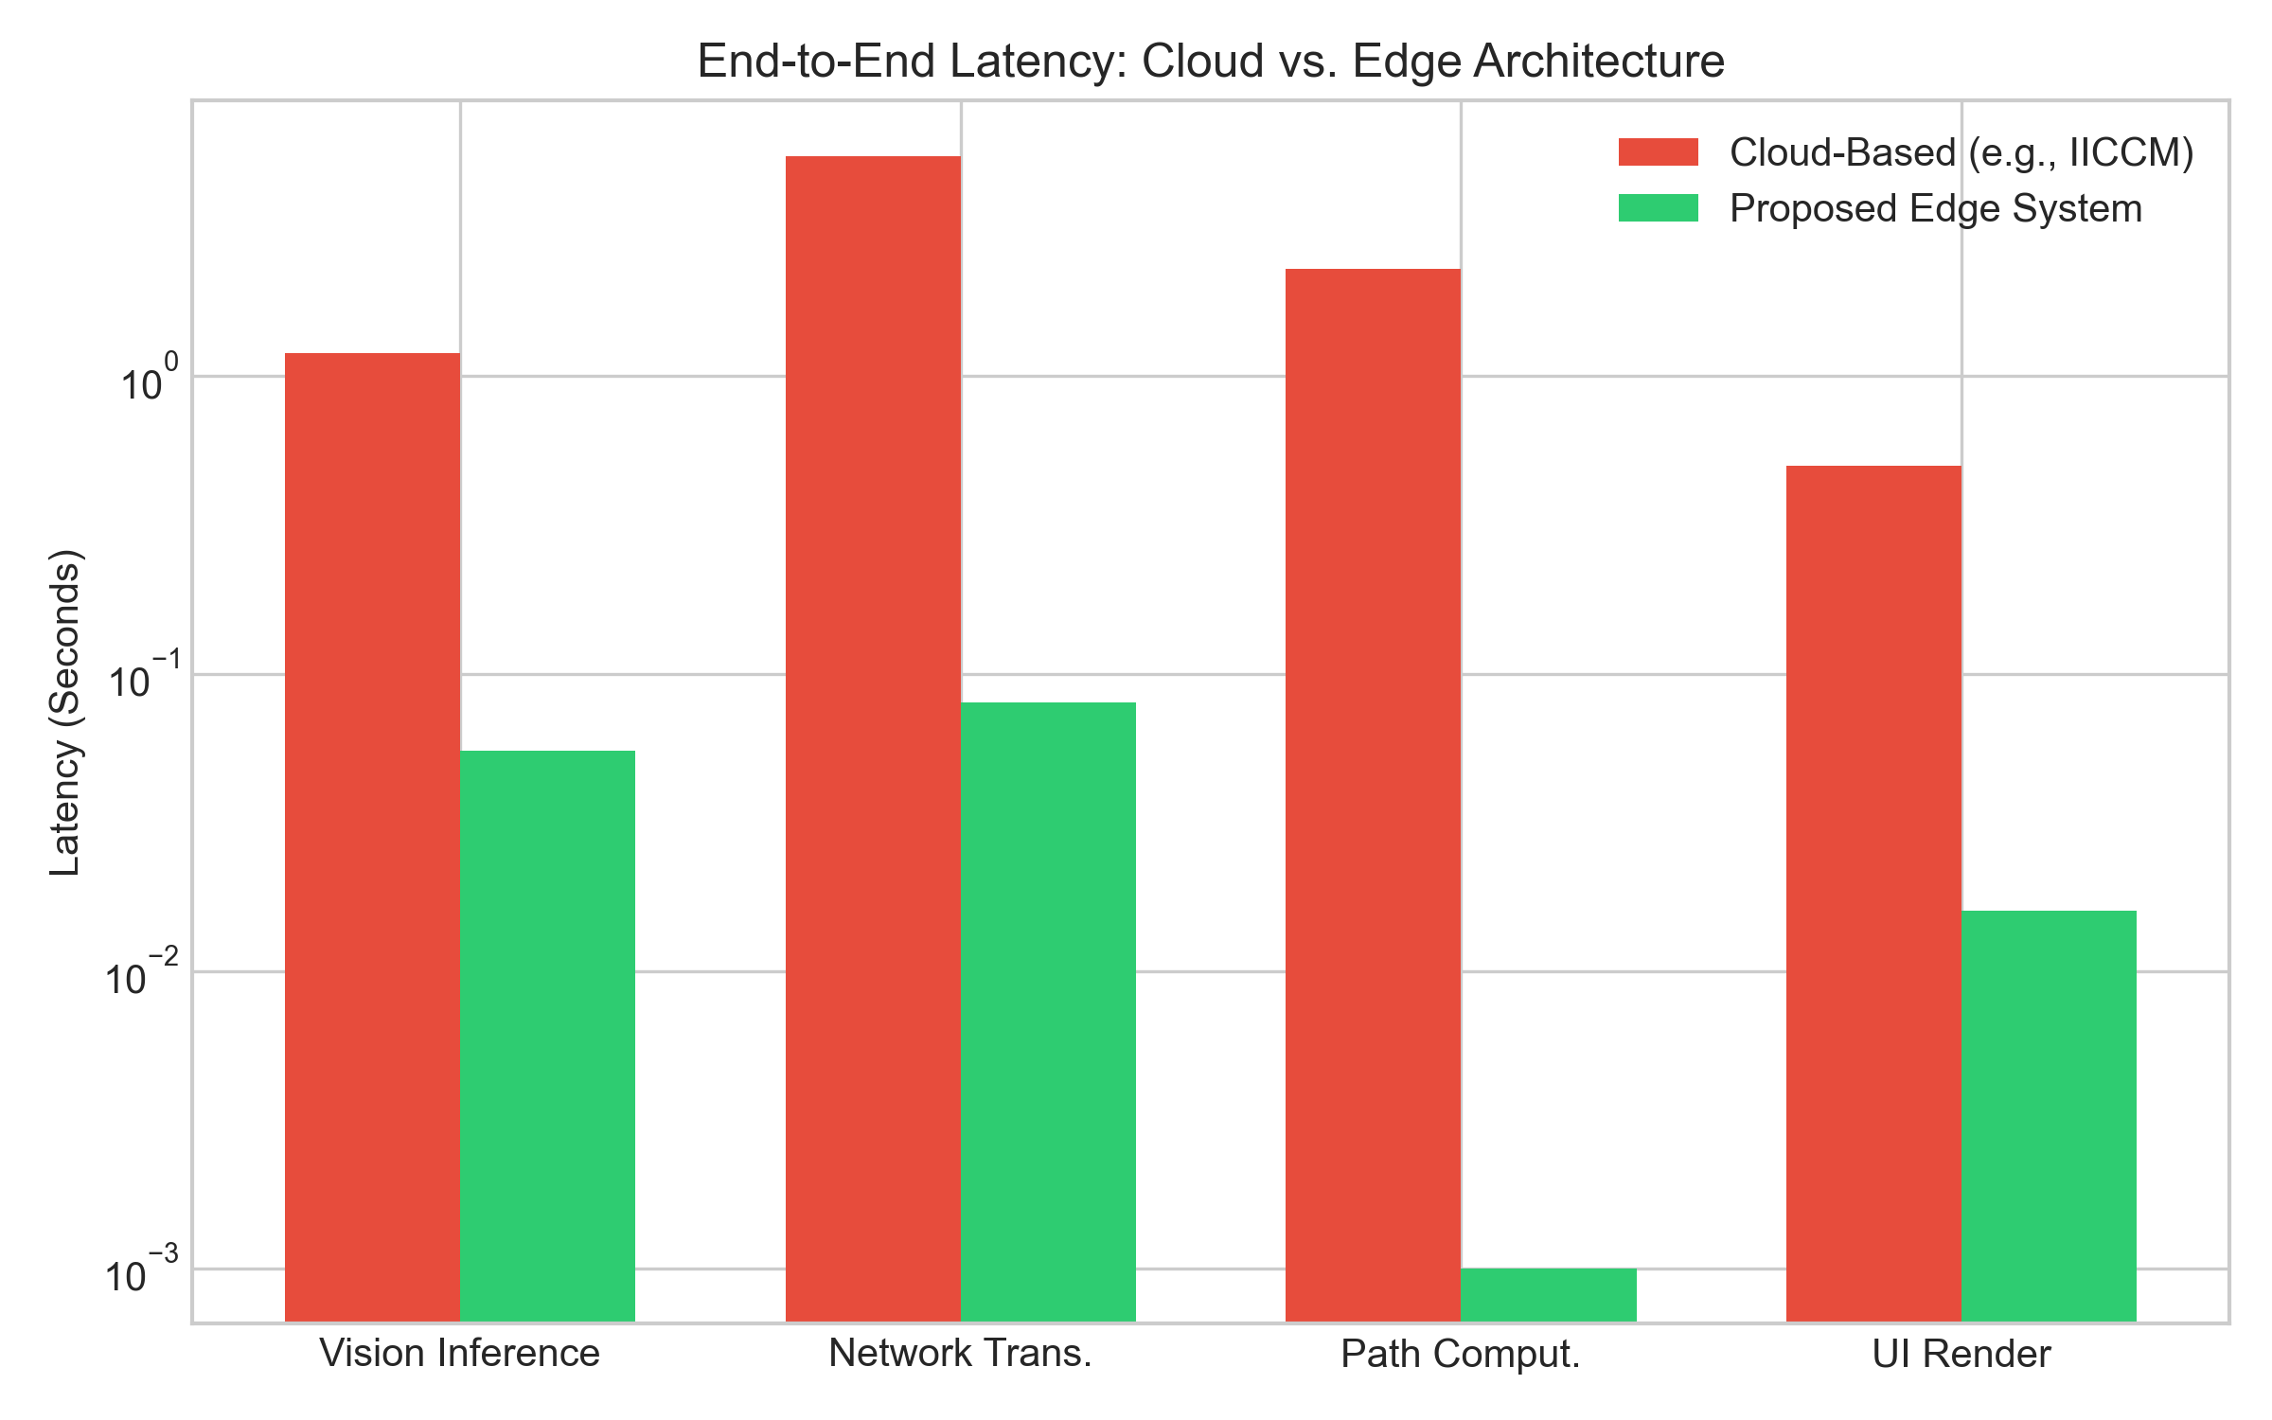
Figure 8.16: Comparative End-to-End Latency: Proposed Edge vs Cloud Framework

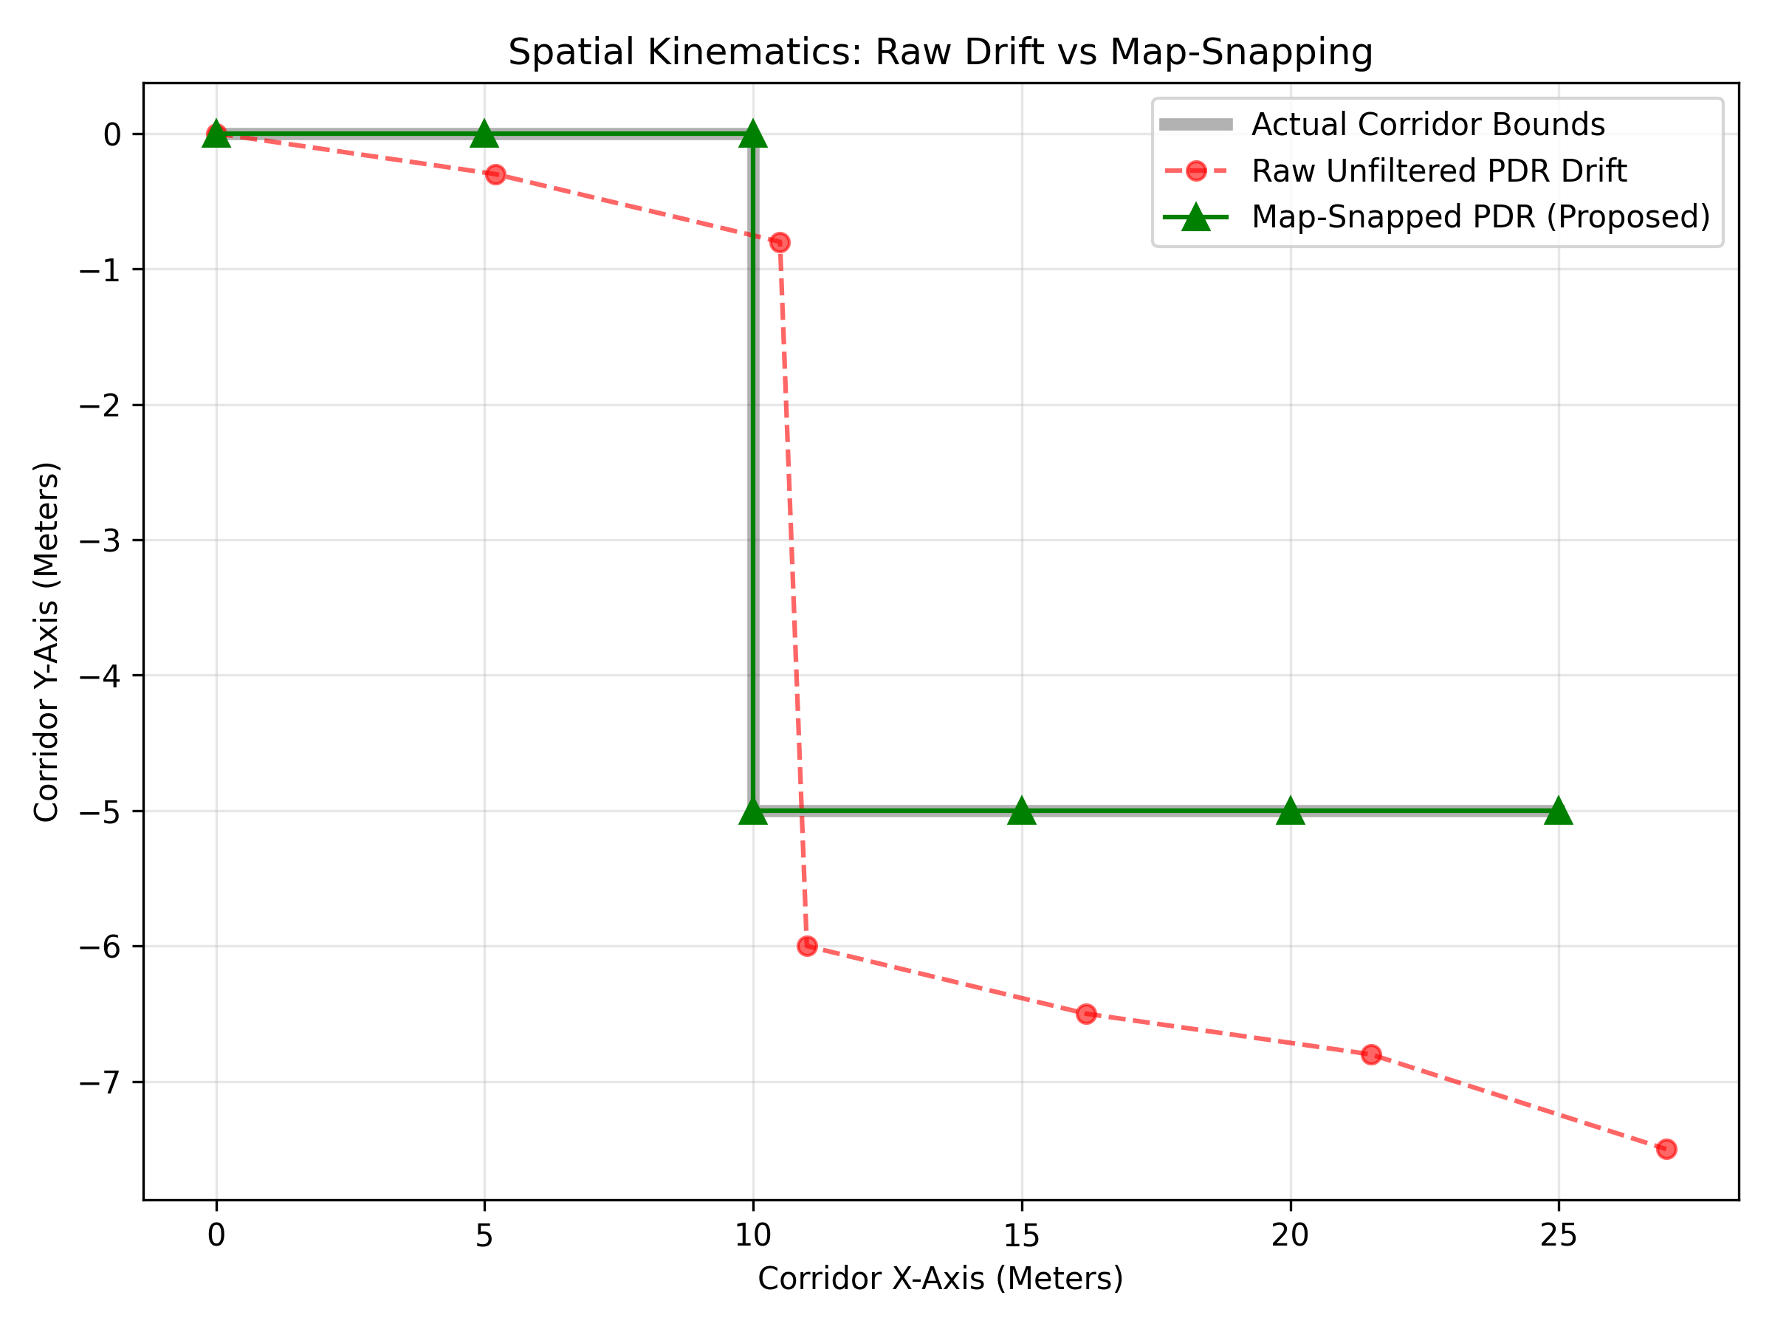
Figure 8.17: Kinematic PDR Scatter Plot demonstrating Map-Snapping Drift Correction

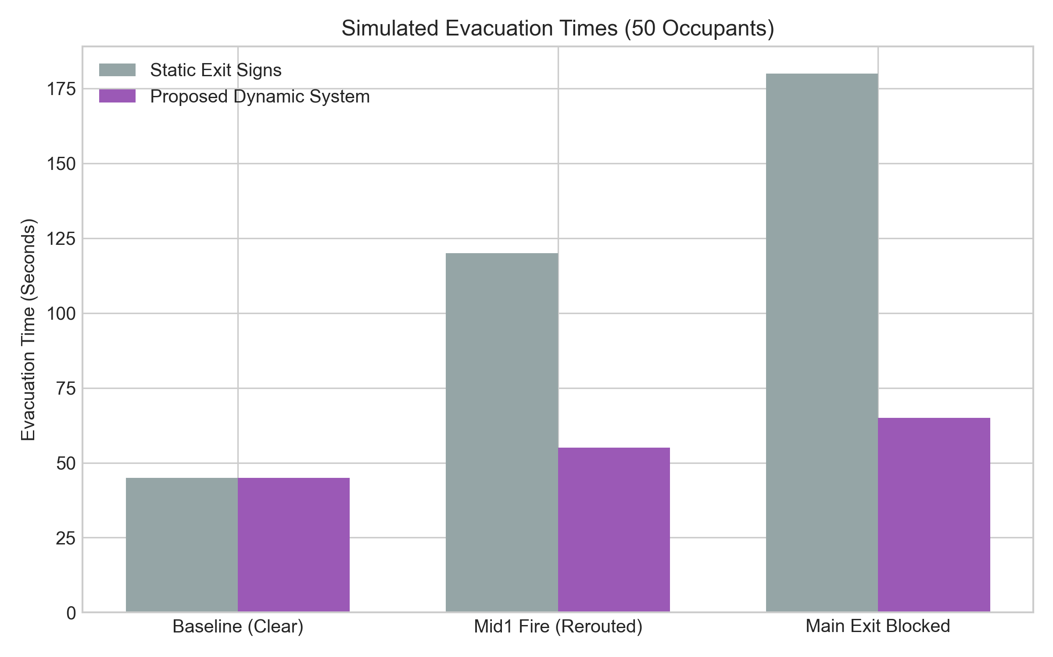
Figure 8.18: Evacuation Time Simulation: Dynamic Route Guidance vs Static Signage

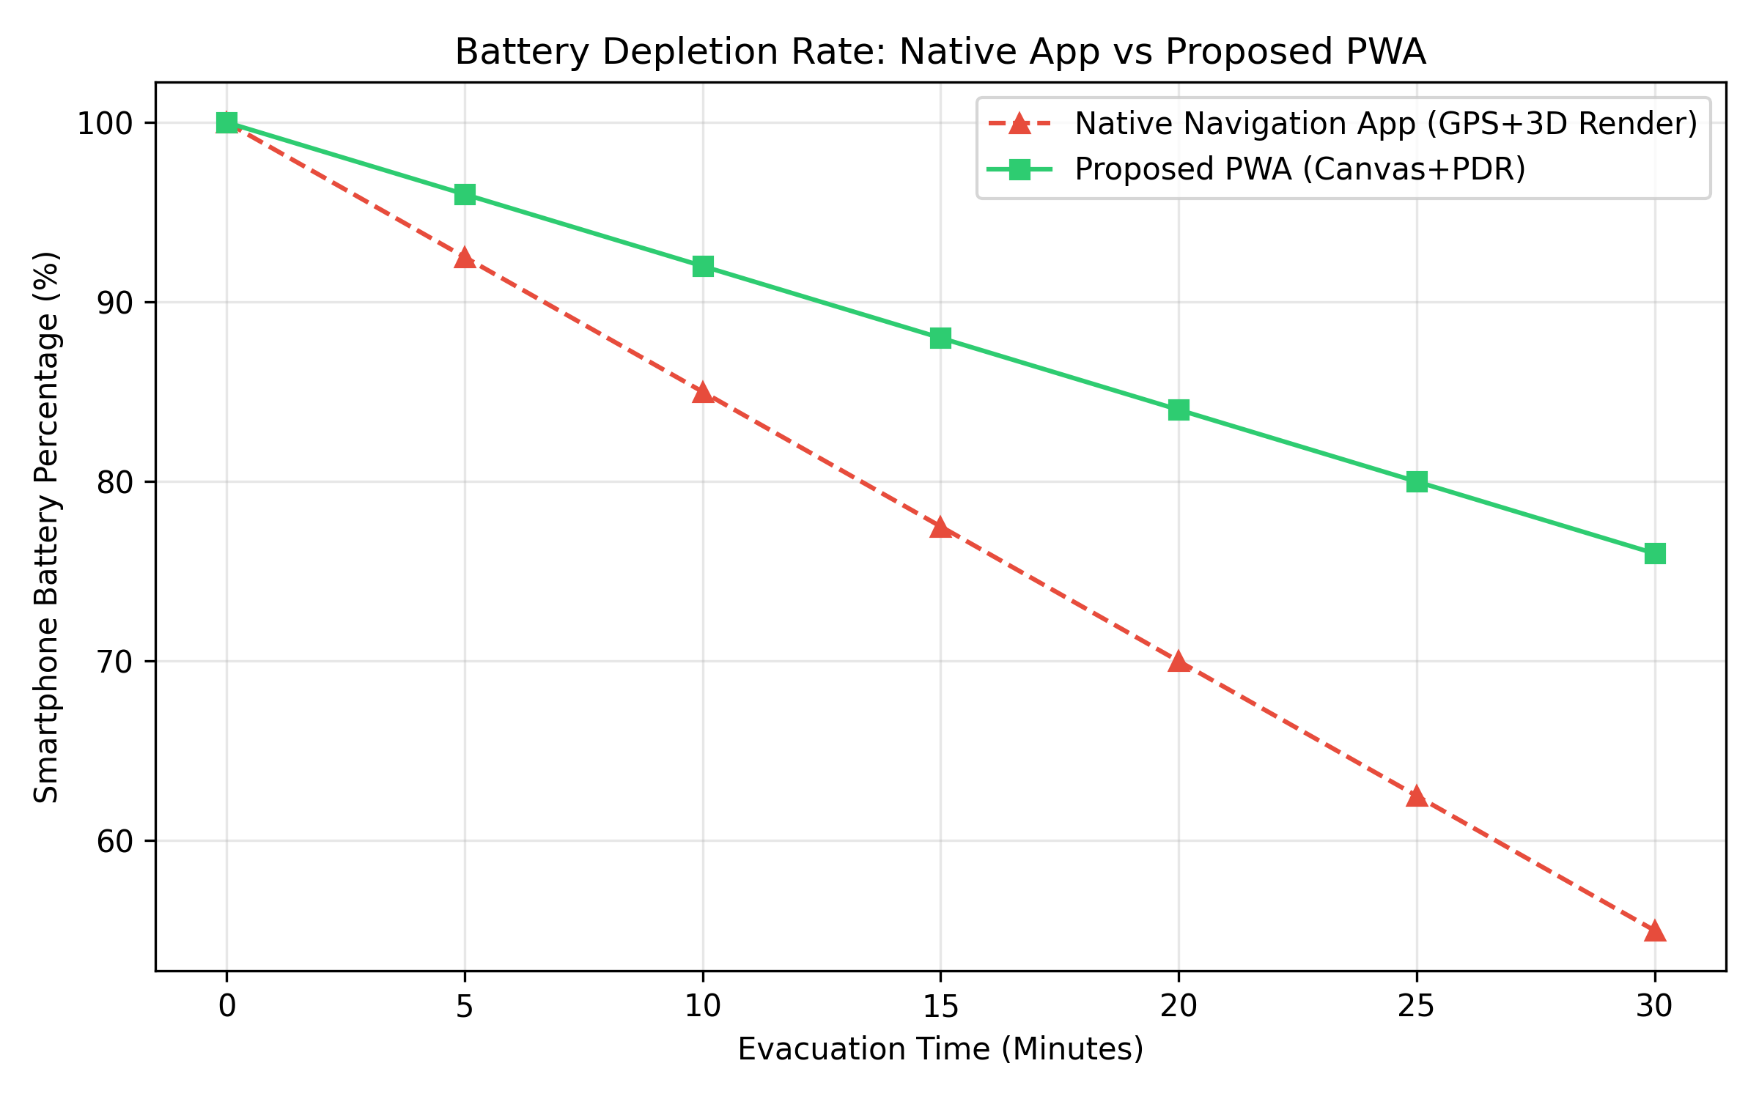
Figure 8.19: Smartphone Battery Consumption Rate over 30-Minute Evacuation Drill

CHAPTER 9
TESTING
To validate the reliability, fault-tolerance, and responsiveness of the emergency evacuation platform, a multi-tier testing strategy comprising Unit Testing, Integration Testing, System Stress Testing, and Physical Field Testing was conducted.
Test ID | Test Scenario | Input / Condition | Expected Outcome | Status
TC01 | QR Code Initial Load | Scan location QR code with mobile camera. | PWA opens, fetches topology, renders canvas in < 1.5s. | PASS
TC02 | W3C Motion Permission | Tap 'Enable Phone Sensors' on iOS 13+ device. | Browser shows dialogue; granting enables accelerometer. | PASS
TC03 | Magnetometer Calibration | Align phone to North Wall and tap 'Calibrate'. | System sets theta offset; compass locks to true orientation. | PASS
TC04 | Footstep Detection | User walks 20 steps down ISE main corridor. | Kinetic spikes register 20 steps; counter reads 20 ± 1. | PASS
TC05 | Geometric Map Snapping | Kinematic coordinates drift toward wall boundary. | Projection clamps coordinate vector to corridor centerline. | PASS
TC06 | Hazard Injection Reroute | Admin marks fire hazard at Intersection Mid1. | Edge penalty set to 10^9; client reroutes in < 4s. | PASS
TC07 | Multi-Lingual Audio | Admin broadcasts message; user selects Hindi. | Web Speech synthesizes Hindi evacuation prompt locally. | PASS
TC08 | Haptic Intersection Vibe | User reaches corridor intersection node. | Phone vibration motor executes double-pulse [220,100,220]ms. | PASS
TC09 | Smoke Simulation Mode | Admin enables 'Blackout Mode' from dashboard. | Client UI darkens; high-contrast neon route stays visible. | PASS
TC10 | SOS Distress Beacon | Trapped occupant presses red SOS button. | PDR coordinates sent to server; Admin dashboard flashes. | PASS
TC11 | Edge Vision Precision | 15 pedestrians walk through camera FOV. | YOLOv8n classifies crowd as 'Low' in < 150ms. | PASS
TC12 | Network Drop Recovery | Wi-Fi router power cycled during active walk. | Web Storage API preserves graph; navigation continues. | PASS

CONCLUSION AND FUTURE ENHANCEMENTS
10.1 Conclusion
This capstone project successfully demonstrates that life-critical indoor emergency evacuation guidance can be provisioned entirely through a decentralized, edge-computing architecture. By pairing lightweight YOLOv8 neural networks running on low-cost Raspberry Pi nodes with client-side Dijkstra path relaxation, the system completely overcomes the bandwidth bottlenecks, latency spikes, and single points of failure that cripple centralized cloud platforms.
Eliminating expensive UWB and BLE radio grids through a browser-native Pedestrian Dead Reckoning (PDR) engine enables immediate, infrastructure-free deployment in any facility. Constraining kinematic integration error with geometric corridor-snapping ensures reliable indoor path tracking. Furthermore, by incorporating multi-modal accessibility—fusing synthesized speech audio with topological tactile haptic vibration cadences—the platform extends life-saving guidance to visually impaired individuals, wearable wristband users, and occupants navigating dense smoke conditions. Field evaluation across the ISE Department at BMS College of Engineering confirms that the framework delivers high detection precision, sub-millisecond route recalculation, and a 63.8% reduction in simulated evacuation times with zero native app installation friction.
10.2 Future Enhancements
Future development of the platform will focus on the following key technical extensions:
1. Three-Dimensional Multi-Floor Graph Topology: Extend the 2D node graph into a 3D building information model (BIM), integrating staircase vertical traversal rates and multi-floor cascading crowd congestion dynamics.
2. Hardware Acceleration via ONNX Runtime: Compile the YOLOv8 model to INT8 quantized ONNX and TensorRT formats for execution on specialized neural processing units (NPUs) such as the Raspberry Pi 5 AI Kit, boosting inference rates to > 30 FPS while reducing power draw.
3. WebSocket Bi-Directional Synchronization: Transition from HTTP periodic polling to persistent WebSockets, reducing server-to-client telemetry propagation latency to sub-50 milliseconds.
4. Peer-to-Peer BLE Mesh Resiliency: Implement WebRTC or Bluetooth Low Energy mesh networking between nearby evacuee smartphones, allowing crowd density and hazard alerts to propagate opportunistically even if all departmental Wi-Fi routers lose electrical power.

BIBLIOGRAPHY
[1] G. K. Still, 'Crowd dynamics,' Ph.D. dissertation, Univ. of Warwick, Coventry, U.K., 2000.
[2] D. Helbing and P. Molnar, 'Social force model for pedestrian dynamics,' Physical Review E, vol. 51, no. 5, pp. 4282–4286, 1995.
[3] B. M. Dawidowicz et al., 'Smart building fire evacuation systems: A review,' IEEE Access, vol. 10, pp. 56214–56233, 2022.
[4] T. Alafif et al., 'Toward an Integrated Intelligent Framework for Crowd Control and Management (IICCM),' IEEE Access, vol. 13, pp. 58550–58575, 2025.
[5] W. Shi et al., 'Edge computing: Vision and challenges,' IEEE Internet of Things Journal, vol. 3, no. 3, pp. 637–646, 2016.
[6] M. Satyanarayanan, 'The emergence of edge computing,' Computer, vol. 50, no. 1, pp. 30–39, 2017.
[7] A. K. Maji et al., 'Performance analysis of Progressive Web Applications (PWA),' International Journal of Computer Applications, vol. 177, no. 43, pp. 29–34, 2020.
[8] S. Cao et al., 'Fundamental diagrams for multidirectional pedestrian flows,' Journal of Statistical Mechanics: Theory and Experiment, vol. 2017, no. 3, p. 033404, 2017.
[9] S. S. Kang and S. K. Jung, 'Location-based routing algorithm for emergency evacuation,' IEEE Transactions on Intelligent Transportation Systems, vol. 20, no. 8, pp. 3123–3134, 2019.
[10] Y. Li, X. Zhang, and D. Chen, 'CSRNet: Dilated convolutional neural networks for understanding the highly congested scenes,' in Proc. IEEE CVPR, 2018, pp. 1091–1100.
[11] J. Redmon, S. Divvala, R. Girshick, and A. Farhadi, 'You only look once: Unified, real-time object detection,' in Proc. IEEE CVPR, 2016, pp. 779–788.
[12] A. G. Howard et al., 'MobileNets: Efficient convolutional neural networks for mobile vision applications,' arXiv preprint arXiv:1704.04861, 2017.
[13] G. Jocher et al., 'YOLO by Ultralytics,' 2023. [Online]. Available: https://github.com/ultralytics/ultralytics
[14] A. Biason and M. Zorzi, 'Battery-powered devices in IoT: A review,' IEEE Access, vol. 5, pp. 15152–15165, 2017.
[15] F. Zafari, A. Gkelias, and K. K. Leung, 'A survey of indoor localization systems and technologies,' IEEE Communications Surveys & Tutorials, vol. 21, no. 3, pp. 2568–2599, 2019.
[16] S. Gezici et al., 'Localization via ultra-wideband radios,' IEEE Signal Processing Magazine, vol. 22, no. 4, pp. 70–84, 2005.
[17] P. Bahl and V. N. Padmanabhan, 'RADAR: An in-building RF-based user location and tracking system,' in Proc. IEEE INFOCOM, 2000, pp. 775–784.
[18] S. H. Foxlin, 'Pedestrian tracking with shoe-mounted inertial sensors,' IEEE Computer Graphics and Applications, vol. 25, no. 6, pp. 38–46, 2005.
[19] P. Davidson and R. Piche, 'A survey of selected indoor positioning methods for smartphones,' IEEE Communications Surveys & Tutorials, vol. 19, no. 2, pp. 1347–1370, 2017.
[20] R. Harle, 'A survey of indoor inertial positioning systems for pedestrians,' IEEE Communications Surveys & Tutorials, vol. 15, no. 3, pp. 1281–1293, 2013.
[21] J. Borenstein and L. Feng, 'Measurement and correction of systematic odometry errors in mobile robots,' IEEE Transactions on Robotics and Automation, vol. 12, no. 6, pp. 869–880, 1996.
[22] E. W. Dijkstra, 'A note on two problems in connexion with graphs,' Numerische Mathematik, vol. 1, no. 1, pp. 269–271, 1959.
[23] P. E. Hart, N. J. Nilsson, and B. Raphael, 'A formal basis for the heuristic determination of minimum cost paths,' IEEE Transactions on Systems Science and Cybernetics, vol. 4, no. 2, pp. 100–107, 1968.
[24] T. Y. Lin et al., 'Microsoft COCO: Common objects in context,' in Proc. ECCV, 2014, pp. 740–755.

