# A Patient-Controlled Medical Records Platform

Traditionally, medical records are stored in centralized databases controlled by healthcare providers, which can make it difficult for patients to access and manage their own health information. This can also create security concerns, as large, centralized databases can be targets for hackers.

By leveraging the Cosmos blockchain, a patient-controlled medical records platform could be created that allows patients to securely store and manage their own health information. This information could be accessed by healthcare providers only with the patient's explicit permission, giving patients greater control over their healthcare data.

**Project Overview**

The healthcare industry is facing numerous challenges, including data privacy and security issues, interoperability problems, and lack of patient control over their medical records. These challenges can negatively impact patient outcomes, increase costs, and compromise the overall quality of healthcare.

To address these challenges, our team is developing a decentralized application on the Cosmos blockchain that enables patients to control and share their medical records securely and efficiently. Our application will provide patients with a secure and user-friendly platform to manage their health data, while also ensuring that healthcare providers have access to the most up-to-date and accurate medical records.

Our project aims to leverage the advantages of Cosmos blockchain, including its interoperability, scalability, and security features, to provide patients and healthcare providers with a seamless and efficient healthcare experience.

The ultimate goal of our project is to improve the quality of healthcare by empowering patients to take control of their health data and share it with healthcare providers securely and efficiently.

# Project Goals

1. Develop a patient-centered decentralized Electronic Health Record(EHR) system that allows patients to maintain full ownership and control of their health data.
2. Create a secure and transparent system for sharing health data with healthcare providers and researchers as needed.
3. Implement a decentralized system that ensures data privacy, security, and interoperability across different healthcare providers and systems.
4. Utilize the Cosmos blockchain to achieve scalability, performance, and interoperability.
5. Develop a working prototype of the decentralized EHR system and present a use case demonstration.

# Process Diagram

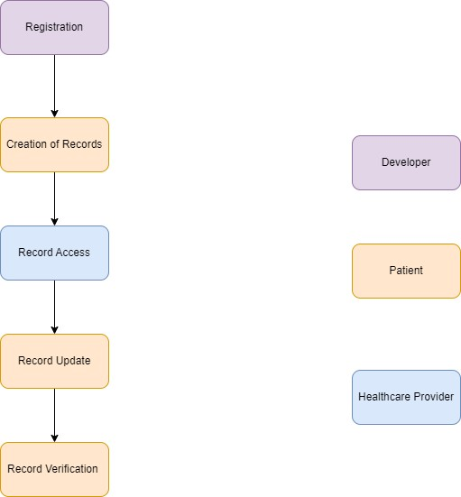

# Features

Patient-controlled medical records: Patients can store and manage their own health information on the blockchain, giving them greater control over their healthcare data. Secure storage: The use of the blockchain provides a secure and tamper-proof way to store medical records, which can help to protect patient privacy and prevent data breaches. Interoperability: The Cosmos blockchain's focus on interoperability between different blockchains can allow for seamless integration with other healthcare systems and blockchains, making it easier for patients to share their health information with different providers and services.

Access control: Patients can grant or revoke access to their medical records to healthcare providers and other authorized parties, helping to ensure that their data is only shared with those who need to see it.

Payment processing: The use of cryptocurrency or other digital assets for payment processing can provide a fast and secure way to pay for healthcare services, without the need for traditional payment methods.

**Benefits**

**Patient empowerment:** By giving patients control over their medical records and data, they can be more actively involved in their healthcare decisions and treatments.

**Improved security:** The use of the blockchain for storing medical records can provide a high level of security and data protection, which can help to prevent data breaches and identity theft.

**Greater efficiency:** The ability to share medical records seamlessly between different healthcare providers and systems can help to improve efficiency and reduce administrative overhead.

**Lower costs:** The use of cryptocurrency or other digital assets for payment processing can provide a cheaper and faster way to pay for healthcare services, without the need for intermediaries or transaction fees.

**Improved healthcare outcomes:** By having access to accurate and up-to-date medical records, healthcare providers can make better-informed decisions and provide more personalized care to their patients.

**Conclusion**

A healthcare application for storing medical records on the Cosmos blockchain has the potential to revolutionize the healthcare industry by providing patients with greater control over their health information and improving data security. By leveraging the interoperability features of the Cosmos blockchain, this application can seamlessly integrate with other healthcare systems and blockchains, making it easier for patients to share their information with different providers and services. With the use of smart contracts and a user-friendly interface, patients can securely store and manage their medical records, while healthcare providers can access this information with the patient's explicit permission. Overall, this application has the potential to significantly improve patient empowerment, data security, and healthcare outcomes.