**Recommendations Decisions to the Business based on my Analyses**

To begin with, I understood the data carefully, and after reviewing the data, I created different graphs. I got various insights from the charts which I will explain in this report. Additionally, I will provide recommendations to the Piscine which will help them to grow their business. Following are the graphs, insights, and recommendations which I got during my analysis.

1. **Sales Trends Over Time:**

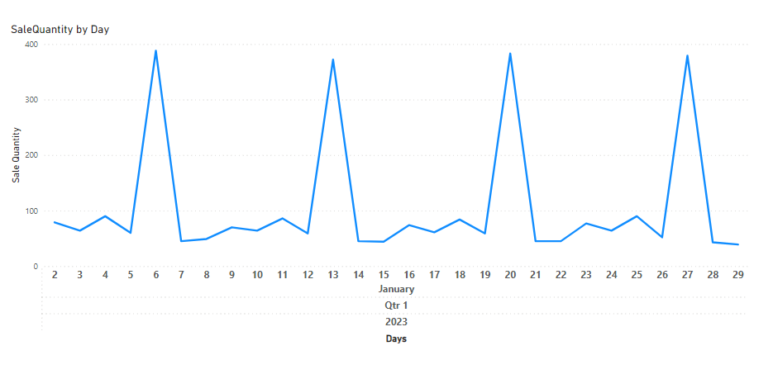

By analyzing sales trends over the time chart, we can identify patterns which Piscine's sales decline significantly over the course of the week. Sundays and Saturdays are the best days for sales, which thereafter decrease throughout the rest of the week. There are several possible reasons for this, including:

**Consumer buying habits:** People usually shop for groceries first thing in the week, and they may purchase fish for a weekend meal.

**Persistence of seafood:** Since fresh seafood spoils more quickly than other proteins, people can be reluctant to purchase it later in the week.  
  
The following recommendations will help Piscine increase sales throughout the course of the week:

* **Run promotions:** To entice customers to buy, think about running specials or discounts on seafood later in the week.
* **Highlight weekend catches:** To create anticipation and promote early sales, publicize their fresh captures early in the week.
* **Provide daily deals:** Make daily specials that highlight various seafood varieties or seafood and other product combos.
* **Emphasize how adaptable seafood is:** Encourage people to think of seafood as a simple, quick dinner choice for any day of the week

1. **Distribution of Seafood Types Sold:**

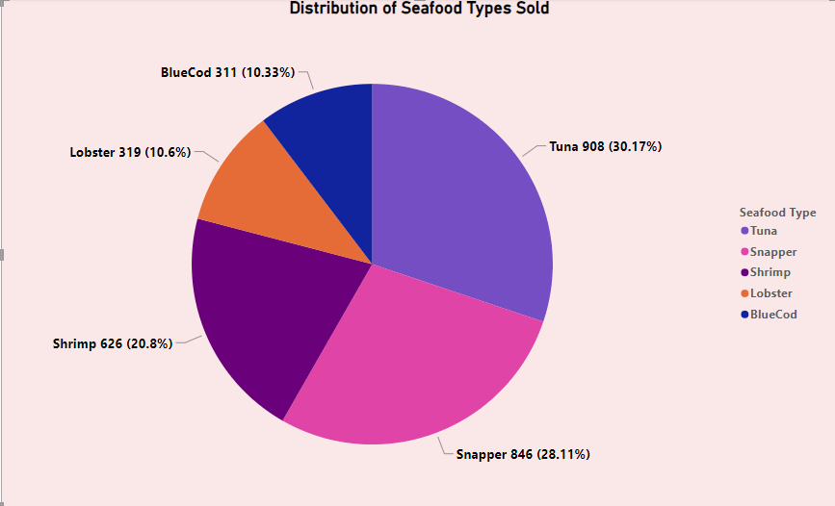

After analyzing the of the pie chart. It is clearly visible that the distribution of seafood types sold by Piscine, with Tuna being the most popular (30.17%) followed by Snapper (28.11%), Shrimp (20.83%), Lobster (10.6%) and BlueCod (10.33%). Here are some recommendations to improve the sales.

* **Concentrate on tuna and snapper to make high money:** The pie chart indicates that, at over 58% of total sales, tuna and snapper are the most popular seafood varieties. Promoting various kinds of seafood and making sure they have an ongoing supply all week long could be the main goals ofPiscine.
* **Keep a range of products available:** Although snapper and tuna are the most popular seafood options, other seafood varieties are also in demand (20.83% for shrimp, 10.6% for lobster, and 10.33 percent for bluefish). A range of items should be maintained by the piscine to accommodate varying consumer tastes.
* **Price Packs:** Put together value packs with complimentary side dishes or sauces that include popular seafood items (such as shrimp and tuna). Customers may be encouraged to try new products and make larger purchases as a result.
* **Targeted promotions:** According to the pie chart, the most popular seafood varieties are tuna (30.17%) and snapper (28.11%), with shrimp (20.80%), lobster (10.60%), and blue cod (10.33%) accounting for lower shares of sales. In order to increase sales of shrimp, lobster, and blue cod, piscine should think about using targeted promotions.

**3)Sales Performance by Quality Grade**

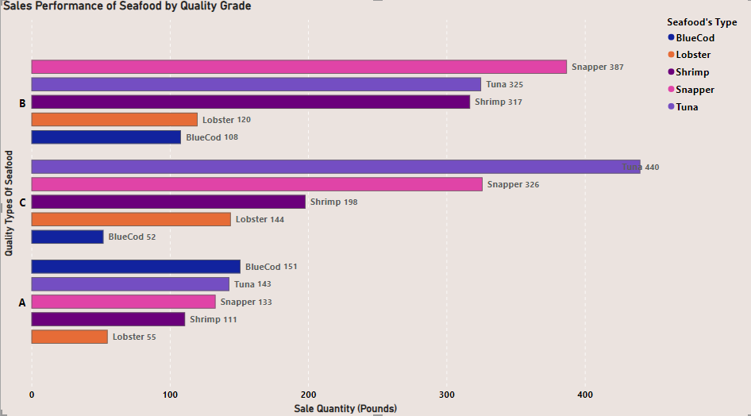

From the above bar chart, we can see that Quality A seafood’s sales are low compared to Quality B and C. Following are some recommendations to improve the sales.

* **Price optimization:** To determine whether there is a chance to improve pricing, and analyze sales data according to quality grade. In our case, there might be potential to lower the price of grade A seafood to make it more competitive if grade C seafood is outselling grade A by a large margin despite grade A being priced more.
* **Grade-specific promotions:** Take into account holding focused campaigns for particular high-quality grades. In our case, Piscine may conduct a deal on grade A seafood to attract people to try it, since grade A seafood has the lowest number of sales.
* **Emphasize quality:** Inform clients about the advantages of buying seafood of a higher caliber as well as the quality grading system. Recipe cards, in-store signs, or staff discussions could all be used to accomplish this.
* **Focus on value:** Draw attention to the benefits that come with each quality tier. consumers seeking a balance between price and quality might want to consider grade-B seafood.
* **Monitor profitability by grade:** It would be helpful to keep tabs on the profitability of every degree of quality. By doing this, Piscine would be able to assess whether its profit margin on all seafood grades is appropriate. For some grades, they could discover that they need to modify their sourcing or pricing strategies.

**4)** **PurchasePrice by Quantity of seafood and Seller**

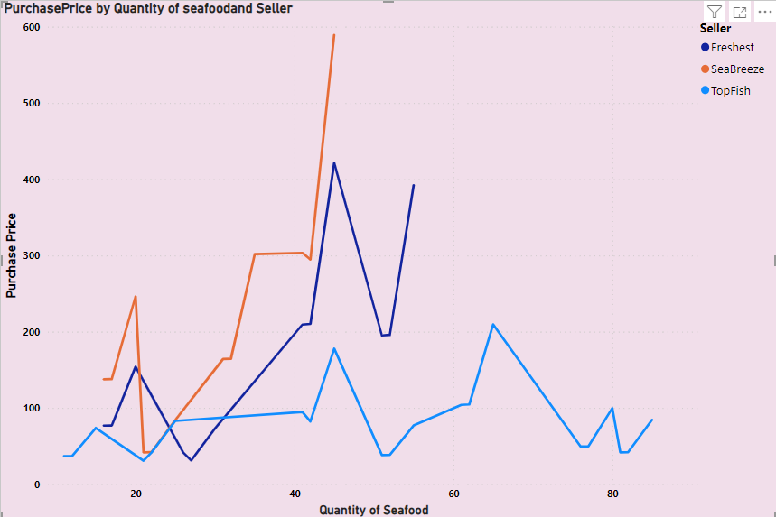

* **Negotiate with SeaBreeze:** Approach SeaBreeze for a better deal, in all quantities, SeaBreeze seems to be the most costly seller. When purchasing bigger quantities of seafood, try negotiating a cheaper price with SeaBreeze.
* **Buy in bulk from TopFish:** TopFish is less expensive to buy than Freshest in every quantity. To receive a cheaper price per unit, think about purchasing in bulk from TopFish.
* **Focus on lower quantities:** The price per unit tends to be higher for lower amounts, as the graph illustrates. To obtain a better deal, try to purchase in more numbers.
* **Investigate Freshest's Offerings:** It's possible that Freshest sells seafood with a greater margin that is of a higher caliber (grade A). In that case, it might make sense to pay a greater price per unit. Piscine want to look at the quality of seafood that each vendor is offering.
* **Compare prices by Seller:** Compare prices from all sellers when purchasing a certain number to make sure you are receiving the most for your money. For instance, SeaBreeze is the least expensive and Freshest is the most expensive when there are 40 in quantity.

**5) Total Revenue by PurchasePrice and Type of seafood**

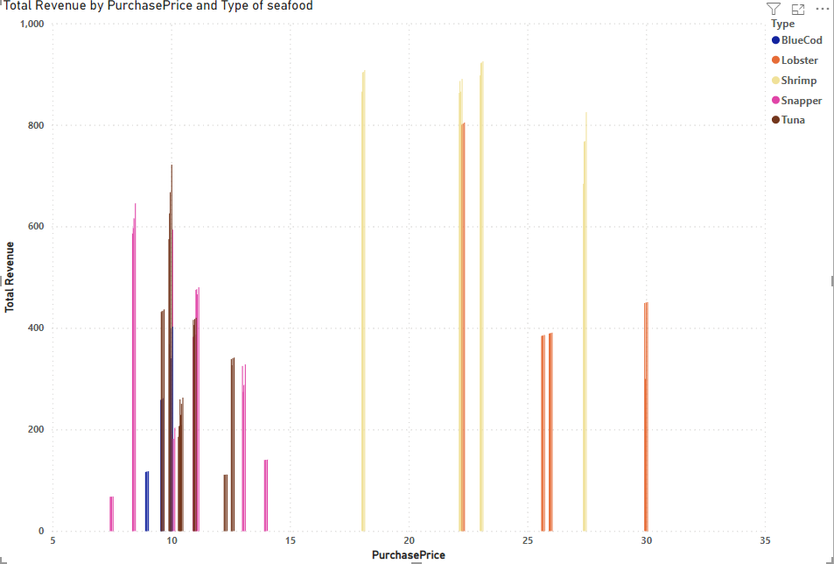

**Focus on Lobster and Shrimp:** According to the graph, among all purchase costs, lobster and shrimp bring in the most money overall. For piscine to make the most money, it should concentrate on buying and selling these kinds of seafood.

**Negotiate with Lobster Sellers:** It looks like Lobster has a significant profit margin because of the wide difference between purchase price and revenue. Approach lobster vendors to discuss how to lower the buying price and boost your profit margin.

**Track weekly trends:** Over time, track overall revenue by seafood type and purchase price. In doing so, Piscine will be better able to recognize patterns and verify which varieties of seafood generate the highest revenue monthly. In view of these changes, Piscine can modify its purchasing strategies.