**ER-Diagram**

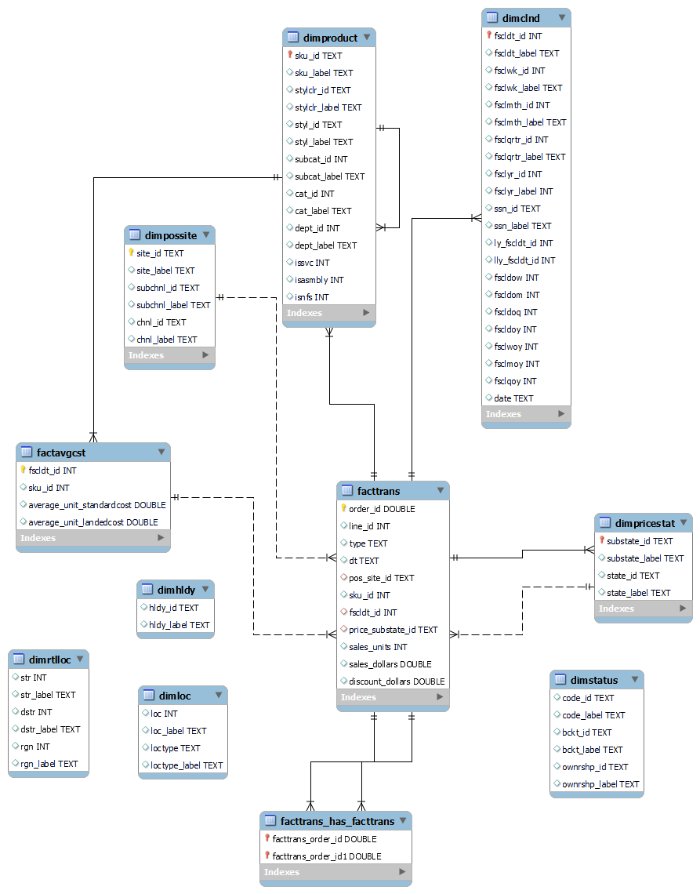

**I have used MySQL Workbench to create the Entity Relationship Diagram.**

**Importance Of ERD:**

**The Entity-Relationship Diagram (ERD) plays a crucial role in the Azure ETL Pipeline project for several reasons:**

1. **Data Modeling: The ERD serves as a blueprint for designing the database schema. It visually represents the entities (tables), attributes, and relationships between them, helping to define the structure of the database.**
2. **Database Design: The ERD guides the database design process by illustrating how data entities are related to each other. It helps in identifying entities, attributes, primary and foreign keys, and cardinalities, which are essential for creating a well-structured database schema.**
3. **Understanding Data Requirements: By studying the ERD, stakeholders can gain insights into the data requirements of the project. They can understand the entities involved, their attributes, and the nature of relationships between them, which aids in clarifying business needs and objectives.**
4. **Normalization: The ERD assists in normalizing the database schema by identifying potential redundancies and anomalies. It helps in organizing data into multiple tables, reducing data duplication, and ensuring data integrity.**
5. **ETL Process: During the ETL process, the ERD guides data extraction, transformation, and loading operations. It helps in mapping source data to destination tables, defining transformation rules, and ensuring data consistency and accuracy throughout the process.**
6. **Data Quality Assurance: The ERD facilitates data quality assurance by defining constraints such as primary key constraints, foreign key constraints, and attribute data types. These constraints help in enforcing data integrity and ensure that only valid and consistent data is stored in the database.**
7. **Documentation and Communication: The ERD serves as documentation for the database schema and data model. It provides a visual representation that can be shared with stakeholders, developers, and other team members to communicate and understand the database structure effectively.**