**Azure ETL PipeLine**

**Steps Involved in the ETL Pipeline Process**

1. **Creating Containers in Blob**
2. **Raw Datasets (assessment)**
3. **Staging Layer (Transformed Staging Data)**

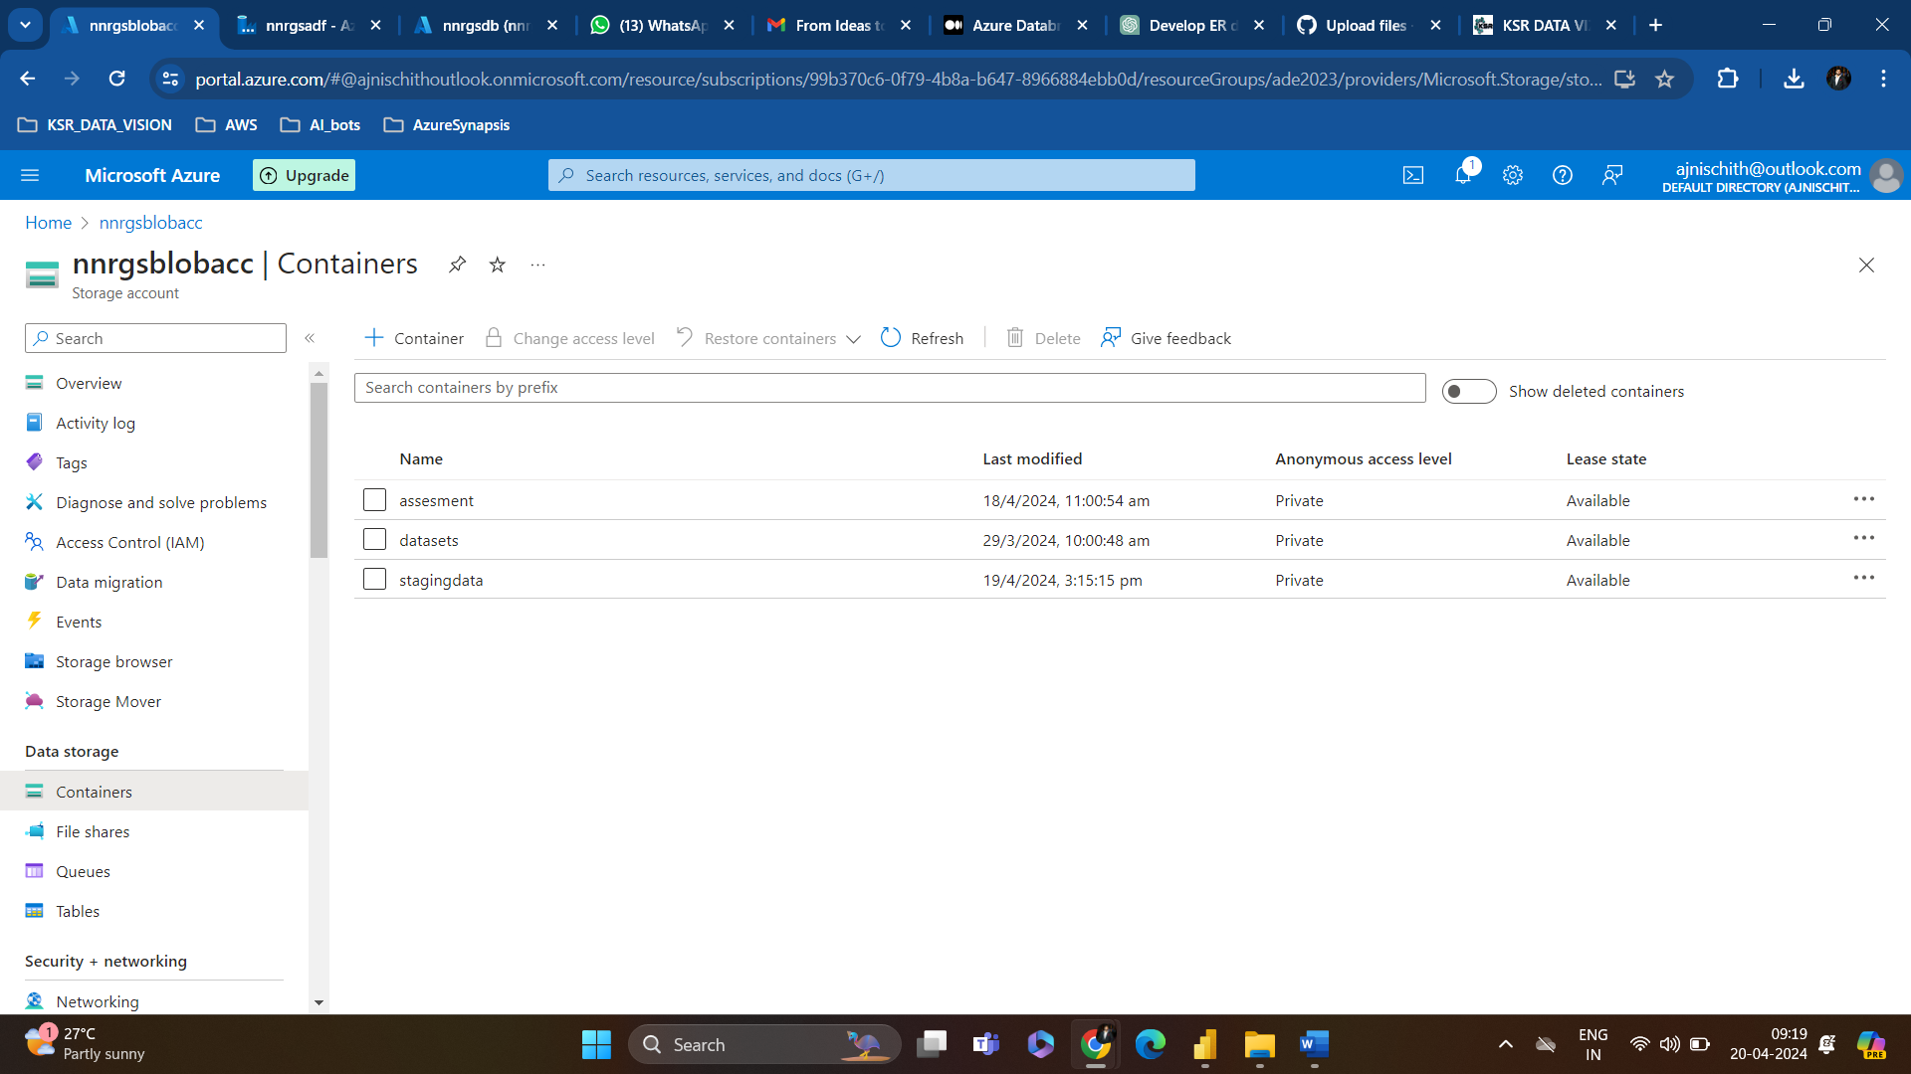

1. **Pulling Data into Azure Data Bricks For Transformation**

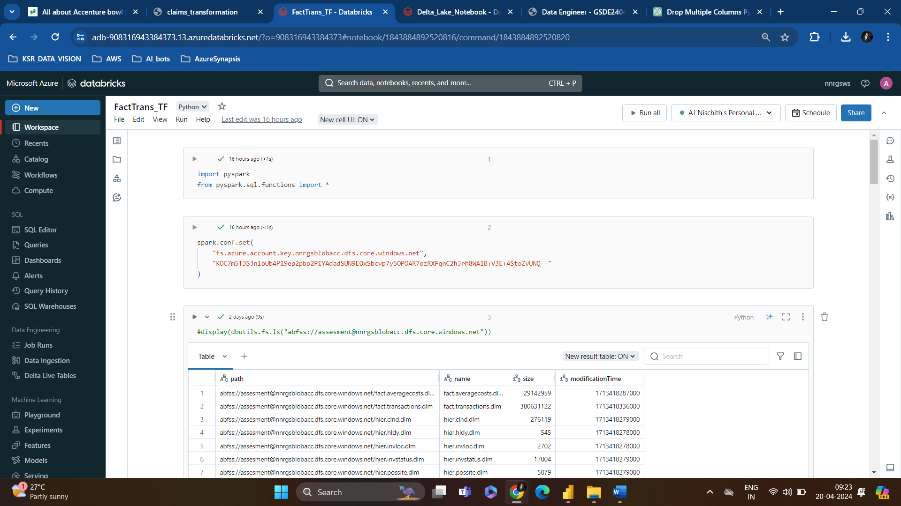

**All the Documents and coding are updated in separate files**

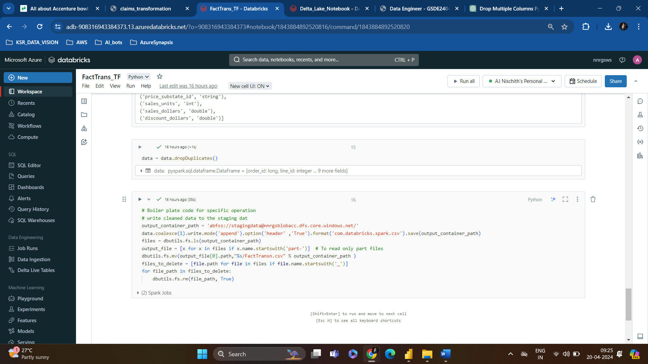

**Flow of transformed data into Staging Layer**

**After testing Each notebook Implementation of Notebooks in ADF pipelines**

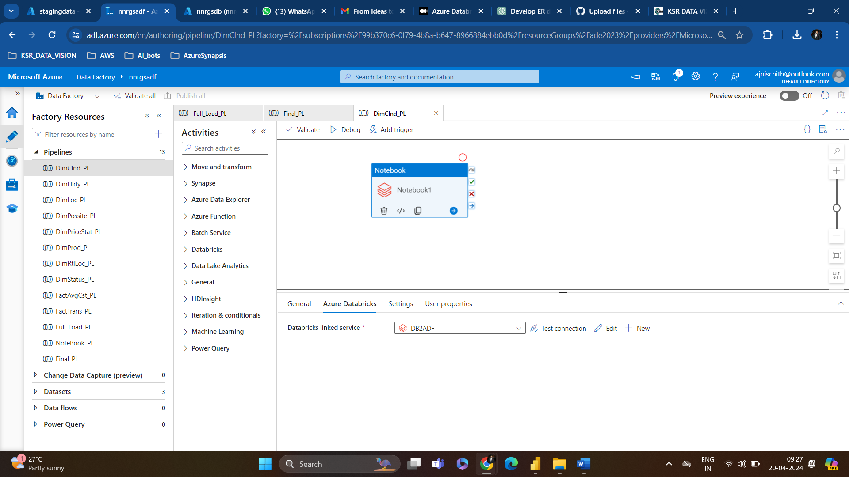

**Create A Pipeline using Execute Pipeline Activity**

1. **Creating a Pipeline for the Execution of All Notebooks**

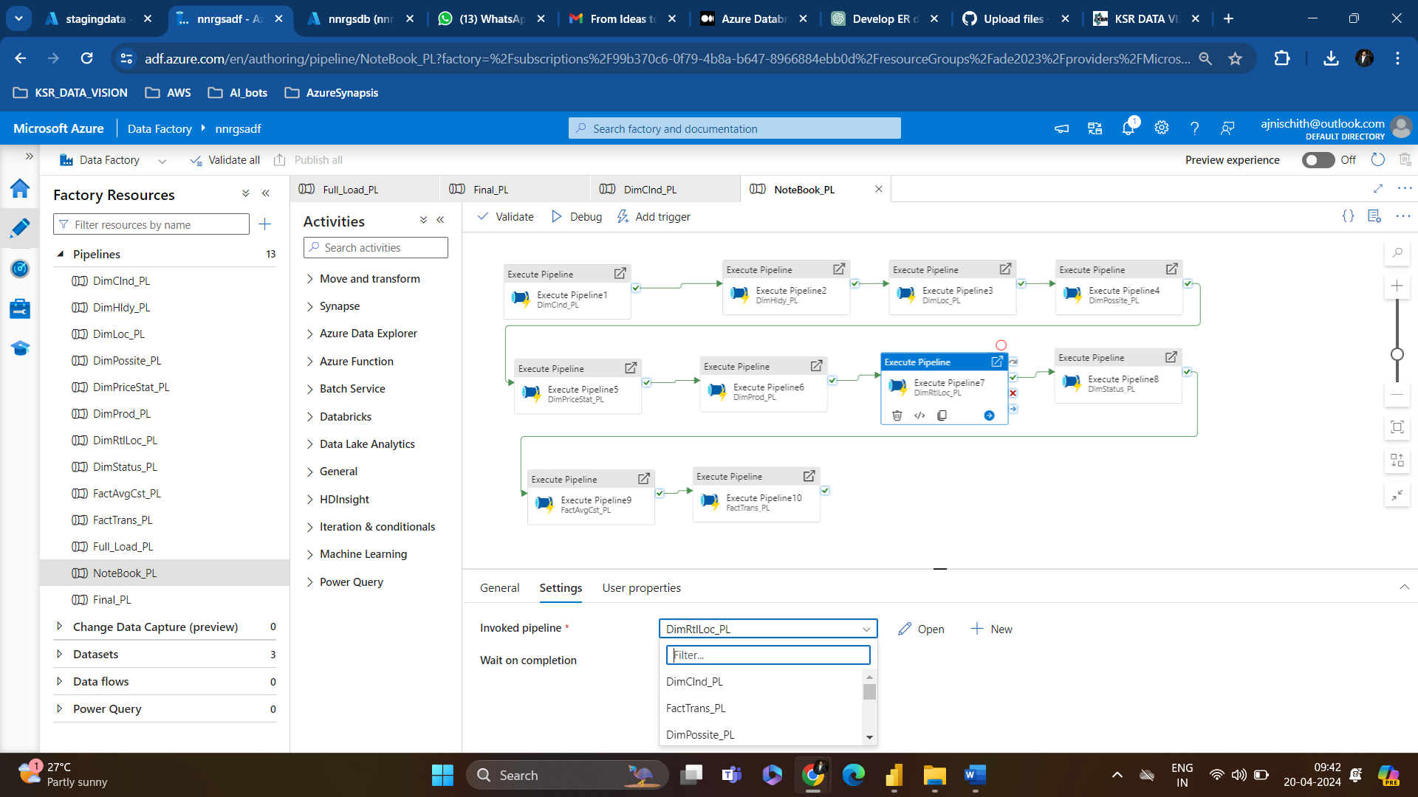

**Once the Staging is Done, Create A copy activity to push data into AZURE SQL Database**

1. **Creating a Pipeline for Moving Staging Data to Target Table**

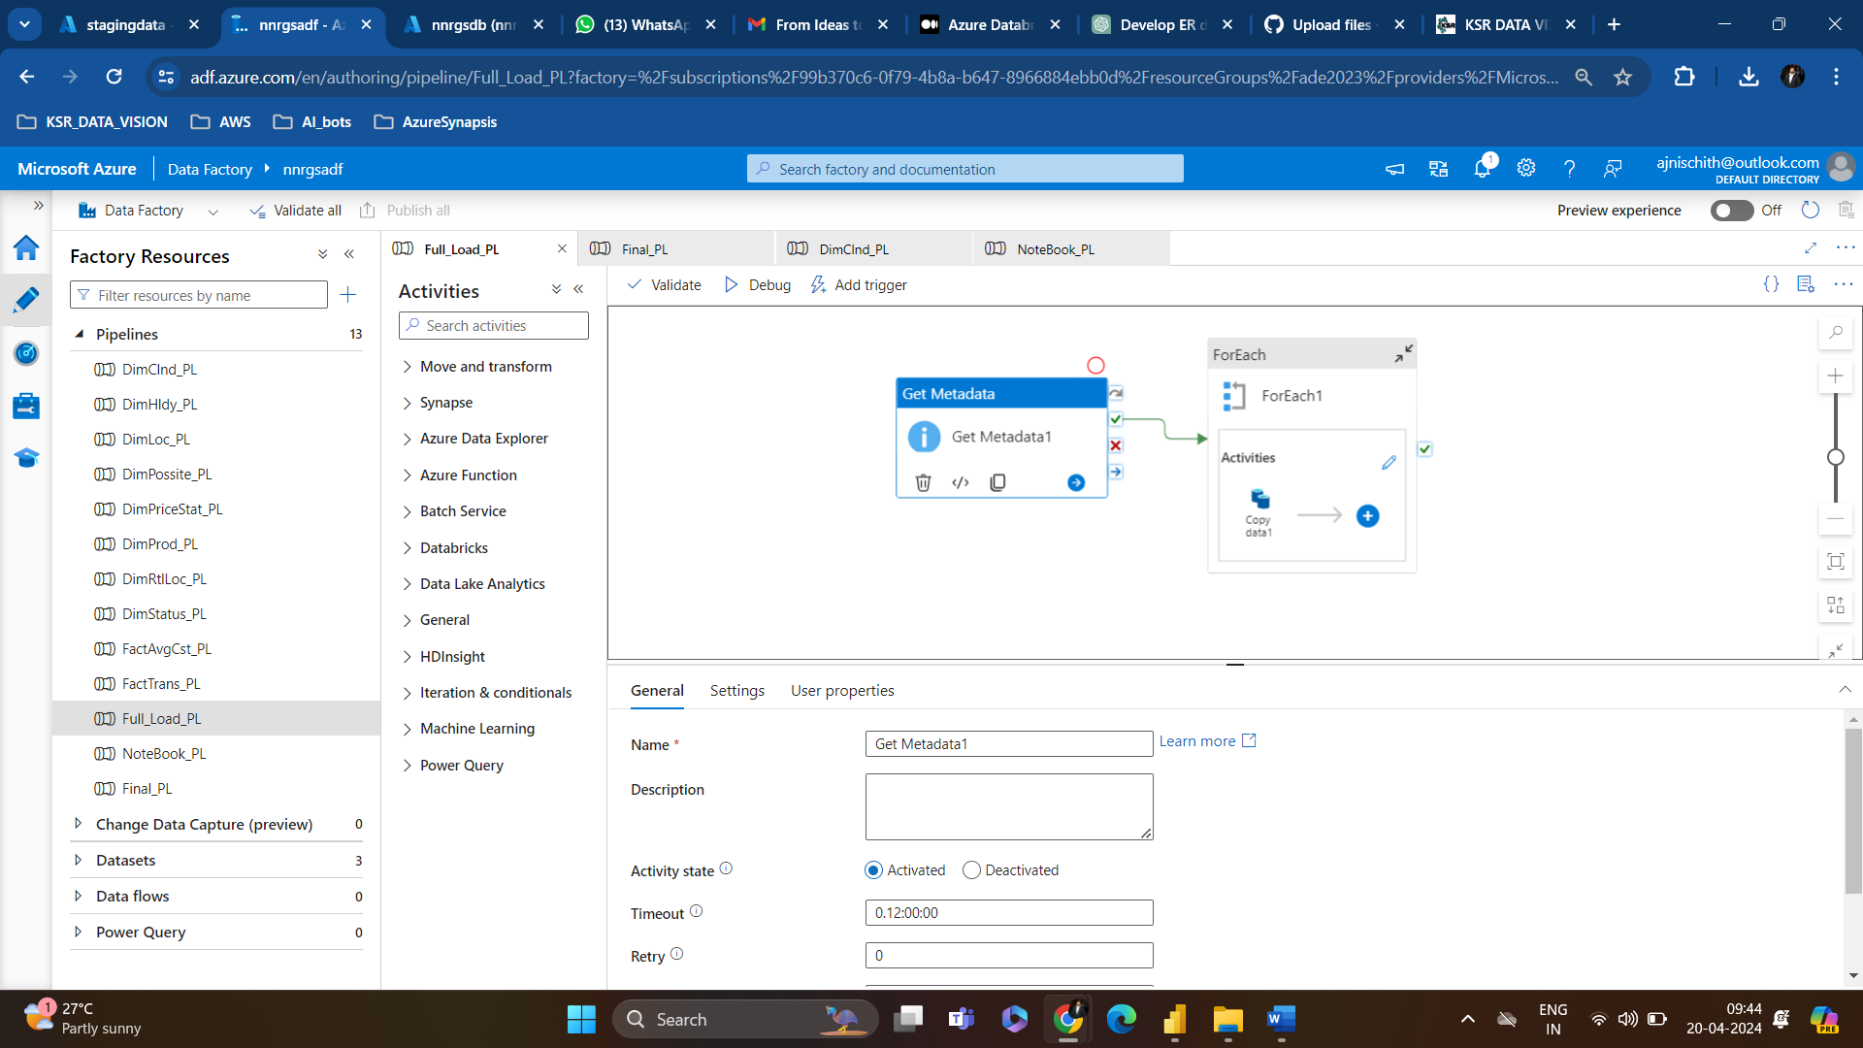

**On Triggering this All the File in the Staging is Moved into the ASQL Database**

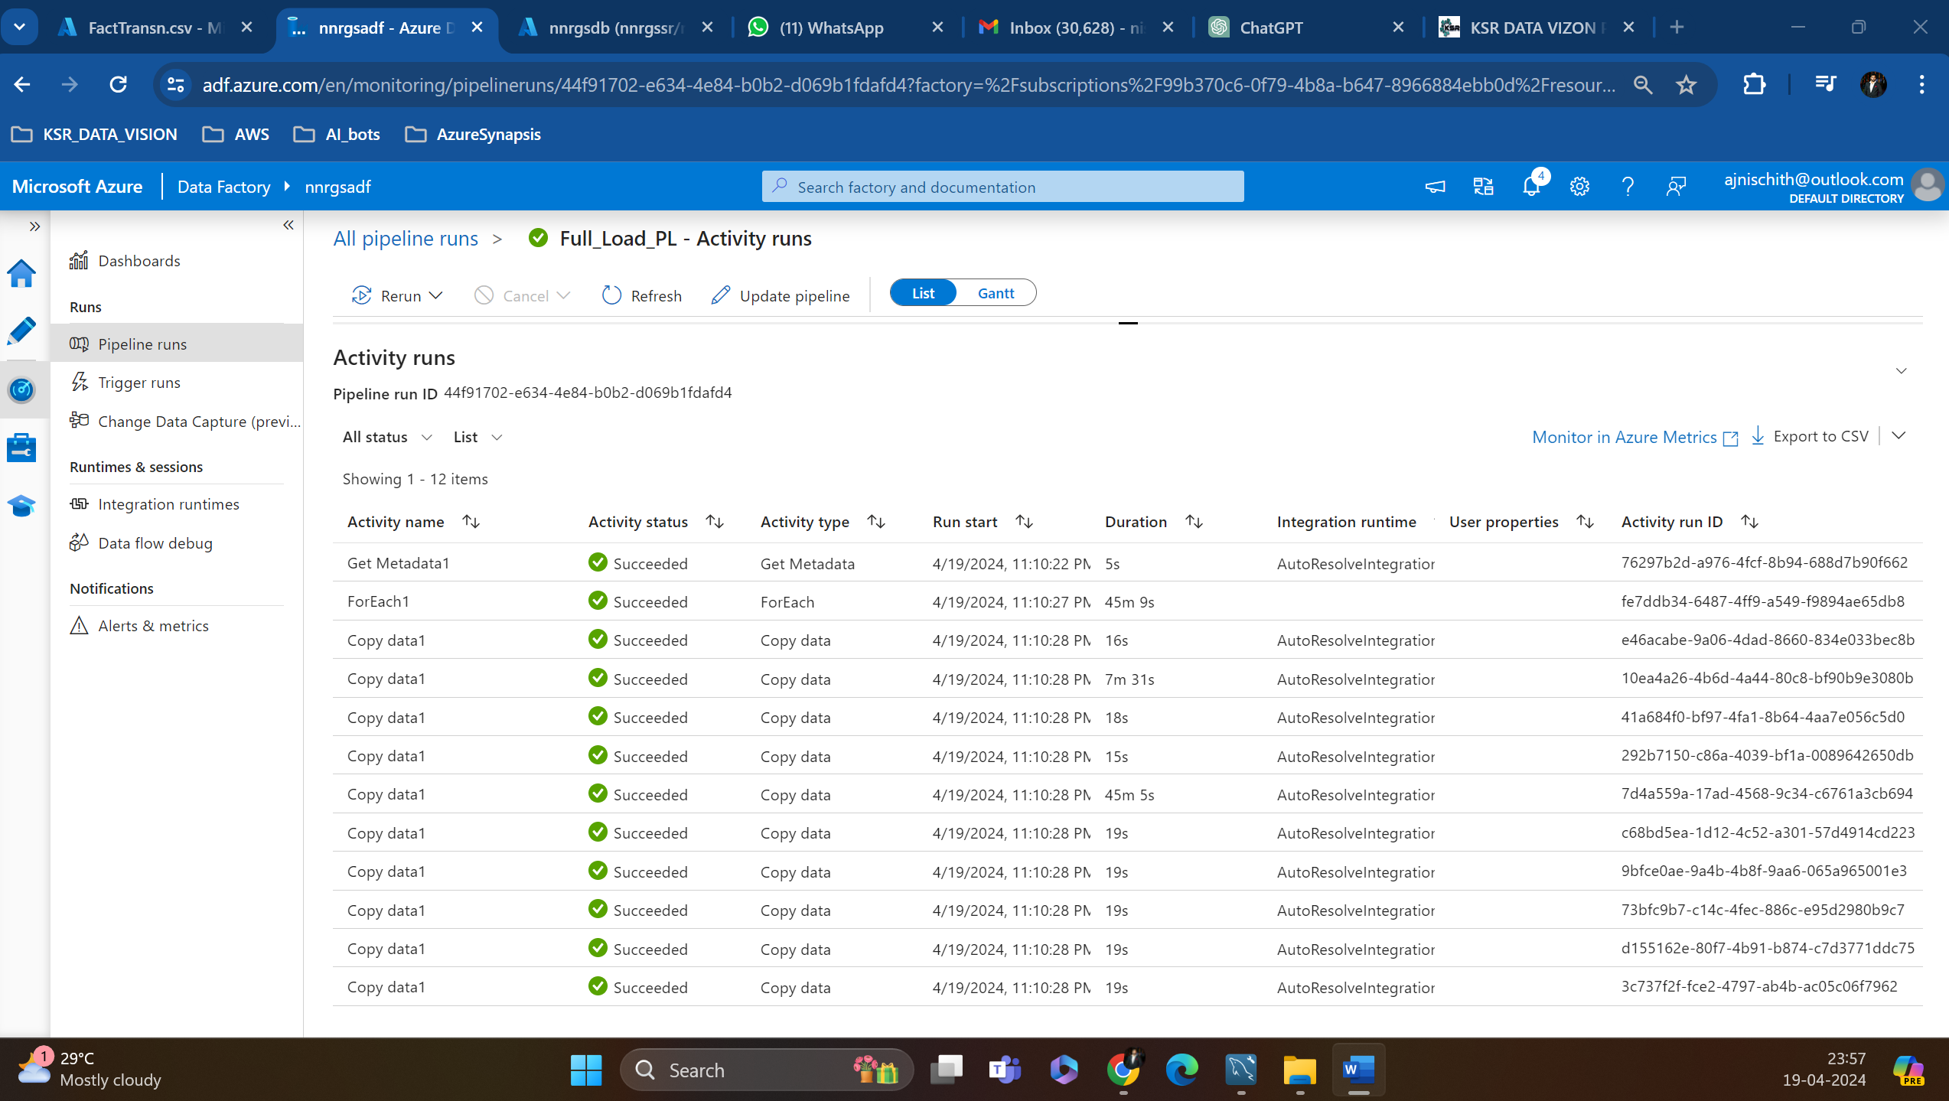

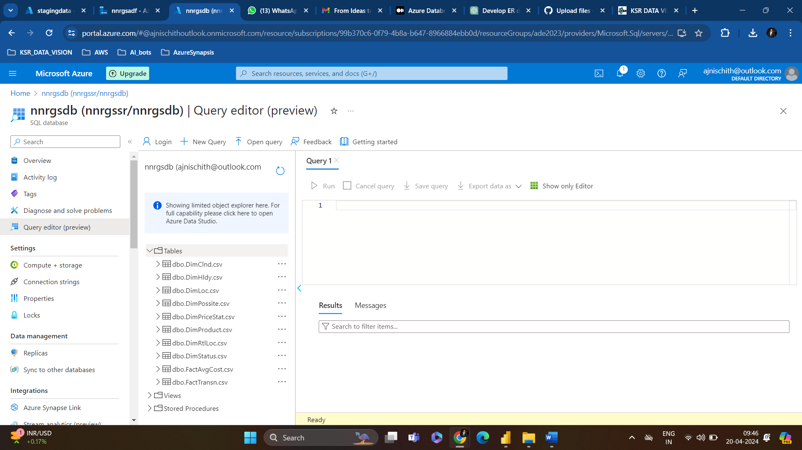**So Now Every Data is Ready for Analytical Purposes or Querying.**

1. **Finally Create a Delta Table in Azure DataBricks for performing Advanced Analytics like ML, AI, etc..**

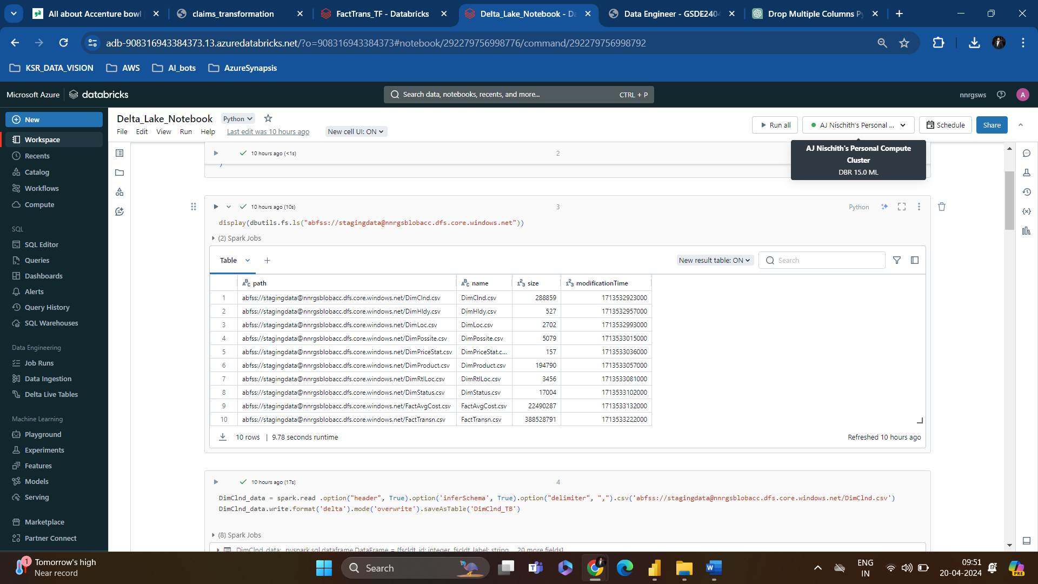

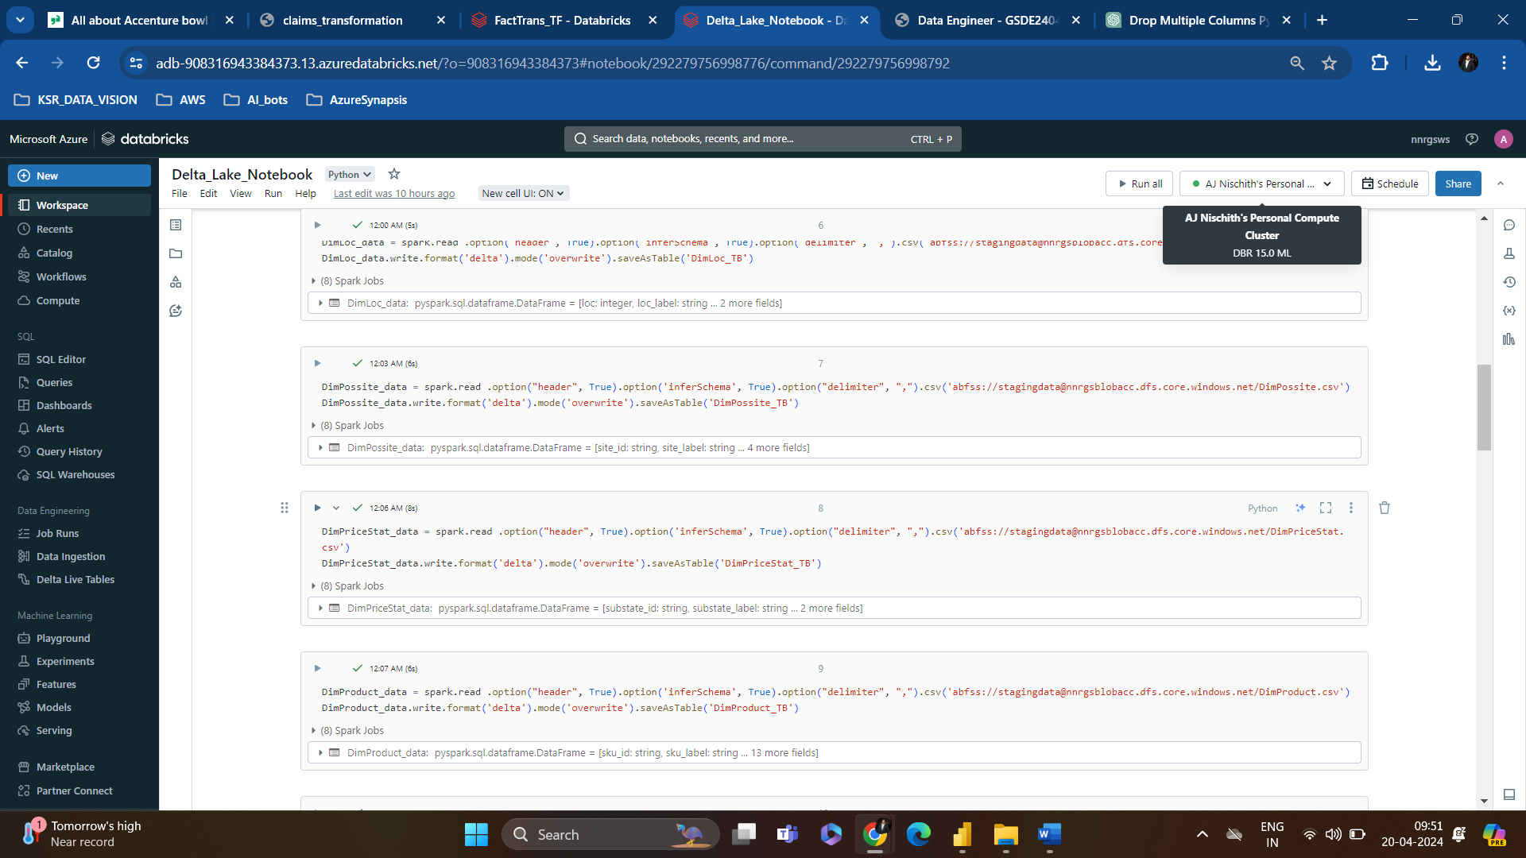

**Now You Can See Delta Tables in the Data Bricks**

