**Assignment 1: Basic SQL**

**Statement: Write the simple SQL queries on the given schema.**

1. **Write the following simple SQL Queries on the University Schema.**

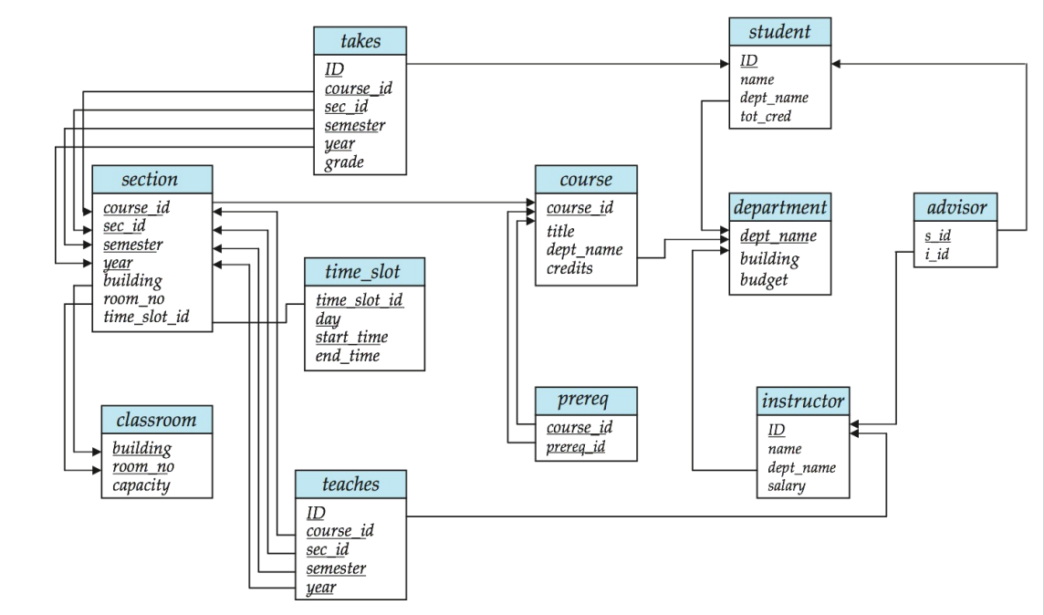

1. **Find the names of all the students whose total credits are greater than 100 .**

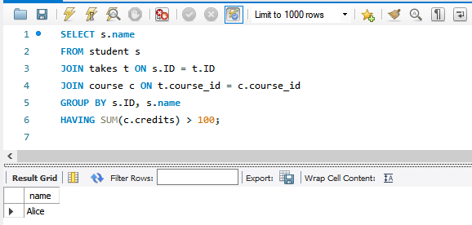

1. **Find the course id and grades of all courses taken by any student named 'Tanaka'.**

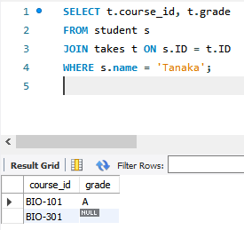

1. **Find the courses which are offered in both 'Fall' and 'Spring' semester (not necessarily in the same year).**

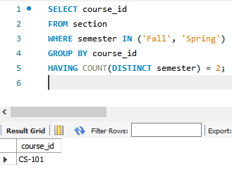

1. **Find the names of all the instructors from Comp. Sci. department.**

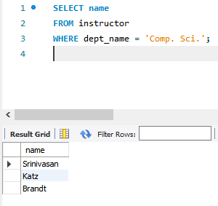

1. **Find the course id and titles of all courses taught by an instructor named 'Srinivasan'**

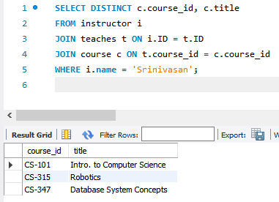

1. **Find the names of instructors who have taught at least one course in Spring 2009.**

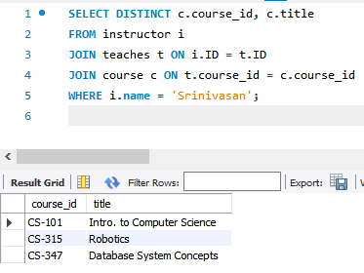

1. **Create the Railway schema using the commands in the [Railway DDL](http://www.it.iitb.ac.in/moodle/pluginfile.php/77066/mod_assign/intro/RailwayDDL.sql)script; The DDL script also contains a description of the railway Schema. Insert sample data using the command in the file  [SampleRailwayData](http://www.it.iitb.ac.in/moodle/pluginfile.php/77066/mod_assign/intro/railwayInsertFile.sql).**

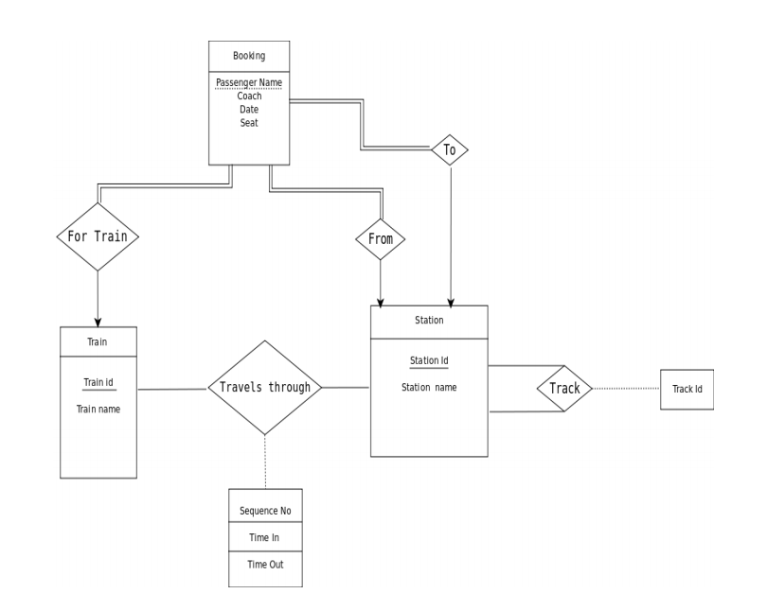

**Write the following Queries for Railway Schema.**

1. **Find pairs of stations (station codes) that have a track (direct connection) with distance less than 20Kms between them.**

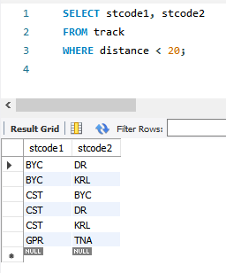

1. **Find the IDs of all the trains which have a stop at THANE**

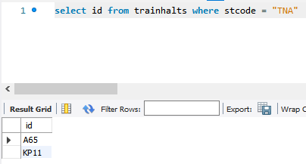

1. **Find the names of all trains that start at MUMBAI.**

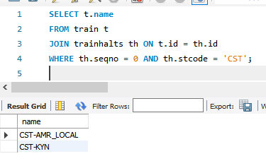

1. **List all the stations in order of visit by the train 'CST-AMR_LOCAL'.**

