Visual Evidence Appendix — All Live Website Pages
iMedX ANZ redesign strategy report | current iMedX, live redesign prototype and RapidCare WHITE
Scope: every redesigned prototype page currently in the build, plus corresponding current iMedX pages where available.
This appendix provides direct visual proof for content migration, page-depth decisions, UX structure, imagery use, visual hierarchy and competitor benchmarking.

Homepage
Actual live browser captures — 25 Sep 2026. Not reconstructed mock-ups.
Current iMedX Australia — Homepage  CURRENT LIVE SITE  https://imedx.com.au/  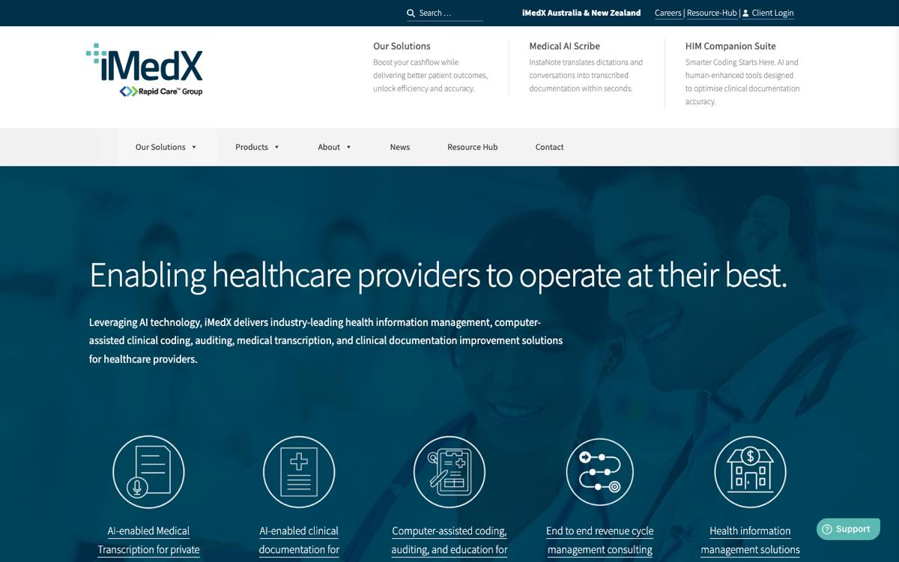 | iMedX ANZ Redesign — Homepage  LIVE PROTOTYPE  https://imedx-anz-redesign.vercel.app/  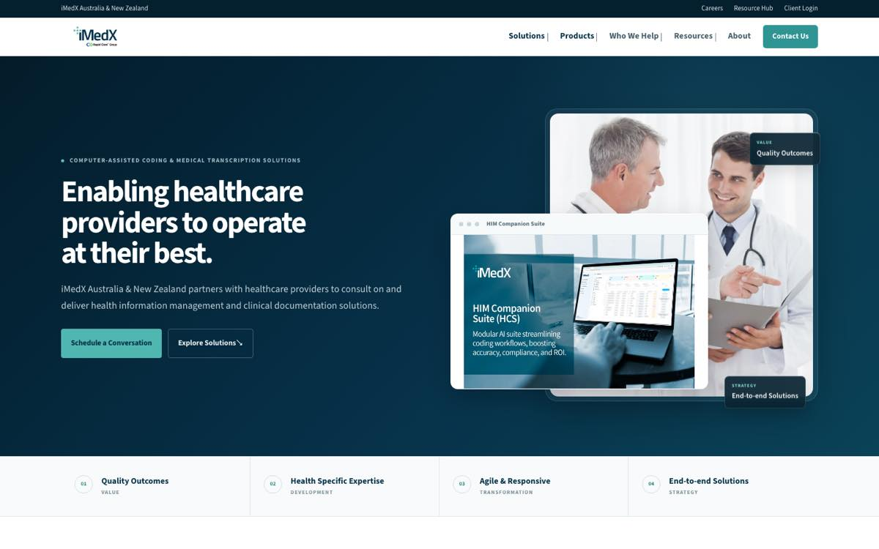

HIM Companion Suite
Actual live browser captures — 25 Sep 2026. Not reconstructed mock-ups.
Current iMedX — Companion Suite  CURRENT LIVE SITE  https://imedx.com.au/products/companion-suite/   | Redesign — HCS  LIVE PROTOTYPE  https://imedx-anz-redesign.vercel.app/hcs.html  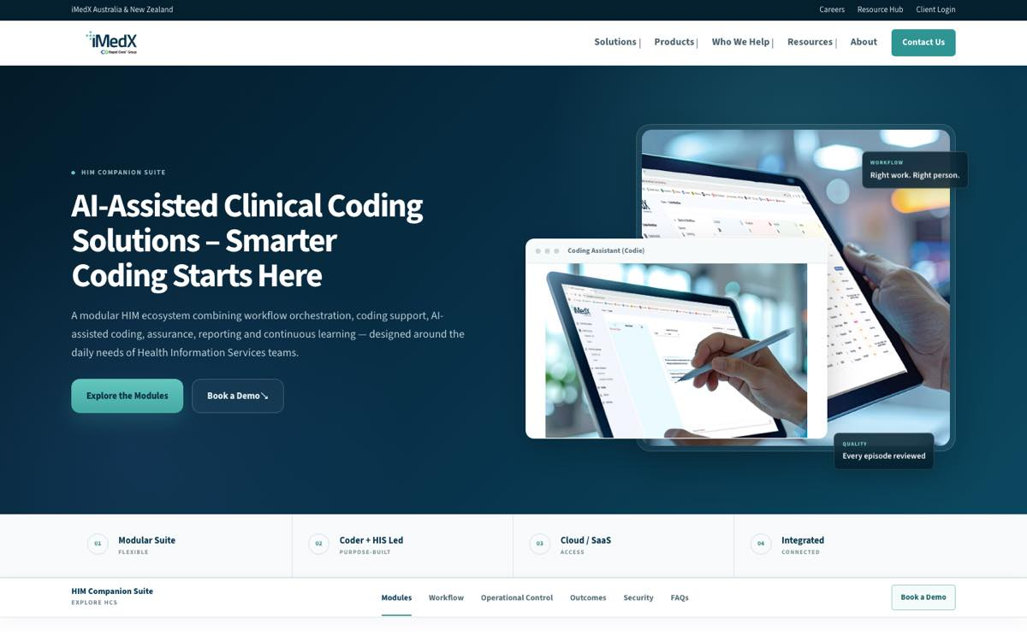

Revenue Cycle Management
Actual live browser captures — 25 Sep 2026. Not reconstructed mock-ups.
Current iMedX — Revenue Cycle Management  CURRENT LIVE SITE  https://imedx.com.au/solutions/revenue-cycle-management/  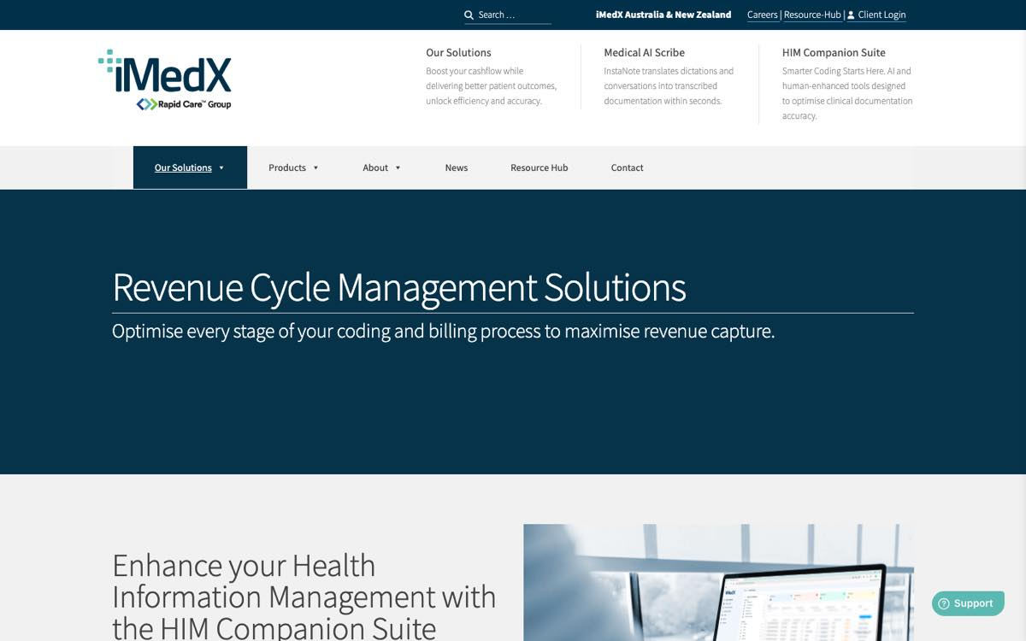 | Redesign — Revenue Cycle Management  LIVE PROTOTYPE  https://imedx-anz-redesign.vercel.app/rcm.html  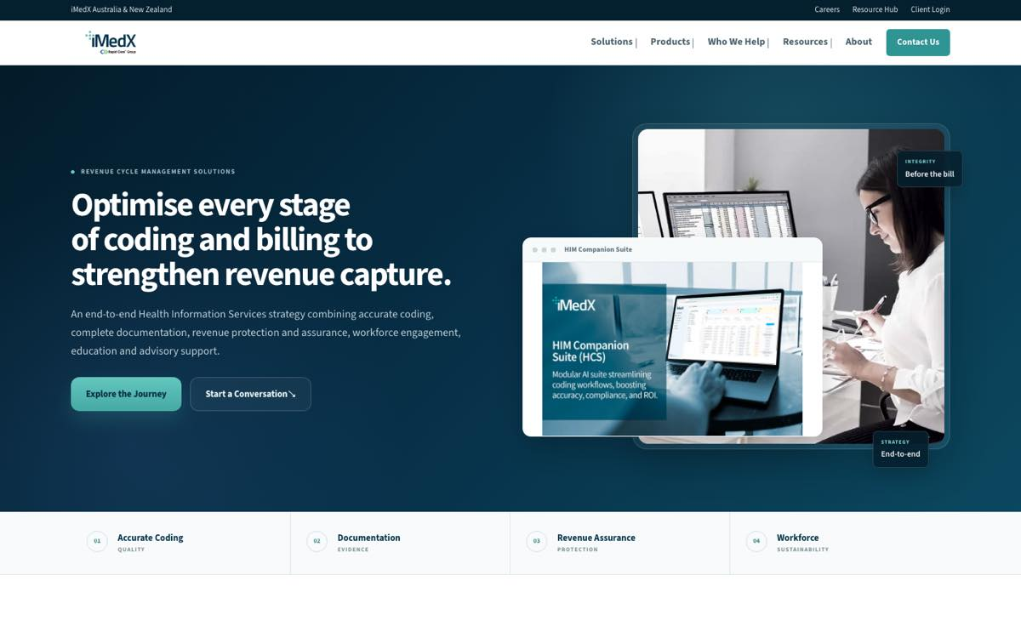

Clinical Documentation
Actual live browser captures — 25 Sep 2026. Not reconstructed mock-ups.
Current iMedX — Clinical Documentation Solutions  CURRENT LIVE SITE  https://imedx.com.au/solutions/clinical-documentation-solutions/   | Redesign — Clinical Documentation  LIVE PROTOTYPE  https://imedx-anz-redesign.vercel.app/clinical-documentation.html  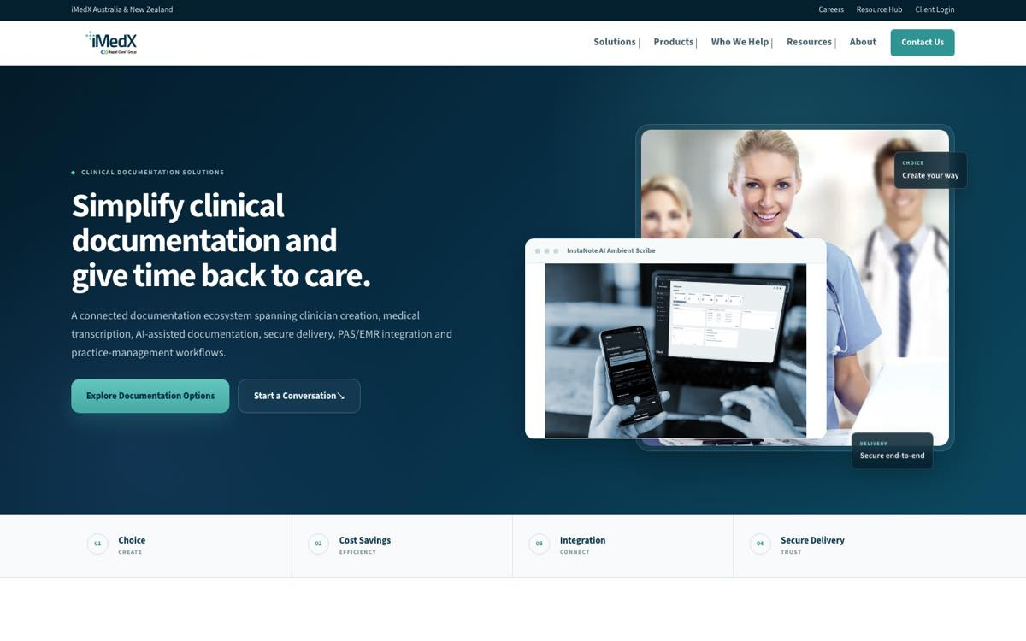

HIM Services
Actual live browser captures — 25 Sep 2026. Not reconstructed mock-ups.
Current iMedX — HIM Services  CURRENT LIVE SITE  https://imedx.com.au/solutions/him-services/  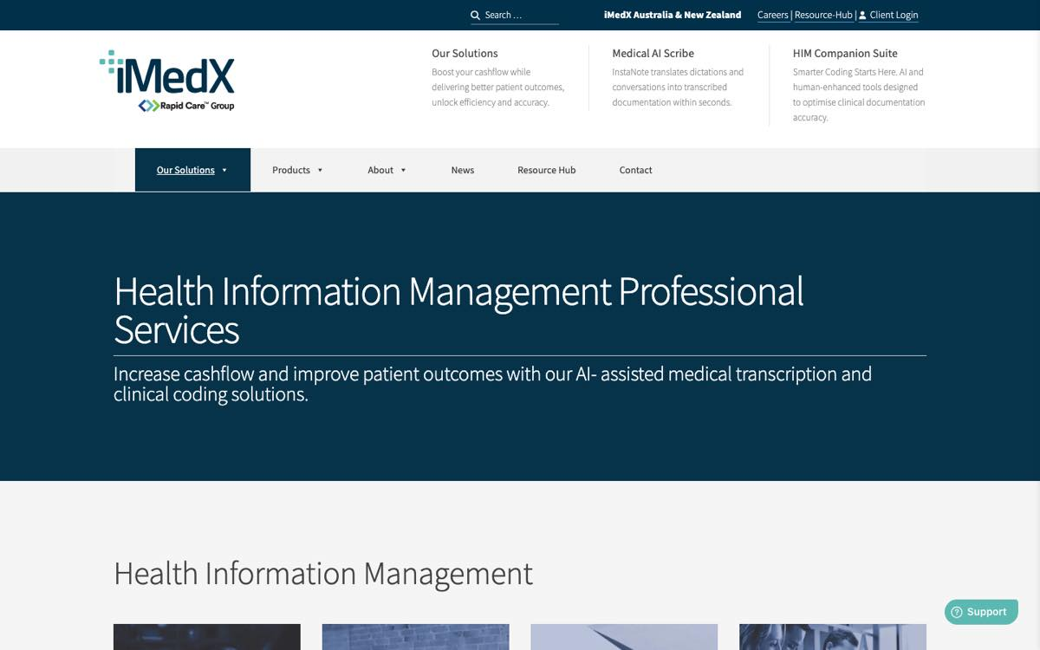 | Redesign — HIM Services  LIVE PROTOTYPE  https://imedx-anz-redesign.vercel.app/him-services.html  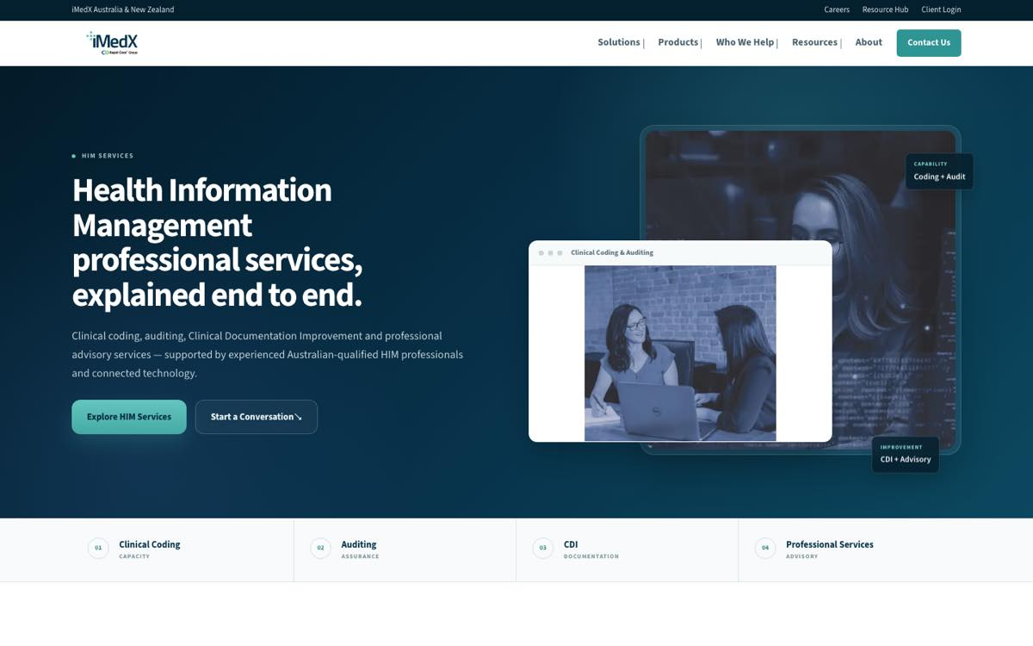

Outsourced Clinical Coding
Actual live browser captures — 25 Sep 2026. Not reconstructed mock-ups.
Current iMedX — Outsourced Clinical Coding  CURRENT LIVE SITE  https://imedx.com.au/solutions/outsourced-clinical-coding/  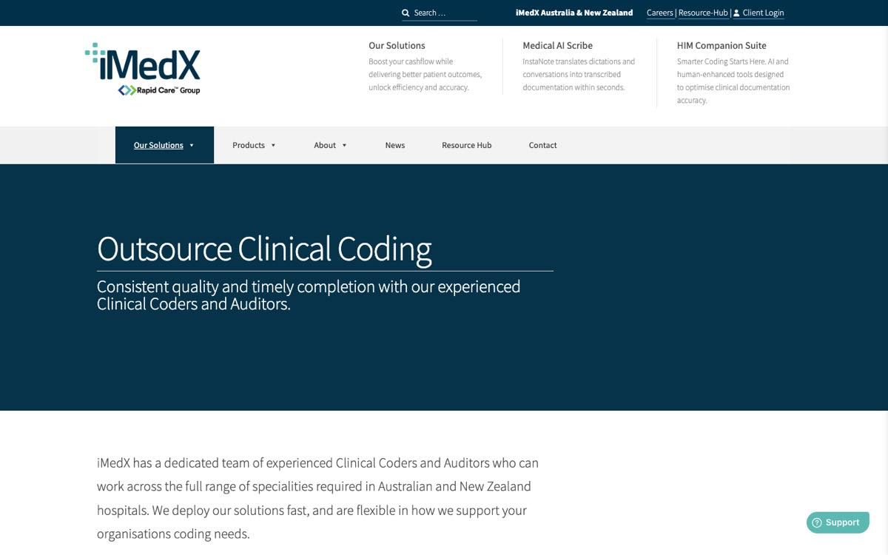 | Redesign — Outsourced Clinical Coding  LIVE PROTOTYPE  https://imedx-anz-redesign.vercel.app/outsourced-clinical-coding.html  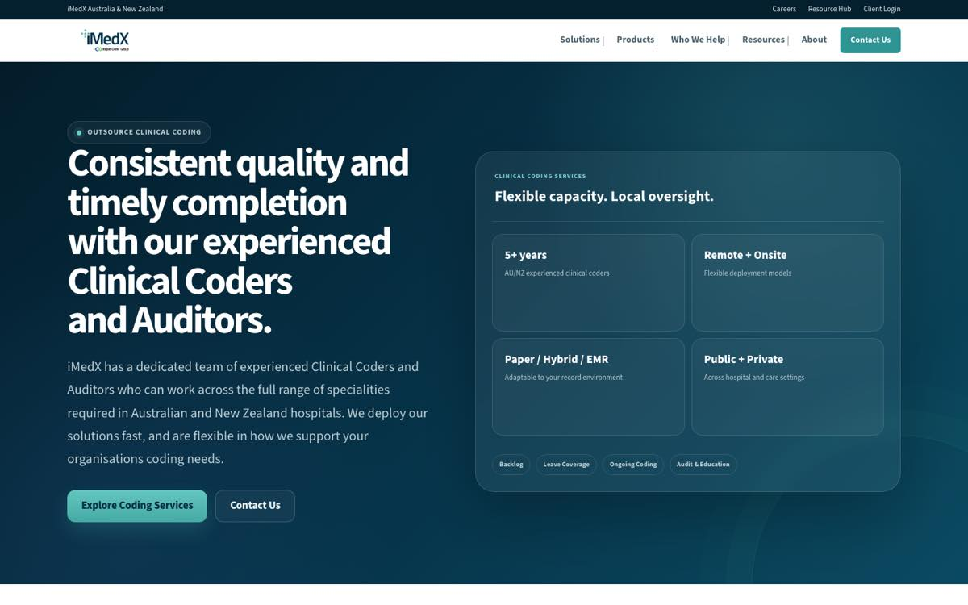

eScription One
Actual live browser captures — 25 Sep 2026. Not reconstructed mock-ups.
Current iMedX — eScription One  CURRENT LIVE SITE  https://imedx.com.au/products/escription-one/  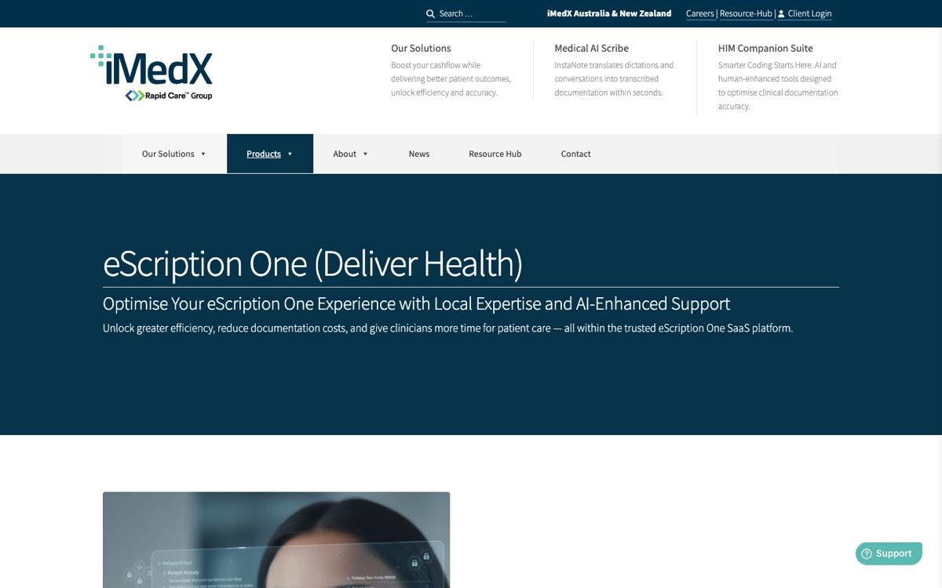 | Redesign — eScription One  LIVE PROTOTYPE  https://imedx-anz-redesign.vercel.app/escription-one.html  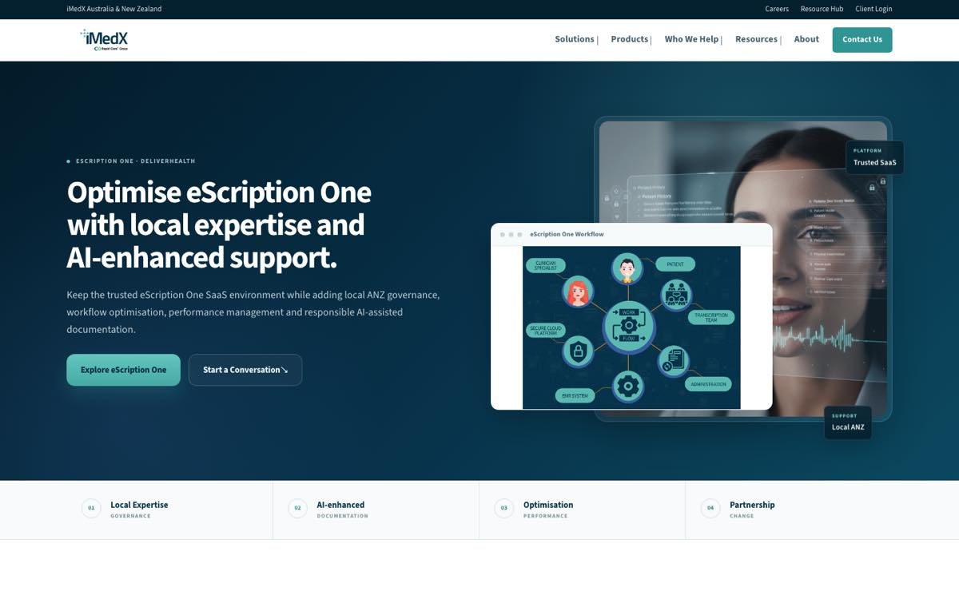

Resource Hub
Actual live browser captures — 25 Sep 2026. Not reconstructed mock-ups.
Current iMedX — Resource Hub  CURRENT LIVE SITE  https://imedx.com.au/resource-hub/  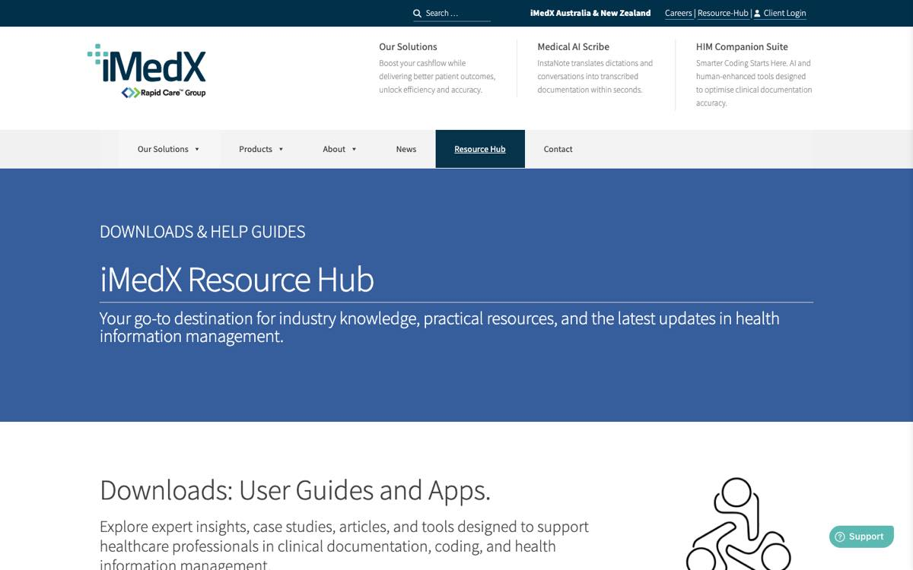 | Redesign — Resource Hub  LIVE PROTOTYPE  https://imedx-anz-redesign.vercel.app/resource-hub.html  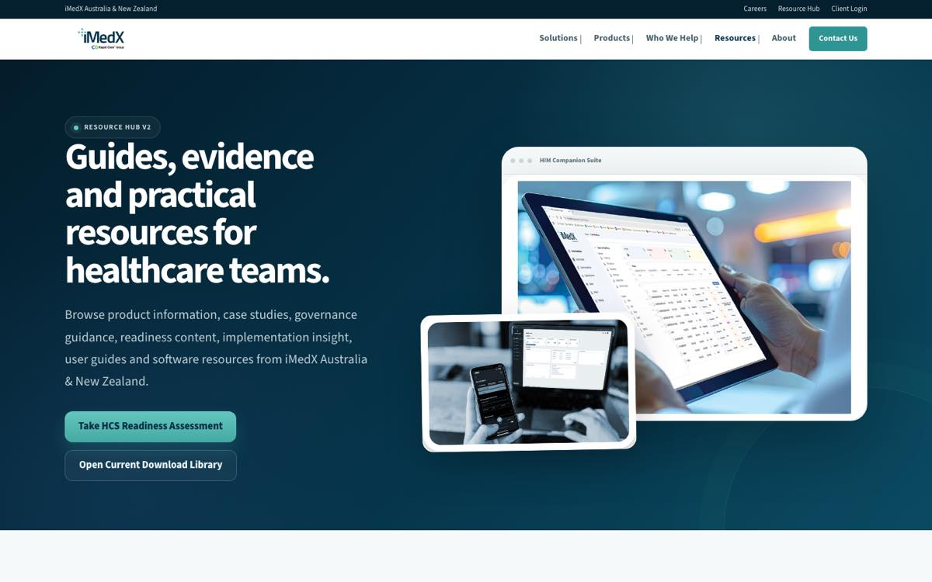

Current iMedX — Supporting Pages
Actual live browser captures — 25 Sep 2026. Not reconstructed mock-ups.
Current iMedX — About  CURRENT LIVE SITE  https://imedx.com.au/about/  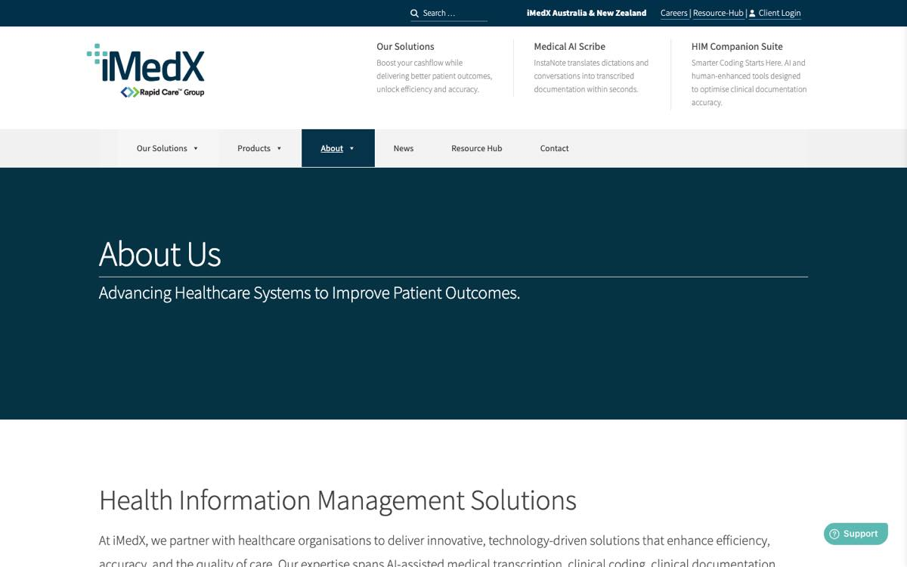 | Current iMedX — Contact  CURRENT LIVE SITE  https://imedx.com.au/contact/  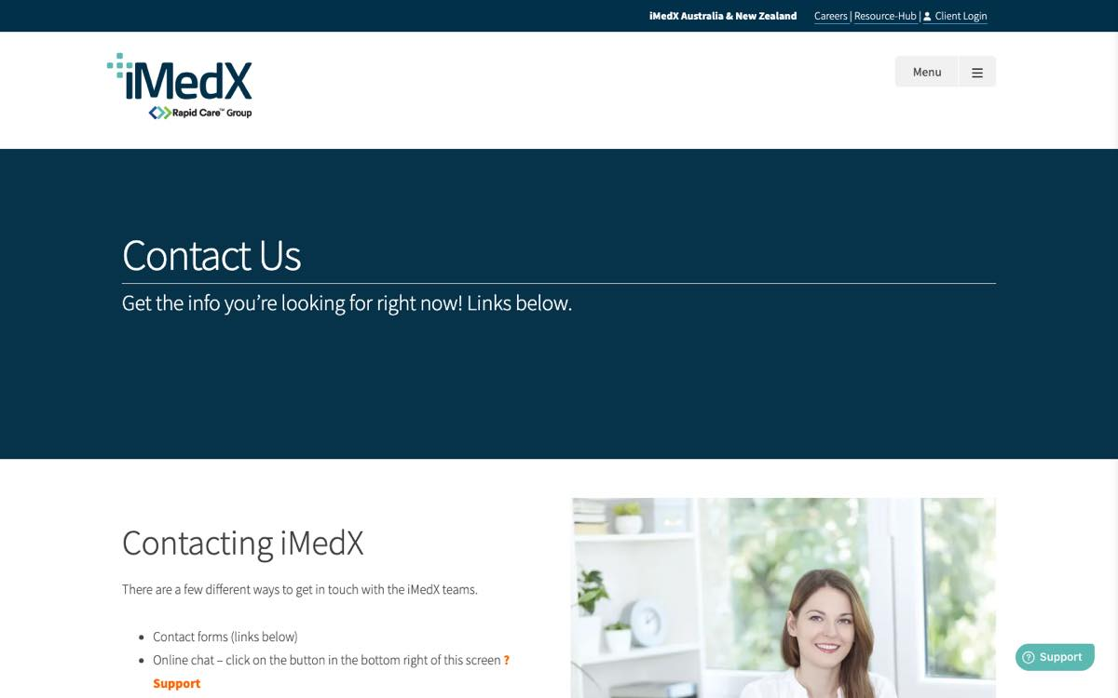

HCS — Alternate / Expanded Presentation
Actual live browser capture — 25 Sep 2026.
HCS v2
LIVE PROTOTYPE
https://imedx-anz-redesign.vercel.app/hcs-v2.html
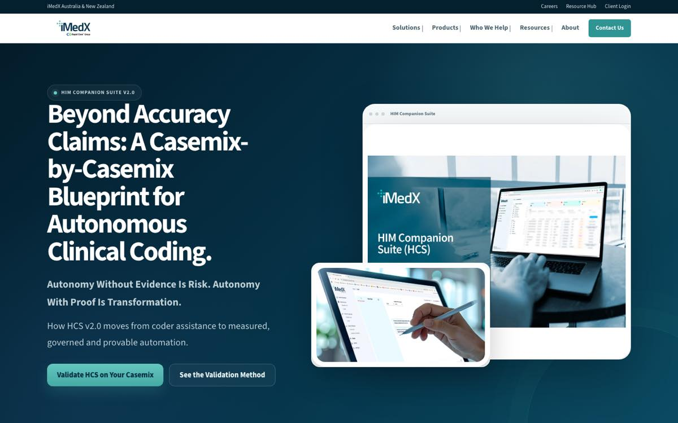

InstaNote Product Page
Actual live browser capture — 25 Sep 2026.
InstaNote
LIVE PROTOTYPE
https://imedx-anz-redesign.vercel.app/instanote.html
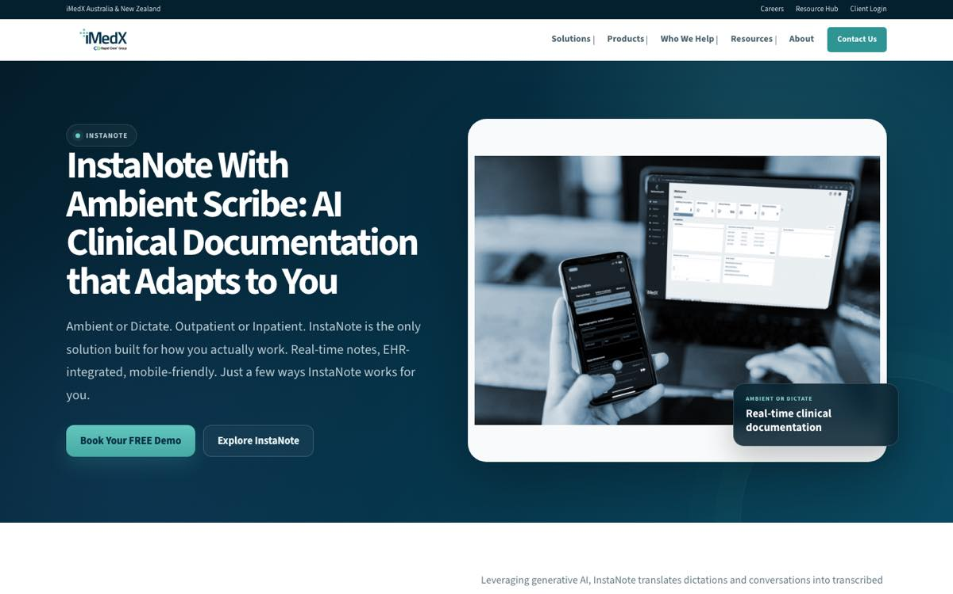

Clinical Documentation — Hospitals
Actual live browser capture — 25 Sep 2026.
Hospitals
LIVE PROTOTYPE
https://imedx-anz-redesign.vercel.app/clinical-documentation-hospitals.html
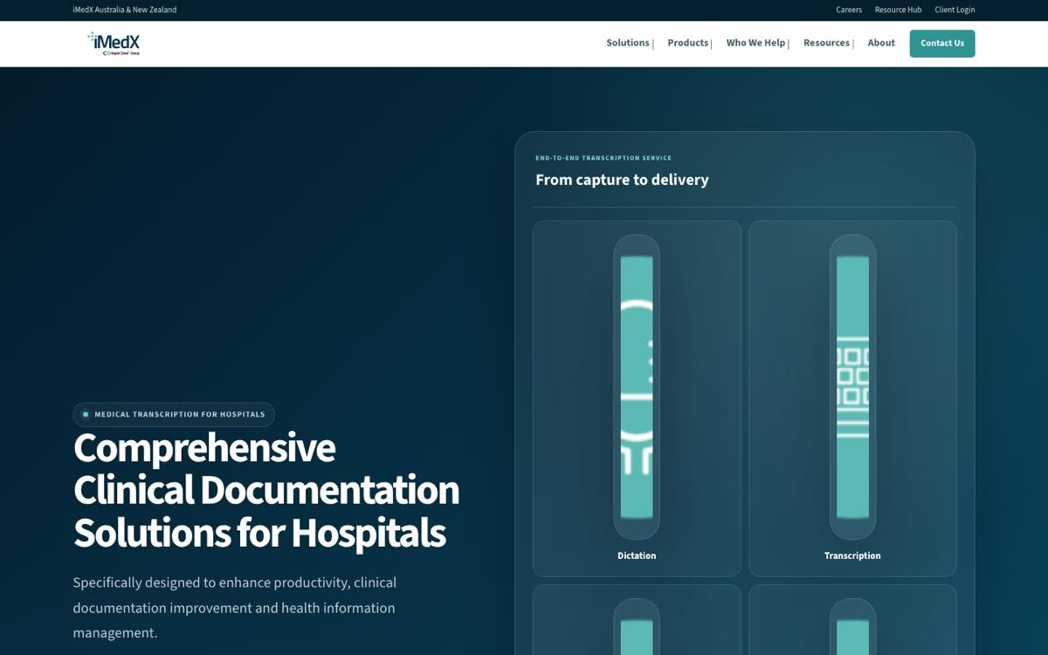

Clinical Documentation — Private Practice
Actual live browser capture — 25 Sep 2026.
Private Practice
LIVE PROTOTYPE
https://imedx-anz-redesign.vercel.app/clinical-documentation-private-practice.html


Clinical Documentation — Radiology
Actual live browser capture — 25 Sep 2026.
Radiology
LIVE PROTOTYPE
https://imedx-anz-redesign.vercel.app/clinical-documentation-radiology.html


Clinical Documentation — Medico-Legal
Actual live browser capture — 25 Sep 2026.
Medico-Legal
LIVE PROTOTYPE
https://imedx-anz-redesign.vercel.app/clinical-documentation-medico-legal.html


Persona Journey — CFO
Actual live browser capture — 25 Sep 2026.
CFO Persona Page
LIVE PROTOTYPE
https://imedx-anz-redesign.vercel.app/persona-cfo.html
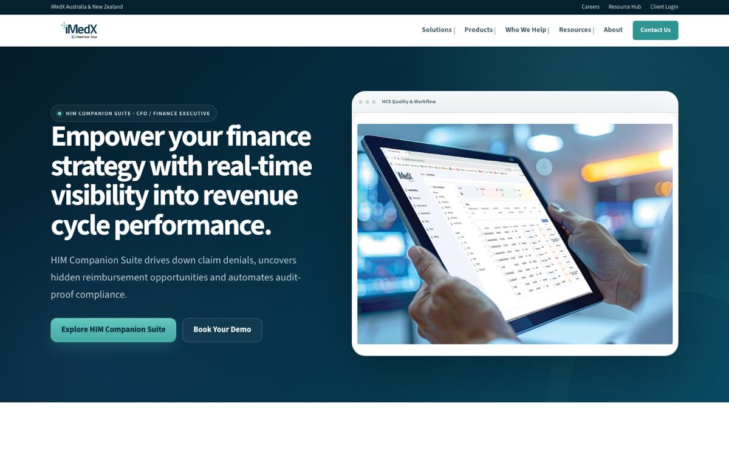

Persona Journey — HIM Manager
Actual live browser capture — 25 Sep 2026.
HIM Manager Persona Page
LIVE PROTOTYPE
https://imedx-anz-redesign.vercel.app/persona-him-manager.html
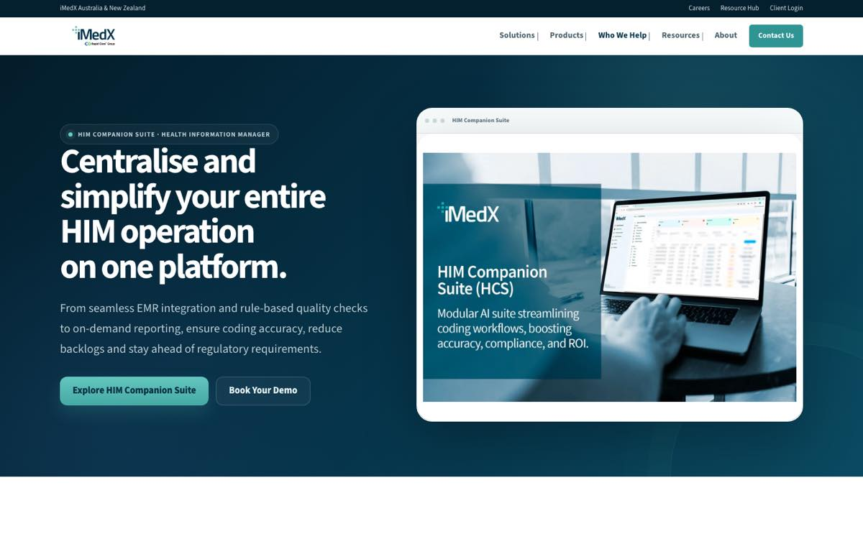

Persona Journey — Clinical Coder
Actual live browser capture — 25 Sep 2026.
Clinical Coder Persona Page
LIVE PROTOTYPE
https://imedx-anz-redesign.vercel.app/persona-coder.html
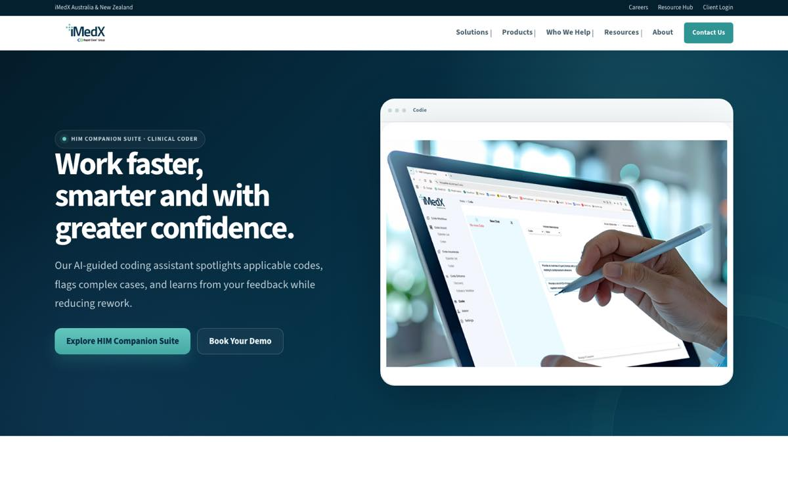

HCS Readiness Assessment
Actual live browser capture — 25 Sep 2026.
HCS Readiness Assessment
LIVE PROTOTYPE
https://imedx-anz-redesign.vercel.app/hcs-readiness-assessment.html
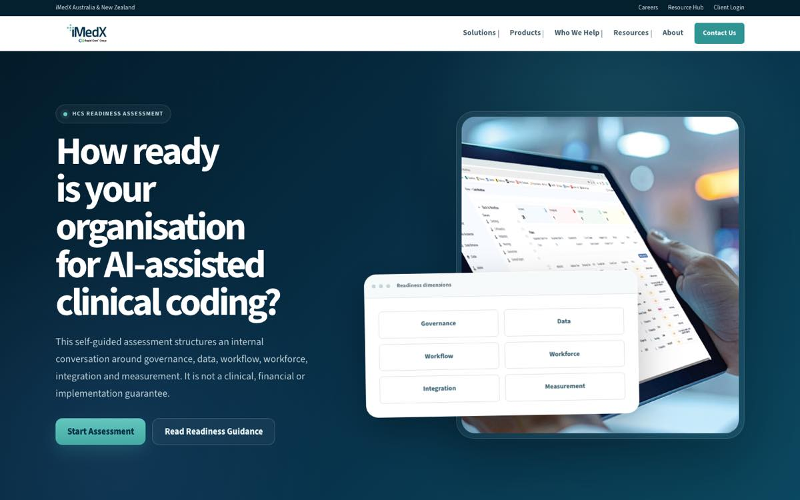

Competitor Reference — RapidCare WHITE
Actual live browser capture — 25 Sep 2026.
RapidCare WHITE AI
COMPETITOR — ACTUAL LIVE WEBSITE
https://rapidcare.ai/white-ai/
