Federated Learning for Video Anomaly Detection Across Two Camera Sites
Nishant Ajit¹, Ashwin Kumar¹, Pushpak Pothuri¹, Rohith E¹, Kalaavathi B^{2,*}
¹ School of Computer Science and Engineering (SCOPE), Vellore Institute of Technology, Vellore, 632014, India
² Professor Level PG1, School of Computer Science and Engineering (SCOPE), Vellore Institute of Technology, Vellore, 632014, India
* Corresponding author: Kalaavathi B (Kalaavathi.b@vit.ac.in)
E-mails: nishant.ajit2023@vitstudent.ac.in, ashwinkumar.s2023a@vitstudent.ac.in, pothuri.pushpak2023@vitstudent.ac.in, rohith.elindram2023@vitstudent.ac.in, Kalaavathi.b@vit.ac.in
Abstract
Cities such as Singapore run large camera networks, and sending all of that footage to one central server raises privacy concerns. Federated learning reduces this exposure, because each camera site trains on its own video and shares only model weights. UCSD Ped1 and Ped2, two public pedestrian datasets, served as two camera sites. Each site trained a small convolutional autoencoder on normal footage, a server combined the two models with federated averaging (FedAvg) over 10 rounds, and frames were scored by reconstruction error. We compared this against the same model trained on pooled data (centralised training) and against models trained at each site alone, using the frame-level area under the ROC curve (AUC) over five runs. The federated model reached a mean AUC of 0.731 against 0.737 for centralised training, a difference of 0.006 (95% confidence interval −0.007 to 0.019) that lies within a ±0.02 equivalence margin. On each site's own test data it was slightly ahead of the model trained at that site alone (+0.013 on Site 1, +0.035 on Site 2), though not significantly, and one shared model served both sites. In single-run checks the gap stayed small with FedProx and with four clients but grew with eight. With 8-frame inputs, mean AUC rose to 0.794 (federated) and 0.780 (centralised), and the federated model stayed level. A gradient-inversion attack on the shared updates recovered no recognisable frames. Training exchanged 52.6 MB in total.
Keywords: federated learning; anomaly detection; surveillance video; autoencoder; data privacy; UCSD pedestrian dataset

1. Introduction
Video cameras today can be seen in numerous locations including streets, subway stations, and schools. Most of the footage recorded is uninteresting, thus creating the need for a system that identifies unusual events, such as a biker using a sidewalk or a car parked in a pedestrian zone. Video anomaly detection is based on the idea that the model is trained only on normal footage, and anything that does not match what it has learned is flagged as unusual.
Singapore illustrates the value of privacy in this context. Its Smart Nation initiative [21] has introduced extensive video surveillance and established a working framework of the Personal Data Protection Act [19] that makes it clear what can and cannot be done with personal data. However, a plan to test facial recognition technology on lamp posts in 2018 raised public fears about privacy [20], which demonstrates that even cities with the necessary source of information are not ready to adopt a surveillance system that sends all recorded footage to one main server.
In federated learning, the original video footage is retained at the location of collection and only the trained model weights are shared with the server, which averages them in order to create a single model over many rounds. This raises the question of what the trade-off is, in terms of detection accuracy, by having data at different sites rather than in a single pool for training. We decided to quantify this trade-off under controlled conditions whereby the study could be repeated from start to finish and see whether there are any advantages of using federated training compared to using the footage collected by the cameras on their own. To do this, we used two sites implementing the FedAvg method [17] whereby the two cameras that were used, UCSD Ped1 and Ped2, were used separately without exchanging the video footage. The results of the federated training were compared to those of the centralized training and single site training with the same model and number of training epochs in five runs. The results obtained with federated training were almost as good as those obtained with centralized training.
The federated model came within 0.006 mean AUC of centralised training and was slightly ahead of single-site training on each site's own data, though not significantly. Unlike single-site training, it gives one shared model that serves both sites. We then checked whether this result holds with FedProx in place of FedAvg, with more clients, with a stronger input of stacked frames, and under a gradient-inversion attack on the shared updates.

2. Literature Review

2.1 Video anomaly detection
Chandola, Banerjee and Kumar [3] survey anomaly detection across many fields. The UCSD pedestrian dataset, released by Mahadevan and colleagues in 2010 [16], is one of the standard benchmarks for video anomaly detection. Hasan and colleagues [8] later showed that a convolutional autoencoder trained only on normal frames gives high reconstruction error on unusual ones, which made reconstruction error usable as an anomaly score. Accuracy has since been pushed up in two main ways, either by predicting the next frame instead of rebuilding the current one, as Liu and colleagues did [14], or by adding a memory of normal patterns, as in MemAE by Gong and colleagues [7]. Sultani and colleagues [23] took weak, video-level labels to large real-world datasets. Wu and colleagues review all of these families in a recent survey [25]. Every one of them trains on video gathered in one place.

2.2 Federated learning
FedAvg, introduced by McMahan and colleagues [17], is the standard federated learning method. A few epochs of local training is performed by each client, and the server takes a weighted average of the returned weights. A large survey led by Kairouz [9] lays out the field's open problems. Its weak spot is non-IID data. Zhao and colleagues [26] showed that accuracy can drop when the data at different clients look different, and separate camera scenes are an obvious case of this. FedProx from Li's team [12] and SCAFFOLD from Karimireddy's [10] were built to reduce this drop. Shared weights are not fully private either. Zhu, Liu and Han [27] recovered training images from shared gradients.

2.3 Federated video anomaly detection
Federated learning reached surveillance video through other vision tasks first. FedVision, by Liu and colleagues [15], trains object detectors for smart-city safety monitoring while each data owner keeps its images, and Deng, Han and Ansari [4] split federated video analytics between smart cameras and edge servers. Video anomaly detection followed only recently. CLAP, by Al-lahham and colleagues [1], trains an unsupervised detector across owners without moving their video. FedVAD, by Qi and colleagues [18], groups similar clients and uses a large language model to guide the global model. Wang and colleagues [24] paired federated learning with weak labels and text prompts for a CLIP-based detector, while Su and colleagues [22] used a mixture of local and global experts to cope with differences between camera scenes. Liu and colleagues [13] survey these and other privacy-preserving approaches. Together these methods show that federation can work for video. The more recent ones, though, rely on large pre-trained models or extra labels.

2.4 Research gap
Table 1 summarises representative studies. Most video anomaly detection work assumes centralised data, and the recent federated methods are large and complex. Few studies report, for a lightweight model, the accuracy gap between federated and centralised training of the same network together with a comparison against training at one site alone.
Study | Approach | Dataset / setting | Limitation
Hasan et al., 2016 [8] | Convolutional autoencoder, reconstruction error | UCSD Ped1, Ped2, Avenue, Subway | Assumes all video is pooled centrally
Liu et al., 2018 [14] | Future frame prediction | UCSD Ped1, Ped2, Avenue, ShanghaiTech | Centralised; larger model
Gong et al., 2019 [7] | Autoencoder with memory module (MemAE) | UCSD Ped2, Avenue, ShanghaiTech | Centralised training only
Al-lahham et al., 2024 [1] | Collaborative unsupervised detection (CLAP) | Large surveillance video benchmarks | Complex pipeline; no single-site comparison
Qi et al., 2024 [18] | Federated detection guided by a language model (FedVAD) | Surveillance benchmarks split across clients | Depends on large pre-trained models
Wang et al., 2025 [24] | Federated weak supervision with text prompts | Weakly labelled surveillance benchmarks | Needs video-level labels and CLIP
Su et al., 2025 [22] | Mixture of local-to-global experts | Scenario-specific clients | Needs video-level labels; complex design
This work | FedAvg over a small convolutional autoencoder | UCSD Ped1 and Ped2 as two sites | Two scenes only; small model; privacy checked with one attack
Table 1. Comparison of related work and the gap addressed by this study.

3. Methodology

3.1 Problem formulation
We have K = 2 camera sites, each holding unshareable footage. The autoencoder maps a frame x to a reconstruction x̂ and is trained with the mean squared error over all H × W pixels in Eq. (1).
ℓ(x) = (1 / HW) ‖x − x̂‖² (1)
At test time, the error of Eq. (1) on a frame is its anomaly score.

3.2 Data
We used the public UCSD Anomaly Detection Dataset, containing two outdoor pedestrian scenes, each filmed by a fixed camera. Ped1 has 34 training clips and 36 test clips of 200 frames each, at 238 × 158 pixels. Ped2 has 16 training clips and 12 test clips of 120 to 180 frames, at 360 × 240 pixels. The training clips show only normal walking. In the test clips cyclists, skaters and small carts also appear, and each test frame is labelled normal or abnormal.
Ped1 acted as Site 1 and Ped2 as Site 2. Video data between site 1 and site 2 is not exchanged at any point in time. Site 1 had 6,800 training frames and 7,200 test frames, 4,045 (56.2%) of them abnormal. Site 2 had 2,550 training frames and 2,010 test frames, 1,648 (82.0%) of them abnormal. The two sites differ in camera angle, image size and amount of data. Every frame was converted to grayscale, resized to 64 × 64 pixels and scaled to [0, 1]. 64 × 64 was chosen to provide a common input to the shared model as both sites record at different resolutions. Small frames also keep the network lightweight. Labels were used only for evaluation. One test frame (Ped1, clip Test017, frame 142) is corrupt, so we replaced it with the previous frame.

3.3 Proposed approach
Figure 1 shows the full system. The encoder has three convolution layers with 32, 64 and 128 filters (4 × 4 kernels, stride 2, padding 1), each halving the image size, so a 64 × 64 frame ends up as a 128 × 8 × 8 code. A mirrored decoder of three transposed convolution layers with the same kernel, stride and padding follows and finishes with a sigmoid, which keeps its output in [0, 1] like the input. In total the model has 329,025 parameters. We left out batch normalisation so that every weight could be averaged directly.
Training followed FedAvg. In each round the server sent the current global weights to both sites. Each site trained them for 3 epochs on its own frames and sent the new weights back, and the server averaged the two sets with Eq. (2), giving each site a share equal to its number of training frames. We ran 10 such rounds. Three local epochs per round put the federated budget at 30 epochs per site, the same as the other two training methods.
θ_{global} = (n₁ θ₁ + n₂ θ₂) / (n₁ + n₂) (2)
Here θ₁ and θ₂ are the weights returned by the two sites, and n₁ and n₂ are their numbers of training frames. For testing, each frame was scored with the error of Eq. (1). As is common on this dataset, the scores were then rescaled to [0, 1] within each test clip using Eq. (3), where e_{t} is the error of frame t and the minimum and maximum are taken over the clip. The labels play no part in this step. Per-clip rescaling is standard on UCSD but tends to inflate frame-level AUC, so our numbers are best compared with each other.
s_{t} = (e_{t} − e_{min}) / (e_{max} − e_{min}) (3)
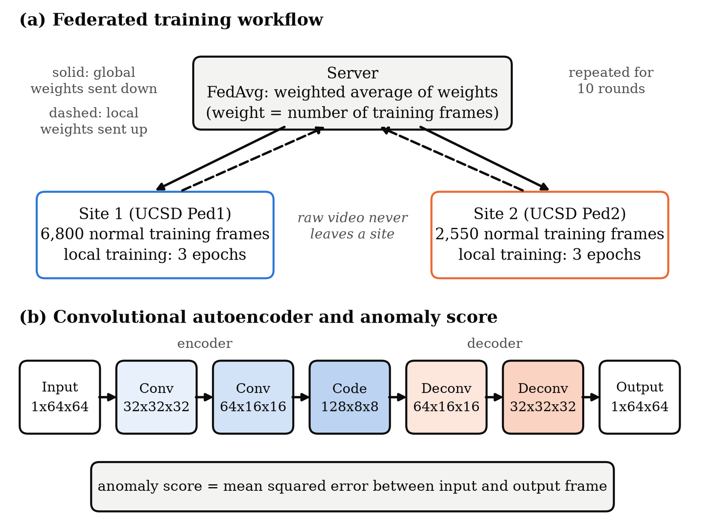
Figure 1. Overview of the system. (a) In each of 10 rounds the server sends the global autoencoder weights to Site 1 (UCSD Ped1) and Site 2 (UCSD Ped2). Each site trains for 3 epochs on its own normal frames, and the server averages the returned weights in proportion to each site's number of training frames. Only weights are exchanged. (b) The convolutional autoencoder (Conv denotes convolution and Deconv transposed convolution) turns a 64 × 64 grayscale frame into a 128 × 8 × 8 code and back. A frame's anomaly score is its mean squared reconstruction error.

3.4 Experimental setup
We trained the same model in three ways, each with 30 passes over each site's data. Federated training ran FedAvg for 10 rounds with 3 epochs per site per round. Centralised training pooled the 9,350 training frames of both sites and trained one model for 30 epochs. It ignores privacy and serves as the reference. In single-site training, each site trained its own model for 30 epochs on its own frames only.
All models used the Adam optimiser of Kingma and Ba [11] with a learning rate of 0.001, a batch size of 64 and the loss of Eq. (1). Our main metric is the frame-level area under the ROC curve (AUC) described by Fawcett [5], computed separately for each site over all of its test frames, and we also report the mean of the two site AUCs. For the saved seed-42 models we also report the area under the precision-recall curve (PR-AUC) and the equal error rate (EER). There was no validation split: the 30-epoch budget was fixed in advance and not tuned. Communication cost follows Eq. (4), where P is the number of parameters at 4 bytes each, the factor 2 counts sending and receiving, K is the number of sites and R the number of rounds.
C = P × 4 bytes × 2 × K × R (4)
Each experiment was repeated 5 times with random seeds 42 to 46, and we report the mean ± standard deviation. To compare two methods we took the per-seed differences over the five runs, on own-site AUC against single-site models and on mean AUC against centralised training, and report the mean difference with its 95% confidence interval (CI) and the p-value of a paired t-test. A t-test that finds no significant difference does not show that two methods are equivalent, so for the federated–centralised gap we also ran a two one-sided tests (TOST) equivalence test with a margin of ±0.02 AUC. We set this margin after the main experiments, as a gap too small to matter for a model at this accuracy, so the TOST result should be read as descriptive. The code was written in Python 3.11.13 with PyTorch 2.14.1 (CUDA 13.0 build) and scikit-learn 1.9.1, and is publicly available (see Declarations). All runs used one NVIDIA GeForce GTX 1650 Ti laptop GPU, with both sites simulated on the same machine. A federated run took about 63 s and a centralised run about 57 s.

3.5 Additional experiments
To test how far the main result holds, we ran five further studies. The first four use the same 30-epoch budget but only one run (seed 42), because of limited compute time, so they show tendencies rather than tested differences. First, FedProx [12] adds a proximal term to each site's local loss, Eq. (5), which keeps the local weights θ close to the global weights θglobal that the site received at the start of the round. We tried μ = 0.001 and μ = 0.01. A larger μ = 0.1 diverged on seed 42 (mean AUC 0.31) and was not pursued.
ℓ_{prox}(θ) = ℓ(x) + (μ / 2) ‖θ − θ_{global}‖² (5)
Second, to see how the gap changes with the number of clients, we split each site's training clips into 2 or 4 groups of consecutive clips and treated every group as a client, giving K = 4 and K = 8. Third, to see how it changes with scene differences, we split one site's training clips into two halves and federated the two halves, so that both clients film the same scene, and compared this with the single-site model trained on the whole site. Fourth, to test whether the gap holds for a stronger detector, we gave the same autoencoder stacks of 8 consecutive frames as 8 input channels, so that it can see motion. Only the first and last layers change, from 1 to 8 channels, and the model grows to 336,200 parameters, or 53.8 MB of communication over 10 rounds. Frame t is scored with the error of the stack that ends at frame t, and the first 7 frames of each clip reuse the error of the first stack.
Fifth, we ran the gradient-inversion attack of Zhu and colleagues [27] against Site 2 with seed 42, using the cosine loss and total-variation prior of Geiping and colleagues [6]. Starting from random images, the attacker adjusts B dummy frames until the gradient they produce points the same way as what the server observed. We gave the attacker two targets: the gradient of a single batch of real frames, which is the easiest case for the attacker, and one full round's weight update after 3 local epochs, which is what FedAvg actually sends. Each target was attacked at the untrained global model of round 1 and at the trained model after round 10, with B = 1 and B = 8 and 1,000 Adam steps. We measured the peak signal-to-noise ratio (PSNR) of each reconstruction against its closest real frame. As a reference we used the mean training frame of Site 2, which shows the scene without any particular person in it.

4. Results

4.1 Detection accuracy
Table 2 gives the results. The federated model reached a mean AUC of 0.731 ± 0.011, against 0.737 ± 0.006 for centralised training. The mean difference was 0.006 in favour of centralised training, with a 95% CI of −0.007 to 0.019. The equivalence test placed the gap within ±0.02 AUC (TOST p = 0.018), but with five runs the interval is still wide enough to allow a gap of nearly 0.02. Per site the picture splits, with the federated model doing better on Site 1 (0.709 against 0.694; difference 0.015, 95% CI 0.007 to 0.023, p = 0.006) and centralised training doing better on Site 2 (0.779 against 0.753; difference 0.027, 95% CI 0.000 to 0.053, p = 0.048).
On its own site, each single-site model came close to the federated one. The Site 1 model reached 0.696 on Site 1 against 0.709 for the federated model (+0.013, 95% CI −0.005 to 0.031, p = 0.12), and the Site 2 model reached 0.718 on Site 2 against 0.753 (+0.035, 95% CI −0.002 to 0.072, p = 0.059). The federated model was ahead in 4 of the 5 runs in both cases, but both intervals include zero. The larger difference is in transfer. The Site 1 model scored only 0.515 on Site 2, close to chance, and the Site 2 model 0.668 on Site 1.
PR-AUC and EER follow the same pattern (seed 42). On Site 1 the federated and centralised models reached a PR-AUC of 0.717 and 0.691 and an EER of 0.332 and 0.353. On Site 2 they reached a PR-AUC of 0.915 and 0.931 and an EER of 0.320 and 0.290. PR-AUC should be read against the share of abnormal frames, 0.562 on Site 1 and 0.820 on Site 2.
Method | Site 1 AUC (Ped1) | Site 2 AUC (Ped2) | Mean AUC | p-value (vs. federated)
Single site, Site 1 model | 0.696 ± 0.011 | 0.515 ± 0.061 | 0.605 ± 0.028 | 0.120 (own site)
Single site, Site 2 model | 0.668 ± 0.005 | 0.718 ± 0.016 | 0.693 ± 0.008 | 0.059 (own site)
Centralised (pooled data) | 0.694 ± 0.004 | 0.779 ± 0.013 | 0.737 ± 0.006 | 0.283 (mean)
Federated (this work) | 0.709 ± 0.006 | 0.753 ± 0.019 | 0.731 ± 0.011 | Reference
Table 2. Frame-level ROC-AUC of each training method on the test clips of both sites. Values are mean ± standard deviation over 5 runs. Single-site models are trained on one site and tested on both. p-values come from a paired t-test against the federated model, on own-site AUC for single-site models and on mean AUC for centralised training; the 95% CIs of these differences are given in the text. Cross-site entries of single-site models are a transfer result. Best result in each column in bold.

4.2 Training rounds and communication cost
Figure 2 tracks the mean AUC of the federated model round by round. It started at 0.668 after round 1, rose to 0.736 by round 7 and then levelled off, ending at 0.731. The spread across runs also narrowed as training went on. Each round exchanged 5.26 MB, which comes to 52.6 MB over the full 10 rounds. Stopping at round 7 would have needed 36.9 MB. For comparison, the raw training video of both sites is about 476 MB.
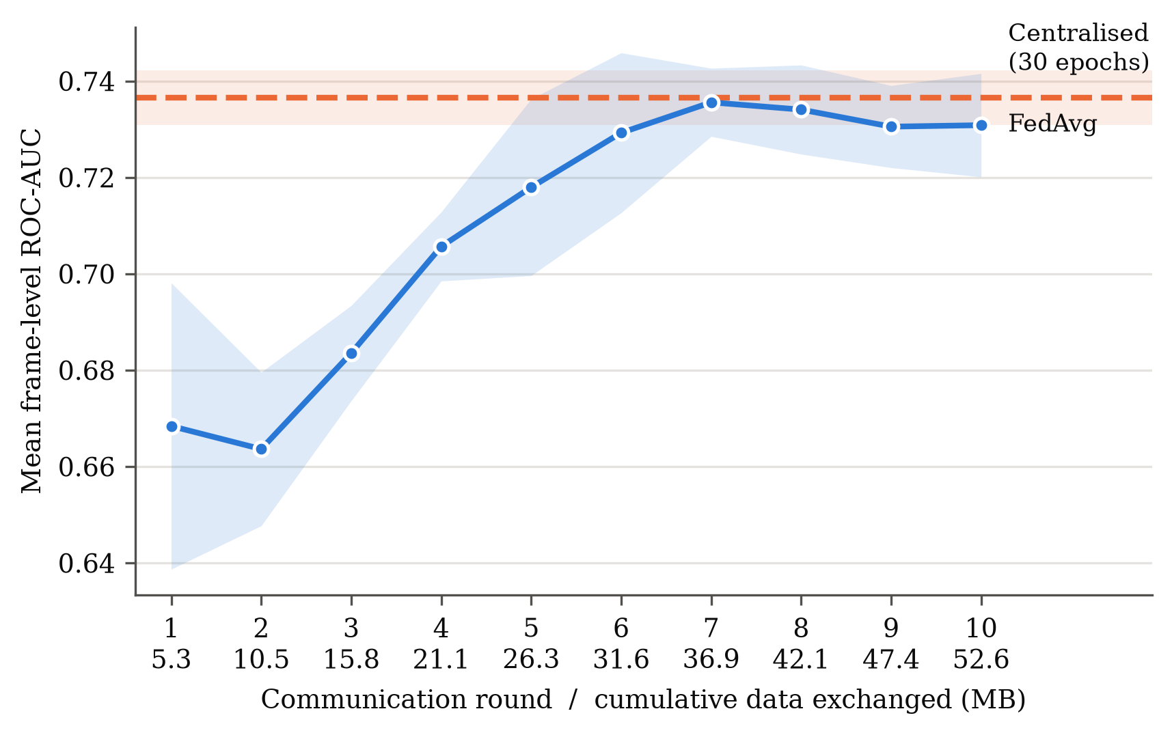
Figure 2. Mean frame-level ROC-AUC (average of Site 1 and Site 2) of the federated model after each round. The solid line is the mean over 5 runs and the shaded band shows ± one standard deviation. The dashed line shows the centralised model after 30 epochs. The second row of x-axis labels gives the total data exchanged so far, in megabytes (MB).

4.3 Example detections
Figure 3 comes from the saved seed-42 federated model, so it shows a single run. Among Ped2 test clips where normal and abnormal frames each make up at least a quarter of the frames, the clip with median per-clip AUC was taken, which was clip 002.
The normal frame shown is the middle normal frame of that clip (frame 48). For the abnormal one we deliberately took the highest-scoring abnormal frame (frame 159), the clearest case the clip offers. Even so, the gap is small, with a mean squared error of 8.7 × 10⁻⁴ against 7.6 × 10⁻⁴. In both error maps the error sits on the people in the scene, whom the decoder blurs regardless of what they are doing. At 64 × 64 an abnormal object covers only a handful of pixels, and that may be part of why the frame-level AUCs in Table 2 are modest.
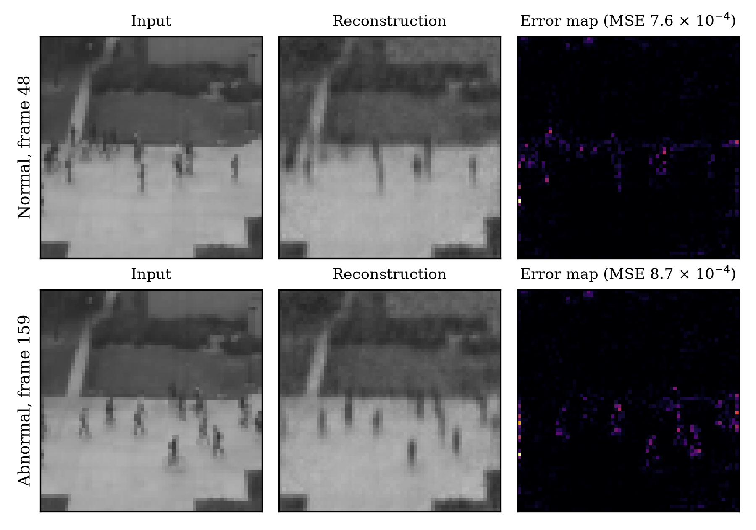
Figure 3. Input, reconstruction and squared-error map for two frames of Ped2 test clip 002, from the seed-42 federated model. The top row is the middle normal frame and the bottom row the highest-scoring abnormal frame. Both error maps use the same colour scale.

4.4 Additional experiments
Table 3 gives the additional studies for seed 42, where FedAvg trailed centralised training by 0.015 in mean AUC. FedProx did not narrow the gap. With μ = 0.001 it reached 0.714, practically the same as FedAvg (0.715), and with μ = 0.01 it fell to 0.694, mainly because Site 2 dropped to 0.694.
Splitting the sites into more clients gave a mean AUC of 0.724 for K = 4 (gap +0.006) and 0.673 for K = 8 (gap +0.057). The drop at K = 8 came from Site 2, which fell to 0.643; there each Site 2 client holds only about 640 training frames. Clients that film the same scene did not close the gap either. Federating the two halves of Site 1 gave 0.706 on Site 1, against 0.712 for the model trained on all of Site 1, and the two halves of Site 2 gave 0.693 on Site 2 against 0.730.
Frame stacks made the detector clearly stronger. The federated model rose from 0.715 to 0.794 in mean AUC (0.770 on Site 1 and 0.818 on Site 2), and the centralised model from 0.730 to 0.780. With stacks, the federated model was 0.014 ahead of centralised training rather than behind it.
Method | Site 1 AUC (Ped1) | Site 2 AUC (Ped2) | Mean AUC | Centralised − method (mean AUC)
Centralised (pooled data) | 0.689 | 0.771 | 0.730 | Reference
FedAvg, K = 2 (main setting) | 0.709 | 0.721 | 0.715 | +0.015
FedProx, μ = 0.001, K = 2 | 0.695 | 0.734 | 0.714 | +0.016
FedProx, μ = 0.01, K = 2 | 0.693 | 0.694 | 0.694 | +0.037
FedAvg, K = 4 | 0.693 | 0.755 | 0.724 | +0.006
FedAvg, K = 8 | 0.703 | 0.643 | 0.673 | +0.057
8-frame stacks, centralised | 0.747 | 0.814 | 0.780 | Reference
8-frame stacks, FedAvg | 0.770 | 0.818 | 0.794 | −0.014
Table 3. Additional studies, frame-level ROC-AUC from a single run (seed 42). K is the number of clients; for K = 4 and K = 8 each site's training clips are split into 2 or 4 clients. The last column is the difference in mean AUC from the centralised model trained on the same input (single frames, or 8-frame stacks for the last row); positive values favour centralised training. With one run these are indications, not tested differences.

4.5 Gradient-inversion check
The attack did not recover recognisable frames (Figure 4). Against a single batch's gradient it matched the gradient almost exactly (cosine similarity 1.00 or higher), yet the reconstructions reached only 13.9 dB PSNR against the real frame for B = 1 and 17.2 dB on average for B = 8 at round 1, and 14.1 and 12.9 dB at the trained model. Against a full round's update the match stayed poor (cosine similarity 0.21 to 0.38) and PSNR against the closest training frame was 9.0 to 10.7 dB. For comparison, the mean training frame, which carries no information about any particular person, scores 30.9 dB against the same batch frames and 33.6 dB against its closest training frame. Every reconstruction was therefore further from the real frames than the plain average of the scene.
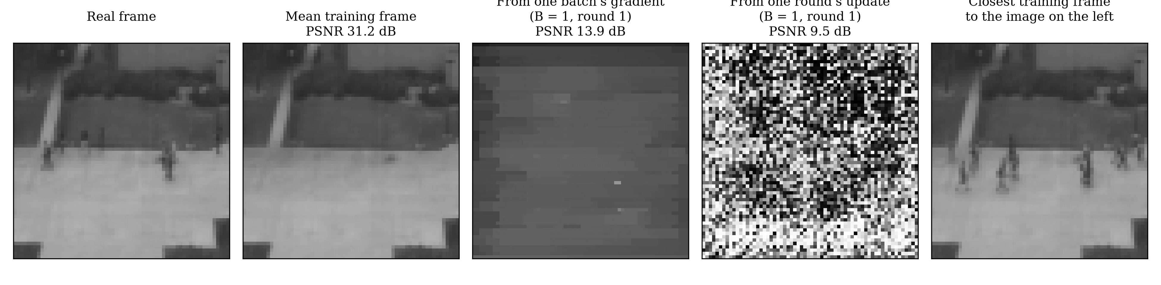
Figure 4. Gradient-inversion check on Site 2 (seed 42, round 1, B = 1). From left: a real training frame; the mean training frame, shown for reference; the attacker's reconstruction from the gradient of that one frame; the reconstruction from a full round's weight update; and the training frame closest to that reconstruction. PSNR is measured against the real frame for the first three panels and against the closest training frame for the fourth.

5. Discussion
Federated training came close to centralised training. The mean AUC gap of 0.006 lies within ±0.02 by the equivalence test, so on this task keeping the video at each site seems to have cost little accuracy, although with five runs and two sites the confidence interval still allows a gap of nearly 0.02. One likely reason is that both scenes show much the same content, namely a fixed camera, a walkway and people walking. A small autoencoder probably spends most of its capacity on these shared patterns, and averaging two models that have learned similar things should lose little. But the per-site results complicate this picture. Averaging shifted the balance between the sites, helping Site 1 and hurting Site 2.
The comparison with single-site training shows where federation helps. On its own site, each single-site model came within 0.013 to 0.035 of the federated model, a margin five runs cannot separate from noise. The clear benefit is that one shared model serves both sites, which single-site training cannot provide. A model trained at one site did poorly when applied to the other (the Site 1 model scored 0.515 on Site 2), whereas the federated model, trained on both sites, reached 0.709 on Site 1 and 0.753 on Site 2. This is a two-scene result. Whether the sites of a real camera network, with many more and more varied scenes, could share one detector in the same way is a question this study cannot answer.
Our AUC values are lower than published results on UCSD. Hasan and colleagues [8], for example, reported 0.810 on Ped1 and 0.900 on Ped2. Their model used larger frames and stacks of frames that capture motion, whereas our main model looks at one small frame at a time, and we did not try to match their scores. Giving our model 8-frame stacks raised its AUC to 0.770 and 0.818 for the federated model, and the federated model stayed level with centralised training. In this run, then, the small federated–centralised gap was not an artefact of a weak detector.
FedProx did not help here, which fits a setting with two clients and only 3 local epochs per round, where local models have little room to drift from the global one. The client-count and same-scene runs point the same way: the gap grew when each client held less data (K = 8, or half of the smaller Site 2), and splitting one scene between two clients cost as much as federating two different scenes. In these single runs, the amount of data per client mattered more than how different the scenes were. Finally, the inversion check found no leak of individual frames from the shared updates of this model. That is evidence for this attack and setting only, not a privacy guarantee.
Limitations. There are only two real sites, and Site 1 holds 73% of the training frames, so FedAvg here is close to a weighted average of two models. Splitting each site into more clients tests how the gap changes with the number of clients, but it does not add new scenes, so the effect of scene differences remains largely untested; a multi-scene dataset with each scene as a client is needed for that. The additional studies in Table 3 use a single run each, so they show tendencies rather than tested differences. We use "federated" rather than "privacy-preserving": raw video stays on site, and one gradient-inversion attack did not recover frames, but stronger attacks exist [6], and we did not add formal protection such as secure aggregation. Per-clip normalisation may inflate frame-level AUC.

6. Conclusion
Within the limits of two sites and five runs, federated averaging let a small autoencoder learn a shared anomaly detector from UCSD Ped1 and Ped2 at little cost in accuracy: the mean AUC gap of 0.006 lay within a ±0.02 equivalence margin, and one model served both sites. Single-run checks suggest that the small gap also holds for a stronger 8-frame model, that FedProx adds nothing in this setting, and that the gap grows when each client holds little data. A gradient-inversion attack did not recover frames from the shared updates. Next we want to use the scenes of a multi-scene dataset as separate clients, repeat the additional studies over more seeds, and add secure aggregation, as in the Bonawitz protocol [2], so that the server cannot see any single site's update.

Declarations
Data availability. The UCSD Anomaly Detection Dataset is publicly available from the Statistical Visual Computing Laboratory, UC San Diego (http://www.svcl.ucsd.edu/projects/anomaly/).
Code availability. The code is available at https://github.com/NishTheFish92/DSC-Federated-Video-Anomaly-Detection. It includes the scripts that produce the results in Tables 2 and 3 and the gradient-inversion check in Figure 4.
Reproducibility. All runs use fixed seeds (42 to 46), and a run repeated with the same seed on the same hardware and software gives exactly the same result. For this revision we re-ran seed 42 and obtained identical values.
Funding. This research received no external funding.
Conflicts of interest. The authors declare no conflicts of interest.
Author contributions. Nishant Ajit: conceptualisation, methodology, software, writing (original draft). Ashwin Kumar: data curation, experiments, validation. Pushpak Pothuri: formal analysis, visualisation. Rohith E: literature review, writing (review and editing). Kalaavathi B: supervision. All authors read and approved the final manuscript.
Use of AI tools. Minimal use to assist with code and with providing appropriate wording for the manuscript text. The authors reviewed and verified all output and take full responsibility for the content.

References
[1] Al-lahham, A., Tastan, N., Zaheer, M.Z., Nandakumar, K. (2024). Collaborative learning of anomalies with privacy (CLAP) for unsupervised video anomaly detection: A new baseline. In Proceedings of the IEEE/CVF Conference on Computer Vision and Pattern Recognition (CVPR), Seattle, WA, USA.
[2] Bonawitz, K., Ivanov, V., Kreuter, B., Marcedone, A., McMahan, H.B., Patel, S., Ramage, D., Segal, A., Seth, K. (2017). Practical secure aggregation for privacy-preserving machine learning. In Proceedings of the ACM SIGSAC Conference on Computer and Communications Security (CCS), Dallas, TX, USA, pp. 1175-1191. https://doi.org/10.1145/3133956.3133982
[3] Chandola, V., Banerjee, A., Kumar, V. (2009). Anomaly detection: A survey. ACM Computing Surveys, 41(3), Article 15. https://doi.org/10.1145/1541880.1541882
[4] Deng, Y., Han, T., Ansari, N. (2020). FedVision: Federated video analytics with edge computing. IEEE Open Journal of the Computer Society, 1, 62-72. https://doi.org/10.1109/OJCS.2020.2996184
[5] Fawcett, T. (2006). An introduction to ROC analysis. Pattern Recognition Letters, 27(8), 861-874. https://doi.org/10.1016/j.patrec.2005.10.010
[6] Geiping, J., Bauermeister, H., Dröge, H., Moeller, M. (2020). Inverting gradients - How easy is it to break privacy in federated learning? In Advances in Neural Information Processing Systems (NeurIPS), 33, pp. 16937-16947.
[7] Gong, D., Liu, L., Le, V., Saha, B., Mansour, M.R., Venkatesh, S., van den Hengel, A. (2019). Memorizing normality to detect anomaly: Memory-augmented deep autoencoder for unsupervised anomaly detection. In Proceedings of the IEEE/CVF International Conference on Computer Vision (ICCV), Seoul, Korea, pp. 1705-1714. https://doi.org/10.1109/ICCV.2019.00179
[8] Hasan, M., Choi, J., Neumann, J., Roy-Chowdhury, A.K., Davis, L.S. (2016). Learning temporal regularity in video sequences. In Proceedings of the IEEE Conference on Computer Vision and Pattern Recognition (CVPR), Las Vegas, NV, USA, pp. 733-742. https://doi.org/10.1109/CVPR.2016.86
[9] Kairouz, P., McMahan, H.B., et al. (2021). Advances and open problems in federated learning. Foundations and Trends in Machine Learning, 14(1-2), 1-210. https://doi.org/10.1561/2200000083
[10] Karimireddy, S.P., Kale, S., Mohri, M., Reddi, S., Stich, S., Suresh, A.T. (2020). SCAFFOLD: Stochastic controlled averaging for federated learning. In Proceedings of the 37th International Conference on Machine Learning (ICML), PMLR 119, pp. 5132-5143.
[11] Kingma, D.P., Ba, J. (2015). Adam: A method for stochastic optimization. In Proceedings of the 3rd International Conference on Learning Representations (ICLR), San Diego, CA, USA.
[12] Li, T., Sahu, A.K., Zaheer, M., Sanjabi, M., Talwalkar, A., Smith, V. (2020). Federated optimization in heterogeneous networks. In Proceedings of Machine Learning and Systems (MLSys), 2, pp. 429-450.
[13] Liu, J., Liu, Y., Zhu, X. (2024). Privacy-preserving video anomaly detection: A survey. arXiv preprint arXiv:2411.14565. https://doi.org/10.48550/arXiv.2411.14565
[14] Liu, W., Luo, W., Lian, D., Gao, S. (2018). Future frame prediction for anomaly detection: A new baseline. In Proceedings of the IEEE Conference on Computer Vision and Pattern Recognition (CVPR), Salt Lake City, UT, USA, pp. 6536-6545. https://doi.org/10.1109/CVPR.2018.00684
[15] Liu, Y., Huang, A., Luo, Y., Huang, H., Liu, Y., Chen, Y., Feng, L., Chen, T., Yu, H., Yang, Q. (2020). FedVision: An online visual object detection platform powered by federated learning. In Proceedings of the AAAI Conference on Artificial Intelligence, New York, NY, USA, 34(08): 13172-13179. https://doi.org/10.1609/aaai.v34i08.7021
[16] Mahadevan, V., Li, W., Bhalodia, V., Vasconcelos, N. (2010). Anomaly detection in crowded scenes. In Proceedings of the IEEE Conference on Computer Vision and Pattern Recognition (CVPR), San Francisco, CA, USA, pp. 1975-1981. https://doi.org/10.1109/CVPR.2010.5539872
[17] McMahan, B., Moore, E., Ramage, D., Hampson, S., Arcas, B.A. (2017). Communication-efficient learning of deep networks from decentralized data. In Proceedings of the 20th International Conference on Artificial Intelligence and Statistics (AISTATS), Fort Lauderdale, FL, USA, pp. 1273-1282.
[18] Qi, F., Pan, R., Zhang, H., Xu, C. (2024). FedVAD: Enhancing federated video anomaly detection with GPT-driven semantic distillation. In Computer Vision, ECCV 2024, Lecture Notes in Computer Science. Cham: Springer. https://doi.org/10.1007/978-3-031-73668-1_14
[19] Republic of Singapore. (2012). Personal Data Protection Act 2012 (No. 26 of 2012). Retrieved from https://sso.agc.gov.sg/Act/PDPA2012, accessed on Oct. 11, 2026.
[20] Reuters. (2018). Singapore to test facial recognition on lampposts, stoking privacy fears. Reuters, Apr. 13, 2018.
[21] Smart Nation and Digital Government Office. (2018). Smart Nation: The way forward. Singapore: Prime Minister's Office. Retrieved from https://www.smartnation.gov.sg/files/publications/smart-nation-strategy-nov2018.pdf, accessed on Oct. 11, 2026.
[22] Su, Y., Li, J., An, S., Xing, M., Feng, Z. (2025). Federated weakly-supervised video anomaly detection with mixture of local-to-global experts. Information Fusion, 103256. https://doi.org/10.1016/j.inffus.2025.103256
[23] Sultani, W., Chen, C., Shah, M. (2018). Real-world anomaly detection in surveillance videos. In Proceedings of the IEEE Conference on Computer Vision and Pattern Recognition (CVPR), Salt Lake City, UT, USA, pp. 6479-6488. https://doi.org/10.1109/CVPR.2018.00678
[24] Wang, B., Huang, C., Wen, J., Wang, W., Liu, Y., Xu, Y. (2025). Federated weakly supervised video anomaly detection with multimodal prompt. In Proceedings of the AAAI Conference on Artificial Intelligence, Philadelphia, PA, USA, 39(20): 21017-21025. https://doi.org/10.1609/aaai.v39i20.35398
[25] Wu, P., Pan, C., Yan, Y., Pang, G., Wang, P., Zhang, Y. (2024). Deep learning for video anomaly detection: A review. arXiv preprint arXiv:2409.05383. https://doi.org/10.48550/arXiv.2409.05383
[26] Zhao, Y., Li, M., Lai, L., Suda, N., Civin, D., Chandra, V. (2018). Federated learning with non-IID data. arXiv preprint arXiv:1806.00582. https://doi.org/10.48550/arXiv.1806.00582
[27] Zhu, L., Liu, Z., Han, S. (2019). Deep leakage from gradients. In Advances in Neural Information Processing Systems (NeurIPS), 32, Vancouver, Canada.

