Federated Learning for Privacy-Preserving Video Anomaly Detection Across Two Camera Sites
Nishant Ajit1,*, Rohith Elindram1, Ashwin Kumar1, Pushpak1
1 [Department, Institution, City, Postcode, Country]
Corresponding author: [email@institution.edu
ORCID: [0000-0000-0000-0000]
Abstract
Cities such as Singapore use large networks of surveillance cameras, but sending all of that footage to one central server raises privacy concerns. Federated learning offers another way: each camera site trains a model on its own video and shares only the model weights. This paper tests how well that works for video anomaly detection. We treated two public pedestrian datasets, UCSD Ped1 and Ped2, as two camera sites. Each site trained a small convolutional autoencoder on normal footage, and a server combined the two models using federated averaging (FedAvg) over 10 rounds. A frame was scored as unusual when the model could not rebuild it well. We compared this with the same model trained on pooled data (centralised training) and with models trained at each site alone, using the frame-level area under the ROC curve (AUC) over five runs. The federated model reached a mean AUC of 0.731, close to the 0.737 of centralised training, and clearly higher than the models trained at a single site. Training exchanged 52.6 MB of model weights in total, and no video left either site.
Keywords: federated learning; anomaly detection; surveillance video; autoencoder; data privacy; UCSD pedestrian dataset

1. Introduction
Surveillance cameras are now common in streets, stations and campuses. Most of what they record is normal activity, so it is useful to have a system that flags the rare moments that look unusual, such as a cyclist on a footpath or a vehicle in a pedestrian area. This task is called video anomaly detection. A common way to do it is to train a model only on normal footage and then flag anything the model finds hard to explain.
Singapore is a good example of why privacy matters here. Its Smart Nation programme has built dense camera coverage on strong digital infrastructure, and its Personal Data Protection Act sets clear rules on how personal data can be used. At the same time, a 2018 plan to test facial recognition on lampposts drew public concern about privacy. A system that sends all video to one central server is therefore hard to accept, even in a city that has the infrastructure to run it.
Federated learning offers a way around this. Each camera site trains a copy of the model on its own video and sends only the learned weights to a server. The server averages the weights from all sites into one shared model and sends it back, and the process repeats. The raw video never leaves the site. The open question is how much detection accuracy is lost by training this way instead of on pooled data.
The objective of this paper is to measure, in a simple and repeatable setting, how close a federated video anomaly detector gets to a centrally trained one, and whether it helps each site compared with training alone.
The principal contributions of this work are as follows:
- A simple federated pipeline in which two simulated camera sites, UCSD Ped1 and Ped2, train one shared convolutional autoencoder with FedAvg without sharing any video.
- A fair comparison of federated, centralised and single-site training that uses the same model, the same number of training epochs and five repeated runs.
- A measured result: the federated model came within 0.006 mean AUC of centralised training, beat single-site training, and needed 52.6 MB of communication.
The remainder of this paper is organised as follows. Section 2 reviews related work. Section 3 describes the method. Section 4 presents the results. Section 5 discusses them, and Section 6 concludes the paper.

2. Literature Review

2.1 Video anomaly detection
The UCSD pedestrian dataset, released by Mahadevan and colleagues in 2010, is one of the standard tests for video anomaly detection. Hasan and colleagues later showed that a convolutional autoencoder trained only on normal frames gives high reconstruction error on unusual frames, which makes reconstruction error a simple anomaly score. Later methods improved accuracy by predicting the next frame instead of rebuilding the current one, as in the work of Liu and colleagues, or by adding a memory of normal patterns, as in MemAE by Gong and colleagues. Sultani and colleagues used weak, video-level labels to handle large real-world datasets. A recent review by Wu and colleagues covers these families of methods. All of them train on video gathered in one place.

2.2 Federated learning
Federated averaging (FedAvg), introduced by McMahan and colleagues, is the standard federated learning method. Each client trains for a few epochs on its own data, and the server takes a weighted average of the returned weights. Zhao and colleagues showed that accuracy can drop when the data at different clients look different, a setting known as non-IID data. Different camera scenes are a natural example of this.

2.3 Federated video anomaly detection
Federated learning has only recently been applied to video anomaly detection. CLAP, by Al-lahham and colleagues, trains an unsupervised detector across owners without moving their video. FedVAD, by Qi and colleagues, groups similar clients and uses a large language model to guide the global model. Wang and colleagues combined federated learning with weak labels and text prompts for a CLIP-based detector, and Su and colleagues used a mixture of local and global experts to handle differences between camera scenes. A survey by Liu and colleagues reviews these and other privacy-preserving approaches. These methods show that federation can work for video, but they rely on large pre-trained models or extra labels.

2.4 Research gap
Table 1 summarises representative studies. Most video anomaly detection work assumes centralised data, and the recent federated methods are large and complex. Few studies report, in a simple setting, the accuracy gap between a federated model and the same model trained centrally, together with a comparison against training at one site alone. This study measures that gap.
Study | Approach | Dataset / setting | Limitation
Hasan et al., 2016 | Convolutional autoencoder, reconstruction error | UCSD Ped1, Ped2, Avenue, Subway | Assumes all video is pooled centrally
Liu et al., 2018 | Future frame prediction | UCSD Ped1, Ped2, Avenue, ShanghaiTech | Centralised; larger model
Gong et al., 2019 | Autoencoder with memory module (MemAE) | UCSD Ped2, Avenue, ShanghaiTech | Centralised training only
Al-lahham et al., 2024 | Collaborative unsupervised detection (CLAP) | Large surveillance video benchmarks | Complex pipeline; no single-site comparison
Qi et al., 2024 | Federated detection guided by a language model (FedVAD) | Surveillance benchmarks split across clients | Depends on large pre-trained models
Wang et al., 2025 | Federated weak supervision with text prompts | Weakly labelled surveillance benchmarks | Needs video-level labels and CLIP
Su et al., 2025 | Mixture of local-to-global experts | Scenario-specific clients | Needs video-level labels; complex design
This work | FedAvg over a small convolutional autoencoder | UCSD Ped1 and Ped2 as two sites | Addressed: same-budget comparison with centralised and single-site training
Table 1. Comparison of related work and the gap addressed by this study.

3. Methodology

3.1 Problem formulation
We have K = 2 camera sites. Each site holds normal training frames that it cannot share. The model is an autoencoder: it compresses a frame x and then rebuilds it as x̂. It is trained to make the rebuilt frame close to the input, using the mean squared error over all H × W pixels in Eq. (1).
ℓ(x) = (1 / HW) ‖x − x̂‖² (1)
Because the model only ever sees normal frames, it rebuilds normal frames well and unusual frames poorly. The error of Eq. (1) on a test frame is therefore used as its anomaly score.

3.2 Data
We used the public UCSD Anomaly Detection Dataset, which has two outdoor pedestrian scenes filmed by fixed cameras. Ped1 has 34 training clips and 36 test clips of 200 frames each, at 238 × 158 pixels. Ped2 has 16 training clips and 12 test clips of 120 to 180 frames, at 360 × 240 pixels. Training clips contain only normal walking. Test clips also contain anomalies such as cyclists, skaters and small carts, and each test frame is labelled normal or abnormal.
Ped1 acted as Site 1 and Ped2 as Site 2, and each site read only its own data. Site 1 had 6,800 training frames and 7,200 test frames, of which 4,045 (56.2%) were abnormal. Site 2 had 2,550 training frames and 2,010 test frames, of which 1,648 (82.0%) were abnormal. The two sites differ in camera angle, image size and amount of data. Every frame was converted to grayscale, resized to 64 × 64 pixels and scaled to the range [0, 1]. Labels were used only for evaluation. One test frame in the dataset (Ped1, clip Test017, frame 142) is corrupt, so we replaced it with the previous frame.

3.3 Proposed approach
Figure 1 shows the whole system. The encoder has three convolution layers with 32, 64 and 128 filters. Each layer halves the image size, so a 64 × 64 frame becomes a 128 × 8 × 8 code. The decoder mirrors the encoder with three transposed convolution layers and ends with a sigmoid, so its output is in [0, 1] like the input. The model has 329,025 parameters. We left out batch normalisation so that every weight can be averaged directly.
Federated training followed FedAvg. In each round the server sent the current global weights to both sites. Each site trained them for 3 epochs on its own frames and sent the new weights back. The server then averaged the two sets of weights using Eq. (2), giving each site a share equal to its number of training frames. This was repeated for 10 rounds.
θ_{global} = (n₁ θ₁ + n₂ θ₂) / (n₁ + n₂) (2)
Here θ₁ and θ₂ are the weights returned by the two sites, and n₁ and n₂ are their numbers of training frames. For testing, each frame received the error of Eq. (1) as its score. As is common on this dataset, the scores were then rescaled to the range [0, 1] within each test clip using Eq. (3), where e_{t} is the error of frame t and the minimum and maximum are taken over the clip. This step uses only the scores, never the labels.
s_{t} = (e_{t} − e_{min}) / (e_{max} − e_{min}) (3)
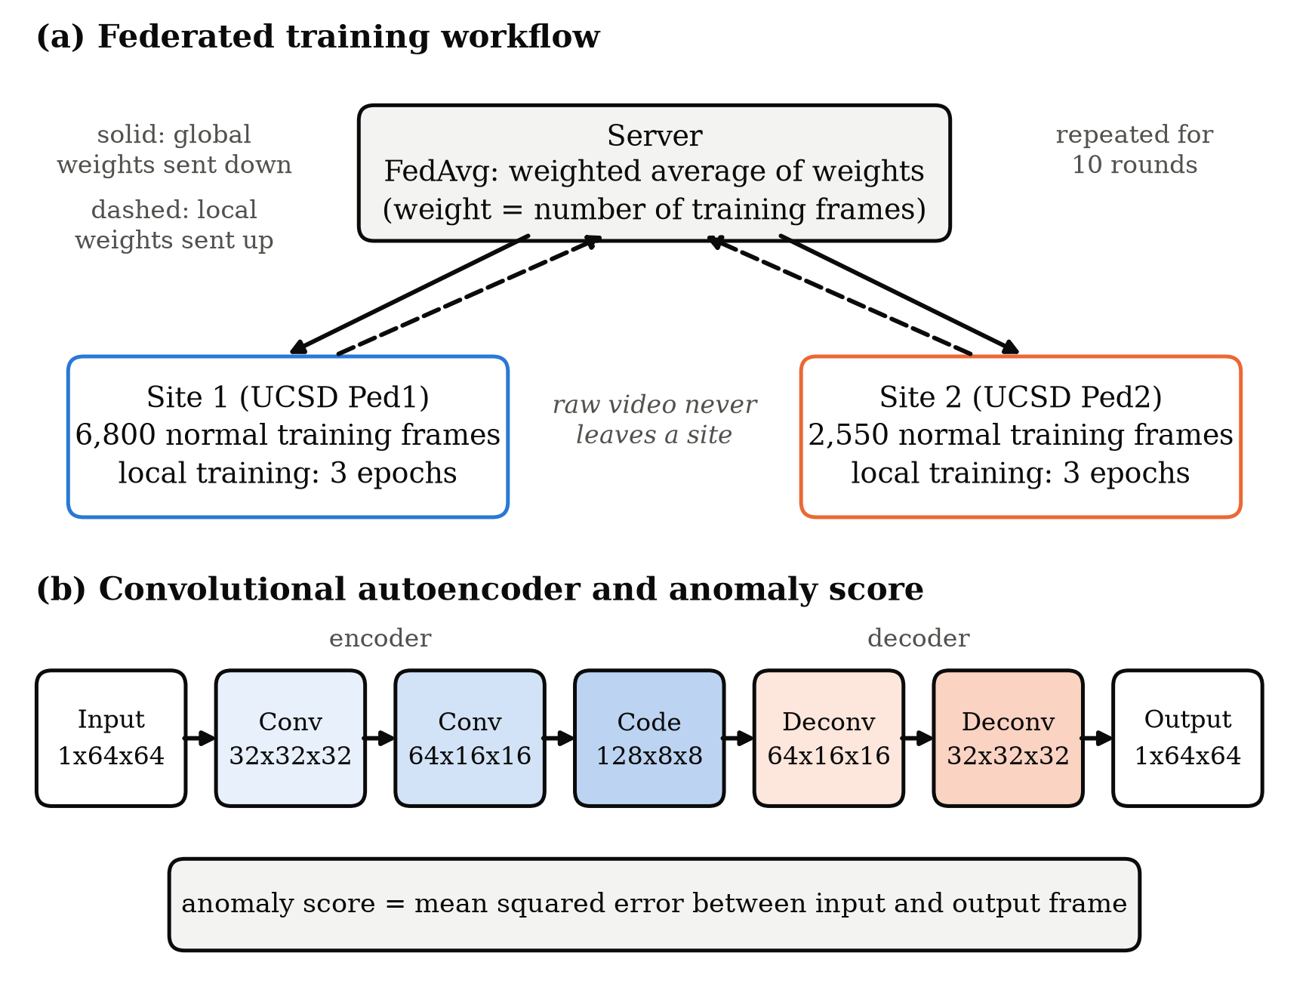
Figure 1. Overview of the system. (a) In each of 10 rounds the server sends the global autoencoder weights to Site 1 (UCSD Ped1) and Site 2 (UCSD Ped2). Each site trains for 3 epochs on its own normal frames, and the server averages the returned weights in proportion to each site's number of training frames (FedAvg). Only weights are exchanged. (b) The convolutional autoencoder (Conv: convolution; Deconv: transposed convolution) turns a 64 × 64 grayscale frame into a 128 × 8 × 8 code and back. A frame's anomaly score is its mean squared reconstruction error.

3.4 Experimental setup
We compared three ways of training the same model, each with 30 passes over each site's data. Federated training used FedAvg with 10 rounds of 3 local epochs. Centralised training pooled the 9,350 training frames of both sites and trained one model for 30 epochs. It ignores privacy and serves as the reference. Single-site training gave each site its own model, trained for 30 epochs on its own frames only. All models were tested on both sites.
All models used the Adam optimiser with a learning rate of 0.001, a batch size of 64 and the loss of Eq. (1). The main metric was the frame-level area under the ROC curve (AUC), computed separately for each site over all of its test frames. An AUC of 1 means perfect detection and 0.5 means random guessing. We also report the mean of the two site AUCs. Communication cost was computed with Eq. (4), where P is the number of parameters, each stored in 4 bytes, the factor 2 counts sending and receiving, K is the number of sites and R the number of rounds.
C = P × 4 bytes × 2 × K × R (4)
Each experiment was run 5 times with random seeds 42 to 46, and we report the mean ± standard deviation. Runs with the same seed give exactly the same result. To check whether a difference between two methods is larger than run-to-run noise, we used a paired t-test on the mean AUC. The code was written in Python 3.11 with PyTorch 2.14 and scikit-learn 1.9, and all runs used one NVIDIA GeForce GTX 1650 Ti laptop GPU. One federated run took about 63 s and one centralised run about 57 s. Both sites were simulated on the same machine.

4. Results

4.1 Detection accuracy
Table 2 shows the results. The federated model reached a mean AUC of 0.731 ± 0.011, and centralised training reached 0.737 ± 0.006. The gap of 0.006 was smaller than the run-to-run variation, and the t-test did not find it significant (p = 0.28). The two methods differed by site: the federated model did better on Site 1 (0.709 against 0.694), while centralised training did better on Site 2 (0.779 against 0.753).
Single-site training was clearly weaker. The Site 1 model reached 0.696 on its own site but only 0.515 on Site 2, close to random guessing. The Site 2 model reached 0.718 on its own site and 0.668 on Site 1. The federated model had a higher mean AUC than both single-site models (p < 0.001 and p = 0.007). It also scored higher than each single-site model on that model's own site in 4 or more of the 5 runs.
Method | Site 1 AUC (Ped1) | Site 2 AUC (Ped2) | Mean AUC | p-value (vs. federated)
Single site, Site 1 model | 0.696 ± 0.011 | 0.515 ± 0.061 | 0.605 ± 0.028 | < 0.001
Single site, Site 2 model | 0.668 ± 0.005 | 0.718 ± 0.016 | 0.693 ± 0.008 | 0.007
Centralised (pooled data) | 0.694 ± 0.004 | 0.779 ± 0.013 | 0.737 ± 0.006 | 0.283
Federated (this work) | 0.709 ± 0.006 | 0.753 ± 0.019 | 0.731 ± 0.011 | Reference
Table 2. Frame-level ROC-AUC of each training method on the test clips of both sites. Values are mean ± standard deviation over 5 runs. Single-site models are trained on one site and tested on both. p-values come from a paired t-test on the mean AUC against the federated model. Best result in each column in bold.

4.2 Training rounds and communication cost
Figure 2 shows the mean AUC of the federated model after each round. It started at 0.668 after round 1, rose to 0.736 at round 7, and then stayed close to that level, ending at 0.731. The results also became more consistent across runs as training went on. Each round exchanged 5.26 MB, so the full 10 rounds exchanged 52.6 MB. Stopping at round 7 would have needed 36.9 MB. For comparison, the raw training video of both sites is about 476 MB.
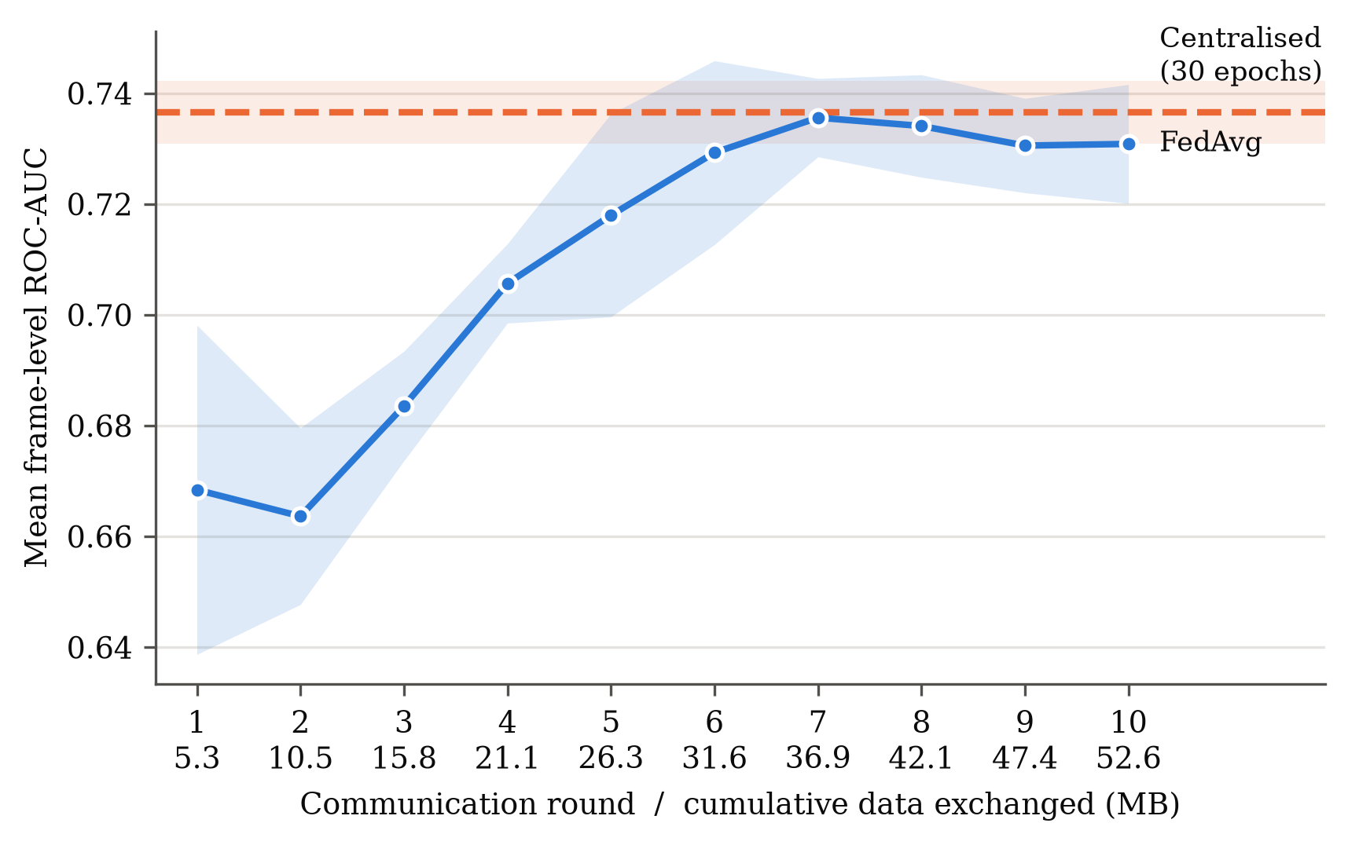
Figure 2. Mean frame-level ROC-AUC (average of Site 1 and Site 2) of the federated model after each round. The solid line is the mean over 5 runs and the shaded band shows ± one standard deviation. The dashed line shows the centralised model after 30 epochs. The second row of x-axis labels gives the total data exchanged so far, in megabytes (MB).

5. Discussion
The main result is that federated training came close to centralised training. The mean AUC gap of 0.006 is smaller than the variation between runs, so for this task keeping the video at each site cost little accuracy. A likely reason is that both scenes show similar content: a fixed camera, a walkway and people walking. The small autoencoder learns these shared patterns, so averaging the two sites' models loses little. The per-site results show that averaging still shifts the balance between sites, since the federated model did better on Site 1 and worse on Site 2.
The comparison with single-site training shows why federation is useful. A model trained at one site did poorly at the other (the Site 1 model scored 0.515 on Site 2), and the federated model did better than either single-site model overall. For a city such as Singapore, this suggests that camera sites with similar scenes could build one shared detector while keeping their footage on site.
Our AUC values are lower than published results on UCSD. For example, Hasan and colleagues reported 0.810 on Ped1 and 0.900 on Ped2. Their model used larger frames and stacks of frames that capture motion, while ours looks at one small frame at a time. Our aim was to measure the gap between training methods, not to reach the best score. The study also has clear limits. It used only two sites from one dataset, both sites ran on one machine, and five runs give limited statistical power. Sharing weights also does not give a formal privacy guarantee, and at this small scale the resized frames themselves would take less space to send than the weights.

6. Conclusion
This study trained a small convolutional autoencoder for video anomaly detection across two simulated camera sites, UCSD Ped1 and Ped2, using federated averaging. It compared the federated model with centralised and single-site training under the same training budget over five runs. The federated model reached a mean frame-level AUC of 0.731, against 0.737 for centralised training, and the difference was not significant. It clearly beat the models trained at a single site. Accuracy peaked after 7 rounds, and the full run exchanged 52.6 MB of weights while no video left either site. These results show, in a simple and repeatable setting, that federated learning can train a shared anomaly detector with little loss in accuracy while keeping footage private. Future work will test more sites with more varied scenes, add motion by using several frames as input, and add secure aggregation so that the server cannot see any single site's update.

Declarations
Acknowledgements. The authors thank the Statistical Visual Computing Laboratory at UC San Diego for making the UCSD Anomaly Detection Dataset publicly available.
Funding. This research received no specific grant from any funding agency.
Conflict of interest. The authors declare no conflict of interest.
Data availability. The UCSD Anomaly Detection Dataset is publicly available from the Statistical Visual Computing Laboratory, UC San Diego (http://www.svcl.ucsd.edu/projects/anomaly/). The code used in this study is available from the corresponding author on reasonable request.
Author contributions. All authors contributed to the conceptualisation, methodology, software, analysis and writing of this manuscript, and all authors read and approved the final version.

References
[1] Al-lahham, A., Tastan, N., Zaheer, M.Z., Nandakumar, K. (2024). Collaborative learning of anomalies with privacy (CLAP) for unsupervised video anomaly detection: A new baseline. In Proceedings of the IEEE/CVF Conference on Computer Vision and Pattern Recognition (CVPR), Seattle, WA, USA.
[2] Gong, D., Liu, L., Le, V., Saha, B., Mansour, M.R., Venkatesh, S., van den Hengel, A. (2019). Memorizing normality to detect anomaly: Memory-augmented deep autoencoder for unsupervised anomaly detection. In Proceedings of the IEEE/CVF International Conference on Computer Vision (ICCV), Seoul, Korea, pp. 1705-1714. https://doi.org/10.1109/ICCV.2019.00179
[3] Hasan, M., Choi, J., Neumann, J., Roy-Chowdhury, A.K., Davis, L.S. (2016). Learning temporal regularity in video sequences. In Proceedings of the IEEE Conference on Computer Vision and Pattern Recognition (CVPR), Las Vegas, NV, USA, pp. 733-742. https://doi.org/10.1109/CVPR.2016.86
[4] Liu, J., Liu, Y., Zhu, X. (2024). Privacy-preserving video anomaly detection: A survey. arXiv preprint arXiv:2411.14565. https://doi.org/10.48550/arXiv.2411.14565
[5] Liu, W., Luo, W., Lian, D., Gao, S. (2018). Future frame prediction for anomaly detection: A new baseline. In Proceedings of the IEEE Conference on Computer Vision and Pattern Recognition (CVPR), Salt Lake City, UT, USA, pp. 6536-6545. https://doi.org/10.1109/CVPR.2018.00684
[6] Mahadevan, V., Li, W., Bhalodia, V., Vasconcelos, N. (2010). Anomaly detection in crowded scenes. In Proceedings of the IEEE Conference on Computer Vision and Pattern Recognition (CVPR), San Francisco, CA, USA, pp. 1975-1981. https://doi.org/10.1109/CVPR.2010.5539872
[7] McMahan, B., Moore, E., Ramage, D., Hampson, S., Arcas, B.A. (2017). Communication-efficient learning of deep networks from decentralized data. In Proceedings of the 20th International Conference on Artificial Intelligence and Statistics (AISTATS), Fort Lauderdale, FL, USA, pp. 1273-1282.
[8] Qi, F., Pan, R., Zhang, H., Xu, C. (2024). FedVAD: Enhancing federated video anomaly detection with GPT-driven semantic distillation. In Computer Vision, ECCV 2024, Lecture Notes in Computer Science. Cham: Springer. https://doi.org/10.1007/978-3-031-73668-1_14
[9] Republic of Singapore. (2012). Personal Data Protection Act 2012 (No. 26 of 2012). Retrieved from https://sso.agc.gov.sg/Act/PDPA2012, accessed on Oct. 11, 2026.
[10] Reuters. (2018). Singapore to test facial recognition on lampposts, stoking privacy fears. Reuters, Apr. 13, 2018.
[11] Smart Nation and Digital Government Office. (2018). Smart Nation: The way forward. Singapore: Prime Minister's Office. Retrieved from https://www.smartnation.gov.sg/files/publications/smart-nation-strategy-nov2018.pdf, accessed on Oct. 11, 2026.
[12] Su, Y., Li, J., An, S., Xing, M., Feng, Z. (2025). Federated weakly-supervised video anomaly detection with mixture of local-to-global experts. Information Fusion, 103256. https://doi.org/10.1016/j.inffus.2025.103256
[13] Sultani, W., Chen, C., Shah, M. (2018). Real-world anomaly detection in surveillance videos. In Proceedings of the IEEE Conference on Computer Vision and Pattern Recognition (CVPR), Salt Lake City, UT, USA, pp. 6479-6488. https://doi.org/10.1109/CVPR.2018.00678
[14] Wang, B., Huang, C., Wen, J., Wang, W., Liu, Y., Xu, Y. (2025). Federated weakly supervised video anomaly detection with multimodal prompt. In Proceedings of the AAAI Conference on Artificial Intelligence, Philadelphia, PA, USA, 39(20): 21017-21025. https://doi.org/10.1609/aaai.v39i20.35398
[15] Wu, P., Pan, C., Yan, Y., Pang, G., Wang, P., Zhang, Y. (2024). Deep learning for video anomaly detection: A review. arXiv preprint arXiv:2409.05383. https://doi.org/10.48550/arXiv.2409.05383
[16] Zhao, Y., Li, M., Lai, L., Suda, N., Civin, D., Chandra, V. (2018). Federated learning with non-IID data. arXiv preprint arXiv:1806.00582. https://doi.org/10.48550/arXiv.1806.00582

