Smart Cascading Risk Prediction for Data Center Monitoring
On-site anomaly detection and short-term fault-risk forecasting
Nishant Ajit (23BCT0097) · Vishnu Charan (23BCT0081)

Abstract
Server rooms need early warning before temperature, humidity or air quality reach unsafe levels, but most IoT monitors only alert after a fixed limit is crossed. This project builds a predictive monitor. An ESP32-S3 node streams temperature, humidity and eCO2 to a local server, which looks at the level, spread and trend of the last five readings. An Isolation Forest flags abnormal behaviour, a fault-attribution step names the likely cause (thermal, ventilation, dust or sensor), and a Markov chain estimates the risk of a fault 10, 15 and 30 minutes ahead. Results stream live to a web dashboard. On data it had not seen, the detector caught 92% of planted faults and outperformed a standard z-score check (ROC-AUC 0.80 against 0.71).

1. Novelty
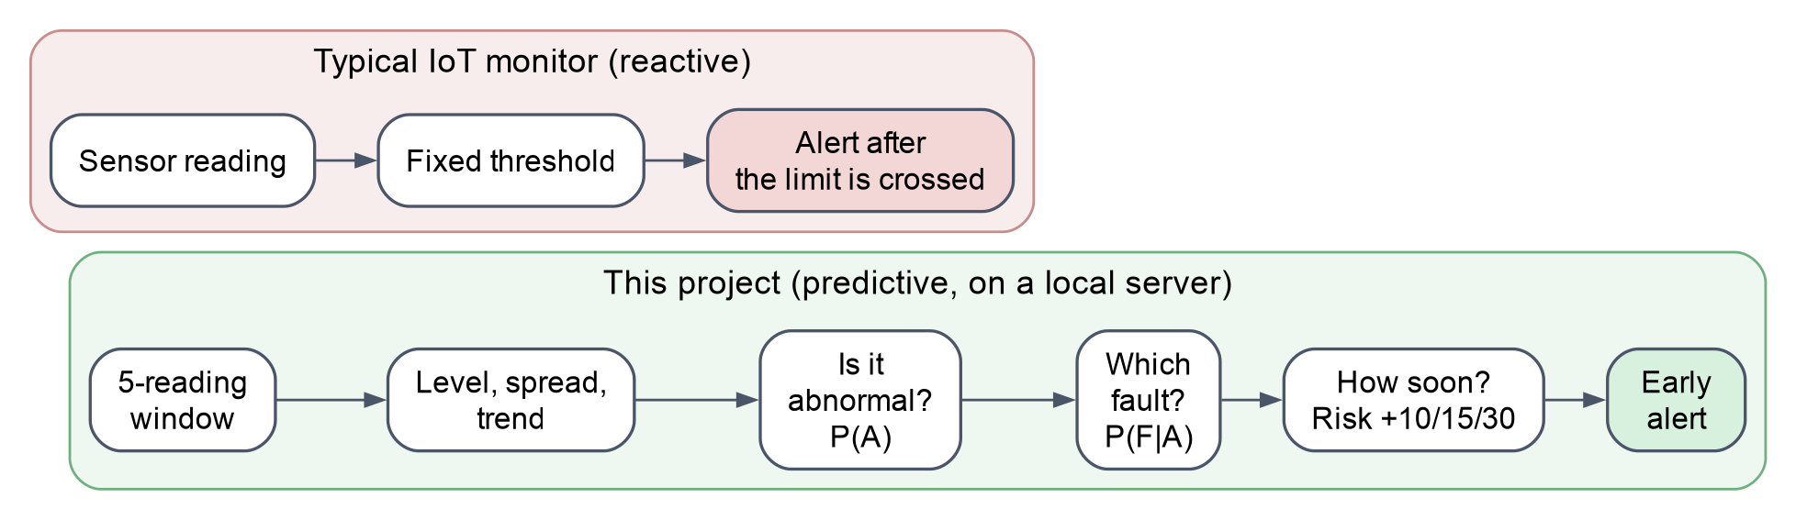
Figure 1. Reactive threshold monitoring compared with the cascading prediction in this project.
The principal contribution of this work is a cascaded prediction scheme. The anomaly probability produced by the detector is converted into a distribution over fault types and then propagated forward in time with a Markov chain, giving fault-risk estimates at 10, 15 and 30 minutes instead of a single threshold alert.
Three further aspects distinguish the system. Windowed trend features (mean, standard deviation and slope) allow gradual drift to be detected, which per-reading thresholds largely miss (ROC-AUC 0.80 against 0.65). All inference runs on a local server, so operation does not depend on internet connectivity. Finally, since labelled fault data is unavailable, the system is evaluated with planted faults and baseline comparisons.

2. Literature Review
Work | Focus | Gap
Onibonoje et al., 2019 | Cloud-based server-room monitoring and control | Reactive; needs internet
Widodo et al., 2022 | Fuzzy-logic temperature and humidity control | No failure prediction
Tishan, Ashly et al., 2023 | Server-room monitoring with instant alerts | Limited prediction
Liu, Ting & Zhou, 2008 | Isolation Forest anomaly detection | No fault type or time horizon
Table 1. Related work.
None of these systems combines detection, fault attribution and time-horizon forecasting on a local server.

2.1 How the dataset is used
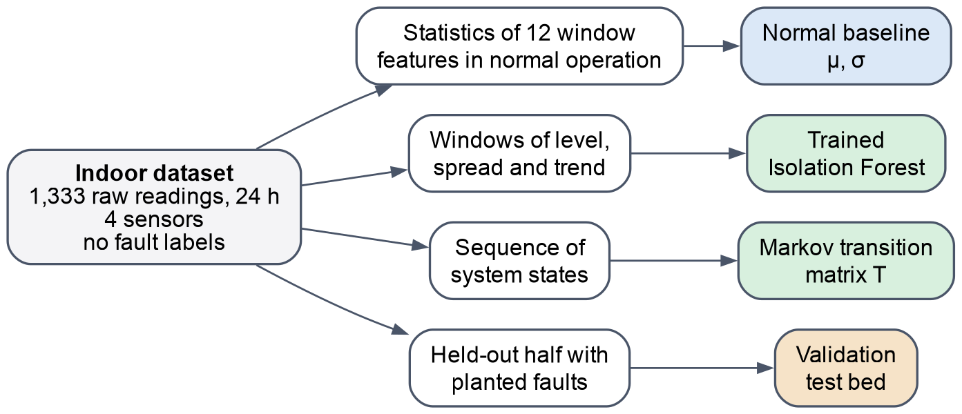
Figure 2. One raw dataset, four separate uses.
The dataset contains only raw sensor readings, with no faults or labels. The project derives four new things from it: a normal baseline, a trained detector, a matrix of how the system moves between states, and a test bed with planted faults. None of these exist in the data itself; the combination is what turns readings into a forecast.

3. System Architecture
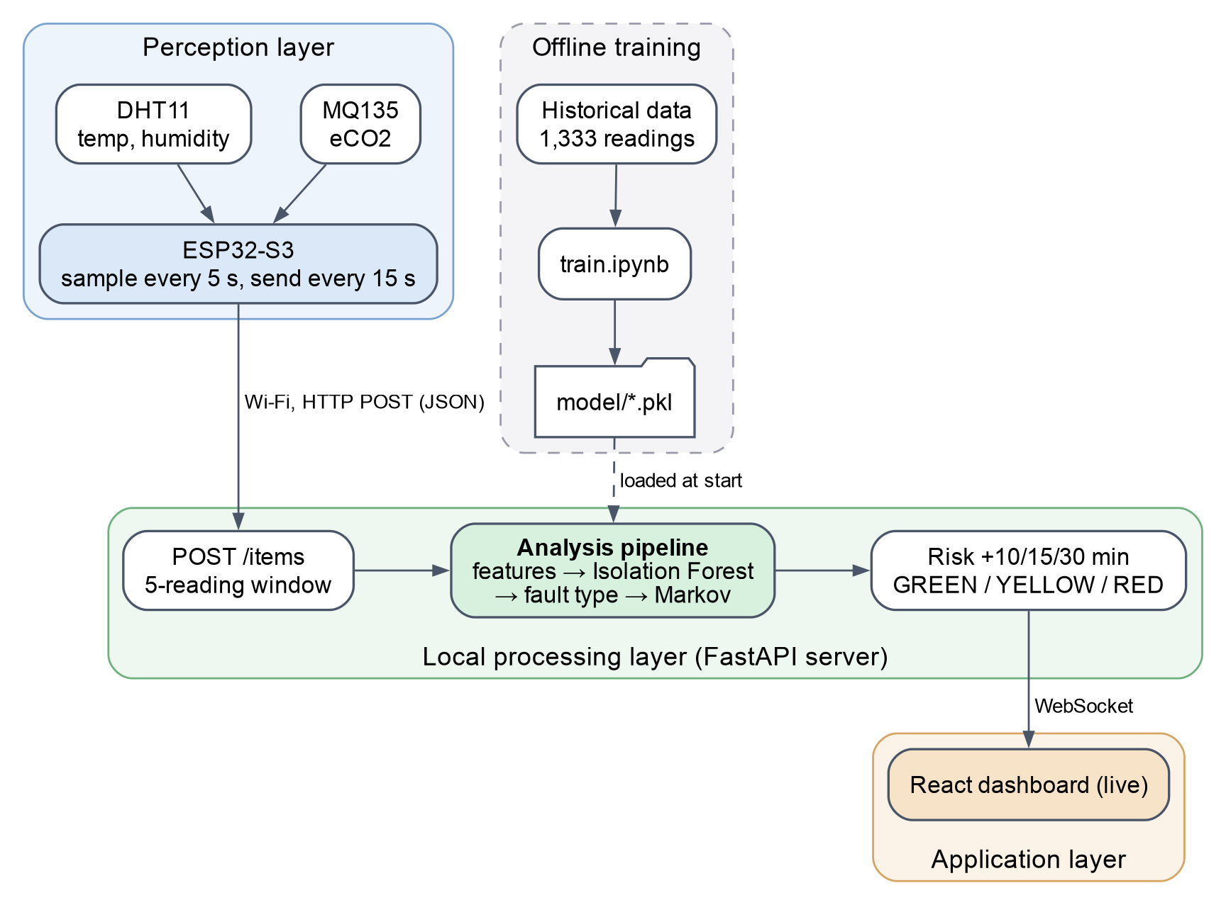
Figure 3. System architecture.

4. Interfacing Diagram
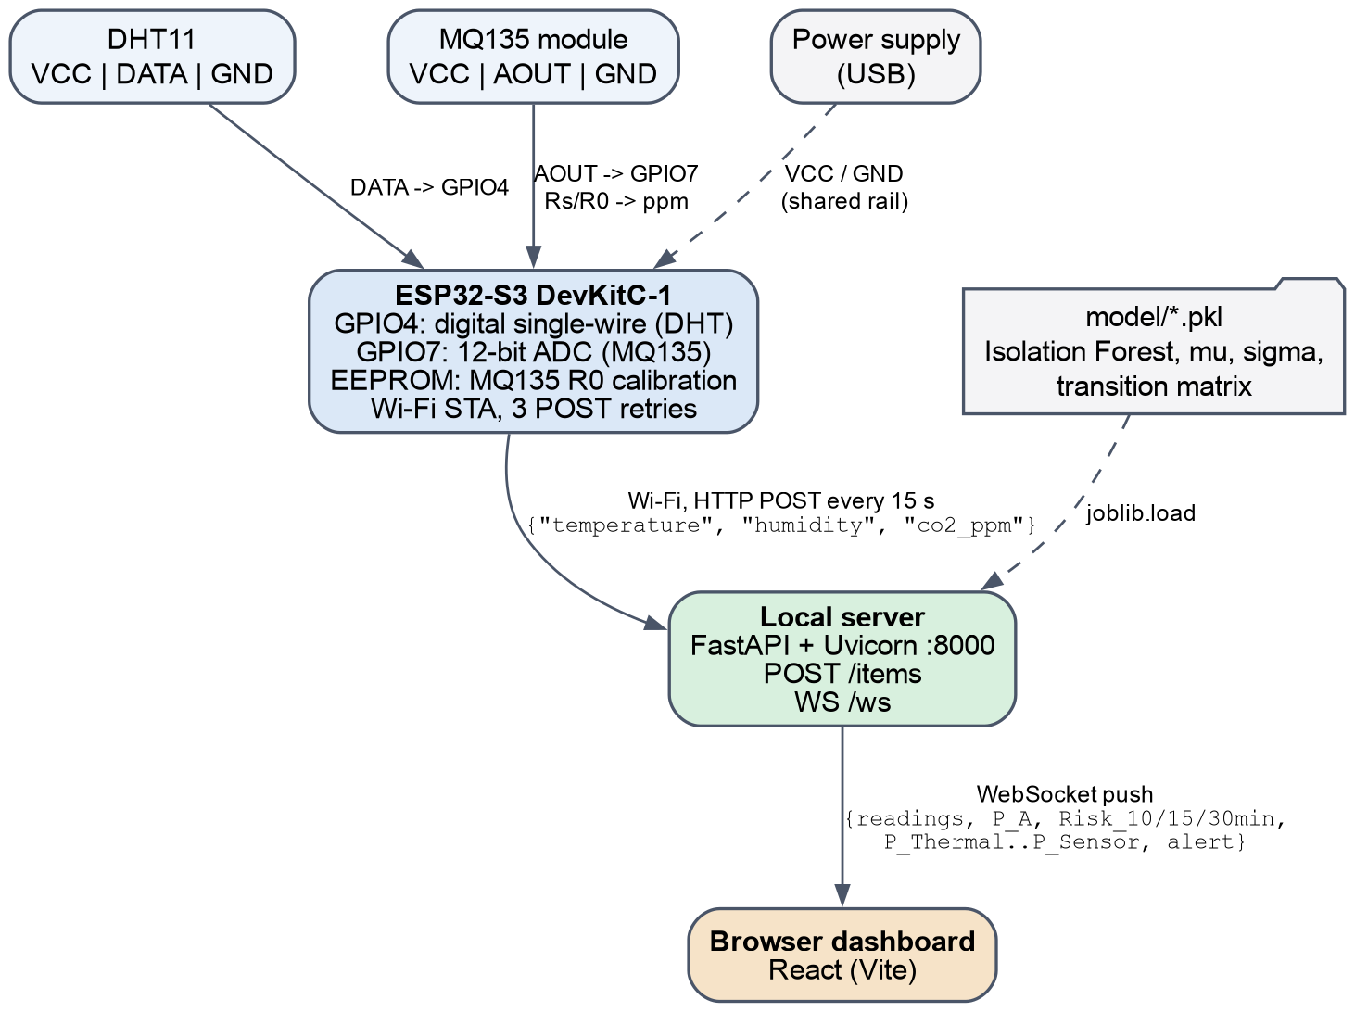
Figure 4. Hardware and software interfaces.
The prototype has no dust sensor yet, so the server substitutes a typical value for the dust channel.

5. Processing Pipeline
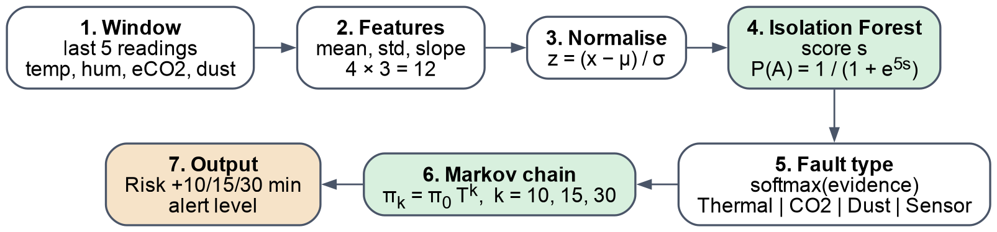
Figure 5. Processing pipeline for each 5-reading window. One Markov step is one reading (about one minute).

6. Results
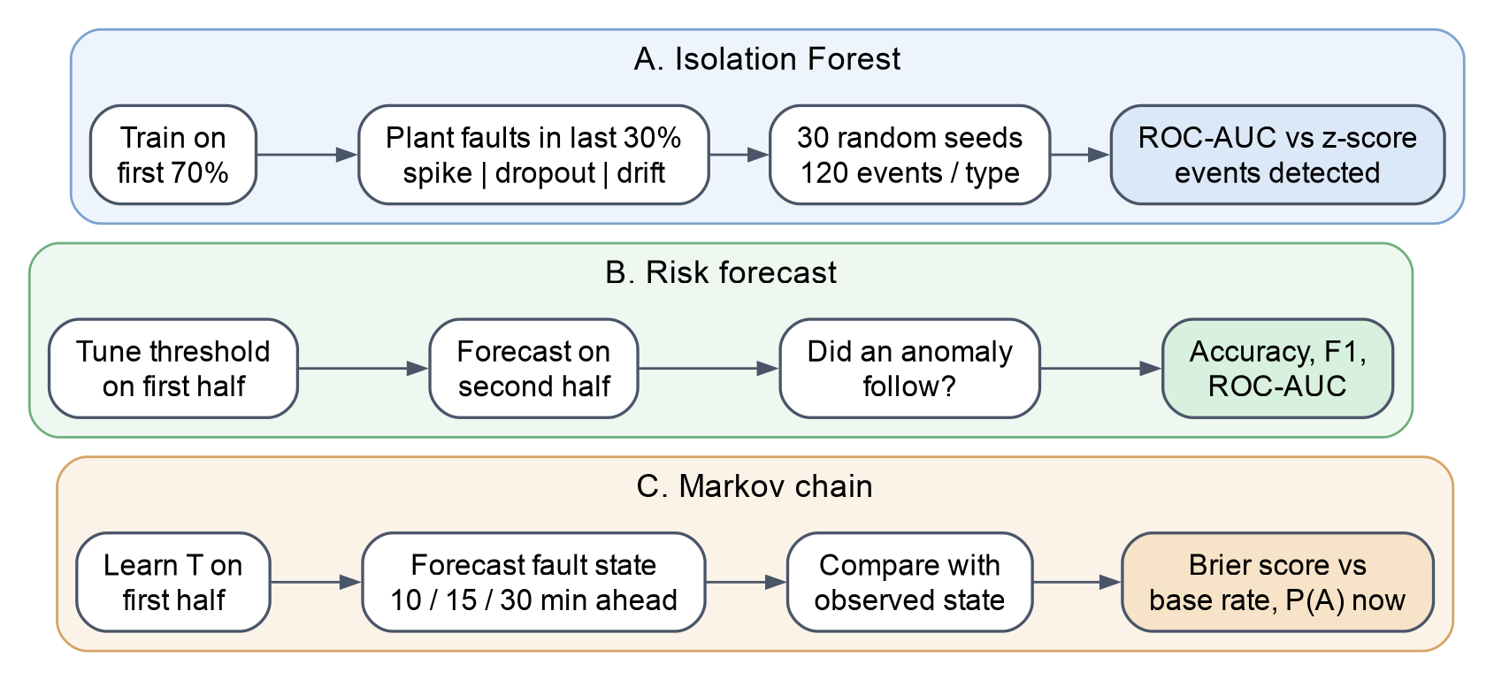
Figure 6. How each component was validated. All tests use data the models were not trained on.
0.80  Isolation Forest ROC-AUC  (baseline 0.71) | 92%  planted faults detected | 0.82  10-min forecast ROC-AUC | 36%  lower Brier score than  P(A) now

6.1 Anomaly detection (planted faults)
Fault | Isolation Forest | z-score | Detected
Spike | 0.82 ± 0.06 | 0.81 ± 0.09 | 89%
Dropout | 0.80 ± 0.06 | 0.86 ± 0.05 | 88%
Drift | 0.80 ± 0.05 | 0.65 ± 0.11 | 99%
All | 0.80 ± 0.04 | 0.71 ± 0.08 | 92%
Table 2. ROC-AUC (mean ± std, 30 seeds) and share of planted events detected.
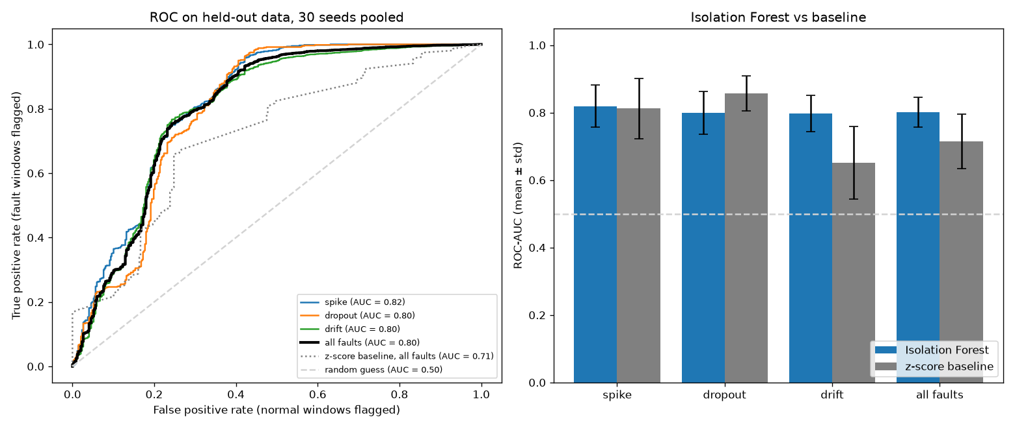
Figure 7. ROC curves (left) and ROC-AUC against the z-score baseline (right).
Each curve shows the share of faults caught (y-axis) for a given share of false alarms (x-axis); curves closer to the top-left are better, and the diagonal is random guessing. The bar chart shows the model ahead of the z-score check overall, and most clearly on gradual drift.
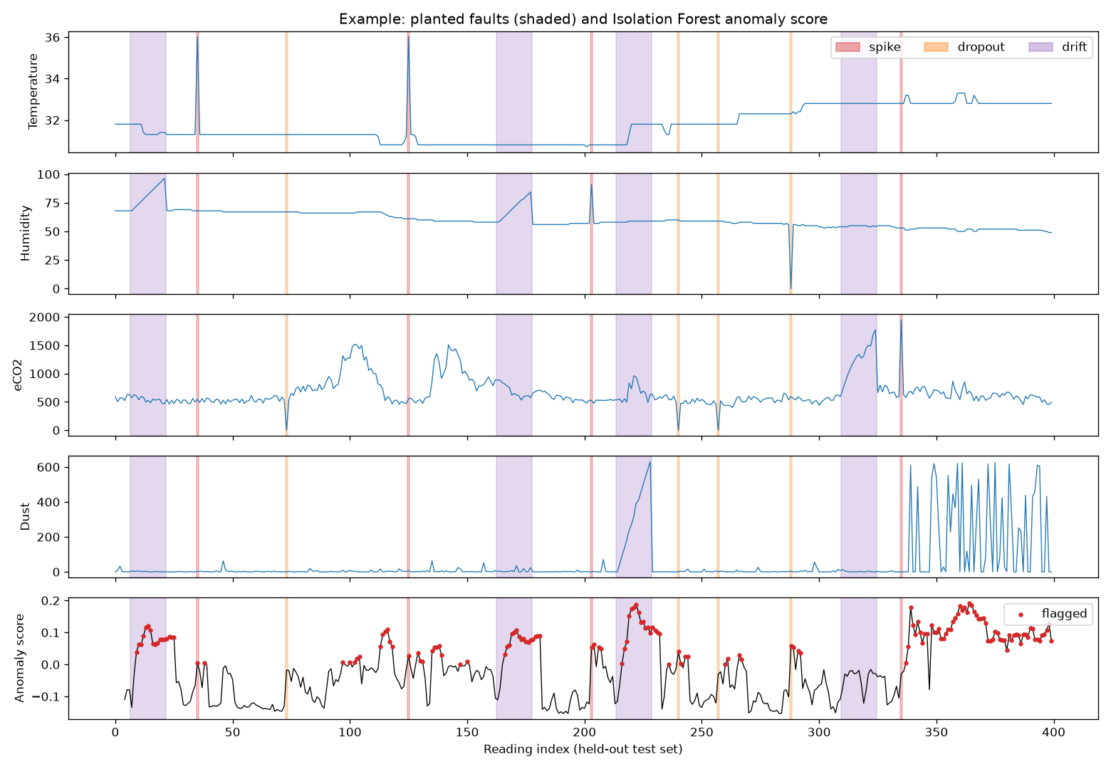
Figure 8. Planted faults (shaded) and the anomaly score; flagged windows in red.
Each shaded band is a fault inserted into real data, and the bottom panel is the model's anomaly score. The score rises at the bands, so the model reacts to the faults. Some flags outside the bands mark real events, such as the eCO2 rise near reading 120 and the erratic dust readings at the end.

6.2 Risk forecast
Horizon | Accuracy | Always 'no' | F1 | ROC-AUC | Correlation
10 min | 0.83 | 0.77 | 0.63 | 0.82 | 0.58
15 min | 0.71 | 0.72 | 0.54 | 0.76 | 0.49
30 min | 0.37 | 0.59 | 0.55 | 0.61 | 0.32
Table 3. Forecast of upcoming anomalies, on the test half.
At 10 minutes the forecast beats always guessing 'no anomaly' and ranks upcoming anomalies correctly 82% of the time. Accuracy falls further ahead, as expected for any forecast.

6.3 Markov chain
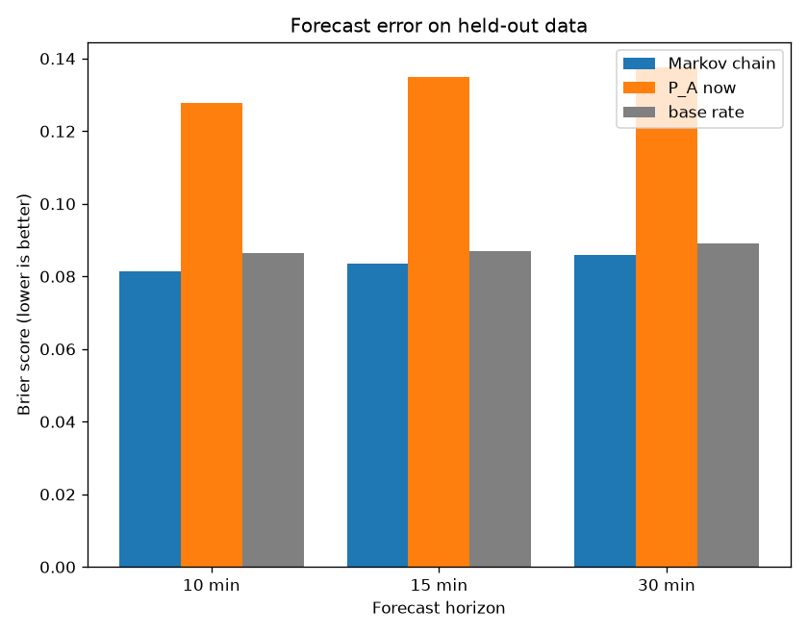
Figure 9. Brier score of the fault-state forecast on held-out data (lower is better).
The Brier score measures how far predicted probabilities are from what actually happened. The Markov chain (blue) is lowest at every horizon: more accurate than assuming the current state continues (orange) or always predicting the average fault rate (grey).
Horizon | Markov | P(A) now | Base rate
10 min | 0.082 | 0.128 | 0.086
15 min | 0.084 | 0.135 | 0.087
30 min | 0.086 | 0.138 | 0.089
Table 4. Brier score by horizon. The Markov chain is the most accurate at every horizon.

7. Conclusion
- End-to-end system, from the sensor node to a live dashboard.
- Beats a z-score baseline overall, most clearly on gradual drift.
- Gives useful fault-risk forecasts, strongest at 10 minutes.
- Next: longer, multi-room data and a dust sensor on the node.

References
- F. T. Liu, K. M. Ting and Z.-H. Zhou, "Isolation Forest," IEEE ICDM, 2008.
- G. W. Brier, "Verification of forecasts expressed in terms of probability," Monthly Weather Review, 1950.
- M. O. Onibonoje et al., "An IoT-based approach to real-time conditioning and control in a server room," 2019.
- A. M. Widodo et al., "IoT based multi-server room temperature and humidity monitoring … fuzzy logic controller," 2022.
- Y. Tishan, I. Ashly et al., "Real-time server room monitoring system using IoT technology," 2023.

