**Table 1. Branch**

Branch_no - Set as PRIMARY KEY Manager_Id Branch_address Contact_no

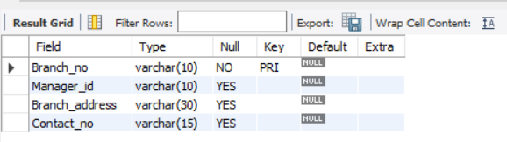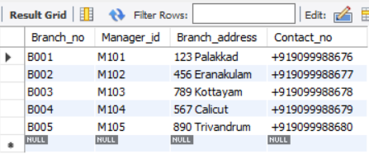

**Table 2. Employee**

Emp_Id – Set as PRIMARY KEY Emp_name Position Salary Branch_no - Set as FOREIGN KEY and it refer Branch_no in Branch

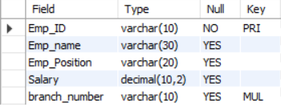

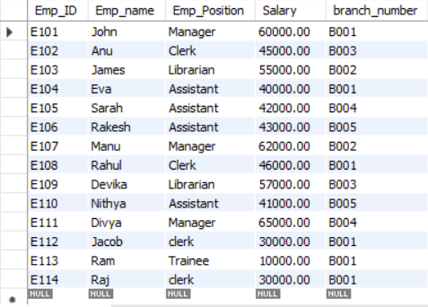

**Table 3. Books**

ISBN - Set as PRIMARY KEY Book_title Category Rental_Price Status [Give yes if book available and no if book not available] Author Publisher

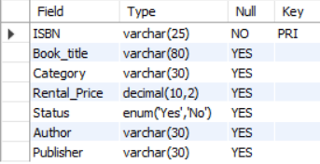



**Table 4. Customer**

Customer_Id - Set as PRIMARY KEY Customer_name Customer_address Reg_date

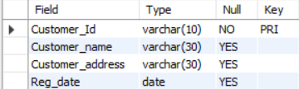

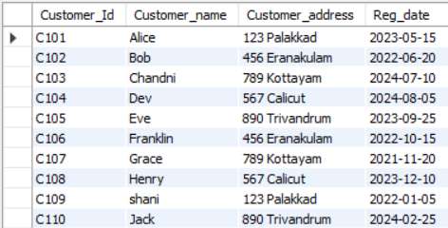

**Table 5. IssueStatus**

Issue_Id - Set as PRIMARY KEY Issued_cust – Set as FOREIGN KEY and it refer customer_id in CUSTOMER table Issued_book_name Issue_date Isbn_book –

Set as FOREIGN KEY and it should refer isbn in BOOKS table

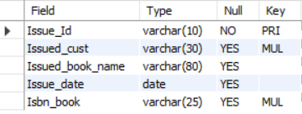

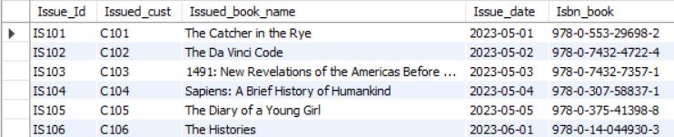

**Table 6. ReturnStatus**

Return_Id - Set as PRIMARY KEY Return_cust Return_book_name Return_date Isbn_book2 - Set as FOREIGN KEY and it should refer isbn in BOOKS

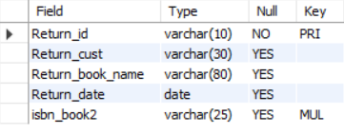

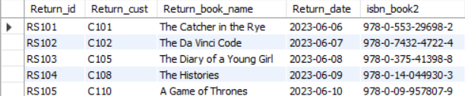

**Queries**

1. Retrieve the book title, category, and rental price of all available books.

SELECT book_title, category, rental_price FROM books

WHERE Status = 'Yes';

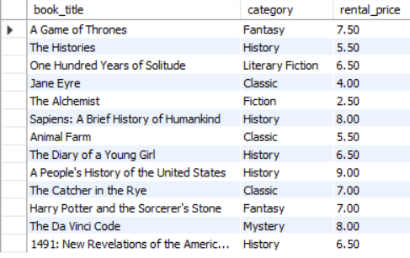

1. List the employee names and their respective salaries in descending order of salary.

SELECT emp_name, salary FROM employee

ORDER BY Salary DESC;

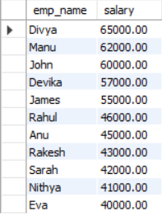

1. Retrieve the book titles and the corresponding customers who have issued those books.

SELECT

issuestatus.Issued_book_name, customer.Customer_name

FROM

issuestatus

INNER JOIN

customer ON issuestatus.Issued_cust = customer.Customer_Id;

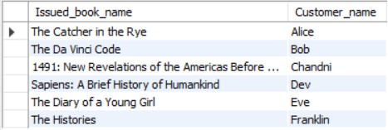

1. Display the total count of books in each category.

SELECT Category, COUNT(Book_title) as count FROM books

GROUP BY Category;

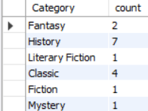

1. Retrieve the employee names and their positions for the employees whose salaries are above Rs.50,000

SELECT Emp_name as Employee_name, emp_position as position from employee where salary>50000;

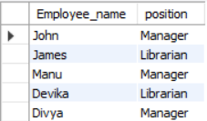

1. List the customer names who registered before 2022-01-01 and have not issued any books yet.

SELECT customer_name FROM customer

WHERE Reg_date < '2022-01-01' AND Customer_Id NOT IN

(SELECT issued_cust FROM issuestatus);

C:\Users\User\Desktop\6.png

1. Display the branch numbers and the total count of employees in each branch.

SELECT Branch_number, COUNT(emp_id) as Count

FROM employee GROUP BY branch_number;

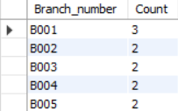

1. Display the names of customers who have issued books in the month of June 2023

SELECT customer.Customer_name as Customer_Name FROM customer

INNER JOIN issuestatus ON

customer.Customer_Id = issuestatus.Issued_cust

WHERE issuestatus.Issue_date >= '2023-06-01'

AND issuestatus.Issue_date <= '2023-06-30';

C:\Users\User\Desktop\8.png

1. Retrieve book_title from book table containing history.

SELECT Book_title FROM books

WHERE Category = 'history';



1. Retrieve the branch numbers along with the count of employees for branches having more than 5 employees

SELECT branch_number, COUNT(emp_id) as count

FROM employee

GROUP BY branch_number

HAVING COUNT(Emp_id) > 5;

C:\Users\User\Desktop\10.png

1. Retrieve the names of employees who manage branches and their respective branch addresses.

Select E.Emp_name , b.Branch_Address from employee E

inner join branch b

on e.branch_number = b.branch_no and emp_position = 'Manager';

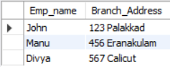

1. Display the names of customers who have issued books with a rental price higher than Rs. 25.

Select C.Customer_Name from customer c

join issuestatus i

on c.Customer_id = I.issued_cust

join books b on I.isbn_book= b.isbn and rental_price>25;

