**Project Title**:

Simple E Commerce Application

**Project Description**:

The project facilitates product management and order management in which products can be added and product details including images are listed along with edit and delete options. The order management includes collecting and listing of customer information like customer name, contact number etc. along product information like price, quantity etc.

**How to install and run the project:**

**Prerequisites:** Installation of Laravel and composer

**Step 1**: Setting up of path using command prompt

cd\

Xampp\htdocs

**Step 2:** Creating project

composer create-project laravel/laravel example-app

**Step 3:** Setting the configuration

**Step 4:** Run the project using

php artisan serve

Path used:

Local path url: <http://127.0.0.1:8000/>

**How to use the project:**

1. The user will be redirected to the page where product can be added. Product details can be added and saved. The entered data will be listed in the same page once product is added and has edit and delete options enabled.

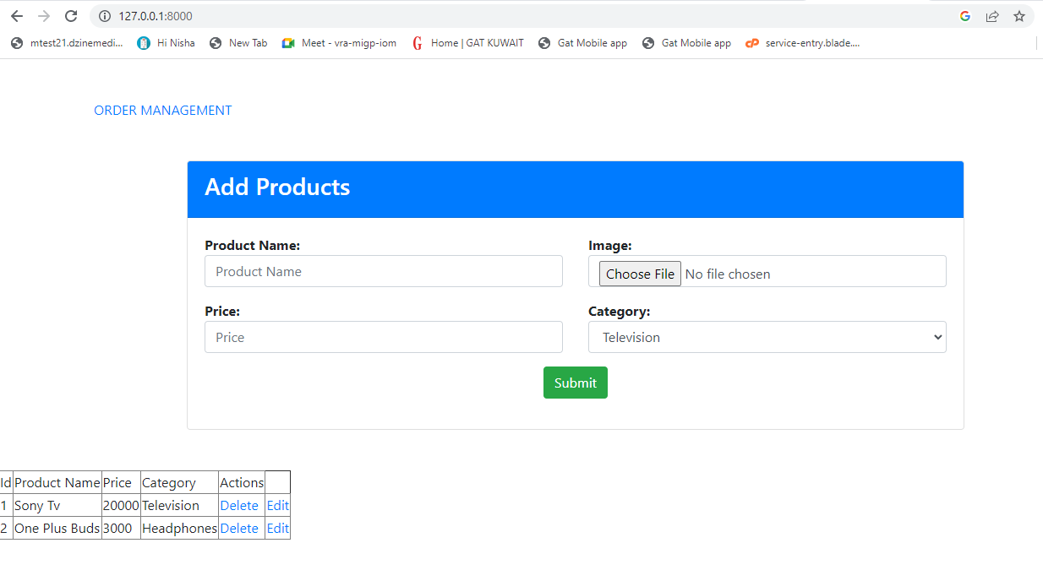

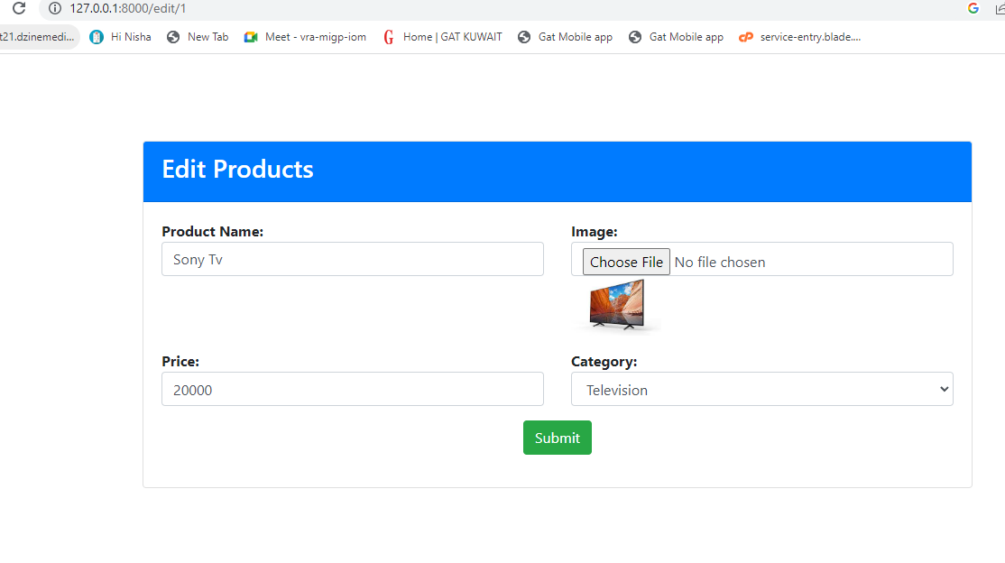

1. A link is provided in the product page that redirects to the order management page in which customer details and product details can be added and listed in the same page including total price.

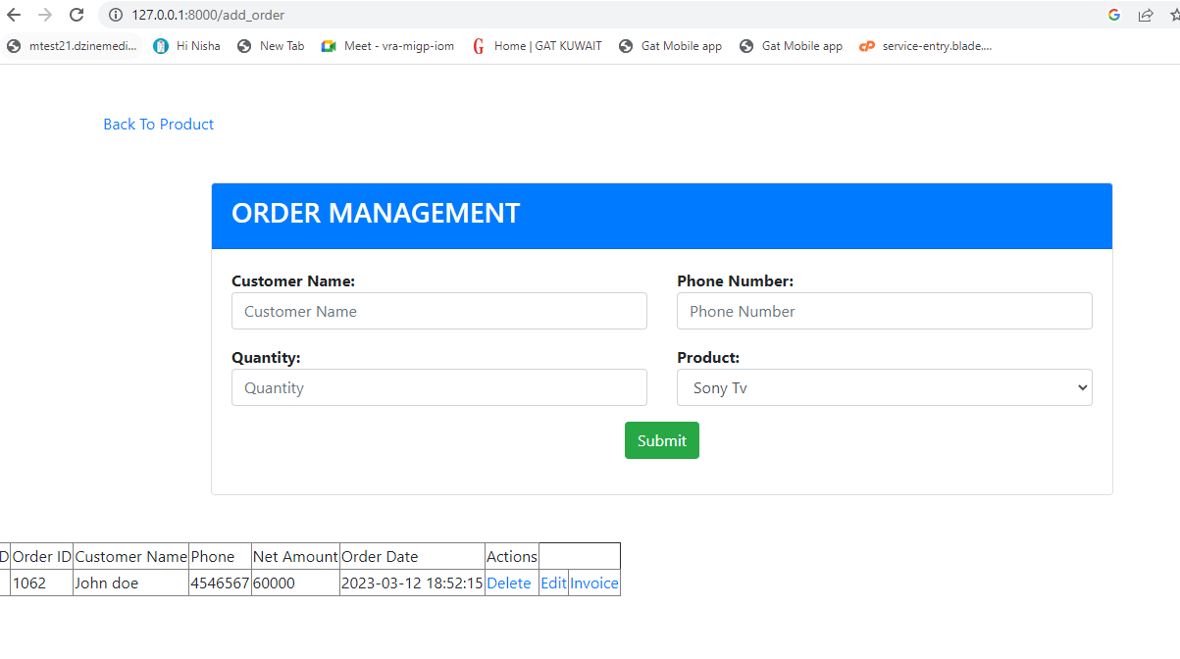

1. Table contains order id, customer name, phone number, net amount, order date with actions like edit, delete and invoice.
2. In the edit section provision to add additional products and corresponding quantities are shown.
3. Link to the main page is provided in the order management page.

**Challenges faced**

Multiple product insertion in edit page

