As you start the program you will see below image .It first will ask you for the valid folder path.

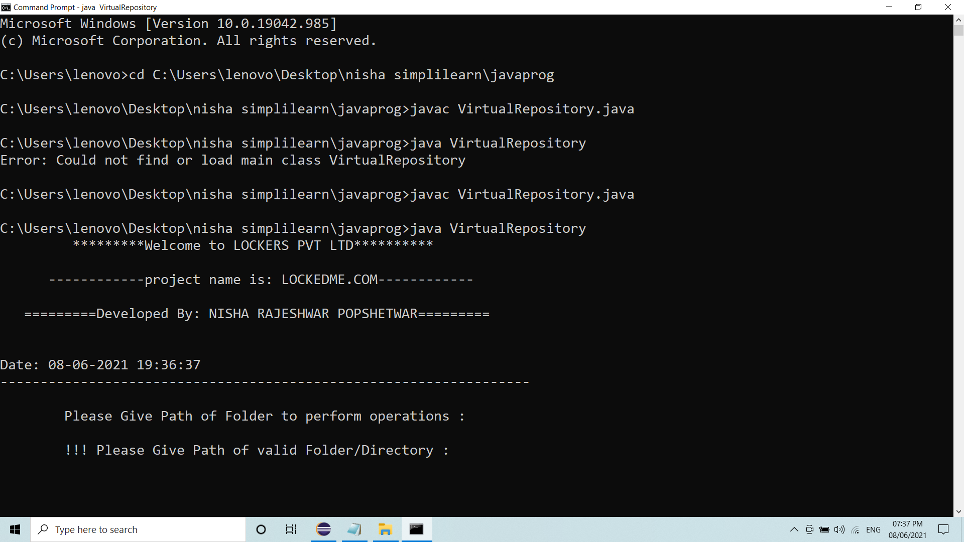

After entering valid folder path .In this image you could see the MainMenu.You have to choose

An option from 1 to 3.

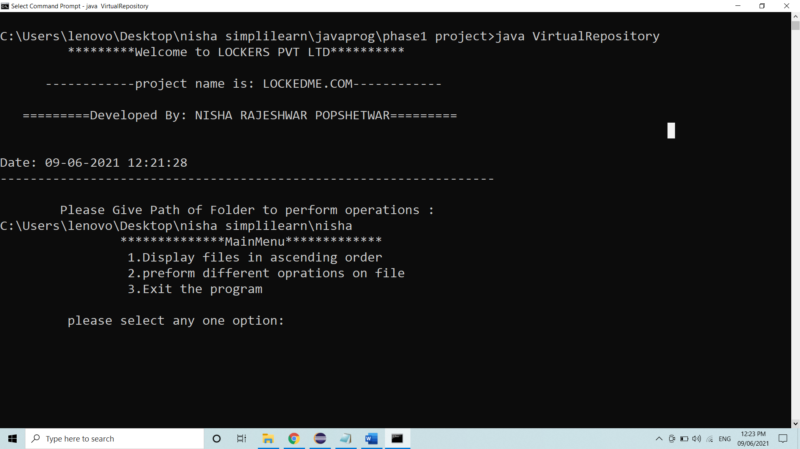

If you choose an option 1 ,it will display files in the folder in ascending order.

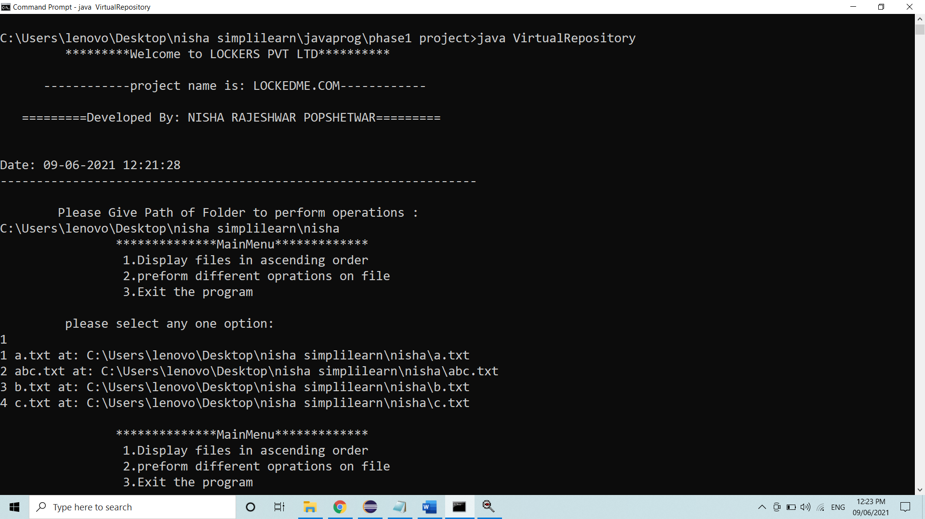

If you choose an option 2 ,it will show file operations.

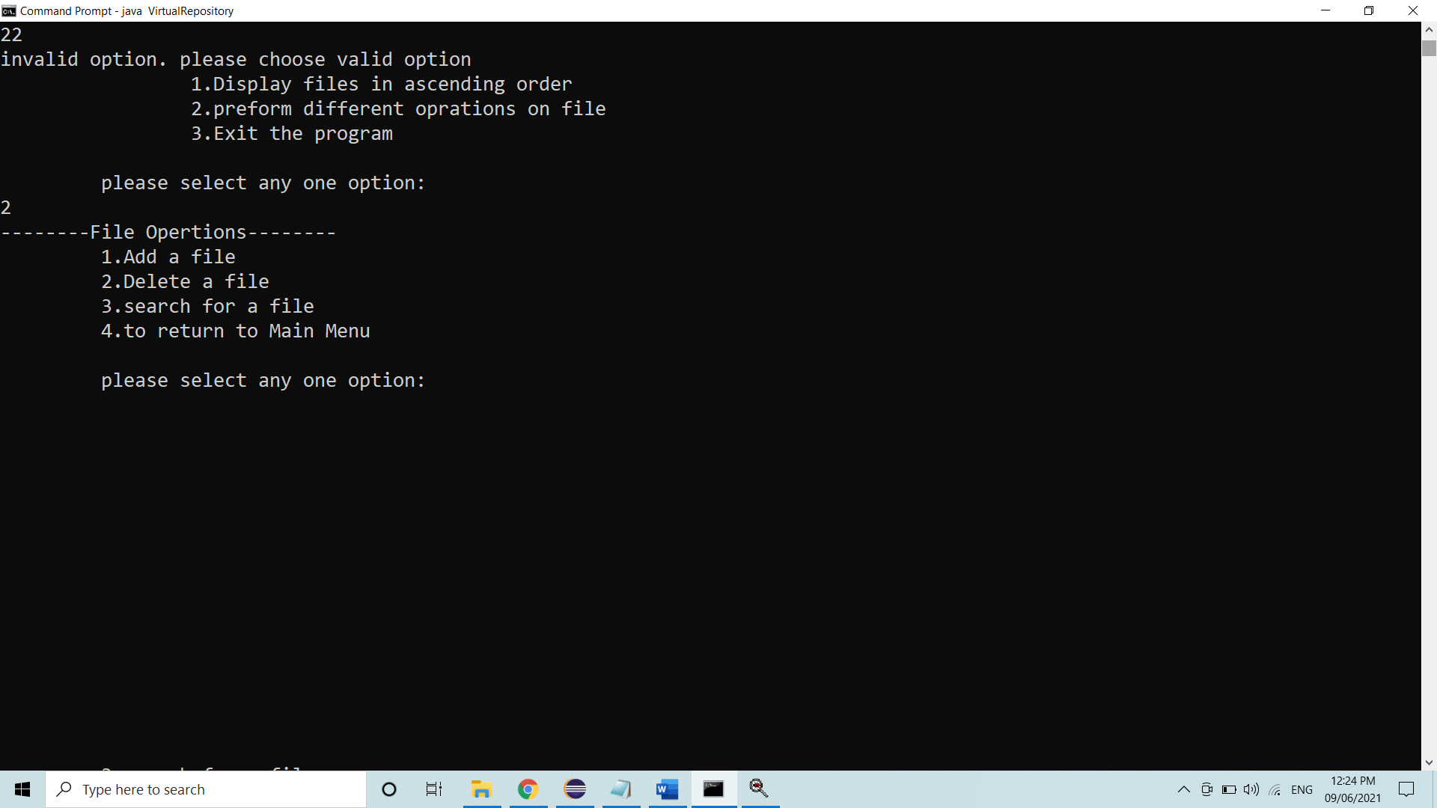

Now you have to choose one of the valid an option from 1 to 4 to perform given operations. If you choose an option 1 it will show below image.

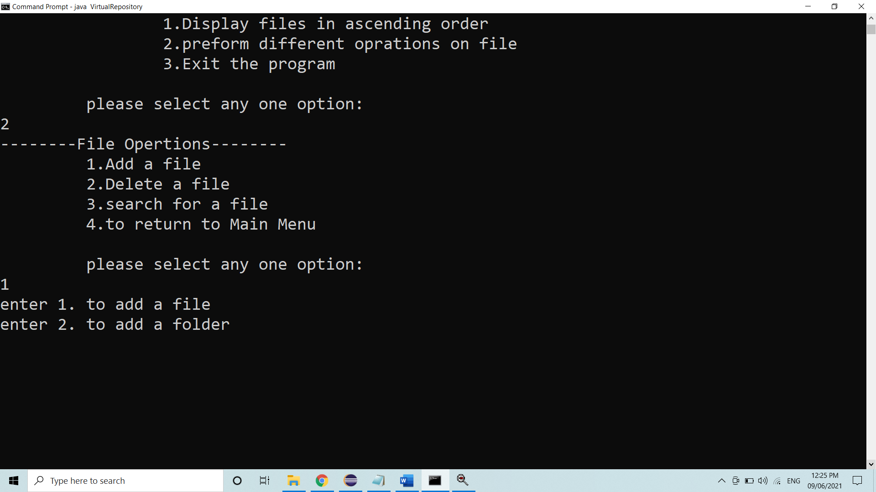

It will ask for folder or file 1 is for file and 2 is for folder. If select 1 then, it will ask a name of file to add. And it again ask for file operations.

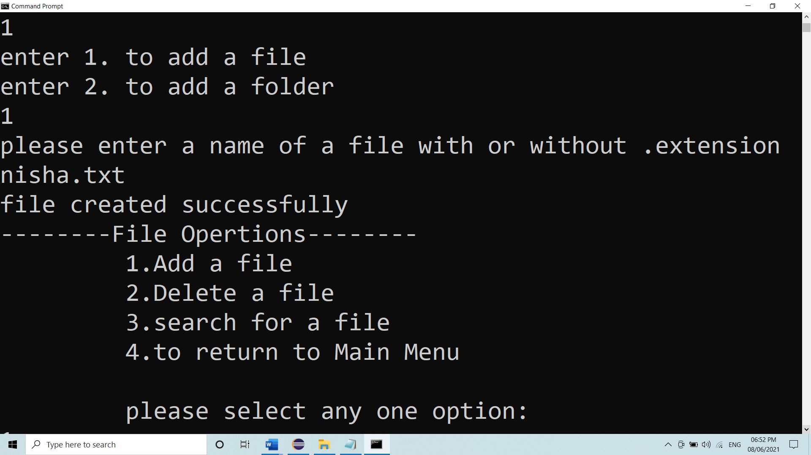

If you choose add a file and in that select an option 2 then it will ask for a path of directory/folder to add in a given folder. And after entering a valid path it will created a folder in given folder. Again ask for file options.

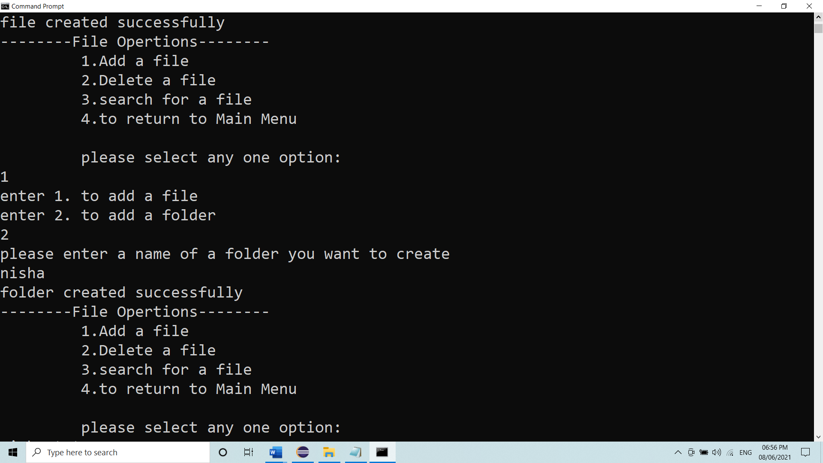

If you choose an option 2 it will ask a valid name of file you want to delete .and ask for conformation to delete a file from folder. and again ask for choose an option.

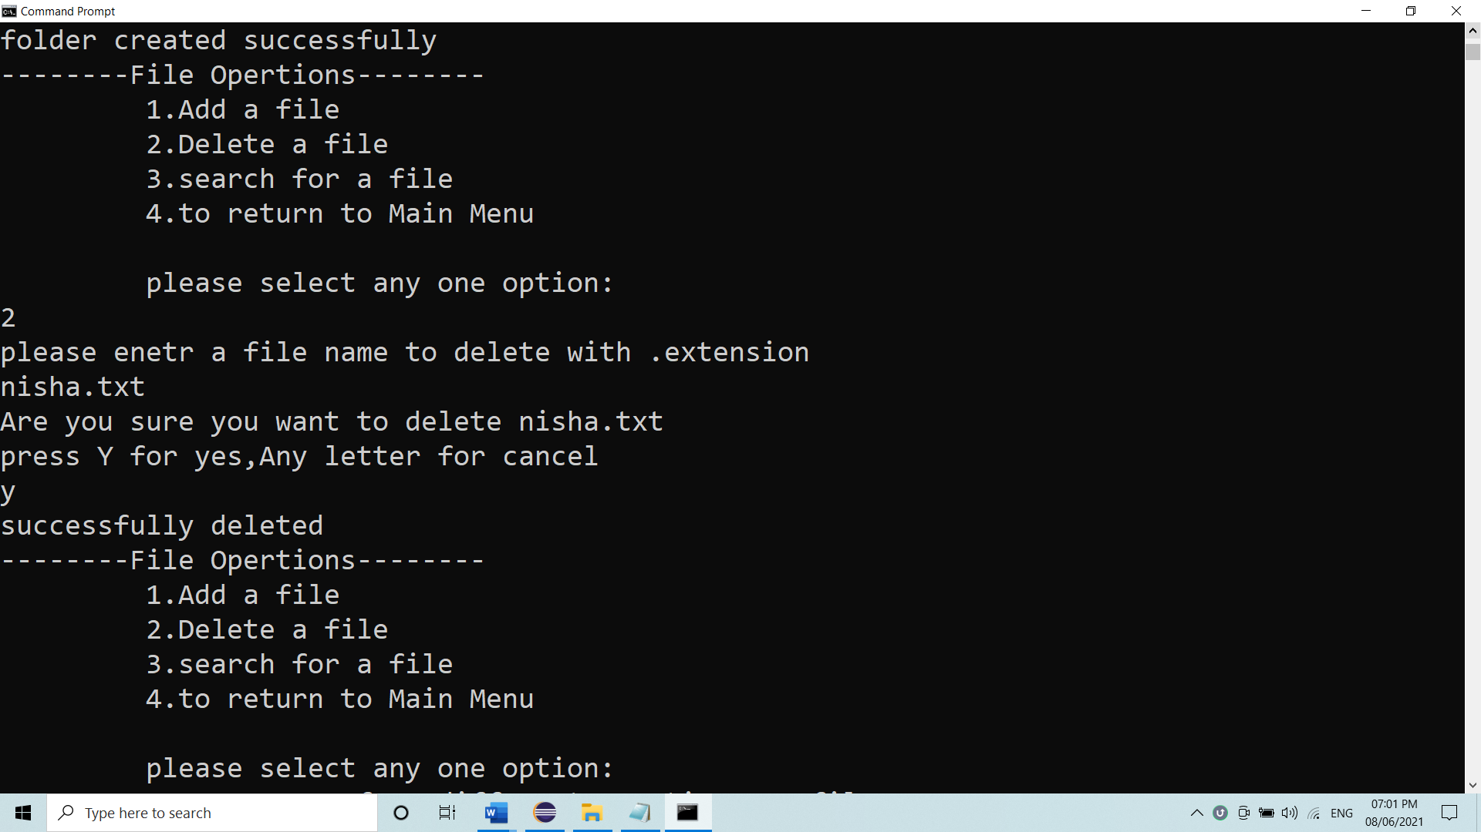

Now if you choose an option 3, it will search for a file in a respective folder. If found it will display a file which you have to search with its path. And again ask for choose an option.

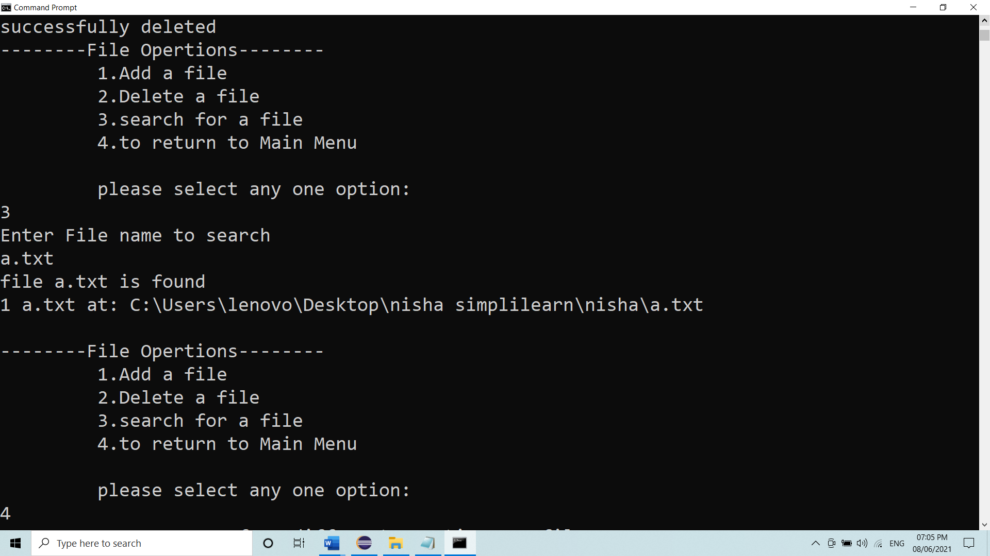

After that fi you choose an option 4 it goes back to Main Menu shown in image below.

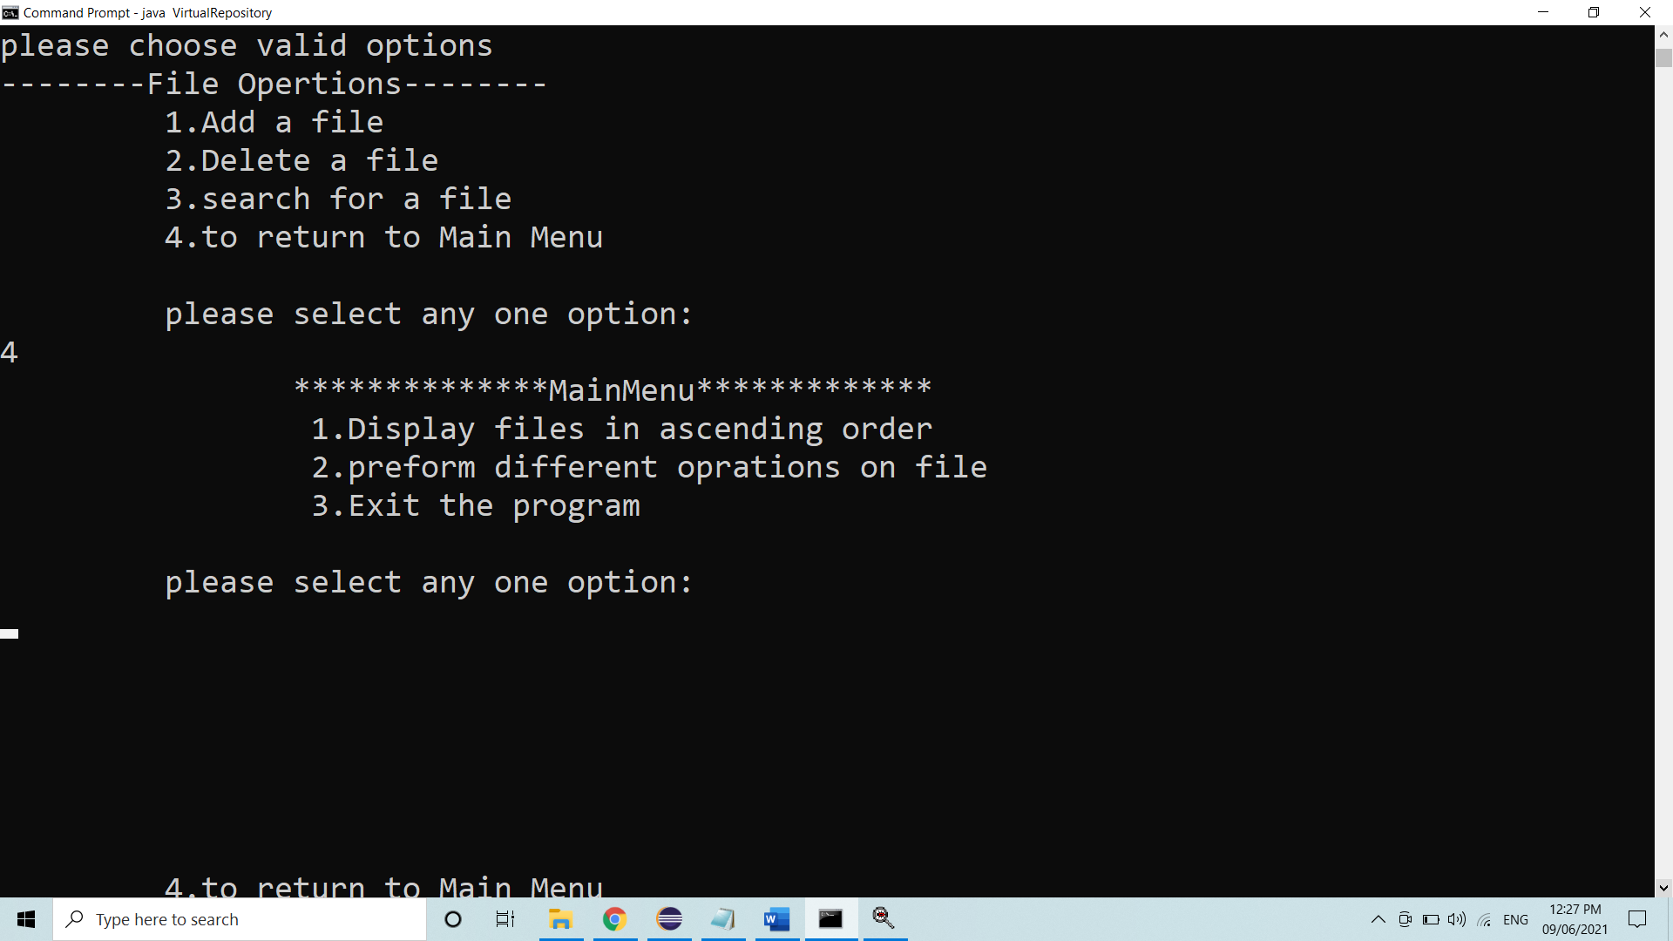

If you choose option 3 from Main Menu. it will exit the program successfully. show in below image

