Assignment Report
NovaMart Retail Inventory Reorder Decision Tree Report

Nisha Naresh
101008896
Ontario Tech University
AI Programming
Zahra Atf

Task 1: Understand the Business Problem
What is the business about?
NovaMart Retail is a mid-sized retail company that sells everyday products through physical stores and an online channel. The company carries products across multiple categories including Apparel, Home Goods, Electronics Accessories, Beauty, Fitness, Kitchenware, Pet Supplies, and Office Supplies. NovaMart operates different store types such as Flagship, Standard, and Outlet stores, with locations in areas like Downtown and Mall, as well as an online platform.
What problem is the business trying to solve?
NovaMart faces two major inventory problems. The first is stockouts, where products run out before the next supplier delivery arrives, leading to lost sales, lower customer satisfaction, and weaker customer loyalty. The second is overstock, where the business orders too much inventory, which increases storage costs, ties up cash, and may result in markdowns or waste. NovaMart needs a simple and explainable decision-support model that helps inventory managers identify which products are likely to need a reorder in the near future before a stockout actually happens.
What decision can machine learning help the business make?
Machine learning can help NovaMart automatically classify each product into one of two categories: Reorder_Needed = Yes or Reorder_Needed = No. Instead of manually checking hundreds of products, managers can use the model to quickly identify which products need attention. A Decision Tree is especially useful here because it produces simple, readable rules that non-technical business users can understand and trust.
What is the target variable in the dataset?
The target variable is Reorder_Needed. It is a binary variable with two possible values: Yes, meaning the product should be reordered soon, and No, meaning the product does not need reordering at this time. This is the variable the Decision Tree model is trained to predict.
What are the input features?
The input features are Product_Category, Store_Location, Store_Type, Supplier_Region, Season, Current_Stock_Units, Average_Weekly_Sales, Lead_Time_Days, Unit_Cost, Selling_Price, Discount_Rate, Customer_Rating, Return_Rate, Website_Views, Previous_Stockout, and Competitor_Price_Index.
Why is this prediction useful for the business?
This prediction is useful to NovaMart for several reasons. It helps prevent lost sales by allowing managers to reorder products before they run out, keeping shelves stocked and customers satisfied. It reduces overstock costs by only flagging products that genuinely need reordering, which frees up storage space and cash flow. It also saves manager time because instead of reviewing every product manually, managers can focus on the products the model flags as high priority. The model supports more consistent and data-driven decisions, and since a Decision Tree produces simple rule-based logic, managers can easily understand and explain the recommendations to stakeholders.
Task 2: Data Preparation
Dataset Overview
Item | Value
Total Rows | 365
Total Columns | 18
Missing Values | 31
Duplicate Rows | 5
Rows after Cleaning | 360
Reorder Needed: No | 250
Reorder Needed: Yes | 115

Target Variable Distribution
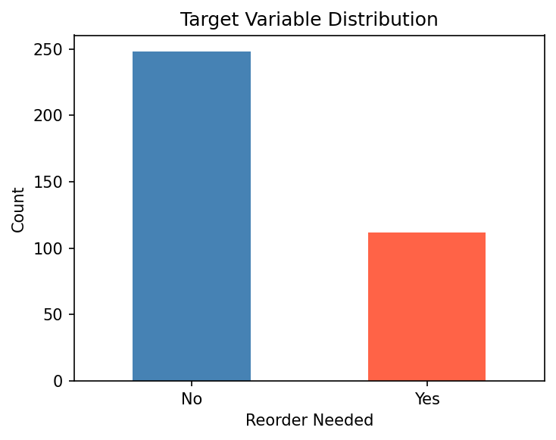
Cleaning Steps
Duplicate rows were removed from the dataset. Missing numerical values were filled using the median of each column. Missing categorical values were filled using the mode. Product_ID was dropped as it is only an identifier and not a useful feature. Categorical features were encoded using Label Encoding. The data was split into 80% training and 20% testing sets using stratified sampling to maintain class balance.

Task 3: Decision Tree Model Results
Training vs Testing Accuracy
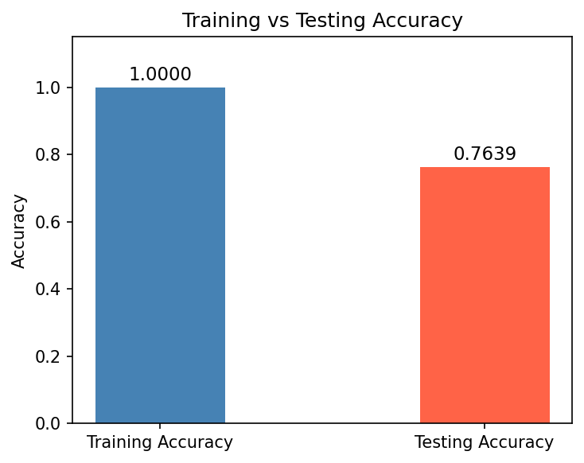
Evaluation Metrics
Metric | Score
Training Accuracy | 1.0000
Testing Accuracy | 0.7639
Precision | 0.6667
Recall | 0.4545
F1-Score | 0.5405

Confusion Matrix
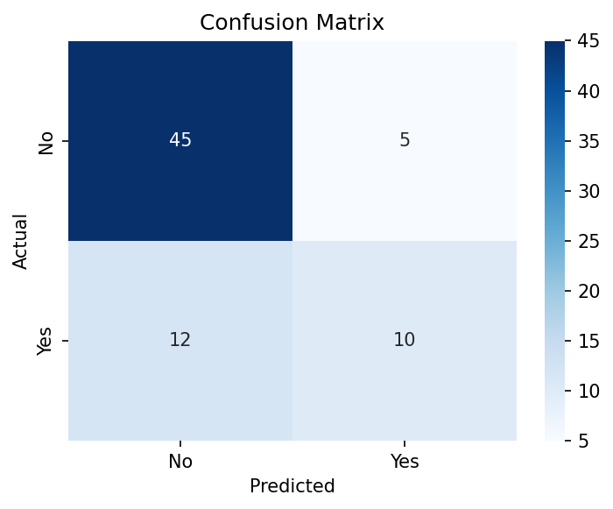
 | Predicted No | Predicted Yes
Actual No | 45 (True Negative) | 5 (False Positive)
Actual Yes | 12 (False Negative) | 10 (True Positive)

Overfitting Check
The Training Accuracy is 1.0000 and the Testing Accuracy is 0.7639. The gap between them is 0.2361, which is large. This indicates that the Decision Tree model is overfitting. The model has memorized the training data too closely and does not generalize well to new unseen data. A Decision Tree with no depth limit tends to overfit because it keeps splitting until every training record is correctly classified. To reduce overfitting, the tree depth could be limited using max_depth or min_samples_leaf parameters.

Task 4: Business Interpretation of Model Results
How well did the Decision Tree model perform?
The Decision Tree model achieved a testing accuracy of 76.39%. Out of 72 test records, the model correctly predicted 55 cases. The precision is 0.6667, recall is 0.4545, and F1-score is 0.5405. The model performs well in identifying products that do not need reordering but struggles to correctly identify all products that truly need reordering.
Is there a large difference between training accuracy and testing accuracy?
Yes, there is a large difference. The training accuracy is 1.0000 which is 100% and the testing accuracy is 0.7639 which is 76.39%. The gap between them is 0.2361, which is significant and suggests the model did not generalize well to new data.
Does the model show signs of overfitting? Why or why not?
Yes, the model shows clear signs of overfitting. The training accuracy is 100%, meaning the model perfectly learned every record in the training data. However, the testing accuracy dropped to 76.39% on unseen data. This large gap means the model memorized the training data instead of learning general patterns. A Decision Tree with no depth limit always overfits because it keeps creating branches until every training record is classified correctly.
Which evaluation metric is most important for this business problem?
Recall is the most important metric for NovaMart. A low recall means the model is missing products that truly need reordering, which leads to stockouts, lost sales, and unhappy customers. The current recall of 0.4545 means the model only correctly identified about 45% of products that actually needed reordering, which is a concern for the business. F1-score is also useful because it balances both precision and recall.
What do false positives mean in this business context?
There are 5 false positives in the confusion matrix. This means the model predicted that 5 products needed reordering, but they actually did not. In business terms, NovaMart would order unnecessary stock for these products, leading to overstock, higher storage costs, and tied-up cash flow.
What do false negatives mean in this business context?
There are 12 false negatives in the confusion matrix. This means the model predicted that 12 products did not need reordering, but they actually did. In business terms, these products would run out of stock before the next delivery, causing stockouts, lost sales, and dissatisfied customers. This is the more costly error for NovaMart.
Which features were most important in the Decision Tree model?
Feature | Importance Score
Current_Stock_Units | 0.2587
Lead_Time_Days | 0.1328
Website_Views | 0.1260
Customer_Rating | 0.1095
Return_Rate | 0.0876

Feature Importance Chart
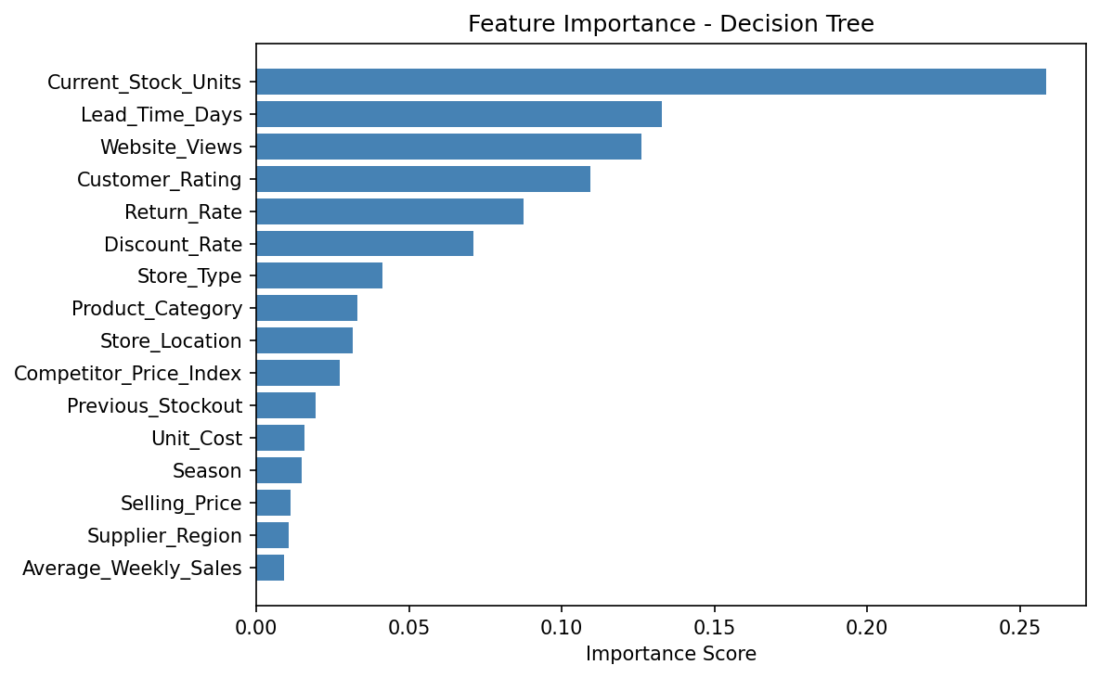
Explanation of Metrics with Confusion Matrix


Accuracy (0.7639): The model correctly predicted 76.39% of all products. Out of 72 test records, 55 were predicted correctly. This looks reasonable overall but hides the fact that the model struggles with the Yes class.
Precision (0.6667): When the model said a product needs reordering, it was correct 66.67% of the time. There were 5 false positives, meaning 5 unnecessary reorder recommendations were made.
Recall (0.4545): The model only caught 45.45% of products that truly needed reordering. Out of 22 actual reorder cases, the model correctly identified only 10. The 12 false negatives represent potential stockouts and are the most serious business risk.
F1-Score (0.5405): The F1-score is the balance between precision and recall. The score of 0.5405 is moderate, reflecting that while precision is reasonable, the low recall is pulling the overall score down. For NovaMart, improving recall should be the priority in future model improvements.
How can these important features help the business make better decisions?
Current_Stock_Units is the strongest signal. When stock levels drop below a certain threshold, the model flags the product for reorder. NovaMart can set automatic alerts when stock falls too low. Lead_Time_Days tells the business how far in advance to reorder based on supplier delivery time. Products with longer lead times need earlier reorder decisions. Website_Views reflects online demand, so products with high views and low stock should be prioritized. Customer_Rating and Return_Rate help the business understand product quality issues that may affect future demand.
What is one possible limitation or bias in the model or dataset?
The dataset is synthetic and does not reflect real-world complexity. One possible bias is that products with historically high website views or past stockouts receive more reorder recommendations, while new products with limited sales history may be underestimated by the model. This means the model may not support new product launches effectively. Real-world factors such as supplier delays, local events, promotions, and economic conditions are also not captured.
Why should human judgment still be used when making business decisions based on model results?
The model cannot capture all real-world context. For example, a product may appear low-risk in the data, but a supplier delay, a local event, a planned promotion, or a seasonal demand spike may increase the actual reorder urgency. Managers understand business context that is not in the dataset. The model is a decision-support tool that helps managers prioritize their review list, but the final ordering decision should always involve human judgment to ensure accuracy and avoid costly mistakes.

Business Analysis
SWOT Analysis
The SWOT analysis below evaluates the strengths, weaknesses, opportunities, and threats of using the Decision Tree model for NovaMart inventory reorder decisions.

Strengths  - Simple and explainable rules that managers can understand  - Automates reorder decisions across hundreds of products  - Current_Stock_Units and Lead_Time_Days are strong predictors  - Reduces manual workload for inventory managers  - Fast predictions with low computational cost | Weaknesses  - Model is overfitting with training accuracy of 100%  - Low recall of 0.4545 means many reorder needs are missed  - Decision Tree is sensitive to small changes in data  - Does not handle new products with limited history well  - Synthetic dataset may not reflect real business patterns
Opportunities  - Apply max_depth pruning to reduce overfitting  - Add real-world data such as promotions and supplier delays  - Expand model to predict reorder quantity not just Yes or No  - Integrate model into NovaMart inventory management system  - Use model results to negotiate better lead times with suppliers | Threats  - False negatives cause stockouts and lost revenue  - False positives cause overstock and increased holding costs  - Model may become outdated as business conditions change  - Over-reliance on the model without human review is risky  - New product categories not in training data may be misclassified

Model Analysis
The Decision Tree Classifier was selected for this problem because it produces explainable and readable rules that inventory managers can understand without technical knowledge. The model was trained on 288 records and tested on 72 records after an 80/20 stratified split.

Aspect | Detail
Model Type | Decision Tree Classifier
Training Set Size | 288 records (80%)
Testing Set Size | 72 records (20%)
Training Accuracy | 1.0000 (100%)
Testing Accuracy | 0.7639 (76.39%)
Precision | 0.6667
Recall | 0.4545
F1-Score | 0.5405
Overfitting Gap | 0.2361 (Large gap detected)
Most Important Feature | Current_Stock_Units (0.2587)
Second Important Feature | Lead_Time_Days (0.1328)
Third Important Feature | Website_Views (0.1260)

The model achieved a reasonable testing accuracy of 76.39%, however the recall score of 0.4545 is a concern. This means the model failed to identify 12 out of 22 products that truly needed reordering. For NovaMart, these missed predictions translate directly into stockouts and lost revenue. The overfitting gap of 0.2361 indicates that the model needs to be improved by applying depth constraints such as max_depth or min_samples_leaf to make it generalize better on unseen data.
Recommendations
Based on the model results and business analysis, the following recommendations are made for NovaMart to improve inventory reorder decision-making.

No. | Recommendation | Business Impact
1 | Apply max_depth pruning to the Decision Tree to reduce overfitting and improve generalization on new data. | Improves testing accuracy and reliability of predictions.
2 | Focus on improving Recall by adjusting the classification threshold or using class_weight to give more importance to the Yes class. | Reduces false negatives and prevents stockouts.
3 | Set automated stock alerts when Current_Stock_Units falls below a safe threshold based on Lead_Time_Days. | Enables proactive reordering before stockouts occur.
4 | Include real-world data such as promotions, seasonal trends, and supplier delay history to improve model accuracy. | Makes predictions more relevant to actual business conditions.
5 | Use the model as a decision-support tool and not a fully automated system. Managers should review all high-risk predictions. | Combines data-driven insights with human business judgment.
6 | Retrain the model regularly as new sales data becomes available to keep predictions accurate and up to date. | Prevents model drift and maintains prediction quality over time.

Overall Recommendation
The Decision Tree model provides a solid foundation for automating inventory reorder decisions at NovaMart. However, the current model should not be deployed in its present state due to overfitting and low recall. The immediate priority is to apply tree pruning to reduce the overfitting gap, and to improve recall so that fewer reorder needs are missed. Once improved, the model can be integrated into NovaMart's inventory system to flag high-risk products daily, allowing managers to focus their attention where it matters most. Combined with human oversight and regular model retraining, this approach will help NovaMart reduce stockouts, control overstock costs, and make smarter and faster inventory decisions.

