ASSIGNMENT 10.3

TABLE CREATION AND LOADING:

Table is created and temp_data.txt is loaded into the table temperature_data

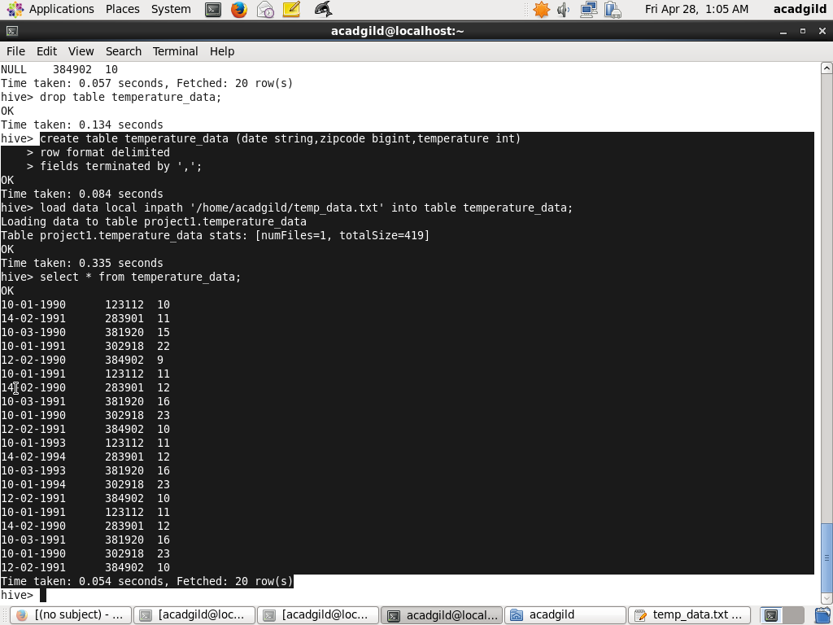

i)Fetch date and temperature from temperature_data where zip code is greater than 300000 and less than 399999.

QUERY AND OUTPUT

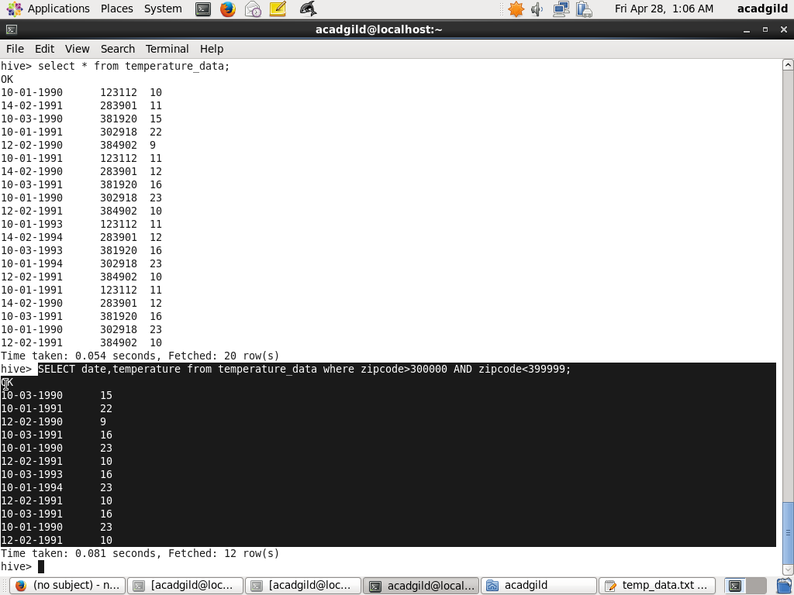

ii)Calculate maximum temperature corresponding to every year from temperature_data table.

QUERY TO CALCULATE MAXIMUM TEMPERATURE

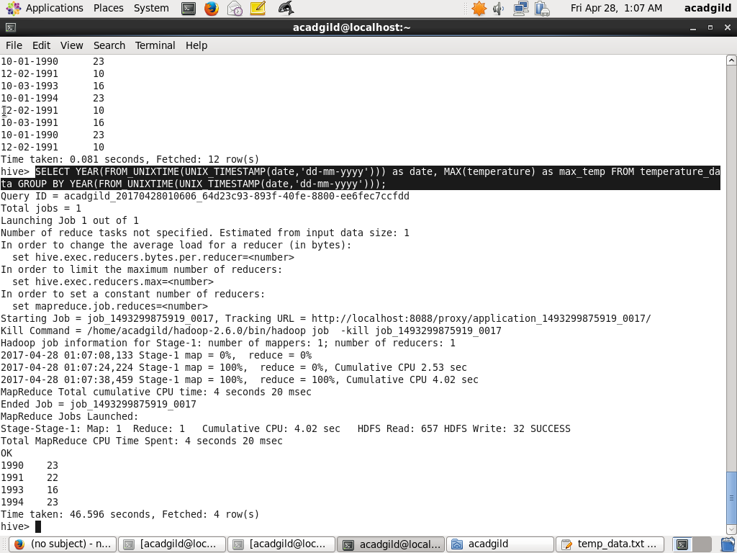

OUTPUT

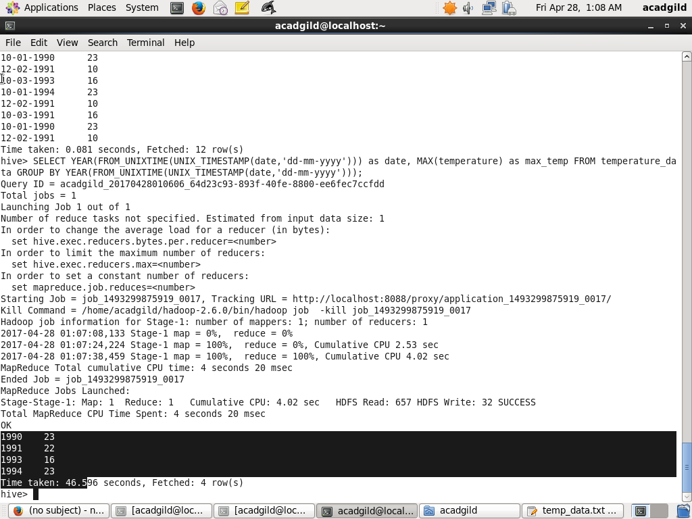

iii)Calculate maximum temperature from temperature_data table corresponding to those years which have at least 2 entries in the table.

QUERY

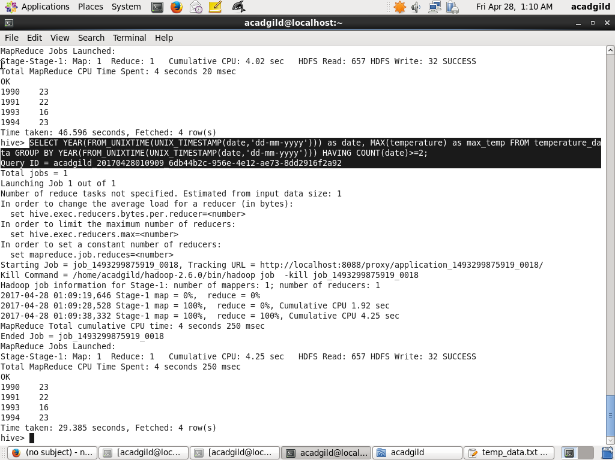

OUTPUT

