Assignment 10.4

CREATION AND LOADING OF DATA INTO TABLE TEMPERATURE_DATA

Creating table Titanic

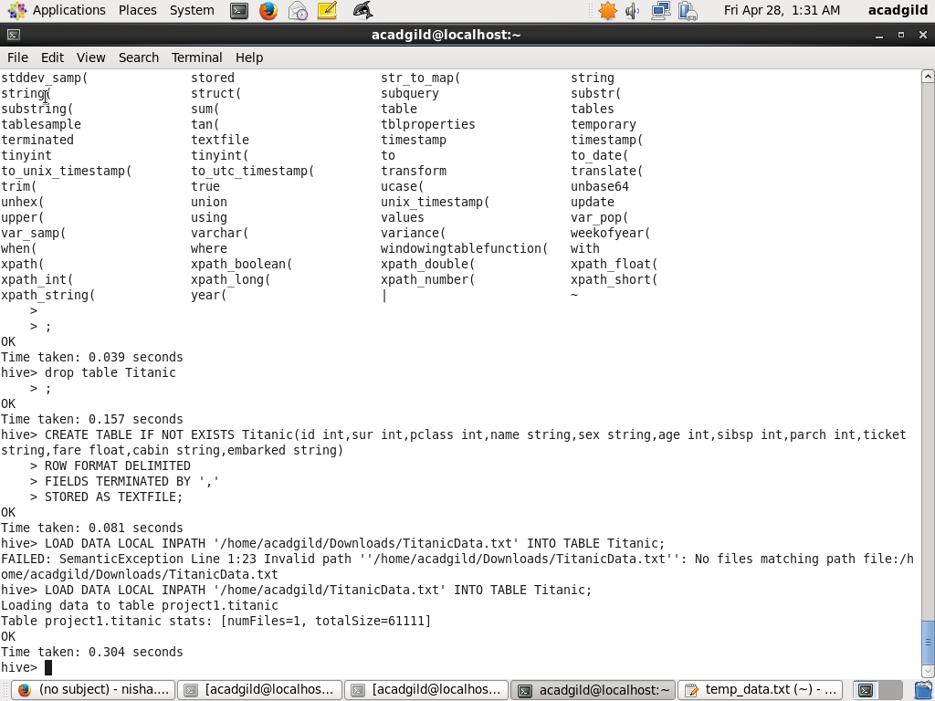

Loading data into table



Write a hive query find the average age of male and female persons died in the titanic tragedy

QUERY TO FIND THE AVERAGE AGE OF MALES AND FEMALE PERSONS DIED

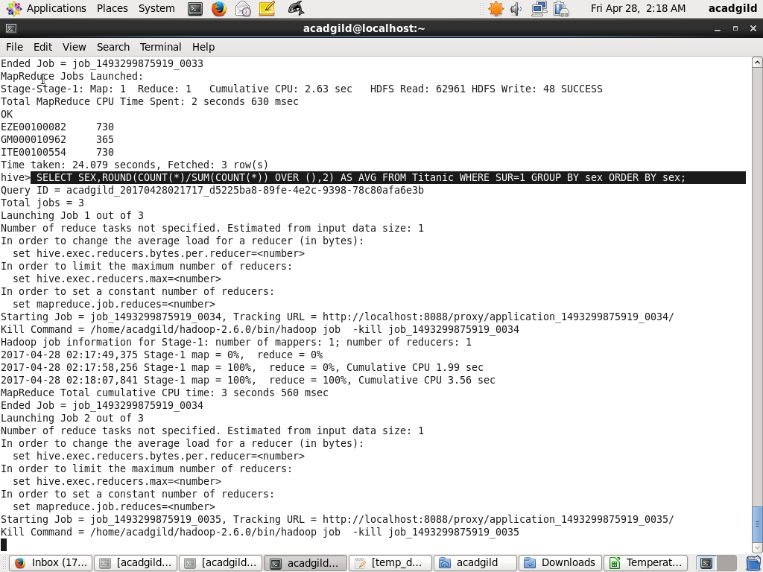

OUTPUT

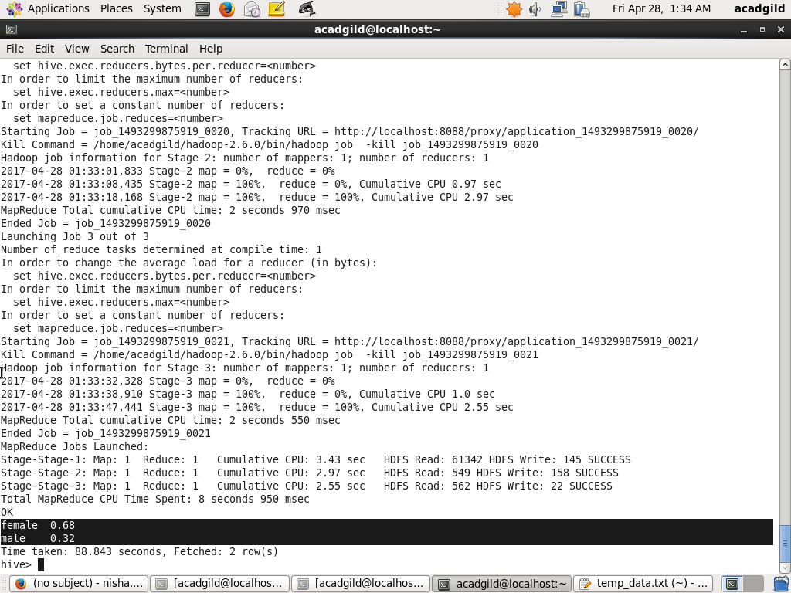

2.Write a hive query to find the number of people died and survived in each class

QUERY TO FIND NUMBER OF PEOPLE DIED IN EACH CLASS

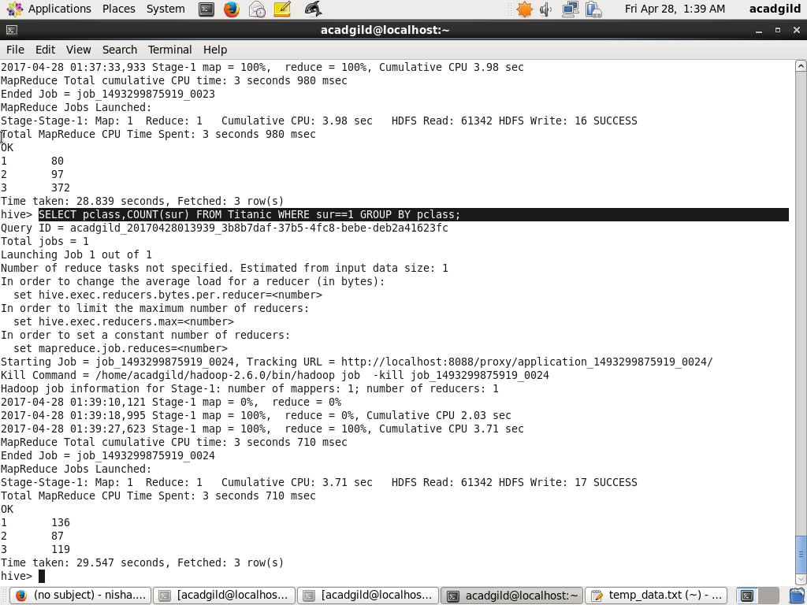

OUTPUT



QUERY TO FIND NUMBER OF PEOPLE SURVIVED IN EACH CLASS

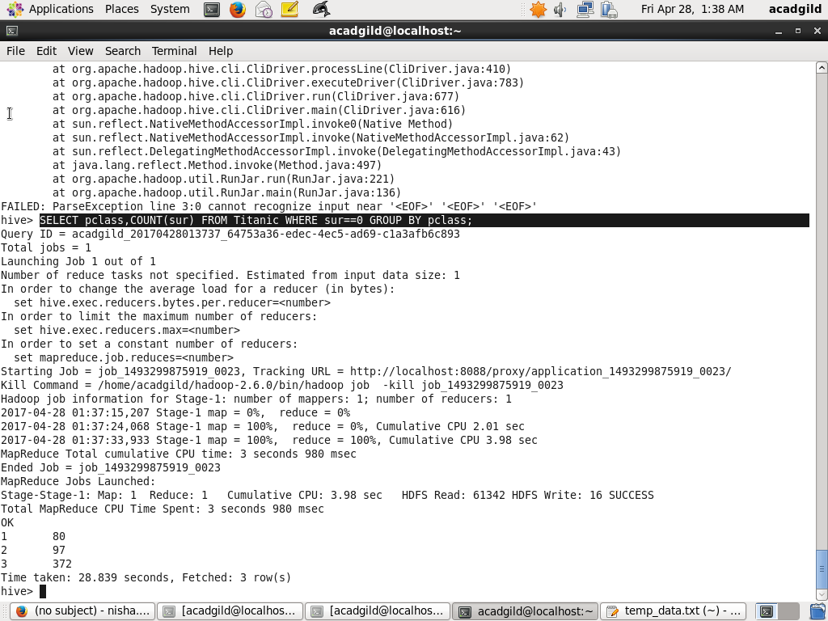

OUTPUT

