ASSIGNMENT 10.5

CREATION OF TABLE TRAVEL_DATA AND LOADING FILE TRAVELDATA.TXT INTO IT

Table travel_data is created and file TravelData.txt is loaded into the table

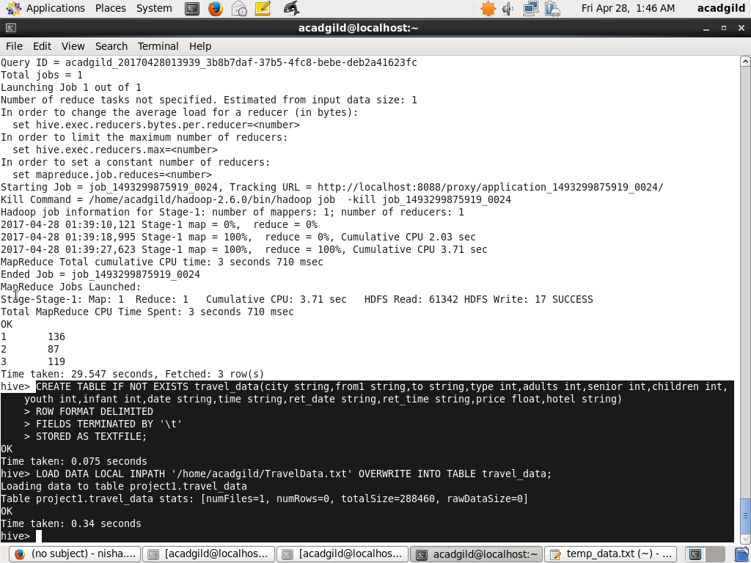

1.Write a hive query to find the top 20 destination people travel the most: Based on the given data

QUERY FOR SELECTION OF TOP 20 DESTINATIONS

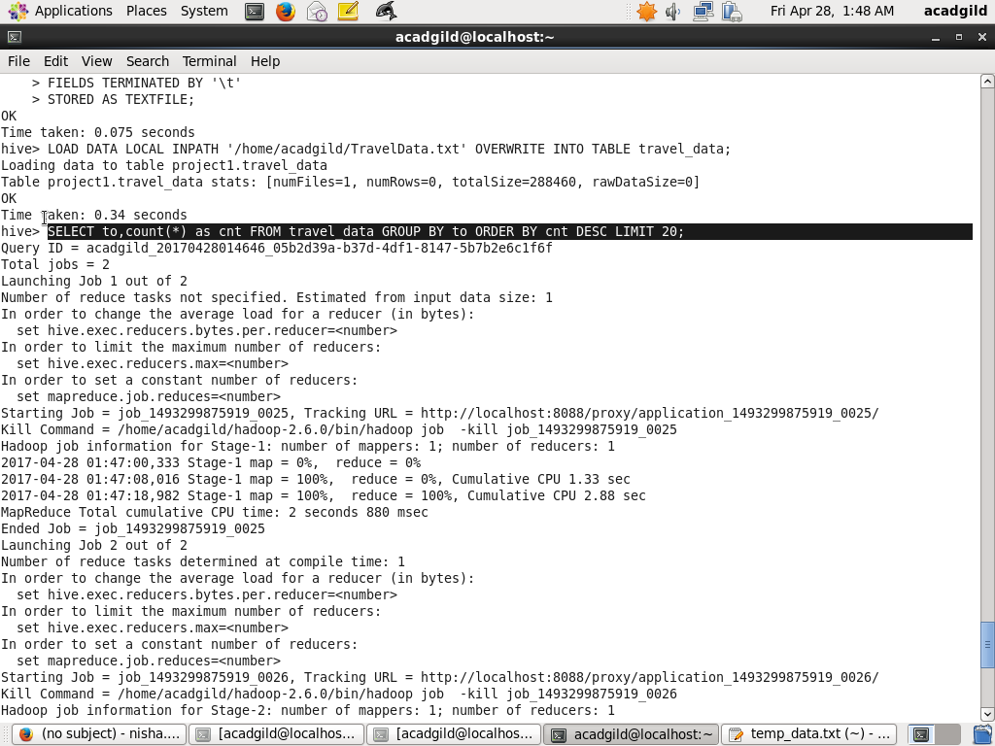

OUTPUT

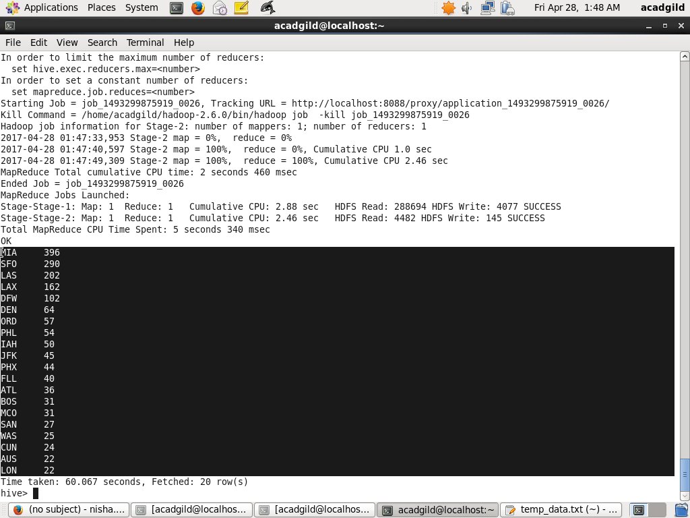

2. Write a hive query to find the top 20 locations from where people travel the most

QUERY TO FIND THE TOP 20 LOCATIONS FROM WHERE PEOPLE TRAVEL THE MOST

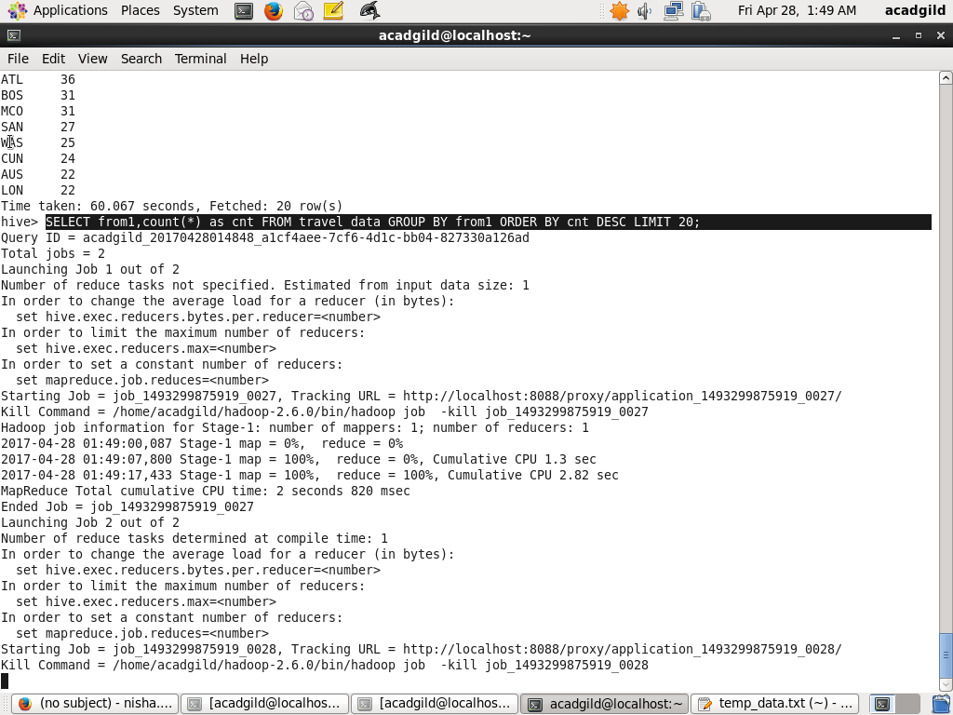

OUTPUT

