ASSIGNMENT 10.6

CREATION OF TABLE AND LOADING OF DATA INTO TABLE TEMP_DATA

Table temp_data is created and temperature.csv file is loaded into the table temp_data

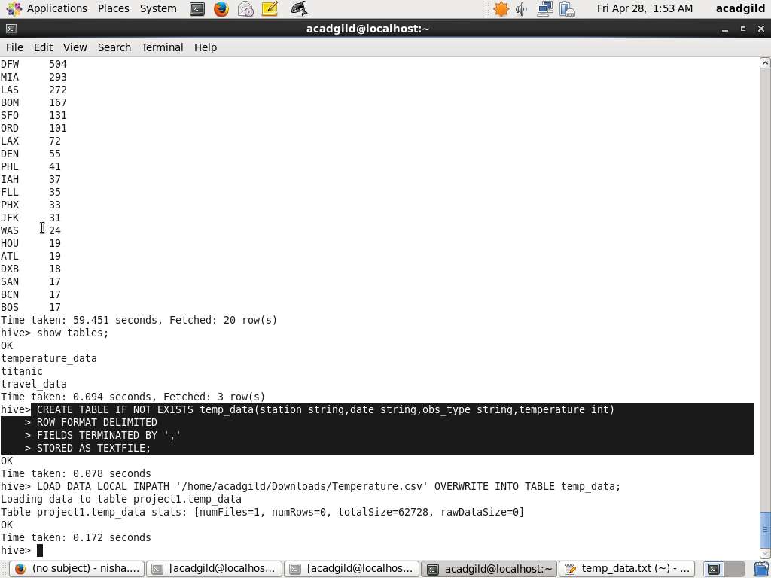

1.Write a hive query to find the minimum temperature observed in a given weather station in a particular year.

QUERY TO FIND THE MINIMUM TEMPERATURE OBSERVED IN THE PARTICULAR YEAR

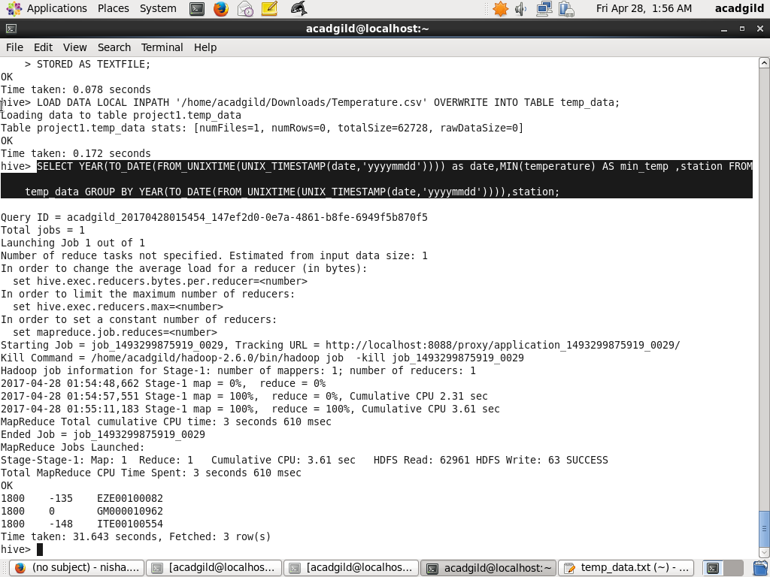

OUTPUT



2. Write a hive query to find the maximum temperature observed in a given weather station in a particular year.

QUERY TO FIND THE MAXIMUM TEMPERATURE OBSERVED IN THE GIVEN YEAR

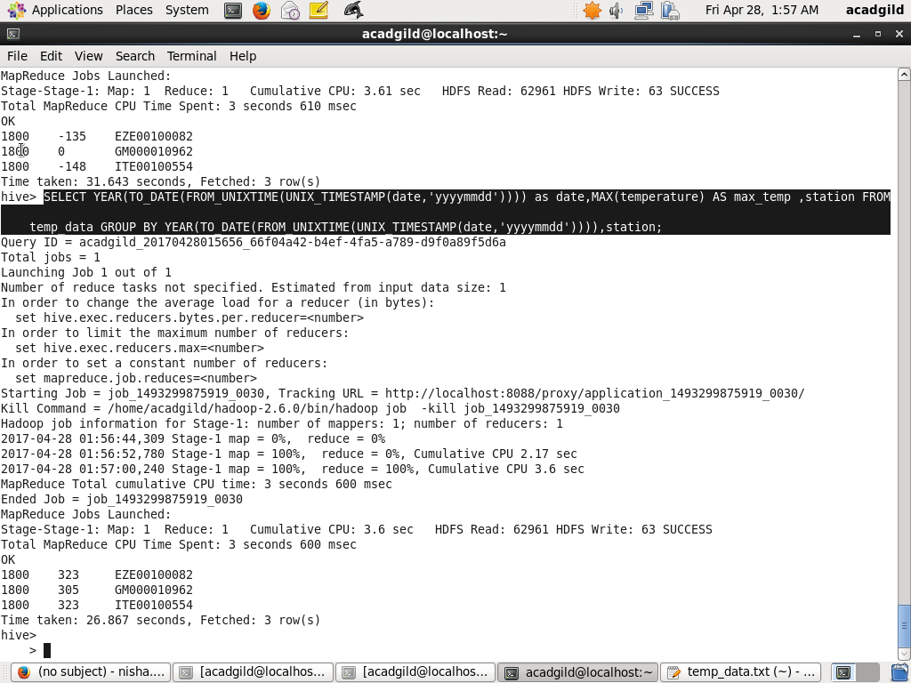

OUTPUT



3. Write a hive query to find the number of readings given by each weather station according to the dataset

QUERY TO FIND THE NUMBER OF READINGS GIVEN BY EACH WEATHER STATION

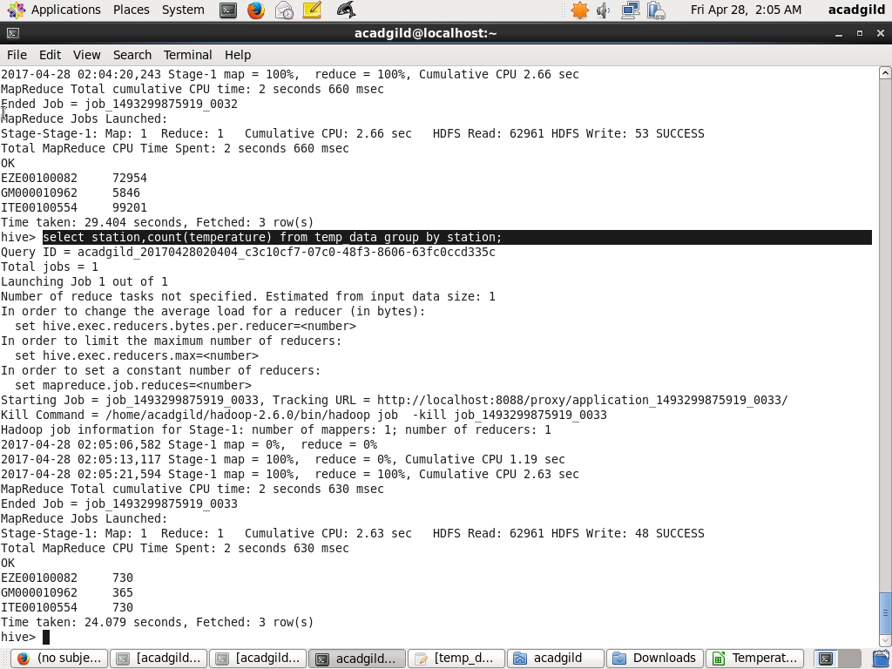

OUTPUT

