ASSIGNMENT 11.1

CREATION OF TABLE

Table Olympic is created and columns are created according to given constraint

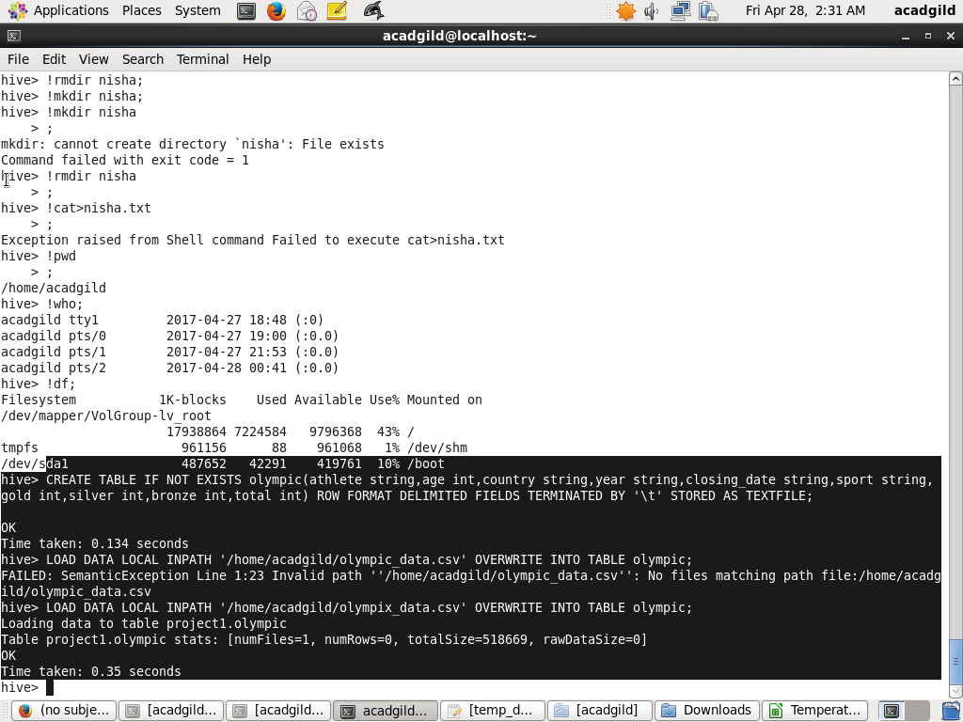

LOADING INTO TABLE

The file olympix_data.csv is loaded into table Olympic



1. Write a Hive program to find the number of medals won by each country in swimming.

QUERY TO FIND THE NUMBER OF MEDALS WON BY EACH COUNTRY IN SWIMMING

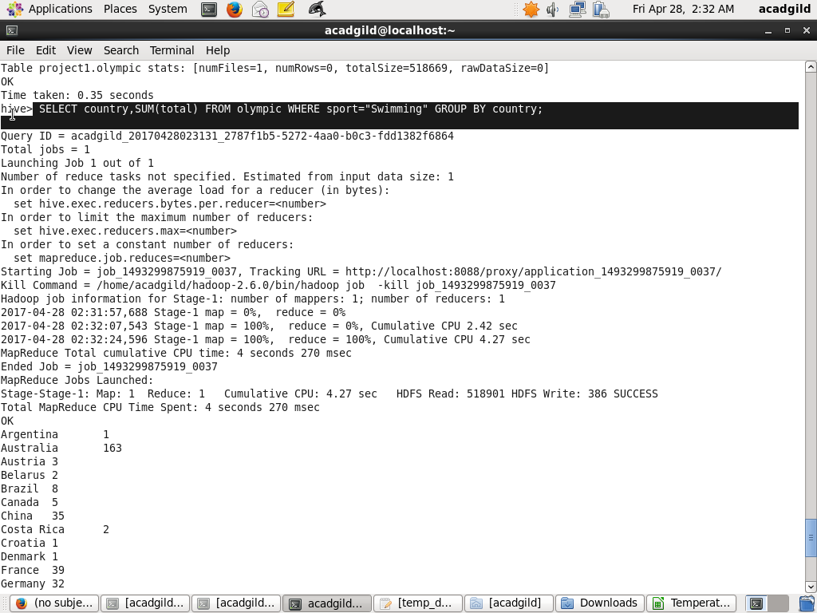

OUTPUT

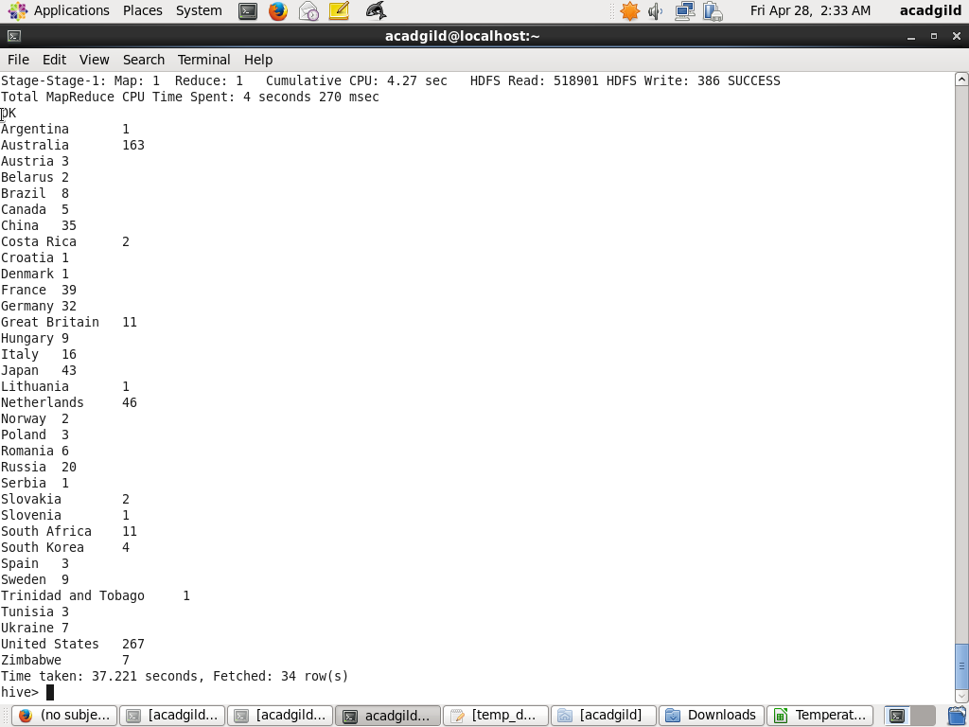

2. Write a Hive program to find the number of medals that India won year wise

QUERY TO FIND THE NUMBER OF MEDALS THAT INDIA WON YEAR WISE

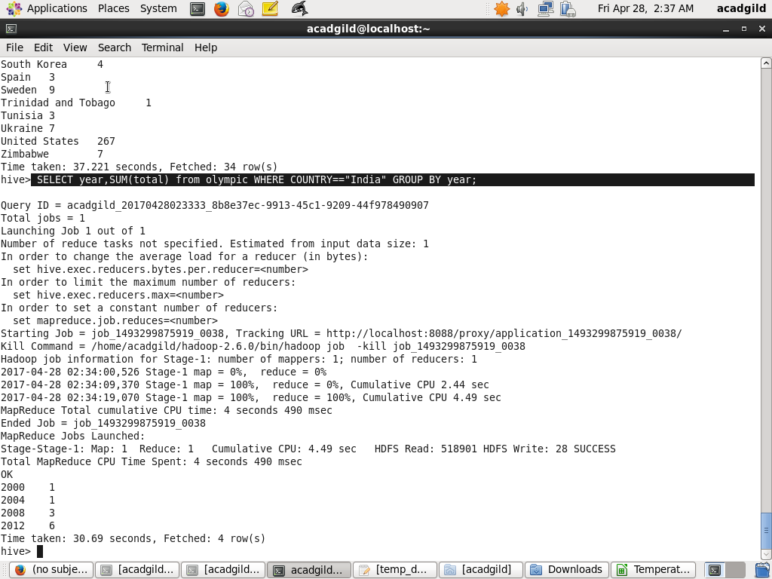

OUTPUT

