Assignments 11.2

1. Create table realEstate in Hive database, with all the columns present in dataset. Also Load dataset into table realEstate.

CREATION OF TABLE

Table real_estate is created with given columns

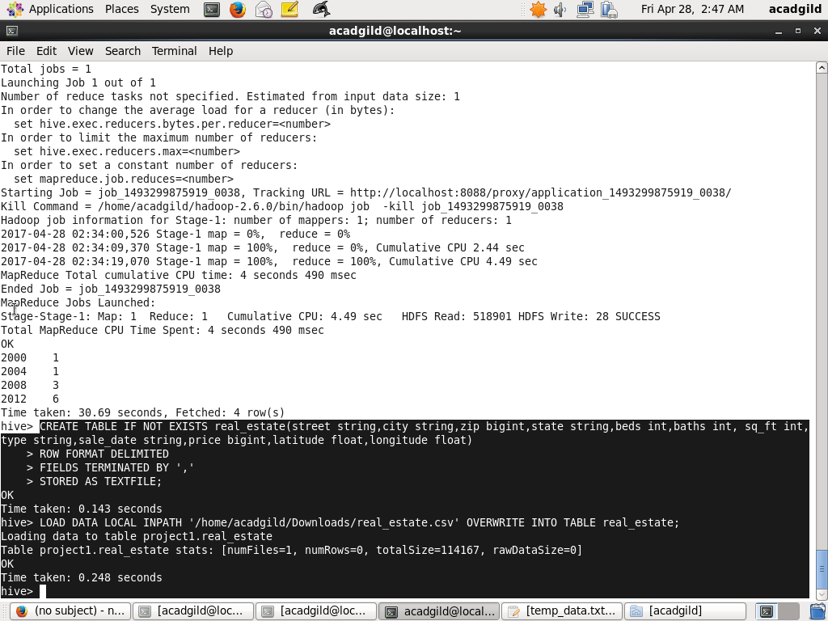

LOADING DATASET INTO TABLE

The dataset is loaded into table real_estate by loading the file real_estate.csv



2. Using Dynamic partition give separate lists of residential apartments with more than 2 beds. Also include columns in following order City,Baths,Sq_feet,Price,flat_type,Beds respectively.

TABLE CREATION

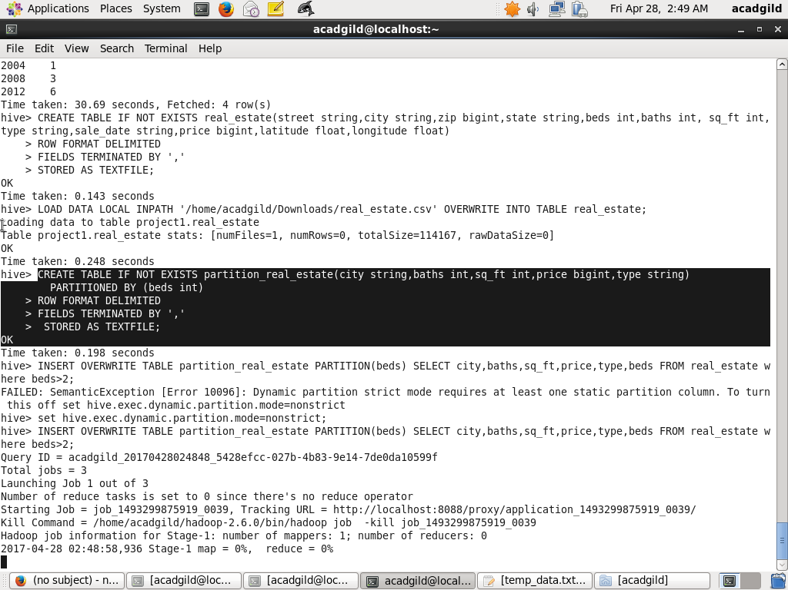

INSERT INTO PARTITION TABLE

By Dynamic partition separate lists of residential apartments with more than 2 beds is created

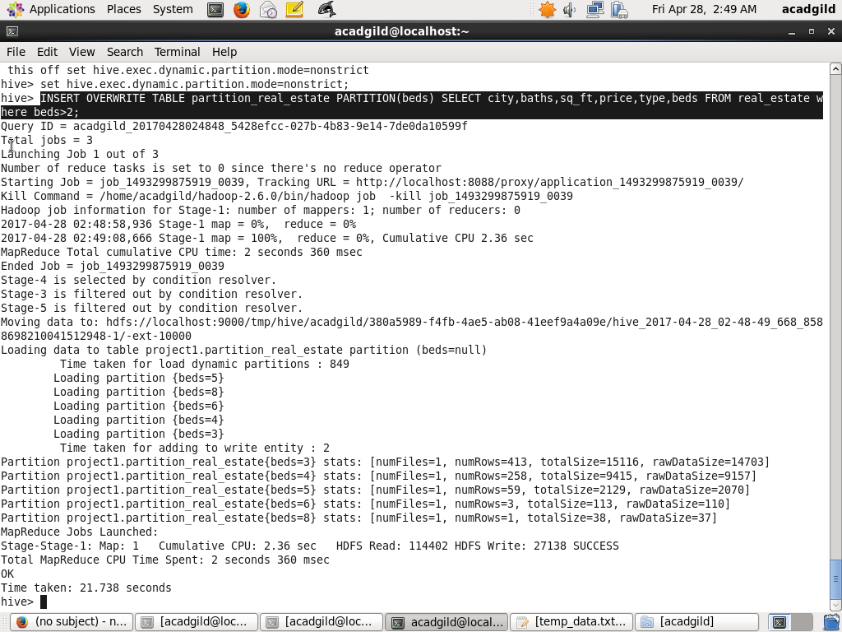

OUTPUT

select * from partition_real_estate

