**ASSIGNMENT 6.5**

1.Write a pig script to find the top 20 destination people travel the most: Based on the given data

PROGRAM TO FIND THE TOP 20 DESTINATIONS

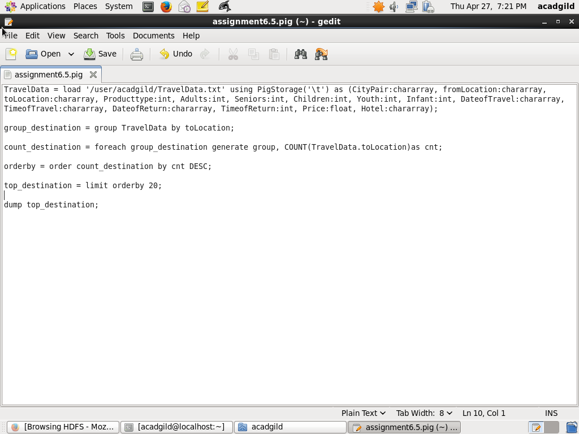

OUTPUT:

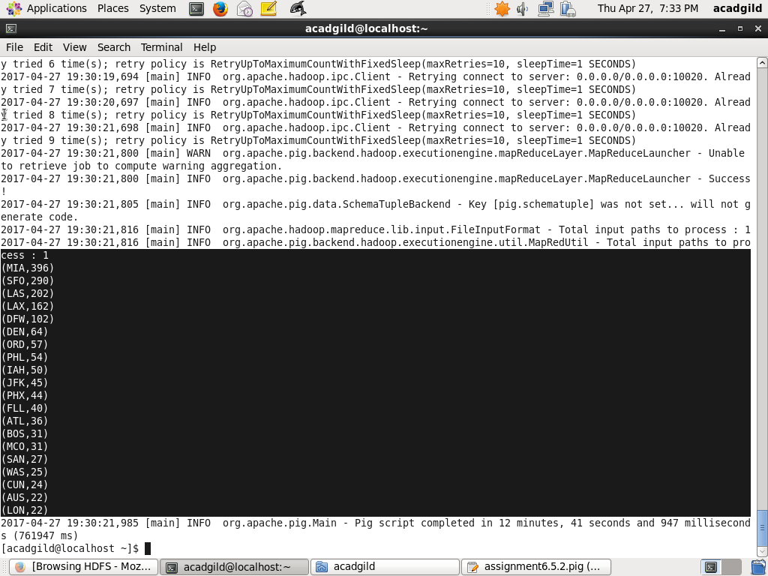

Write a pig script to find the top 20 locations from where people travel the most

PROGRAM TO FIND THE TOP 20 LOCATIONS WHERE PEOPLE TRAVEL THE MOST:

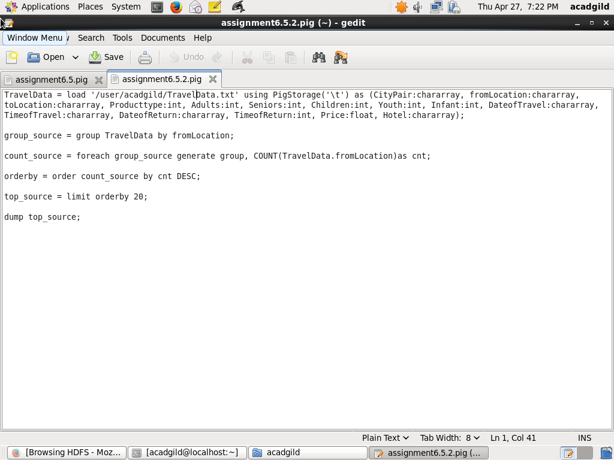

OUTPUT

