ASSIGNMENT7.6

PIG SCRIPT

Pig script for all the three questions

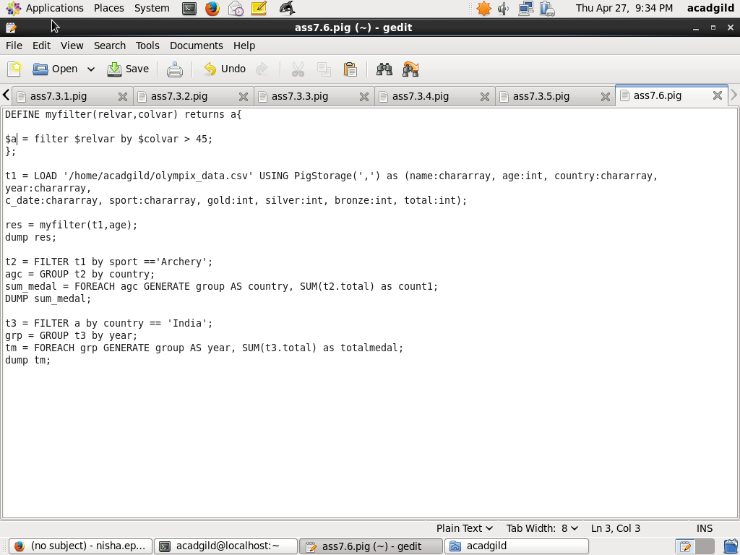

Write a macro in pig to filter out the people with age >45 from the below given dataset.

MACRO



OUTPUT

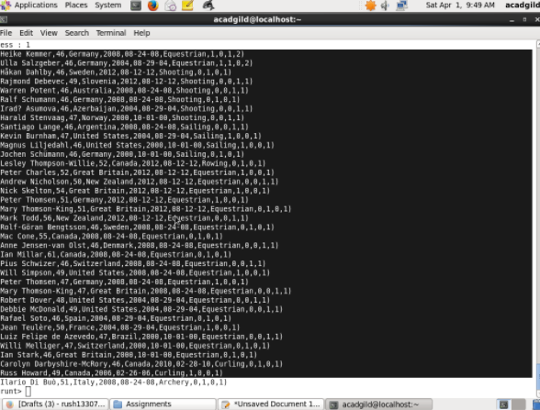

Find out the number of medals each country won in archery

PIGSCRIPT



OUTPUT

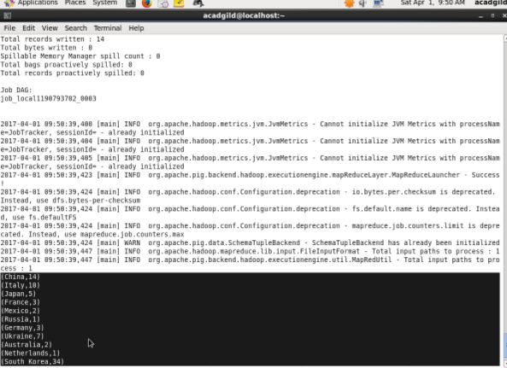

Find out the number of medals india won year wise

PIGSCRIPT



OUTPUT

