ASSIGNMENT 9.1

Create a flume agent that streams data from Twitter and stores it in the HDFS cluster

STEP1: Download and include the snapshot jar

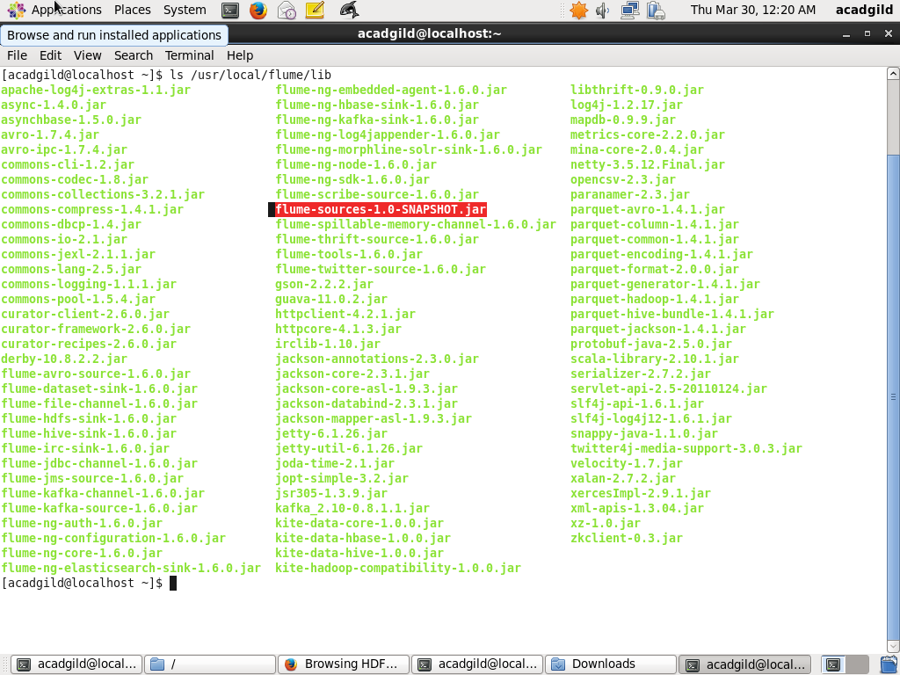

STEP 2: Flume path must be set

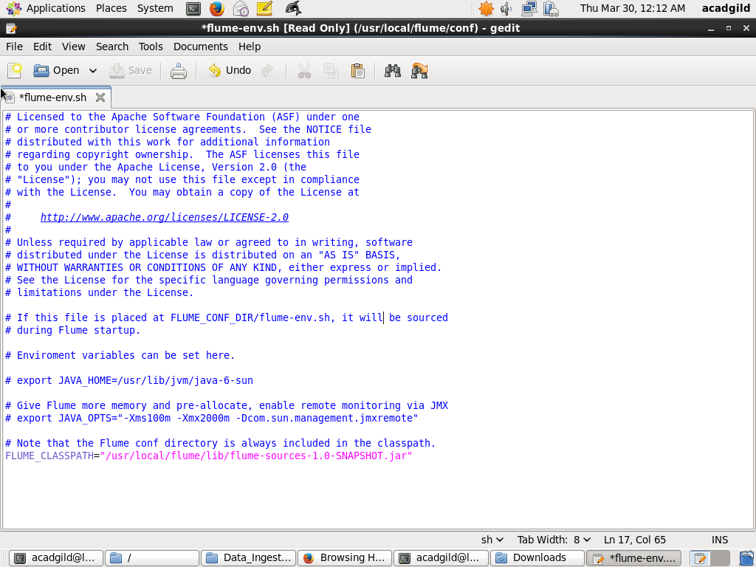

STEP3: .con File is edited with the necessary credentials

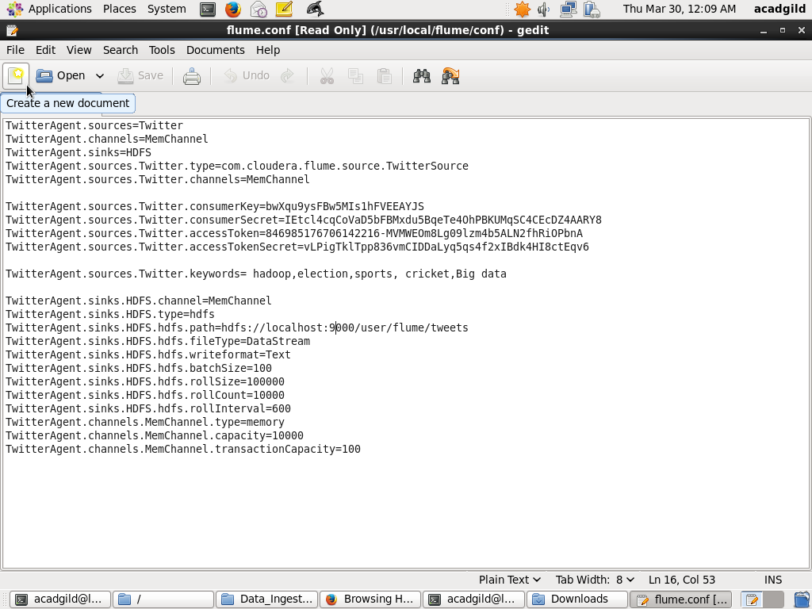

STEP 4: The file permissions are changed

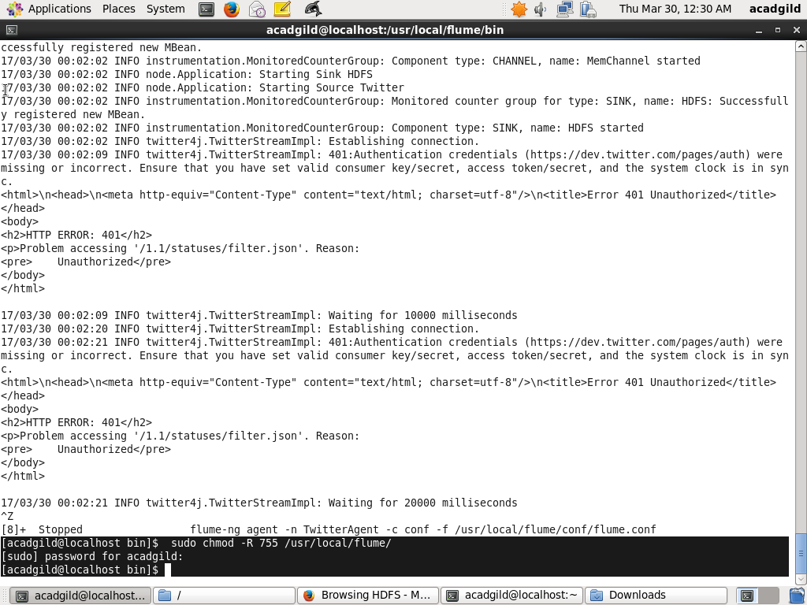

STEP 5: The data is fetched from the twitter

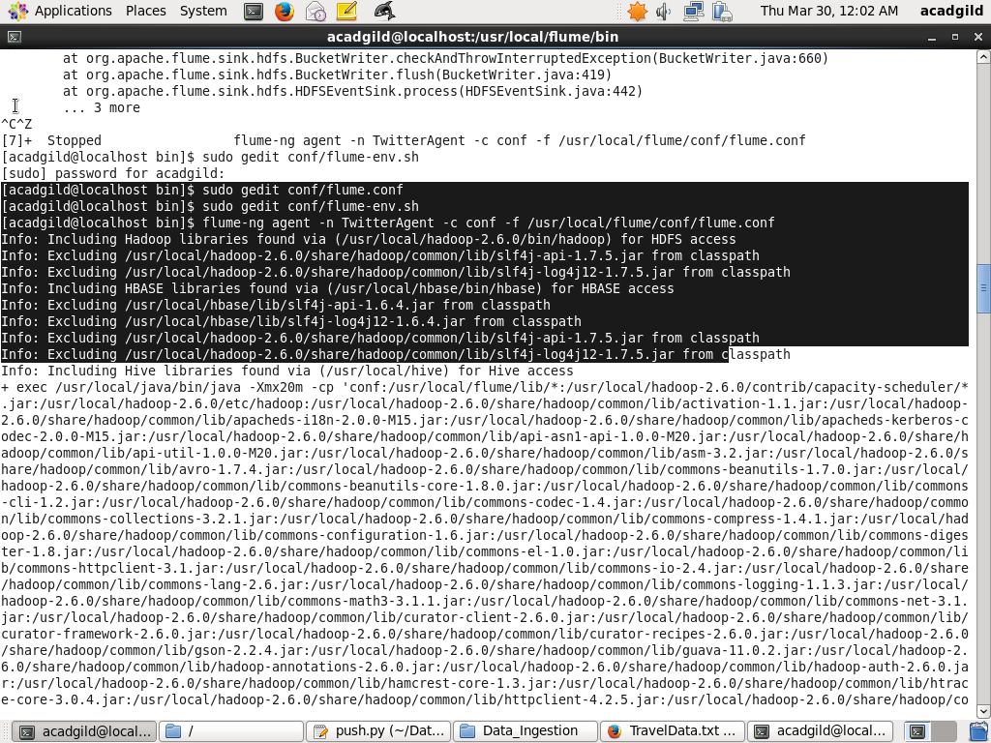

STEP 6: The resultant directory is created in HDFS

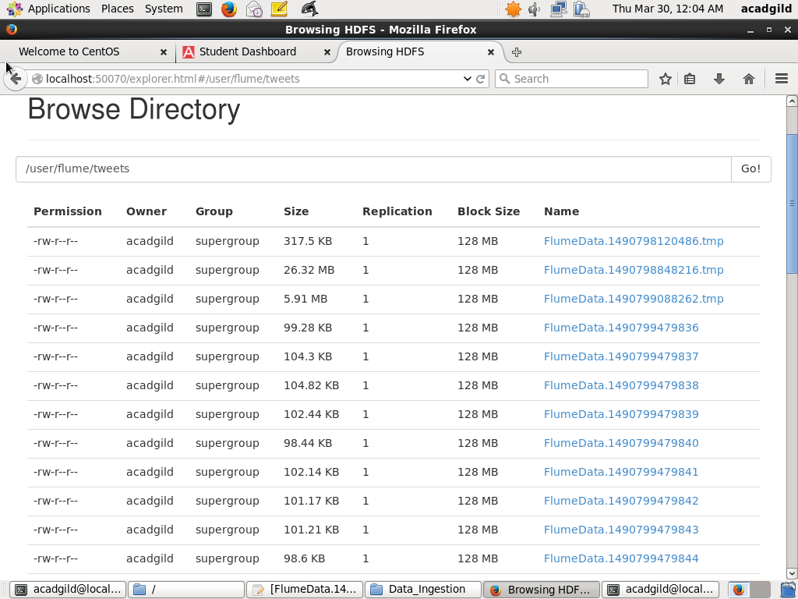

STEP 7: The streaming data inside the .tmp file

