ASSIGNMENT 9.4

Transfer streaming data from your local file system to HDFS using flume spool directory.

CREATE A FOLDER SPOOL WITH TWO FILES

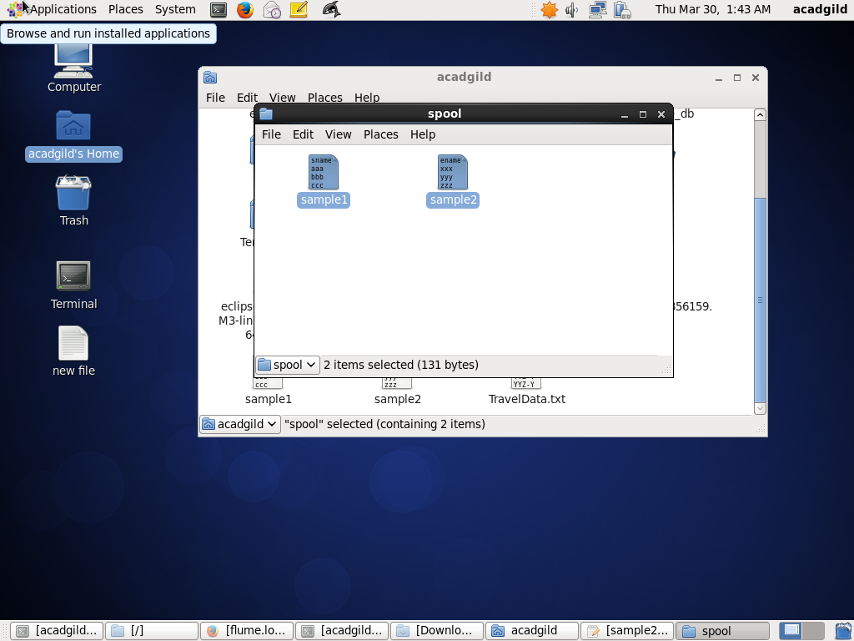

MOVE THE CONFIGURATION FILE INTO conf FOLDER OF FLUME

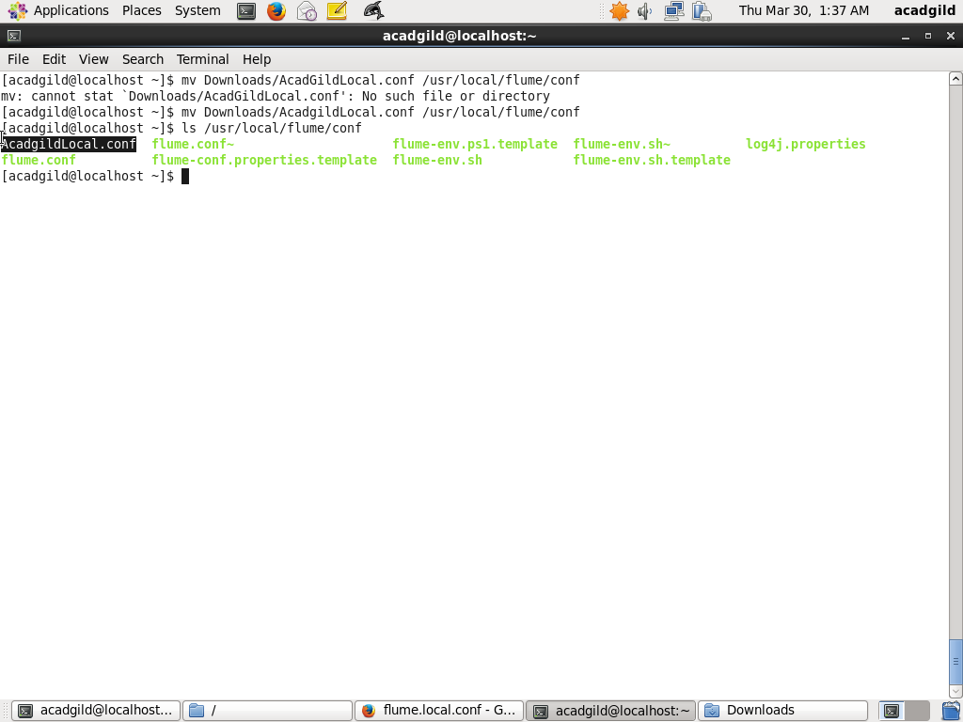

CREATION OF THE OUTPUT DIRECTORY

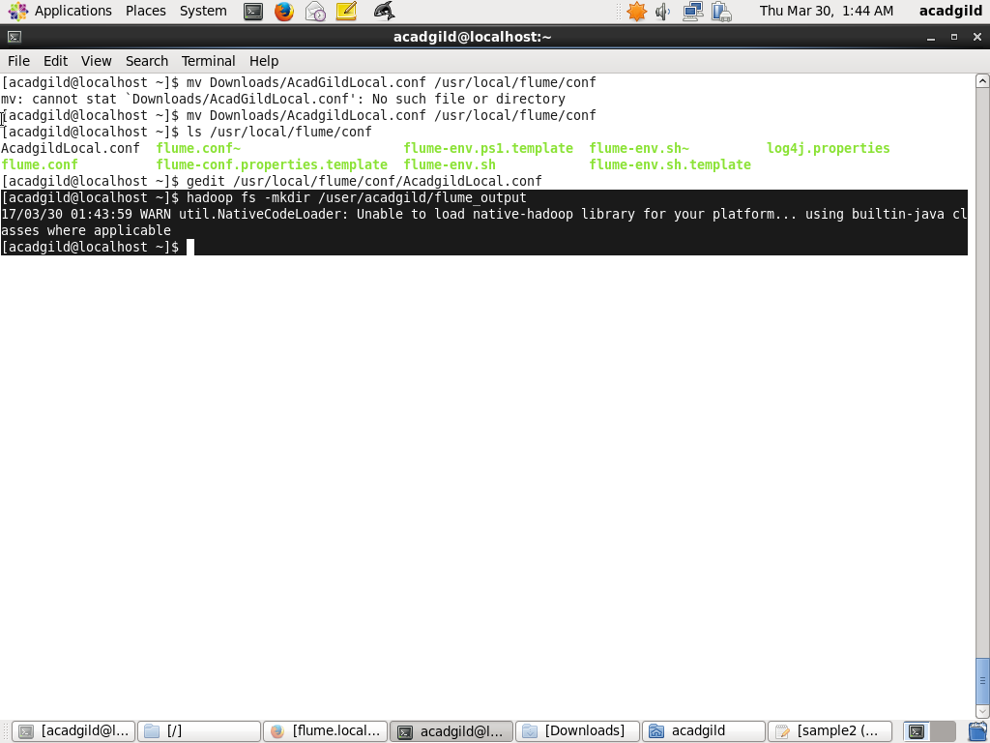

MODIFICATION OF .CONF FILE ACCORDING TO SPECIFIEDPATH

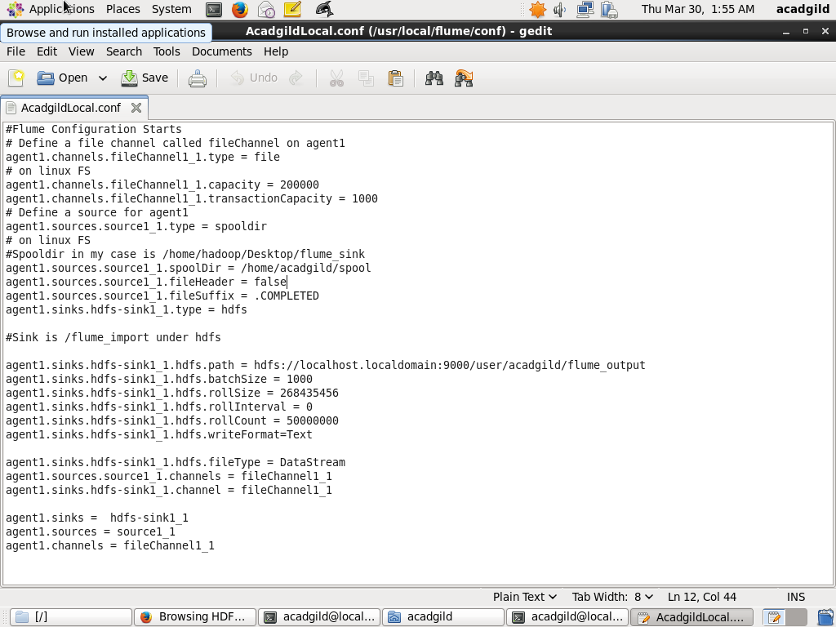

RUNNING THE FLUME AGENT

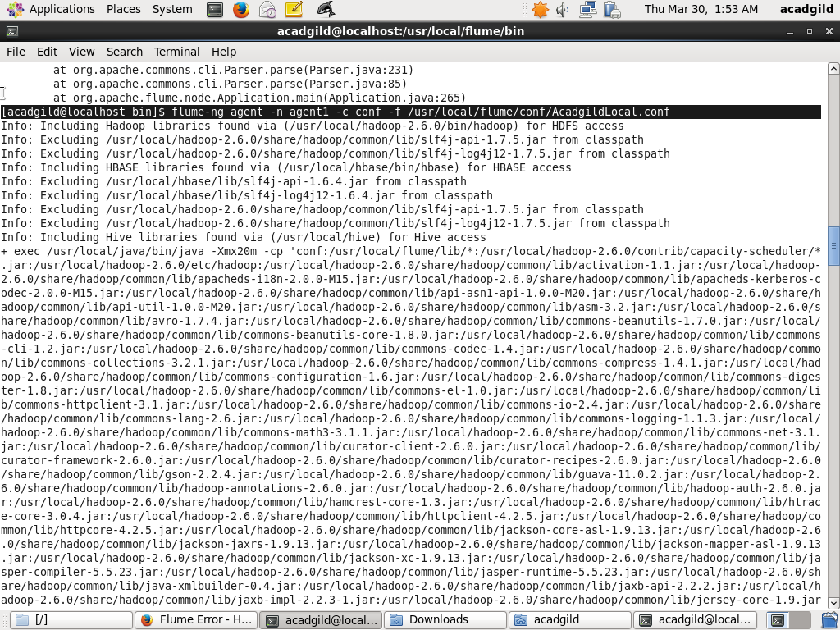

OUTPUT

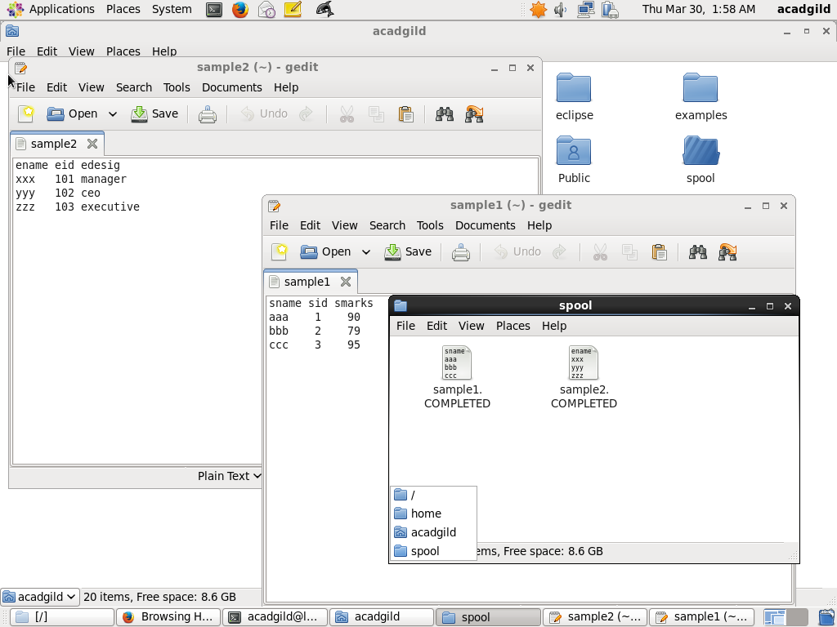

OUTPUT BEING STORED ON HDFS

