

Low Level Design

**Airport Data Analysis**

| **Written By** | Nisha singh |
| --- | --- |
| **Document Version** | 0.3 |
| **Last Revised Date** | 28/01/2023 |

**DOCUMENT CONTROL**

**Change Record:**

| **VERSION** | **DATE** | **AUTHOR** | **COMMENTS** |
| --- | --- | --- | --- |
| 0.1 | 28/01/2023 | Nisha singh | Introduction and architecture defined |
| 0.2 | 28/01/2023 | Nisha singh | Architecture & Architecture description appended and updated. |



**Contents**

**1. Introduction…………………………………………………………………………………………………………**

**1.1 What is a Low-Level Design Document? …………………………………………………….**

**1.2 Scope ……………………………………………………………………………………………………...**

**2. Architecture ………………………………………………………………………………………………………..**

**3 .Deployment ………………………………………………………………………………………**

**1. Introduction** 

**1.1 What is a Low-Level design document?**

The goal of the LDD or Low-level design document (LLDD) is to give the internal logic design of the actual program code for the House Price Prediction dashboard. LDD describes the class diagrams with the methods and relations between classes and programs specs. It describes the modules so that the programmer can directly code the program from the document.

**1.2 Scope**

Low-level design (LLD) is a component-level design process that follows a step-by-step refinement process. The process can be used for designing data structures, required software architecture, source code and ultimately, performance algorithms. Overall, the data organization may be defined during requirement analysis and then refined during data design work.

**2. Architecture**

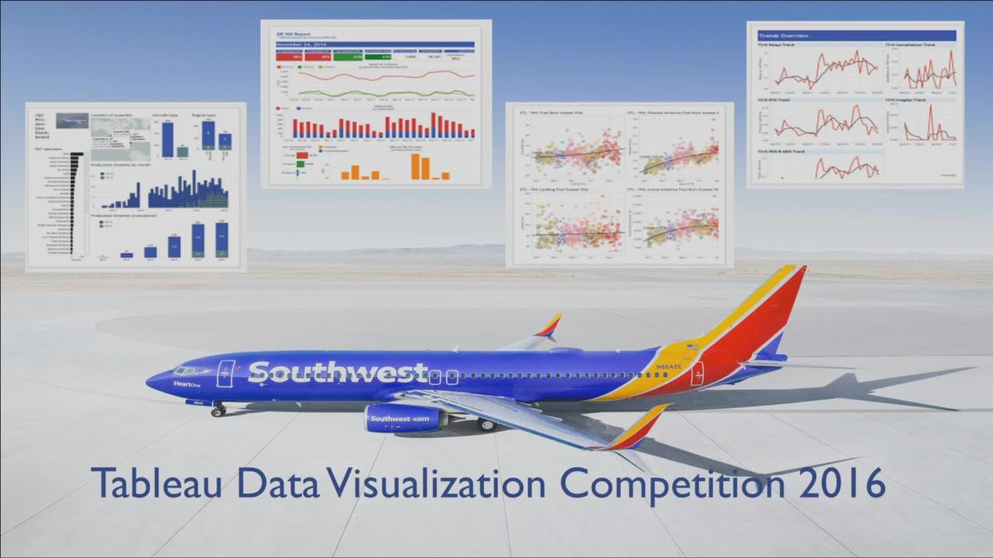

**Tableau Server Architecture**

Tableau has a highly scalable, n-tier client-server architecture that serves mobile clients, web clients and desktop-installed software. Tableau Server architecture supports fast and flexible deployments.

The following diagram shows Tableau Server’s architecture:

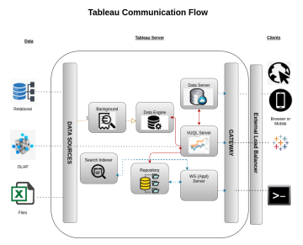Tableau Server is internally managed by the multiple server processes.

**. Gateway/Load Balancer**

It acts as an Entry gate to the Tableau Server and also balances the load to the Server if multiple Processes are configured.

**Application Server:-**

Application Server processes (wgserver.exe) handle browsing and permissions for the Tableau Server web and mobile interfaces. When a user opens a view in a client device, that user starts a session on Tableau Server. This means that an Application Server thread starts and checks the permissions for that user and that view.

**Repository:-**

Tableau Server Repository is a PostgreSQL database that stores server data. This data includes information about Tableau Server users, groups and group assignments, permissions, projects, data sources, and extract metadata and refresh information.

**Data Engine:-**

It Stores data extracts and answers queries.

**Backgrounder:-**

The backgrounder Executes server tasks which includes refreshes scheduled extracts, tasks initiated from and manages other background tasks.

**Data Server:-**

Data Server Manages connections to Tableau Server data sources

It also maintains metadata from Tableau Desktop, such as calculations, definitions, and groups.

**Web Scraping**

Web scraping is a technique to automatically extract content and data from websites using bots. It is also known as web data extraction or web harvesting. Web scraping is made simple nowadays, many tools are used for web scraping. Some of the python libraries used for web scraping are Beautiful Soup, Scrapy, Selenium, etc.

**Data Transformation**

In the Transformation Process, we will convert our original datasets with other necessary attributes format. And will merge it with the Scrapped dataset.

**Data Insertion into Database**

a. Database Creation and connection - Create a database with name passed. If the database is already created, open the connection to the database.

b. Table creation in the database.

c. Insertion of files in the table

**Export Data from Database**

Data Export from Database - The data in a stored database is exported as a CSV file to be used for Data Pre-processing.

**3. Deployment.**

Once you’ve completed your dashboard, follow these steps:**- Server, Tableau Public, Save to Tableau Public As**

You may be prompted to log into your Tableau Public profile first if this is your first time publishing.