FINAL DATA SCIENCE CAPSTONE PROJECT REPORT
Loan Default Risk Prediction and Financial Risk Analytics Using Machine Learning
Task 6 | Data Science Internship | October 2026
Based on the executed Loan_Default_Risk_Analysis.ipynb notebook

Executive Summary
This project develops a reproducible educational credit-risk classification workflow using the UCI Statlog German Credit dataset. It integrates business problem framing, data validation, feature engineering, exploratory analysis, machine learning pipelines, stratified validation, model interpretation, and practical recommendations. The dataset contains 1,000 historical records: 700 good-risk and 300 bad-risk. After an 80/20 stratified split, Logistic Regression and Random Forest were compared. Five-fold stratified cross-validation selected Random Forest based on mean ROC-AUC (0.7923). On the 200-record test set, Random Forest achieved 76.50% accuracy, 61.02% bad-risk precision, 60.00% bad-risk recall, F1 of 60.50%, and ROC-AUC of 0.7851. These results are promising for a classroom prototype but insufficient for automated credit decisions: 24 of 60 bad-risk cases were missed. The dataset labels are historical credit-risk categories, not independently verified default events.

1. Business Problem, Objectives and Scope

1.1 Business context
Lenders must evaluate uncertainty associated with credit applications. Historical records contain signals related to financial position, borrowing history and loan terms. A data science workflow can organize these signals and quantify how effectively statistical classifiers distinguish recorded risk categories. Such classification does not prove causation and cannot replace governance, affordability assessments or human decision-making.

1.2 Problem statement
Given the attributes of a historical credit record, predict its binary good-risk (0) or bad-risk (1) label, evaluate competing classifiers with appropriate minority-class metrics, and translate the findings into defensible analytical recommendations.

1.3 Objectives and deliverables
The project objectives are to validate a public dataset; inspect numerical and categorical variables; construct descriptive and engineered features; produce readable exploratory charts; fit two supervised classifiers using leakage-conscious pipelines; compare accuracy, precision, recall, F1 and ROC-AUC; select a model using training-only cross-validation; interpret predictive drivers; and communicate limitations and next steps. Deliverables consist of the executed notebook, prepared data and summary CSVs, charts, saved model, report and presentation.

1.4 Scope and success criteria
The scope is offline binary classification on the supplied German Credit dataset. Success is defined by a reproducible workflow and transparent quantitative evaluation rather than deployment readiness. Real-world loan approvals, online inference, economic impact measurement and fairness certification are outside scope.

2. Data Source, Dictionary and Quality
Source: UCI Machine Learning Repository, Statlog (German Credit Data), original german.data text file. The notebook explicitly assigns 20 predictor names and one target column. Original labels 1 (good) and 2 (bad) are mapped to 0 and 1 respectively. Categorical variables include Checking_Status, Credit_History, Purpose, Savings_Status, Employment, Housing and other coded fields. Numerical variables include Duration, Credit_Amount, Installment_Rate, Residence_Since, Age, Existing_Credits and Dependents. Category codes must be interpreted using the source dictionary, rather than guessed from their alphanumeric form.
Data-quality measure | Notebook result
Observations | 1,000
Original columns | 21
Missing entries | 0 in every column
Duplicate records | 0
Good-risk records | 700 (70%)
Bad-risk records | 300 (30%)
Train / test | 800 / 200, stratified
The 70:30 class split means a classifier predicting only good risk could achieve 70% accuracy while detecting no bad-risk records. Consequently, accuracy must be considered alongside recall, precision and class-specific errors. No missing-value imputation or duplicate removal was necessary in this notebook.

3. Descriptive Statistics and Feature Engineering
Variable | Mean | Median | Range
Duration (months) | 20.903 | 18 | 4–72
Credit amount | 3,271.258 | 2,319.5 | 250–18,424
Age | 35.546 | 33 | 19–75
Installment rate | 2.973 | 3 | 1–4
The mean credit amount exceeds the median, suggesting a right-skewed distribution with relatively large loans. Duration and credit amount have a Pearson correlation of approximately 0.62 in the notebook; duration and the binary bad-risk label have correlation 0.21, while credit amount and the label have correlation 0.15. These are descriptive associations, not causal effects.
Three engineered variables were added: Credit_Per_Month = Credit_Amount / Duration; Age_Group with four descriptive age bands; and Duration_Group with four duration bands. Credit_Per_Month is not a true installment payment because it excludes interest and repayment terms. The processed table contains 24 columns. Age_Group and Duration_Group were created for analysis but excluded from model inputs. The model also excluded Age, Personal_Status and Foreign_Worker, a limited precaution that does not eliminate possible proxy bias.

4. Exploratory Data Analysis and Findings

4.1 Class distribution
The dataset comprises 70% good-risk and 30% bad-risk records. This imbalance motivates stratified splitting and class-sensitive evaluation.
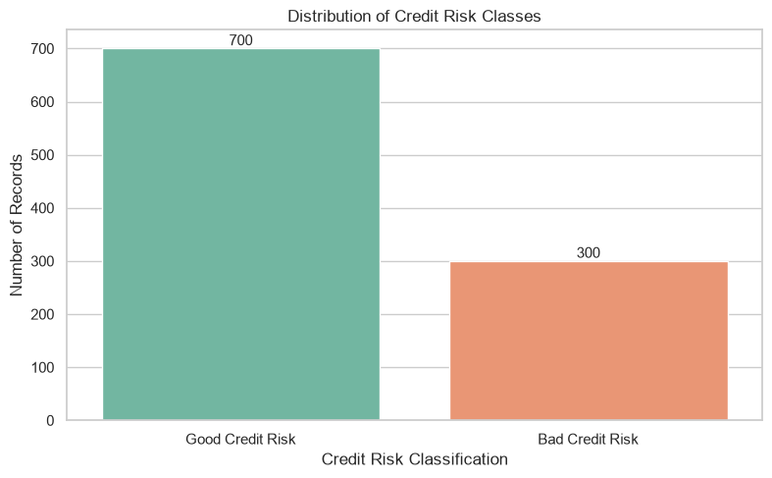
Figure: Credit risk class distribution

4.2 Credit amount distribution
The credit-amount histogram compares the two risk groups and highlights variation and overlap. The overall mean is 3,271.26 and median 2,319.50; these do not by themselves demonstrate that any individual loan amount causes bad credit risk.
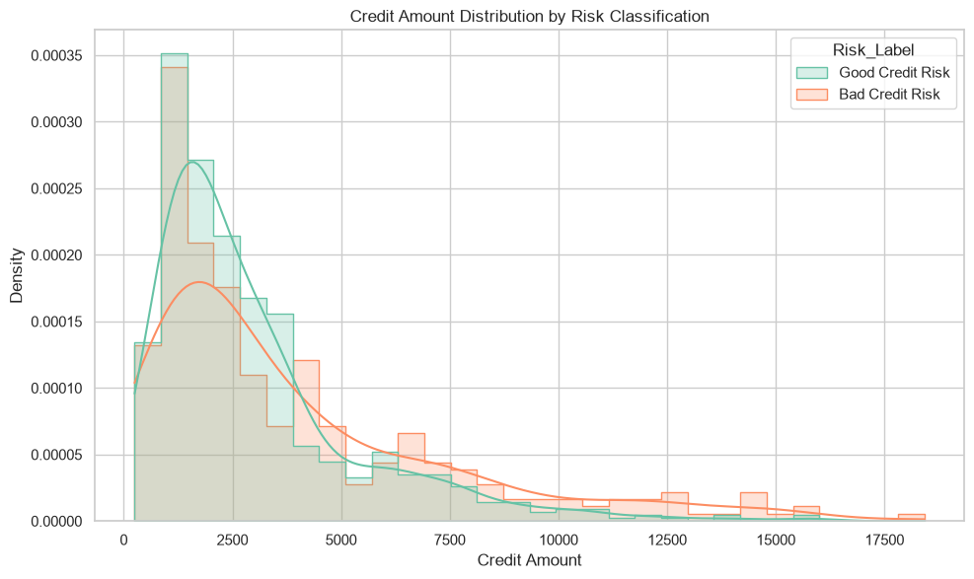
Figure: Credit amount distribution by risk class

4.3 Loan duration distribution
Boxplots compare the location, spread and outliers of loan duration between classes. Duration is associated with the risk label in the sample, but this association may reflect other correlated attributes.
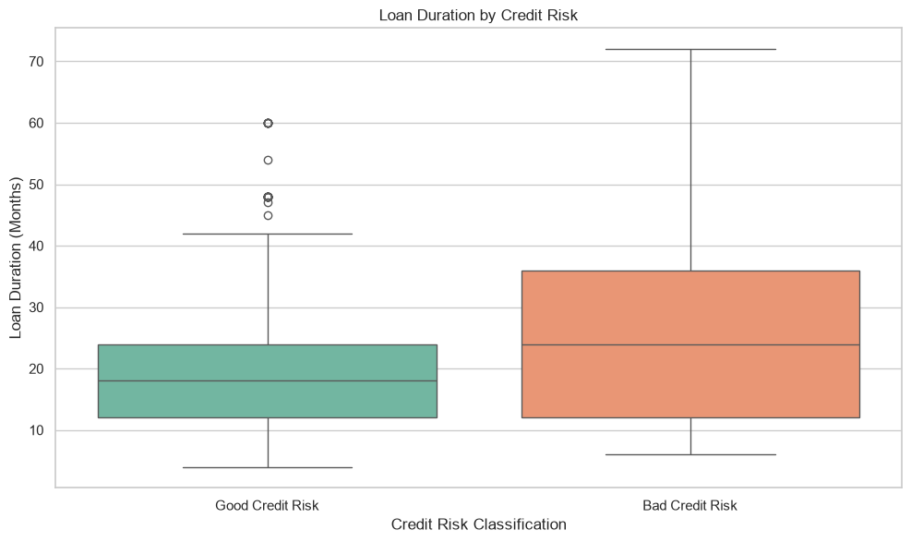
Figure: Loan duration by credit risk

4.4 Checking account status
Category | Records | Bad-risk rate
A11 | 274 | 49.27%
A12 | 269 | 39.03%
A13 | 63 | 22.22%
A14 | 394 | 11.68%
The observed bad-risk rate varies markedly by checking-status code. The chart supports prioritizing careful validation of this feature, not automatically imposing a lending rule based on category membership.
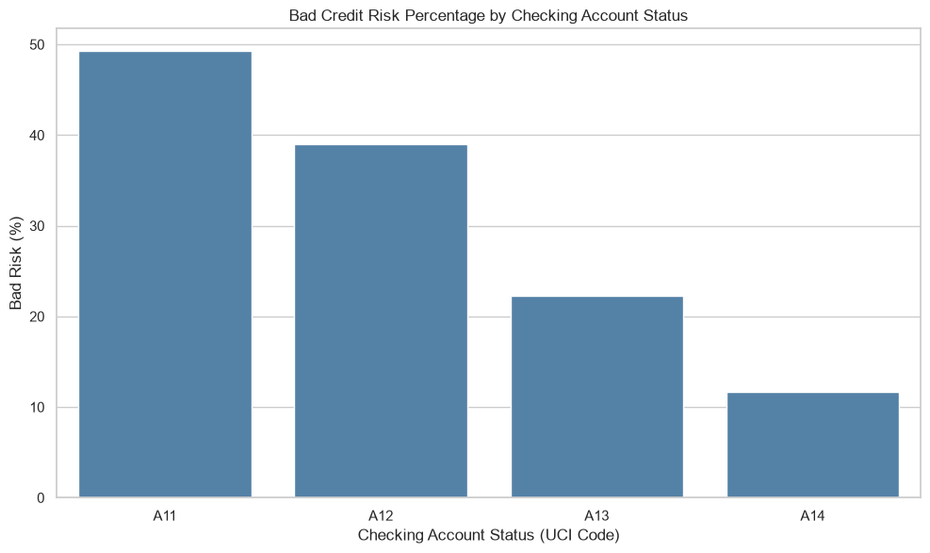
Figure: Bad-risk percentage by checking account status

4.5 Duration groups
Duration | Records | Bad-risk rate
Up to 12 months | 359 | 21.17%
13–24 months | 411 | 29.68%
25–36 months | 143 | 39.86%
Above 36 months | 87 | 51.72%
Historical bad-risk share increases across these duration groups, from 21.17% to 51.72%. Group sizes differ, especially for the longest loans, and the result is observational rather than a controlled effect.
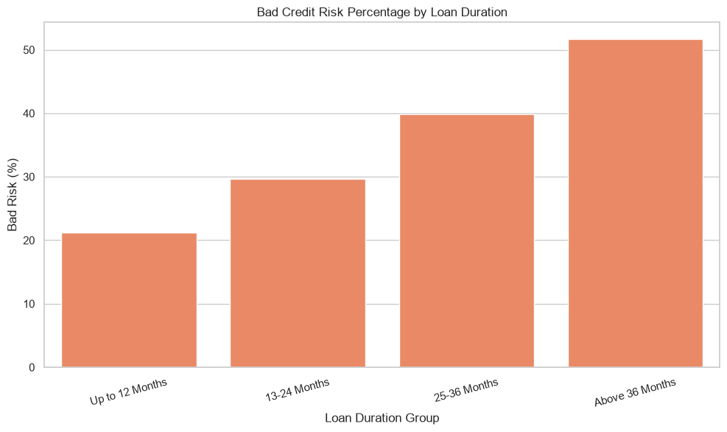
Figure: Bad-risk percentage by loan duration group

4.6 Joint credit amount and duration
The scatter plot shows how loan amounts and terms coexist across the two classes. Visual overlap reinforces the need to combine features rather than rely on a single threshold.
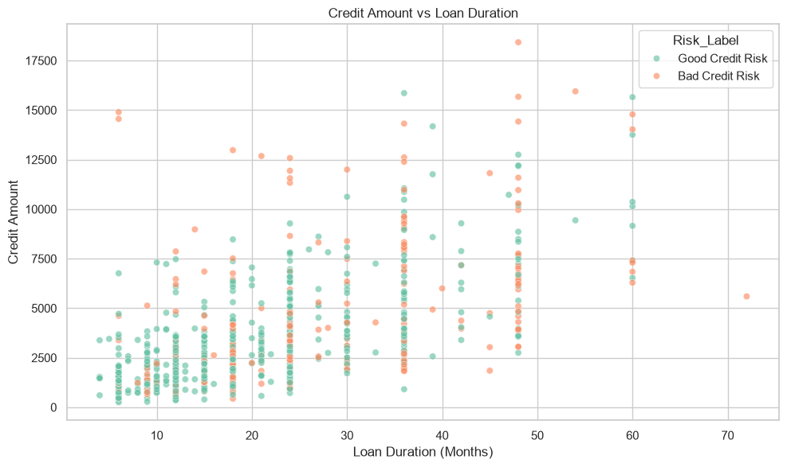
Figure: Credit amount versus loan duration

4.7 Numerical correlations
The heatmap summarizes pairwise linear correlations among the chosen numerical attributes and the encoded target. It does not measure nonlinear or conditional relationships, and correlations between encoded targets and numerical features must be interpreted cautiously.
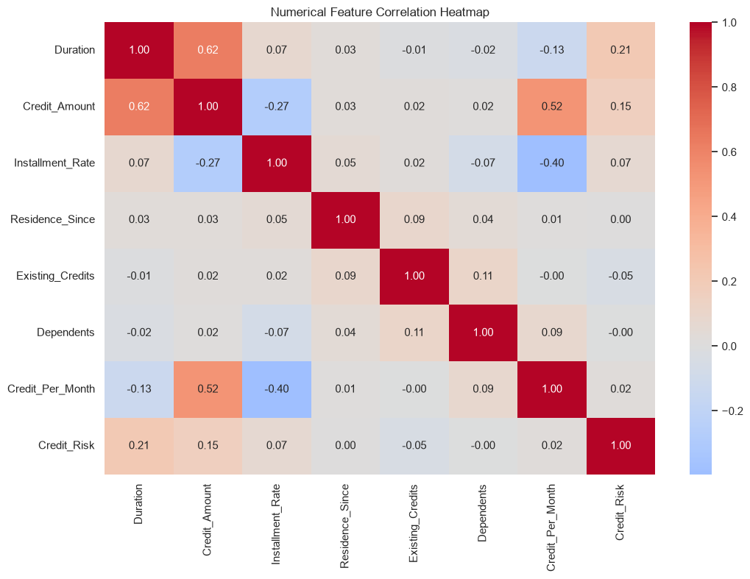
Figure: Numerical correlation heatmap

4.8 Savings status
Category | Records | Bad-risk rate
A61 | 603 | 35.99%
A62 | 103 | 33.01%
A63 | 63 | 17.46%
A64 | 48 | 12.50%
A65 | 183 | 17.49%
Observed rates differ by savings-status category, with A61 showing the largest bad-risk proportion among the five groups. Interpretation of the category labels requires the source codebook.
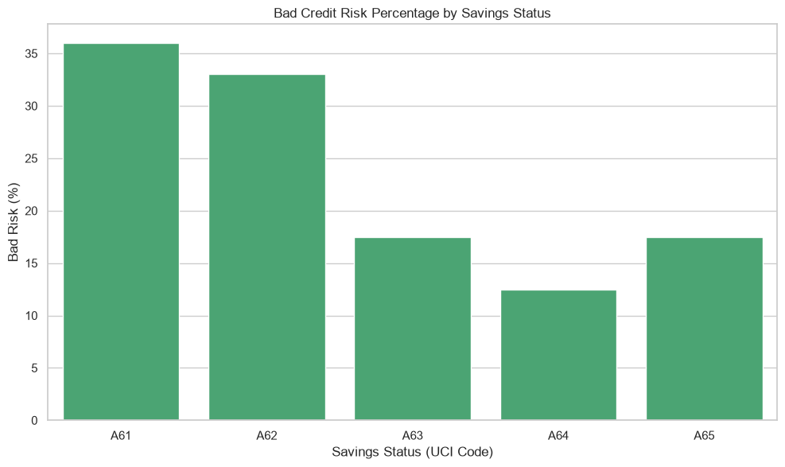
Figure: Bad-risk percentage by savings status

5. Modeling Pipeline and Technical Methodology

5.1 Split and leakage control
The notebook uses train_test_split(test_size=0.20, random_state=42, stratify=y), yielding 560 good/240 bad training cases and 140 good/60 bad test cases. Preprocessing is wrapped in each estimator pipeline, ensuring the scaler and encoder are fitted on the training partition in each fold.

5.2 Transformations
StandardScaler transforms numerical variables by centering and scaling using training statistics. OneHotEncoder(handle_unknown="ignore") expands categorical codes into indicator columns and allows unseen categories at prediction time. ColumnTransformer applies each operation to the corresponding column subset. This is particularly important for Logistic Regression, whose optimization and coefficients are affected by feature scales.

5.3 Logistic Regression
Logistic Regression models the log-odds of the bad-risk class as a linear combination of transformed predictors and converts the result to a probability through the logistic function. The notebook uses max_iter=1000 and random_state=42. It serves as an interpretable baseline, although one-hot encoded features and correlated predictors complicate direct coefficient interpretation.

5.4 Random Forest
Random Forest aggregates predictions from multiple decision trees trained on resampled data and random feature subsets. It can capture nonlinear interactions without explicitly specifying them. The notebook uses 200 trees, class_weight="balanced", and random_state=42. Balanced class weights alter the relative contribution of each class during fitting; they do not guarantee high minority-class recall.

5.5 Metrics
Accuracy = (TP+TN)/N; precision = TP/(TP+FP); recall = TP/(TP+FN); F1 = 2×precision×recall/(precision+recall). Here positive means bad risk. ROC-AUC summarizes discrimination across probability thresholds. A high ROC-AUC does not imply well-calibrated probabilities, and accuracy can conceal minority-class errors.

6. Results, Validation and Interpretation

6.1 Initial test comparison
Metric | Logistic Regression | Random Forest
Accuracy | 0.7800 | 0.7650
Precision | 0.6667 | 0.6102
Recall | 0.5333 | 0.6000
F1 | 0.5926 | 0.6050
ROC-AUC | 0.7931 | 0.7851
Logistic Regression is slightly stronger on test accuracy, precision and ROC-AUC. Random Forest detects more bad-risk cases and has a slightly higher F1 score. This comparison was performed before the cross-validation stage, so the test set was not wholly untouched during the overall workflow.
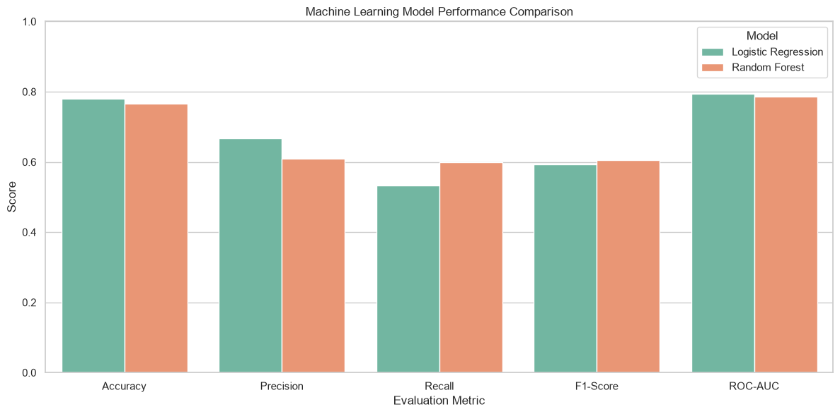
Figure: Initial model performance comparison

6.2 Confusion matrices
Outcome | Logistic Regression | Random Forest
True negative (good correctly labeled) | 124 | 117
False positive (good flagged bad) | 16 | 23
False negative (bad missed) | 28 | 24
True positive (bad identified) | 32 | 36
Of 60 truly bad-risk test cases, Random Forest catches 36 and misses 24; Logistic Regression catches 32 and misses 28. Random Forest therefore trades seven extra false alarms for four fewer missed bad-risk cases. The operational preference depends on the relative consequences of these two errors, which were not quantified in the dataset.
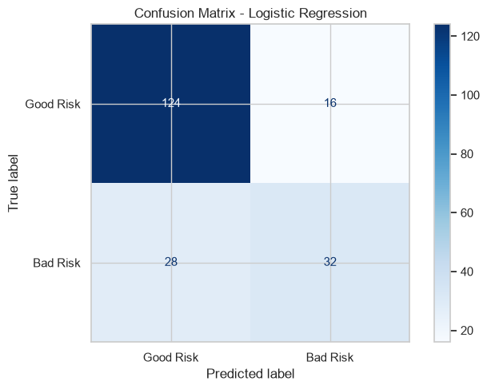
Figure: Confusion matrix — Logistic Regression
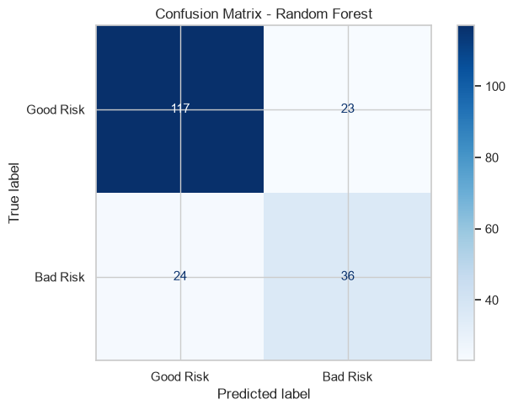
Figure: Confusion matrix — Random Forest

6.3 ROC analysis
Test ROC-AUC is 0.7931 for Logistic Regression and 0.7851 for Random Forest. Both exceed the random-discrimination reference of 0.5, but the small difference is not evidence of a statistically significant superiority.
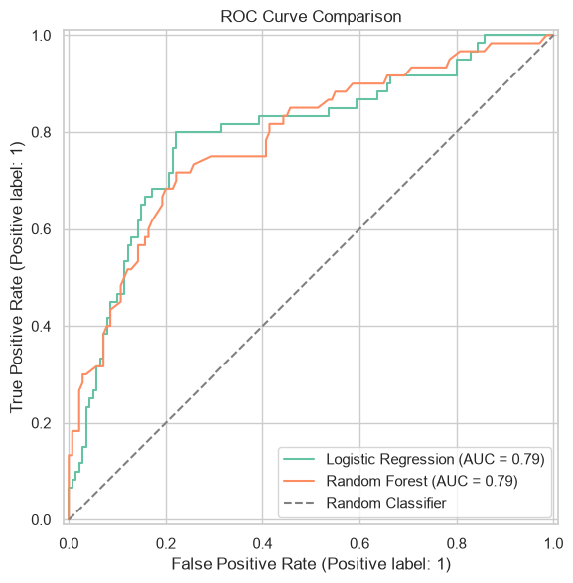
Figure: ROC curve comparison

6.4 Feature importance
Feature | Permutation ROC-AUC decrease
Checking_Status | 0.1309
Purpose | 0.0166
Savings_Status | 0.0126
Credit_History | 0.0106
Other_Debtors | 0.0106
Other_Installment_Plans | 0.0068
Credit_Per_Month | 0.0065
Credit_Amount | 0.0049
Job | 0.0046
Residence_Since | 0.0043
Permutation importance measures how much test ROC-AUC decreases when an input feature is shuffled. Checking_Status dominates this particular fitted model, but importance is not causation, can be diluted by correlated predictors, and was estimated on the same test data used for evaluation.
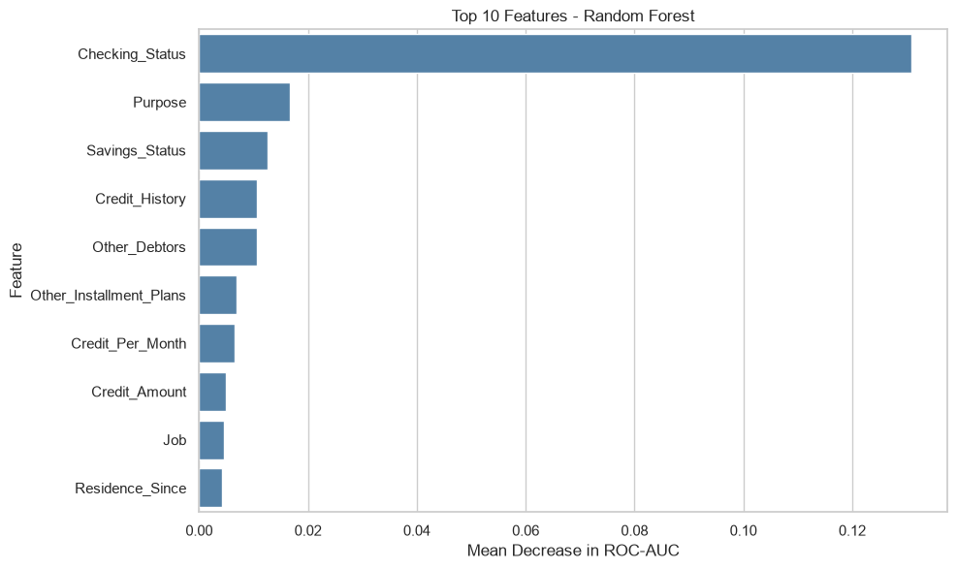
Figure: Random Forest permutation importance

6.5 Five-fold stratified cross-validation
Metric | Logistic Regression | Random Forest
Mean accuracy | 0.7425 | 0.7513
Mean precision | 0.5975 | 0.5844
Mean recall | 0.4417 | 0.5833
Mean F1 | 0.5058 | 0.5818
Mean ROC-AUC | 0.7625 | 0.7923
ROC-AUC fold SD | 0.0586 | 0.0406
StratifiedKFold(n_splits=5, shuffle=True, random_state=42) preserves class balance within folds. Random Forest has the larger mean validation ROC-AUC and stronger recall/F1, despite slightly lower precision. The fold standard deviation is descriptive and should not be interpreted as a confidence interval.
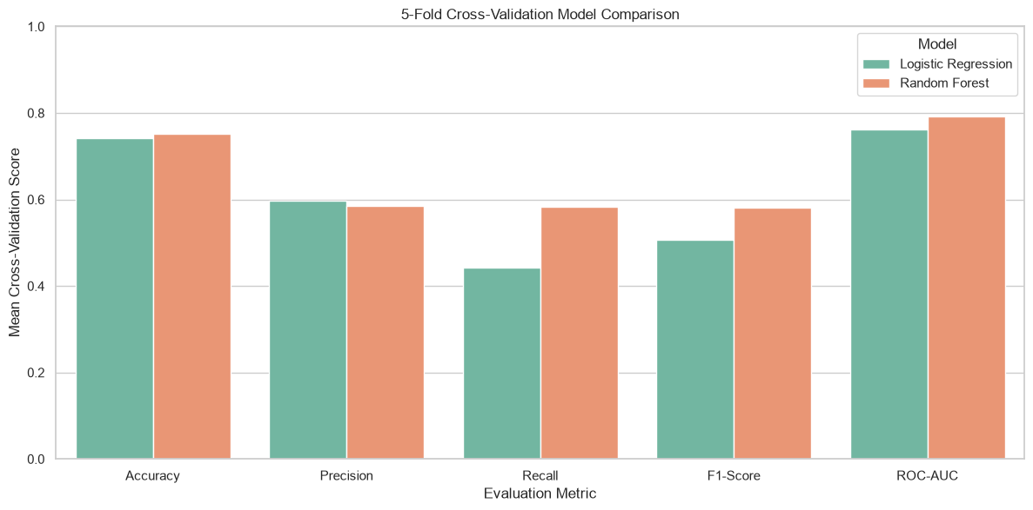
Figure: Five-fold cross-validation comparison

6.6 Final selected model
Using the higher mean cross-validation ROC-AUC as the selection rule, the notebook chooses Random Forest and refits it on the 800 training records. The final saved artifact is models/final_credit_risk_model.pkl. Its test results remain accuracy 0.7650, precision 0.6102, recall 0.6000, F1 0.6050 and ROC-AUC 0.7851. The earlier file best_credit_risk_model.pkl represents an initial test-based Logistic Regression choice and is not the final model.

7. Business Interpretation and Recommendations
The empirical findings suggest three priorities. First, checking-account status warrants careful investigation because both observed risk rates and model permutation importance vary markedly by category. Second, longer-duration groups show increasing historical bad-risk shares; this is a descriptive pattern that should be assessed jointly with loan amount, purpose and credit history. Third, the false-negative rate of 40% among bad-risk test cases is too high to justify automated decisions.

Priority 1 — Review feature definitions and quality
Verify that financial codes are mapped correctly, available at decision time and stable across data sources. Document missingness, drift and potential proxies.

Priority 2 — Improve sensitivity through validation
Study the 24 missed bad-risk records, examine precision-recall trade-offs, and choose any alternative threshold using validation folds rather than test-set tuning.

Priority 3 — Evaluate business costs
Develop explicit hypothetical costs for false positives and false negatives; evaluate cost curves and calibration before interpreting probabilities as actionable risks.

Priority 4 — Establish responsible governance
Require independent validation, fairness assessment, privacy protections, transparent explanations and human review before any real lending use.

8. Limitations and Threats to Validity
The dataset is small, historical and geographically specific. The target describes good/bad credit risk rather than a confirmed loan default outcome. The project compares only two algorithms and does not conduct hyperparameter search, probability calibration, cost-sensitive threshold selection, or external validation. Sensitive variables were excluded from model inputs, but correlated proxy variables may remain. The feature-importance analysis was performed on the test set, and the test set was examined before the final cross-validation selection procedure; reported results should therefore be viewed as an exploratory benchmark, not an unbiased estimate of future operational performance. No statistical confidence intervals, fairness subgroup results or business return-on-investment calculations are provided by the notebook.

9. Future Work
Recommended extensions include nested or otherwise strictly separated model selection and testing; repeated stratified validation; a truly external dataset; gradient-boosting baselines; hyperparameter optimization; threshold and cost sensitivity analysis; probability calibration with reliability diagrams and Brier score; explainability methods such as SHAP; subgroup fairness evaluation; drift monitoring; and an aggregate dashboard. Any deployment pathway would require a modern representative dataset and legal/regulatory review.

10. Reproducibility and Deliverables
The notebook is organized into six major steps: (1) exploration/preprocessing, (2) EDA, (3) model development/evaluation, (4) cross-validation/final selection, (5) insights/recommendations, and (6) final summary. It saves prepared data, EDA summary, model-comparison CSV, cross-validation CSV, final model summary, PNG visualizations, and serialized models to project subdirectories. To reproduce, use Python with pandas, numpy, matplotlib, seaborn, scikit-learn and joblib, run notebook cells in order, and retain the original data source URL. The notebook contains executed outputs; reproducibility still depends on compatible package versions and access to the public dataset.

11. Conclusion
The capstone demonstrates an end-to-end applied data science workflow on the UCI German Credit dataset. It identifies meaningful historical patterns, develops two supervised classifiers and uses five-fold stratified validation to select Random Forest. The selected model achieves 76.50% accuracy and 0.7851 ROC-AUC on the recorded test partition but misses 24 of 60 bad-risk cases. The most important outcome is not an automated lending tool; it is a transparent, reproducible analysis that connects dataset quality, model selection, class-specific errors, feature interpretation and cautious business recommendations.

References
UCI Machine Learning Repository. Statlog (German Credit Data). https://archive.ics.uci.edu/dataset/144/statlog+german+credit+data
Scikit-learn documentation. https://scikit-learn.org/stable/
McKinney, W. (2010). Data Structures for Statistical Computing in Python. Proceedings of SciPy. https://doi.org/10.25080/Majora-92bf1922-00a
NumPy documentation. https://numpy.org/doc/
Matplotlib documentation. https://matplotlib.org/stable/
Waskom, M. (2021). seaborn: statistical data visualization. Journal of Open Source Software, 6(60), 3021. https://doi.org/10.21105/joss.03021

