SIMATS ENGINEERING
ASSESSMENT TOOL 2

COURSE NAME: Database Management Systems COURSE CODE: CSA0509

COURSE OUTCOME COVERED

CO3: Analyze relational databases using functional dependencies, normalization
(1NF to 5NF), and key constraints to identify redundancy and ensure data integrity.
(BL2, BL3)

Activity Tool : Case Study (Medium) Assessment Tool Weightage: 30%

QUESTIONS Total Marks: 50
Q.N  o | Question | Bloom's Level | Marks
1 | Analyze the case: An online shopping platform stores  Order(OrderID, CustID, CustName, ProdID, ProdName, Qty, Price). Identify FDs and normalize to 3NF. | BL2 – Understand | 5
2 | A hospital maintains Patient(PID, PName, DocID, DocName, Specialization, WardNo, WardName). Identify anomalies and normalize to BCNF. | BL3 – Apply | 5
3 | Case study: A university stores Enrollment(SID, SName, CourseID, CourseName, Faculty, Grade). Analyze FDs and apply 2NF decomposition. | BL3 – Apply | 5
4 | Given the airline booking case: Booking(FlightNo, PassID, PassName, Seat, DeptCity, ArrCity, Date). Normalize up to BCNF. | BL3 – Apply | 5
5 | Analyze an HR system schema for a multinational company. Identify all functional and transitive dependencies and normalize to 3NF. | BL2 – Understand | 5
6 | Case: Library(MemberID, MemberName, BookID, Title, Author, Genre, BorrowDate). Identify MVDs and decompose to 4NF. | BL3 – Apply | 5

7 | Analyze a telecom billing schema and identify all candidate keys, primary keys, and functional dependencies before normalization. | BL2 – Understand | 5
8 | A retail inventory system has Product(PID, PName, SupplierID, SupplierName, Category, Price, Warehouse). Apply complete normalization. | BL3 – Apply | 5
9 | Study the given poorly normalized schema for a School ERP and propose a fully normalized design up to BCNF with justification. | BL3 – Apply | 5
10 | Given a movie streaming platform schema, identify join  dependencies and decompose to 5NF with lossless-join verification. | BL3 – Apply | 5

Code of Conduct:
I, Nisha R (192311415) (Name / Reg No) certify that this submission is my original work and that I have adhered to the guidelines specified for this assessment. I understand that any violation of academic integrity rules will result in disciplinary action.

Signature of the student: Nisha R

Analyze the case: An online shopping platform stores Order(OrderID, CustID, CustName, ProdID, ProdName, Qty, Price). Identify FDs and normalize to 3NF.
Given relation:
Order(OrderID, CustID, CustName, ProdID, ProdName, Qty, Price)

Understanding of the Case
The relation contains information about orders, customers, and products. Customer details and product details are repeated for every order, which creates data redundancy and may lead to insertion, deletion, and update anomalies.

Functional Dependencies
The major functional dependencies are:
  - OrderID → CustID, ProdID, Qty
  - CustID → CustName
  - ProdID → ProdName, Price
Assuming one order contains one product, the candidate key is:
Candidate Key = OrderID

1NF
The relation is already in 1NF because all attributes contain atomic values. Order(OrderID, CustID, CustName, ProdID, ProdName, Qty, Price)

2NF
Since the candidate key is a single attribute OrderID, there cannot be a partial dependency. Therefore, the relation is in 2NF.

3NF Decomposition
There are transitive dependencies: OrderID → CustID → CustName and
OrderID → ProdID → ProdName, Price Therefore, decompose the relation into: Customer
Customer(CustID, CustName)

Product
Product(ProdID, ProdName, Price)

Order
Order(OrderID, CustID, ProdID, Qty)
Final 3NF Schema Customer(CustID, CustName) Product(ProdID, ProdName, Price) Order(OrderID, CustID, ProdID, Qty) Primary Keys:
  - Customer → CustID
  - Product → ProdID
  - Order → OrderID Foreign Keys:
  - Order.CustID → Customer.CustID
  - Order.ProdID → Product.ProdID

SQL Queries
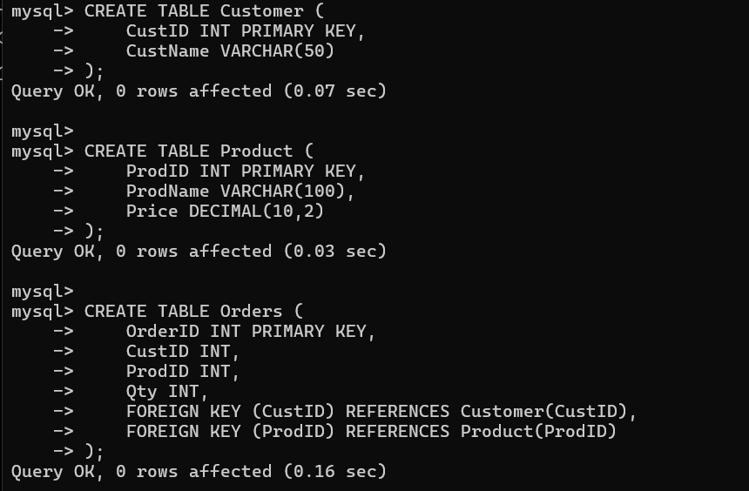

Justification:
The decomposition removes transitive dependencies and avoids unnecessary duplication of customer and product information. It also prevents update, insertion, and deletion anomalies while maintaining referential integrity.

A hospital maintains Patient(PID, PName, DocID, DocName, Specialization, WardNo, WardName). Identify anomalies and normalize to BCNF.
Given relation:
Patient(PID, PName, DocID, DocName, Specialization, WardNo, WardName)

Functional Dependencies
The functional dependencies are:
  - PID → PName, DocID, WardNo
  - DocID → DocName, Specialization
  - WardNo → WardName Candidate Key:
Candidate Key = PID

Identification of Anomalies
There are transitive dependencies:
PID → DocID → DocName, Specialization PID → WardNo → WardName
Therefore, storing all attributes in one relation causes redundancy.

BCNF Decomposition
A relation is in BCNF if for every non-trivial functional dependency: X → Y
X must be a superkey. In the original relation:
DocID → DocName, Specialization but DocID is not a superkey.
Similarly:
WardNo → WardName
but WardNo is not a superkey. Therefore, the relation violates BCNF.

Decomposed Relations Patient
Patient(PID, PName, DocID, WardNo)

Doctor
Doctor(DocID, DocName, Specialization)

Ward
Ward(WardNo, WardName)

SQL
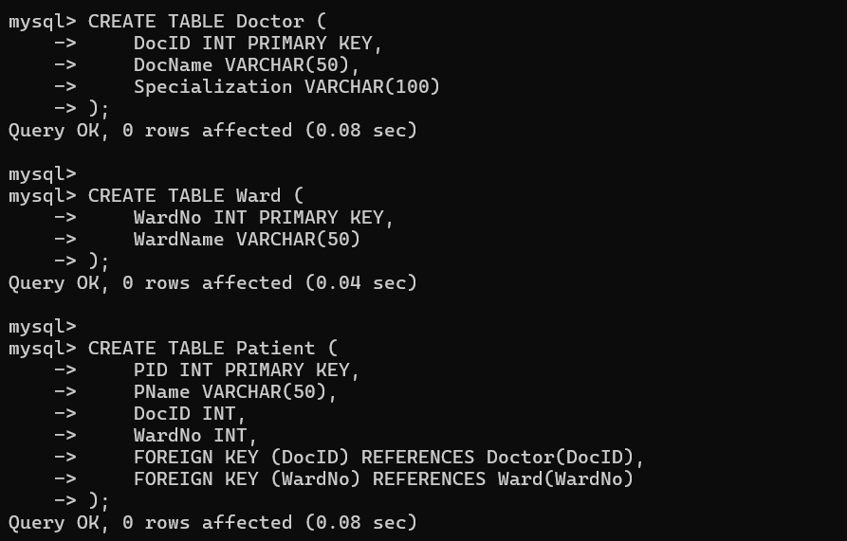

Justification:
The decomposition places each determinant in its own relation, making every determinant a candidate key of its relation. Hence, the resulting relations satisfy BCNF and reduce redundancy.

Case study: A university stores Enrollment(SID, SName, CourseID, CourseName, Faculty, Grade). Analyze FDs and apply 2NF decomposition.
Given relation:
Enrollment(SID, SName, CourseID, CourseName, Faculty, Grade)

Functional Dependencies
The functional dependencies are:
  - SID → SName
  - CourseID → CourseName, Faculty
  - (SID, CourseID) → Grade Candidate Key:
(SID, CourseID)

1NF
All attributes are atomic, so the relation is in 1NF.

2NF Analysis
The candidate key is composite:
(SID, CourseID) However:
SID → SName
CourseID → CourseName, Faculty
These are partial dependencies because non-key attributes depend on only part of the composite key.
Therefore, the relation is not in 2NF.

Decomposition into 2NF Student
Student(SID, SName)

Course
Course(CourseID, CourseName, Faculty)

Enrollment
Enrollment(SID, CourseID, Grade)

SQL
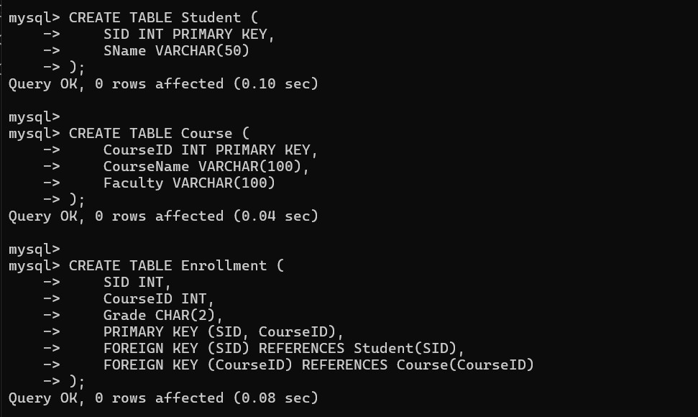

Justification:
The decomposition removes partial dependencies by storing student information and course information separately. The Enrollment table stores only attributes dependent on the complete composite key (SID, CourseID). Therefore, the schema satisfies 2NF.

Given the airline booking case: Booking(FlightNo, PassID, PassName, Seat, DeptCity, ArrCity, Date). Normalize up to BCNF.
Given relation:
Booking(FlightNo, PassID, PassName, Seat, DeptCity, ArrCity, Date)

Functional Dependencies
Assuming a passenger can book a particular flight and seat:
  - PassID → PassName
  - FlightNo → DeptCity, ArrCity
  - (FlightNo, PassID) → Seat, Date Candidate Key:
(FlightNo, PassID)

BCNF Analysis
Consider:
PassID → PassName
PassID is not a superkey of the complete Booking relation. Also:
FlightNo → DeptCity, ArrCity
FlightNo is not a superkey of the complete Booking relation. Therefore, the relation violates BCNF.

BCNF Decomposition Passenger
Passenger(PassID, PassName)

Flight
Flight(FlightNo, DeptCity, ArrCity)

Booking
Booking(FlightNo, PassID, Seat, Date)

SQL
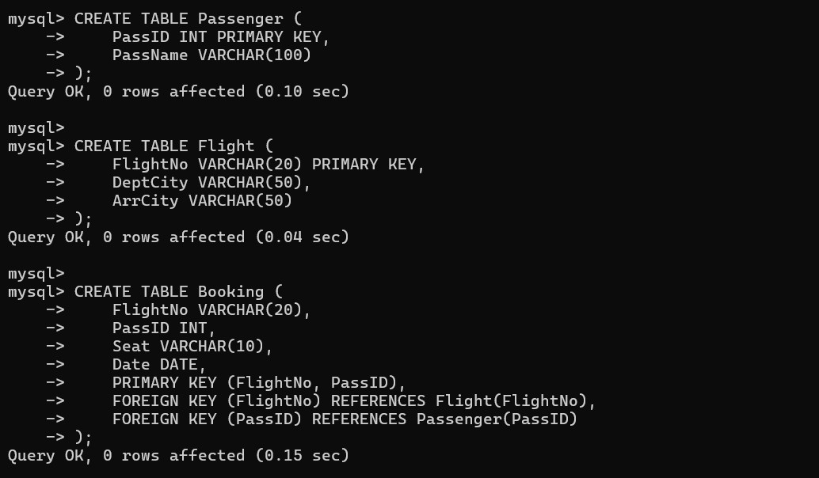

Justification
The decomposition ensures that:
  - Passenger information depends only on PassID.
  - Flight information depends only on FlightNo.
  - Booking information depends on the complete booking key.
Thus, every determinant becomes a candidate key in its respective relation, satisfying BCNF.

Analyze an HR system schema for a multinational company. Identify all functional and transitive dependencies and normalize to 3NF.
Given Schema
An HR system contains employee information such as:
Employee(EmpID, EmpName, DeptID, DeptName, ManagerID, ManagerName, Salary)

Functional Dependencies
The functional dependencies are:
EmpID → EmpName, DeptID, Salary DeptID → DeptName, ManagerID ManagerID → ManagerName Candidate Key:
EmpID

Transitive Dependencies
There are transitive dependencies:
EmpID → DeptID → DeptName EmpID → DeptID → ManagerID
EmpID → DeptID → ManagerID → ManagerName Therefore, storing all information together causes redundancy.

3NF Decomposition Employee
Employee(EmpID, EmpName, DeptID, Salary)

Department
Department(DeptID, DeptName, ManagerID)

Manager
Manager(ManagerID, ManagerName)

SQL
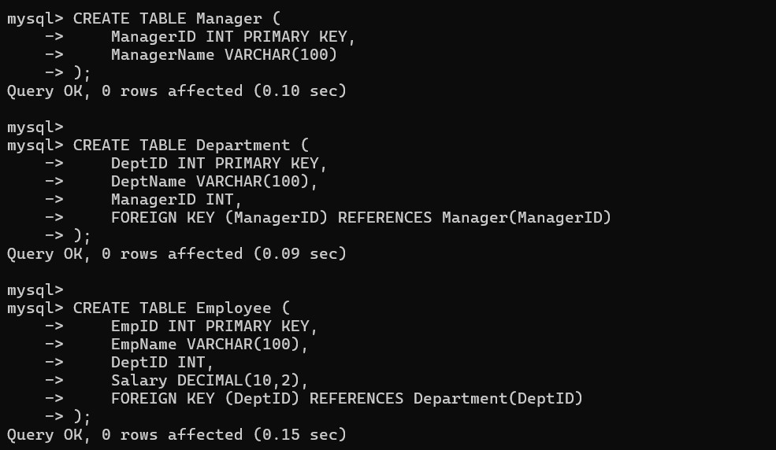

Justification
The decomposition removes transitive dependencies. Employee details depend only on EmpID, department details depend only on DeptID, and manager details depend only on ManagerID. Therefore, the schema satisfies 3NF.

Case: Library(MemberID, MemberName, BookID, Title, Author, Genre, BorrowDate). Identify MVDs and decompose to 4NF.
Given relation:
Library(MemberID, MemberName, BookID, Title, Author, Genre, BorrowDate)

Multivalued Dependencies
Assume a member can borrow multiple books and a book can have multiple authors. The following independent multivalued dependencies may exist:
MemberID →→ BookID BookID →→ Author
The book's title and genre depend on BookID:
BookID → Title, Genre

Problem
If a member borrows multiple books and each book has multiple authors, combining both independent multivalued facts creates unnecessary combinations.
For example:
Member 1 → Book A Member 1 → Book B and
Book A → Author X Book A → Author Y
can produce redundant combinations.

Decomposition into 4NF Member
Member(MemberID, MemberName)

Book
Book(BookID, Title, Genre) BookAuthor BookAuthor(BookID, Author) Borrow
Borrow(MemberID, BookID, BorrowDate)

SQL
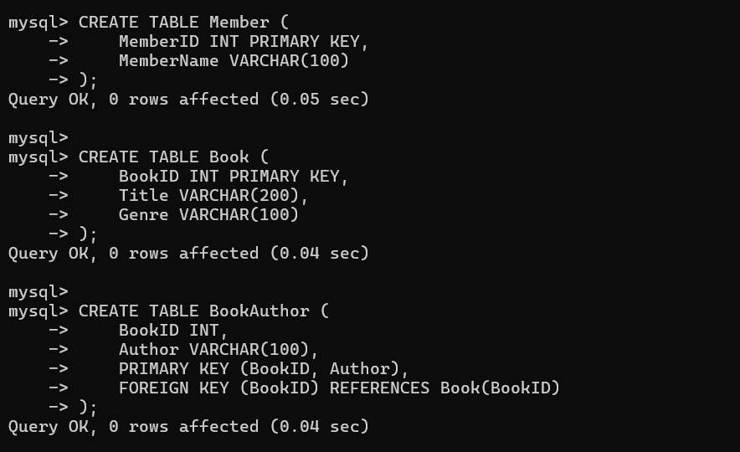

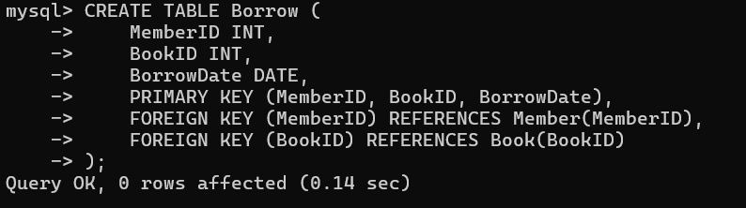

Justification
The independent multivalued relationships are separated into different relations. This prevents unnecessary combinations and removes multivalued dependencies from the same relation. Therefore, the design satisfies 4NF.

Analyze a telecom billing schema and identify all candidate keys, primary keys, and functional dependencies before normalization.
Given Case
Consider a relation:
R(StudentID, StudentName, CourseID, CourseName, FacultyID, FacultyName, Grade)
Functional Dependencies
The functional dependencies are: StudentID → StudentName
CourseID → CourseName, FacultyID FacultyID → FacultyName (StudentID, CourseID) → Grade

Candidate Key
To determine all attributes:
From:
StudentID → StudentName CourseID → CourseName, FacultyID FacultyID → FacultyName
and:
(StudentID, CourseID) → Grade we obtain:
(StudentID, CourseID)+ which gives:
StudentID StudentName CourseID CourseName FacultyID FacultyName Grade Therefore:
Candidate Key = (StudentID, CourseID)

Primary Key
The composite candidate key can be selected as the primary key: PRIMARY KEY(StudentID, CourseID)

Prime Attributes
The prime attributes are:
StudentID CourseID
The remaining attributes are non-prime attributes.

SQL

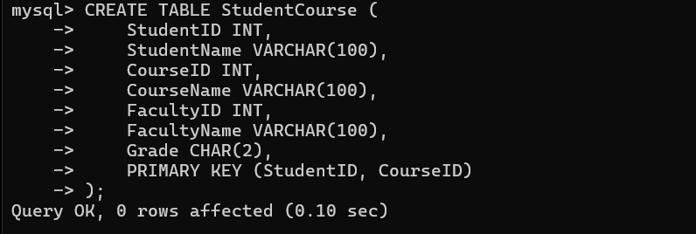

Conclusion
The composite key (StudentID, CourseID) uniquely identifies each enrollment record. The identified functional dependencies can then be used to normalize the relation into 2NF and 3NF.

A retail inventory system has Product(PID, PName, SupplierID, SupplierName, Category, Price, Warehouse). Apply complete normalisation.
Given relation:
Product(PID, PName, SupplierID, SupplierName, Category, Price, Warehouse)

Functional Dependencies
Assuming:
PID → PName, SupplierID, Category, Price, Warehouse SupplierID → SupplierName
Candidate Key:
PID

Normalization Analysis
The dependency:
SupplierID → SupplierName creates a transitive dependency:
PID → SupplierID → SupplierName Therefore, the original relation is not in 3NF.

Decomposition Supplier
Supplier(SupplierID, SupplierName)

Product
Product(PID, PName, SupplierID, Category, Price, Warehouse)

SQL
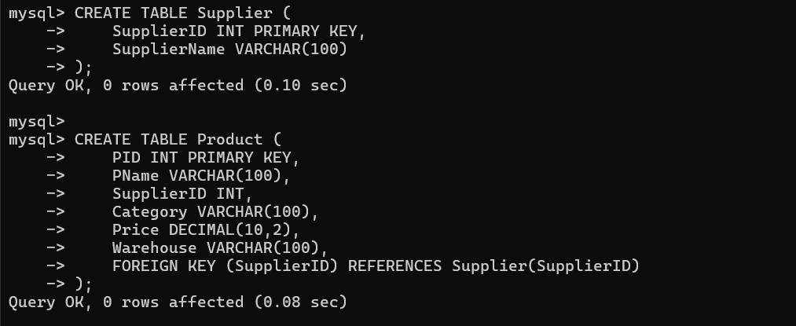

Justification
Supplier information is stored separately so that the supplier name does not have to be repeated for every product supplied by the same supplier. This removes transitive dependency and reduces update anomalies.
The resulting relations are in 3NF, assuming the stated functional dependencies.

Study the given poorly normalized schema for a School ERP and propose a fully normalized design up to BCNF with justification.Poorly Normalized Relation
Consider:
SchoolERP( StudentID, StudentName, ClassID, ClassName, TeacherID, TeacherName, SubjectID, SubjectName, Marks
)

Functional Dependencies
The dependencies are:
StudentID → StudentName, ClassID ClassID → ClassName, TeacherID TeacherID → TeacherName SubjectID → SubjectName (StudentID, SubjectID) → Marks Candidate Key:
(StudentID, SubjectID)

Problems in the Original Relation
There are partial dependencies:
StudentID → StudentName, ClassID SubjectID → SubjectName
There are also transitive dependencies: StudentID → ClassID → ClassName
StudentID → ClassID → TeacherID → TeacherName Therefore, the relation is not in 2NF or 3NF.

BCNF Decomposition Student
Student(StudentID, StudentName, ClassID)

Class
Class(ClassID, ClassName, TeacherID)

Teacher
Teacher(TeacherID, TeacherName)

Subject
Subject(SubjectID, SubjectName)

Marks
Marks(StudentID, SubjectID, Marks)

SQL
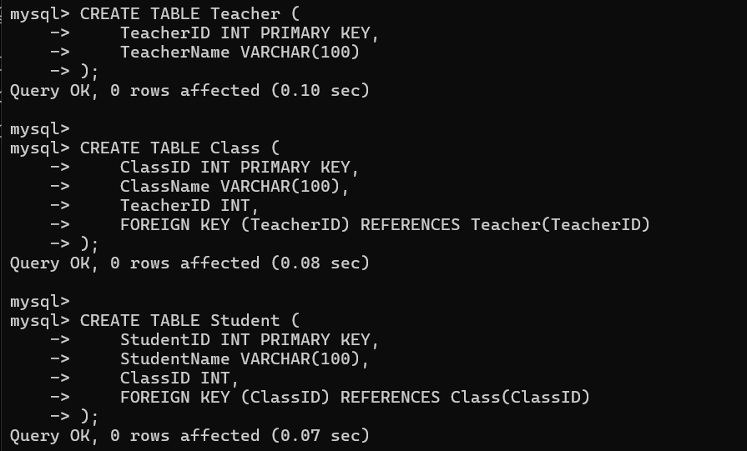

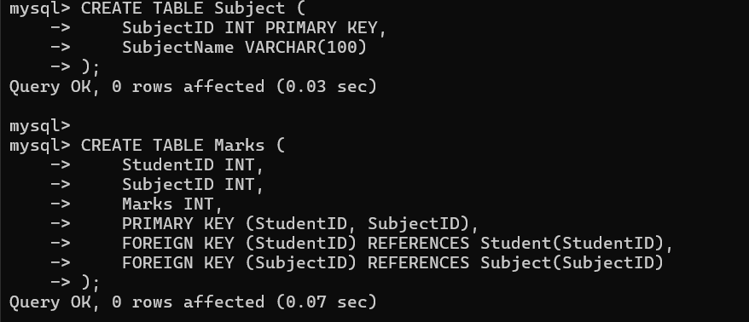

BCNF Justification
In each decomposed relation, the determinant is a candidate key: StudentID → StudentName, ClassID
ClassID → ClassName, TeacherID TeacherID → TeacherName SubjectID → SubjectName (StudentID, SubjectID) → Marks
Therefore, the relations satisfy BCNF under the stated assumptions.

Given a movie streaming platform schema, identify join dependencies and decompose to 5NF with lossless-join verification. Given Schema
Consider:
MovieStreaming( MovieID, MovieName, ActorID, ActorName, GenreID, GenreName
)
Assume that a movie can have multiple actors and multiple genres, and these two relationships are independent.

Multivalued Dependencies
The following multivalued dependencies exist:
MovieID →→ ActorID MovieID →→ GenreID
This means that actors and genres are independently associated with a movie.

Problem with the Relation
Suppose:
Movie M1 Actors: A1, A2 Genres: G1, G2
The combined relation may require: M1 A1 G1
M1 A1 G2 M1 A2 G1 M1 A2 G2
This creates redundant combinations.

Decomposition
Separate the independent relationships:

Movie
Movie(MovieID, MovieName)

Actor
Actor(ActorID, ActorName)

Genre
Genre(GenreID, GenreName) MovieActor MovieActor(MovieID, ActorID) MovieGenre MovieGenre(MovieID, GenreID)

SQL
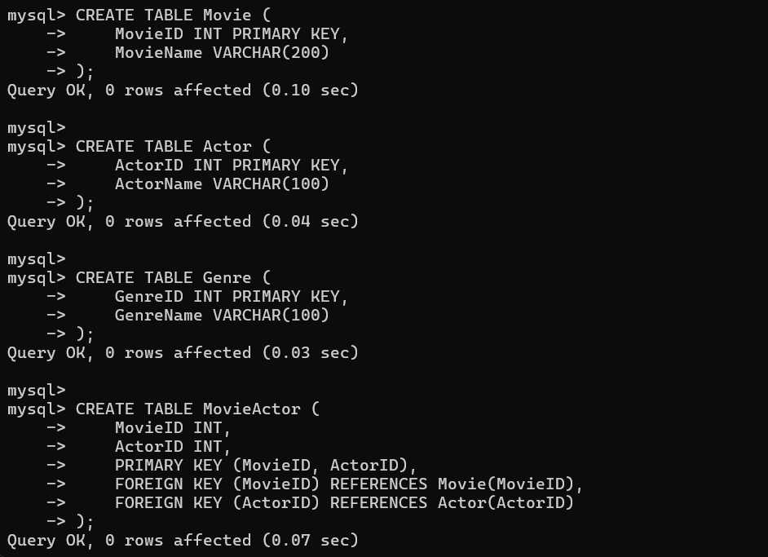

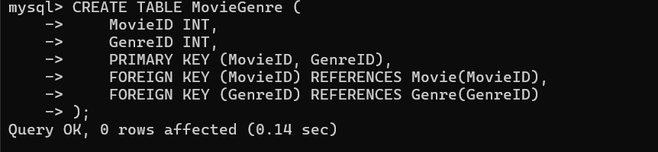

Join Dependency and 5NF
The original relation can be represented using the decomposition:
Movie MovieActor MovieGenre
The independent relationships are stored separately, so the relation can be reconstructed through joins without storing unnecessary combinations.
The join dependency can be represented conceptually as:
R = MovieActor ⋈ MovieGenre
with the Movie, Actor, and Genre information maintained separately.

Justification
The decomposition removes independent multivalued facts and eliminates redundancy caused by combinations of actors and genres. The resulting design is suitable for 5NF because the relation is decomposed into smaller relations based on join dependencies, and no non-trivial join dependency remains that can be further decomposed without loss of information.

