SIMATS ENGINEERING
ASSESSMENT TOOL 3

COURSE NAME: Database Management Systems COURSE CODE: CSA0509

COURSE OUTCOME COVERED

CO2: Apply the relational model, relational algebra, SQL query structures, and views to solve database querying and data manipulation problems. (BL3, BL6)

Activity Tool: Debugging & Optimisation Task (Low) Assessment Tool Weightage: 10%

QUESTIONS
Q.N  o | Question | Bloom's Level
1 | Identify and correct errors in a given SQL CREATE TABLE statement with incorrect syntax and missing constraints. | BL2 –  Understand
2 | Debug an SQL query that incorrectly uses aggregate functions without GROUP BY and fix the issue. Bloom’s Level: | BL2 –  Understand
3 | Correct a faulty SELECT query where column names are misspelled or improperly referenced. | BL1 –  Remember
4 | Fix errors in an SQL query using JOIN, where the join condition is missing or incorrect. | BL3 – Apply
5 | Identify and correct a subquery error where multiple values are returned instead of a single value. | BL2 –  Understand
6 | Debug a VIEW creation statement that contains invalid column references or syntax errors. | BL1 –  Remember
7 | Examine an SQL query with unnecessary conditions and optimize it by simplifying the WHERE clause. | BL3 – Apply
8 | Identify violations of integrity constraints in a given table and correct them. | BL2 –  Understand

9 | Fix a relation that violates 1NF or 2NF by removing repeating groups or partial dependencies. | BL3 – Apply
10 | Identify redundant attributes in a relation and apply basic normalization (up to 3NF) to improve design. | BL3 – Apply

Code of Conduct:
I, Nisha. R (192311415) (Name / Reg No) certify that this submission is my original work and that I have adhered to the guidelines specified for this assessment. I understand that any violation of academic integrity rules will result in disciplinary action.

Signature of the student:
Nisha

RUBRICS FOR CALCULATION:

Criteria | Level 4 (Exemplary) | Level 3 (Proficient) | Level 2 (Developing) | Level 1 (Beginning)
Problem Identification | Accurately identifies all errors and  root causes with  clear understanding | Identifies most errors with minor gaps | Identifies some errors  but misses key issues | Unable to identify errors correctly
Debugging | Applies systematic debugging techniques effectively to  resolve issues | Uses appropriate debugging methods with minor errors | Limited debugging approach; requires guidance | Unable to debug or resolve issues
Optimization | Optimizes code by  significantly improving time complexity using efficient algorithms | Improves time complexity with minor gaps in efficiency | Limited improvement in time complexity | No improvement; inefficient approach retained
Analysis | Demonstrates strong logical reasoning and clear  justification of  solutions | Shows reasonable analysis with some justification | Limited analysis; weak reasoning | No analytical reasoning demonstrated

Code Quality | Produces clean, well-structure  d code with proper comments and | Code is mostly clear with minor documentation gaps | Code lacks structure and proper  documentation | Poorly written code with no documentation

- Identify and correct errors in a given SQL CREATE TABLE statement with incorrect syntax and missing constraints.
Original (Faulty):
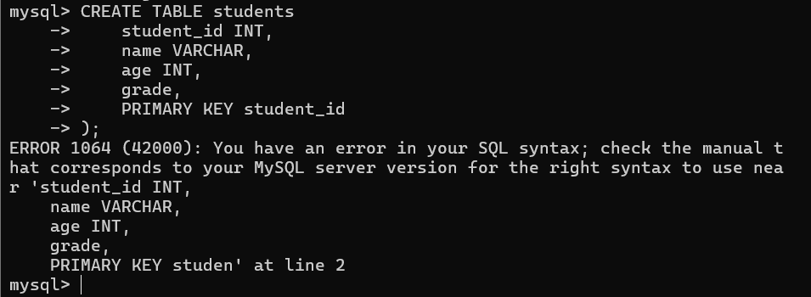
Corrected:
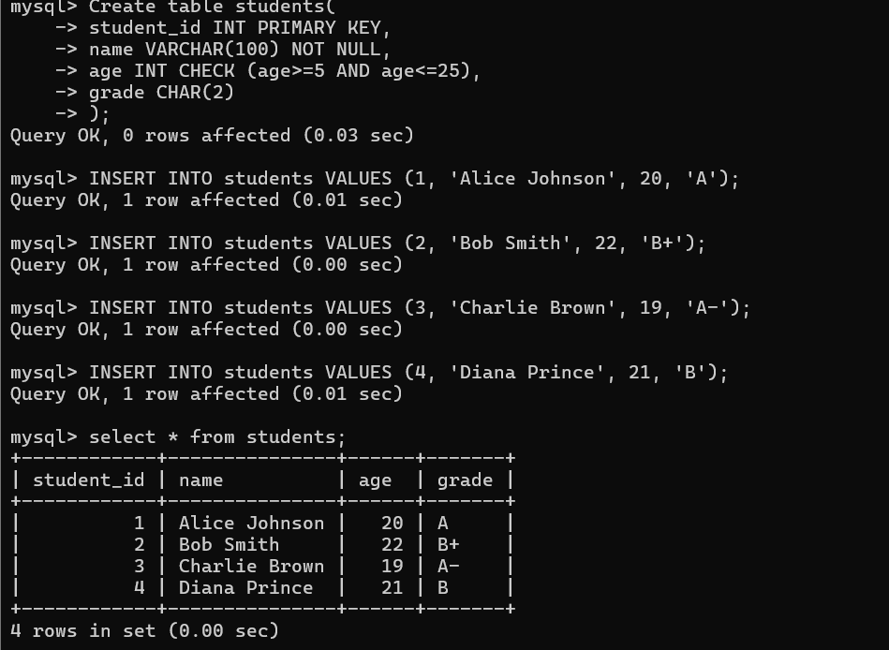
Errors Fixed:
  - Missing parentheses around column definitions
  - VARCHAR missing size parameter
  - 'grade' column missing data type
  - PRIMARY KEY syntax incorrect (should be after column definition or with parentheses)

- Debug an SQL query that incorrectly uses aggregate functions without GROUP BY and fix the issue.
Original (Faulty):
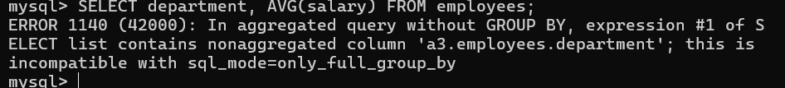
Corrected:
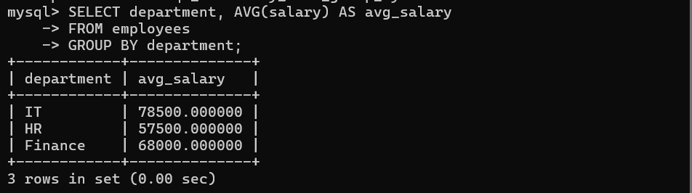
Error Fixed: Added GROUP BY department to aggregate salaries by department

- Correct a faulty SELECT query where column names are misspelled or improperly referenced.
Original (Faulty):
Corrected:
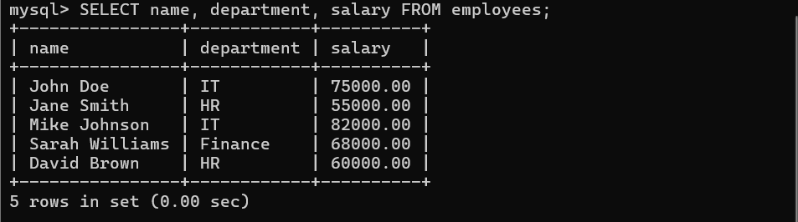
Error Fixed: Corrected column names: emp_name→name, depatment→department, sallary→salary

- Fix errors in an SQL query using JOIN, where the join condition is missing or incorrect.
Original (Faulty):
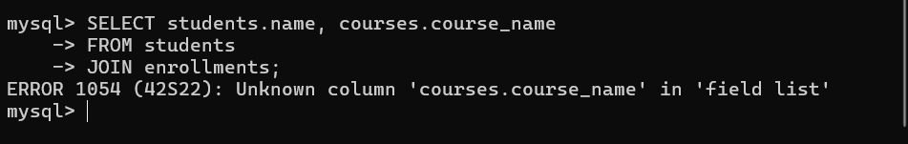
Corrected:
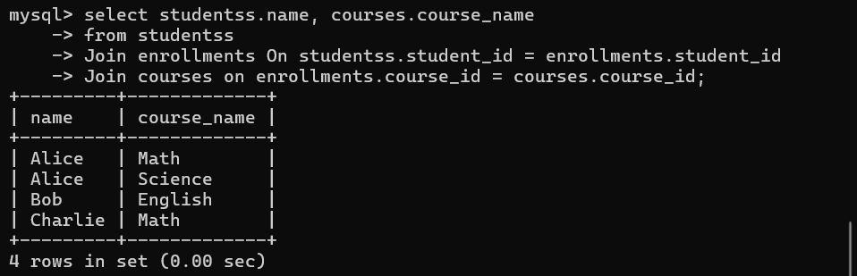
Error Fixed: Added proper JOIN conditions

- Identify and correct a subquery error where multiple values are returned instead of a single value
Original (Faulty):
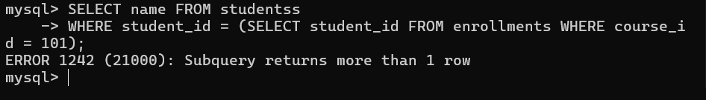
Corrected:
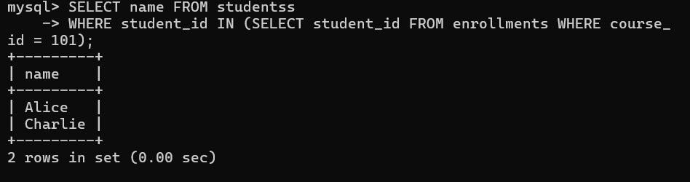
Error Fixed: Changed '=' to 'IN' when subquery returns multiple values

- Debug a VIEW creation statement that contains invalid column references or syntax errors. Original (Faulty):
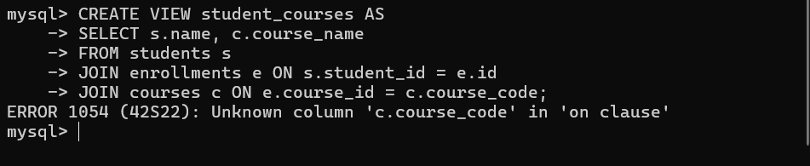

Corrected:
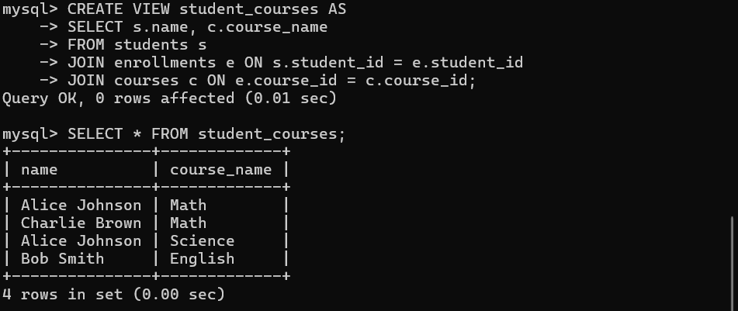
Errors Fixed:
  - Corrected e.id to e.student_id
  - Corrected c.course_code to c.course_id

- Examine an SQL query with unnecessary conditions and optimize it by simplifying the WHERE clause.
Original (Faulty - Unnecessary Conditions):
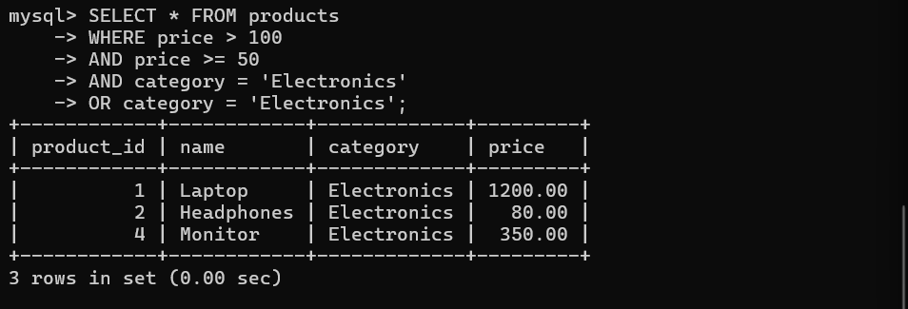
Corrected:
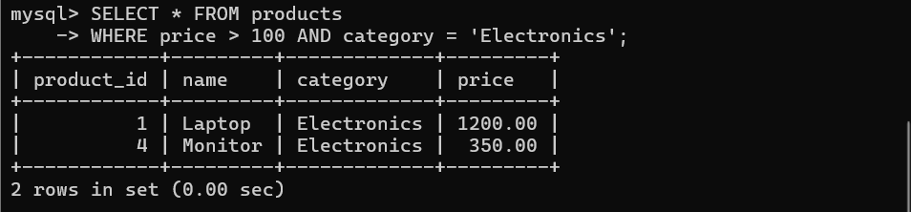
Optimisation: Removed redundant conditions (price >= 50 was redundant with price > 100, and duplicate category condition)

- Identify violations of integrity constraints in a given table and correct them. Original (Faulty Data):
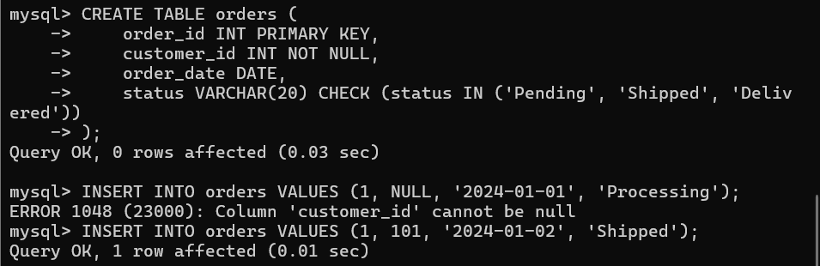
Corrected:
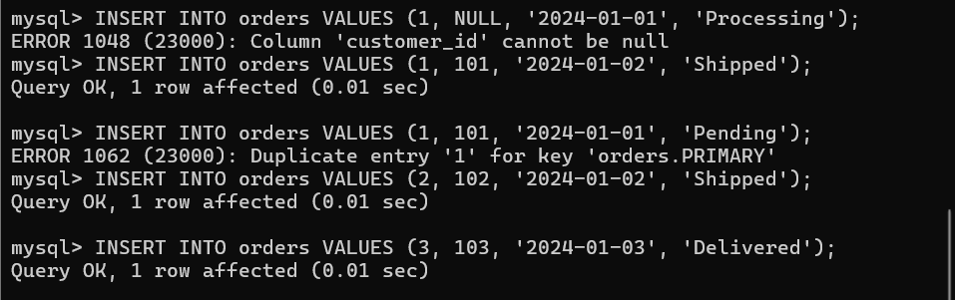
Errors Fixed:
  - customer_id cannot be NULL (NOT NULL constraint)
  - status must be one of: 'Pending', 'Shipped', 'Delivered' (CHECK constraint)
  - order_id must be unique (PRIMARY KEY constraint)

- Fix a relation that violates 1NF or 2NF by removing repeating groups or partial dependencies. Original (Violating 1NF - Repeating Groups):
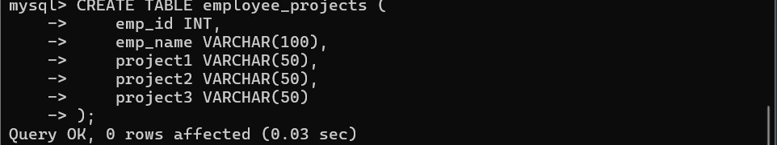
Corrected (1NF & 2NF):
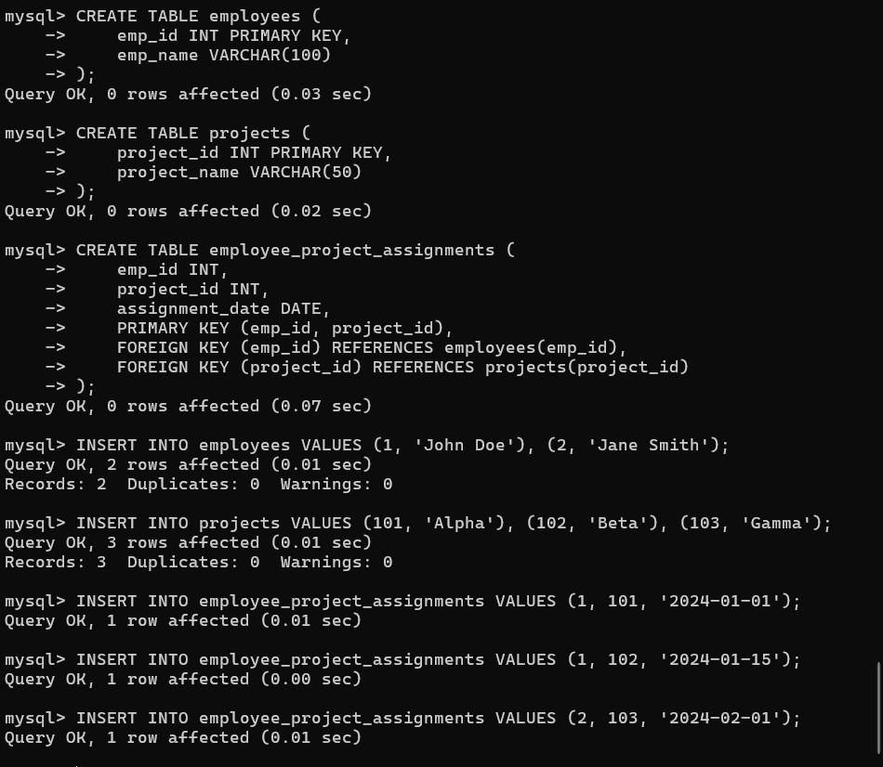

Improvements:
- 1NF: Eliminated repeating groups (project1, project2, project3)
- 2NF: Created separate tables to remove partial dependencies

- Identify redundant attributes in a relation and apply basic normalization (up to 3NF) to improve design.
Original (Redundant Data):
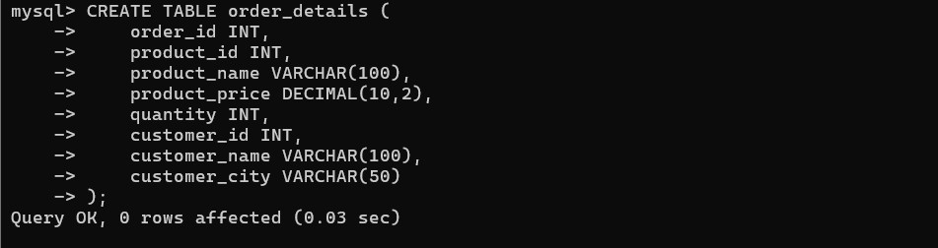
Corrected (3NF Normalization):
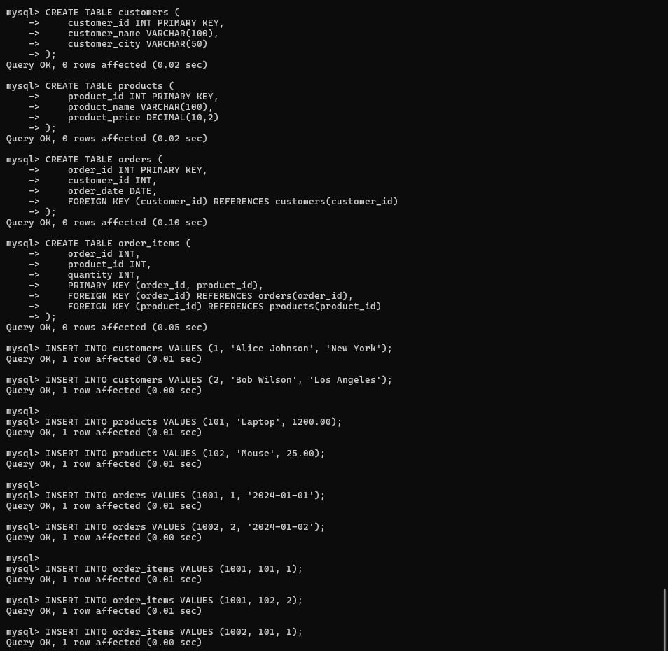

Improvements:
- Eliminated redundant customer and product data
- Separated into logical tables (Customers, Products, Orders, OrderItems)
- Achieved 3NF by removing transitive dependencies
- product_price depends on product_id, not order_id

