SIMATS ENGINEERING
ASSESSMENT TOOL 1

COURSE NAME: Database Management Systems COURSE CODE: CSA0509

COURSE OUTCOME COVERED

CO3: Analyze relational databases using functional dependencies, normalization (1NF to 5NF), and key constraints to identify redundancy and ensure data integrity. (BL2, BL3)

Activity Tool: Experiments (High) Assessment Tool Weightage: 40%

QUESTIONS |  | Total Marks: 50
Q.N  o | Question | Bloom's Level | Marks
1 | For the relation STUDENT_COURSE(SID, SName, CID, CName, Instructor, Grade), identify all functional dependencies and determine the candidate keys. | BL2 – Understand | 5
2 | Demonstrate the process of converting an unnormalized relation into 1NF with step-by-step justification and example. | BL3 – Apply | 5
3 | Given relation R(A,B,C,D,E) with FDs: A→BC, BC→D, D→E. Analyze and decompose it to 2NF eliminating partial dependencies. | BL3 – Apply | 5
4 | Apply 3NF decomposition on the relation EMPLOYEE(EmpID, EmpName, DeptID, DeptName, ManagerID) with transitive dependencies. | BL3 – Apply | 5
5 | Verify whether R(A,B,C,D) with FDs: AB→C, C→D, D→A is in BCNF. If not, decompose it into BCNF. | BL3 – Apply | 5
6 | Experimentally verify lossless-join decomposition for a given relation using the tabular (Chase) algorithm. | BL3 – Apply | 5
7 | Identify the multi-valued dependencies in TEACHER(TID, Subject, Hobby) and decompose it into 4NF. | BL3 – Apply | 5

8 | Demonstrate how join dependencies lead to redundancy. Decompose a given relation to 5NF (Project-Join Normal Form). | BL3 – Apply | 5
9 | Given a poorly designed database schema for a college, identify all anomalies (insertion, deletion, update) and normalize it to 3NF. | BL2 – Understand | 5
10 | Compute the closure of attribute sets for the given FDs and determine all candidate keys for the relation. | BL3 – Apply | 5

Code of Conduct:

I Nisha.R(192311415) (Name / Reg No) certify that this submission is my original work and that I have adhered to the guidelines specified for this assessment. I understand that any violation of academic integrity rules will result in disciplinary action.

Signature of the student:
Nisha. R

RUBRICS FOR CALCULATION:

Criteria | Level 4 – Exemplary | Level 3 – Proficient | Level 2 – Developing | Level 1 – Beginning
Understanding of Concepts | Demonstrates thorough understanding and effectively integrates multiple concepts/technologie  s | Good understanding with proper integration of most concepts | Basic understanding; limited or partial integration | Poor understanding; unable to integrate concepts
Experimental Design | Well-planned, systematic  implementation with optimal solution | Correct implementatio  n with minor issues | Basic implementatio  n with errors or inefficiencies | Incorrect or incomplete  implementatio n
Use of Tools | Effective and advanced use of tools/technologies with proper  configuration | Appropriate use of tools with correct execution | Limited or inconsistent use of tools | Incorrect or minimal use of tools
Analysis of Results | Insightful analysis with accurate  interpretation and validation of results | Good analysis with  reasonable interpretation | Basic analysis with limited insights | Poor or incorrect analysis of  results
Documentatio n | Clear, well-structured documentation with  diagrams, code, and results | Organized documentation  with necessary details | Basic documentation  with missing details | Poor or incomplete documentation

Q1. STUDENT_COURSE – Functional Dependencies and Candidate Keys Given relation
STUDENT_COURSE(SID, SName, CID, CName, Instructor, Grade)
Assume:
- A student ID uniquely identifies a student.
- A course ID uniquely identifies a course.
- A student's grade depends on both the student and course.

Functional Dependencies
The functional dependencies are:
- SID → SName
- CID → CName
- CID → Instructor
- (SID, CID) → Grade
Therefore,
F = { SID → SName, CID → CName, CID → Instructor, SID,CID → Grade } Finding Candidate Key
Take:
(SID, CID)+
Start:
{SID, CID}
Using SID → SName:
{SID, CID, SName}
Using CID → CName, Instructor:
{SID, CID, SName, CName, Instructor} Using SID,CID → Grade:
{SID, CID, SName, CName, Instructor, Grade} Therefore,
(SID, CID)+ = all attributes
Hence:
Candidate Key = {SID, CID}
Neither SID nor CID alone can determine all attributes.

Final Answer:
Candidate Key = (SID, CID)

Q2. Convert an Unnormalized Relation into 1NF Example Unnormalized Relation
Consider:

STUDENT(SID, SName, PhoneNumbers)

SID | SName | PhoneNumbers
S01 | Ravi | "98768765"
S02 | Priya | "91238234"
Here, PhoneNumbers contains multiple values. Therefore, it violates 1NF.

Step 1: Identify repeating group
For S01:
PhoneNumbers = {9876, 8765} For S02:
PhoneNumbers = {9123, 8234}
A 1NF relation must contain atomic values. Step 2: Convert to 1NF
Create one row for each phone number.

SID | SName | PhoneNumber
S01 | Ravi | 9876
S01 | Ravi | 8765
S02 | Priya | 9123
S02 | Priya | 8234
Now every attribute contains a single atomic value. Primary Key
The combination:

(SID, PhoneNumber)
can uniquely identify each record.

Conclusion
The original relation was not in 1NF because PhoneNumbers contained multiple values. After decomposition:
STUDENT_PHONE(SID, SName, PhoneNumber)
is in 1NF.

Q3. Decompose into 2NF Given
Relation: R(A, B, C, D, E)
Functional Dependencies:
- A → BC
- BC → D
- D → E
We need to decompose into 2NF. Step 1: Find Candidate Key Calculate A+:
A+ = {A}
Using A → BC: = {A, B, C} Using BC → D: = {A, B, C, D} Using D → E: = {A, B, C, D, E}
Therefore:
A+ = {A,B,C,D,E}
So: Candidate Key = A
Since the candidate key consists of only one attribute, there cannot be any partial dependency on a part of the key.
Therefore, the relation is already in 2NF. Step 2: Check dependencies
A → BC is a dependency from the complete key.
BC → D and D → E do not violate 2NF because 2NF is concerned with partial dependency on a proper subset of a composite candidate key.

Conclusion
Since the candidate key is a single attribute:

R(A,B,C,D,E) is in 2NF.
However, it has a transitive dependency: A → BC → D → E
Therefore, it may require decomposition to achieve 3NF

Q4. 3NF Decomposition of EMPLOYEE Given relation
EMPLOYEE(EmpID, EmpName, DeptID, DeptName, ManagerID)
Functional dependencies:
- EmpID → EmpName, DeptID
- DeptID → DeptName, ManagerID Step 1: Identify Candidate Key
EmpID determines:
EmpID → EmpName, DeptID DeptID → DeptName, ManagerID Therefore:
EmpID+ = {EmpID, EmpName, DeptID, DeptName, ManagerID}

EmpID | EmpName | DeptID | DeptName | ManagerID
E01 | Ravi | D01 | Computer  Science | M01
E02 | Priya | D01 | Computer  Science | M01
E03 | Arun | D02 | Information  Technology | M02
Hence:
Candidate Key = EmpID

Step 2: Identify transitive dependency
We have:
EmpID → DeptID and
DeptID → DeptName, ManagerID

EmpID | EmpName | DeptID | DeptName | ManagerID
E01 | Ravi | D01 | Computer Science | M01
E02 | Priya | D01 | Computer Science | M01
E03 | Arun | D02 | Information  Technology | M02
Therefore:
EmpID → DeptID → DeptName, ManagerID

This is a transitive dependency. Hence the relation is not in 3NF. Step 3: Decompose
Create:

Relation 1
EMPLOYEE(EmpID, EmpName, DeptID)

EmpID | EmpName | DeptID
E01 | Ravi | D01
E02 | Priya | D01
E03 | Arun | D02

FD: EmpID → EmpName, DeptID
Candidate Key: EmpID Relation 2

DEPARTMENT(DeptID, DeptName, ManagerID)

DeptID | DeptName | ManagerID
D01 | Computer Science | M01
D02 | Information Technology | M02

FD: DeptID → DeptName, ManagerID
Candidate Key: DeptID Final decomposition

EMPLOYEE(EmpID, EmpName, DeptID) DEPARTMENT(DeptID, DeptName, ManagerID) Why is it in 3NF?
In EMPLOYEE: EmpID → EmpName, DeptID EmpID is a candidate key.
In DEPARTMENT: DeptID → DeptName, ManagerID DeptID is a candidate key.
Therefore, both relations satisfy 3NF.

Q5. Check BCNF and Decompose Given
Relation:
R(A, B, C, D)

A | B | C | D
a1 | b1 | c1 | d1
a2 | b2 | c2 | d2
a3 | b3 | c3 | d3
Functional dependencies:
- AB → C
- C → D
- D → A
We need to determine whether R is in BCNF.
Step 1: Find Candidate Keys AB+
AB+ = {A,B}
Using AB → C: = {A,B,C} Using C → D: = {A,B,C,D}
Therefore:

AB is a candidate key.
BC+
BC+ = {B,C}
Using C → D: = {B,C,D} Using D → A: = {A,B,C,D}
Therefore: BC is also a candidate key. So candidate keys are: AB and BC Step 2: Check BCNF
BCNF condition: For every non-trivial FD X → Y, X must be a superkey. Check:
AB → C
AB is a candidate key. Therefore, satisfied.
C → D
C is not a superkey because:

C+ = {C,D,A}
It does not contain B. Therefore:
C → D violates BCNF.
D → A
D is also not a superkey. D+ = {D,A}
It does not contain B or C.
Therefore: D → A also violates BCNF.
Hence: R is NOT in BCNF. Step 3: BCNF Decomposition Using C → D:
Create: R1(C,D) and R2(A,B,C) R1(C,D)
C | D
c1 | d1
c2 | d2
c3 | d3
FD: C → D
C is the key of R1. Therefore R1 is in BCNF.

R2(A,B,C)

A | B | C
a1 | b1 | c1
a2 | b2 | c2
a3 | b3 | c3
FD: AB → C
AB is a key.
Therefore R2 is in BCNF.

Q6. Lossless-Join Decomposition Using Chase Algorithm
Since the question does not specify a particular relation, consider this standard example.

Given
Relation: R(A, B, C) Functional dependency: A → B Decompose into:
R1(A,B)
R2(A,C)
We need to verify whether the decomposition is lossless. Step 1: Create Chase Table
Create columns A, B and C. For R1(A,B), use:
Row | A | B | C
R1 | a | b | c1
R2 | a | b1 | c
Here:
- Common attribute = A
- R1 has A and B
- R2 has A and C
Step 2: Apply FD A → B
Both rows contain the same value for A: A = a
Therefore, according to: A → B their B values must become the same.

Row | A | B | C
R1 | a | b | c1
R2 | a | b | c

Step 3: Check for a Distinguished Row
The first row now contains: a, b, c
where all attributes have the common/distinguished symbols. Therefore, the chase succeeds.

Result
Since a row becomes completely distinguished: The decomposition is lossless-join. Conclusion
R(A,B,C) → R1(A,B), R2(A,C) is a lossless decomposition.

Q7. MVD and 4NF Decomposition Given
Relation: TEACHER(TID, Subject, Hobby)
Suppose a teacher can teach multiple subjects and can have multiple hobbies independently. Example:
TID | Subject | Hobby
T01 | DBMS | Cricket
T01 | DBMS | Music
T01 | AI | Cricket
T01 | AI | Music

Step 1: Identify Multivalued Dependencies
Subjects and hobbies are independent. Therefore:
TID →→ Subject and
TID →→ Hobby

These are multivalued dependencies (MVDs). Step 2: Check 4NF
A relation is in 4NF if: For every non-trivial MVD X →→ Y, X must be a superkey. Here: TID →→ Subject
But TID alone does not determine all attributes. Therefore, TID is not a superkey. So the relation violates 4NF.

Step 3: Decompose
Create two relations: 1.TEACHER_SUBJECT

TID | Subject
T01 | DBMS
T01 | AI
- TEACHER_HOBBY

TID | Hobby
T01 | Cricket
T01 | Music
Final Answer TEACHER_SUBJECT(TID, Subject) TEACHER_HOBBY(TID, Hobby)
Both relations are in 4NF because their determinants are keys.

Q8. Join Dependency and 5NF Given
Consider: SUPPLY(Supplier, Part, Project)
Suppose the information can be represented independently through:
  - Supplier supplies a Part
  - Supplier works for a Project
  - Part is used in a Project This creates a join dependency. Step 1: Join Dependency
The relation can be decomposed into:
SP(Supplier, Part) SJ(Supplier, Project) PJ(Part, Project)
The join dependency is:
(Supplier, Part, Project) → SP ⋈ SJ ⋈ PJ

Step 2: Why redundancy occurs?
Suppose:

Supplier | Part | Project
S1 | P1 | J1
S1 | P1 | J2
S1 | P2 | J1
S1 | P2 | J2

If the three facts are independent, storing every combination creates redundant tuples. For example,
information about S1 supplying P1 is repeated for every project.

Step 3: Decompose Create: SP SP(Supplier, Part)
Supplier | Part
S1 | P1
S1 | P2

SJ
SJ(Supplier, Project)

Supplier | Project
S1 | J1
S1 | J2

PJ
PJ(Part, Project)

Part | Project
P1 | J1
P1 | J2
P2 | J1
P2 | J2

Step 4: 5NF
A relation is in 5NF if every non-trivial join dependency is implied by candidate keys. The decomposition separates the independent relationships.

Final Answer
SUPPLY → SP(Supplier, Part)
SJ(Supplier, Project) PJ(Part, Project)
This removes join dependency-related redundancy and produces a 5NF decomposition.

Q9. Anomalies and Normalization to 3NF
Consider the poorly designed college relation:
COLLEGE(StudentID, StudentName, CourseID, CourseName, InstructorID, InstructorName)

Example:

StudentID | StudentName | CourseID | CourseName | InstructorID | InstructorName
S01 | Ravi | C01 | DBMS | I01 | Kumar
S02 | Priya | C01 | DBMS | I01 | Kumar
S03 | Arun | C02 | AI | I02 | Meena

Step 1: Functional Dependencies
- StudentID → StudentName
- CourseID → CourseName, InstructorID
- InstructorID → InstructorName Candidate key: (StudentID, CourseID)
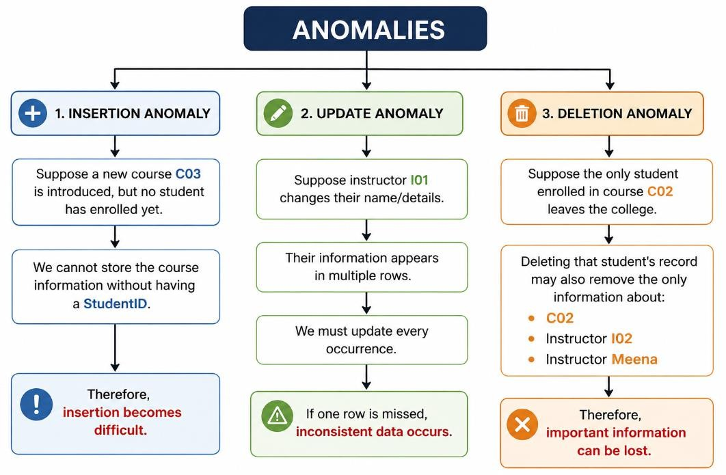

Step 2: Normalize to 3NF
The transitive dependency is:
CourseID → InstructorID and
InstructorID → InstructorName
Therefore: CourseID → InstructorID → InstructorName
This violates 3NF.

Decomposition: STUDENT STUDENT(StudentID, StudentName) StudentID,StudentName
S01 | Ravi
S02 | Priya
S03 | Arun
Primary Key: StudentID COURSE

COURSE(CourseID, CourseName, InstructorID)

CourseID | CourseName | InstructorID
C01 | DBMS | I01
C02 | AI | I02
Primary Key: CourseID INSTRUCTOR

INSTRUCTOR(InstructorID, InstructorName)

InstructorID | InstructorName
I01 | Kumar
I02 | Meena
Primary Key: InstructorID ENROLLMENT

ENROLLMENT(StudentID, CourseID)

StudentID | CourseID
S01 | C01
S02 | C01
S03 | C02
Primary Key: (StudentID, CourseID) Final Answer
The original college relation is decomposed into: STUDENT(StudentID, StudentName) COURSE(CourseID, CourseName, InstructorID) INSTRUCTOR(InstructorID, InstructorName) ENROLLMENT(StudentID, CourseID)
This eliminates insertion, deletion and update anomalies and results in a 3NF design.

Q10. Attribute Closure and Candidate Keys
Since the question does not specify an FD set, consider this standard example.

Given
Relation:
R(A, B, C, D, E)
Functional dependencies:
- A → B
- B → C
- CD → E
- E → A
Find attribute closures and all candidate keys.
Step 1: Calculate A+
Start:
A+ = {A}
Using A → B:
A+ = {A,B}
Using B → C:
A+ = {A,B,C}
We do not have D.
Therefore, CD → E cannot be applied. So:
A+ = {A,B,C}
A is not a key.
Step 2: Calculate E+
Start: E+ = {E}
Using E → A: E+ = {E,A} Using A → B: E+ = {E,A,B} Using B → C: E+ = {E,A,B,C}
D is missing.
Therefore: E+ = {A,B,C,E}
E is not a key.
Step 3: Calculate CD+
Start: CD+ = {C,D}
Using: CD → E

we get: {C,D,E}
Using: E → A
we get: {A,C,D,E}
Using: A → B
we get: {A,B,C,D,E}
Therefore: CD+ = {A,B,C,D,E}

So: CD is a candidate key.
Step 4: Find Another Candidate Key
Consider DE+. Start:
DE+ = {D,E}
E → A: {D,E,A}
A → B: {D,E,A,B}
B → C: {D,E,A,B,C}
Therefore: DE+ = {A,B,C,D,E}

So: DE is also a candidate key.

Closure Summary

AttributeSet | Closure | IsCandidateKey
A | A,B,C | No
E | A,B,C,E | No
CD | A,B,C,D,E | Yes
DE | A,B,C,D,E | Yes

Final Answer
Candidate Keys = CD and DE

