SIMATS ENGINEERING
CO1 - ASSESSMENT TOOL 2

COURSE NAME: Database Management Systems
COURSE CODE: CSA05

Name: Nisha. R
Reg. no: 192311415

Submitted to: R Kesavan
Submitted on:20-07-2026

1.Construct a concept map linking the following terms: DBMS, Schema, Instance, Data Model, ER Diagram, Entity, Attribute, Relationship.
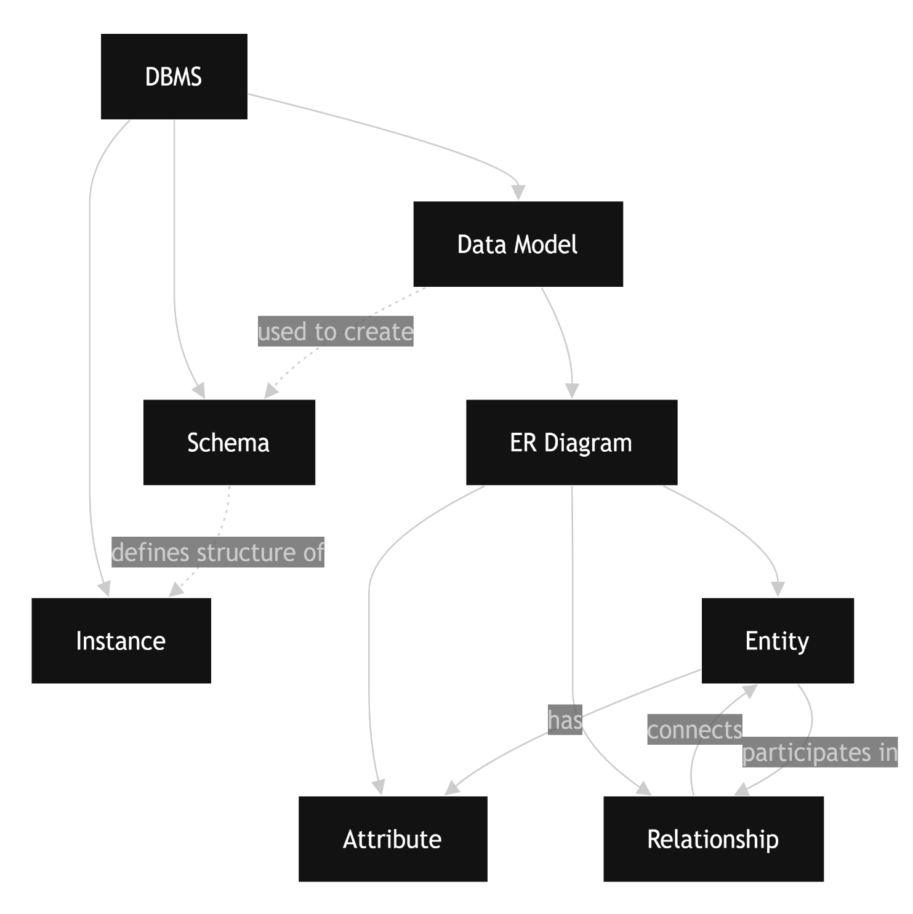

2. Create a concept map for the three-level ANSI/SPARC architecture showing data independence at each level.

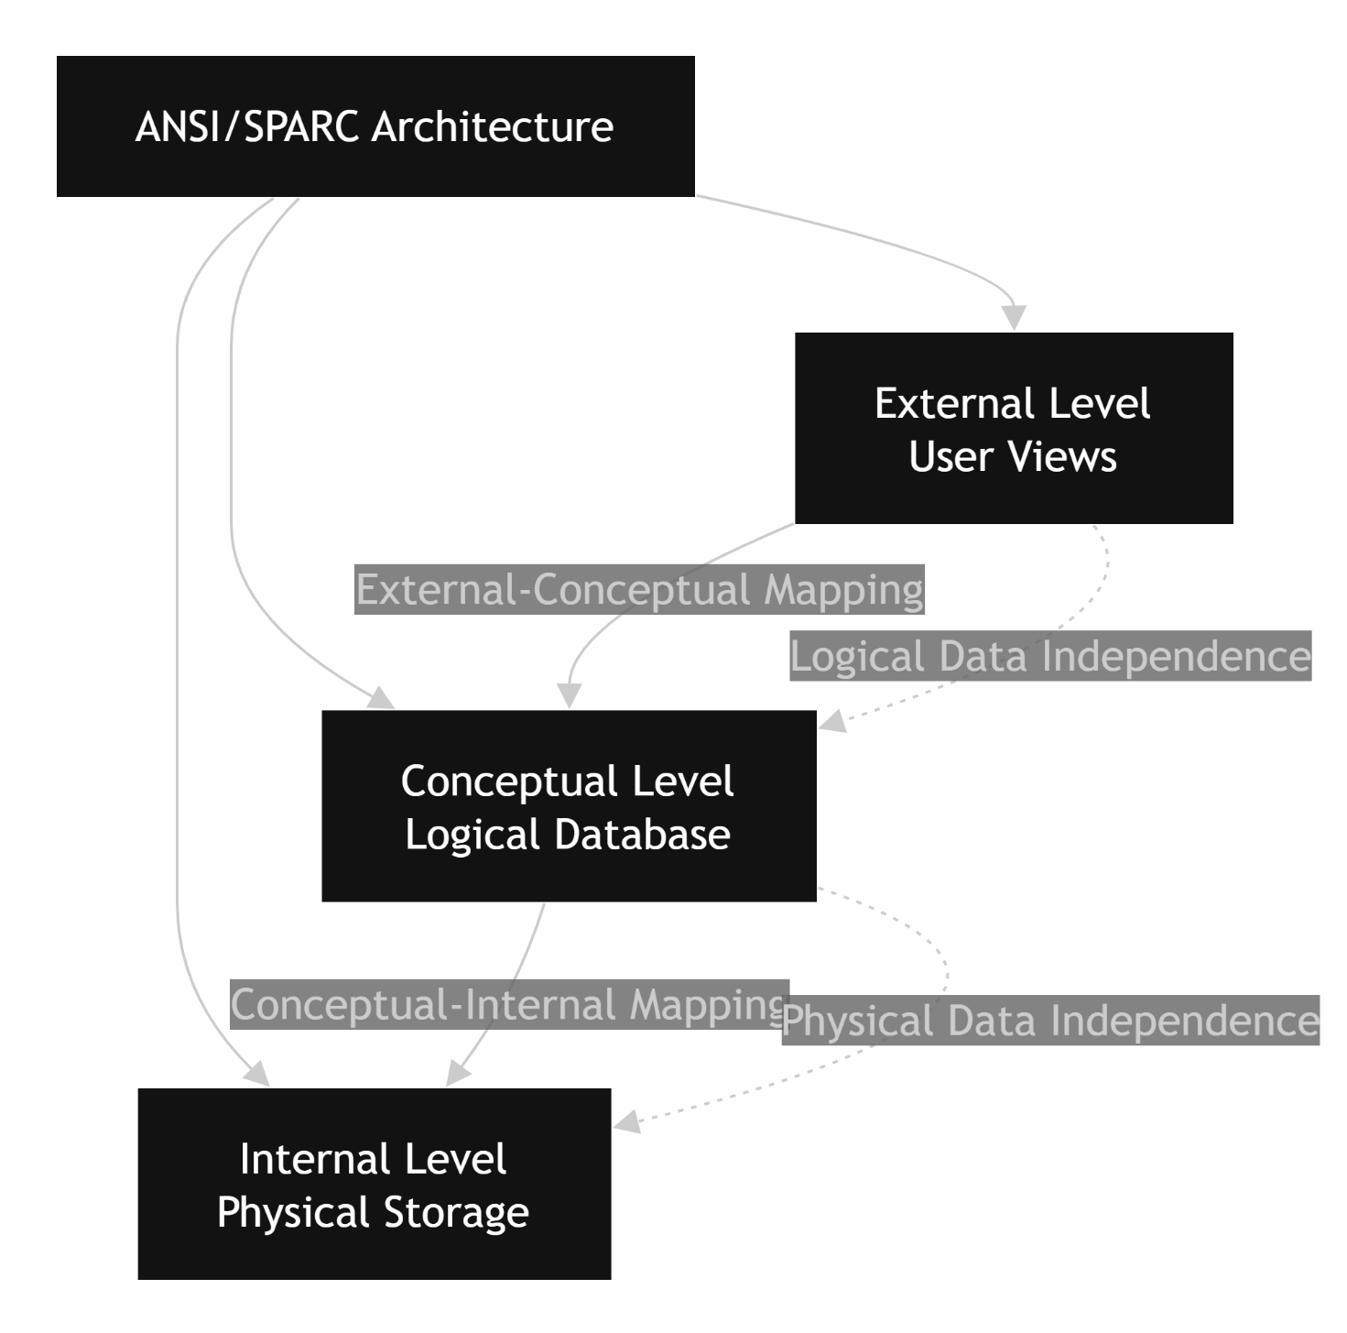

3. Map the relationship between file-based systems and database systems, highlighting the problems solved by DBMS.
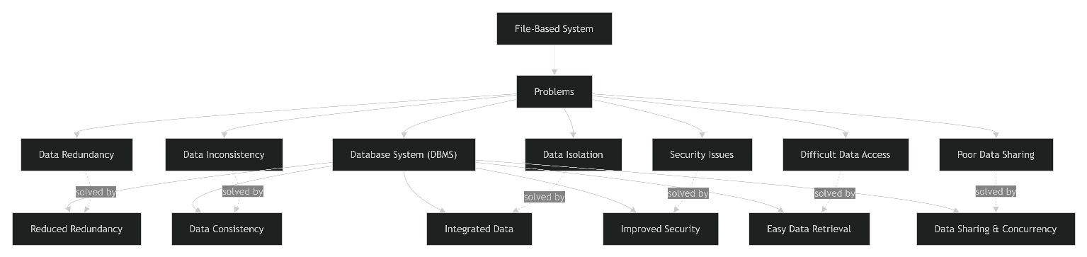

4.Design a concept map for ER diagram components: entity, weak entity, attribute types, relationship types, and participation constraints.

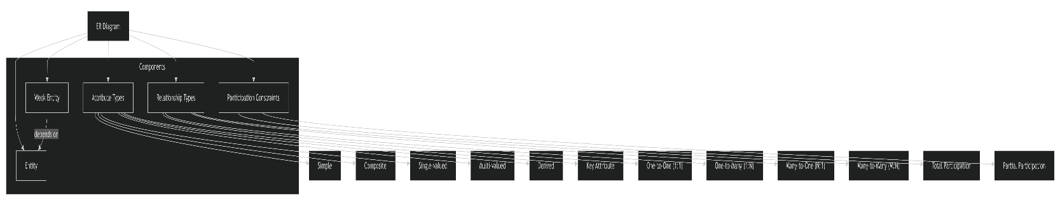

5. Construct a concept map comparing Hierarchical, Network, and Relational data models with their key properties.
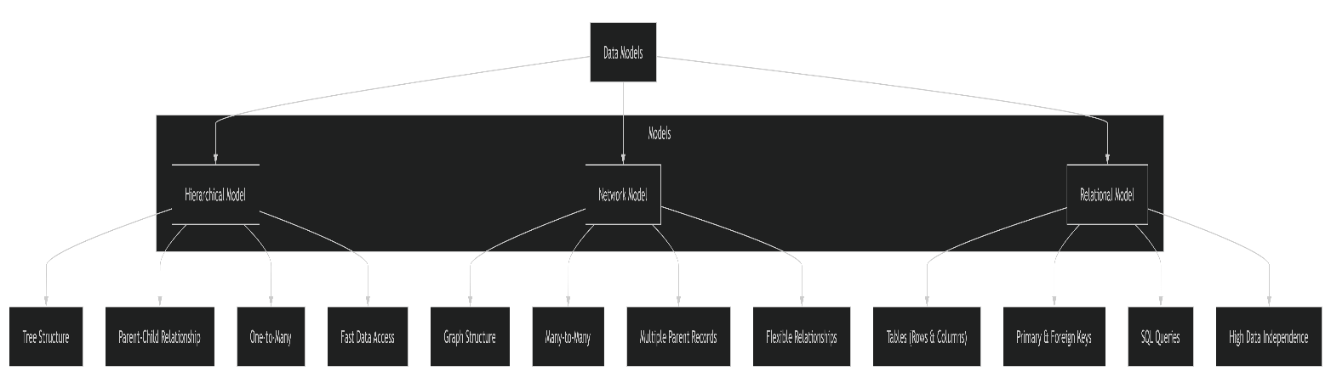

6. Develop a concept map for the EER model showing how it extends the basic ER model with generalization, specialization, and aggregation.
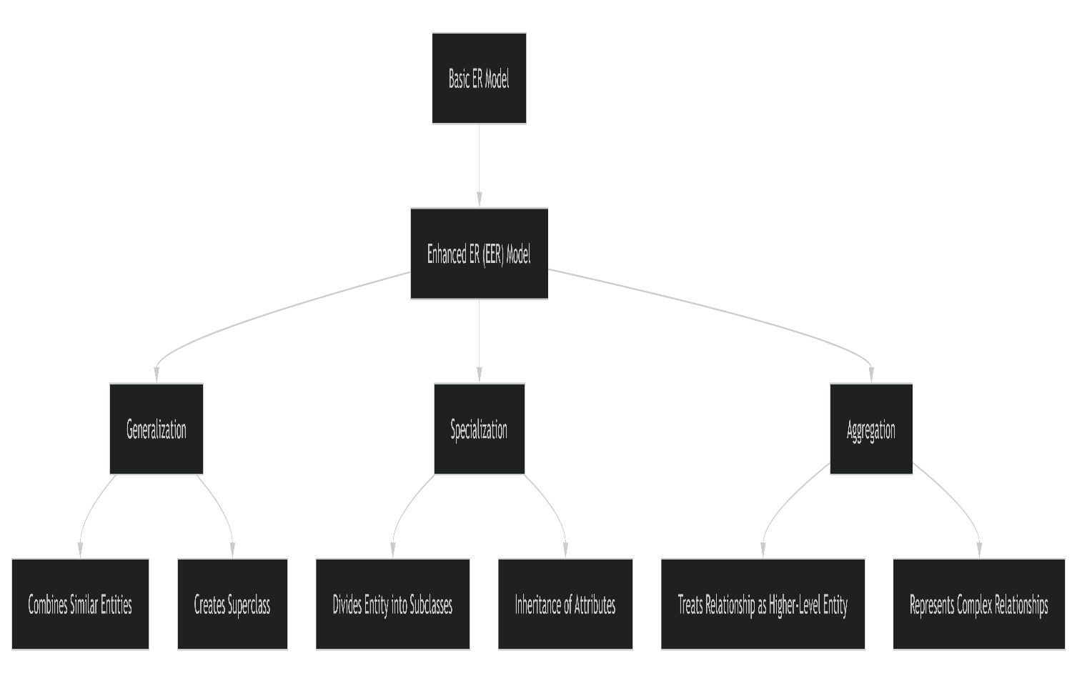

7. Create a visual concept map for the DBMS software architecture, illustrating the flow from user request to data retrieval.
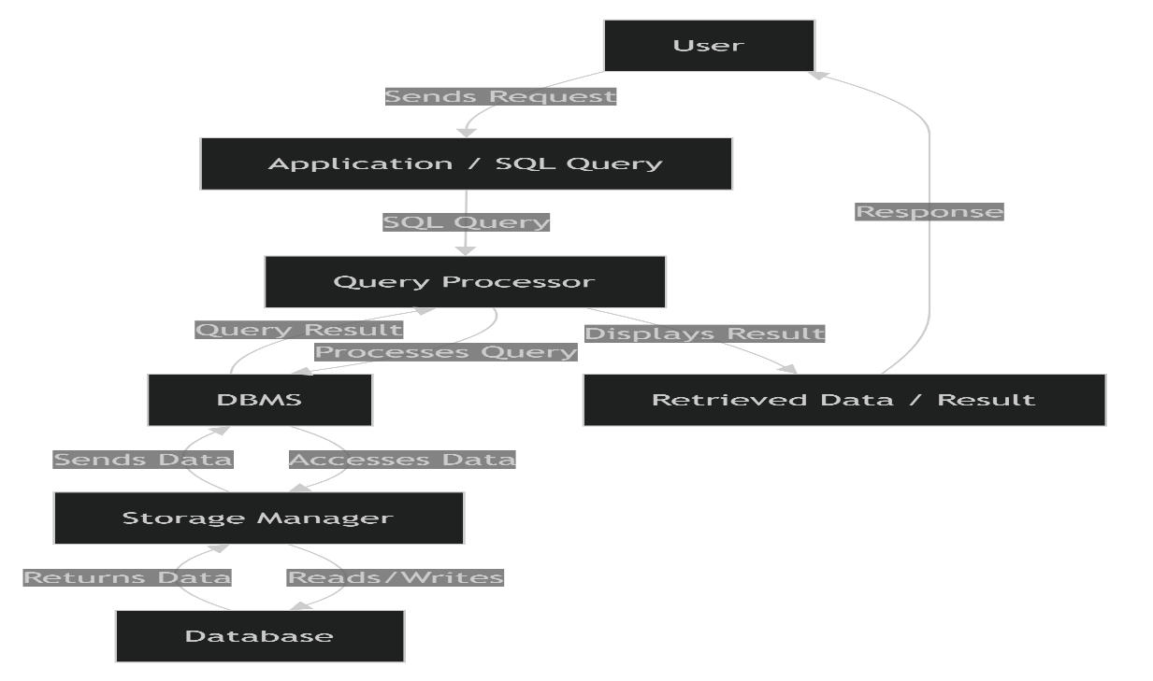
8. Map the data models discussed in CO1 to real-world applications and explain the suitability of each model.
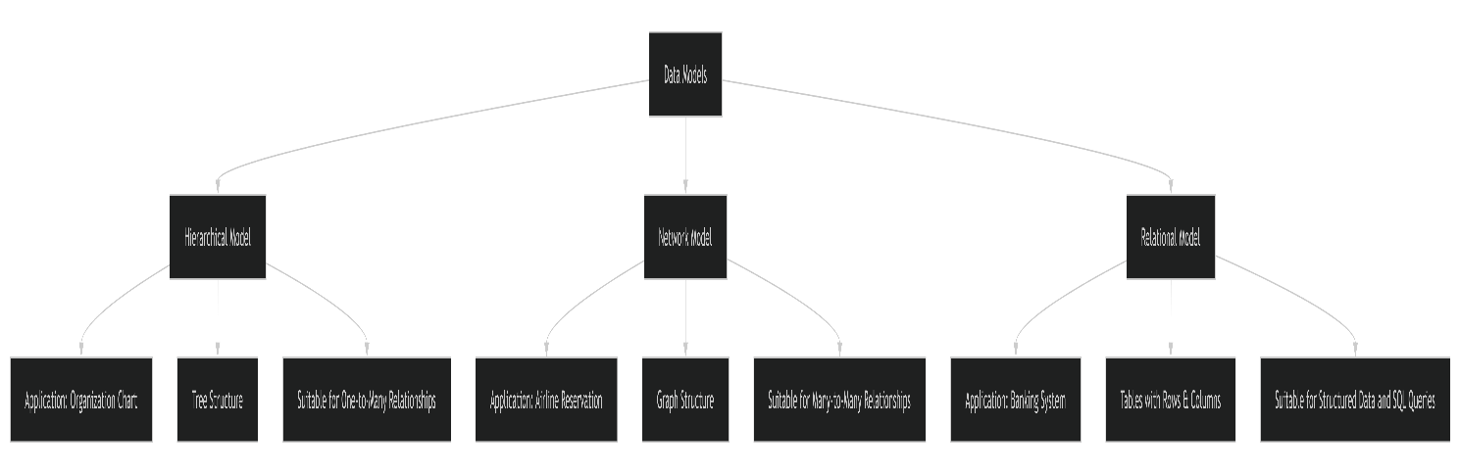

9. Construct a concept map for schemas and instances, showing how they relate to physical and logical data independence.
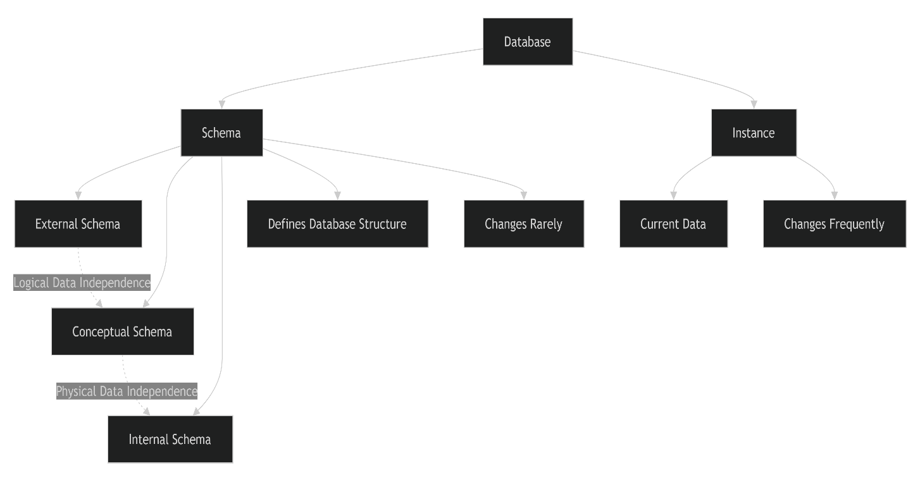

10. Design a concept map for the roles and responsibilities in a DBMS environment: DBA, End User, Application Developer.
