CSA0509 – DATABASE MANAGEMENT SYSTEMS
CO1 – AT1
SHORT ANSWERS

NAME: NISHA. R
REG. NO: 192311415

SUBMITTED TO: KESAVAN R
SUBMITTED ON:14-07-2026

QUESTION 1
Explain Schema and Instance with Examples. Distinguish between Logical Schema, Physical Schema, and View Schema.
Schema
A schema is the overall structure or blueprint of a database. It specifies how data is organized, including tables, columns, relationships, constraints, and data types. The schema is designed before data is entered and usually remains unchanged for a long period.
Example:
Student Table
Student_ID | Student_Name | Department | Age
CREATE TABLE Student(
Student_ID INT PRIMARY KEY,
Student_Name VARCHAR(50),
Department VARCHAR(30),
Age INT
);
The above table structure represents the database schema.

Instance
An instance is the collection of data stored in the database at a specific point in time. Unlike the schema, the instance changes whenever records are inserted, updated, or deleted.
Example
Student_ID | Student_Name | Department | Age
101 | Rahul | CSE | 20
102 | Meena | AI & DS | 21
103 | Kavin | ECE | 19

These records form the current instance of the Student table.

Difference between Schema and Instance
Schema | Instance
Defines the database structure. | Represents the actual stored data.
Changes very rarely. | Changes frequently.
Created during database design. | Updated during daily operations.
Specifies tables and constraints. | Contains real records.

Types of Schema
1. Logical Schema
The Logical Schema explains the logical organization of the database. It defines tables, attributes, primary keys, foreign keys, and relationships without considering physical storage.
Example
Student(Student_ID, Student_Name, Department, Age)
Course(Course_ID, Course_Name)

2. Physical Schema
The Physical Schema describes how the database is stored on disk. It includes storage blocks, indexing methods, file organization, and access paths that improve performance.
Example
- Student table stored in disk blocks.
- B+ Tree index created on Student_ID.
- Records organized using file structures.

3. View Schema
A View Schema presents only the required portion of the database to different users. It improves security by hiding unnecessary information.
Example
Faculty View
Student_ID | Student_Name | Department
Student View
Student_ID | Student_Name | Age

Conclusion
The schema provides the framework of a database, while the instance represents the current data stored within it. Logical, Physical, and View schemas together help in organizing, storing, and presenting data efficiently in a Database Management System.

QUESTION 2
Identify the entities, attributes, and relationships for a Bank Management System and construct its ER Diagram.
Introduction
A Bank Management System is used to maintain customer information, accounts, loans, employees, and branch details. The ER model helps represent the data and the relationships among different entities.

Entities and Attributes
1. Customer
Attributes:
- Customer_ID (Primary Key)
- Customer_Name
- Address
- Phone_Number
- Email_ID

2. Account
Attributes:
- Account_Number (Primary Key)
- Account_Type
- Available_Balance
- Date_Opened

3. Branch
Attributes:
- Branch_ID (Primary Key)
- Branch_Name
- Branch_Location

4. Loan
Attributes:
- Loan_ID (Primary Key)
- Loan_Amount
- Interest_Rate
- Loan_Status

5. Employee
Attributes:
- Employee_ID (Primary Key)
- Employee_Name
- Designation
- Salary

Relationships
- A Customer can maintain one or more Accounts.
- A Branch manages multiple Accounts.
- A Customer may apply for a Loan.
- A Branch sanctions different Loans.
- A Branch employs many Employees.

ER Diagram:
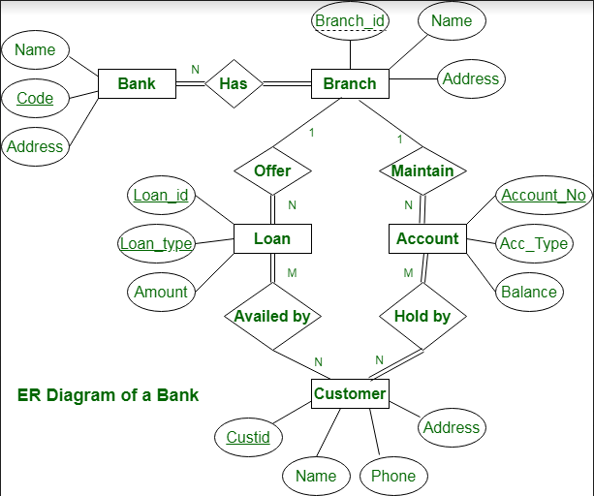

QUESTION 3
Explain the Extended ER (EER) Model. Describe the concepts of Generalization, Specialization, and Aggregation.
Extended ER (EER) Model
The Extended Entity Relationship (EER) Model is an enhanced version of the traditional ER model. It provides additional features to represent complex database structures more effectively. Besides entities, attributes, and relationships, it supports concepts such as inheritance, superclass, subclass, generalization, specialization, and aggregation.
Features of EER Model
- Supports Superclass and Subclass
- Allows Inheritance of attributes
- Includes Generalization
- Includes Specialization
- Supports Aggregation
- Helps model real-world applications efficiently

1. Generalization
Generalization is a bottom-up approach in which two or more lower-level entities with similar characteristics are combined into a single higher-level entity called a Superclass.
Example
Car Bike Bus
\ | /
\ | /
VEHICLE
In this example, Car, Bike, and Bus share common properties such as Registration Number and Owner. These common features are grouped into the Vehicle superclass.
Advantages
- Reduces duplication of common attributes.
- Improves database organization.
- Simplifies maintenance.

2. Specialization
Specialization is a top-down approach in which one higher-level entity is divided into multiple lower-level entities based on specific characteristics.
Example
EMPLOYEE
/ \
/ \
Manager Clerk
Both Manager and Clerk inherit common Employee attributes such as Employee_ID, Name, and Salary while also having their own specialized attributes.
Advantages
- Represents different categories clearly.
- Improves data accuracy.
- Makes database design more flexible.

3. Aggregation
Aggregation is used when a relationship itself needs to participate in another relationship. It treats the relationship as a higher-level entity.
Example
Employee -------- Works_On -------- Project
|
|
Assignment
|
|
Department
Here, Works_On is considered an Assignment, allowing another entity (Department) to be associated with it.
Advantages
- Represents complex relationships easily.
- Reduces ambiguity in database design.
- Improves representation of real-world scenarios.

Comparison between Generalization and Specialization
Generalization | Specialization
Bottom-up approach | Top-down approach
Combines similar entities | Divides one entity into smaller entities
Produces a Superclass | Produces Subclasses
Removes redundancy | Adds detailed classification
Example: Vehicle from Car, Bike | Example: Employee into Manager, Clerk

Conclusion
The Extended ER Model improves the capabilities of the basic ER model by supporting inheritance and advanced relationship concepts. Generalization combines similar entities into one superclass, Specialization creates subclasses from a superclass, and Aggregation treats relationships as higher-level entities. These features make database models more flexible, organized, and suitable for complex applications.

QUESTION 4
Design an EER Diagram for a Hospital Management System incorporating Inheritance and Weak Entity.
Introduction
A Hospital Management System stores and manages information about doctors, patients, appointments, medical tests, and treatments. The Extended Entity Relationship (EER) Model is used to represent inheritance and weak entities, making the database more organized and easier to maintain.

Inheritance (Specialization)
In this system, the DOCTOR entity acts as the Superclass. It is divided into two subclasses based on specialization.

Superclass: DOCTOR
Attributes:
- Doctor_ID (Primary Key)
- Doctor_Name
- Gender
- Qualification
- Phone_Number
Subclasses
1. Specialist Doctor
Additional Attribute
- Specialization (Cardiologist, Neurologist, Orthopedic, etc.)
2. General Physician
Additional Attribute
- Experience_Years
Both subclasses inherit all common attributes from the DOCTOR entity.

Weak Entity
The MEDICAL_TEST entity is treated as a Weak Entity because it cannot exist without a PATIENT.
Patient Attributes
- Patient_ID (Primary Key)
- Patient_Name
- Age
- Gender
- Address
Medical Test Attributes
- Test_ID (Partial Key)
- Test_Name
- Test_Date
- Test_Result
The Medical_Test entity is identified using:
Patient_ID + Test_ID
Therefore, it depends on the PATIENT entity for its existence.
Advantages
- Minimizes data redundancy through inheritance.
- Improves organization of doctor information.
- Represents dependent entities accurately.
- Makes the hospital database easier to maintain.
- Enhances data consistency and integrity.
ER DIAGRAM:
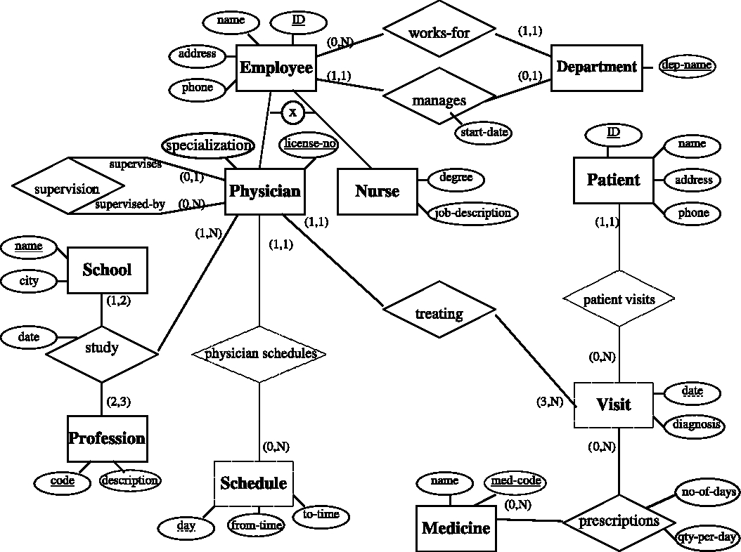

Conclusion
The Hospital Management System EER model effectively demonstrates the use of inheritance and weak entities. The Doctor superclass is specialized into Specialist Doctor and General Physician, while the Medical_Test entity depends on the Patient entity for identification. This design improves flexibility, reduces redundancy, and supports efficient database management.

QUESTION 5
Explain the Role of a DBA (Database Administrator) and the Responsibilities Associated with the Position.
Definition
A Database Administrator (DBA) is a professional responsible for managing, securing, and maintaining databases within an organization. The DBA ensures that the database operates efficiently, remains secure, and is always available to users whenever required.

Responsibilities of a DBA
1. Database Installation and Configuration
The DBA installs the Database Management System (DBMS) software and configures it according to the organization's requirements.
Responsibilities
- Install DBMS software.
- Configure database servers.
- Create database instances.
- Verify successful installation.

2. Database Design
A DBA helps in designing the structure of the database to ensure efficient data storage and retrieval.
Responsibilities
- Create tables.
- Define primary and foreign keys.
- Establish relationships.
- Design indexes for faster access.

3. Security Management
Protecting confidential information is one of the most important responsibilities of a DBA.
Responsibilities
- Create user accounts.
- Assign user roles.
- Grant and revoke permissions.
- Prevent unauthorized access.
- Maintain database security policies.

4. Backup and Recovery
The DBA performs regular backups to prevent data loss and restores the database whenever failures occur.
Responsibilities
- Schedule automatic backups.
- Restore damaged databases.
- Maintain recovery procedures.
- Prepare disaster recovery plans.

5. Performance Optimization
The DBA continuously monitors database performance and improves system efficiency.
Responsibilities
- Optimize SQL queries.
- Create appropriate indexes.
- Reduce response time.
- Monitor CPU and memory utilization.

6. Storage Management
The DBA manages storage resources to ensure sufficient space for database growth.
Responsibilities
- Allocate storage space.
- Monitor disk usage.
- Manage database files.
- Remove unnecessary data.

7. Data Integrity
Maintaining accurate and consistent information is another major responsibility of a DBA.
Responsibilities
- Enforce integrity constraints.
- Eliminate duplicate records.
- Maintain consistency of data.
- Ensure reliable transactions.

8. Database Monitoring
The DBA continuously checks database health to ensure uninterrupted service.
Responsibilities
- Monitor server performance.
- Detect system errors.
- Resolve database issues.
- Maintain high availability.

9. User Support and Maintenance
The DBA provides technical assistance to developers and end users.
Responsibilities
- Solve database-related problems.
- Assist application developers.
- Update documentation.
- Perform regular maintenance.

Skills Required for a DBA
- SQL Programming
- Database Design
- Backup and Recovery
- Security Management
- Performance Tuning
- Problem Solving
- Communication Skills
- Database Troubleshooting

Advantages of a DBA
- Protects sensitive information.
- Improves database performance.
- Prevents data loss through backups.
- Supports multiple users efficiently.
- Ensures high availability and reliability.
- Maintains data accuracy and consistency.

Conclusion
A Database Administrator (DBA) plays a vital role in the successful management of databases. From installation and security to backup, recovery, performance tuning, and user support, the DBA ensures that the database remains secure, reliable, and efficient. Effective database administration helps organizations maintain data integrity, improve system performance, and provide uninterrupted access to information.

