***Monitoring-alerting***

**Steps to do :-**

a .Launch 2 server and connect both   
1. Node-server  
2.grafana-prometheus

b.create iam role for Grafana-prometheus

c.create AMI for node server  
  
**code for node-server:**

#!/bin/bash

set -e

echo "=============================="

echo " Installing Alertmanager + Node Exporter"

echo "=============================="

# ============ 1. Install Alertmanager ============

echo "[*] Downloading Alertmanager..."

cd /tmp

curl -LO https://github.com/prometheus/alertmanager/releases/download/v0.27.0/alertmanager-0.27.0.linux-amd64.tar.gz

tar -xvf alertmanager-0.27.0.linux-amd64.tar.gz

cd alertmanager-0.27.0.linux-amd64

echo "[*] Installing Alertmanager binaries..."

sudo cp alertmanager amtool /usr/local/bin/

sudo mkdir -p /etc/alertmanager /var/lib/alertmanager

sudo cp alertmanager.yml /etc/alertmanager/

sudo chown -R nobody:nogroup /etc/alertmanager /var/lib/alertmanager

echo "[*] Creating systemd service for Alertmanager..."

sudo tee /etc/systemd/system/alertmanager.service >/dev/null <<'EOF'

[Unit]

Description=Alertmanager

After=network.target

[Service]

User=nobody

ExecStart=/usr/local/bin/alertmanager \

--config.file=/etc/alertmanager/alertmanager.yml \

--storage.path=/var/lib/alertmanager/

Restart=always

[Install]

WantedBy=multi-user.target

EOF

sudo systemctl daemon-reexec

sudo systemctl enable --now alertmanager

echo ">>> Alertmanager installed and running on port 9093"

# ============ 2. Install Node Exporter ============

echo "[*] Creating node_exporter user..."

sudo useradd --no-create-home --shell /bin/false node_exporter || true

echo "[*] Downloading Node Exporter..."

cd /tmp

curl -LO https://github.com/prometheus/node_exporter/releases/download/v1.8.2/node_exporter-1.8.2.linux-amd64.tar.gz

tar -xvf node_exporter-1.8.2.linux-amd64.tar.gz

cd node_exporter-1.8.2.linux-amd64

echo "[*] Installing Node Exporter binary..."

sudo cp node_exporter /usr/local/bin/

sudo chown node_exporter:node_exporter /usr/local/bin/node_exporter

echo "[*] Creating systemd service for Node Exporter..."

sudo tee /etc/systemd/system/node_exporter.service >/dev/null <<'EOF'

[Unit]

Description=Node Exporter

Wants=network-online.target

After=network-online.target

[Service]

User=node_exporter

ExecStart=/usr/local/bin/node_exporter

Restart=always

[Install]

WantedBy=multi-user.target

EOF

sudo systemctl daemon-reexec

sudo systemctl enable --now node_exporter

echo "[*] Updating system packages..."

sudo apt update && sudo apt upgrade -y

echo ">>> Node Exporter installed and running on port 9100"

echo "=============================="

echo " Installation Completed ✅"

echo "=============================="

**code for Grafana-prometheus**:

#!/bin/bash

set -e

echo "=============================="

echo " Installing Promethous-grafana-Alertmanager--Node Exporter"

echo "=============================="

# ============ 1. Update System ============

sudo apt update && sudo apt upgrade -y

# ============ 2. Install Prometheus ============

sudo useradd --no-create-home --shell /bin/false prometheus || true

sudo mkdir -p /etc/prometheus /var/lib/prometheus

sudo chown prometheus:prometheus /etc/prometheus /var/lib/prometheus

cd /tmp

curl -LO https://github.com/prometheus/prometheus/releases/download/v2.55.1/prometheus-2.55.1.linux-amd64.tar.gz

tar -xvf prometheus-2.55.1.linux-amd64.tar.gz

cd prometheus-2.55.1.linux-amd64

sudo cp prometheus promtool /usr/local/bin/

sudo chown prometheus:prometheus /usr/local/bin/prometheus /usr/local/bin/promtool

sudo cp -r consoles/ console_libraries/ /etc/prometheus/

sudo cp prometheus.yml /etc/prometheus/prometheus.yml

sudo chown -R prometheus:prometheus /etc/prometheus/*

sudo tee /etc/systemd/system/prometheus.service >/dev/null <<'EOF'

[Unit]

Description=Prometheus

Wants=network-online.target

After=network-online.target

[Service]

User=prometheus

ExecStart=/usr/local/bin/prometheus \

--config.file=/etc/prometheus/prometheus.yml \

--storage.tsdb.path=/var/lib/prometheus/ \

--web.console.templates=/etc/prometheus/consoles \

--web.console.libraries=/etc/prometheus/console_libraries

Restart=always

[Install]

WantedBy=multi-user.target

EOF

sudo systemctl daemon-reexec

sudo systemctl enable --now prometheus

# ============ 3. Install Grafana ============

sudo apt-get install -y software-properties-common

sudo add-apt-repository -y "deb https://packages.grafana.com/oss/deb stable main"

wget -q -O - https://packages.grafana.com/gpg.key | sudo apt-key add -

sudo apt update

sudo apt install grafana -y

sudo systemctl enable --now grafana-server

# ============ 4. Install Alertmanager ============

cd /tmp

curl -LO https://github.com/prometheus/alertmanager/releases/download/v0.27.0/alertmanager-0.27.0.linux-amd64.tar.gz

tar -xvf alertmanager-0.27.0.linux-amd64.tar.gz

cd alertmanager-0.27.0.linux-amd64

sudo cp alertmanager amtool /usr/local/bin/

sudo mkdir -p /etc/alertmanager /var/lib/alertmanager

sudo cp alertmanager.yml /etc/alertmanager/

sudo chown -R prometheus:prometheus /etc/alertmanager /var/lib/alertmanager

sudo tee /etc/systemd/system/alertmanager.service >/dev/null <<'EOF'

[Unit]

Description=Alertmanager

After=network.target

[Service]

User=prometheus

ExecStart=/usr/local/bin/alertmanager \

--config.file=/etc/alertmanager/alertmanager.yml \

--storage.path=/var/lib/alertmanager/

Restart=always

[Install]

WantedBy=multi-user.target

EOF

sudo systemctl daemon-reexec

sudo systemctl enable --now alertmanager

# ============ 5. Configure Prometheus Alerts ============

sudo tee /etc/prometheus/alert.rules.yml >/dev/null <<'EOF'

groups:

- name: example-alerts

rules:

- alert: InstanceDown

expr: up == 0

for: 1m

labels:

severity: critical

annotations:

summary: "Instance {{ $labels.instance }} is down"

description: "Prometheus target {{ $labels.instance }} has been unreachable for more than 1 minute."

- alert: HighCPUUsage

expr: 100 - (avg by(instance) (irate(node_cpu_seconds_total{mode="idle"}[5m])) * 100) > 40

for: 2m

labels:

severity: critical

annotations:

summary: "High CPU usage detected on {{ $labels.instance }}"

description: "CPU usage > 40% for more than 2 minutes. VALUE = {{ $value }}%"

- alert: UnauthorizedRequests

expr: increase(http_requests_total{status=~"401|403"}[5m]) > 0

for: 1m

labels:

severity: warning

annotations:

summary: "Unauthorized requests on {{ $labels.instance }}"

description: "Detected unauthorized (401/403) requests in the past 5 minutes."

EOF

# ============ 6. PagerDuty Integration ============

sudo tee /etc/alertmanager/alertmanager.yml >/dev/null <<'EOF'

route:

receiver: pagerduty

group_wait: 10s

group_interval: 10s

repeat_interval: 1h

receivers:

- name: pagerduty

pagerduty_configs:

- routing_key: "50d89a73e5e4490cc00564f8767e9a71"

severity: "critical"

EOF

sudo systemctl restart alertmanager

# ============ 7. Install Node Exporter ============

sudo useradd --no-create-home --shell /bin/false node_exporter || true

cd /tmp

curl -LO https://github.com/prometheus/node_exporter/releases/download/v1.8.2/node_exporter-1.8.2.linux-amd64.tar.gz

tar -xvf node_exporter-1.8.2.linux-amd64.tar.gz

cd node_exporter-1.8.2.linux-amd64

sudo cp node_exporter /usr/local/bin/

sudo chown node_exporter:node_exporter /usr/local/bin/node_exporter

sudo tee /etc/systemd/system/node_exporter.service >/dev/null <<'EOF'

[Unit]

Description=Node Exporter

Wants=network-online.target

After=network-online.target

[Service]

User=node_exporter

ExecStart=/usr/local/bin/node_exporter

Restart=always

[Install]

WantedBy=multi-user.target

EOF

sudo systemctl daemon-reexec

sudo systemctl enable --now node_exporter

# ============ 8. Prometheus Config ============

sudo tee /etc/prometheus/prometheus.yml >/dev/null <<'EOF'

global:

scrape_interval: 15s

evaluation_interval: 15s

alerting:

alertmanagers:

- static_configs:

- targets: ["localhost:9093"]

- ec2_sd_configs:

- region: us-east-1

port: 9093

filters:

- name: "tag:Name"

values: ["node-server"]

relabel_configs:

- source_labels: [__meta_ec2_private_ip]

regex: (.*)

target_label: __address__

replacement: "$1:9093"

rule_files:

- "alert.rules.yml"

scrape_configs:

- job_name: "prometheus"

static_configs:

- targets: ["localhost:9100"]

- job_name: "ec2-node-exporters"

ec2_sd_configs:

- region: us-east-1

port: 9100

filters:

- name: "tag:Name"

values: ["node-server"]

relabel_configs:

- source_labels: [__meta_ec2_private_ip]

regex: (.*)

target_label: __address__

replacement: "$1:9100"

EOF

sudo systemctl restart prometheus

# Final system update

sudo apt update && sudo apt upgrade -y

echo "=============================="

echo " Installation Completed ✅"

echo "=============================="

then login in Grafana using Grafana-prometheus’s publicip:port number and Prometheus

**port numbers:-**

Grafana : 3000

Prometheus: 9090

Node-server:9100

username: admin  
passward : admin  
change passward   
login  
stablish connection by clicking connection in Grafana after that create a dashboard using url of your garafana…..then load import and you can see laods of server…

**reference pictures :-  
 servers :-**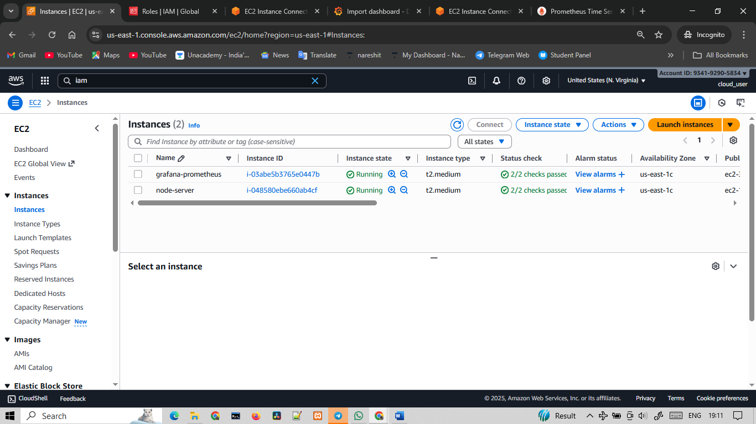

**connection and installation Grafana-prometheus :-**

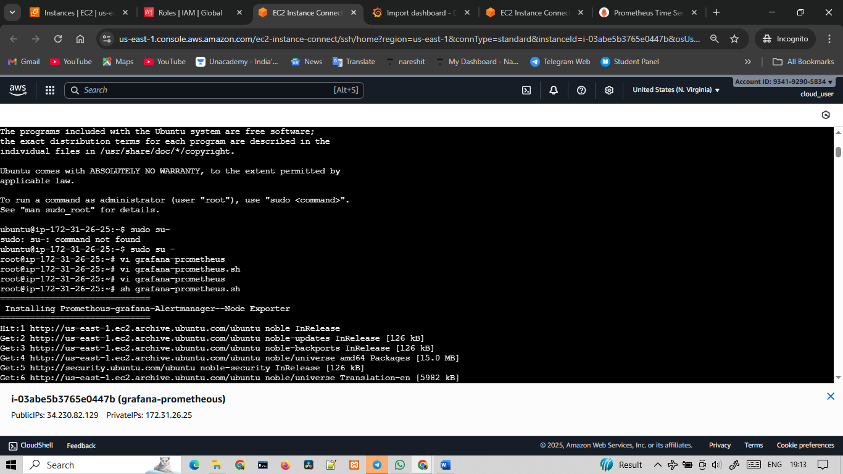

**Connection and installation node-server –**

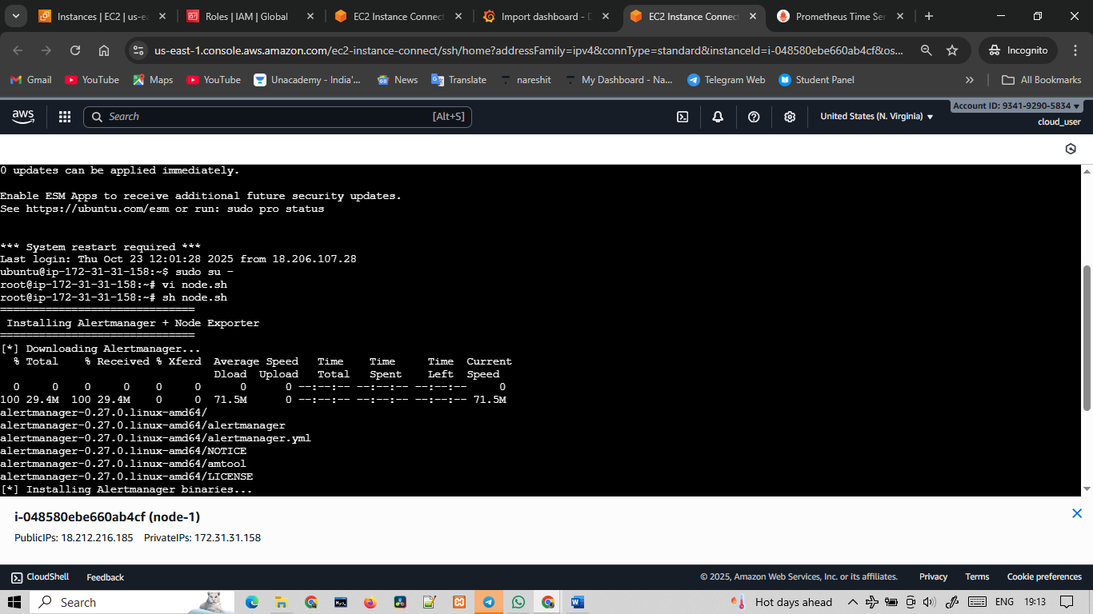

**Prometheus :-**

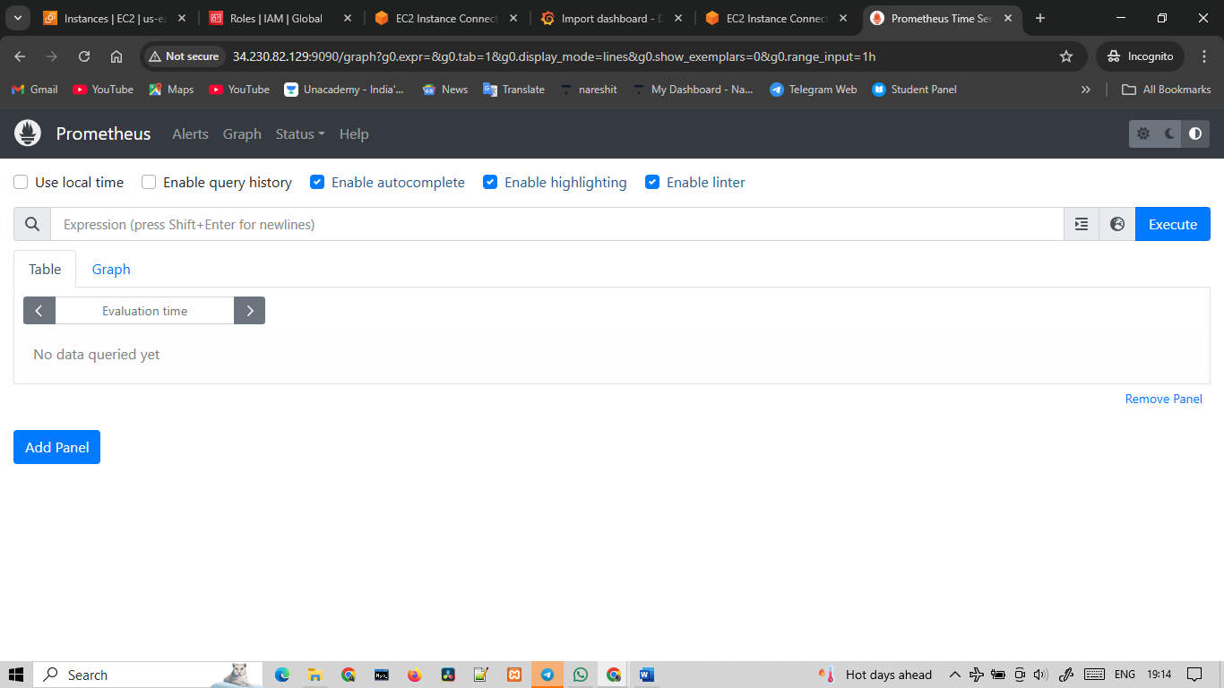

**Grafana :-**

