Project Title: Amazon Music Clustering
The goal of this project was to automatically group similar songs based on their audio characteristics using unsupervised learning techniques (clustering). This helps us categorise musical genres or moods.
Dataset Overview
- Total records: ~95,000 songs
- Features used:
  - Danceability
  - Energy
  - Loudness
  - Speechiness
  - Acousticness
  - Instrumentalness
  - Liveness
  - Valence
  - Tempo
These features represent different aspects of a song’s rhythm, intensity, mood, and composition.
Clustering Approach
Algorithm Used: K-Means Clustering
ELBOW Method: K = 3 or K = 4
Silhouette Score: 0.249 (Moderate cluster separation)
Davies-Bouldin Score: 1.51 (Moderate Compactness)
Cluster Visualisation: Used PCA (Principal Component Analysis) for 2D visualisation
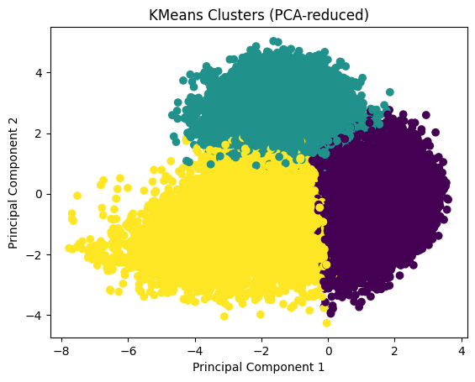

Cluster Interpretation:
- Cluster 0 → Energetic / Dance / Pop
  - High energy, danceability, and valence
  - Low acousticness
  - Faster tempo
Represents party and upbeat songs
- Cluster 1 → Speech / Spoken Content
  - Very high speechiness
  - Higher liveness
Represents: Spoken word, Podcasts, Rap-heavy tracks
- Cluster 2 → Acoustic / Chill
  - High acousticness
  - Low energy and valence
  - Moderate instrumentalness
Represents soft, emotional, acoustic songs

