Q1.Write an HTML code to:

* Insert various types of headings in a webpage.
* Display text exactly in the way it’s written in the HTML document.
* Insert an absolute and relative image in a webpage
* Insert a hyperlink in a webpage, which opens “google.com” in a new tab.

Code:

<!DOCTYPE html>

<html lang="en">

<head>

<meta charset="UTF-8">

<meta http-equiv="X-UA-Compatible" content="IE=edge">

<meta name="viewport" content="width=device-width, initial-scale=1.0">

<style>

.relative { position:relative;

}

.absolute { position:absolute;

}

</style>

</head>

<body>

<h1>Heading 1</h1>

<h2>Heading 2</h2>

<h3>Heading 3</h3>

<h4>Heading 4</h4>

<h5>Heading 5</h5>

<h6>Heading 6</h6>

<hr>

<a href="https://www.google.com/" target="_blank">click</a>

<hr>

<pre> Lorem ipsum dolor sit amet consectetur adipisicing elit.

Dolor aliquid quidem asper</pre>

<hr>

<div class="relative">

<img style="width:200px; " src="https://images.shiksha.com/mediadata/images/1576563781phpQj94TQ.jpeg" alt="gehu"> </div>

<hr>

<div class="absolute">

<img style="width:200px;"src="https://www.euttaranchal.com/icms/cmsphotos/Graphic-Era-University.webp" alt="geu">

</div>

<a href="https://www.google.com/" target="_blank">click</a>

</body>

</html>

OUTPUT:

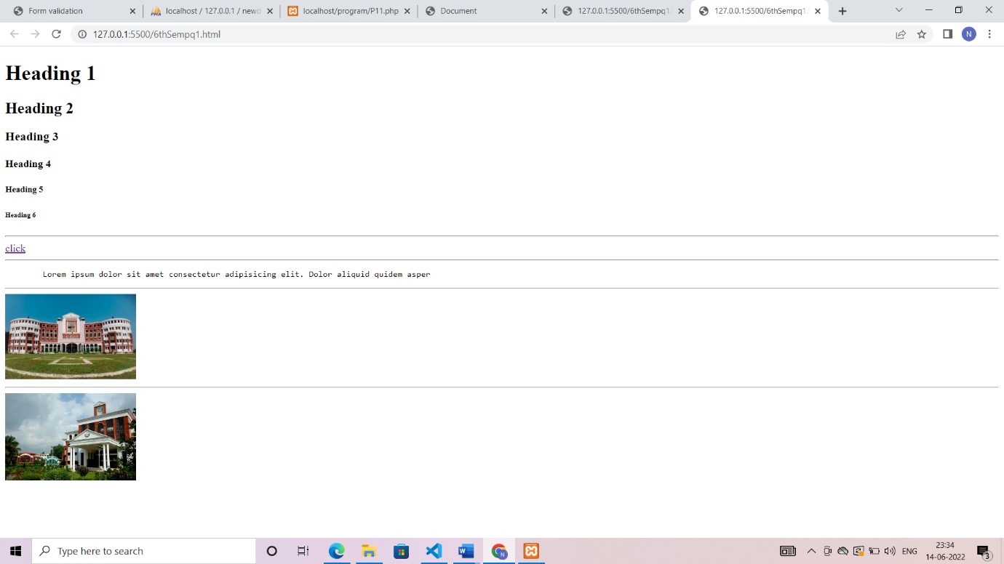

Q2.Write an HTML code to create a table, such that:

* It should consist of 2 columns – Name and Age - The column names must be headers.
* It should have 3 rows containing appropriate name and age of people.
* The table should have dashed boundary with a width of 2 pixel.
* The cells should have a padding of 5 pixels.

CODE :

<!DOCTYPE html>

<html lang="en">

<head>

<meta charset="UTF-8">

<meta http-equiv="X-UA-Compatible" content="IE=edge">

<meta name="viewport" content="width=device-width, initial-scale=1.0">

<style> table,tr,td,th{ border:2px dashed black; border-collapse:collapse;

}

</style>

</head>

<body>

<table cellpadding="20px">

<tr>

<th>Name</th>

<th>Age</th>

</tr>

<tr>

<td>Yash</td>

<td>12</td>

</tr>

<tr>

<td>Nisha</td>

<td>20</td>

</tr>

<tr>

<td>Neha</td>

<td>18</td>

</tr>

</table>

</body>

</html>

OUTPUT:

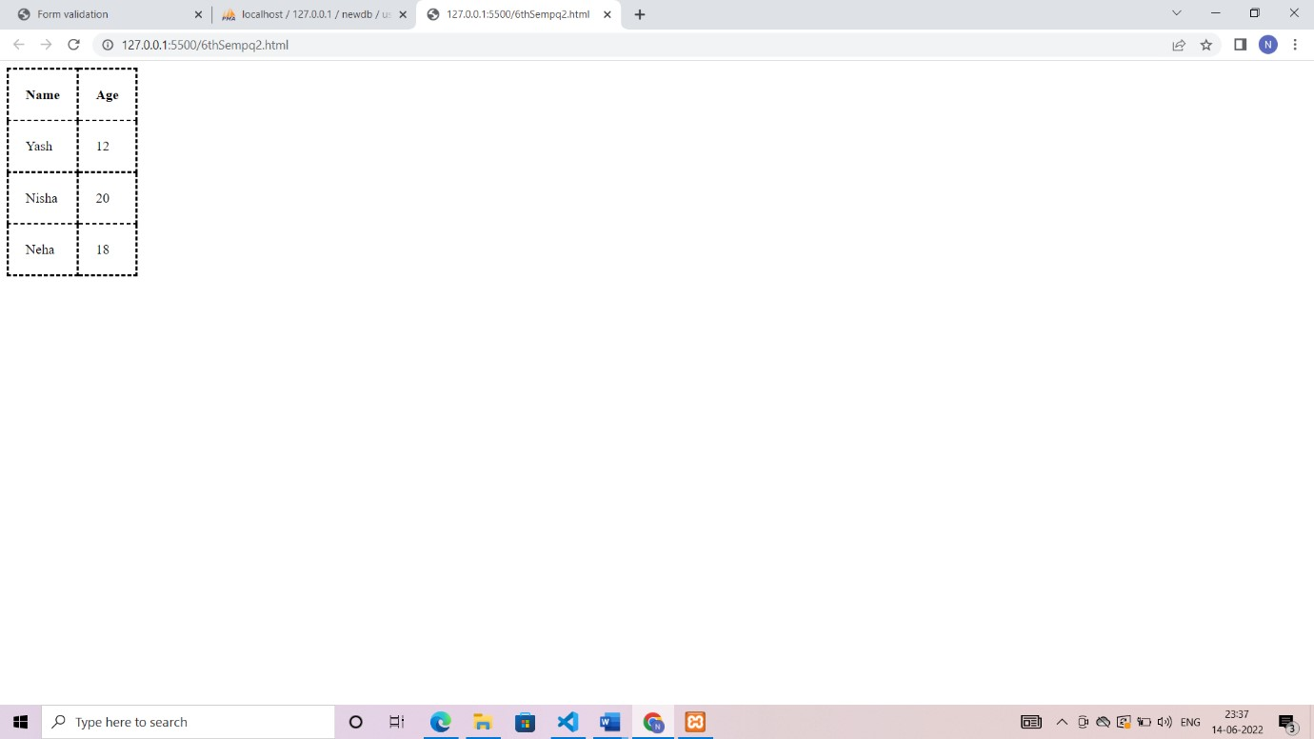

Q3.Write an HTML code to create your college website using frames:

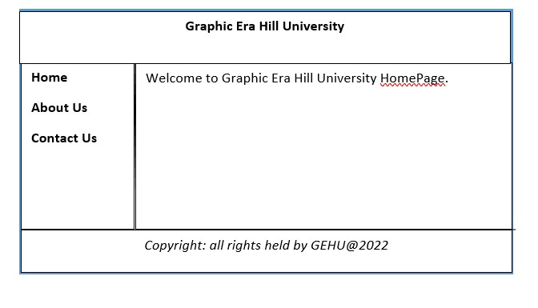

CODE:

Q3.html

<html>

<frameset rows="20%,60%,20%">

<frame src="f1.html">

<frameset cols="20%,80%">

<frame src="f2.html">

<frame src="f4.html">

</frameset>

<frame src="f3.html">

</frameset>

</html>

F1.html

<!DOCTYPE html>

<html lang="en">

<head>

<title>header</title>

</head>

<body>

<h3 style="text-align:center;">Graphic era Hill University</h3>

</body>

</html>

F2.html

<!DOCTYPE html>

<html lang="en">

<head>

<title>menu</title>

</head>

<body>

<a href="">Home</a><br>

<a href="">Abouts Us</a><br>

<a href="">Contact</a><br>

</body>

</html>

F3.html

<!DOCTYPE html>

<html lang="en">

<head>

<title>footer</title>

</head>

<body>

<p style="text-align: center; font-style : italic; "><b>Copyright: all rights held by GEHU &copy;2022</b></p>

</body>

</html>

F4.html

<!DOCTYPE html>

<html lang="en">

<head>

<meta charset="UTF-8">

<meta http-equiv="X-UA-Compatible" content="IE=edge">

<meta name="viewport" content="width=device-width, initial-scale=1.0">

</head>

<body>

<p>Welcome to Graphic Era Hill University</p>

<a href ="">Home Page</a>

</body>

</html>

OUTPUT:

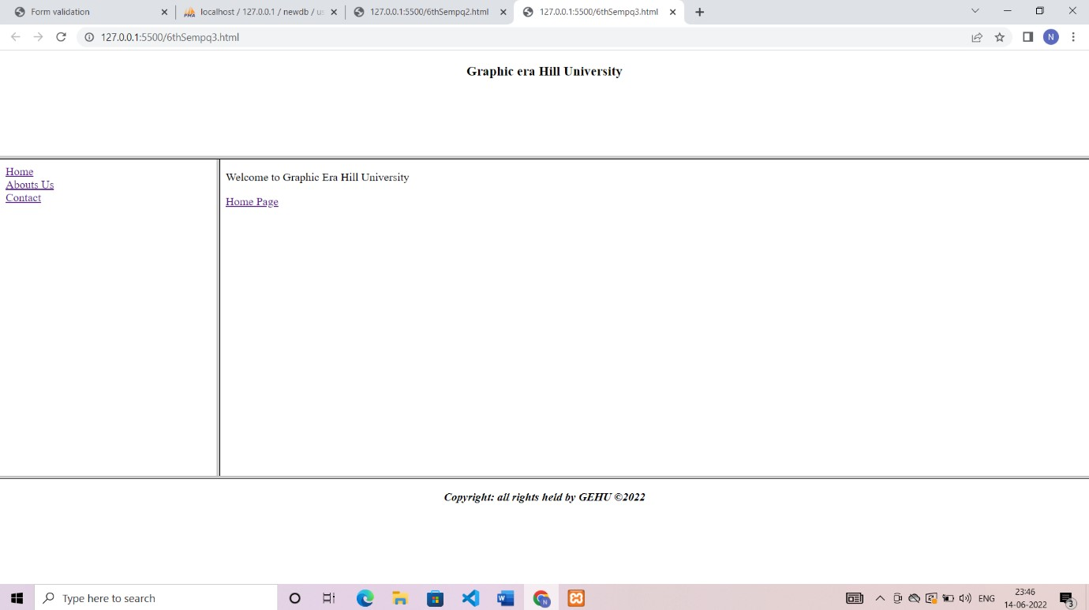

Q4.Write CSS code for inserting a background image to a red-colored text. Also add padding and margin at appropriate places.

CODE:

<html>

<head>

<link rel="stylesheet" href="style.css">

</head>

<body>

<div class="text">

<p>Hello World</p>

<img src="https://www.thenews.com.pk/assets/uploads/updates/2022-

03-16/941981_6314090_2_updates.jpg" alt="">

<div class="jmes">

<p>Jeon Jungkook</p>

</div>

</div>

</body>

</html>

OUTPUT:

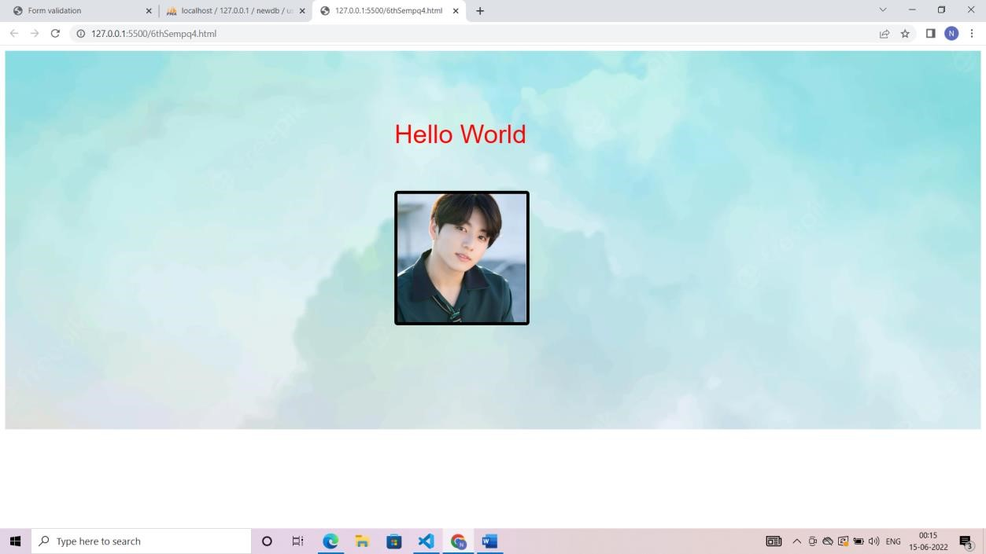

Q5.Write CSS code to show following types of positioning on a red-colored text:

* Relative
* Absolute
* Fixed
* Sticky CODE :

<html>

<head> <style> body{ margin:0px; padding:10px;

} .fixed{ position: fixed; color:red;

} .sticky{ position:sticky; color:red; } .relative{ position:relative; color:red; } .absolute{ position:absolute; color:red;

} pre{

padding: 0px 45px;

}

</style>

</head>

<body>

<div class="fixed">

<h1>Fixed Text</h1>

</div>

<pre> Lorem ipsum, dolor sit amet consectetur adipisicing elit. Non fugit, voluptatem labore aspernatur rem

animi eaque odit quod dolores quibusdam porro facere cumque pariatur minima fugiat quasi commodi eos est voluptate similique excepturi dolorem deleniti numquam cupiditate? Voluptates libero fuga quis sit

, vel,

Lorem ipsum dolor sit amet consectetur adipisicing elit. Necessitatibus a, distinctio ipsam voluptatem dolorem rerum!

Ratione fugiat itaque incidunt magnam. </pre>

<div class="absolute">

<h1>Absolute Text</h1>

</div>

<pre> iste doloremque qui id quod labore sequi non est beatae similique quaerat minima. Magnam sapiente nesciunt explicabo. Commodi doloribus maiores, aspernatur doloremque ea dolor tempora. Eaque delectus necessitatibus doloribus facilis corrupti impedit laborum quae animi cum, numquam facere quia, eos rerum! Tempora vero eligendi excepturi ut totam inventore consectetur saepe, iste quasi illo repellendus, rerum architecto earum explicabo, libero consequuntur! Necessitatibus placeat ipsam, quis

</pre>

<div class="relative">

<h1>Relative Text</h1>

</div>

<pre> explicabo voluptate expedita dolorum incidunt velit recusandae minus nulla itaque, mollitia rerum voluptatem nam voluptas eligendi ex iste minima error reiciendis quos praesentium sint corporis. Veniam

perspiciatis voluptate architecto ipsum cumque quam aut debitis dolore praesentium tempora, maxime ipsam laborum quaerat est nostrum incidunt explicabo facere, obcaecati quod iusto, quo laboriosam. Dolorum laudantium atque voluptatibus perferendis veritatis blanditiis reiciendis quia temporibus quibusdam

libero, quam culpa facere id ipsa sit rerum obcaecati repudiandae assumenda, iusto a dignissimos ipsum?

</pre>

<div class="sticky">

<h1>Sticy Text</h1>

</div>

<pre>

Qui aliquid mollitia adipisci, tempora optio cupiditate cum blanditiis repellendus expedita voluptate laboriosam nesciunt unde, rem suscipit eveniet doloribus tempore, saepe incidunt molestiae autem sapiente voluptatem facere. Tempore, nostrum repellendus atque eos illo, soluta saepe vitae vero quae fuga tempora nam quas adipisci. Maiores, natus incidunt vitae ipsam tenetur possimus nisi. Voluptatibus ipsam ut veniam incidunt eveniet iure nobis ab velit dolores fuga reiciendis atque sint delectus ratione sed saepe, expedita esse exercitationem laborum, commodi unde sunt. Debitis quos voluptatum illo libero optio? Temporibus, velit sed beatae quam, incidunt harum perferendis similique recusandae aut sapiente aspernatur maxime dolore, modi iste vel iure dolorem? Itaque impedit officia molestias, quae dolores vitae ipsa sequi debitis aliquid sint veniam!

Lorem ipsum dolor sit amet consectetur, adipisicing elit. Sint, debitis aperiam vel, provident, assumenda consequatur repudiandae natus impedit quos cum laudantium dolorum. Aliquid dicta temporibus autem nulla provident beatae dignissimos!

</pre>

</body>

</html>

OUTPUT:

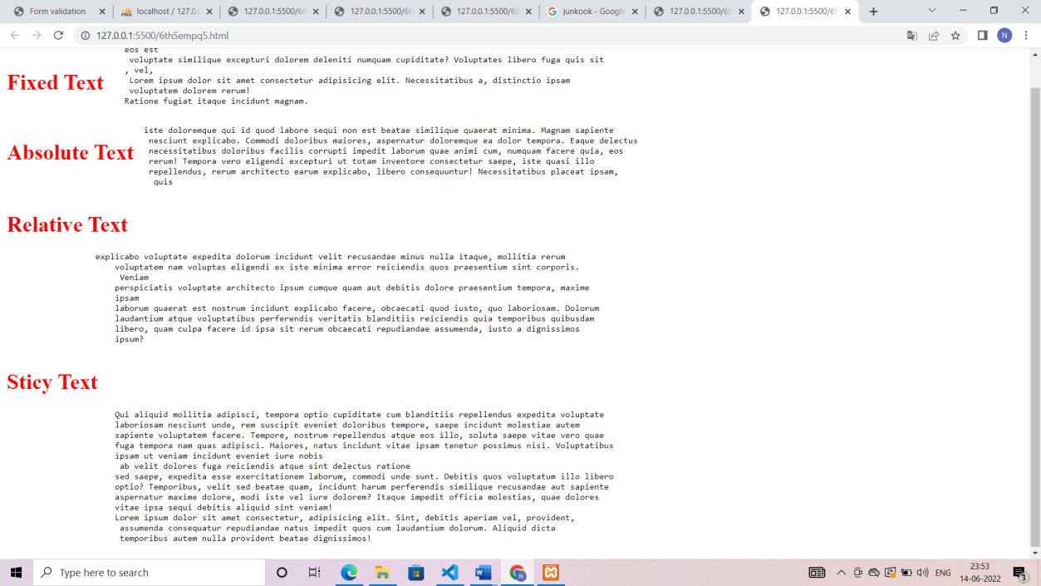

Q6.Write CSS code to show different fonts in different size and colors. Also show how to use Google fonts in your HTML webpage.

CODE:

<!DOCTYPE html>

<html lang="en">

<head>

<meta charset="UTF-8">

<meta http-equiv="X-UA-Compatible" content="IE=edge">

<meta name="viewport" content="width=device-width, initial-scale=1.0">

<link rel="preconnect" href="https://fonts.googleapis.com">

<link rel="preconnect" href="https://fonts.gstatic.com" crossorigin>

<link href="https://fonts.googleapis.com/css2?family=Kdam+Thmor+Pro&display=swap" rel="stylesheet"> <style> .font1 { font-family: 'Franklin Gothic Medium', 'Arial Narrow', Arial, sans-serif; font-weight: bold; font-size: 30px;

}

.font2 { font-family: 'Times New Roman', Times, serif; font-size: 40px; font-style: italic;

}

.font3 {

font-family: Verdana, Geneva, Tahoma, sans-serif; font-weight: 200;

} .font4{ font-family:Kdam Thmor Pro; line-height:2em; font-size: 50px;;

}

</style>

</head>

<body>

<div class="font1">

<p>Lorem, ipsum dolor sit amet consectetur adipisicing elit. Voluptas, doloribus.</p>

</div>

<div class="font2">

<p>Lorem ipsum dolor sit amet consectetur adipisicing elit. Explicabo, earum.</p> </div>

<div class="font3">

<p>Lorem ipsum dolor sit amet consectetur adipisicing elit. Dicta, commodi!</p>

</div>

<div class="font4">

<p> Web Font font-family : Kdam Thmor Pro </p> </div>

</body>

</html>

OUTPUT:

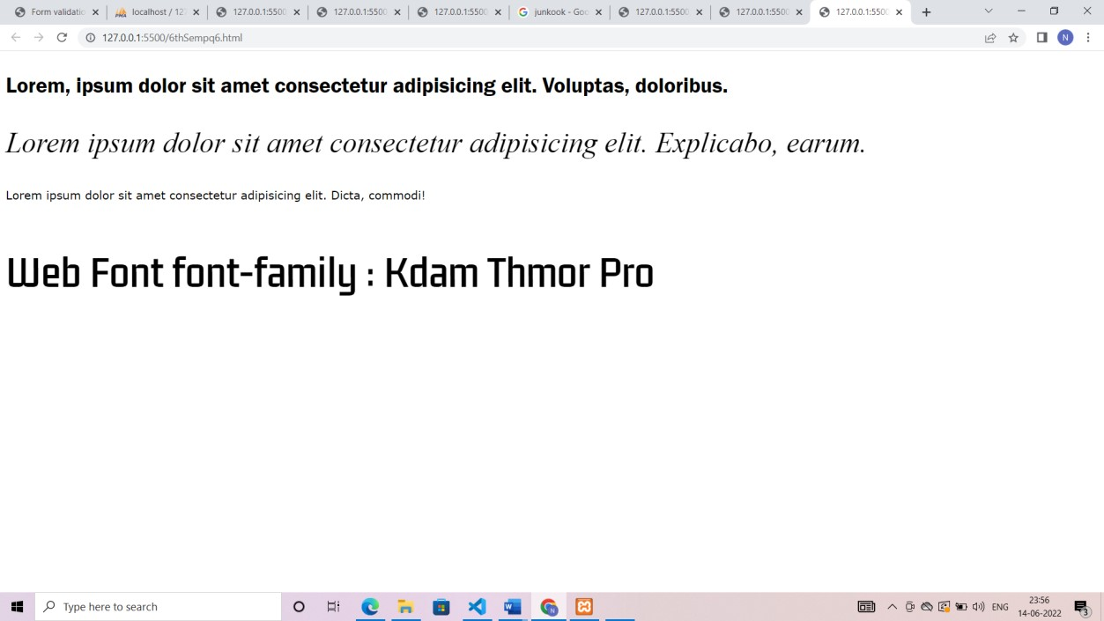

Q7.Create an HTML form consisting of name (textbox) and gender (radio button) and apply validation on it using Javascript.

CODE:

<!DOCTYPE html>

<html lang="en">

<head>

<head>

<meta charset="UTF-8">

<meta http-equiv="X-UA-Compatible" content="IE=edge">

<meta name="viewport" content="width=device-width, initial-scale=1.0">

<title>Form validation</title>

<script> function validate() { document.getElementById("u").style.visibility = "hidden"; document.getElementById("gm").style.visibility="hidden"; if (document.getElementById("unm").value == "") { document.getElementById("u").style.visibility = "visible"; document.getElementById("unm").focus(); return false;

} var fe = document.forms.gen; for (i = 0; i < fe.length; i++) { if (fe[i].checked == true) return true;

} document.getElementById("gm").style.visibility="visible"; return false;

}

</script> <style> form { background-color: aqua; margin: 5% 40%; height: 30%; width: 20%; border-radius: 10px; padding: 10px;

}

</style>

</head>

<body><div>

<form action="" name="forms">

<div>

username: <input type="text" id="unm" placeholder="name">

<div id="u" style="color:red; visibility:hidden;">enter user name</div>

</div>

<div>

Gender : Female <input type="radio" name="gen" > Male <input type="radio" name="gen">

Others <input type="radio" name="gen" >

<div> <p id="gm" style="color:red; visibility:hidden;">select one option</p></div>

</div>

<div class="btn">

<center><input type="submit" value="SUBMIT" style="borderradius: 10px;" onclick="return validate()">

</center>

</div>

</form>

</div>

</body></html>

OUTPUT:

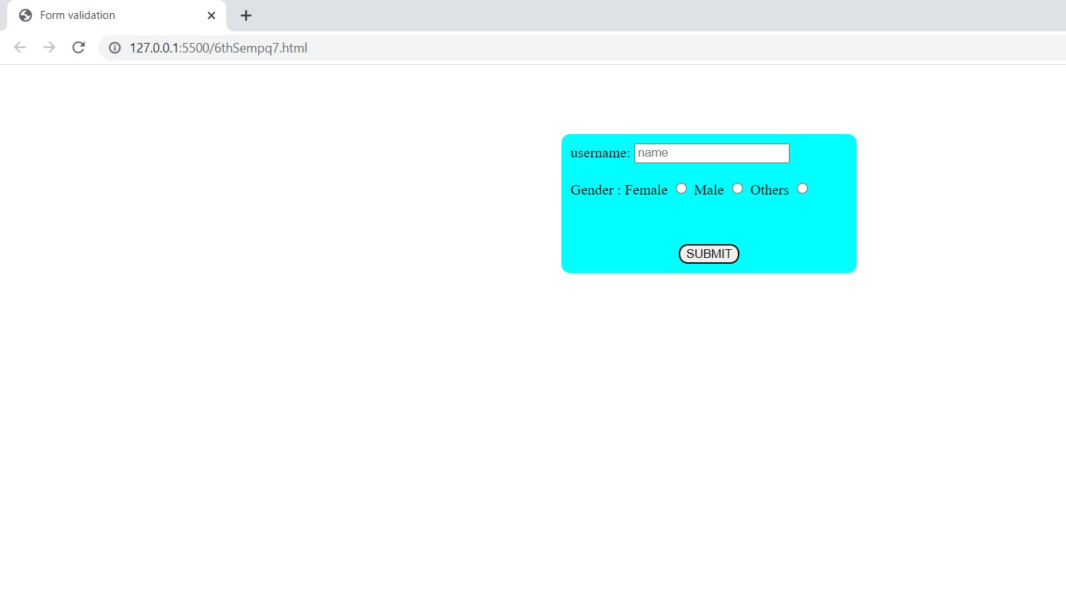

Q8.Insert a button in an HTML page and then using DOM, create and insert an h1 heading in the page on click of that button.

CODE:

<!DOCTYPE html>

<html lang="en">

<head>

<meta charset="UTF-8">

<meta http-equiv="X-UA-Compatible" content="IE=edge">

<meta name="viewport" content="width=device-width, initial-scale=1.0">

<title>DOM</title> <script> function myFunction() { const ins = document.getElementById("dom"); let html = "<h1>new Heading.</h1>"; ins.insertAdjacentHTML("afterend", html);

}

</script>

</head>

<body>

<button onclick="myFunction()">SUBMIT</button>

<h2 id="dom">Insert</h2>

</body>

</html>

OUTPUT:

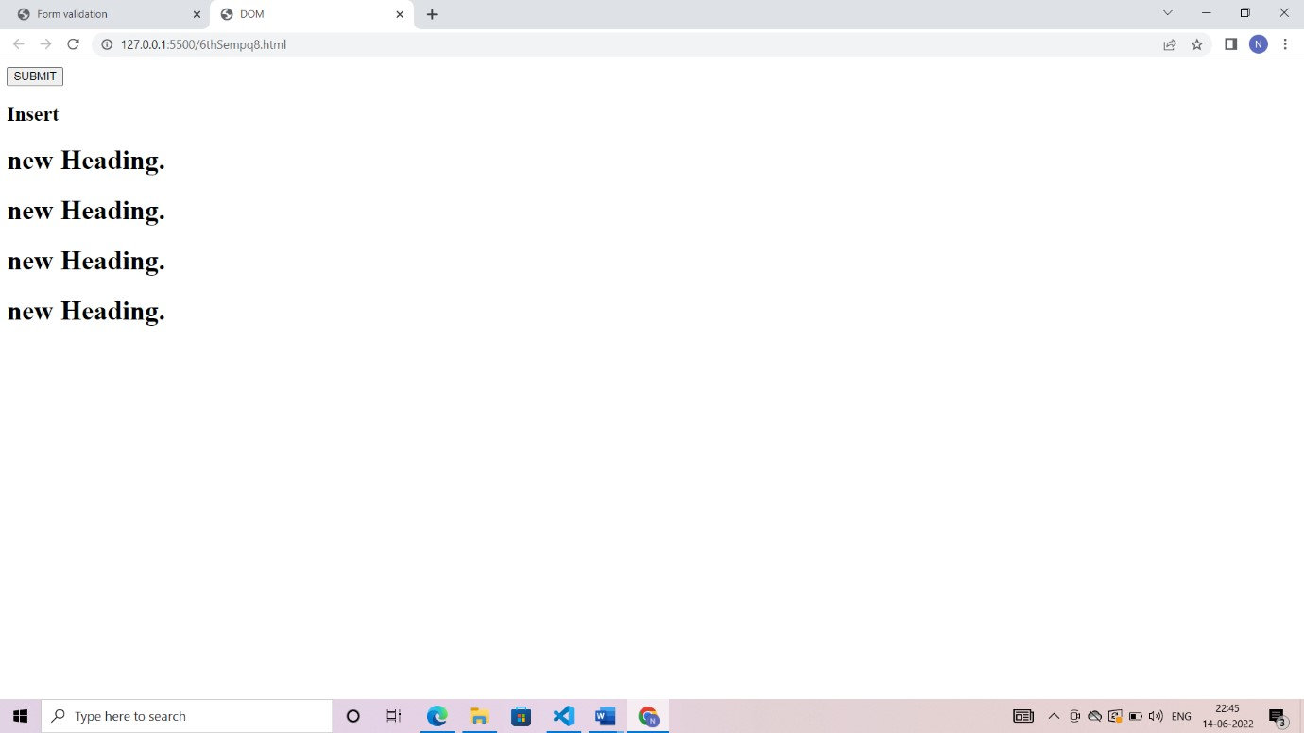

Q9.Write PHP code to accept form data from user and insert it in the database.

CODE:

<!DOCTYPE html>

<html lang="en">

<head>

<meta charset="UTF-8">

<meta http-equiv="X-UA-Compatible" content="IE=edge">

<meta name="viewport" content="width=device-width, initial-scale=1.0">

<title>FORM</title>

<style> body { font-size: 16px; background: #f9f9f9; font-family: "Segoe UI", "Helvetica Neue", Arial, sans-serif; } h2 { text-align: center; text-decoration: underline;

} form { width: 300px; background: #fff; padding: 15px 40px 40px; border: 1px solid #ccc; margin: 150px auto 0; border-radius: 5px;

} input, select {

border: 1px solid #ccc; padding: 10px; display: block; width: 100%; box-sizing: border-box; border-radius: 6px;

}

#btn { font-size: 110%; font-weight: 100; background: #006dcc; border-color: black; border-radius: 6px; color: #fff; margin-top: 10px;

}

</style>

</head>

<body> <?php if($_SERVER['REQUEST_METHOD']=='POST'){

$name = $_POST['name'];

$email = $_POST['email'];

$servername = "localhost";

$username = "root";

$password = "";

$database = "newdb";

$conn = mysqli_connect($servername, $username, $password, $database);

if (!$conn) { die("The Server was connect successfully".mysqli_connect_error());

} else {

$sql = "INSERT INTO `user`(`NAME`, `EMAIL`) VALUES ('$name', '$email');";

$result = mysqli_query($conn, $sql);

if ($result) { echo '<div>

<strong>Success!</strong> Your form was submitted successfully.

</div>'; } else { echo '<div>

<strong>Error!</strong> Your form was not submitted successfully.

</div>';

}

}

}

?>

<form class="container" method="post">

<h1>Fill The Form!</h1>

<div class="form-group">

<label for="Name">Enter Your Name</label>

<input type="Name" name="name" class="form" id="Name">

</div>

<div class="form-group">

<label for="Email">Email address</label>

<input type="email" name="email" class="form" id="Email">

</div>

<button type="submit" class="btn" id="btn">Submit</button>

</form>

</body>

</html>

OUTPUT:

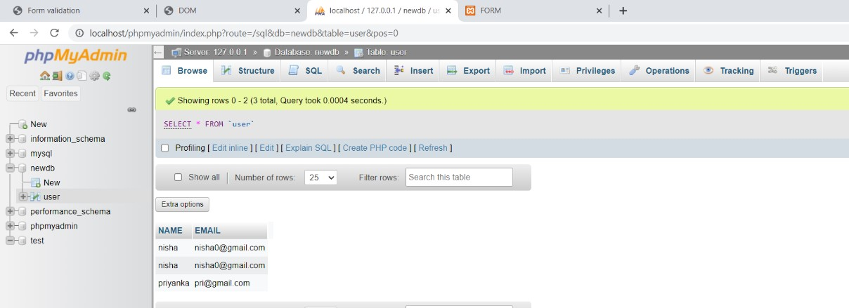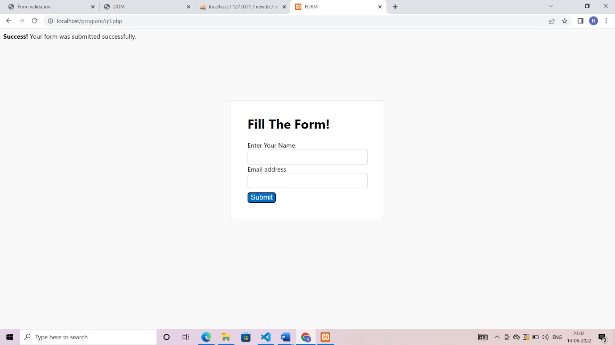

Write PHP code to print all the rows from the database.

CODE:

<?php

$servername = "localhost";

$username = "root";

$password = "";

$database = "newdb";

$conn = mysqli_connect($servername, $username, $password, $database); if ($conn) { echo "The server was connected successfully<br>";

} else { echo "The server was not connected successfully".mysqli_connect_erroe(); }

$sql = "SELECT * FROM `user`";

$result = mysqli_query($conn, $sql);

$num = mysqli_num_rows($result); echo $num; echo " records found in the DataBase<br>";

if ($num>0) { while ($row = mysqli_fetch_assoc($result)) { echo " Name is " . $row['NAME'] . ", email is " . $row['EMAIL']; echo "<br>";

}

}

?>

OUTPUT:

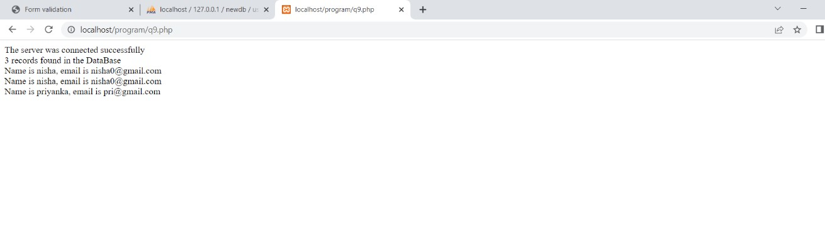

Write PHP code to set a “**name**” cookie on a client’s request and then print **“Welcome:”** followed by name on next request.

CODE:

<?php setcookie("Name", "Nisha"); echo "The cookie is Set";

?>

<?php

$name = $_COOKIE['Name']; echo "Welcome: $name";

?>

OUTPUT:

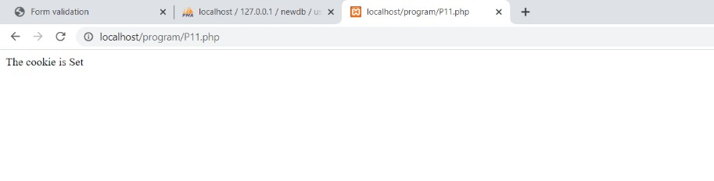

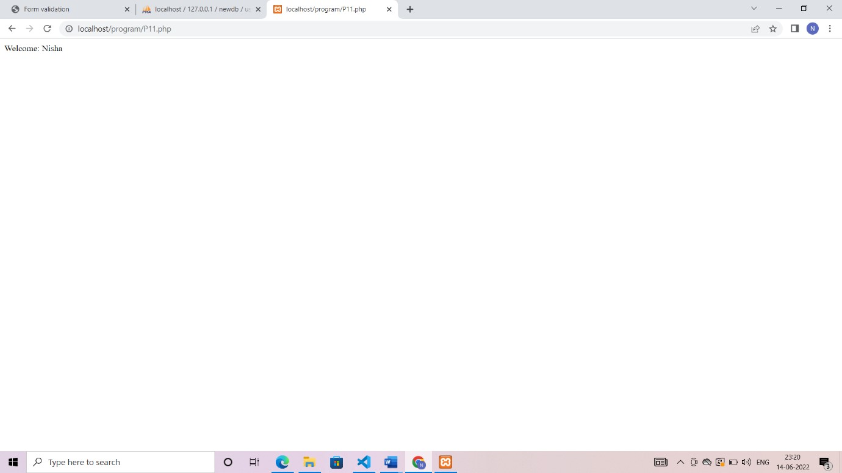

Write JQuery code to make an Ajax call to a URL and print the data received. Print error in case the call was not successful.

CODE

Q12Index.html

<!DOCTYPE html>

<html lang="en">

<head>

<title>Document</title>

<script src="https://cdnjs.cloudflare.com/ajax/libs/jquery/3.6.0/jquery.js" integrity="sha512n/4gHW3atM3QqRcbCn6ewmpxcLAHGaDjpEBu4xZd47N0W2oQ+6q7oc3PXstrJYXcbNU1OHdQ1T7pAP

+gi5Yu8g==" crossorigin="anonymous" referrerpolicy="no-referrer"></script>

</head>

<body>

<button id="action-button">Click me to load info!</button>

<div id="info"></div>

<script type="text/javascript" src="Q12Script.js"></script>

</body>

</html>

Q12Script.js

$('#action-button').click(function() {

$.ajax({

url: 'https://api.joind.in/v2.1/talks/10889', error: function() {

$('#info').html('<p>An error has occurred</p>');

},

success: function(data) { var $title = $('<h1>').text(data.talks[0].talk_title);

var $description = $('<p>').text(data.talks[0].talk_description);

$('#info')

.append($title)

.append($description);

}, type: 'GET'

});

});

OUTPUT:

