Terraform Installation:

sudo wget https://releases.hashicorp.com/terraform/0.12.2/terraform_0.12.2_linux_amd64.zip

sudo unzip ./terraform_0.12.2_linux_amd64.zip –d /usr/local/bin

terraform -v

terraform init

terraform apply

terraform destroy

terraform plan : For testing the infrastructure would be build based on terraform files:

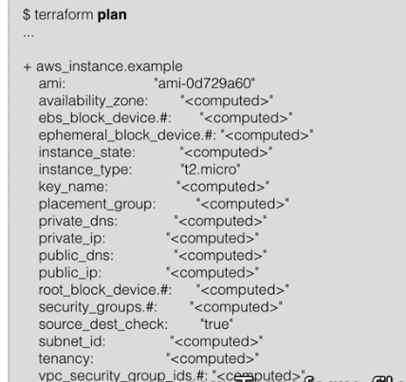

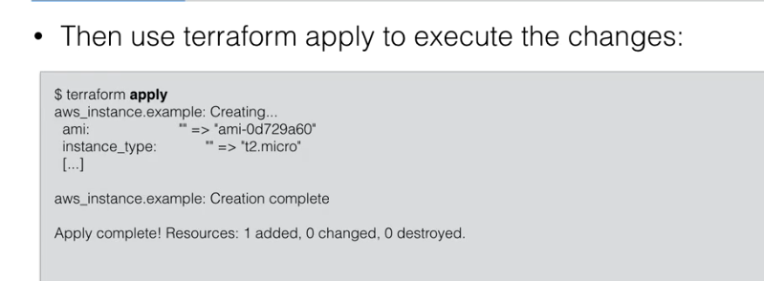

terraform plan -out out.terraform

terraform apply out.terraform

terraform plan -out file ; terraform apply file ; rm file ;

Ubuntu Image Locator:

<https://cloud-images.ubuntu.com/locator/ec2/>

AWS Regions:

<https://docs.aws.amazon.com/general/latest/gr/rande.html>

