Ideation Phase
Brainstorm & Idea Prioritization Template
Date | 28 September 2026
Team ID | 6ab1d547afd88be4583ffc29
Project Name | IMPORT DATA USING TRANSFORM MAPS(SPREADSHEET)
Maximum Marks | 4 Marks
Brainstorm & Idea Prioritization Template:
This document follows the supplied template's three stages: Team Gathering and Problem Statement, Brainstorm/Idea Listing and Grouping, and Idea Prioritization.
Project basis: structured employee data is imported from an external spreadsheet into ServiceNow using Import Sets and Transform Maps; field mapping and Coalesce support the transformation and duplicate-prevention process, followed by reports and an Employee Analytics Dashboard.
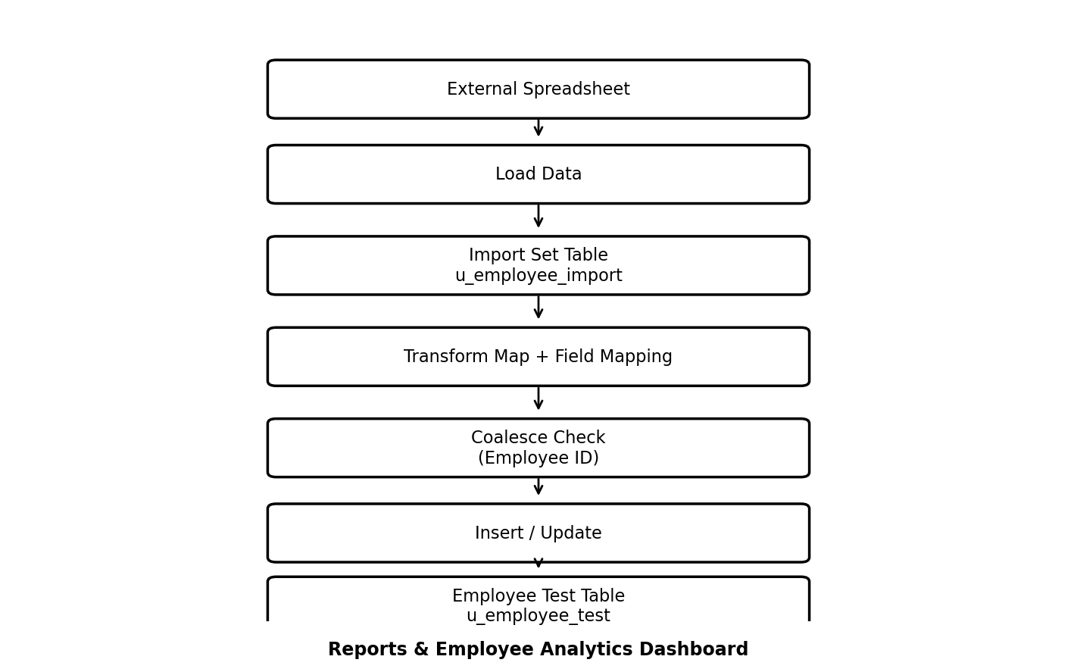
Project-specific workflow diagram

Step-1: Team Gathering, Collaboration and Select the Problem Statement
Team Members:
- Nisha Nandhini K
- Vinija S
- Subasri M
- Sri Shanmugapriya K
Department: Computer Science
College: Govt Arts College for women, Ramanathapuram.
College Code: ALUAU15
Selected Problem Statement
Manual entry of large amounts of employee information into ServiceNow can be time-consuming and may result in duplicate or inconsistent records. A systematic method is required to import spreadsheet data efficiently, map source fields correctly, update existing records, prevent duplicate records, and provide useful reports for monitoring the imported information.
Objectives Used for the Brainstorm
- Import structured employee data from a spreadsheet into ServiceNow.
- Create a custom Employee Test table for storing employee records.
- Create an Import Set table for temporary/staging data.
- Configure a Transform Map between source and target tables.
- Map source fields to the corresponding target fields.
- Use Coalesce to identify existing employee records and prevent duplicates.
- Validate inserted and updated records after transformation.
- Create reports based on department, location, and employee details.
- Create a dashboard containing the project reports.
Brainstorming Rules
Stay on topic | Ideas address employee data import, transformation, data quality, reporting or visualization.
Encourage ideas | The team considers multiple solutions before prioritization.
Defer judgment | Ideas are listed and grouped before feasibility/importance prioritization.

Step-2: Brainstorm, Idea Listing and Grouping
Project-specific idea generation:
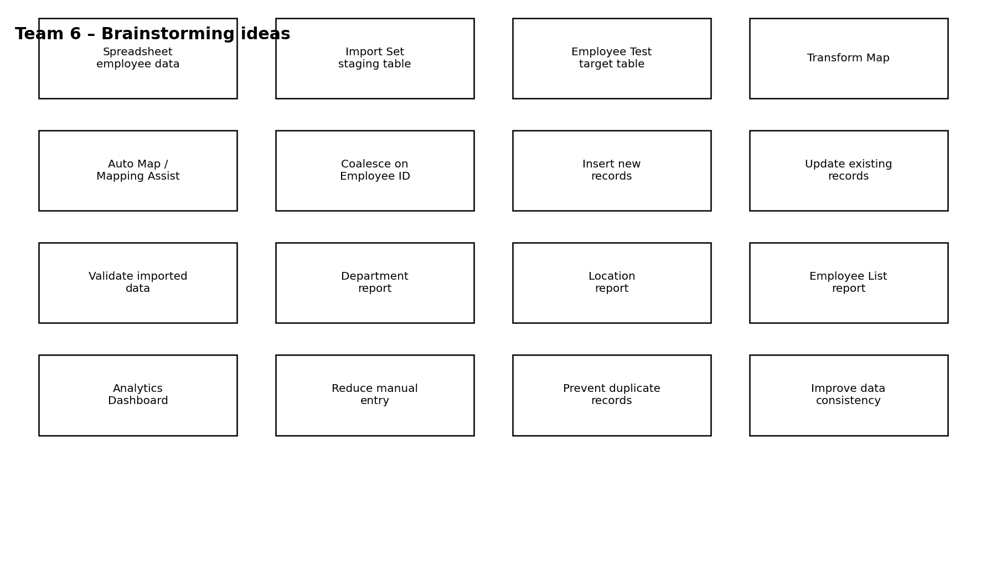
Idea-generation diagram
Group Ideas
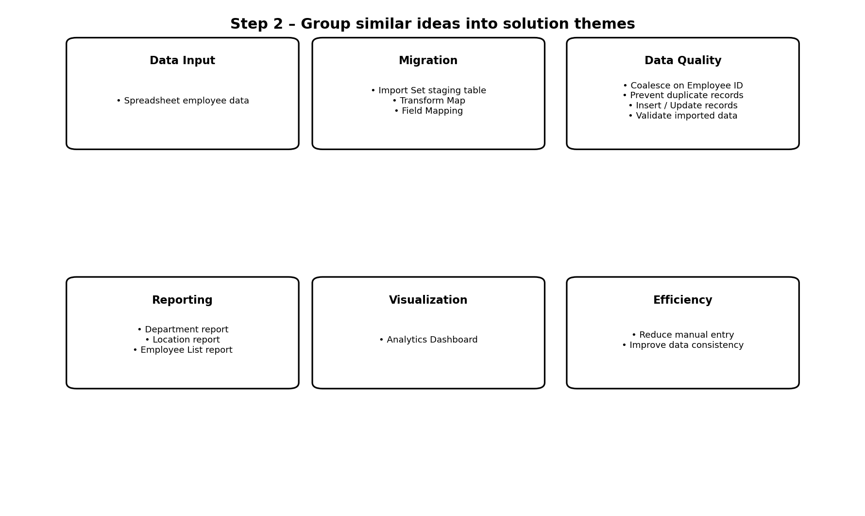
Idea grouping diagram
Group | Specific ideas
Data Input | Spreadsheet employee data
Migration | Import Set staging table; Transform Map; Field Mapping
Data Quality | Coalesce on Employee ID; Prevent duplicate records; Insert / Update records; Validate imported data
Reporting | Department report; Location report; Employee List report
Visualization | Analytics Dashboard
Efficiency | Reduce manual entry; Improve data consistency

Step-3: Idea Prioritization
The ideas are positioned using the template's Importance and Feasibility dimensions. The matrix below is tailored to the documented ServiceNow workflow.
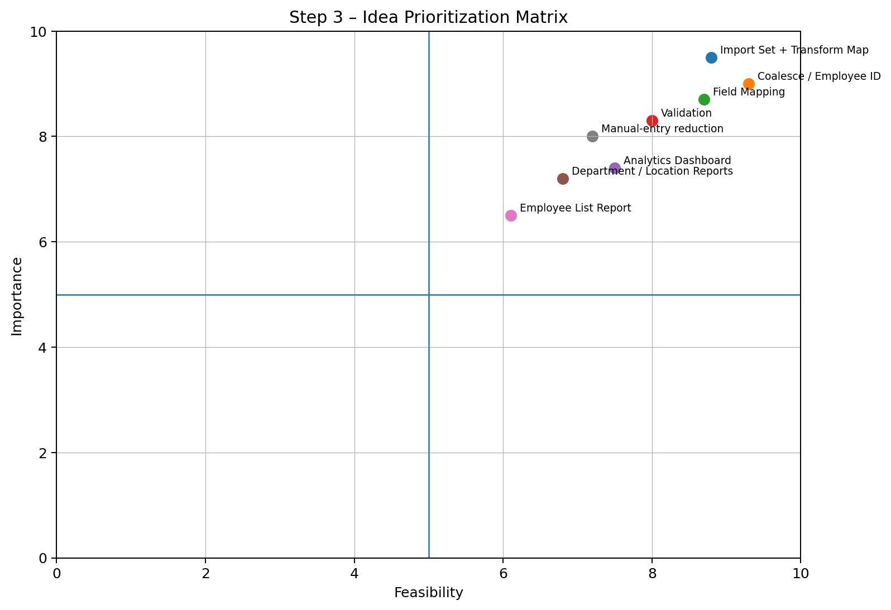
Importance vs. feasibility prioritization diagram
Prioritized Ideas
Priority | Idea | Importance | Feasibility
1 | Import Set + Transform Map | 9.5/10 | 8.8/10
2 | Coalesce / Employee ID | 9.0/10 | 9.3/10
3 | Field Mapping | 8.7/10 | 8.7/10
4 | Validation | 8.3/10 | 8.0/10
5 | Manual-entry reduction | 8.0/10 | 7.2/10
6 | Analytics Dashboard | 7.4/10 | 7.5/10
7 | Department / Location Reports | 7.2/10 | 6.8/10
8 | Employee List Report | 6.5/10 | 6.1/10
Final Brainstorming Result
The final concept is an end-to-end ServiceNow employee data import workflow. Spreadsheet data is loaded into the Import Set table, transformed through the Transform Map with field mapping, checked using Coalesce on Employee ID, and stored in the Employee Test table. The resulting employee information is then presented through department, location and employee-list reports and an Employee Analytics Dashboard.
Expected Project Outcome
- Efficient spreadsheet-to-ServiceNow employee data import.
- Correct source-to-target field mapping.
- Insertion of new records and updating of existing records.
- Duplicate prevention through Coalesce using Employee ID.
- Validation of transformed employee records.
- Department-wise, location-wise and detailed employee reporting.
- Centralized Employee Analytics Dashboard.

