**Cinema Booking System Specification**

**System -** Main functionality - viewing, booking, system administration

**Purpose** - to allow customers to book cinema tickets

**Actors -** Users - Customer(s) and manager(s), booking system **Goals** - buying tickets, booking, searching movies, cinema and booking

**Problem Domain Classes** - Class Diagram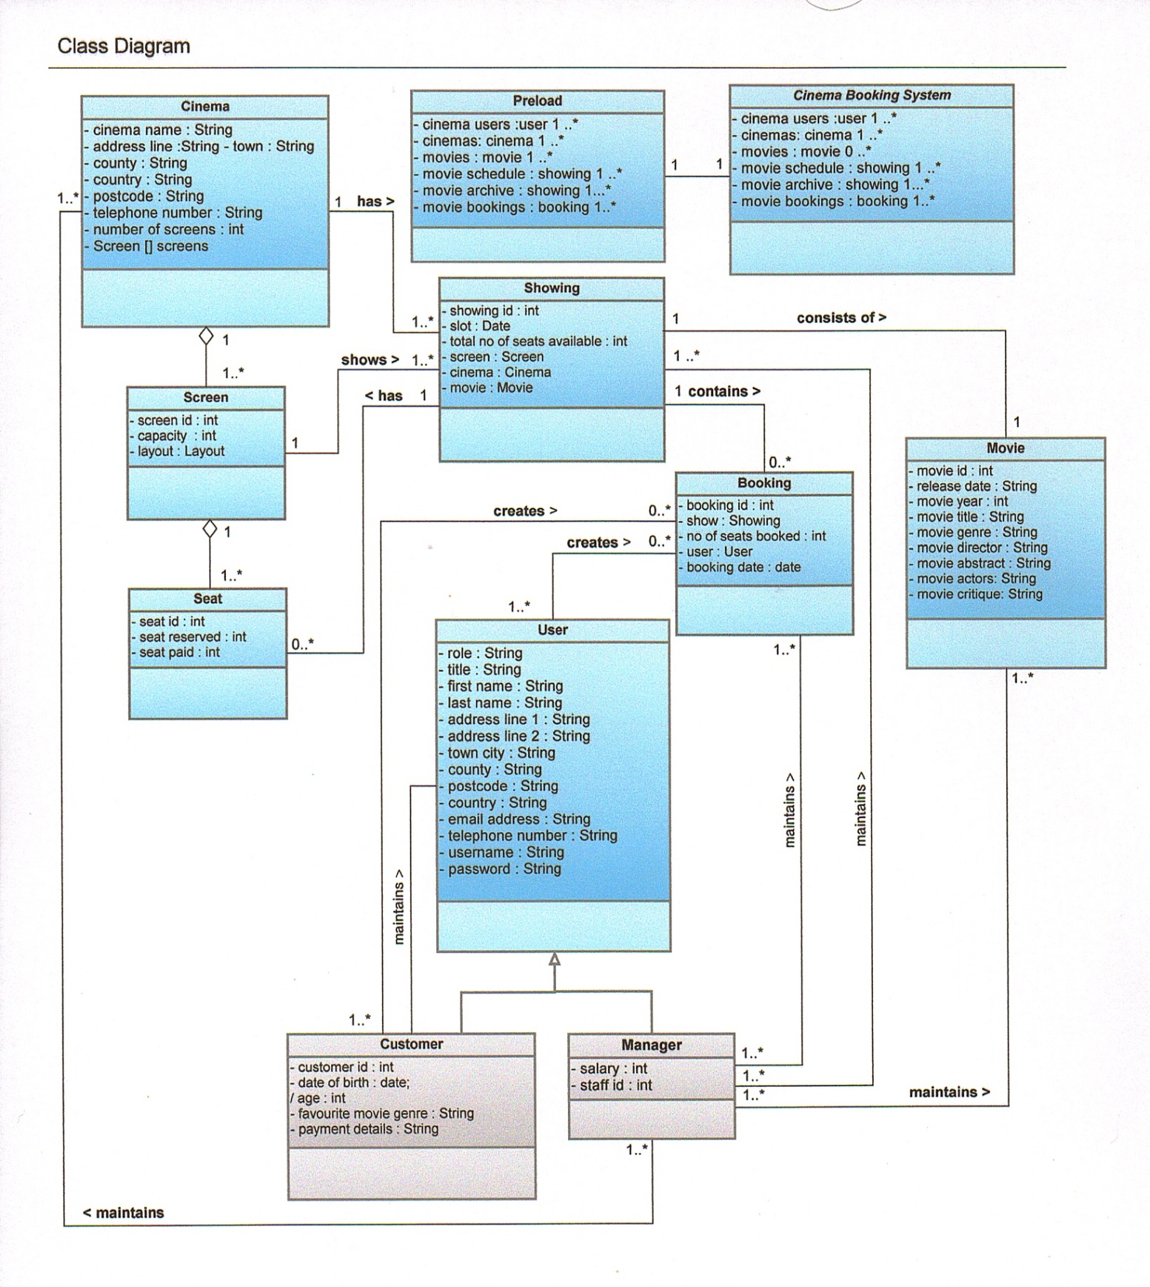

**Use Cases**

**User Login** - Users (Customers and managers) will log into the booking system as a customer or manager and will be presented with a list of different operations they can carry out or they can register as a new user. (CREATE, READ)

**Editing user details** - Users (customers or managers) will be able to choose to modify their details from a list except their username. (UPDATE)

**Display previous bookings** - Customers will be able to choose to view bookings they have made previously from movie bookings list. (READ)

**Display a scheduled movie** - Users will selects to view a list of showings from the movie schedule (list). (READ)

**Display a past movie** - Customer will select to view showings from the movie archive(list). (READ)

**Booking** - Users (Customers) will make a booking by selecting a showing from the displayed showings (movie schedule) and selecting the no of tickets required. If seats are available and if funds are available payment is taken for the showing and the booking is made and confirmed. Showing details are updated to show available seats to future users. Booking details are updated to show date and time of purchase, no of seats booked and purchase price in addtion to the other showing details. (CREATE, READ)

**System Administration**

**Modify cinemas** - Manager will select to add, display, update and delete cinemas (including screens). from cinemas list (CREATE, READ, UPDATE, DELETE)

**Modify movies** - Manager will select to add, display, update and delete movies from movies list. (CREATE, READ, UPDATE, DELETE)

**Modify showings** - Manager will select to create, display, update (reschedule) and delete showings (if no bookings exist for a showing) from the movie schedule (CREATE, READ, UPDATE, DELETE)

**Modify bookings** - Manager will select to create booking for a customer, display, update and delete (cancel) booking(s). The booking number will allow the manager to cancel the customers booking based only on the time of cancellation which dictates if a refund is given and how much refund will be given. (CREATE, READ, UPDATE, DELETE). If cancellation is done at least 24 hours before the showing then the customer can have a 25% refund. If the cancellation is done at least 48 hours before the movie showing then the customer can have a 50% refund. If the cancellation is done at least 78 hours before the movie showing then the customer can have a 100% refund. If the customer cancels less than 24 hours (late cancellation) before showing then they will not be allowed a refund and the seats will be made available again for general sale. Once a refund has been initiated and approved then the seats are released and made available for general sale and will be available for purchase for that showing.

**Preload** - the system will be preloaded with 1 or more users, cinemas, movies, showings and bookings. Objects will be saved on system exit (CREATE, READ, UPDATE)

References

Wixom, D (2010. Systems Analysis and Design and UML. 3rd ed. Asia: Wiley. Chp 5, 6 and 9.

Barnes, D & Kolling, M (2009). Obects First With Java - A Practical Introduction Using Bluej. 4th ed. USA: Pearson International. Chp 13 Designing Applications.