Who Gets Credit for the Sale? Recency Bias in Last-Click Attribution and the Case for Comparing Attribution Models
Nishaad Gangal  Pimpri Chinchwad College of Engineering  Pune, India  nishaad.gangal23@pccoepune.org | Om Katole  Pimpri Chinchwad College of Engineering  Pune, India  om.katole23@pccoepune.org | Satyam Kumar  Pimpri Chinchwad College of Engineering  Pune, India  satyam.kumar23@pccoepune.org

Akshat Jhanwar  Pimpri Chinchwad College of Engineering  Pune, India  akshat.jhanwar23@pccoepune.org | Minal Shahakar  Pimpri Chinchwad College of Engineering  Pune, India  minal.shahakar@pccoepune.org

Abstract—Customers usually interact with several digital channels before buying, yet most businesses judge channels by last-click reports. We study multi-channel attribution and conversion using four public datasets and a known-answer simulation. In 16.5 million Criteo display impressions, only 54.2% of 435,810 conversions that followed a Criteo click were credited to Criteo under the advertiser's last-click rule. Credit was driven by recency: it fell from 87% when the purchase came within an hour of the click to 26% after 7 to 31 days (logistic odds ratio 0.61 per unit of log hours), while additional clicks barely mattered (odds ratio 1.04). In 10,022 real Google Analytics 360 journeys, 52% of buyers returned over several sessions but only 12% used more than one channel; within those, first and last touch disagreed sharply (Direct 42% against 1% of the credit). In 12,205 e-commerce sessions, new visitors converted at 24.9% against 14.1% for returning visitors, and early-session behaviour predicted purchase with ROC-AUC 0.78. A simulation with known channel effects showed that no attribution model is best everywhere: last touch was most accurate when advertising acts immediately (4.2 percentage points mean error) and time decay when it acts with carry-over (5.7 points), while first touch was worst in both. We release ChannelTrace, a free tool that applies seven attribution models to a business's own Google Ads, Meta Ads or journey data and explains the results through a grounded AI assistant.
Index Terms—multi-touch attribution, last-click, customer journey, conversion prediction, Markov chain, Shapley value, digital marketing analytics
I. Introduction
A typical online purchase is preceded by several touchpoints: a social media advertisement, a search, an email, a direct return visit. Advertising platforms and analytics tools record these interactions, and attribution decides how much credit each channel receives for the resulting sale. Because budgets follow credit, the attribution rule shapes which channels are funded and which are cut.
In practice most reports still use last-click attribution, which gives all credit to the final interaction. Each platform also reports from its own perspective, so several platforms can claim the same sale while channels that start journeys appear to contribute little. Data-driven alternatives exist [1]-[4], but they are usually locked inside paid or single-platform tools, and small businesses rarely have the skills to interpret them.
This study asks five research questions. RQ1: what channel journeys precede a conversion? RQ2: how do converting and non-converting sessions differ? RQ3: does a channel's estimated importance change with the attribution model? RQ4: which visitor and session characteristics are associated with conversion? RQ5: can these methods be packaged so that a small business obtains correct, usable insight from its own data?
Our contributions are: (i) evidence from 16.5 million real display impressions that last-click credit is governed mainly by recency; (ii) a cross-session analysis of real multi-channel journeys showing where attribution models disagree; (iii) a known-answer simulation showing that the most accurate attribution model depends on how advertising works, which argues for comparing models rather than choosing one; (iv) an analysis of session behaviour associated with purchase; and (v) ChannelTrace, an open, zero-cost tool that implements the methods for any business's data.
II. Related Work
Multichannel attribution. Li and Kannan [1] modelled how customers consider and visit a firm's channels before converting, using individual-level data and a field experiment, and showed that channel contributions differ substantially from what last-click metrics suggest. Berman [5] analysed last-touch attribution theoretically and showed how it can distort advertisers' incentives and spending.
Data-driven attribution. Shao and Li [2] proposed learning channel contributions from converting and non-converting histories and argued that a model should be judged on both accuracy and stability. Dalessandro et al. [6] framed attribution causally and connected it to the Shapley value; Zhao et al. [7] developed simplified Shapley methods for online advertising. Anderl et al. [3] represented journeys as Markov chains and measured each channel by its removal effect, finding that heuristic models misallocate credit.
Display advertising and conversion prediction. Diemert et al. [4] studied attribution for real-time bidding and released the Criteo dataset used here. Sakar et al. [8] predicted purchasing intention from session clickstream data and released the UCI Online Shoppers dataset. Lemon and Verhoef [9] reviewed the customer journey concept that underlies all of this work.
Most prior studies evaluate attribution on proprietary data without ground truth. We combine public data with a simulation in which the true contribution of each channel is known, and we package the methods for practitioners.
III. Data
Each dataset is used only for the questions it can support; the datasets come from different populations and are never pooled (Table I).
Table I
Datasets and Their Role
Dataset | Content | Used for
UCI Online Shoppers [8] | 12,205 sessions (after removing 125 duplicates), 17 features, purchase outcome | RQ2, RQ4
Criteo Attribution [4] | 16,468,027 impressions, 6,142,256 users, 675 campaigns, 30 days | RQ3 (last-click gap, recency)
Google Analytics 360 sample [10] | 903,653 sessions, 714,167 visitors, named channels, 12 months | RQ1, RQ3
Facebook Ad Campaign [11] | 1,143 real ads, spend, clicks, conversions, age, gender | RQ5 (tool validation)
Simulated journeys | 6 random worlds x 2 scenarios x 3,000 users with known channel effects | RQ3 (model accuracy)

A validity check shaped the design. In the Criteo data, 99.3% of conversions involve a single campaign, and all impressions in converting journeys are clicks because the public sample retains clicked impressions for converting users. Criteo therefore cannot compare channels or campaigns within a journey, nor clicked against viewed impressions; we use it for the last-click gap and its recency effect. In the UCI data, traffic sources are anonymised codes, so it is used for behaviour rather than channel comparison.
IV. Methods
A. Attribution Models
For a converting journey of touchpoints c1 ... cn, five rule-based models assign credit: first touch (all to c1), last touch (all to cn), linear (1/n each), time decay (weights halving every 7 days before the purchase) and position based (40% first, 40% last, 20% shared). Two data-driven models use converting and non-converting journeys: the Markov chain removal effect [3], which estimates how much the probability of reaching conversion from the start state falls when a channel is removed, and the Shapley value [6], [7], each channel's average marginal contribution to conversions over all channel coalitions. Every model distributes exactly the total number of conversions; we verified this for all models in the implementation.
B. Known-Answer Validation
Observational data offers no ground truth for attribution, so we simulated journeys in which channel effects are set by design. Each user's first channel and subsequent channels are drawn from random distributions; each touch raises the log-odds of purchase by a channel-specific lift. In the immediate scenario a touch raises the chance of buying in the same visit; in the carry-over scenario it raises the chance only on later visits, as with awareness advertising. A channel's true contribution is the number of conversions lost when its effect is switched off, computed with common random numbers. Six random worlds per scenario (3,000 users each) were generated. Models are scored by mean absolute error (MAE) between their credit shares and the true shares, and by Spearman rank correlation. Stability was assessed with 200 bootstrap resamples of journeys.
C. Recency of Last-Click Credit
For each Criteo conversion we record whether Criteo received last-click credit, the number of Criteo clicks and the hours from the last click to the conversion. We test association with a chi-square test over six time bands and a logistic regression of the credit indicator on log(1 + hours) and the number of clicks.
D. Session Behaviour and Conversion
Converting and non-converting UCI sessions are compared with two-sided Mann-Whitney U tests (numeric measures) and chi-square tests (visitor type, month). Logistic regression, random forest and gradient boosting classifiers are trained on a stratified 75/25 split with class-balanced weights and evaluated by ROC-AUC. Because the PageValues feature is computed from pages viewed before a transaction and partly encodes the outcome, every model is reported with and without it. Feature importance is measured by permutation on the test set.
V. Results
A. Last-Click Credit Is Driven by Recency (RQ3)
All 435,810 Criteo conversions followed at least one Criteo click, yet only 54.2% were credited to Criteo by the advertiser's last-click rule; the remainder were claimed by other channels. Converting journeys were short (mean 1.85 clicks; 68% with one click; median 20.3 hours from the last click to purchase). Fig. 1 shows that credit falls steadily with time since the last click (chi-square = 126,214, df = 5, p < 0.001).
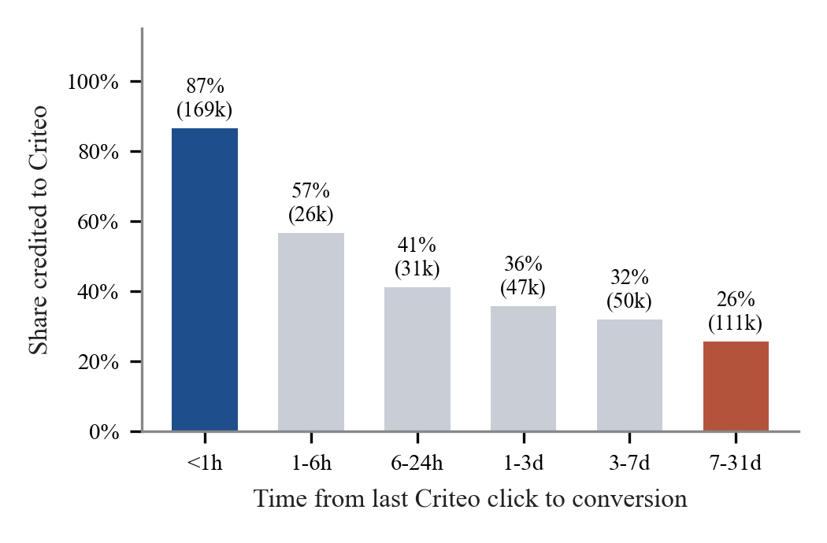
Fig. 1. Share of conversions credited to Criteo under last-click, by time from the last Criteo click to the conversion.
Table II
Logistic Regression of Last-Click Credit to Criteo (n = 433,745)
Predictor | Odds ratio | 95% CI | p
log(1 + hours since click) | 0.607 | 0.606 to 0.609 | < 0.001
Criteo clicks (capped at 10) | 1.037 | 1.033 to 1.041 | < 0.001

Holding clicks constant, each unit increase in log(1 + hours) multiplies the odds of Criteo receiving credit by 0.61, whereas each additional click multiplies them by only 1.04 (pseudo R-squared 0.22). The credit share was 54.2% for single-click journeys and 57.8% for six or more clicks. Under last-click, which platform is paid for a sale depends far more on timing than on how much a channel was used.
B. Real Multi-Channel Journeys (RQ1, RQ3)
The Google Analytics 360 sample covers 714,167 visitors and 903,653 sessions of the Google Merchandise Store over one year. Following each visitor across sessions up to the first purchase gives 10,022 converting journeys (1.4% of all journeys). Buying took repeated visits: 52% of converting journeys spanned more than one session (mean 2.28 sessions, against 1.23 for journeys without a purchase), yet only 12% involved more than one channel. Most customers returned through the channel that first brought them.
Table III
Credit Share by Channel, All Converting Journeys (GA360)
Channel | First | Last | Linear | Markov | Shapley
Referral | 39.9% | 45.5% | 42.8% | 42.5% | 42.4%
Organic Search | 31.5% | 31.1% | 31.4% | 32.0% | 31.3%
Direct | 22.0% | 17.1% | 19.2% | 18.2% | 19.5%
Paid Search | 4.4% | 4.2% | 4.3% | 4.3% | 4.4%
Display | 1.3% | 1.1% | 1.3% | 1.3% | 1.3%
Social | 0.8% | 1.0% | 0.9% | 1.2% | 0.9%
Affiliates | 0.1% | 0.1% | 0.1% | 0.5% | 0.1%

Because so few journeys mix channels, the seven models broadly agree on the whole sample (Table III); the largest swing, for Referral, is from 39.9% to 45.5%. The disagreement is concentrated in the 1,189 multi-channel journeys (Fig. 2). There, first touch gives Direct 42% of the credit and last touch 1%, while Referral moves from 13% to 60%; the most common multi-channel paths were Direct > Referral and Organic Search > Referral. For these customers the choice of model decides which channel is funded.
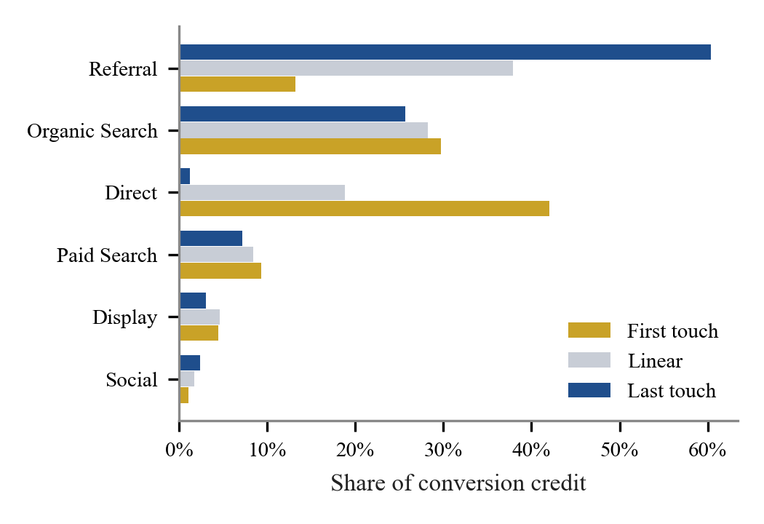
Fig. 2. Credit share by channel within the 1,189 GA360 converting journeys that used more than one channel.
Two properties of the data qualify this. Google Analytics labels a returning direct visit with the source of the visitor's previous campaign: 40,356 of the 104,838 Referral sessions are flagged in the data as direct visits. Direct can therefore rarely follow another channel, which mechanically lowers its last-touch share. And 97% of converting Referral sessions record no referring site, so Referral's large share cannot be read as the value of third-party sites.
C. No Attribution Model Is Best Everywhere (RQ3)
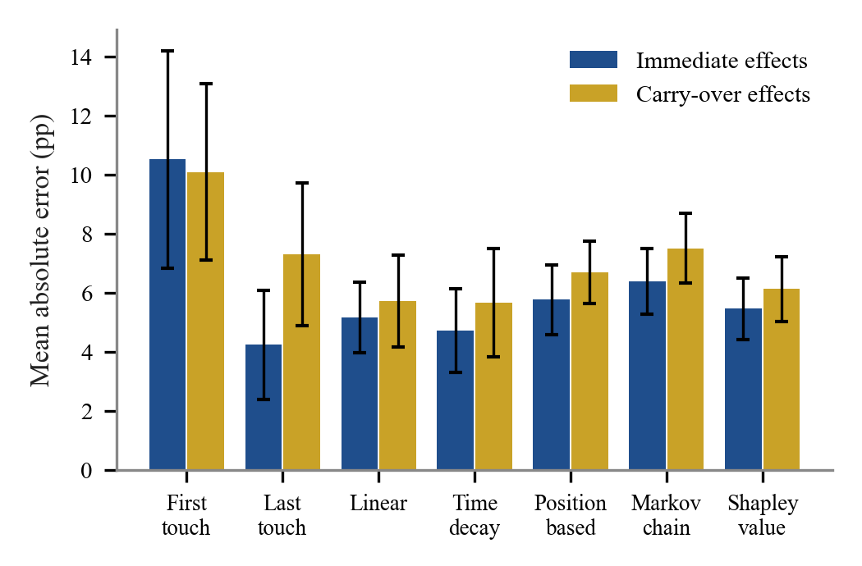
Fig. 3. Mean absolute error between model and true credit shares (percentage points; bars show the standard deviation over six worlds).
Table IV
Accuracy of Attribution Models Against Known Channel Effects
Model | Immediate MAE | ρ | Carry-over MAE | ρ
First touch | 10.5 | 0.17 | 10.1 | 0.18
Last touch | 4.2 | 0.66 | 7.3 | 0.37
Linear | 5.2 | 0.68 | 5.7 | 0.60
Time decay | 4.7 | 0.66 | 5.7 | 0.50
Position based | 5.8 | 0.67 | 6.7 | 0.56
Markov chain | 6.4 | 0.61 | 7.5 | 0.45
Shapley value | 5.5 | 0.69 | 6.1 | 0.60

When advertising acts immediately, last touch came closest to the truth (4.2 pp), with time decay close behind (4.7 pp). With carry-over effects, last-touch error rose to 7.3 pp and its rank agreement fell from 0.66 to 0.37, while time decay and linear became the most accurate (5.7 and 5.7 pp). The highest rank agreement came from Shapley value under immediate effects (0.69) and linear under carry-over (0.60), with the Shapley value close behind in both (0.69 and 0.60). First touch was worst in both. The Markov removal effect was never the most accurate under these data-generating processes, a reminder that data-driven does not automatically mean correct.
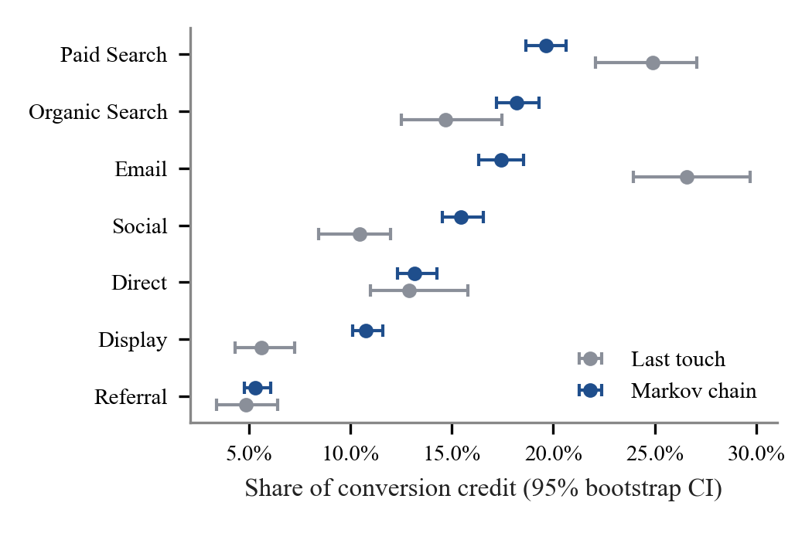
Fig. 4. Last-touch and Markov credit shares with 95% bootstrap intervals on 4,000 synthetic journeys with designed channel roles.
On a separate synthetic dataset in which Social and Display were designed to start journeys and Email and Paid Search to close them, the data-driven models recovered those roles: last touch gave Display 6% of the credit against 11% under Markov, and Email 27% against 17%. The bootstrap intervals are narrow (about plus or minus one percentage point), so these differences are not sampling noise.
D. Session Behaviour Associated With Purchase (RQ2, RQ4)
The overall conversion rate was 15.6%. New visitors converted at 24.9% against 14.1% for returning visitors, who made up 85% of sessions (chi-square p < 0.001). Conversion peaked in Nov (25.5%) and was lowest in Feb (1.7%; Fig. 5).
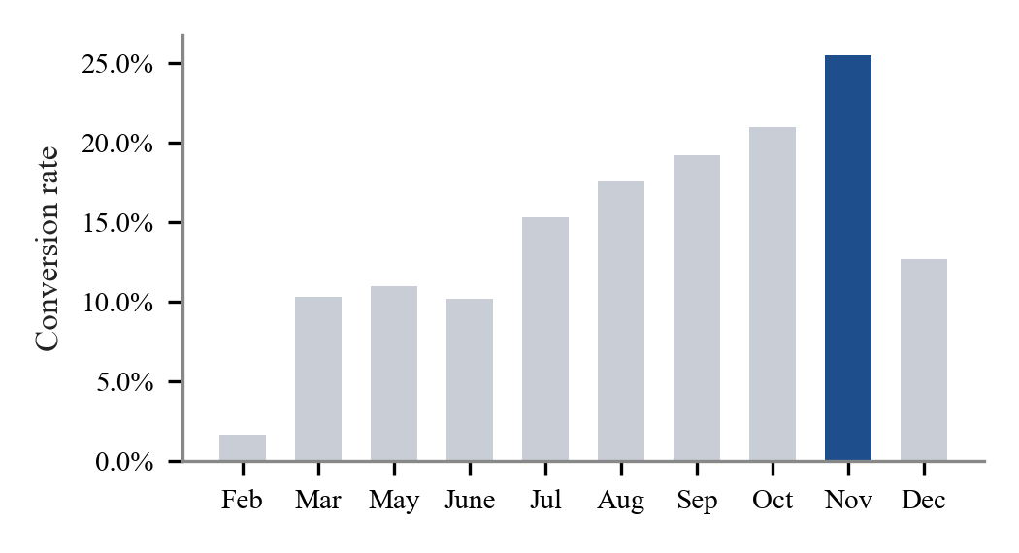
Fig. 5. Conversion rate by month in the UCI Online Shoppers data (January and April are absent).
Table V
Session Behaviour of Buyers and Non-Buyers (Means; Mann-Whitney U)
Measure | Buyers | Non-buyers | p
Product pages viewed | 48.2 | 29.1 | 3.7e-102
Time on product pages | 31.3 min | 18.0 min | 4.2e-122
Account/admin pages viewed | 3.4 | 2.1 | 8.9e-74
Bounce rate | 0.005 | 0.023 | 1.1e-56
Exit rate | 0.020 | 0.046 | 3.0e-169
Page value | 27.3 | 2.0 | < 1e-300

Table VI
Purchase Prediction (ROC-AUC on Held-Out 25%)
Model | With PageValues | Without PageValues
Logistic regression | 0.906 | 0.742
Random forest | 0.932 | 0.775
Gradient boosting | 0.924 | 0.758

All ten behavioural measures differed significantly. Buyers viewed a median of 29 product pages against 16 and bounced and exited far less (Table V). With PageValues the best model reached ROC-AUC 0.932; without it, 0.775, which is the honest estimate of what early-session behaviour reveals. The strongest signals without PageValues were time on product pages, exit rate, the November season (Table VI).
E. Tool Validation on Real Advertising Data (RQ5)
ChannelTrace was run on the real Facebook Ad Campaign data. It recognised the export format automatically and reproduced the campaign totals computed independently in Python to the cent (spend 58,705.23; cost per acquisition 54.41). It found that 10.0% of spend went to ad sets with no approved conversions, that the 30-34 age group had the lowest cost per acquisition (30.88 against 99.76 for ages 45-49), and that men converted more cheaply than women (41.44 against 69.70). The browser implementation of all seven attribution models matched the Python reference exactly on the synthetic journeys. A usability study (System Usability Scale [12]) and an accuracy test of the assistant on a fixed question set are planned.
VI. The ChannelTrace System
ChannelTrace is a web application built with React and hosted on Vercel at no cost. Its analysis runs entirely in the user's browser, so uploaded files are never sent to a server. An ad-performance module detects Google Ads, Meta Ads Manager and similar exports, computes CTR, CPC, conversion rate, CPA and ROAS, gives each campaign a verdict relative to the account average (scale candidate, on track, expensive, no conversions), measures spend with no return and breaks results down by audience and day. A journey module applies all seven attribution models and shows where last-click over- or under-credits each channel. A marketing assistant answers questions using only a fact sheet of computed results: it uses a free generative model when configured and otherwise a built-in TF-IDF retrieval model, so it works offline and never invents numbers.
VII. Discussion
The Criteo results show concretely why platforms disagree about who made a sale. A display network whose clicks precede every one of these conversions is credited for barely half of them, and its share depends mainly on how long the customer waited before buying. A business that reads last-click reports at face value will therefore undervalue channels whose influence is delayed, such as awareness advertising, and overvalue whichever channel happens to be last.
The simulation explains why the remedy is not simply to switch to a single data-driven model. Model accuracy depended on how advertising works: last touch was competitive when effects were immediate but degraded sharply with carry-over, while linear, time decay and the Shapley value were more robust. Since a business rarely knows its true mechanism, comparing several models, and treating channels whose credit swings strongly between them as uncertain, is the safer practice. ChannelTrace is built around that comparison.
The GA360 journeys add a practical nuance. For most of this store's customers the attribution model hardly matters, because they return through the same channel; it matters a great deal for the minority who move between channels, typically arriving directly or through search and buying later through a referral link. A business can check this cheaply: if few of its converting journeys mix channels, last-click reports are roughly adequate; if many do, the models must be compared before budgets are moved.
For marketers the session results suggest three practical actions: re-engage returning visitors, who are most of the traffic but convert least; concentrate budget before the seasonal peak; and send paid traffic directly to product pages, where depth of browsing is the strongest early signal of purchase intent.
VIII. Limitations and Future Work
All findings are associations. Attribution assigns credit and does not establish that a channel caused a sale; only randomised experiments can do that. The Criteo sample covers one channel and retains only clicked impressions for converting users, so view-through effects cannot be studied. The UCI traffic sources are anonymised. The simulation uses two stylised mechanisms and six worlds each; other mechanisms may favour other models. The GA360 sample is one store, uses Google Analytics' own channel definitions and links sessions only through a cookie-based visitor ID, so journeys across devices are split. A usability study of the tool and an accuracy evaluation of the assistant are the next steps.
IX. Conclusion
Using public data at scale and a simulation with known answers, we found that last-click credit is governed mainly by recency, that attribution models disagree mainly on the customers who move between channels, and that the most accurate attribution model depends on how advertising works. Businesses should therefore compare attribution models rather than trust any single report. ChannelTrace makes that comparison free and accessible, together with plain-language explanations of the results.
Acknowledgment
This work was carried out for the MDM Digital Marketing Capstone (BCE27MD06) at Pimpri Chinchwad College of Engineering, Pune, under the guidance of Minal Shahakar.
References
[1] H. Li and P. K. Kannan, "Attributing conversions in a multichannel online marketing environment: An empirical model and a field experiment," Journal of Marketing Research, vol. 51, no. 1, pp. 40-56, 2014.
[2] X. Shao and L. Li, "Data-driven multi-touch attribution models," in Proc. 17th ACM SIGKDD Int. Conf. Knowledge Discovery and Data Mining, 2011, pp. 258-264.
[3] E. Anderl, I. Becker, F. von Wangenheim, and J. H. Schumann, "Mapping the customer journey: Lessons learned from graph-based online attribution modeling," International Journal of Research in Marketing, vol. 33, no. 3, pp. 457-474, 2016.
[4] E. Diemert, J. Meynet, P. Galland, and D. Lefortier, "Attribution modeling increases efficiency of bidding in display advertising," in Proc. AdKDD and TargetAd Workshop, KDD, 2017.
[5] R. Berman, "Beyond the last touch: Attribution in online advertising," Marketing Science, vol. 37, no. 5, pp. 771-792, 2018.
[6] B. Dalessandro, C. Perlich, O. Stitelman, and F. Provost, "Causally motivated attribution for online advertising," in Proc. Sixth Int. Workshop on Data Mining for Online Advertising (ADKDD), 2012.
[7] K. Zhao, S. H. Mahboobi, and S. R. Bagheri, "Shapley value methods for attribution modeling in online advertising," arXiv:1804.05327, 2018.
[8] C. O. Sakar, S. O. Polat, M. Katircioglu, and Y. Kastro, "Real-time prediction of online shoppers' purchasing intention using multilayer perceptron and LSTM recurrent neural networks," Neural Computing and Applications, vol. 31, pp. 6893-6908, 2019.
[9] K. N. Lemon and P. C. Verhoef, "Understanding customer experience throughout the customer journey," Journal of Marketing, vol. 80, no. 6, pp. 69-96, 2016.
[10] Google, "BigQuery sample dataset for Google Analytics 360," Google Analytics Help. [Online]. Available: https://support.google.com/analytics/answer/7586738
[11] Kaggle, "Sales conversion optimization (Facebook ad campaign data)," Kaggle Datasets. [Online]. Available: https://www.kaggle.com/datasets/loveall/clicks-conversion-tracking
[12] J. Brooke, "SUS: A quick and dirty usability scale," in Usability Evaluation in Industry. London: Taylor & Francis, 1996, pp. 189-194.

