Who Gets Credit for the Sale? Recency Bias in Last-Click Attribution and the Case for Comparing Attribution Models
Nishaad Gangal  Dept. of Information Technology  Pimpri Chinchwad College of Engineering  Pune, India  nishaad.gangal23@pccoepune.org | Om Katole  Dept. of Information Technology  Pimpri Chinchwad College of Engineering  Pune, India  om.katole23@pccoepune.org | Satyam Kumar  Dept. of Information Technology  Pimpri Chinchwad College of Engineering  Pune, India  satyam.kumar23@pccoepune.org

Akshat Jhanwar  Dept. of Information Technology  Pimpri Chinchwad College of Engineering  Pune, India  akshat.jhanwar23@pccoepune.org | Minal Shahakar  Dept. of Computer Engineering (Regional Language)  Pimpri Chinchwad College of Engineering  Pune, India  minal.shahakar@pccoepune.org

Abstract—Customers usually interact with several digital channels before buying, yet most businesses judge channels by last-click reports. We study multi-channel attribution and conversion using four public datasets, a known-answer simulation. In 16.5 million Criteo display impressions, only 54.2% of 435,810 conversions that followed a Criteo click were credited to Criteo under the advertiser's last-click rule. Credit was driven by recency: it fell from 87% when the purchase came within an hour of the click to 26% after 7 to 31 days (logistic odds ratio 0.61 per unit of log hours), while additional clicks barely mattered (odds ratio 1.04). In 10,022 real Google Analytics 360 journeys, 52% of buyers returned over several sessions but only 12% used more than one channel; within those, first and last touch disagreed sharply (Direct 42% against 1% of the credit). In 12,205 e-commerce sessions, new visitors converted at 24.9% against 14.1% for returning visitors, and early-session behaviour predicted purchase with ROC-AUC 0.78. A simulation with known channel effects showed that no attribution model is best everywhere: last touch was most accurate when advertising acts immediately (4.2 percentage points mean error) and time decay when it acts with carry-over (5.7 points), while first touch was worst in both. We release ChannelTrace, a free tool that applies seven attribution models to a business's own Google Ads, Meta Ads or journey data and explains the results through a grounded AI assistant.
Index Terms—multi-touch attribution, last-click, customer journey, conversion prediction, Markov chain, Shapley value, retrieval-grounded assistant, digital marketing analytics
I. Introduction
A typical online purchase is preceded by several touchpoints: a social media advertisement, a search, an email, a direct return visit. The customer journey has replaced the linear purchase funnel as the way marketers describe this process [1], [2], and digital channels make each step of it measurable [3]. Attribution decides how much credit each channel receives for the resulting sale. Because budgets follow credit, the attribution rule shapes which channels are funded and which are cut.
In practice most reports still use last-click attribution, which gives all credit to the final interaction. The rule is simple but it distorts incentives, rewarding channels that appear late in the journey [4]. Each advertising platform also reports from its own perspective, so several platforms can claim the same sale while channels that start journeys appear to contribute little. Google has retired the first-click, linear, time-decay and position-based models from Google Ads, leaving last click and its own data-driven model [5], whose workings an advertiser cannot inspect. The gold standard, a randomised experiment, is expensive and statistically demanding even for very large advertisers [6], [7], and is out of reach for a small business.
Data-driven alternatives have been proposed for over a decade [8]-[11], but they are usually evaluated on proprietary data without ground truth, and they are rarely available to the small businesses, student teams and local marketers who most need simple, trustworthy guidance. This paper takes a practitioner's view of the problem and asks five research questions:
RQ1: what channel journeys precede a conversion?
RQ2: how do converting and non-converting sessions differ?
RQ3: does a channel's estimated importance change with the attribution model, and which model is most accurate?
RQ4: which visitor and session characteristics are associated with conversion?
RQ5: can these methods be packaged so that a small business obtains correct, usable insight from its own data?
Our contributions are: (i) evidence from 16.5 million real display impressions that last-click credit is governed mainly by recency; (ii) a cross-session analysis of real multi-channel journeys showing where attribution models disagree; (iii) a known-answer simulation showing that the most accurate attribution model depends on how advertising works, which argues for comparing models rather than choosing one; (iv) an analysis of session behaviour associated with purchase; and (v) ChannelTrace, an open, zero-cost tool that implements the methods for any business's data, with a grounded assistant that explains the results in plain language.
Section II reviews related work. Section III describes the data and Section IV the methods. Section V presents the ChannelTrace system and Section VI the results. Section VII discusses implications and threats to validity, Section VIII limitations and future work, and Section IX concludes.
II. Related Work
A. Customer Journeys and Multichannel Marketing
Lemon and Verhoef [2] reviewed the customer journey as a sequence of pre-purchase, purchase and post-purchase touchpoints, many of which the firm does not control. Kannan and Li [3] placed attribution within a broader research agenda for digital marketing and identified it as one of the field's open measurement problems. Wiesel et al. [12] linked online and offline marketing actions to funnel progression and profit, and Kireyev et al. [13] showed that display advertising raises later search activity, so a channel can create value that is credited to another. De Haan et al. [14] compared online advertising forms in a multiple-channel framework and found that last-click attribution undervalues content-integrated advertising.
B. Probabilistic and Data-Driven Attribution
Shao and Li [9] proposed learning channel contributions from converting and non-converting histories and argued that a model should be judged on both accuracy and stability. Li and Kannan [8] modelled how customers consider and visit a firm's channels before converting, using individual-level data and a field experiment, and showed that channel contributions differ substantially from what last-click metrics suggest. Anderl et al. [10] represented journeys as Markov chains and measured each channel by its removal effect, finding that heuristic models misallocate credit. Xu et al. [15] modelled ad exposures and conversions as mutually exciting point processes, and Ji and Wang [16] used survival analysis with additive hazards so that the influence of an exposure decays over time. Berman [4] analysed last-touch attribution theoretically and showed how it can distort advertisers' incentives and spending.
C. Game-Theoretic Attribution
The Shapley value [17] divides a joint payoff among players by averaging each player's marginal contribution over all coalitions. Dalessandro et al. [18] framed attribution causally and connected it to the Shapley value, and Zhao et al. [19] developed simplified Shapley methods for online advertising. Singal et al. [20] built an axiomatic framework for attribution, showed how common heuristics fail its axioms, and proposed a counterfactual adjusted Shapley value. The same idea underlies SHAP explanations of machine learning models [21].
D. Deep Learning Attribution
Recent work learns attribution from sequences with neural networks. Li et al. [22] used attention over touchpoints with user controls; Ren et al. [23] proposed a dual-attention recurrent network that combines post-view and post-click effects; Du et al. [24] used a recurrent network with counterfactual reasoning to estimate incremental contributions; and Kumar et al. [25] added a causal correction for selection bias in channel exposure. Several of these models are evaluated on the Criteo attribution dataset [11], which we also use. Their accuracy is measured by conversion prediction, which does not directly test whether the credit is correct.
E. Experiments and Incrementality
Field experiments measure what attribution can only approximate. Blake et al. [26] found that eBay's brand-keyword search advertising produced little incremental revenue, Johnson et al. [27] introduced "ghost ads" to make experiments cheaper, and Gordon et al. [7] showed in large Facebook experiments that observational methods often fail to recover experimental lift. Lewis and Rao [6] explained why even large experiments struggle to measure returns precisely. These results motivate a known-answer test of attribution models when experiments are not available.
F. Clickstream Conversion Prediction
Moe and Fader [28] modelled how conversion probability evolves over repeated store visits, Montgomery et al. [29] predicted purchase from page-to-page browsing paths, and Bucklin and Sismeiro [30] reviewed clickstream analysis in marketing. Sakar et al. [31] predicted purchasing intention from session data and released the UCI Online Shoppers dataset used here.
G. Research Gap
Table I
Representative Attribution Studies Compared With This Work
Study | Data | Method | Known truth
Shao and Li [9] | Advertiser campaign logs | Bagged logistic, probabilistic | No
Li and Kannan [8] | Hospitality firm journeys | Bayesian channel model | Field experiment
Anderl et al. [10] | Four online businesses | Markov chain | No
Ren et al. [23] | Criteo and a second ad dataset | Dual-attention RNN | No
Kumar et al. [25] | Criteo | Causal attention RNN | No
Gordon et al. [7] | 15 Facebook experiments | Experiment vs. observational | Experiment
This work | Four public datasets | Seven models compared, open tool | Simulation

Table I shows the gap this work addresses. Most studies rely on proprietary data, evaluate a single proposed model and offer nothing a practitioner can run. We combine public data with a simulation in which the true contribution of each channel is known, compare models rather than champion one, and package the methods in a free tool whose assistant explains the results.
III. Data
Each dataset is used only for the questions it can support; the datasets come from different populations and are never pooled (Table II).
Table II
Datasets and Their Role
Dataset | Content | Used for
UCI Online Shoppers [31] | 12,205 sessions (after removing 125 duplicates), 17 features, purchase outcome | RQ2, RQ4
Criteo Attribution [11] | 16,468,027 impressions, 6,142,256 users, 675 campaigns, 30 days | RQ3 (last-click gap, recency)
Google Analytics 360 sample [32] | 903,653 sessions, 714,167 visitors, named channels, 12 months | RQ1, RQ3
Facebook Ad Campaign [33] | 1,143 real ads, spend, clicks, conversions, age, gender | RQ5 (tool validation)
Simulated journeys | 6 random worlds x 2 scenarios x 3,000 users with known channel effects | RQ3 (model accuracy)

UCI Online Shoppers. Each row is one session on an online store over a year, with counts of and time on administrative, informational and product pages, bounce and exit rates, Google Analytics page value, the month, visitor type, weekend flag, anonymised traffic source and whether the session ended in a purchase. We removed 125 exact duplicate rows.
Criteo Attribution. Each row is a display impression with a user, campaign, timestamp, click flag and, for converting users, the conversion time and a flag for whether the advertiser's last-click rule credited the conversion to Criteo. We grouped impressions into journeys ending at each conversion. A validity check shaped the design: 99.3% of conversions involve a single campaign, and all impressions in converting journeys are clicks because the public sample retains clicked impressions for converting users. Criteo therefore cannot compare channels or campaigns within a journey, nor clicked against viewed impressions; we use it for the last-click gap and its recency effect.
Google Analytics 360. The public BigQuery sample covers the Google Merchandise Store from August 2016 to August 2017. Each row is a session with a persistent visitor identifier, start time, Google's default channel grouping and the number of transactions. A journey is a visitor's sessions in time order up to and including the first session with a transaction; journeys without a purchase run to the visitor's last session. Converting journeys were downloaded individually; non-converting journeys were aggregated by channel path inside BigQuery, which is all the Markov model needs and keeps memory low.
Facebook Ad Campaign. A public export of 1,143 ads with spend, impressions, clicks, total and approved conversions and the targeted age and gender. It serves as a realistic file for testing the tool. Simulated journeys and the assistant test set are described in Section IV.
IV. Methods
A. Notation and Rule-Based Models
A converting journey is a sequence of touchpoints $(c_{1},t_{1}),…,(c_{n},t_{n})$, where $c_{i}$ is a channel, $t_{i}$ a time and the purchase happens at time $T$ after the last touch. An attribution model assigns each touch a weight $w_{i}$ with $\sum_{i}{w_{i}=1}$, and the credit of channel $k$ is the sum of the weights of its touches over all converting journeys:
$A(k)=\sum_{\text{journeys}}{\sum_{i:c_{i}=k}{w_{i}}}$ (1)
First touch sets $w_{1}=1$, last touch sets $w_{n}=1$ and linear sets $w_{i}=1/n$. Time decay halves a touch's weight for every $h=7$ days between it and the purchase:
$w_{i}=\frac{2^{−(T−t_{i})/h}}{\sum_{j}{2^{−(T−t_{j})/h}}}$ (2)
Position based gives 40% each to the first and last touch and shares the remaining 20% equally among the touches in between (half each when $n=2$, all of it when $n=1$).
B. Markov Chain Removal Effect
Following Anderl et al. [10], all journeys, converting and not, are treated as paths through the states start, the channels, conversion and null. The transition probability from state $a$ to state $b$ is estimated from the transition counts $N$:
$p(a,b)=\frac{N(a,b)}{\sum_{b^{′}}{N(a,b^{′})}}$ (3)
Conversion and null are absorbing states. Splitting the transition matrix into its transient part $Q$ and absorbing part $R$, the absorption probabilities are $B=(I−Q)^{−1}R$ [34], and $P(\text{conv})$ is the entry of $B$ for start and conversion. Removing channel $k$ redirects every transition into $k$ to the null state. Its removal effect and credit are
$RE(k)=1−\frac{P_{−k}(\text{conv})}{P(\text{conv})}$ (4)
$A(k)=C·\frac{RE(k)}{\sum_{j}{RE(j)}}$ (5)
where $C$ is the number of conversions. For GA360, aggregated non-converting paths enter the count matrix with a weight equal to the number of journeys they represent; we verified that this gives results identical to the unweighted computation.
C. Shapley Value
Let $K$ be the set of channels and $v(S)$ the number of converting journeys whose channels all lie in the coalition $S⊆K$. The Shapley value [17] of channel $k$ is
$ϕ(k)=\sum_{S⊆K⧵\{k\}}{\frac{|S|!(|K|−|S|−1)!}{|K|!}[v(S∪\{k\})−v(S)]}$ (6)
By the efficiency property $\sum_{k}{ϕ(k)=v(K)=C}$, so, like the other models, it distributes exactly the observed conversions. Exact computation is exponential in $|K|$ and the implementation is limited to 12 channels, which covers every dataset here. Table III summarises the seven models.
Table III
Attribution Models Compared
Model | Credit rule | Uses non-buyers | Implicit assumption
First touch | All to first touch | No | Discovery drives sales
Last touch | All to last touch | No | Closing drives sales
Linear | 1/n to each touch | No | All touches equal
Time decay | Halves every 7 days | No | Recent touches matter more
Position based | 40/20/40 | No | Opening and closing matter
Markov chain | Removal effect (4)-(5) | Yes | Next step depends on current channel
Shapley value | Marginal contribution (6) | No | Channels cooperate as a coalition

D. Known-Answer Validation
Observational data offers no ground truth for attribution, so we simulated journeys in which channel effects are set by design. In each random world, seven channels receive a lift $λ_{k}$ drawn uniformly from $[0.01,0.25]$, and the first channel and each subsequent channel are drawn from Dirichlet(2) distributions. A user makes up to eight visits; after visit $m$ without a purchase the user leaves with probability 0.35, otherwise returns after an exponential gap with a mean of 60 hours. The purchase probability at visit $m$ is
$P(\text{buy at }m)=κ_{m}σ(−3+6\sum_{j∈J(m)}{λ_{c_{j}})}$ (7)
where $σ$ is the logistic function, $κ_{1}=0.25$ and $κ_{m}=0.45$ for later visits. In the immediate scenario $J(m)$ includes visit $m$, so a touch can trigger a purchase in the same visit; in the carry-over scenario $J(m)$ includes only earlier visits, as with awareness advertising. A channel's true contribution is the number of conversions lost when its lift is switched off, computed with the same random numbers so that only that channel's effect changes. Its true share $s_{k}$ is that loss divided by the sum of losses over all channels. Each model's credit shares ${\hat{a}}_{k}$ are scored by
$\text{MAE}=\frac{1}{|K|}\sum_{k}{|{\hat{a}}_{k}−s_{k}|}$ (8)
in percentage points, and by Spearman rank correlation [35] with the true shares. Six worlds of 3,000 users were generated per scenario. Stability was assessed with 200 bootstrap resamples of journeys [36] on a separate synthetic dataset in which Social and Display were designed to start journeys and Email and Paid Search to close them.
E. Recency of Last-Click Credit
For each Criteo conversion $i$ we record whether Criteo received last-click credit ($y_{i}=1$), the number of Criteo clicks $n_{i}$ (capped at 10) and the hours $h_{i}$ from the last click to the conversion. We test association with Pearson's chi-square test [37] over six time bands and with the logistic regression
$logitP(y_{i}=1)=β_{0}+β_{1}log(1+h_{i})+β_{2}n_{i}$ (9)
F. Session Behaviour and Conversion
Converting and non-converting UCI sessions are compared with two-sided Mann-Whitney U tests [38] for numeric measures and chi-square tests for visitor type, month and weekend. Logistic regression, random forest [39] and gradient boosting [40] classifiers, implemented in scikit-learn [41], are trained on a stratified 75/25 split with class-balanced weights and evaluated by ROC-AUC [42]. Because the PageValues feature is computed from pages viewed before a transaction and partly encodes the outcome, every model is reported with and without it. Feature importance is measured by permutation on the test set.
V. The ChannelTrace System
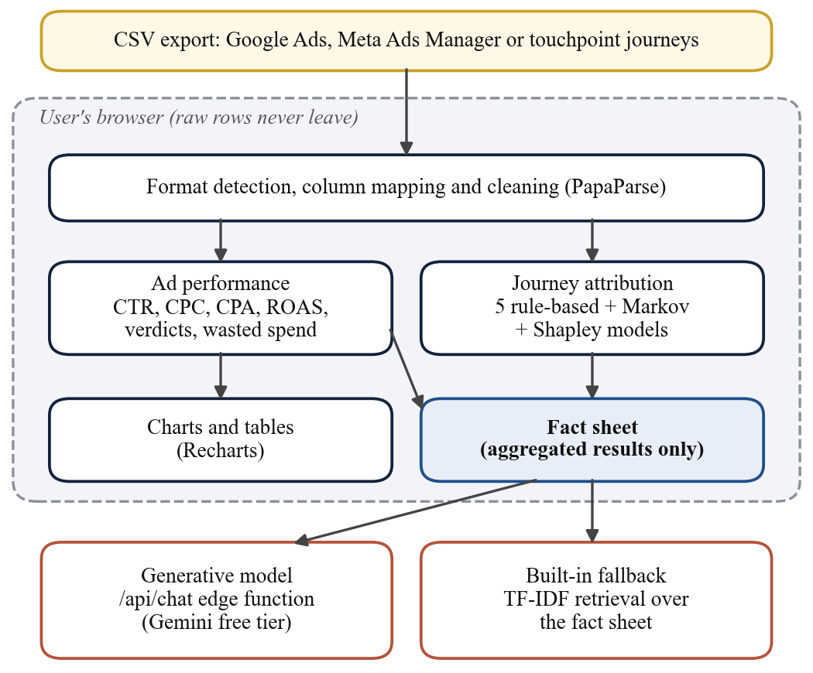
Fig. 1. ChannelTrace architecture. Everything inside the dashed box runs in the user's browser; only the aggregated fact sheet reaches the assistant.
ChannelTrace is a web application written in TypeScript with React and hosted on Vercel at no cost (Fig. 1). Its analysis runs entirely in the user's browser, so uploaded files are never sent to a server. An ad-performance module detects Google Ads, Meta Ads Manager and similar exports, maps their columns, computes click-through rate, cost per click, conversion rate, cost per acquisition (CPA) and return on ad spend, gives each campaign a verdict relative to the account average (scale candidate, on track, expensive, no conversions), measures spend with no return and breaks results down by audience and day. A journey module applies all seven attribution models and shows where last click over- or under-credits each channel. The browser implementation of the models was checked against the Python reference used for the research.
Results are condensed into a fact sheet: short, labelled statements of computed figures, with suggested actions and caveats. The assistant answers questions only from this sheet, a form of retrieval grounding that reduces invented content [43], [44]. When the site has a key configured, an edge function sends the sheet and the question to a free generative model; because free model versions are retired and often overloaded, it tries several in turn within a fixed time budget. Otherwise a built-in model scores fact-sheet statements against the question with TF-IDF weighting [45] and quotes the most relevant ones, so the assistant works offline and can only repeat computed numbers.
VI. Results
A. Last-Click Credit Is Driven by Recency (RQ3)
All 435,810 Criteo conversions followed at least one Criteo click, yet only 54.2% were credited to Criteo by the advertiser's last-click rule; the remainder were claimed by other channels. Converting journeys were short (mean 1.85 clicks; 68% with one click; median 20.3 hours from the last click to purchase; median 3.8 days from first to last click in multi-click journeys). Fig. 2 shows that credit falls steadily with time since the last click (chi-square = 126,214, df = 5, p < 0.001).
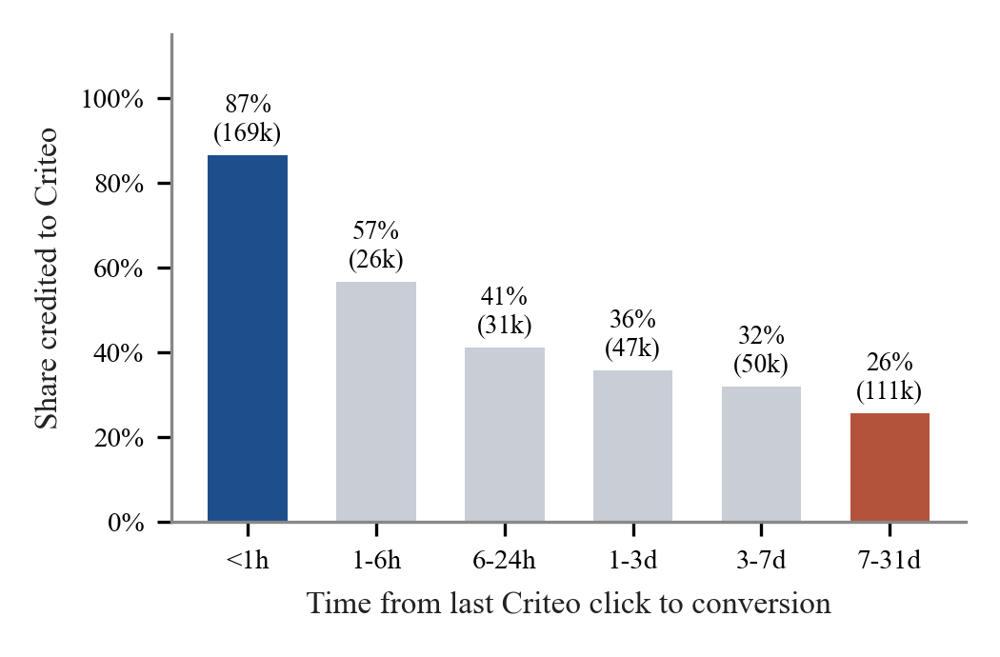
Fig. 2. Share of conversions credited to Criteo under last click, by time from the last Criteo click to the conversion (number of conversions in brackets).
Table IV
Logistic Regression of Last-Click Credit to Criteo (n = 433,745)
Predictor | Odds ratio | 95% CI | p
log(1 + hours since click) | 0.607 | 0.606 to 0.609 | < 0.001
Criteo clicks (capped at 10) | 1.037 | 1.033 to 1.041 | < 0.001

Holding clicks constant, each unit increase in log(1 + hours) multiplies the odds of Criteo receiving credit by 0.61, whereas each additional click multiplies them by only 1.04 (pseudo R-squared 0.22; Table IV). Table V confirms this directly: the credit share hardly moves with the number of clicks.
Table V
Last-Click Credit to Criteo by Number of Criteo Clicks
Clicks in journey | Conversions | Credited to Criteo
1 | 294,992 | 54.2%
2 | 70,816 | 53.3%
3 | 28,813 | 53.7%
4 | 14,292 | 54.6%
5 | 8,154 | 55.3%
6 or more | 18,743 | 57.8%

Under last click, which platform is paid for a sale depends far more on timing than on how much a channel was used. A customer who clicks a display ad and buys an hour later almost always credits it; one who buys a week later, after a search or an email, usually does not.
B. Real Multi-Channel Journeys (RQ1, RQ3)
The Google Analytics 360 sample covers 714,167 visitors and 903,653 sessions. Following each visitor across sessions up to the first purchase gives 10,022 converting journeys (1.4% of all journeys). Buying took repeated visits: 52% of converting journeys spanned more than one session (mean 2.28 sessions, maximum 138, against 1.23 for journeys without a purchase), and multi-session buyers took a median of 4.7 days from first visit to purchase. Yet only 12% of converting journeys involved more than one channel. The most common converting paths were a single Referral session (1,755), a single Organic Search session (1,712) and Referral > Referral (969).
Table VI
Sessions and Converting Sessions by Channel (GA360)
Channel | Sessions | Converting | Rate
Referral | 104,838 | 5,322 | 5.08%
Display | 6,262 | 143 | 2.28%
Paid Search | 25,326 | 469 | 1.85%
Direct | 143,026 | 2,061 | 1.44%
Organic Search | 381,561 | 3,443 | 0.90%
Affiliates | 16,403 | 9 | 0.05%
Social | 226,117 | 104 | 0.05%

Channels differ widely in how often a session ends in a purchase (Table VI). Referral sessions converted at 5.1%, while Social, the second-largest source of traffic with 226,117 sessions, converted at 0.05%. Organic Search brought the most sessions but converted at 0.9%.
Table VII
Credit Share by Channel, All Converting Journeys (GA360)
Channel | First | Last | Linear | Markov | Shapley
Referral | 39.9% | 45.5% | 42.8% | 42.5% | 42.4%
Organic Search | 31.5% | 31.1% | 31.4% | 32.0% | 31.3%
Direct | 22.0% | 17.1% | 19.2% | 18.2% | 19.5%
Paid Search | 4.4% | 4.2% | 4.3% | 4.3% | 4.4%
Display | 1.3% | 1.1% | 1.3% | 1.3% | 1.3%
Social | 0.8% | 1.0% | 0.9% | 1.2% | 0.9%
Affiliates | 0.1% | 0.1% | 0.1% | 0.5% | 0.1%

Because so few journeys mix channels, the seven models broadly agree on the whole sample (Table VII); the largest swing, for Referral, is from 39.9% to 45.5%. The disagreement is concentrated in the 1,189 multi-channel journeys (Fig. 3). There, first touch gives Direct 42% of the credit and last touch 1%, while Referral moves from 13% to 60%; the most common multi-channel paths were Direct > Referral (134) and Organic Search > Referral (94). For these customers the choice of model decides which channel is funded.
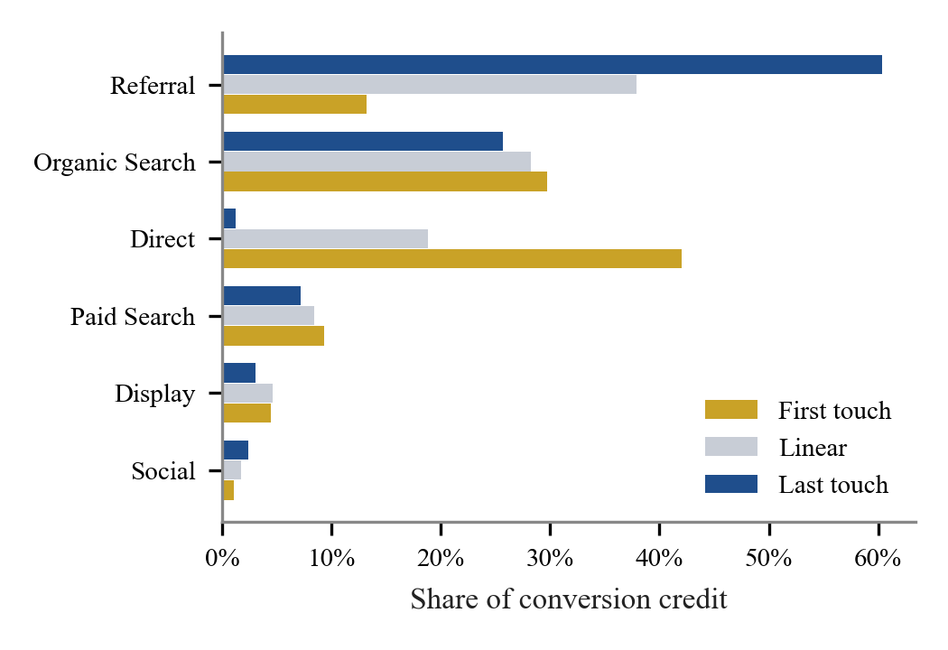
Fig. 3. Credit share by channel within the 1,189 GA360 converting journeys that used more than one channel.
Channels also differ in whether they hand journeys on. The share of converting journeys that ended in a different channel from the one they began with was Display 39%, Paid Search 23%, Direct 23%, Organic Search 10% and Referral 2% (channels starting at least 100 journeys). Journeys that start with Display, Paid Search or Direct are the ones most often closed by another channel, which is exactly where last click moves credit away from the channel that started them; a referral, by contrast, almost never hands on.
Two properties of the data qualify these figures. Google Analytics labels a returning direct visit with the source of the visitor's previous campaign: 40,356 of the 104,838 Referral sessions are flagged in the data as direct visits. Direct can therefore rarely follow another channel, which mechanically lowers its last-touch share. And 97% of converting Referral sessions record no referring site, so Referral's large share cannot be read as the value of third-party sites.
C. No Attribution Model Is Best Everywhere (RQ3)
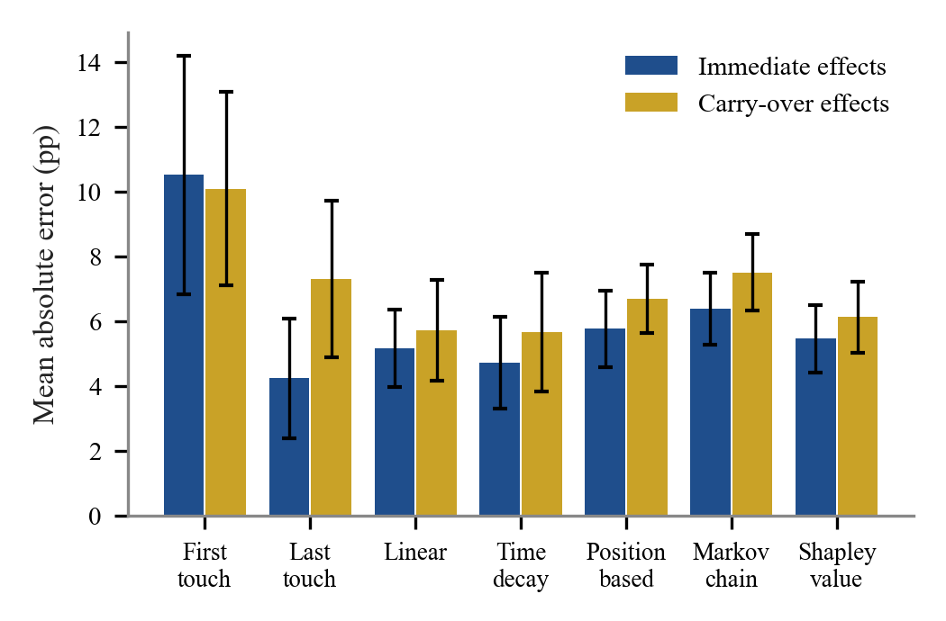
Fig. 4. Mean absolute error between model and true credit shares (percentage points; bars show the standard deviation over six worlds).
Table VIII
Accuracy of Attribution Models Against Known Channel Effects
Model | Immediate MAE | ρ | Carry-over MAE | ρ
First touch | 10.5 | 0.17 | 10.1 | 0.18
Last touch | 4.2 | 0.66 | 7.3 | 0.37
Linear | 5.2 | 0.68 | 5.7 | 0.60
Time decay | 4.7 | 0.66 | 5.7 | 0.50
Position based | 5.8 | 0.67 | 6.7 | 0.56
Markov chain | 6.4 | 0.61 | 7.5 | 0.45
Shapley value | 5.5 | 0.69 | 6.1 | 0.60

When advertising acts immediately, last touch came closest to the truth (4.2 pp), with time decay close behind (4.7 pp). With carry-over effects, last-touch error rose to 7.3 pp and its rank agreement fell from 0.66 to 0.37, while time decay and linear became the most accurate (5.7 and 5.7 pp; Fig. 4, Table VIII). The highest rank agreement came from Shapley value under immediate effects (0.69) and linear under carry-over (0.60), with the Shapley value close behind in both (0.69 and 0.60). First touch was worst in both. The Markov removal effect was never the most accurate under these data-generating processes, a reminder that data-driven does not automatically mean correct.
The pattern has a simple explanation. Under immediate effects the touch that triggers a purchase is usually the last one, so last touch is nearly right. Under carry-over the decisive touches come earlier and the purchase happens on a later visit, possibly through a weak channel, so any rule that concentrates credit at one end of the journey errs, and rules that spread credit do better.
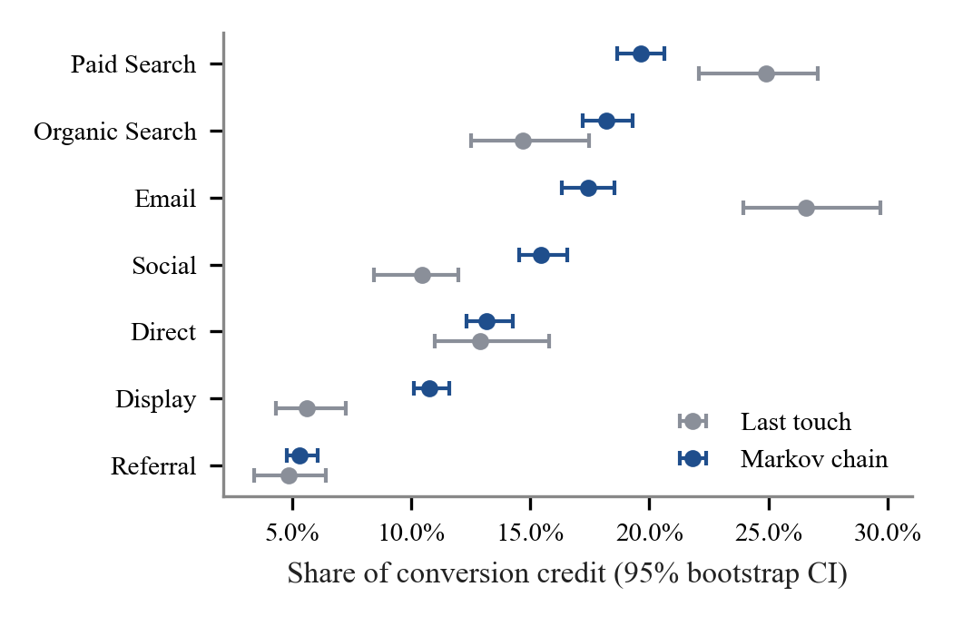
Fig. 5. Last-touch and Markov credit shares with 95% bootstrap intervals on 4,000 synthetic journeys with designed channel roles.
On the separate synthetic dataset in which Social and Display were designed to start journeys and Email and Paid Search to close them, the data-driven models recovered those roles (Fig. 5): last touch gave Display 6% of the credit against 11% under Markov, and Email 27% against 17%. The bootstrap intervals are narrow (about plus or minus one percentage point), so these differences are not sampling noise.
D. Session Behaviour Associated With Purchase (RQ2, RQ4)
The overall conversion rate was 15.6%. New visitors converted at 24.9% against 14.1% for returning visitors, who made up 85% of sessions (chi-square p < 0.001). Conversion peaked in Nov (25.5%) and was lowest in Feb (1.7%; Fig. 6). Weekend sessions converted at 17.5% against 15.1% on weekdays (chi-square p = 0.002), a small but significant difference.
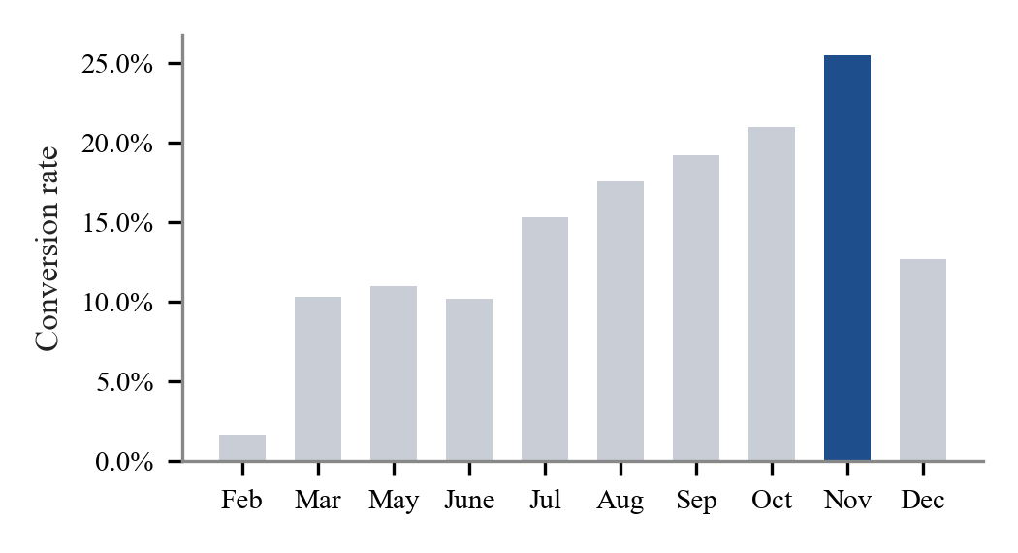
Fig. 6. Conversion rate by month in the UCI Online Shoppers data (January and April are absent).
Table IX
Session Behaviour of Buyers and Non-Buyers (Means; Mann-Whitney U)
Measure | Buyers | Non-buyers | p
Product pages viewed | 48.2 | 29.1 | 3.7e-102
Time on product pages | 31.3 min | 18.0 min | 4.2e-122
Account/admin pages viewed | 3.4 | 2.1 | 8.9e-74
Bounce rate | 0.005 | 0.023 | 1.1e-56
Exit rate | 0.020 | 0.046 | 3.0e-169
Page value | 27.3 | 2.0 | < 1e-300

Table X
Purchase Prediction (ROC-AUC on Held-Out 25%)
Model | With PageValues | Without PageValues
Logistic regression | 0.906 | 0.742
Random forest | 0.932 | 0.775
Gradient boosting | 0.924 | 0.758

All ten behavioural measures differed significantly. Buyers viewed a median of 29 product pages against 16 and bounced and exited far less (Table IX). With PageValues the best model reached ROC-AUC 0.932; without it, 0.775, which is the honest estimate of what early-session behaviour reveals (Table X). The strongest signals without PageValues, by permutation importance (drop in AUC), were time on product pages (0.047); exit rate (0.037); a November visit (0.032); product pages viewed (0.012); account/admin pages viewed (0.010). Time spent on product pages carries more information than the number of pages viewed.
E. Tool Validation on Real Advertising Data (RQ5)
ChannelTrace was run on the real Facebook Ad Campaign data. It recognised the export format automatically and reproduced the campaign totals computed independently in Python to the cent (spend 58,705.23; cost per acquisition 54.41). It found that 10.0% of spend went to ad sets with no approved conversions, that the 30-34 age group had the lowest cost per acquisition (30.88 against 99.76 for ages 45-49), and that men converted more cheaply than women (41.44 against 69.70). The browser implementation of all seven attribution models matched the Python reference exactly on the synthetic journeys.
VII. Discussion
A. Implications for Practitioners
The Criteo results show concretely why platforms disagree about who made a sale. A display network whose clicks precede every one of these conversions is credited for barely half of them, and its share depends mainly on how long the customer waited before buying. A business that reads last-click reports at face value will therefore undervalue channels whose influence is delayed, such as awareness advertising, and overvalue whichever channel happens to be last, consistent with the incentive problems described by Berman [4] and the search spill-overs found by Kireyev et al. [13].
The simulation explains why the remedy is not simply to switch to a single data-driven model. Model accuracy depended on how advertising works: last touch was competitive when effects were immediate but degraded sharply with carry-over, while linear, time decay and the Shapley value were more robust. Since a business rarely knows its true mechanism, comparing several models, and treating channels whose credit swings strongly between them as uncertain, is the safer practice. ChannelTrace is built around that comparison.
The GA360 journeys add a practical nuance. For most of this store's customers the attribution model hardly matters, because they return through the same channel; it matters a great deal for the minority who move between channels, typically arriving directly or through search and buying later through a referral link. A business can check this cheaply: if few of its converting journeys mix channels, last-click reports are roughly adequate; if many do, the models must be compared before budgets are moved.
For marketers the session results suggest three practical actions: re-engage returning visitors, who are most of the traffic but convert least; concentrate budget before the seasonal peak; and send paid traffic directly to product pages, where time spent is the strongest early signal of purchase intent. These are suggestions to test, not proven effects; where budgets allow, a holdout experiment [7], [27] is the way to confirm them.
B. Implications for Research
Attribution models are usually compared by how well they predict conversion. Our simulation shows that a model can rank well on that criterion and still distribute credit wrongly, because prediction and credit are different targets. Known-answer simulations, though stylised, give a direct test of credit and are cheap to extend to new mechanisms, and we encourage their use alongside experimental benchmarks. Public journey data with named channels remains scarce; the GA360 sample is one of the few sources and shows how strongly a platform's own channel definitions shape the result.
C. Threats to Validity
Construct validity. Credit is not causal contribution: every model here, including the data-driven ones, assigns observed conversions and none measures what would have happened without a channel. The simulation's true shares are causal by construction, which is why it is used to judge the models. Internal validity. The Criteo credit flag is the advertiser's own last-click decision and the other channels are not observed, so the recency effect describes how credit was assigned, not why. GA360 journeys depend on a cookie-based visitor identifier and on Google's channel rules, including the relabelling of direct visits. External validity. Each dataset represents one store, network or advertiser, mostly from mature markets; results for Indian small businesses may differ and should be checked on their own data, which the tool allows. Statistical conclusion validity. With hundreds of thousands of observations almost any difference is significant, so we report effect sizes (credit shares, odds ratios, AUC and error in percentage points) alongside p-values.
D. Ethics and Privacy
All datasets are public and anonymised, and no personal data was collected. ChannelTrace processes uploaded files in the browser and sends only the aggregated fact sheet, never raw rows, to the generative model. The assistant is instructed to label recommendations as suggestions and to state that the data shows associations, not proof of cause, so that users are not led to over-trust its advice.
VIII. Limitations and Future Work
All findings are associations. The Criteo sample covers one channel and retains only clicked impressions for converting users, so view-through effects cannot be studied. The UCI traffic sources are anonymised. The simulation uses two stylised mechanisms and six worlds each; other mechanisms, such as diminishing returns or interactions between channels, may favour other models. The GA360 sample is one store, uses Google Analytics' own channel definitions and splits journeys across devices. The accuracy of the assistant has not yet been measured.
Future work has five parts: an accuracy test of the assistant on a fixed question set with known answers; a usability study of the tool with small-business users using the System Usability Scale [46]; a business-intelligence dashboard (Power BI or Looker Studio) on the same data; simulations with further mechanisms and comparison with the neural models of Section II-D [23], [25]; and, with a partner business, a holdout experiment to compare attribution credit with measured incremental lift.
IX. Conclusion
Using public data at scale and a simulation with known answers, we found that last-click credit is governed mainly by recency, that attribution models disagree mainly on the customers who move between channels, and that the most accurate attribution model depends on how advertising works. Businesses should therefore compare attribution models rather than trust any single report. ChannelTrace makes that comparison free and accessible, and its grounded assistant explains the results in plain language from computed figures only.
Acknowledgment
This work was carried out for the MDM Digital Marketing Capstone (BCE27MD06) at Pimpri Chinchwad College of Engineering, Pune, under the guidance of Mrs. Minal Shahakar.
References
[1] D. Court, D. Elzinga, S. Mulder, and O. J. Vetvik, "The consumer decision journey," McKinsey Quarterly, no. 3, pp. 96-107, 2009.
[2] K. N. Lemon and P. C. Verhoef, "Understanding customer experience throughout the customer journey," Journal of Marketing, vol. 80, no. 6, pp. 69-96, 2016.
[3] P. K. Kannan and H. Li, "Digital marketing: A framework, review and research agenda," International Journal of Research in Marketing, vol. 34, no. 1, pp. 22-45, 2017.
[4] R. Berman, "Beyond the last touch: Attribution in online advertising," Marketing Science, vol. 37, no. 5, pp. 771-792, 2018.
[5] Google, "About attribution models," Google Ads Help. [Online]. Available: https://support.google.com/google-ads/answer/6259715
[6] R. A. Lewis and J. M. Rao, "The unfavorable economics of measuring the returns to advertising," The Quarterly Journal of Economics, vol. 130, no. 4, pp. 1941-1973, 2015.
[7] B. R. Gordon, F. Zettelmeyer, N. Bhargava, and D. Chapsky, "A comparison of approaches to advertising measurement: Evidence from big field experiments at Facebook," Marketing Science, vol. 38, no. 2, pp. 193-225, 2019.
[8] H. Li and P. K. Kannan, "Attributing conversions in a multichannel online marketing environment: An empirical model and a field experiment," Journal of Marketing Research, vol. 51, no. 1, pp. 40-56, 2014.
[9] X. Shao and L. Li, "Data-driven multi-touch attribution models," in Proc. 17th ACM SIGKDD Int. Conf. Knowledge Discovery and Data Mining, 2011, pp. 258-264.
[10] E. Anderl, I. Becker, F. von Wangenheim, and J. H. Schumann, "Mapping the customer journey: Lessons learned from graph-based online attribution modeling," International Journal of Research in Marketing, vol. 33, no. 3, pp. 457-474, 2016.
[11] E. Diemert, J. Meynet, P. Galland, and D. Lefortier, "Attribution modeling increases efficiency of bidding in display advertising," in Proc. AdKDD and TargetAd Workshop, KDD, 2017.
[12] T. Wiesel, K. Pauwels, and J. Arts, "Marketing's profit impact: Quantifying online and off-line funnel progression," Marketing Science, vol. 30, no. 4, pp. 604-611, 2011.
[13] P. Kireyev, K. Pauwels, and S. Gupta, "Do display ads influence search? Attribution and dynamics in online advertising," International Journal of Research in Marketing, vol. 33, no. 3, pp. 475-490, 2016.
[14] E. de Haan, T. Wiesel, and K. Pauwels, "The effectiveness of different forms of online advertising for purchase conversion in a multiple-channel attribution framework," International Journal of Research in Marketing, vol. 33, no. 3, pp. 491-507, 2016.
[15] L. Xu, J. A. Duan, and A. Whinston, "Path to purchase: A mutually exciting point process model for online advertising and conversion," Management Science, vol. 60, no. 6, pp. 1392-1412, 2014.
[16] W. Ji and X. Wang, "Additional multi-touch attribution for online advertising," in Proc. 31st AAAI Conf. Artificial Intelligence, 2017, pp. 1360-1366.
[17] L. S. Shapley, "A value for n-person games," in Contributions to the Theory of Games II, H. W. Kuhn and A. W. Tucker, Eds. Princeton, NJ, USA: Princeton Univ. Press, 1953, pp. 307-317.
[18] B. Dalessandro, C. Perlich, O. Stitelman, and F. Provost, "Causally motivated attribution for online advertising," in Proc. Sixth Int. Workshop on Data Mining for Online Advertising (ADKDD), 2012.
[19] K. Zhao, S. H. Mahboobi, and S. R. Bagheri, "Shapley value methods for attribution modeling in online advertising," arXiv:1804.05327, 2018.
[20] R. Singal, O. Besbes, A. Désir, V. Goyal, and G. Iyengar, "Shapley meets uniform: An axiomatic framework for attribution in online advertising," Management Science, vol. 68, no. 10, pp. 7457-7479, 2022.
[21] S. M. Lundberg and S.-I. Lee, "A unified approach to interpreting model predictions," in Advances in Neural Information Processing Systems 30, 2017, pp. 4765-4774.
[22] N. Li, S. K. Arava, C. Dong, Z. Yan, and A. Pani, "Deep neural net with attention for multi-channel multi-touch attribution," arXiv:1809.02230, 2018.
[23] K. Ren, Y. Fang, W. Zhang, S. Liu, J. Li, Y. Zhang, Y. Yu, and J. Wang, "Learning multi-touch conversion attribution with dual-attention mechanisms for online advertising," in Proc. 27th ACM Int. Conf. Information and Knowledge Management (CIKM), 2018, pp. 1433-1442.
[24] R. Du, Y. Zhong, H. S. Nair, B. Cui, and R. Shou, "Causally driven incremental multi touch attribution using a recurrent neural network," arXiv:1902.00215, 2019.
[25] S. Kumar, G. Gupta, R. Prasad, A. Chatterjee, L. Vig, and G. Shroff, "CAMTA: Causal attention model for multi-touch attribution," in Proc. IEEE Int. Conf. Data Mining Workshops (ICDMW), 2020, pp. 79-86.
[26] T. Blake, C. Nosko, and S. Tadelis, "Consumer heterogeneity and paid search effectiveness: A large-scale field experiment," Econometrica, vol. 83, no. 1, pp. 155-174, 2015.
[27] G. A. Johnson, R. A. Lewis, and E. I. Nubbemeyer, "Ghost ads: Improving the economics of measuring online ad effectiveness," Journal of Marketing Research, vol. 54, no. 6, pp. 867-884, 2017.
[28] W. W. Moe and P. S. Fader, "Dynamic conversion behavior at e-commerce sites," Management Science, vol. 50, no. 3, pp. 326-335, 2004.
[29] A. L. Montgomery, S. Li, K. Srinivasan, and J. C. Liechty, "Modeling online browsing and path analysis using clickstream data," Marketing Science, vol. 23, no. 4, pp. 579-595, 2004.
[30] R. E. Bucklin and C. Sismeiro, "Click here for Internet insight: Advances in clickstream data analysis in marketing," Journal of Interactive Marketing, vol. 23, no. 1, pp. 35-48, 2009.
[31] C. O. Sakar, S. O. Polat, M. Katircioglu, and Y. Kastro, "Real-time prediction of online shoppers' purchasing intention using multilayer perceptron and LSTM recurrent neural networks," Neural Computing and Applications, vol. 31, pp. 6893-6908, 2019.
[32] Google, "BigQuery sample dataset for Google Analytics 360," Google Analytics Help. [Online]. Available: https://support.google.com/analytics/answer/7586738
[33] Kaggle, "Sales conversion optimization (Facebook ad campaign data)," Kaggle Datasets. [Online]. Available: https://www.kaggle.com/datasets/loveall/clicks-conversion-tracking
[34] J. R. Norris, Markov Chains. Cambridge, U.K.: Cambridge Univ. Press, 1997.
[35] C. Spearman, "The proof and measurement of association between two things," American Journal of Psychology, vol. 15, no. 1, pp. 72-101, 1904.
[36] B. Efron and R. J. Tibshirani, An Introduction to the Bootstrap. New York, NY, USA: Chapman & Hall, 1993.
[37] K. Pearson, "On the criterion that a given system of deviations from the probable in the case of a correlated system of variables is such that it can be reasonably supposed to have arisen from random sampling," Philosophical Magazine, ser. 5, vol. 50, no. 302, pp. 157-175, 1900.
[38] H. B. Mann and D. R. Whitney, "On a test of whether one of two random variables is stochastically larger than the other," Annals of Mathematical Statistics, vol. 18, no. 1, pp. 50-60, 1947.
[39] L. Breiman, "Random forests," Machine Learning, vol. 45, no. 1, pp. 5-32, 2001.
[40] J. H. Friedman, "Greedy function approximation: A gradient boosting machine," Annals of Statistics, vol. 29, no. 5, pp. 1189-1232, 2001.
[41] F. Pedregosa et al., "Scikit-learn: Machine learning in Python," Journal of Machine Learning Research, vol. 12, pp. 2825-2830, 2011.
[42] T. Fawcett, "An introduction to ROC analysis," Pattern Recognition Letters, vol. 27, no. 8, pp. 861-874, 2006.
[43] P. Lewis et al., "Retrieval-augmented generation for knowledge-intensive NLP tasks," in Advances in Neural Information Processing Systems 33, 2020, pp. 9459-9474.
[44] Z. Ji et al., "Survey of hallucination in natural language generation," ACM Computing Surveys, vol. 55, no. 12, pp. 1-38, 2023.
[45] G. Salton and C. Buckley, "Term-weighting approaches in automatic text retrieval," Information Processing & Management, vol. 24, no. 5, pp. 513-523, 1988.
[46] J. Brooke, "SUS: A quick and dirty usability scale," in Usability Evaluation in Industry. London, U.K.: Taylor & Francis, 1996, pp. 189-194.

