Setup and Deployment steps of Coding assistant using Azure App Services

1.First create a virtual environment and start your app folder there.

2.Finish installing the requirements.txt which contains all the required packages for the app

3.Go to Azure Portal and create a resource. There create a web app under the App services.

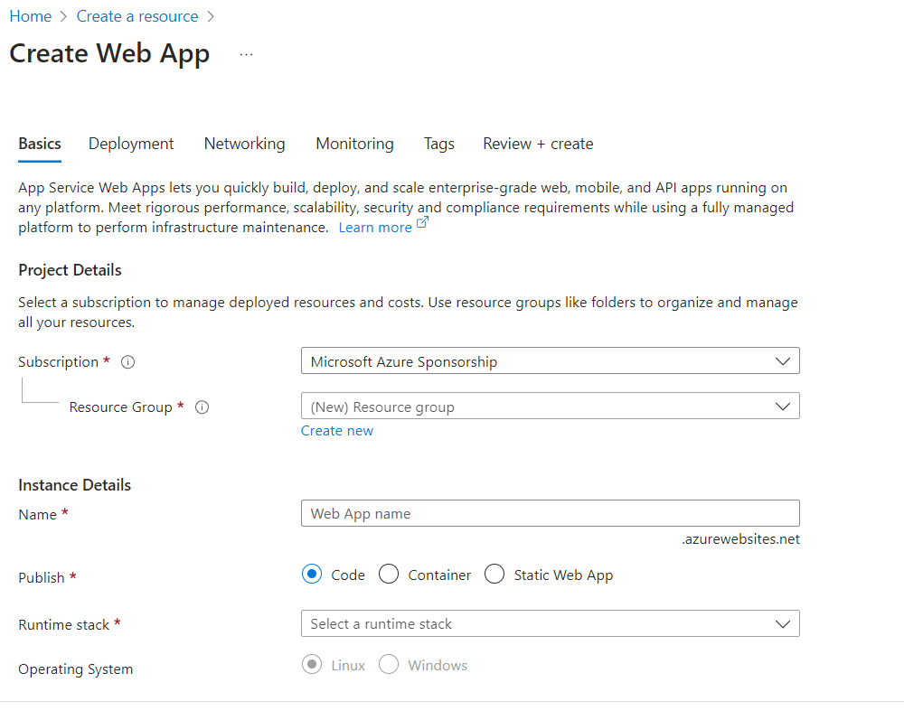   
4.Set all your environment variables under the app settings.  
5.Configure your App settings under Configuration.

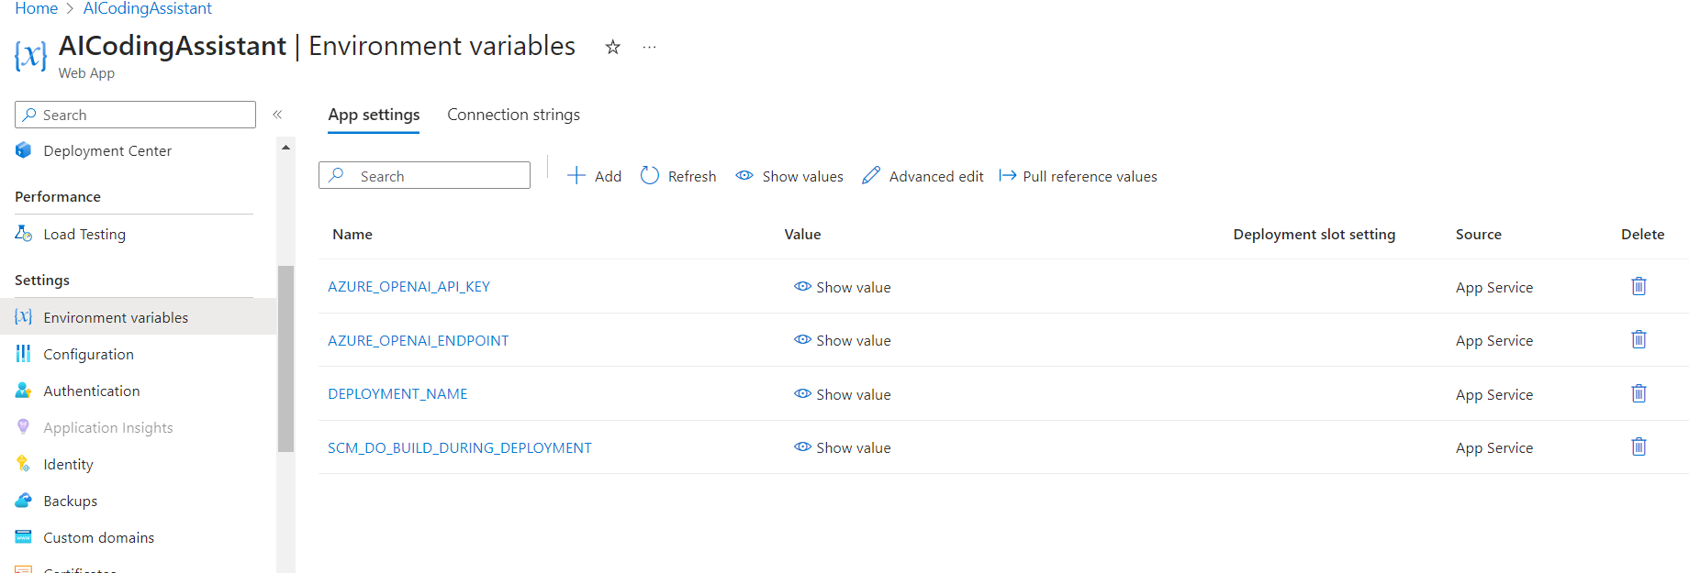

6.Then go to deployment center and connect your github account and the corresponding repository of the application.

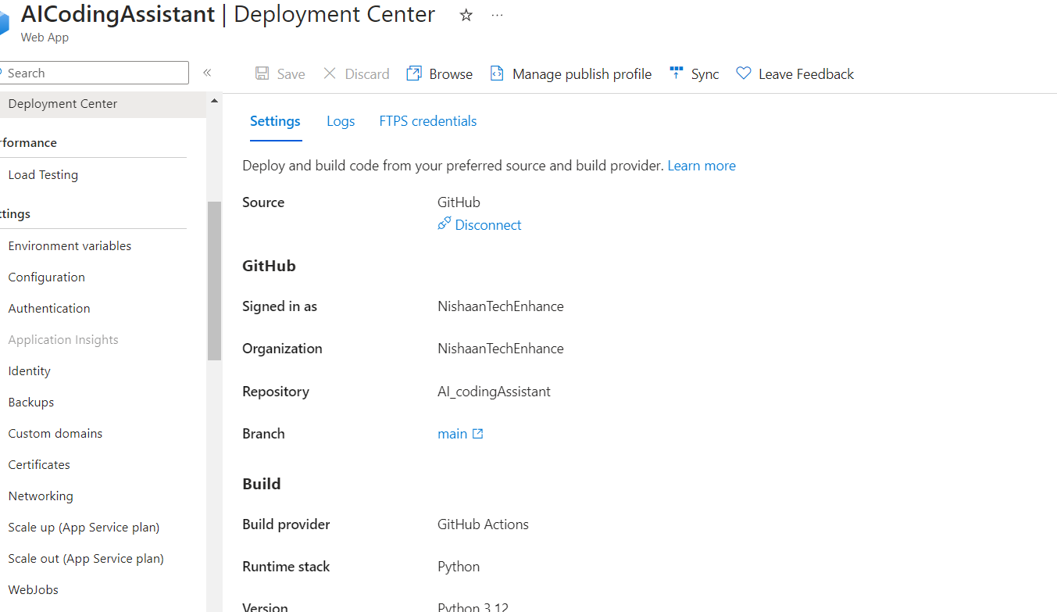

7.Next the deployment takes place through GitHub actions where a workflow is created.

8.Go to GitHub to check the deployment. Here the application is first built and then deployed. To check for any errors, access the application logs to debug them.

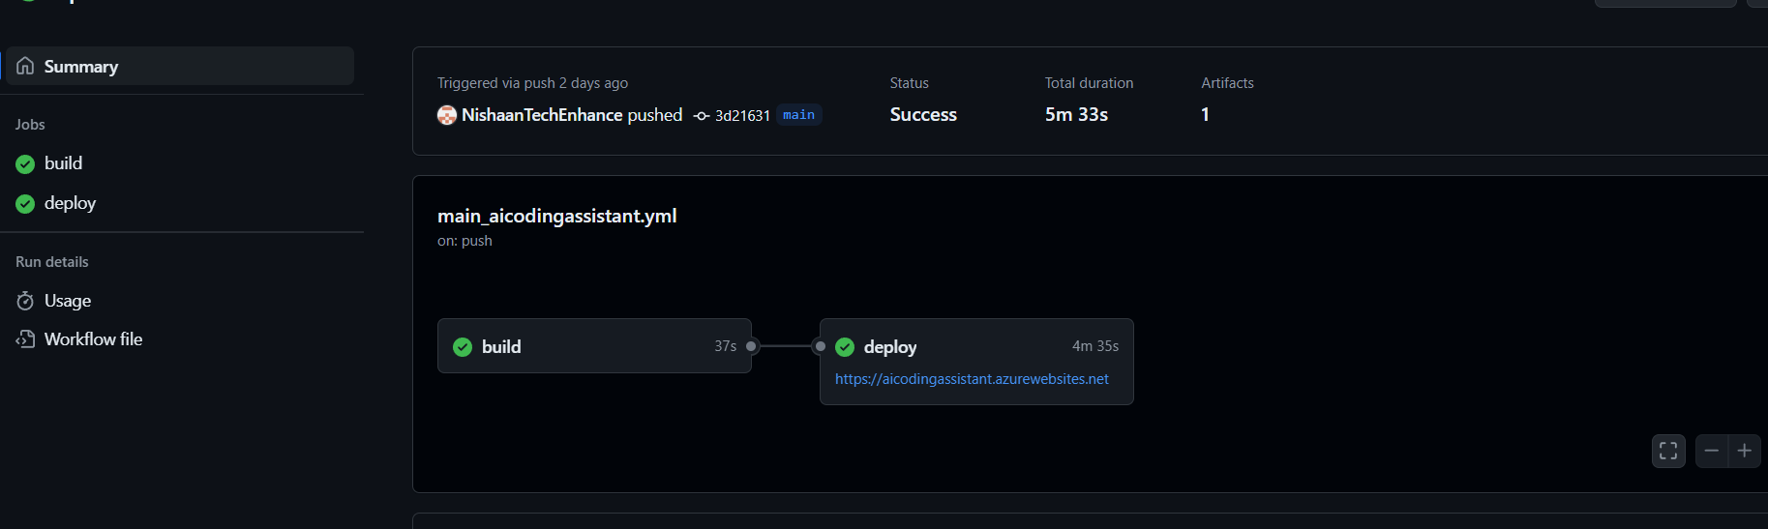

9.Finally, you can access your application through the URL provided.