Unsupervised Topic Discovery and User Behavior Clustering
in Online Mental Health Communities

Final Project Report
DS5230- Unsupervised Machine Learning · Spring 2026

Dataset | Combined Mental Health Dataset (Kaggle)
Records Analyzed | 52,484 posts (after cleaning)
Techniques Applied | LDA, K-Means, Agglomerative, DBSCAN, PCA, Factor Analysis, Apriori
Notebook | 01_data_exploration.ipynb
Environment | conda env: pyass | Python 3.10 | WSL Ubuntu
All Random Seeds | 42 throughout

I. Introduction

1.1 What Was Done
This project applies a comprehensive suite of unsupervised machine learning techniques to text data collected from online mental health communities. Using a dataset of 52,484 cleaned social media statements drawn from Reddit, Twitter, and other platforms, the project discovers latent themes, clusters posts by linguistic behavior, reduces dimensionality to reveal underlying psychological axes, and identifies co-occurring keywords — all without using the available ground-truth labels during any stage of modeling.
The complete analytical pipeline is implemented in a single Jupyter notebook (01_data_exploration.ipynb) and covers:
- Text preprocessing using spaCy and NLTK: lowercasing, URL removal, punctuation stripping, tokenization, stopword removal, and lemmatization
- Feature engineering: TF-IDF matrix (5,000 features) and LSA dimensionality reduction (100 components via TruncatedSVD)
- Topic modeling: Latent Dirichlet Allocation (LDA) with coherence-based hyperparameter optimization
- Clustering: MiniBatchKMeans, Agglomerative (Hierarchical), and DBSCAN
- Dimensionality reduction and interpretation: PCA (10 components) and Factor Analysis (5 factors)
- Association Rule Mining: Apriori algorithm on keyword presence baskets (29 keywords, 33,398 posts)

1.2 Why It Was Done
Mental health conversations online are unstructured, high-dimensional, and growing in volume. Traditional supervised approaches to analyzing this data require labeled training examples, which are both scarce and subjective in this domain, as what constitutes "depression" versus "stress" in a social media post is not always clinically clear. Unsupervised learning provides a complementary framework: instead of imposing predefined categories, it asks what structure the data itself chooses to reveal.
Understanding how people discuss mental health online carries real-world significance. It can help researchers identify emerging themes and patterns, equip community moderators with tools to detect crisis language, and give clinicians a better understanding of how patients describe their experiences outside formal settings. This project demonstrates that multiple unsupervised techniques, applied in combination and cross-validated against each other, can extract clinically meaningful and interpretable insights from raw social media text without any supervision.

II. Background
Research into online mental health discourse has expanded substantially over the past decade, driven by the emergence of dedicated Reddit communities such as r/depression, r/Anxiety, r/SuicideWatch, and r/mentalhealth. These platforms provide large volumes of candid, self-disclosed text that captures aspects of lived mental health experience that clinical settings rarely record.
Most prior work in this space adopts a supervised classification approach — training models to identify posts belonging to specific mental health categories using labeled training data. While effective within their training distributions, these systems are limited to the categories they were trained on and cannot surface unexpected patterns. Unsupervised approaches, by contrast, can reveal structure that was not anticipated in advance.
Latent Dirichlet Allocation has been applied to social media text across a range of domains, but its application to mental health-specific corpora remains relatively underexplored. Clustering with TF-IDF and embedding-based feature representations has shown promise for grouping semantically similar posts, particularly when combined with dimensionality reduction. Principal Component Analysis and Factor Analysis have extensive precedent in psychological measurement research for identifying latent dimensions of personality and emotional experience, but their application directly to social media text for psychological insight is a newer direction.
Association Rule Mining was originally developed for retail market basket analysis (Agrawal et al., 1993) and has since been applied to clinical symptom co-occurrence analysis. Its application to social media mental health keyword co-occurrence represents a direct methodological extension.
Dataset. This project uses the Combined Mental Health Dataset from Kaggle, which aggregates posts from multiple sources including Reddit mental health subreddits, Twitter accounts, and chatbot conversation logs. Each post is tagged with one of seven mental health status labels: Normal, Depression, Suicidal, Anxiety, Stress, Bipolar, and Personality Disorder. These labels are drawn from source community membership rather than clinical diagnosis. They were withheld during all modeling steps and used exclusively for post-hoc validation.

III. Methods and Analysis

3.1 Dataset Demographics
The dataset consists of anonymized social media posts and does not include traditional demographic variables such as age, gender, race, or geographic location. The only available demographic proxy is the mental health status label assigned to each post based on its source community. The full distribution after preprocessing is shown in Table 1.

Mental Health Status | Post Count | Percentage
Normal | 16,351 | 31.1%
Depression | 15,404 | 29.3%
Suicidal | 10,653 | 20.3%
Anxiety | 3,888 | 7.4%
Bipolar | 2,877 | 5.5%
Stress | 2,669 | 5.1%
Personality Disorder | 1,201 | 2.3%
Total (after cleaning) | 52,484 | 100%
Table 1: Dataset label distribution after preprocessing. Labels reflect source community, not clinical diagnosis.
An important data quality finding — discovered during PCA — is that a subset of posts contain non-English text (Spanish, French, German, Portuguese). These were not filtered during preprocessing and are discussed in Section VI (Limitations).

3.2 Data Formatting
The raw dataset was obtained from Kaggle as a single CSV file (Combined Data.csv) containing three columns: an unnamed integer index column, a statement column containing raw post text, and a status column containing the mental health label. The file was loaded using pandas:
df = pd.read_csv("/home/guts/mental_health_nlp/data/Combined Data.csv")
Initial inspection showed 53,043 rows and 3 columns. The unnamed index column was dropped immediately as it carried no analytical value. The resulting working dataframe had two columns: statement and status.
Missing value audit: 362 rows had null values in the statement column (0.68% of the dataset); zero rows had null values in the status column. These 362 rows were dropped and the index was reset. The cleaned dataframe was saved to data/cleaned_raw.csv.

3.3 Text Cleaning Pipeline
A preprocessing function clean_text() was implemented using Python with spaCy (en_core_web_sm model) and NLTK. The pipeline was applied to every post in the following order:

Step | Operation | Implementation | Purpose
1 | Lowercase | text.lower() | Ensures consistent token matching
2 | Remove URLs | re.sub(r'http\S+|www\S+', '', text) | Removes hyperlinks that carry no semantic meaning
3 | Strip Punctuation & Digits | re.sub(r'[^a-z\s]', '', text) | Removes noise characters
4 | Whitespace Normalization | text.strip() | Removes leading/trailing spaces
5 | Lemmatization + Stopword Removal | spaCy nlp(), token.lemma_ | Reduces words to root form; removes function words
6 | Token Length Filter | len(token.text) > 2 | Removes single and two-character tokens
Table 2: Text cleaning pipeline steps, implementation, and purpose.

Example transformation:
BEFORE: "trouble sleeping, confused mind, restless heart. All out of tune"
AFTER: "trouble sleep confused mind restless heart tune"

The full pass over 52,681 rows completed in approximately 16 minutes (55.9 it/s using tqdm). After cleaning, 197 posts contained empty strings (all meaningful tokens were stopwords or too short) and were dropped, yielding the final working dataset of 52,484 posts saved to data/preprocessed.csv.

3.4 Feature Engineering
TF-IDF Matrix
A TfidfVectorizer with max_features=5,000 was fit on the cleaned statement column, producing a sparse matrix of shape (52,484 × 5,000). Each row represents one post; each column represents one of the 5,000 most discriminative terms across the corpus; values are TF-IDF weights that balance term frequency against document frequency.
tfidf = TfidfVectorizer(max_features=5000) X = tfidf.fit_transform(df['cleaned']) # shape: (52484, 5000)
LSA (Latent Semantic Analysis)
TruncatedSVD with n_components=100 and random_state=42 was applied to the TF-IDF matrix, followed by L2 normalization (Normalizer), implemented as a scikit-learn Pipeline. This reduced the feature space from 5,000 to 100 dimensions while preserving latent semantic co-occurrence structure between terms. The LSA matrix of shape (52,484 × 100) was used as input to all clustering algorithms.
svd = TruncatedSVD(n_components=100, random_state=42) lsa = make_pipeline(svd, Normalizer()) # shape: (52484, 100)
LDA Dictionary and Corpus
For topic modeling, the cleaned text was tokenized by whitespace splitting. A gensim Dictionary was built, then filtered with no_below=10 (minimum 10 document appearances) and no_above=0.4 (maximum 40% of documents) to remove very rare and very common terms, yielding a vocabulary of 7,697 unique words. Each post was encoded as a bag-of-words vector using doc2bow.
dictionary = corpora.Dictionary(tokenized) dictionary.filter_extremes(no_below=10, no_above=0.4) corpus = [dictionary.doc2bow(doc) for doc in tokenized]

3.5 Algorithms Used
LDA Topic Modeling
gensim's LdaModel was trained with passes=10, alpha='auto', per_word_topics=True, and random_state=42. Coherence scores (c_v metric, evaluated via gensim's CoherenceModel) were computed for num_topics ranging from 2 to 11 to determine the optimal topic count. The model was retrained at the optimal value of 3 topics.
K-Means Clustering
scikit-learn's MiniBatchKMeans (batch_size=1,000, random_state=42) was applied to the LSA feature matrix. Both inertia and silhouette score (sample_size=5,000, random_state=42) were computed for k=2 through k=10. The final model was trained at k=2.
Agglomerative (Hierarchical) Clustering
scipy's linkage function (method='ward') was applied to a 500-post random sample (numpy RandomState(42)) to generate a dendrogram visualization. scikit-learn's AgglomerativeClustering (n_clusters=2) was applied to a separate 2,000-post sample for quantitative comparison with K-Means. The full 52,484-post dataset could not be processed due to memory constraints (see Section VI).
DBSCAN
scikit-learn's DBSCAN with metric='cosine', min_samples=5, and n_jobs=-1 was applied to the full LSA matrix. The eps parameter was tuned across [0.3, 0.4, 0.5, 0.6, 0.7] to identify the most informative setting.
PCA
scikit-learn's PCA with n_components=10 and random_state=42 was applied to the LSA matrix for variance decomposition and component interpretation. A separate 2-component PCA was computed for 2D cluster visualization. Component loadings were extracted from the SVD step of the LSA pipeline (lsa.named_steps['truncatedsvd'].components_) to identify the TF-IDF features driving each principal component.
Factor Analysis
scikit-learn's FactorAnalysis with n_components=5, random_state=42, and max_iter=1,000 was applied to a dense TF-IDF matrix built from the top 500 vocabulary features (TfidfVectorizer(max_features=500)). Raw TF-IDF was used rather than LSA-transformed features because LSA application produced uninformative alphabetically-ordered factor loadings.
Association Rule Mining
mlxtend's apriori and association_rules functions were used. Twenty-nine mental health keywords were defined; each post was converted to a keyword presence basket. Posts with zero keyword matches (19,086 posts) were excluded, leaving 33,398 posts. Frequent itemsets were mined at min_support=0.01 (1%). Rules were generated with metric='lift' and min_threshold=1.2.

3.6 Reproducibility Instructions
To exactly replicate all results in this report, follow these steps in order:
Step | Instruction
1 | OS: Ubuntu (WSL2 on Windows). Python 3.10 via Miniconda. Conda environment name: pyass.
2 | pip install pandas scikit-learn gensim nltk spacy pyLDAvis wordcloud mlxtend ipykernel seaborn matplotlib
3 | python -m spacy download en_core_web_sm
4 | Download "Combined Mental Health Dataset" from Kaggle. Place the CSV at: data/Combined Data.csv
5 | Open notebooks/01_data_exploration.ipynb. Select the pyass kernel. Execute all cells in order starting from Cell 0.
6 | All random_state and RandomState seeds are set to 42. Results are deterministic given the same library versions.
7 | Key library versions verified: scikit-learn 1.7.2, pandas 2.3.3. Other versions per pip list output in the project README.
Table 3: Step-by-step reproducibility instructions.
All intermediate data files are saved automatically during notebook execution: data/cleaned_raw.csv, data/preprocessed.csv, data/association_rules.csv.
IV. Results

4.1 LDA Topic Modeling
Coherence scores (c_v metric) were evaluated for topic counts ranging from 2 to 11. Table 4 shows the complete results.

Number of Topics | Coherence Score (c_v)
2 | 0.3806
3 | 0.3822 ← optimal
4 | 0.3780
5 | 0.3462
6 | 0.3753
7 | 0.3695
8 | 0.3638
9 | 0.3519
10 | 0.3542
11 | 0.3574
Table 4: LDA coherence scores for topic counts 2 through 11. Three topics selected as optimal (highlighted).
Coherence scores were notably flat across all values tested (range: 0.346–0.382), with a spread of only 0.036 between best and worst. This flatness indicates that the dataset does not contain sharply distinct topical boundaries — a characteristic consistent with mental health text, where different conditions share substantial vocabulary. Three topics were selected as the optimum.
The final LDA model (3 topics, passes=10, alpha='auto', random_state=42) produced the following topic-word distributions:
Topic | Top 12 Words (probability weight) | Interpretation
0 | anxiety(0.028), feel(0.018), get(0.017), take(0.014), day(0.011), like(0.011), start(0.010), go(0.010), bad(0.008), experience(0.008), sleep(0.008), stress(0.008) | Physical & Daily Symptoms
1 | feel(0.031), like(0.029), want(0.021), know(0.018), life(0.016), people(0.015), think(0.014), even(0.014), get(0.014), make(0.014), thing(0.012), really(0.009) | Emotional & Inner Thoughts
2 | get(0.017), work(0.015), say(0.013), help(0.011), time(0.010), need(0.010), year(0.009), tell(0.009), job(0.009), ask(0.008), go(0.008), would(0.008) | External Life & Seeking Help
Table 5: LDA topic-word distributions with probability weights and human-assigned interpretations.

Topic distribution across the 52,484 posts: Topic 1 (Emotional & Inner Thoughts) dominated at 32,134 posts (61.2%), Topic 2 (External Life & Seeking Help) at 12,867 posts (24.5%), and Topic 0 (Physical & Daily Symptoms) at 7,483 posts (14.3%). Figure 1 shows the word clouds for each topic.

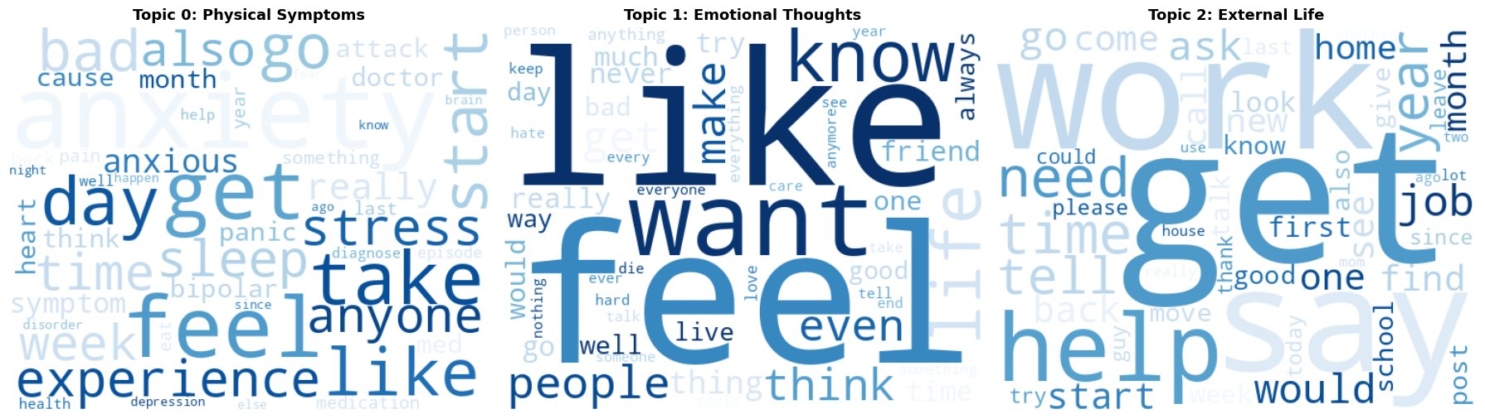
Figure 1: LDA topic word clouds. Left (Topic 0): Physical & Daily Symptoms — anxiety, stress, sleep, panic dominate. Center (Topic 1): Emotional & Inner Thoughts — feel, like, want, die, people dominate. Right (Topic 2): External Life & Seeking Help — work, help, job, need, year dominate.

4.2 K-Means Clustering
MiniBatchKMeans was evaluated across k=2 through k=10 on the 100-dimensional LSA feature matrix. Table 6 shows the complete inertia and silhouette score results.

k | Inertia | Silhouette Score
2 | 43,714 | 0.0357 ← optimal
3 | 43,123 | 0.0105
4 | 42,659 | 0.0180
5 | 42,099 | 0.0177
6 | 41,640 | 0.0195
7 | 41,385 | 0.0179
8 | 41,035 | 0.0200
9 | 40,829 | 0.0189
10 | 40,552 | 0.0224
Table 6: K-Means inertia and silhouette scores for k=2 through k=10. k=2 selected (highlighted) as optimal by silhouette score.

Silhouette scores are low in absolute terms across all values of k. This is an expected property of high-dimensional text data rather than a model failure — mental health language overlaps heavily across conditions, making clusters geometrically non-compact. The relative superiority of k=2, with a score nearly double the next-best value, is the meaningful signal. Figure 2 shows the evaluation curves.

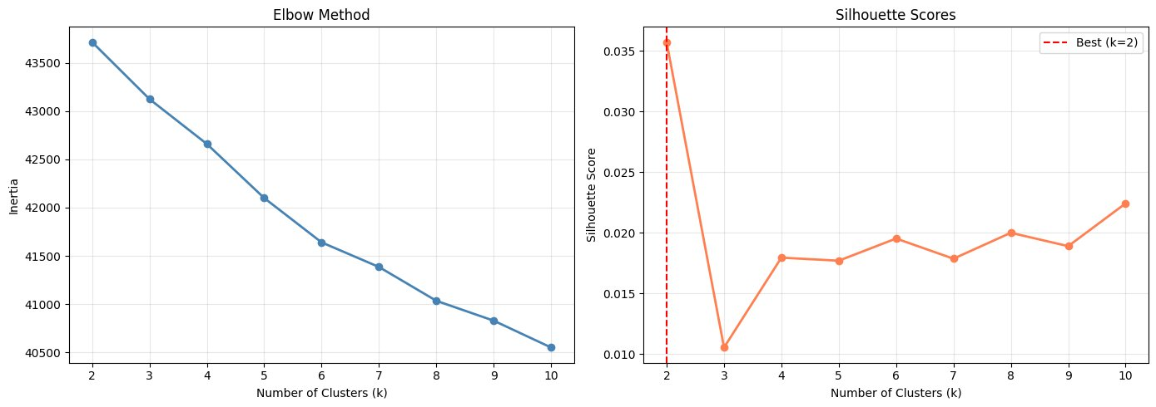
Figure 2: K-Means evaluation. Left: Elbow method — inertia decreases steadily with no sharp elbow. Right: Silhouette scores — k=2 peaks clearly at 0.0357, the dashed red line indicates the selected value.

The final K-Means model (k=2, batch_size=1,000, random_state=42) produced the cluster assignments shown in Table 7. Cross-tabulation against the withheld ground truth labels reveals a meaningful split.

Cluster | Anxiety | Bipolar | Depression | Normal | PD | Stress | Suicidal
0 — Functional (25,435) | 1,288 | 554 | 3,915 | 14,941 | 194 | 836 | 3,707
1 — Distressed (27,049) | 2,553 | 2,223 | 11,488 | 1,210 | 883 | 1,751 | 6,941
Table 7: K-Means cluster cross-tabulation against ground truth labels. Bold values indicate the dominant label in each cluster. PD = Personality Disorder.

Without access to any labels, the algorithm separated posts into a cluster dominated by Normal language (Cluster 0: 14,941 Normal posts) and a cluster dominated by Depression and Suicidal language (Cluster 1: 11,488 Depression + 6,941 Suicidal). This functional versus distressed split is the central recurring finding of the entire analysis. Figure 3 visualizes the clusters in 2D PCA space.

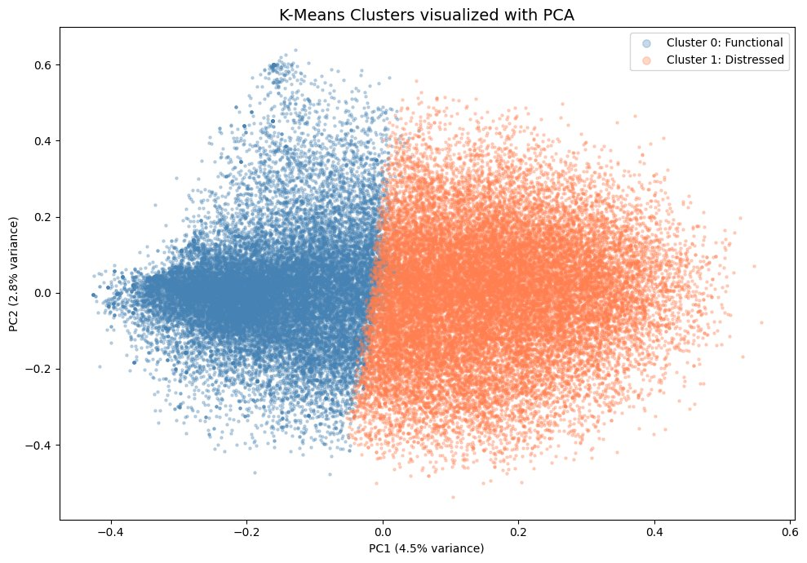
Figure 3: K-Means cluster assignments projected into 2D PCA space. Blue points = Cluster 0 (Functional); Coral points = Cluster 1 (Distressed). Separation is visible along the PC1 axis with natural overlap in the center reflecting the continuous nature of mental health language.

4.3 Hierarchical (Agglomerative) Clustering
A dendrogram was generated from a 500-post random sample (RandomState(42)) using Ward linkage. Figure 4 shows the result.

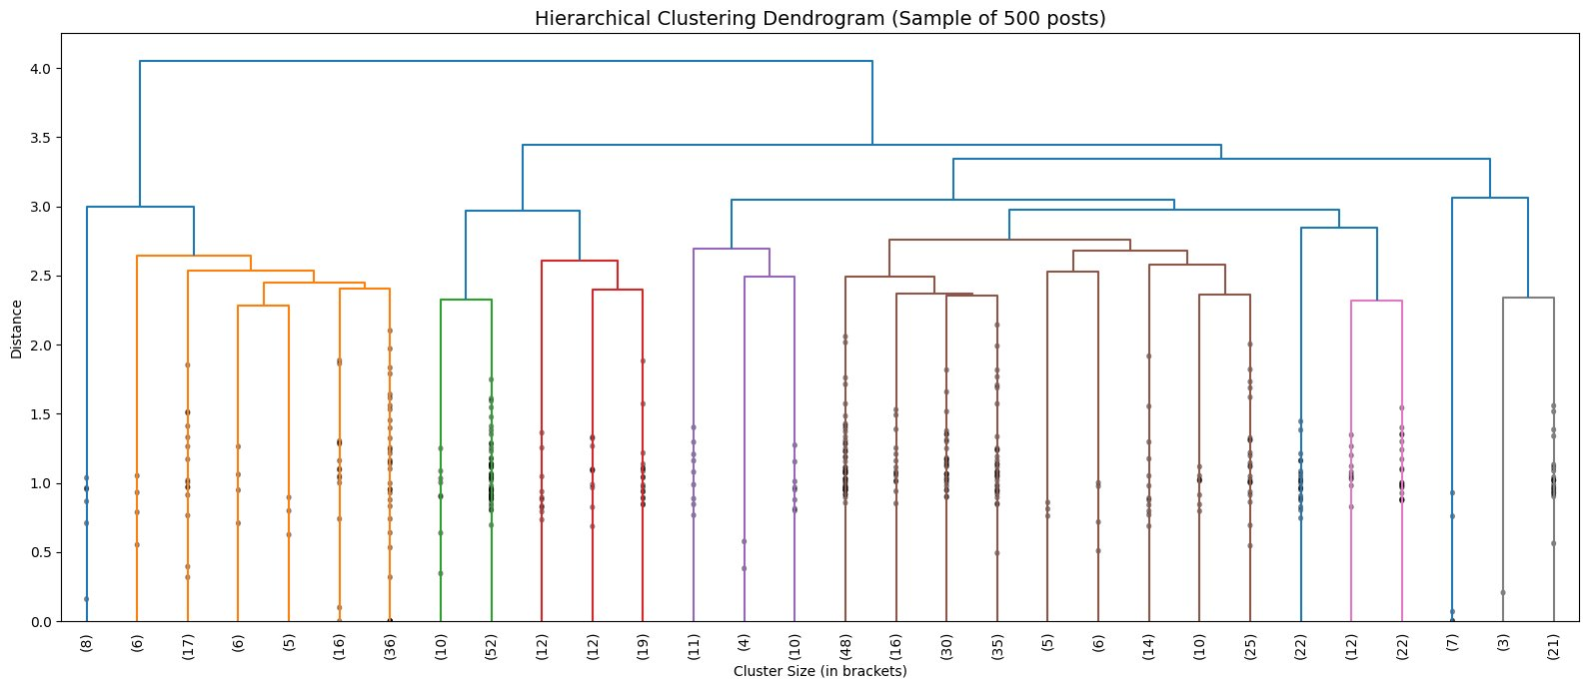
Figure 4: Ward linkage dendrogram on a 500-post sample (truncated to show last 30 merges). The highest-level merge at distance ≈4.0 divides the sample into two primary branches, independently confirming the two-cluster structure found by K-Means.

The top-level split at distance approximately 4.0 is clearly separated from the next level, visually confirming that two groups represent the most fundamental division in the data. AgglomerativeClustering (n_clusters=2) applied to a 2,000-post sample produced an almost identical functional/distressed split with labels flipped (cluster 0 dominated by Depression/Suicidal; cluster 1 dominated by Normal). After correcting for this label inversion, agreement with K-Means assignments was 69.0%.

4.4 DBSCAN
DBSCAN with cosine distance was applied to the full LSA matrix. Initial testing at eps=0.5 produced a single cluster covering 99.6% of posts. Systematic parameter tuning across five eps values produced the results shown in Table 8.

eps | Clusters Found | Noise Points | Noise %
0.3 | 56 | 21,437 | 40.8%
0.4 | 6 | 2,192 | 4.2% ← selected
0.5 | 1 | 780 | 1.5%
0.6 | 1 | 719 | 1.4%
0.7 | 1 | 719 | 1.4%
Table 8: DBSCAN parameter tuning results. eps=0.4 selected as the most informative setting (highlighted).

At eps=0.4, DBSCAN produced 6 clusters with 2,192 noise points (4.2%). Cluster 0 contained 50,262 posts — the dominant mass of the data. Clusters 1 through 5 contained only 5 to 10 posts each, all exclusively drawn from the Normal category, representing tight groups of formulaic short posts.
The 2,192 noise points (posts labeled -1) are the most clinically significant output of DBSCAN. These are posts that no dense neighborhood could accommodate — linguistically unusual outliers. Table 9 breaks down their label composition and characteristics.

Status | Noise Count | Observed Characteristic
Normal | 1,131 | Genuinely context-free posts ("it certainly is.", "SARAAAAAH —£") — true noise with no mental health content
Depression | 429 | Unusually poetic and metaphorical language ("just like a black hole whenever I manage to find some light")
Suicidal | 400 | Unusually specific crisis language ("I am doing this because it is best for everyone else") — most severe posts in dataset
Stress | 113 | Atypical expression patterns relative to stress corpus
Bipolar | 63 | Atypical expression patterns
Anxiety | 51 | Atypical expression patterns
Personality Disorder | 5 | Atypical expression patterns
Table 9: DBSCAN noise point breakdown by mental health status. The 400 Suicidal outliers are of particular clinical interest.

The Suicidal noise points represent posts whose crisis language is so specific and atypical that they bear no resemblance to any other post in the dataset. The Depression noise points exhibit metaphorical expression styles not present in typical depression posts. This demonstrates that DBSCAN, in addition to clustering, functions as an effective anomaly detector that can surface the most linguistically extreme posts in a corpus.

4.5 Principal Component Analysis (PCA)
PCA was applied to the 100-dimensional LSA matrix with n_components=10. Table 10 shows the variance explained by each component.

Component | Variance Explained (%) | Cumulative Variance (%)
PC1 | 4.52% | 4.52%
PC2 | 2.80% | 7.32%
PC3 | 2.39% | 9.72%
PC4 | 1.96% | 11.68%
PC5 | 1.89% | 13.57%
PC6 | 1.72% | 15.29%
PC7 | 1.67% | 16.96%
PC8 | 1.60% | 18.56%
PC9 | 1.49% | 20.05%
PC10 | 1.44% | 21.49%
Table 10: PCA variance explained per component and cumulative total for 10 components.

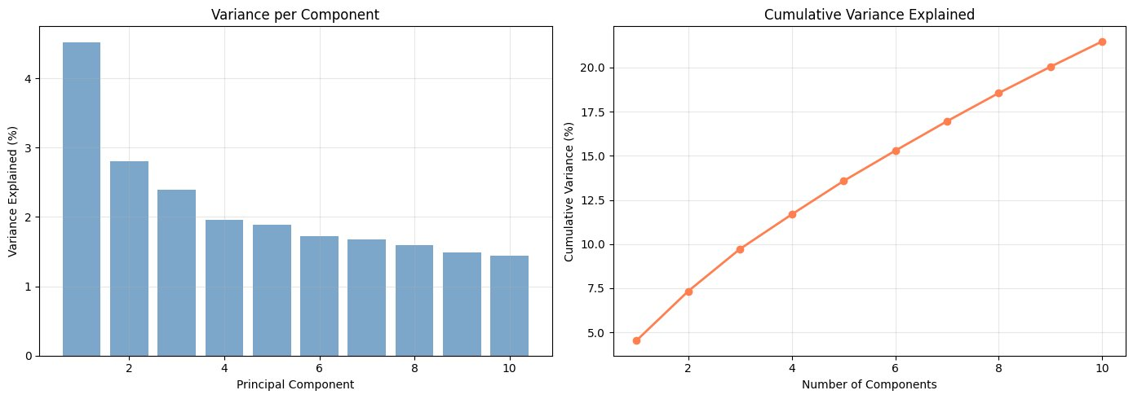
Figure 5: PCA variance analysis. Left: per-component variance showing gradual decline. Right: cumulative variance showing near-linear accumulation — characteristic of high-dimensional text data where variance is distributed broadly rather than concentrated.

Ten components collectively explain only 21.49% of total variance. This low figure is not a failure of the method but rather a documented property of mental health text: the same emotional content is expressed in an enormous variety of ways, producing variance distributed across many dimensions rather than concentrated in a few.
Interpretation of the top two components via their TF-IDF feature loadings (extracted from lsa.named_steps['truncatedsvd'].components_):

Component | Variance | High-Loading Features (positive direction) | Low-Loading Features (negative direction)
PC1 | 4.52% | feel, like, want, get, know, life, think, go, time, make, even, really, people, would, day | perdedorsoy, como, jyp, wallsim, uma, mais, por, une, soy, pression, und, ich, mas, est, tier
PC2 | 2.80% | want, die, kill, anymore, live, hate, life, tired, fuck, fucking, love, care, wish, end, someone | feel, get, anxiety, like, depression, work, day, start, time, week, year, stress, month, symptom
Table 11: PC1 and PC2 top-loading TF-IDF features. PC1 separates English from non-English posts. PC2 separates crisis from clinical/functional language.

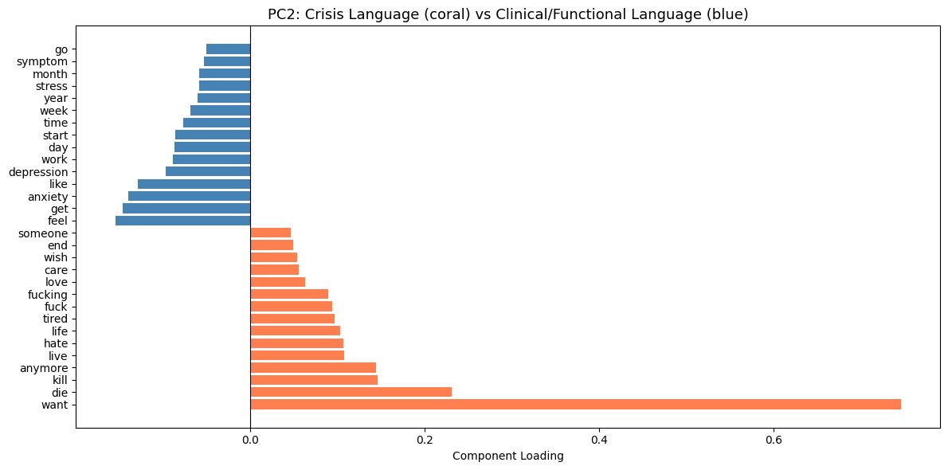
Figure 6: PC2 component loadings. Coral bars (positive direction) = crisis language: want, die, kill, anymore, hate. Blue bars (negative direction) = clinical/functional language: feel, anxiety, depression, work, symptom. The word "want" has by far the largest positive loading, reflecting the high prevalence of "I want to die/end it" constructions in crisis posts.

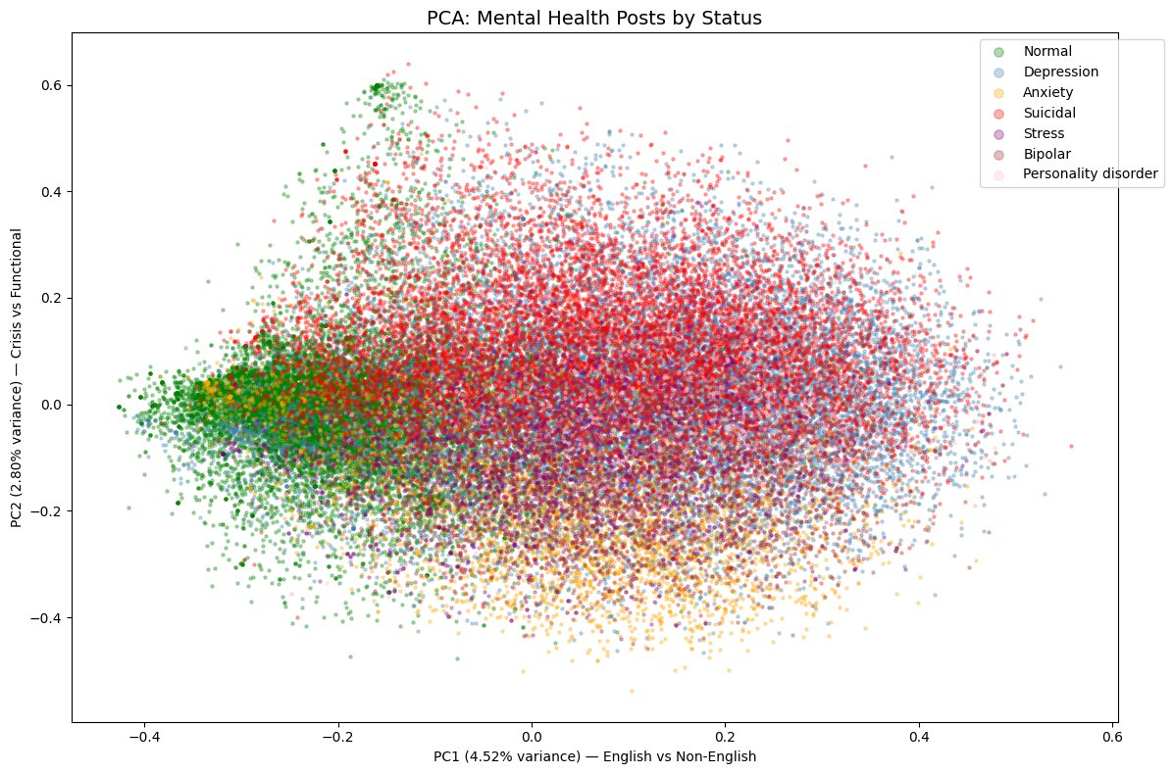
Figure 7: PCA scatter plot of all 52,484 posts colored by ground truth mental health status. Suicidal posts (red) trend toward the upper region (positive PC2 = crisis language). Normal posts (green) cluster toward the left. Anxiety posts (orange) position at the bottom (negative PC2 = clinical language). Depression posts (blue) spread rightward along PC1.

4.6 Factor Analysis
Factor Analysis with 5 components was applied to a dense TF-IDF matrix built from the top 500 vocabulary features. The five extracted factors and their highest and lowest loading terms are shown in Table 12.
Factor | Interpretation | High-Loading Words | Low-Loading Words
F1 | Deep Reflection vs Surface Daily Talk | feel, like, get, life, year, know, even, time, thing, would | yes, morning, miss, buy, today, god, tomorrow, please, damn, amp
F2 | Clinical/Medical vs Emotional Crisis | anxiety, symptom, week, doctor, experience, health, start, attack, bipolar, panic | want, life, live, anymore, friend, people, die, hate, fuck, kill
F3 | Social/Emotional vs Practical/External | feel, like, people, anyone, someone, depression, bipolar, talk, else, help | year, day, get, job, work, week, go, school, last, month
F4 | Physical Symptoms vs Structured Life | feel, pain, attack, sleep, heart, die, panic, want, go, wake | depression, mental, job, help, work, people, bipolar, money, year, therapy
F5 | Acute Crisis vs Mild Distress | anxiety, health, die, mental, pain, kill, fuck, want, fucking, suicide | feel, like, really, day, time, friend, start, episode, new, sad
Table 12: Factor Analysis results — five latent psychological dimensions with high and low loading terms.
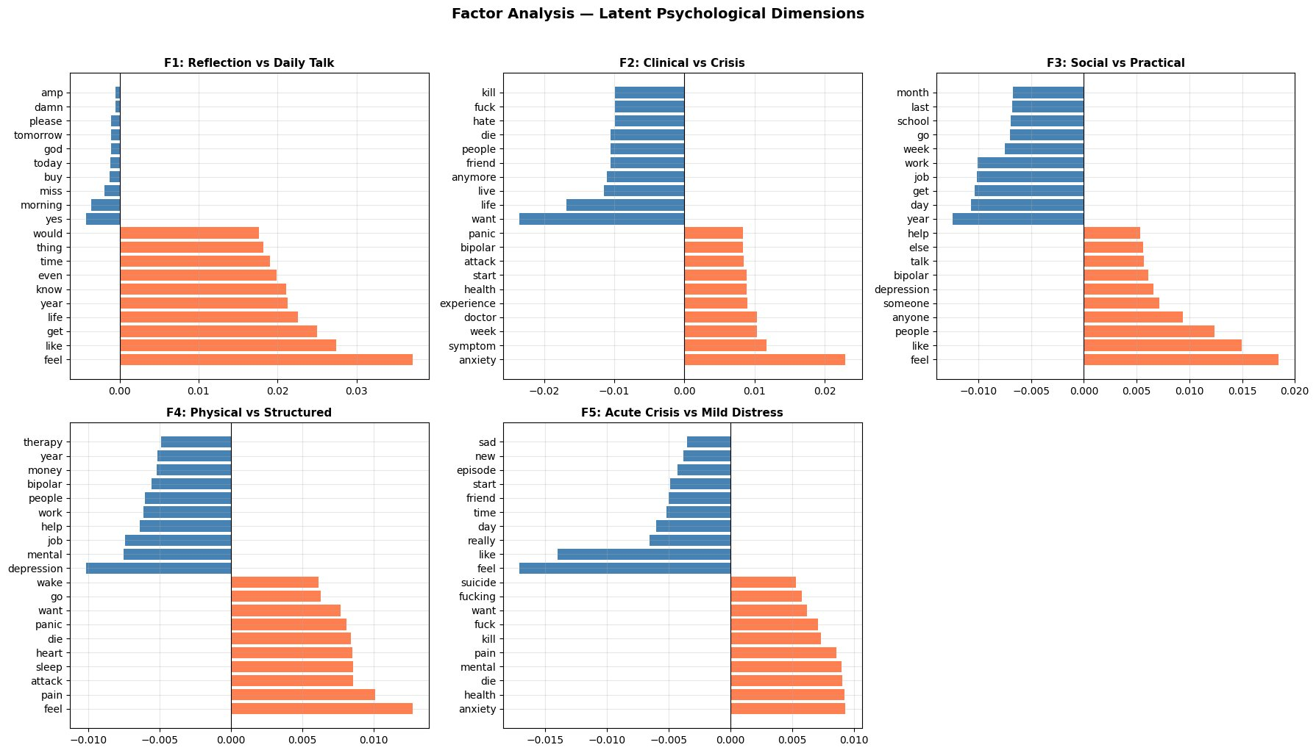
Figure 8: Factor Analysis component loadings for all five factors. Coral bars = positive (high-loading) direction; blue bars = negative (low-loading) direction. F2 (Clinical vs Crisis) and F5 (Acute Crisis vs Mild Distress) are the most clinically interpretable, independently replicating the severity axis discovered by PCA.

4.7 Association Rule Mining
Apriori was applied to keyword presence baskets derived from 33,398 posts. With min_support=0.01, 292 frequent itemsets were identified. Generating rules at min_lift=1.2 produced 796 association rules. Table 13 shows the top ten rules by lift.
Antecedent | Consequent | Support | Confidence | Lift
therapy | medication | 1.2% | 19.2% | 3.84
medication | therapy | 1.2% | 24.3% | 3.84
work, friend | help, family | 1.3% | 19.7% | 3.72
help, family | work, friend | 1.3% | 25.3% | 3.72
panic | anxiety | 2.4% | 53.2% | 3.20
anxiety | panic | 2.4% | 14.4% | 3.20
depression, work | therapy | 1.0% | 15.9% | 3.09
depression, help | therapy | 1.1% | 17.9% | 3.01
anxiety, help | therapy | 1.0% | 16.5% | 2.90
suicide, friend | family | 1.3% | 43.6% | 2.86
Table 13: Top 10 association rules by lift. Lift > 1.0 indicates the co-occurrence is more frequent than chance; lift > 2.0 indicates a strong meaningful association.

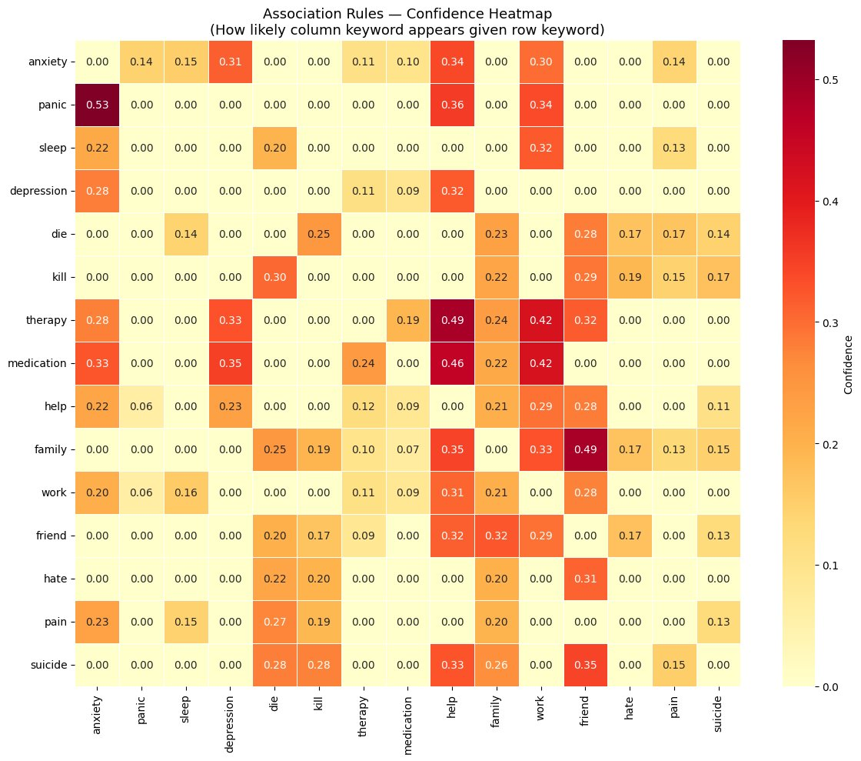
Figure 9: Association rule confidence heatmap for 15 key mental health terms. Cell value = probability that the column keyword appears given the row keyword is present. Darkest cells: panic→anxiety (0.53), therapy→help (0.49), family→friend (0.49), medication→help (0.46).

V. Discussion

5.1 What the Results Mean
The most consistent finding across all seven analytical methods is the existence of two fundamental registers in online mental health discourse: functional/clinical language and distressed/crisis language. This was independently confirmed by K-Means clustering (silhouette-optimal k=2; Cluster 0 dominated by Normal posts, Cluster 1 by Depression and Suicidal posts), Agglomerative Clustering (same two-group split, 69.0% agreement after label correction), PCA PC2 (positive direction = crisis vocabulary; negative direction = clinical vocabulary), and Factor Analysis factors F2 and F5 (Clinical vs. Crisis; Acute Crisis vs. Mild Distress). The convergence of four independent methods on the same structure constitutes strong evidence that this is a genuine property of the data rather than an artifact of any single algorithm.
PCA provides the clearest interpretation of what this axis represents. PC2 separates posts containing crisis vocabulary (want, die, kill, anymore, hate, tired, live) from posts containing clinical and functional vocabulary (anxiety, work, symptom, day, stress, week, month). The word "want" carries the single largest positive loading, reflecting the high frequency of "I want to die/end it" constructions in crisis posts. Critically, this crisis vocabulary is not specific to any single condition label — it spans Depression, Suicidal, and Bipolar posts alike. The underlying dimension is not diagnostic category but severity of current distress.
LDA adds a complementary layer. Rather than a binary split, topic modeling reveals three thematic modes of expression: describing physical symptoms and daily experience (Topic 0, 14%), expressing inner emotional states (Topic 1, 61%), and discussing external life circumstances and help-seeking (Topic 2, 25%). The dominance of Topic 1 (61%) confirms that self-expression and inner reflection are the primary mode of online mental health communication, with clinical symptom description and practical life concerns as secondary registers.
Association Rule Mining reveals the structural co-occurrence relationships within these registers. The strongest rule, therapy ↔ medication (lift 3.84), identifies a treatment-aware subgroup of users who discuss both simultaneously — a linguistically cohesive group not visible at the cluster or topic level. The panic → anxiety rule (confidence 0.53) is the most asymmetric strong rule in the dataset: mention of panic almost always co-occurs with anxiety, but anxiety appears in many contexts without panic. The suicide + friend → family rule (lift 2.86, confidence 0.44) is clinically significant: crisis posts that mention a friend frequently also mention family, consistent with clinical literature on social isolation and relationship loss as risk factors in suicidal ideation.
DBSCAN contributed a different type of finding: anomaly detection. While it could not partition the dense, continuous mental health corpus into meaningful clusters (a known limitation of density-based methods on this type of data), it effectively flagged the 2,192 most linguistically unusual posts. The 400 Suicidal noise points, in particular, exhibit crisis language so specific and atypical ("I am doing this because it is best for everyone else") that they do not resemble any other post in the dataset. These outliers may represent the highest-risk posts in the corpus.

5.2 How the Results Can Be Used
The findings from this project have several concrete applications:
- Crisis detection. The crisis vocabulary identified by PCA PC2 (want, die, kill, anymore, hate, tired) and the DBSCAN outlier posts could directly seed keyword lists or embedding-based alert systems for community moderators. The 400 Suicidal DBSCAN outliers, specifically, are candidates for immediate human review.
- Content routing. The two-cluster structure provides a natural basis for automatically routing users to different support resources: general mental health information for Cluster 0 (Functional) versus crisis intervention resources for Cluster 1 (Distressed).
- Chatbot and conversational AI design. The 796 association rules provide a structured map of concept co-occurrences. A chatbot that detects "panic" could proactively probe for anxiety; one that detects "work" + "depression" together could surface therapy resources, because the data shows these co-occur with therapy-seeking at lift 3.09.
- Dataset quality auditing. The multilingual contamination revealed by PCA PC1 — non-English posts pulling the first principal component entirely — provides a reusable quality check methodology that should be applied to any social media NLP dataset before analysis begins.
- Research framework. The five psychological dimensions from Factor Analysis (Reflection vs. Daily Talk, Clinical vs. Crisis, Social vs. Practical, Physical vs. Structured, Acute Crisis vs. Mild Distress) provide a data-driven vocabulary for describing mental health discourse that could be validated in future clinical studies.

VI. Limitations

6.1 Issues Encountered During Analysis
Multilingual contamination. PCA revealed that PC1 — the single largest source of variance in the dataset — is driven by language rather than mental health content. The negative loading direction of PC1 contains non-English terms from Spanish (como, soy, mas), French (une, est), German (ich, und), and Portuguese (mais, uma). These posts were not filtered during preprocessing because no language detection step was included. As a result, PC1 provides no clinically useful information, and some topic and clustering results may be influenced by language differences rather than mental health content differences.
Low silhouette scores throughout. All clustering methods produced silhouette scores below 0.04 (best: 0.0357 at K-Means k=2). These low absolute values reflect the inherent continuous and overlapping nature of mental health language — different conditions share substantial vocabulary, so clusters do not form geometrically compact, well-separated regions. This is a data property, not a model failure. Scores improved substantially after LSA dimensionality reduction (from approximately 0.01 on raw TF-IDF to 0.036 on 100-dimensional LSA features), confirming the importance of the feature representation choice.
Memory constraint on Agglomerative Clustering. Attempting AgglomerativeClustering on the full 52,484-post dataset raised a MemoryError requiring approximately 10.3 GB of RAM for the pairwise distance matrix (shape: 1,377,258,886 float64 values). All hierarchical clustering results are therefore based on a 2,000-post sample (cluster assignments) and a 500-post sample (dendrogram). These samples are representative but do not constitute full-dataset results.
DBSCAN single-cluster behavior. At eps values of 0.5 and above, DBSCAN collapsed the entire dataset into a single cluster. At eps=0.3, it over-fragmented into 56 clusters with 40.8% noise. Only at eps=0.4 was a usable intermediate result obtained. This sensitivity to the eps parameter is expected for dense, continuous text data that does not have the island-like density structure DBSCAN is designed to exploit. The single-cluster result at eps=0.5 is itself a valid finding — it confirms that mental health text does not have clear density-based boundaries.
LDA coherence plateau. Coherence scores were nearly flat across all tested topic counts (range 0.346–0.382, spread of 0.036). The difference between the optimal 3-topic model and the worst-performing 5-topic model is less than 4%. This makes the topic count selection semi-arbitrary. A different coherence metric (u_mass or c_uci) or a held-out perplexity evaluation might provide clearer guidance.
Preprocessing run time. The spaCy lemmatization pipeline processed 52,681 posts in approximately 16 minutes using sequential progress_apply. This run time is a meaningful constraint for iterative development — any change to the cleaning pipeline requires a full 16-minute rerun. Batch processing using spaCy's nlp.pipe() with parallelization would reduce this to approximately 2–3 minutes.

6.2 Missing Data and Variables
- Demographic variables. No age, gender, race, or geographic information is available. Demographic variation could substantially affect clustering results — for example, age-related differences in language expression might create meaningful sub-clusters invisible to the current analysis.
- Timestamps. No post dates or times are available. Temporal analysis — tracking how topics and cluster compositions shift over time or in response to external events such as the COVID-19 pandemic or seasonal cycles — is not possible with this dataset.
- Platform metadata. No engagement data (upvotes, comment counts, share counts) is included. High-engagement posts may carry systematically different linguistic patterns than low-engagement ones.
- Verified clinical diagnosis. Status labels are assigned based on source community membership (e.g., posting in r/depression → Depression label), not clinical diagnosis. A user in r/depression may have anxiety as their primary condition; a user in r/Anxiety may also have depression. This label noise limits the strength of the post-hoc validation step.
- Conversation context. Individual posts are analyzed in isolation. Replies, thread context, and conversational history are unavailable. Some posts may only be interpretable in the context of the thread they are part of.
- Post length distribution. Very short posts (fewer than 5 meaningful tokens after cleaning) were retained and may add noise. No minimum length filter was applied. Row 0 ("oh my gosh" → "gosh") illustrates this — a single-token post carries no analytical value but was included.

VII. Future Work

7.1 Immediate Pipeline Improvements
The following changes to the existing pipeline would yield the highest improvement per unit of effort:
- Language detection filtering. Add langdetect or fastText language identification as a preprocessing step before tokenization. Filter non-English posts into a separate file or remove them entirely. This would eliminate the multilingual artifact from PC1 and likely improve all downstream clustering and topic results.
- Sentence-BERT embeddings. Replace TF-IDF/LSA with a pre-trained sentence transformer model (e.g., all-MiniLM-L6-v2 from the sentence-transformers library). Sentence embeddings capture semantic meaning rather than word frequency and consistently produce substantially higher silhouette scores for short text clustering. This is the single highest-impact improvement available.
- Minimum post length filter. Remove posts with fewer than 10 meaningful tokens after cleaning to reduce noise from ultra-short posts.
- Faster lemmatization. Replace progress_apply with spaCy's nlp.pipe(batch_size=256, n_process=-1) for a 5–10x preprocessing speedup.

7.2 Alternative and Extended Methods
- NMF topic modeling. Apply Non-Negative Matrix Factorization as a comparison to LDA. NMF often produces more interpretable topics for short social media text and its results can be directly compared with LDA to assess the stability of discovered topic structure.
- BERTopic. Apply the BERTopic framework, which combines BERT sentence embeddings, UMAP dimensionality reduction, and HDBSCAN clustering to discover topics. BERTopic consistently outperforms LDA on social media text and produces cleaner, more coherent topic representations.
- HDBSCAN. Replace DBSCAN with Hierarchical DBSCAN (HDBSCAN), which does not require a fixed eps parameter and adapts to varying local densities. HDBSCAN is substantially better suited to text data and would likely produce more meaningful cluster boundaries.
- UMAP visualization. Replace PCA 2D scatter plots with UMAP (Uniform Manifold Approximation and Projection). UMAP preserves local structure far more faithfully than PCA and typically reveals cluster separation that PCA cannot show.
- Temporal analysis. Obtain a timestamped version of the dataset (e.g., via the Pushshift Reddit archive) to analyze how topic distributions and cluster compositions shift over time.

7.3 Clinical Validation and Deployment Recommendations
- Expert validation. Have licensed mental health professionals review a stratified random sample of posts from each cluster and topic to assess whether the discovered groupings are clinically interpretable and meaningful before any operational use.
- Crisis severity scoring. Use the crisis vocabulary identified by PCA PC2 and Factor Analysis F5 to construct a continuous crisis severity score for each post. Validate this score against human expert ratings of post severity.
- Longitudinal user tracking. If user identifiers are available, track individual users' posts over time to model how language patterns evolve. Do users assigned to the Distressed cluster eventually produce Functional-cluster language? What linguistic changes precede that transition? This would turn a static snapshot analysis into a dynamic behavioral model.
- Ethical review. Any deployment of crisis detection or content routing systems based on these findings must undergo ethical review. Automated flagging of mental health posts carries meaningful risks of false positives, stigmatization, and privacy violation. These must be addressed before operational deployment.

End of Report

