**Summer Internship Report**



**INTERNSHIP PORTAL**

Name: NISHA CHOUDHARY

Roll No: 15CSU126

Date: 22-05-2017 to 22-0702017

***Table of Contents***

1. Tables used
2. Abstract
3. Introduction
4. Training description
5. Analysis
6. Conclusion
7. Bibliography
8. Appendix

***Tables Used***

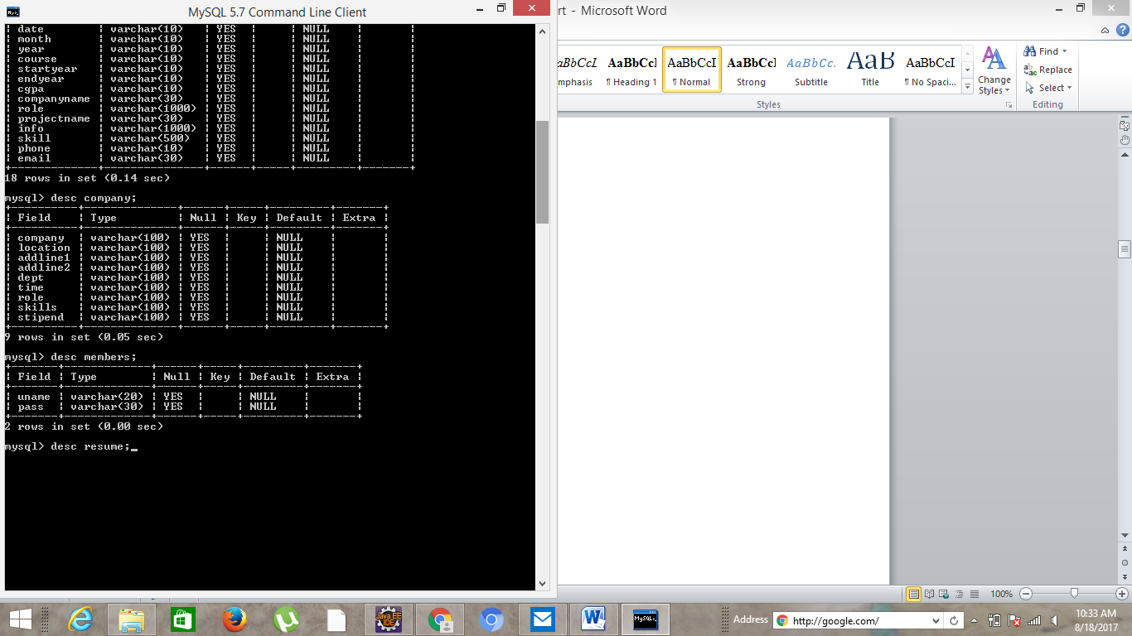

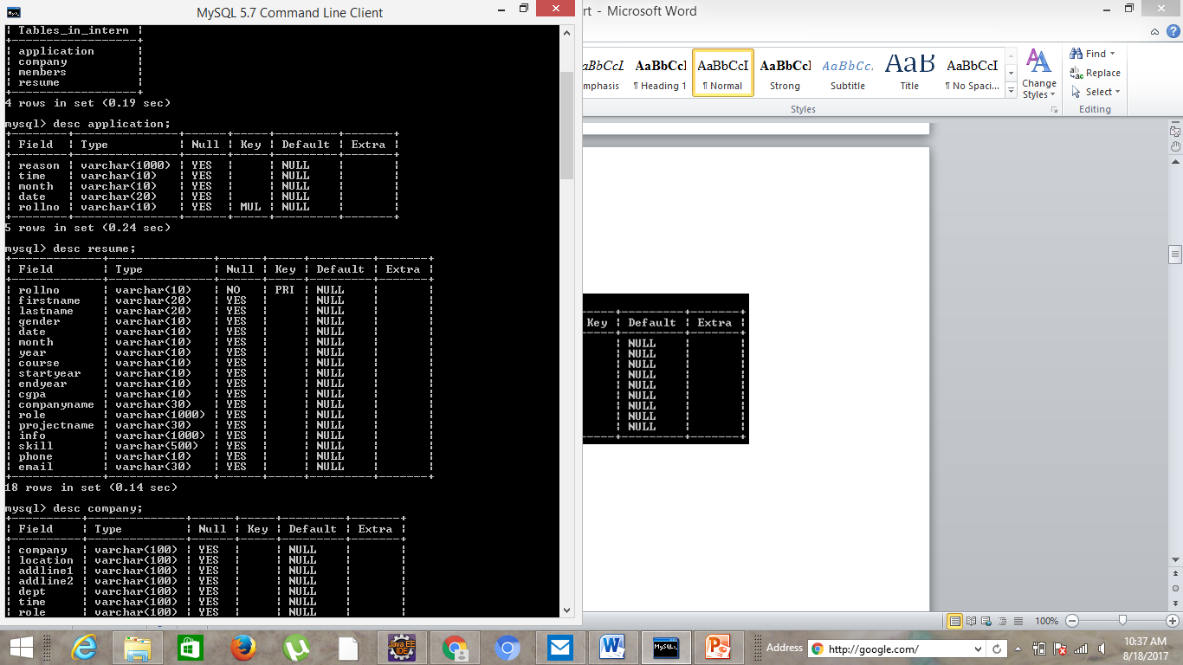

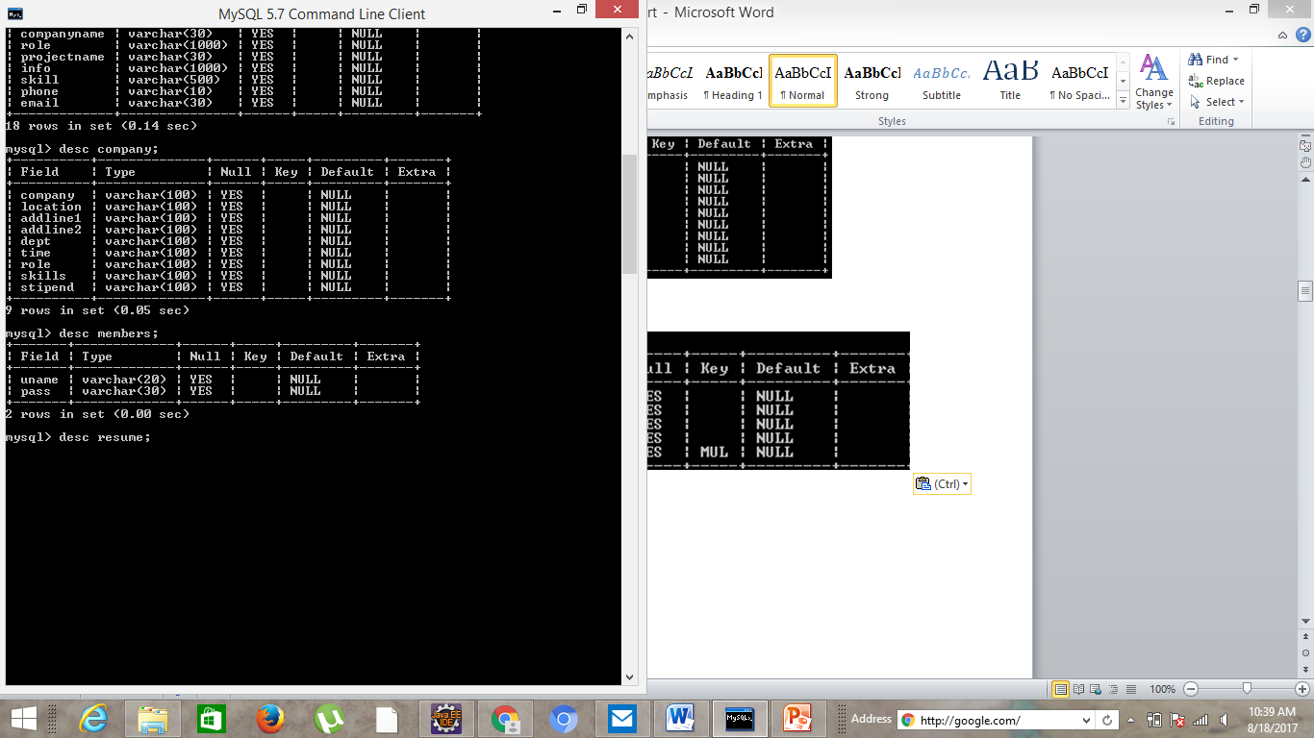

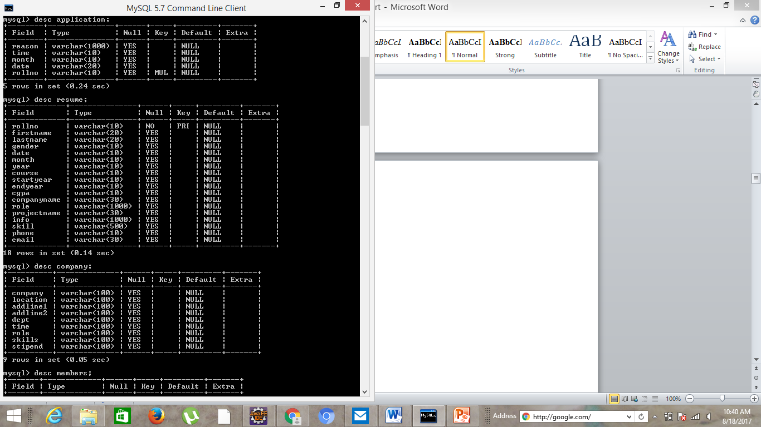

***Abstract***

My summer training internship was carried out in the university itself, The NorthCap University Sec-23A, Gurgaon, Haryana and the department which offered me this opportunity is Computer Science Department. The purpose of the internship was to provide us with an opportunity to practice various engineering techniques in the real world.  In addition, it provided us with an understanding on how technology-based organizations operate. The topic of my project is Internship Portal. I carried out this task with my partner Nikhil Budhiraja. We learned many new concepts and about team work. Team work is an essential element to complete the work effectively. Every team was alloted a mentor and we were allotted with Ms. Kavita Khanna who guided us throughout our project. After that we had to report to Ms. Supriya Raheja who is the faculty incharge for the internship projects of our university. The project has been developed to help the department maintain the students details and how they can apply for the internship to the companies through the university. With the help of this project the concerned departments will be able to improve the productivity, reduce the time, cost factors associated with the system. The automation of the system will help the organization in proper maintenance of the record, less manpower, less cost, proper and accurate functioning.

***INTRODUCTION***

My summer training internship was carried out in the university itself, The NorthCap University Sec-23A, Gurgaon, Haryana and the department which offered me this opportunity is Computer Science Department. I worked on the intranet based project Internship Project. The area in which I worked is computer science and I worked on the softwares like Java eclipse oxygen and Mysql. It includes languages such as HTML, CSS, JSP. In brief we can say this system was required to automate the processing of students applying for the internship for companies through our university and maintaining their records.

***TRAINING DESCRIPTION***

The topic of the project is Internship Portal. It is a project which will help the students to apply for their internships online and we could have the details of for the internships applied by the students of different branches and years. These details include name, roll number, branch, year, list of internships applied by the student. It also provides the student to edit and view the resume, and internship he applied for. The Administrator can view the details of the students applied for various companies and add new internships.

**Features of this project include :**

* Login system for
* Adminstrator
* Student
* Role based access level
* Adding internship
* View/Edit students resume
* Applying of Internships

**Objective:**

* To provide a platform to students for applying for industrial internships

via college administered procedure.

**Screenshots of the outputs and database are as follows:**

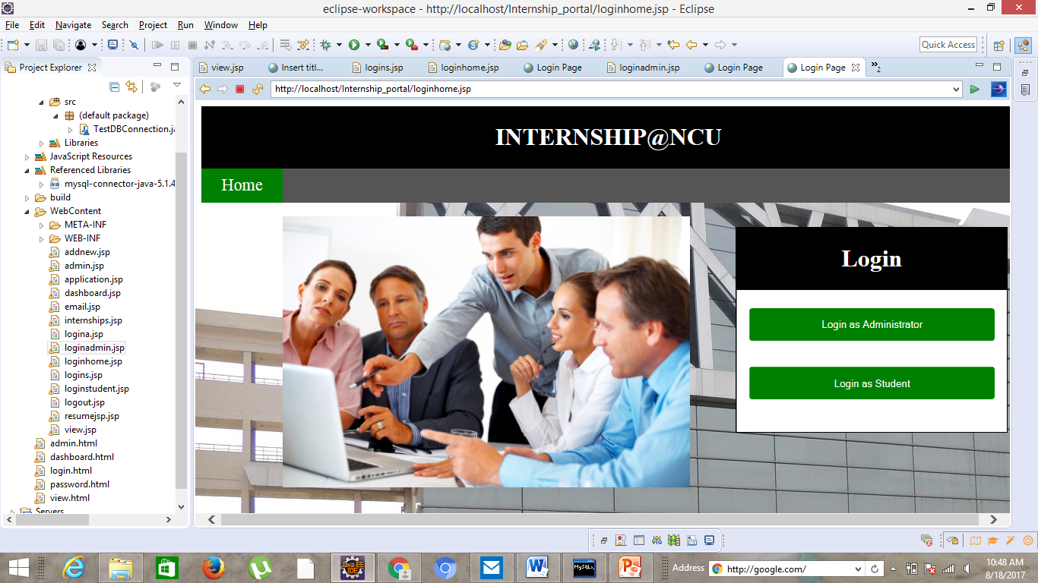

Login as admin/student:

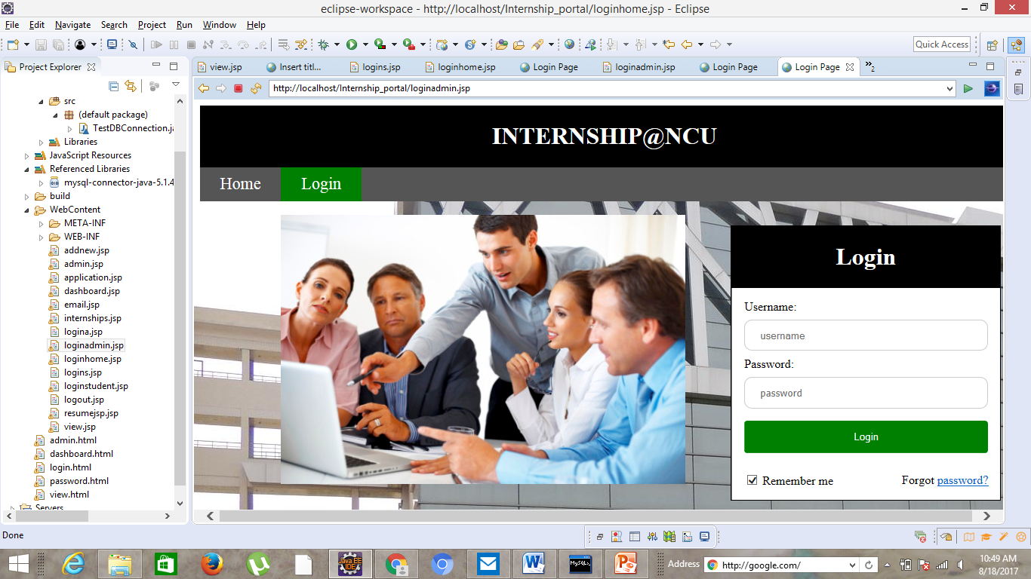

Actions for admin:

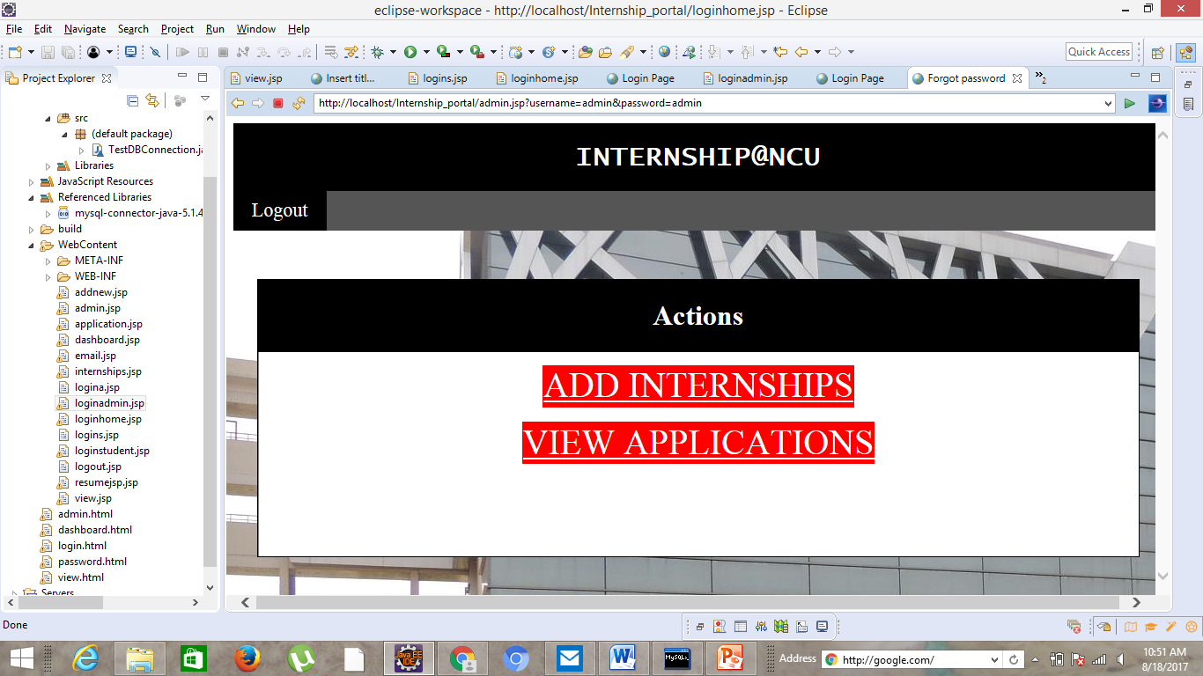

Add internship form:

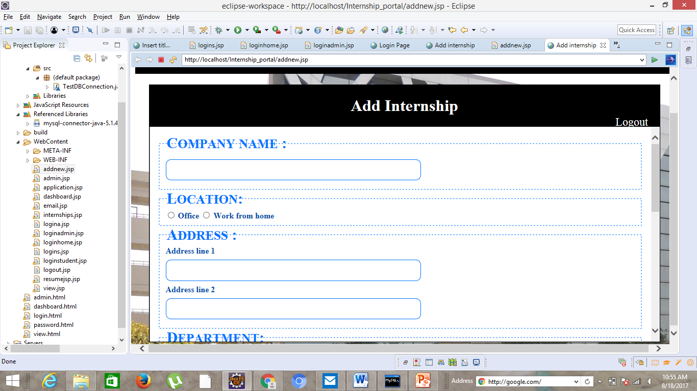

Student resume:

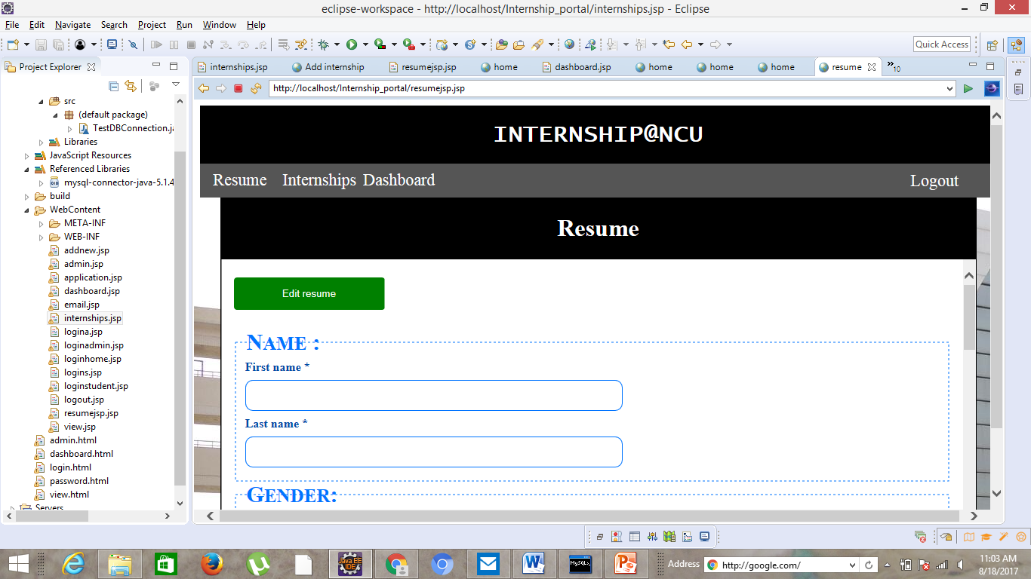

Student internships:

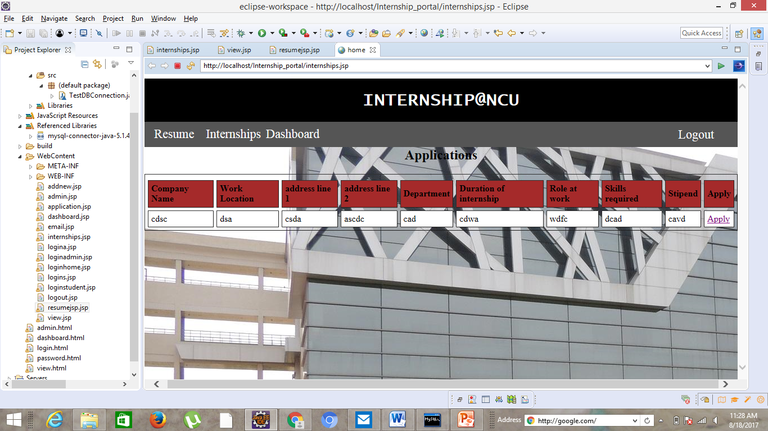

***ANALYSIS***

We learnt a lot during this whole procedure. Team work is an essential element. Every team was alloted a mentor and we are allotted with Ms. Kavita Khanna who guided us throughout the process. After that we had to report to Ms. Supriya Raheja who was the faculty incharge of the intership projects given by our university. The project has been developed to help the department maintaining the student details, of the students applying for the internships, with the help of this project the concerned departments will be able to improve the productivity, reduce the time, cost factors associated with the system. the automation of the system will help the organization in proper maintenance of the record, less manpower, less man-days , less cost, proper and accurate functioning. The softwares we worked on are Java eclipse oxygen and Mysql. And the languages used are HTML, CSS, JSP. During this I realized that my managerial skills are good. I got to know how to work in team to achieve your goals, and how time should be managed. I do not panic and do my work with an open mind. My curiosity of learning made me improve my knowledge. I realized that taking others help in times of need is an important aspect of every project as we tend to learn more when an experienced person guides us. I would like to work more on my programming skills. I definitely will learn more and keep on working on different projects to enhance my skills.

***CONCLUSION***

Our project is only a humble venture to satisfy the needs in a university to manage internship records of the student applying for the internship via our university. Several user friendly coding have also adopted. This package shall prove to be a powerful package in satisfying all the requirements. The objective of software planning is to provide a frame work that enables a manager to make reasonable estimates made within a limited time frame at the beginning of the software project and should be updated regularly as the project processes. Now talking about my experience, I would say that this was necessary to enhance my skills and this definitely connected me to real life problems. I gained some more technical skills as after every error we tend to more learn. Team work, unity, hard work are the main key elements of every project.

***BIBLIOGRAPHY***

* Google for problem solving
* [www.javaworld.com](http://www.javaworld.com)
* www.w3schools.com
* Java: The Complete Reference, Tenth Edition

Book by Herbert Schildt

***Appendix***

**The NorthCap University**, formerly **ITM University**, is an autonomous university situated in Sector 23-A, Gurugram, Haryana, India. It was founded in 1996 by Educate India Society, registered under the Registration of Societies Act of 1860 as an Engineering Institute, to provide education in Technical and Management. Formerly it was under Maharshi Dayanand University, Rohtak.

The Institute gained the status of private university in the Academic Year 2009-10, and was renamed ITM University under section 2(f) of the UGC Act 1956 and *Private Universities Act NO 25 OF 2009*, Government of Haryana.

The University is located in Sector 23-A, Gurugram, Haryana, which is about 5 km from Indira Gandhi International Airport. The campus is spread over an area of 10 acres of land in urban area.

The university increased its intake capacity in January 2014 with the addition of a new five-storey academic block that includes double basement parking, an auditorium that seats 460, seminar rooms and tutorial rooms.

The University has four schools offering courses at the undergraduate, graduate and doctoral level, namely the School of Engineering & Technology, School of Management, School of Law and School of Professional Attachment,[ as well as a Centre for Languages Learning.

|  |  |  |
| --- | --- | --- |
| Project Daily Task | | |
| Date | **Day** | **Work** |
| 22-5-2017 – 28-5-2017 | Monday-Sunday | Analyzed the requirements and made a structure of the project. |
| 29-5-2017 – 3-6-2017 | Monday-Saturday | Strategized and distributed work amongst each other. |
| 4-6-2017 – 6-6-2017 | Sunday-Tuesday | Free |
| 7-6-2017 – 16-6-2017 | Wednesday-Friday | Learnt the concepts of HTML, CSS and JSP. |
| 17-7-2017 – 19-6-2017 | Saturday-Monday | Free |
| 20-6-2017 – 30-6-2017 | Tuesday-Friday | Designed frames of application, viewing internships using HTML and CSS. |
| 1-7-2017 – 2-7-2017 | Saturday-Sunday | Free |
| 3-7-2017 – 9-7-2017 | Monday-Sunday | Worked on backend using JSP for the designed pages. |
| 10-7-2017 – 13-7-2017 | Monday-Thursday | Created SQL tables in the database |
| 14-7-2017 –15-7-2017 | Friday-Saturday | Debugging errors. |
| 16-7-2017 – 17-7-2017 | Sunday-Monday | Reviewed the pages and refined the design |
| 18-7-2017 – 22-7-2017 | Tuesday-Saturday | Connection |